|  |
| --- |
| Cybage Software Pvt. Ltd. |
| Sample File Generator Tool |
|  |
|  |
| **Shalaj Shukla** |
| **10/25/2016** |

|  |
| --- |
|  |

Contents

Sample File Generator 2

Introduction - Why Sample File Generator? 2

Prerequisite 2

How to use Sample File Generator Tool 2

Windows Tool 2

Linux Tool 5

# Sample File Generator

 Sample File Generator tool is a simple program which generates files of any size with ease.

# Introduction - Why Sample File Generator?

Many a time this happened that we have a sample input file with limited amount of data and we cannot perform performance testing on it due to low volume of the data, Sample file generator tool solve this problem, we just need to pass the input file which have low volume of data also we need to specify the delimiter and we can produce a sample output file with large volume of data

# Prerequisite

Java must be installed on machine and path of bin must be set in environment variables

# How to use Sample File Generator Tool

We have two version of tool one for windows and other for Linux

## Windows Tool



1. extract this zip file in any of the folder it contains jars folder and SampleFileGenerator.bat file

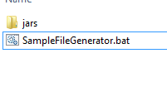

Just double click on SampleFileGenerator.bat file; it will open a User interface

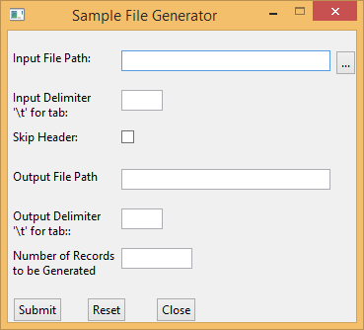

We need to provide below arguments

**Input File Path** – Browse and select any sample input file with limited amount of data

**Input Delimiter**- Enter the input file delimiter

**Skip Header** – If sample input file contains header like column name you can skip header by just selecting the check box

**Output File Path** – Provide path of the output file that will be generated by this tool

**Output Delimiter** – Enter output file delimiter (this could be different from input delimiter)

**Number of Records**- Enter number of records that you want to generate in output file

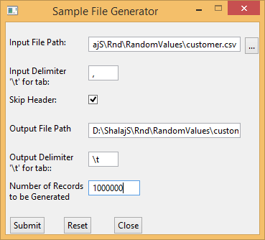

Fill all values and click on submit button

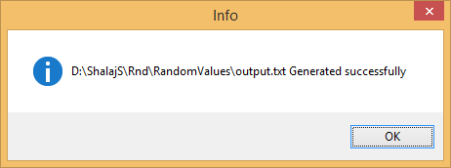

This will create the sample output file which will have 100 records separated by tab

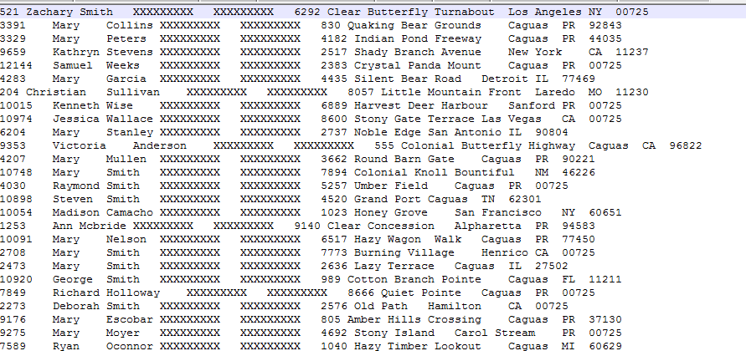

## Linux Tool



1. extract this zip file in any of the folder it contains jars folder and SampleFileGenerator.sh file



2. Give execute permission to SampleFileGenerator.sh file by executing below command

|  |
| --- |
| chmod +x SampleFileGenerator.sh |

3. Now run SampleFileGenerator.sh file by executing below command

|  |
| --- |
| ./SampleFileGenerator.sh |

Rests of the steps are same as windows.

Source code are attached herewith

