**Note that if your application is for public consumption, using the Google Finance API is against Google's terms of service.**

For downloading historic data again, you could use the Google APIs.

[http://www.google.com/finance/historical?q=NASDAQ:ADBE&startdate=Jan+01%2C+2009&enddate=Aug+2%2C+2012&output=csv](http://www.google.com/finance/historical?q=NASDAQ%3aADBE&startdate=Jan+01%2C+2009&enddate=Aug+2%2C+2012&output=csv)

**Historical data in csv format**

http://finance.google.com/finance/historical?q= NASDAQ:MSFT&startdate=Jan+01%2C+2009&enddate=Aug+2%2C+2012&output=csv

http://finance.google.com/finance/historical?q= NASDAQ:MSFT&startdate=Jan 01 2009&enddate=June 5 2017&output=csv

<http://www.google.com/finance/info?q=CURRENCY:GBPUSD>

// [ { "id": "-2001" ,"t" : "GBPUSD" ,"e" : "CURRENCY" ,"l" : "1.2887" ,"l_fix" : "" ,"l_cur" : "" ,"s": "0" ,"ltt":"" ,"lt" : "Jun 6, 2:53PM GMT" ,"lt_dts" : "2017-06-06T14:53:58Z" ,"c" : "-0.00198" ,"c_fix" : "" ,"cp" : "-0.154" ,"cp_fix" : "" ,"ccol" : "chr" ,"pcls_fix" : "" } ]

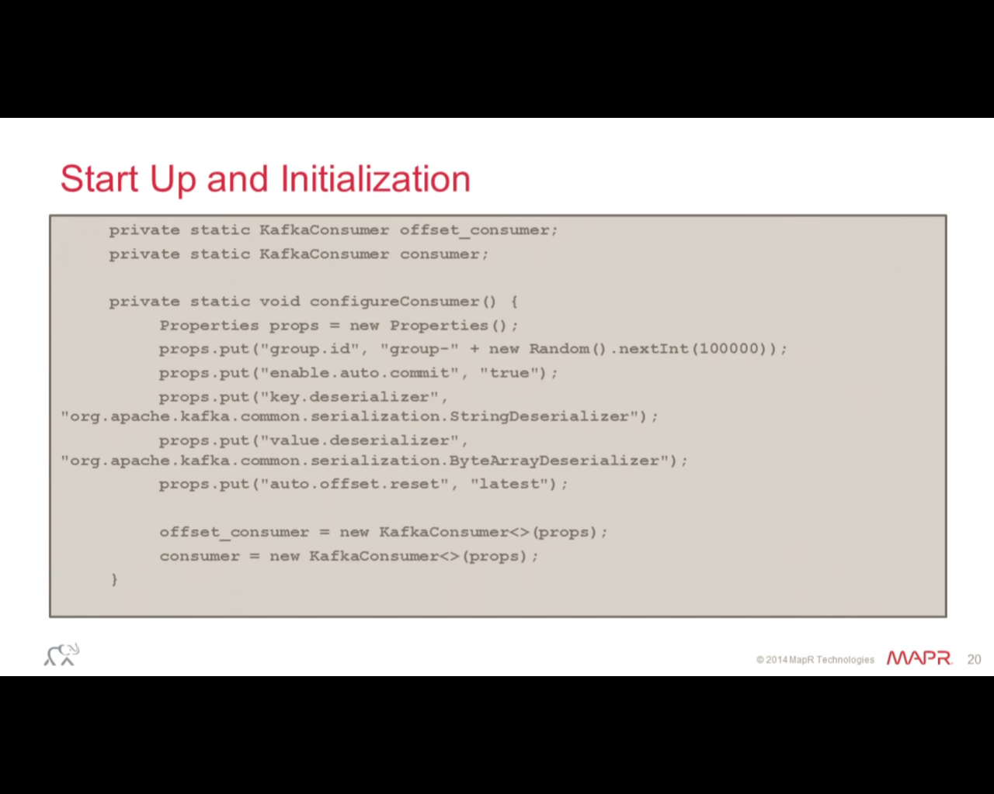

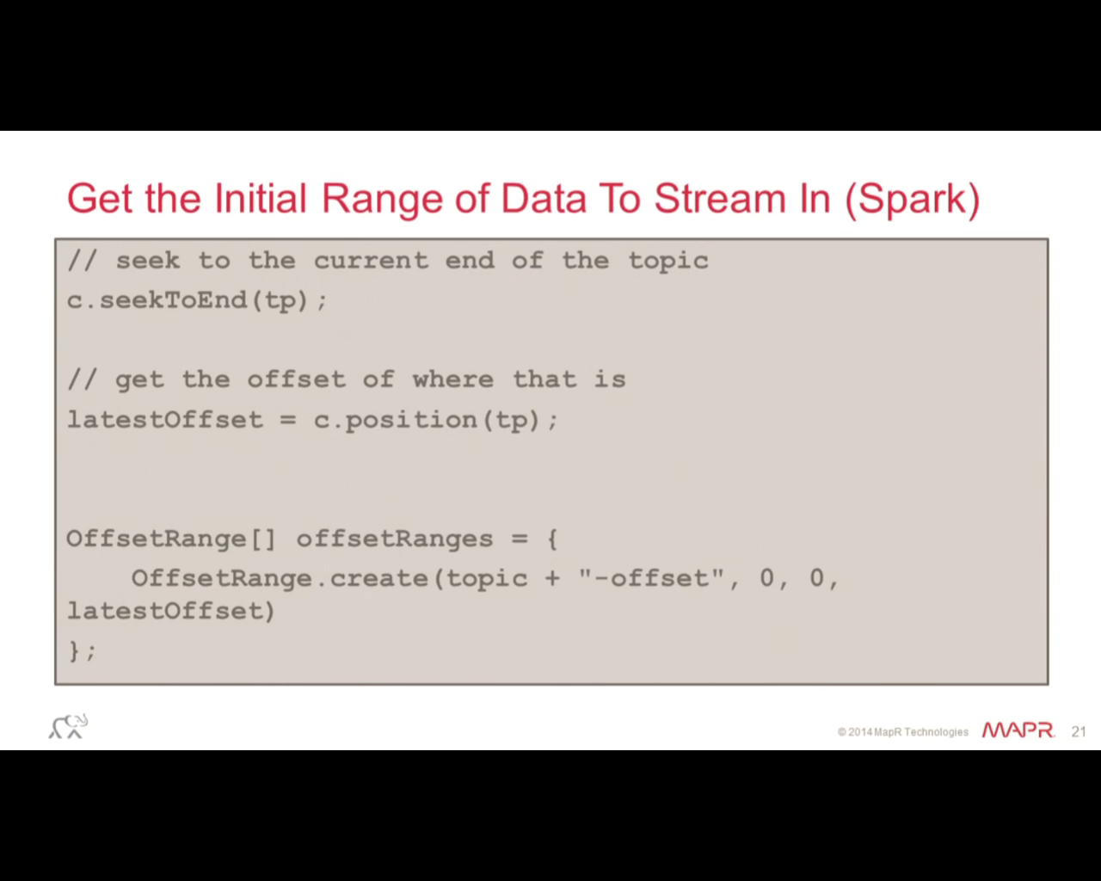

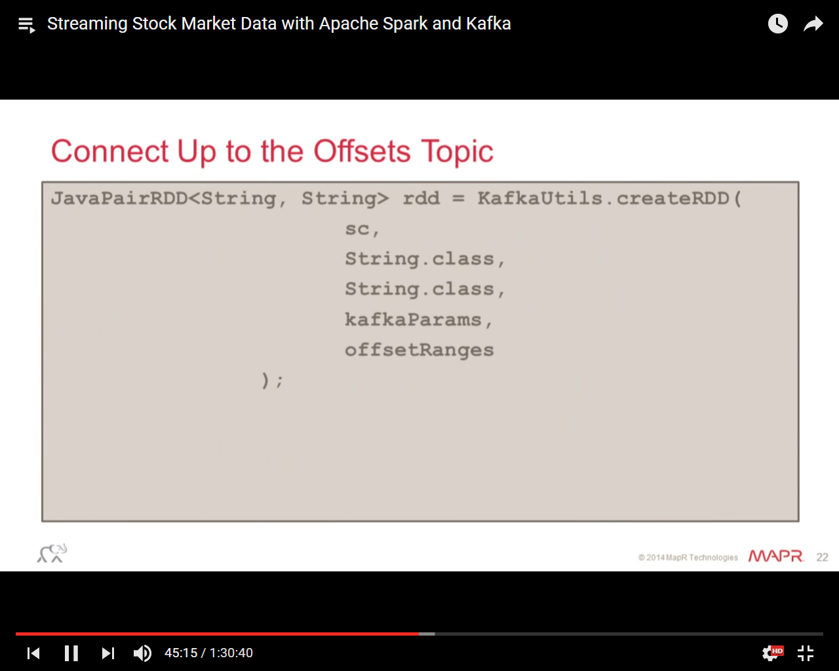

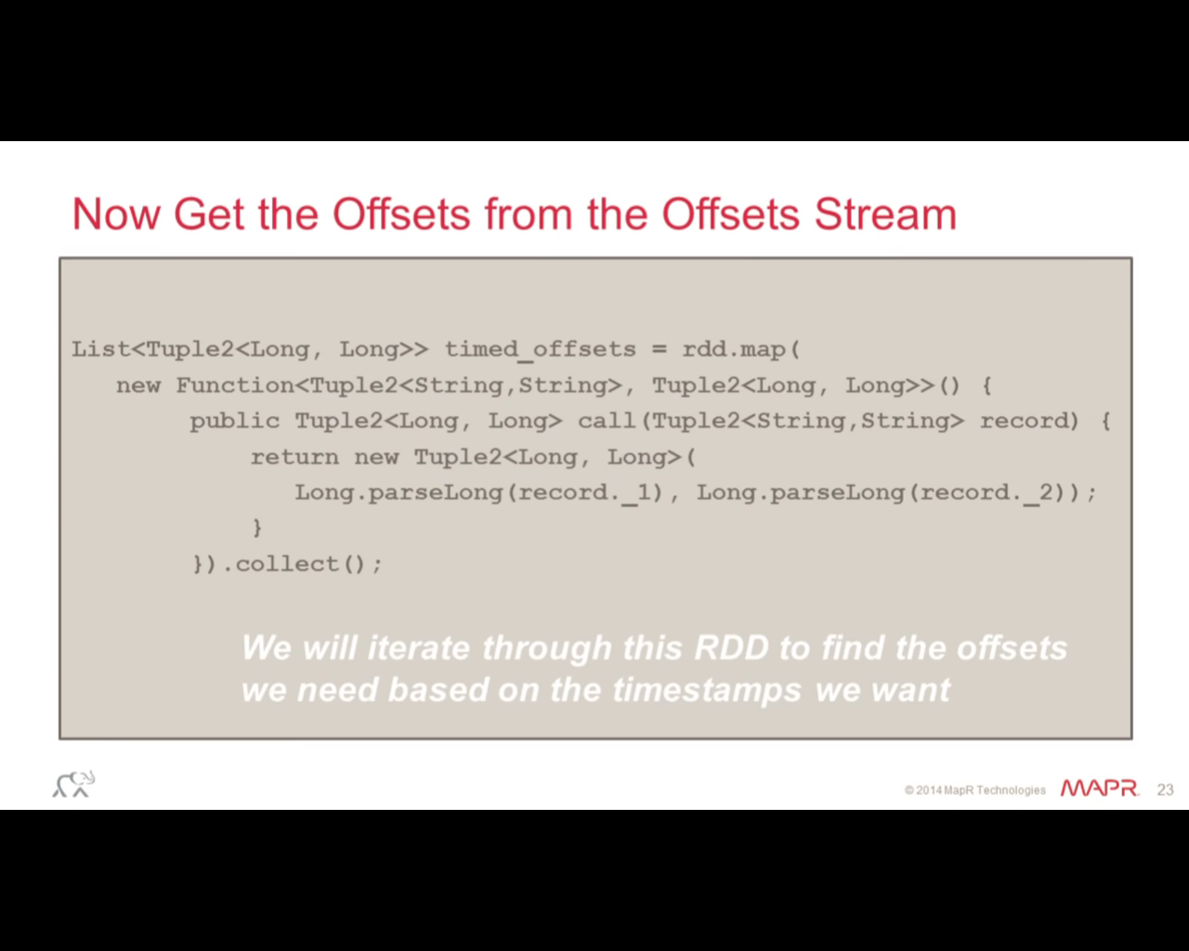

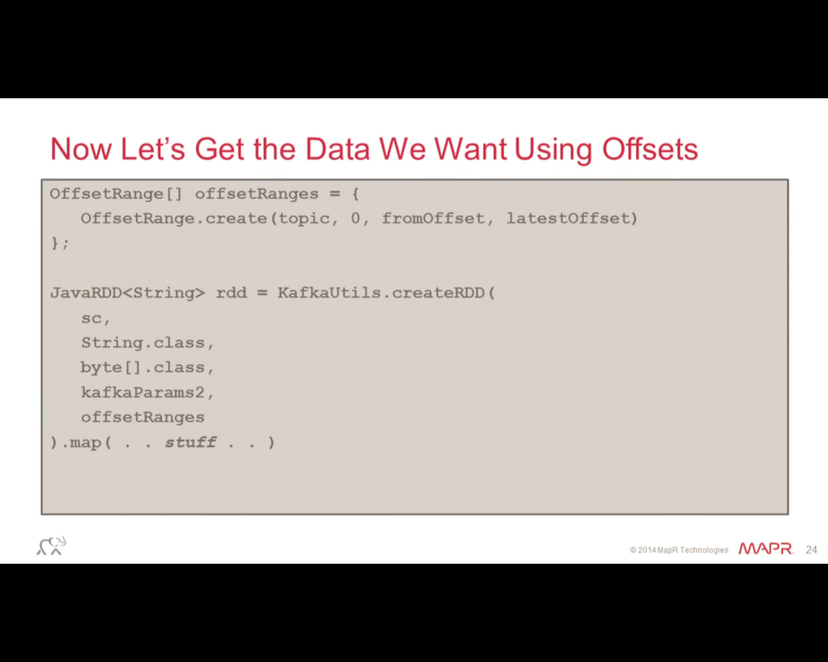

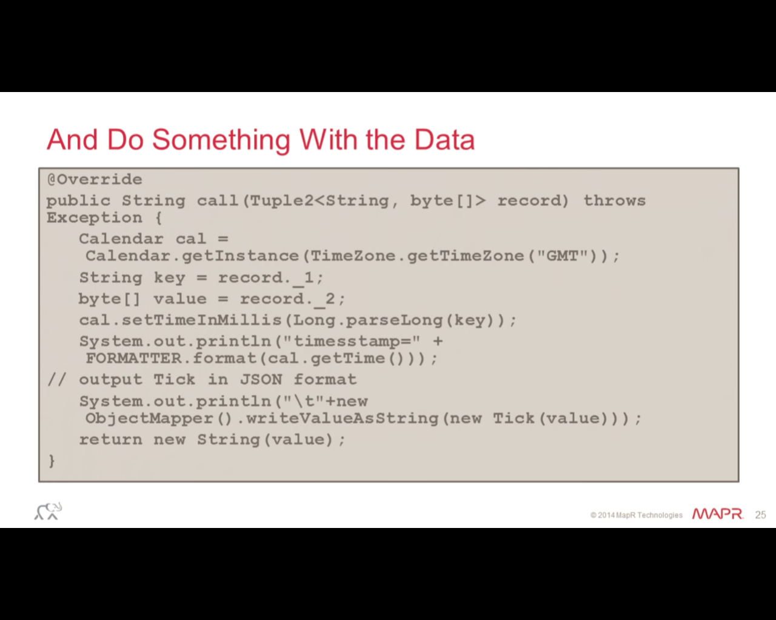

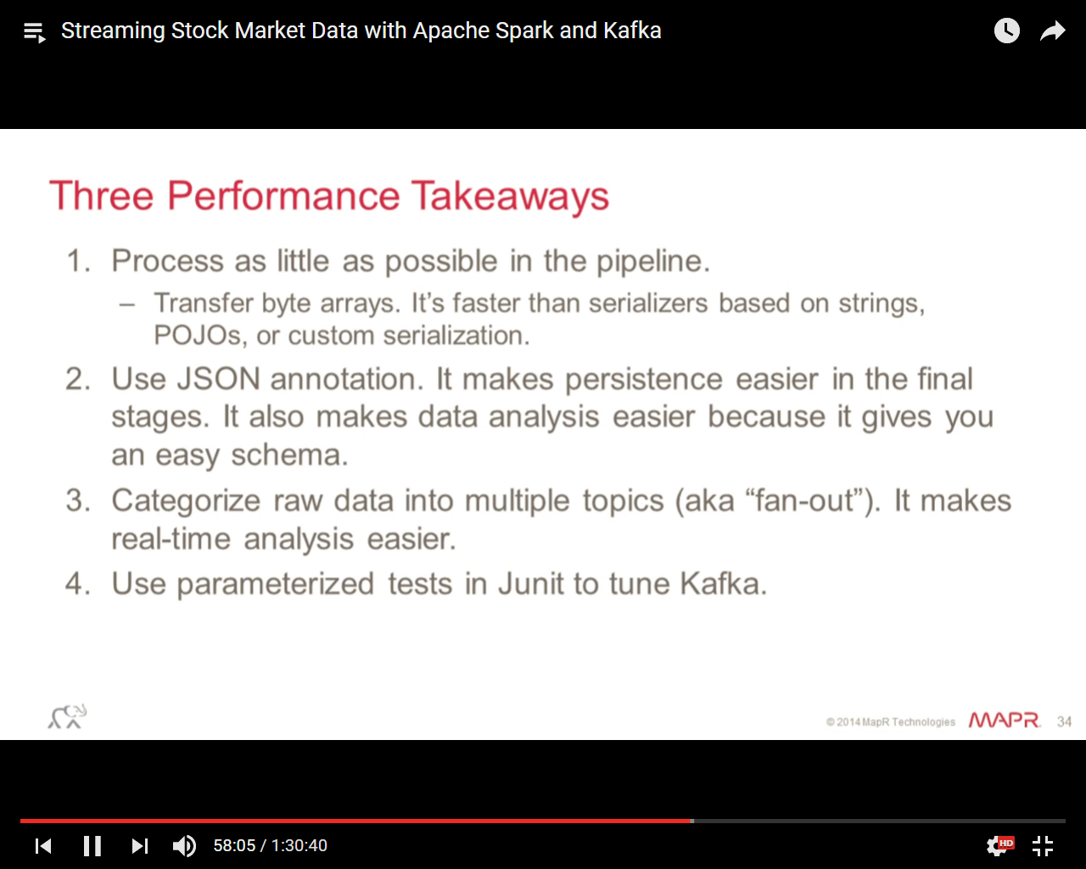

<https://github.com/mapr-demos/finserv-application-blueprint>