NanoIO
Authors:
David Freese, W1HKJ
Ervin Hegedüs, HA2OS

An FSK / CW interface based on the Arduino nano. Sketch is expanded version of

tinyFSK, http://www.frontiernet.net/~aflowers/tinyfsk/

and includes an FSK modulator, a CW computer interface, a CW iambic-A/B keyer.

FSK Specifications:
- 5 bit Baudot
- baud rates 45.45, 50, 75 and 100

CW Specifications:
- 5 to 100 WPM
- dash/dot ratio adjustable 2.5 to 3.5
- in-line increment decrement WPM using ^ and | characters
- incremental size user adjustable

PTT signal generated by Arduino

Both: an internal buffer of 200 characters is available for buffered transmit.

Hardware requirement

- Arduino nano or compatible (author used nano from Elegoo)
- LTV-847 quad opto-isolator
- 4 620 ohm ¼ watt resistor (should work with 500 < R < 820 ohm)
- suitable connectors to interface to transceiver
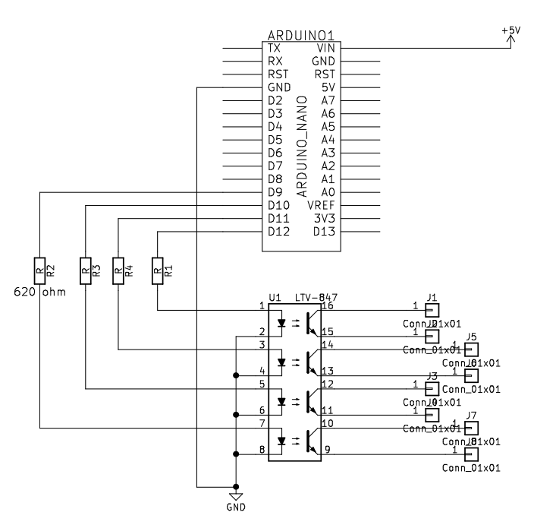
Default pin assignments defined in Arduino Sketch for the above circuit.

D9 / PIN 9 – spare
D10 / PIN 10 – PTT
D11 / PIN 11 - FSK_PIN
D12 / PIN 12 – CW

When compiling for MORTTY, you should change the pin assignments:

D11 / PIN 11 – common CW / FSK output
D13 / PIN 13 – PTT output

Default startup configuration:

- nanoIO 1.0
- Mode: FSK
- FSK: Baud: 45.45, Mark LOW
- CW: WPM: 18/18, dash/dot 3.00, incr 2, IambicA keyer
This is the current command set / configuration parameters for nanoIO
USB serial command strings all begin with the tilde, ~, character
Cmd ~...
- C,c CW mode
- F,f FSK mode
- T,t CW Tune
- Snnns computer wpm 10...100
- Unnnu key (user) wpm 10...100
- Dnnnd dash/dot 250...350 (2.5...3.5)
- In CW incr (1..9)
- A,a IambicA
- B,b IambicB
- K,k Straight key
- 0 FSK mark = HIGH
- 1 FSK mark = LOW
- 4 45.45 baud
- 5 50 baud
- 7 75 baud
- 9 100 baud
- ? Show config
- W Write EEPROM
- ~ Show cmds

In line special characters:
Both:
- [ PTT on
- ] PTT off
- \ escape; clear internal buffer and set PTT off
CW:
- ^ increase computer wpm by increment value (default is 2) *
- | decrease computer wpm by increment value *
- % <SK>
- & <AS>
- + <KN>
- - <BT>
- < <AS>
- = <BT>
- > <AR>
- { left brace <HM>
- } right brace <VE>
* - the ^| wpm modifiers do not effect the paddle CW, just the computer CW.
for example, a CW string might contain:
- ~C~S24s[tu ^^5nn|| k]

- Mode is changed to CW
- Computer WPM is set to 24
- PTT is set ON
- the string “tu “ is sent
- Computer WPM is increased by 2 increment factors
- the string “5nn” is sent
- Computer WPM is decreased by 2 increment factors
- the string “ k” is sent
- PTT is set OFF

PTT will enable before starting the CW transmission. PTT will disable after the last CW character (k) is completed.

nanoIO is a merger of my own code and:
tinyFSK, by Andrew T. Flowers K0SM
Iambic Keyer, by Steven T. Elliott
It expands the tinyFSK to include 100 WPM Baudot TTY. It shares a common set of control strings. The default wake up mode is FSK.
The keyer implementation is less robust than Steven's Iambic Keyer. It only provides Straight key, Iambic-A, and Iambic-B modes. It does add weighting to the key output. The key weighting and the computer CW weighting are the same. The current implementation does not have a tone output.
CW is generated from USB serial input strings and/or the paddle inputs. Paddle input overrides the serial string, but does not currently clear the string buffer. That could be changed, but the USB serial interface provides a very easy escape character to do just that.

NanoIO can be used as the sketch for the MORTTY (c) hardware interface. MORTTY shares a common output pin for both CW and FSK keyline. The user will have to swap FSK / CW line connectors when changing mode.

