Quick Start Guide for pyKeyer

A VERY ROUGH DRAFT!!!!!!!!!!

J. B. Attili, AA2IL
Rev. August 2025

1. Overview

Over the years, a number of very good logging programs have been developed. The most popular of these today is the N1MM Logger. Unfortunately, this is a Windoz-only application and is very difficult to get working under linux. My experience with the other options available for Linux are either not being actively maintained and/or are too bloated and/or lacking to be useful for contesting. Hence, the development of yet another keying/logging program.

This package is part of a suite of software that I use in my day-to-day amateur radio activities and includes three applications:

pyKeyer.py – The main contest keyer and logging app
paddling.py – A program for sending and headcopy practice
qrz.py – A program to quickly look-up known information about an op

The keying and logging app, pyKeyer.py, is fully integrated with the other components of this suite (SDR, Bandmap and World Clock) – see Figure 1.1. Although primarily developed for contesting, provisions have been included for non-contest operations such as rag-chewing, POTA/SOTA, etc.. The other two programs are stand-alone utilities that break out facilities that are part of pyKeyer.

The remainder of this User’s Manual is structured as follows. Section 2 provides a quick background of the author of this program. Section 3 provides detailed installation instructions for both Linux and Windoz operating systems. Section 4 provides detailed instructions for the paddling and qrz utilities while those for pyKeyer are provided in Section 5.

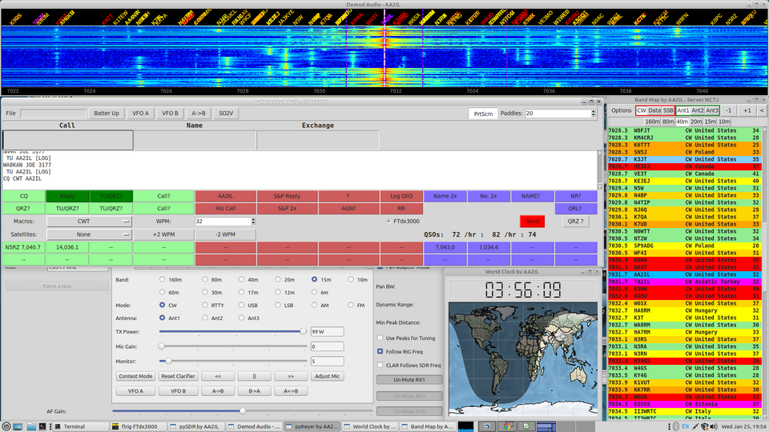
Figure 1.1. Screenshot of AA2IL suite of ham radio software during a typical CWT contest.

2. Background

I was originally licensed as a teenager in the late 1970s and always had an affinity for CW and chasing DX. Like many ops in our great hobby, life (i.e. job, family, etc.) got in the way and I was dormant for over 25-years. When I finally returned to the hobby in 2013, it was evident that things had changed dramatically. Not only was the equipment vastly improved but computers had become an integral part of ham radio. Inasmuch as I am a professional electrical engineer, computers were always a tool for my work and I actually enjoy “hacking away” and developing applications and devices related to ham radio.

Much of the software in common use in ham shacks runs under Windows. This was a bit of a surprise to me as, IMHO, software development and interfacing with hardware is much easier Linux. Although there are environments that allow Windows software to run under Linux, configuring these environments can sometimes be tricky and all to often, the results are unsatisfactory. As I was unable to find a suitable logger for Linux, I decided to set about developing my own

Another aspect of the hobby that had changed since the 1970s is that the CW speeds seem to have increased dramatically, especially in radio sport. In the past, when morse code was a required element for obtaining a ham license, there were always slower ops around to converse and practice with to help build up proficiency. This is much more difficult now but, fortunately, there are computer programs to fill this void as well as training classes offered by clubs such as CWops and LICW. Accordingly, one of the features I wanted to include in my logger program was the ability to provide off-air practice and feedback for both sending and receiving CW. While excellent apps exist and are quite popular (e.g. Morse Runner and RufzXP) I also wanted to be practicing using the same interface I’d be using in an actual contest.)

3. Installation Instructions

The most current installation instructions are provided in the README.md file in the github repository containing the source code:

https://github.com/aa2il/pyKeyer/README.md

The procedures for installation under Linux and Windoz are very similar and are described Sections 3.1 and 3.2 below. Section 3.3 briefly discusses porting the code to MacOS while Section 3.4 discusses the various support data files.

3.1 Linux Installation – PC and Raspberry Pi

Recent releases of Linux distributions have imposed severe restrictions on the ability to install additional python libraries. This is meant to protect the integrity of the system libraries since python code has become a prevalent part of the OS. Accordingly, python developers and users are being forced to use a separate “container” or “sandbox” for third-party apps such as pyKeyer. Recently, an app called uv has been released and make the process of installing and maintaining such virtual environments relatively simple. The recommended installation method for the code found in this repository is to use uv to setup the “sandbox” for pyKeyer. It is also possible to use conda/mini-conda if your prefer that. Both methods are described in README.md.

Assuming python is installed on your system, the first step is to install uv. This can be by a single user via

curl -LsSf https://astral.sh/uv/install.sh | sh
rehash

or for all users via

curl -LsSf https://astral.sh/uv/install.sh | sudo env UV_INSTALL_DIR="/usr/local/bin" sh
rehash

Next, we need to clone the source code and support files from the github repository. The recommended approach is to place everything under a directory called “Python” in your home directory but it is possible to move the location of this directory and configure the package accordingly:

cd
mkdir Python
cd Python
git clone https://github.com/aa2il/pyKeyer
git clone https://github.com/aa2il/libs
git clone https://github.com/aa2il/data

One of the features of uv is that the setup requirements for the virtual environment (a.k.a. container or sandbox) is included in the github repository. You should not have to do anything since uv will install the environment and required packages the first time you run any of these codes.

However, if you run into trouble, try rebuilding the uv environment:

cd ~/Python/pyKeyer
rm -r .venv pyproject.toml .python-version uv.lock
uv init --python 3.12
rm main.py
uv add -r requirements.txt

If last uv add command throws an error, try

uv pip install -r requirements.txt

before panicking.

Before you can run the various app scripts, you will need to make sure that they are executable:

cd ~/Python/pyKeyer
chmod +x pyKeyer.py paddling.py qrz.py start start_cw

and that python can find the necessary libraries:

Under csh/tcsh: setenv PYTHONPATH $HOME/Python/libs
Under bash: export PYTHONPATH="$HOME/Python/libs"

There are three python scripts you can then run:

uv run pyKeyer.py
uv run paddling.py
uv run qrz.py

The C-shell scripts start and start_cw demonstrated how to stich together the various python scripts and associated command line arguments.

3.2 Windoz Installation

Python is not “native” for Windoz but is reasonably well supported so it is possible to install the python interpreter under windows and run the source from the command line, similar to linux. This if preferrable to building a standalone executable as these tend to be very large, even for the simplest of python programs. An advantage is that the latest code can be pulled from github and used.

Installation using uv is very similar to that under Linux. To install uv, search for and open cmd.exe and enter the following command:

powershell -ExecutionPolicy ByPass -c "irm https://astral.sh/uv/install.ps1 | iex"

You will also need a git client. I use the command line version available from:

https://git-scm.com/downloads/win

Simply point your browser to this link, download and run the installer.

The rest of the installation is similar to that described for Linux above, with the necessary syntax changes. If needed, uv will install python for you. First, clone the required repositories:

cd %userprofile%
mkdir Python
cd Python
git clone https://github.com/aa2il/pyKeyer
git clone https://github.com/aa2il/libs
git clone https://github.com/aa2il/data

As before, uv should rebuild its virtual environment the first time you run one of the scripts but if there are problems, try rebuilding the virtual environment via

cd %userprofile%/Python/pyKeyer
rd /s .venv pyproject.toml .python-version uv.lock
uv init
del main.py
uv add -r requirements.txt

If last uv add command throws an error, try

uv pip install -r requirements.txt

before panicking.

You will also need to set the PYTHONPATH environment. To set it for the current session, use:

set PYTHONPATH="%userprofile%\Python\libs"

To make this permanent, open another cmd window with administrator privileges and execute

setx PYTHONPATH "%userprofile%\Python\libs"

If you run into trouble, do a web search for “windows set environment variable” for other ways to set environment variables in WIndoz.

There are three python scripts you can then run:

cd %userprofile%/Python/pyKeyer
uv run pyKeyer.py
uv run paddling.py
uv run qrz.py

As with Linux, it is possible to stich together “batch” scripts to run these programs along with their associated command line arguements. There is the start of a primitive script in start_cw.bat.

*** In a future release, I will add desktop icons to run these scripts ***

3.3 Mac OS Installation

Mac OS is Linux-based and there should be no reason why these codes cannot be easily made to run on a Mac. Although my main shack computer is an old iMac (cira 2012), I have long since blown away the Mac OS and have no means of testing this theory. (This was not my choice – Apple decided long ago to drop support for older machines even though they may be more than adequate for typical use-cases.) I suspect, however, that the Linux recipe will work. Any volunteers?

3.4 Support Files

There are several support files that these scripts use. The first is ~/.keyerrc which contains your user information (call sign, name, QTH, etc.). This is created the first time you run pyKeyer or paddling. There are also databases for parsing call signs and “pre-fill” contest info in the Python/data directory. This directory also contains assorted imagery and country data. The ADIF log file is created and stored in ~/URCALL/URCALL.adif where URCALL is your callsign.

4. Getting Started

Which ever OS and installation method, there are three codes available in this package:

pyKeyer.py – The main keyer/logger app
paddling.py – A program for sending practice
qrz.py – A program to quickly look-up known information about an op

The latter two are standalone versions of features that are part of pyKeyer but are very useful in their own right. In what follows, we’ll begin with these two codes as they have fewer options to become confused by. We first discuss the user information that is required in Section 4.1 . The detailed instructions for the qrz and paddling utilities are given in Sections 4.2 and 4.3 respectively.

4.1 User Settings

All three applications in this package require some minimal amount of configuration information to work properly. This information is stored in a file called .keyerrc in the user’s home directory. Inasmuch as this file doesn’t exist, the first time you start any of these apps, you will be presented with a settings dialog where you can fill in this information – see Figure 4.1.

At a bare minimum, you will need to fill in the following:

My Call - your call sign, self explanatory;
My Keyer Device - the type of keyer you are using, usually WINKEYER;
My Keyer Device ID - an identifier for the USB port that the keyer is connected to; and
My Data Dir - the location of the various support files.

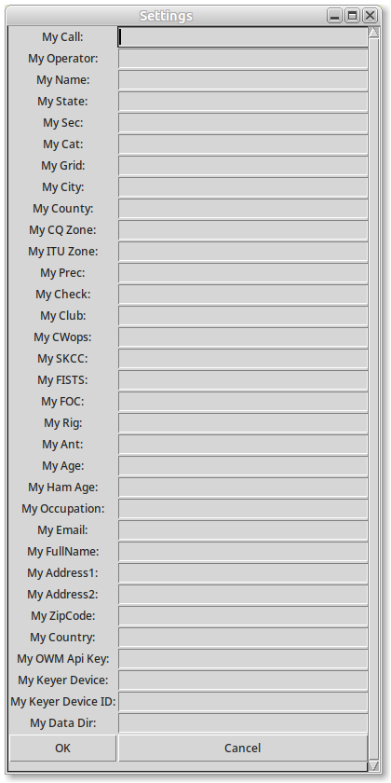
Figure 4.1. Empty Settings Dialog.
It is recommended, however, that you fill out as many of the fields as possible when this pop-up appears. You can always go back and update the information using the File→ Settings from the main menu bar.

On Windoz, the keyer device is usually the com port used by device (e.g. COM4) and can be found using the control panel. Under Linux, a suitable descriptor can be found via the command

python3 -m serial.tools.list_ports -v

This command also works on Windoz if you’ve installed the python interpreter. (You can also run paddling.py and it will issue the command for you.) On my shack computer, this results in

:
:
/dev/ttyUSB0
desc: USB2.0-Ser!
hwid: USB VID:PID=1A86:7523 LOCATION=3-4.3
/dev/ttyUSB1
desc: CP2105 Dual USB to UART Bridge Controller - Enhanced Com Port
hwid: USB VID:PID=10C4:EA70 SER=AH046H3M120067 LOCATION=3-2.1:1.0
/dev/ttyUSB2
desc: CP2105 Dual USB to UART Bridge Controller - Standard Com Port
hwid: USB VID:PID=10C4:EA70 SER=AH046H3M120067 LOCATION=3-2.1:1.1

This first device, USB0, is my homebrew K3NG Winkeyer clone (hosted on an Arduino Nano) so I use USB2.0-Ser to identify this device. The other two devices are the two USB ports on my Yaesu FTdx3000 radio.

Finally, the location of the various support images and data files (including master.csv) depends on how you installed the software. If you followed the above installation instructions verbatim, these files will be in ~/Python/data. You have the option to leave the My Data Dir field empty and the software will find one of the defaults. However, if you choose to install the software elsewhere, you will need to fill in this field with the location of these files.

Figure 4.2 shows the settings field with this minimal configuration information filled in. However, to avoid having to revisit this issue as you make use of more of the program features, I recommend that you fill in as much of this basic information as you can. The data you entered is written to ~/.keyerrc once you press the “OK” button; The “Cancel” button provides an escape mechanism if you change your mind and don’t want to save the data. Figure 4.3 shows my completed settings dialog. If you need to change this information in the future, you can either 1) start any of these three app using the -settings command line switch, 2) select Settings … under the File menu in pyKeyer, or 3) directly edit ~/.keyerrc using your favorite text editor.

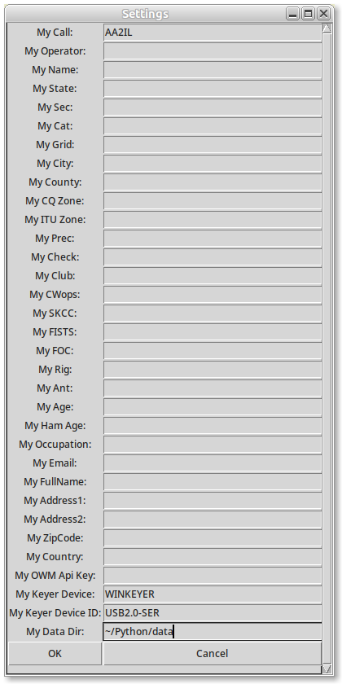
Figure 4.2. Settings Dialog with minimal configuration information.
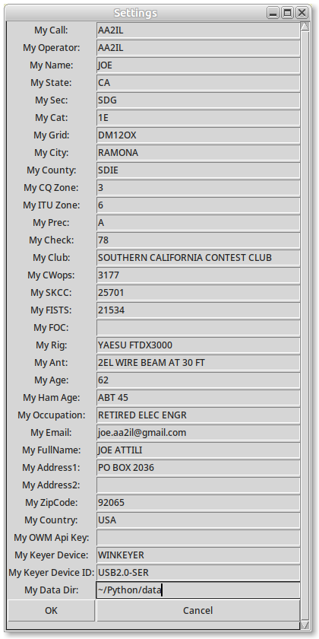
Figure 4.3. Settings Dialog with complete configuration information.

4.2 qrz.py

Most competitive contesters make use of a call history file (CHF) to fill in exchange information that is unlikely to change often, e.g. the name and state of an op. The team behind N1MM maintains these files and most ops will use the CHF from the most-recent running of a particular contest. The approach I’ve adopted is to combine the call histories from the various contests that I regularly participate in into a “master call history file,” master.csv. Also included in this master CHF is information scraped from the published membership rosters of the CWops, SKCC, FISTS and FOC clubs. The result is data from several thousand ops and includes the overwhelming majority of ops you are likely to run into in a contest. Qrz.py is a utility to investigate what information is stored in the master CHF about one or more ops.

Qrz.py, as well as the other two apps in this package, are meant to be “old style” command line utilities. As such, there are various options that can be specified. To see a list of this options, use the –help flag:

$ qrz.py --help
usage: qrz.py [-h] [-cwops] [-cw] [-settings] [call ...]

QRZ???

positional arguments:
call Call(s) worked

options:
-h, --help show this help message and exit
-cwops CWops Reverse Lookup
-cw Look only for CW QSOs
-settings Open setting window

Usually, we are interested in looking up a particular call sign, e.g.:

$ qrz.py aa2il

This results in the dialog shown in Figure 4.4. If you prefer to use a graphical user interface (GUI), don’t supply a call sign and you will be prompted to enter one or more call signs as in Figure 4.5. Multiple call signs can be separated by spaces of commas.

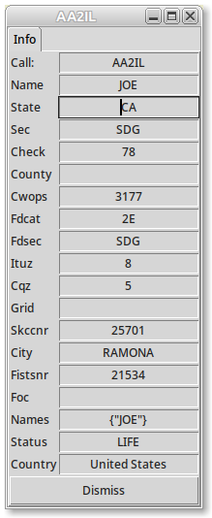
Figure 4.4. All information available in master call history file for my call.

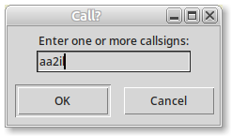
Figure 4.5. GUI call sign prompt.

4.3 paddling.py

One mark of a good cw operator is a “fist” that is easy to copy and who makes few mistakes. Achieving this takes dedicated practice and time on the air. I fully admit that I am very biased toward contesting and don’t do very much in the way of rag-chewing. Except for the SST and MST practice sessions, I am very reluctant to send using my paddles during a contest as I don’t want to slow down the other ops who are gracious enough to call me and/or return my call. Hence, I generally rely on my computer and keyer to do the sending for me - and my fist has suffered accordingly.

There is at least one program available dedicated to sending practice that I am aware of, Iambic Master. However, this program only uses the sprint format for practice messages and I wanted something that covers variety of message formats including panagrams and rag-chews. As such, I added a component to pyKeyer that generates test messages and uses feedback from the keying device to asses and tune my fist. Over time, I broke this component out as a stand-along app call paddling.py. Figure 4.6 shows graphical interface for this app.

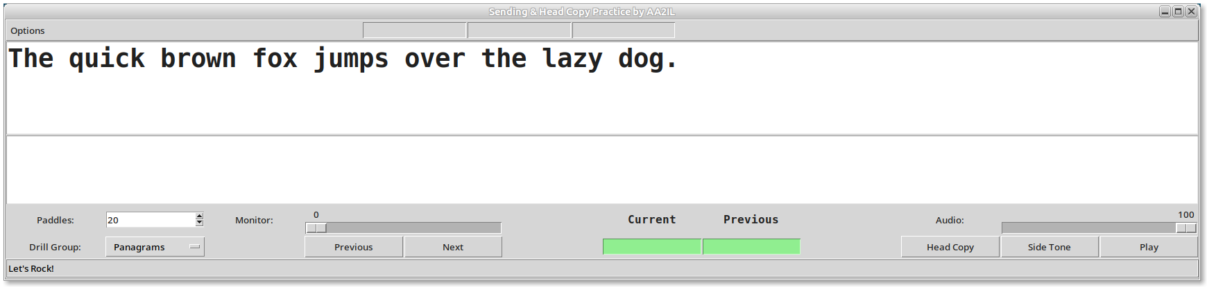
Figure 4.6. Sending Practice GUI.

The upper text window displays a practice message to be sent while the lower text window echos the characters from the keyer as they are sent. The green box marked “Current” indicates the distance between the message and what is actually sent. If the two match, this distance will be zero and the app advances to the next test message. The user can restart/repeat a message as often as he’d like and visually compare the contents of the two text boxes to gain feedback on his fist. Pressing the spacebar will generate a new test message.

The “Options” entry in the menu-bar above the upper text window gives the user access several configuration options for this program:

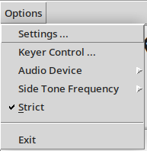

The “Paddles” spin-box to the left below the lower text box controls the sending speed (wpm). If a rig sidetone is being used (see below), the volume of the sidetone is controlled via the “Monitor” slider. The “Drill Group” spin-box selects the type of practice message:

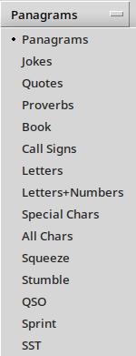
The “Previous” and “Next buttons allow the user to go back to the previous or advance to the next test message respectively. The green “Current” and “Previous” entry boxes display the “score” (i.e. match distance) between the drill and keyer text for the current and prior drill messages.

I have recently added an audio playback capability to this code as well. The intention of this is for head-copy practice. The items on the lower right of the GUI window control this facility. By default, the text is played using the speaker in the keyer device (e.g. winkeyer). However, if you click on the “sidetone” button, the audio will be played on the computer speakers instead. The “Audio” slider controls the speaker volume. The “Head Copy” button controls whether or not the text is displayed in the upper text window. For normal head-copy practice, you will want to select this but if you are having trouble decoding a message, you can press this button again to see the message. Finally, the “Play” button plays the text message.

Here is a list of the command line arguments that are available:

$ paddling.py --help

usage: paddling.py [-h] [-wpm WPM]
[-rig {FLDIGI,FLRIG,DIRECT,HAMLIB,KCAT,ANY,NONE,FTdx3000,FT991a,IC9700,
IC7300,TS850,IC706,TYT9000d,KC505} [{FLDIGI,FLRIG,DIRECT,HAMLIB,KCAT,ANY,NONE,FTdx3000,
FT991a,IC9700,IC7300,TS850,IC706,TYT9000d,KC505} ...]]
[-keyer {WINKEY,NANO,K3NG,ANY}]
[-kport KPORT]
[-settings]

options:
-h, --help show this help message and exit
-wpm WPM Keyer Speed
-rig {FLDIGI,FLRIG,DIRECT,HAMLIB,KCAT,ANY,NONE,FTdx3000,FT991a,IC9700,
IC7300,TS850,IC706,TYT9000d,KC505}
[{FLDIGI,FLRIG,DIRECT,HAMLIB,KCAT,ANY,NONE,FTdx3000,
FT991a,IC9700,IC7300,TS850,IC706,TYT9000d,KC505} …] Connection Type
-keyer {WINKEY,NANO,K3NG,ANY} Keyer Type
-kport KPORT Connection Port for Keyer
-settings Open settings window

The -wpm flag sets the starting keyer speed (default is 25 wpm) and the -settings flag opens the settings dialog described earlier. -keyer and -kport can be used to specify the type of external keyer being used and the USB port it is attached to. It is preferable, however, to configure these in the setting dialog. Most users will likely be using a winkeyer.

Similarly, the -rig flag is used to configure the rig. For this particular app, the break-in function is turned off and the rig is only used for sidetone audio. There are two acceptable formats for this flag but it is best to supply two arguments. The first argument is the type of connection to establish with the rig and the second argument is the type of rig. The connection type can be one of HAMLIB, FLRIG, FLDIGI or DIRECT and specifies the “middle-ware” the manages the rig communications. The preferred protocol is HAMLIB but a DIRECT connection to the rig also works well for send practice. The KCAT option is developmental and should not be used for now.

At present, only a handful of rigs are supported – those that I either own or have owned in the past. The FTdx3000, FT991a, and IC9700 are known to correctly work with this package. Adding support for additional rigs should not be difficult but will take a bit of effort to make the necessary modifications and test.

There are a few keyboard strokes that this app understands:

Space – advance to next test message
PgUp or + – Increase keyer speed (wpm)
PgDn or - – Decrease keyer speed (wpm)

5. pyKeyer.py

pyKeyer.py is a full-featured contest logging program. Figure 4.1 shows the graphical interface for this app. The numerous capabilities of this app are organized such that related activities are grouped together in the GUI, e.g. items for manipulating rig VFOs are along the top row. Sub-sections 5.1-5.7 below describe these capabilities as they appear on the GUI from top to bottom. Sub-section 5.8 briefly discusses the various command line parameters and switches that can be used to configure pyKeyer at run-time. Sub-section 5.9 describes the contest practice facility included in the app. Finally, the use of pyKeyer for RTTY contesting is considered in Sub-section 5.10.

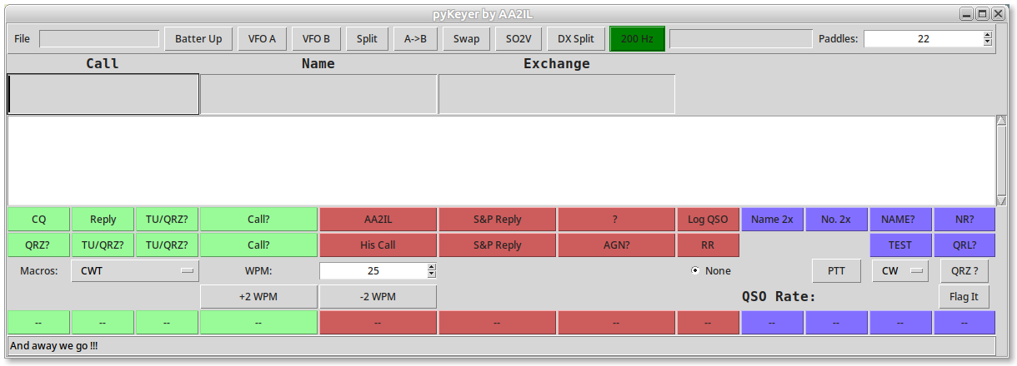
Figure 5.1. pyKeyer GUI.

5.1 The Top Row

In the upper left is the only pull-down menu – File. This menu provides access to various configuration and run-time options:

Settings … - Brings up settings dialog described in Section ?
Rig Control … - Brings up dialog for directly controlling rig options
Keyer Control … - Brings up dialog for directly controlling keyer options
Paddling … - Brings up sending practice window described in Section ?
Clear Stores … - Clears stored state data from prior run (deprecated)

Set Rig CW - Puts rig into CW mode
Capture Audio - Toggles capture of receiver audio
Farnsworth - Toggles Farnsworth CW timing
Tune - Antenna tuning
Practice Mode - Toggles Practice Mode
Auto-fill - Toggle automatic filling of exchange fields from call history
Show Hints - Show relevant info from call history
Show SCP - Show Super Check Partial list of likely call signs
Auto-complete - Toggles automatic completion of call sign if only one call in SCP list
Sidetone - Toggles generation of sidetone through computer audio
Adjust Speed - Toggles keyer speed adjustment in practice mode
Lock Speed - Lock speeds of computer keying and paddles
Nano Echo - Toggles echoing of characters from keyer
Split TX Window - Toggles separate window for sending text
Immediate TX - Toggles immediately transmission of typed in text
Clear All Spots - Clears stored memory data

The next several buttons along the top row relate to advance operations involving VFO manipulations. There is some rudimentary support for Single Operator Two VFO (SO2V) and Single Operator Two Radio (SO2R) operations. The two “split” buttons are useful for chasing DX operations running split. The difference between these two is whether the split is effected using dual VFOs or via the rig’s XIT/RIT functions.

The green button mark 200Hz provides rapid access to the audio bandwidth. This is particularly useful if you are attempting to pull out a weak signal. The text box next to this button is used for displaying miscellaneous information during an operation. Finally, the “Paddles” spinbox in the upper right allow the user to specify a different keyer speed for text sent via the paddles vs via the computer. This is useful if you cannot reliably control the paddles at the higher speeds typical of a contest. Unfortunately, this option is only available on my homebrew keyer.

5.2 Call Sign and Exchange Entry

The next row of entry boxes is where call sign and exchange information is entered. The boxes displayed vary depending on the particular contest. Navigation through these boxes is either via a mouse click (the hard way) or the forward and backward tab keys (preferred). If SCP or Hints are enabled, these boxes will appear here as well; data from these boxes can be selected via double clicking with the mouse.

5.3 Text Message Boxes

The text from the various message is echoed in the large box in the middle. You can also type in text to be sent by clicking on this box. There is also an option to split this box horizontally so that the sent text is kept separate. With this, it is still possible to send a message if no keyer is attached or if you are using pyKeyer for RTTY operations.

5.4 Marcos

The two rows of buttons below the large text box are the keyboard macros. These are, of course, contest dependent and are broken up into three groups: Running (green), Search and Pounce (Red) and Repeats/Fills (Blue). The twelve buttons in the first row correspond to the twelve function keys and those in the second row correspond to the “shifted” function keys (e.g. CQ is send if F1 is pressed while QRZ? is sent if Shift-F1 is pressed). The buttons may also be selected via a mouse click.

5.5 Run-time Options

The group of GUI widgets provide easy access to various run-time options. The macros for a particular contest are selected via the pull-down “Macros” menu (CWT in the figure). The speed for the computer-generated text is controlled via the group of “WPM” widgets. In addition to the +2 WPM and -2 WPM buttons, keyer speed can be changed on the fly by pressing Page Up and Page Down on the keyboard.

Pykeyer can control up to three radios at a time. (I have only used this in VHF contests which tend to be rather slow-paced events here in SoCal.) The group of radio buttons in the middle is used to select the active radio. “None” indicates no radio is connected. The PTT button can be used in a voice contests to effect a transmission or in a CW or RTTY contest to send a carrier or diddle for antenna tuning. The mode pull-down allows the operator to change modes. The QRZ? button triggers a query to qrz.com for the current call in the call sign box. The area marked QSO Rate provides rate data for the last ten-minutes and hour. Finally, as there is currently no convenient way to correct a logging mistake, the “Flag It” button is provide to insert a note in the ADIF log file that the last qso needs to be reviewed/update. (I use this in conjunction with written notes made during a contest to correct a log prior to submission. At some point, a pop-up window will be added to do this on-the-fly but this hasn’t been added as yet.)

5.6 Rapid Memory Store and Recalls

Near the bottom of the pyKeyer window is one or more rows of memory buttons. The idea behind these is to improve on the STORE and RECALL features available on most modern rigs. This is particular useful when Searching and Pouncing in contest when you come across a station that is busy. Rather than spending a lot of time trying to break through his pile-up, it is usually more efficient to mark his location and come back later. Left-clicking with the mouse on one of these buttons will not only store the current rig frequency but also any call sign and exchange information that has been entered. Right-clicking on a button will immediately restore that spot data and tune the rig to that spot. Clicking with the middle mouse button will clear the spot.

5.7 Status Bar

The final line of the pyKeyer GUI is a status bar where various messages are displayed. During may contests, a summary of your current score is also displayed here.

5.8 Command Line Options

PyKeyer has many configuration options. Although most of these options are available from the GUI, this program is designed to be started from the command line. Below is a list of the available options:

$ pyKeyer.py --help

usage: pyKeyer.py [-h] [-ss] [-naqp] [-cq160m] [-sst] [-mst] [-awt] [-skcc] [-cwt] [-cwopen]
[-pota] [-wpx] [-arrl_dx] [-arrl_10m] [-arrl_160m] [-cqp]
[-state [STATE ...]] [-aa] [-wfd] [-fd] [-vhf] [-mak] [-stew] [-jidx]
[-yuri] [-spdx] [-ocdx] [-marconi] [-solar] [-cqmm] [-holy] [-iota] [-marac]
[-sat] [-sprint] [-wrt] [-cqww] [-cqvhf] [-iaru] [-ten] [-foc] [-wag]
[-sac] [-beru] [-rac] [-ragchew] [-dx] [-calls] [-default] [-sending]
[-autofill] [-autocomplete] [-test] [-practice] [-immediate] [-sidetone]
[-split] [-hints] [-capture] [-aggressive] [-force] [-ca_only] [-wpm WPM]
[-farnsworth FARNSWORTH] [-paddles PADDLES] [-adjust] [-scp]
[-rig {FLDIGI,FLRIG,DIRECT,HAMLIB,KCAT,ANY,NONE,FTdx3000,FT991a,IC9700,
IC7300,TS850,IC706,TYT9000d,KC505}
[{FLDIGI,FLRIG,DIRECT,HAMLIB,KCAT,ANY,NONE,FTdx3000,FT991a,
IC9700,IC7300,TS850,IC706,TYT9000d,KC505} ...]]
[-port PORT]
[-rig2 {FLDIGI,FLRIG,DIRECT,HAMLIB,KCAT,ANY,NONE,FTdx3000,FT991a,IC9700,
IC7300,TS850,IC706,TYT9000d,KC505}
[{FLDIGI,FLRIG,DIRECT,HAMLIB,KCAT,ANY,NONE,FTdx3000,FT991a,
IC9700,IC7300,TS850,IC706,TYT9000d,KC505} ...]]
[-port2 PORT2]
[-rig3 {FLDIGI,FLRIG,DIRECT,HAMLIB,KCAT,ANY,NONE,FTdx3000,FT991a,IC9700,
IC7300,TS850,IC706,TYT9000d,KC505}
[{FLDIGI,FLRIG,DIRECT,HAMLIB,KCAT,ANY,NONE,FTdx3000,FT991a,
IC9700,IC7300,TS850,IC706,TYT9000d,KC505} ...]]
[-port3 PORT3] [-max_age MAX_AGE]
[-nrows NROWS] [-keyer {NONE,NANO,K3NG,WINKEY,ANY}]
[-kport KPORT] [-nano] [-k3ng] [-winkeyer] [-noecho] [-cwio]
[-lock] [-mode {None,CW,SSB,RTTY}] [-log LOG]
[-rotor {HAMLIB,NONE}] [-port9 PORT9] [-server]
[-udp] [-shadow] [-gps] [-use_log_hist]
[-use_adif_hist] [-digi] [-wfonly] [-geo GEO]
[-desktop DESKTOP] [-settings] [-special]

options:
-h, --help show this help message and exit
-ss ARRL Sweepstakes
-naqp NAQP
-cq160m CQ 160m CW
-sst K1USN SST
-mst ICWC MST
-awt Japan AW Test
-skcc SKCC
-cwt CWops Mini Tests
-cwopen CWops CW Open
-pota POTA
-wpx CQ WPX (CW or RTTY)
-arrl_dx ARRL Intl DX
-arrl_10m ARRL 10m
-arrl_160m ARRL 160m
-cqp California QP
-state [STATE ...] State QP
-aa All Asia DX
-wfd Winter Field Day
-fd ARRL Field Day
-vhf ARRL VHF
-mak Makrothen RTTY
-stew Stew Parry
-jidx JIDX CW
-yuri Yuri Gagarin DX
-spdx SP DX CW
-ocdx OC DX CW
-marconi Marconi Memorial
-solar Solar Eclipse
-cqmm CQMM DX
-holy Holyland DX
-iota RSGB IOTA
-marac MARAC US Counties
-sat Satellites
-sprint NCCC CW Sprint
-wrt Weekly RTTY Test
-cqww CQ Worldwide
-cqvhf CQ VHF
-iaru IARU HF Championship
-ten 10-10 CW
-foc FOC BW
-wag Work All Germany
-sac Scandinavia Activity
-beru RSGB Commonwealth
-rac RAC Summer or Winter QPs
-ragchew Regular Ragchew QSO
-dx DX QSO
-calls Random Calls
-default Default (quick) QSO
-sending Sending Practice
-autofill Auto fill known information
-autocomplete Auto Complete Partial Callsigns
-test Disable TX
-practice Practice mode
-immediate Send text immediately
-sidetone Sidetone Osc
-split Split Text Window
-hints Show hints
-capture Record Rig Audio
-aggressive Aggressively keep main window on top
-force Force rig connection (debugging)
-ca_only Only use California Stations for Practice
-wpm WPM Keyer Speed
-farnsworth FARNSWORTH
Farnsworth Speed
-paddles PADDLES Paddle Speed
-adjust Adjust speed based on correct copy
-scp Enable Super Check partial
-rig {FLDIGI,FLRIG,DIRECT,HAMLIB,KCAT,ANY,NONE,FTdx3000,
FT991a,IC9700,IC7300,TS850,IC706,TYT9000d,KC505} [{FLDIGI,FLRIG,DIRECT,HAMLIB,KCAT,ANY,NONE,FTdx3000,
FT991a,IC9700,IC7300,TS850,IC706,TYT9000d,KC505} ...]
Connection Type - 1st rig
-port PORT Connection Port - 1st rig
-rig2 {FLDIGI,FLRIG,DIRECT,HAMLIB,KCAT,ANY,NONE,FTdx3000,
FT991a,IC9700,IC7300,TS850,IC706,TYT9000d,KC505} [{FLDIGI,FLRIG,DIRECT,HAMLIB,KCAT,ANY,NONE,FTdx3000,
FT991a,IC9700,IC7300,TS850,IC706,TYT9000d,KC505} ...]
Connection Type - 2nd rig
-port2 PORT2 Connection Port - 2nd rig
-rig3 {FLDIGI,FLRIG,DIRECT,HAMLIB,KCAT,ANY,NONE,FTdx3000,
FT991a,IC9700,IC7300,TS850,IC706,TYT9000d,KC505} [{FLDIGI,FLRIG,DIRECT,HAMLIB,KCAT,ANY,NONE,FTdx3000,
FT991a,IC9700,IC7300,TS850,IC706,TYT9000d,KC505} ...]
Connection Type - 3rd rig
-port3 PORT3 Connection Port - 3rd rig
-max_age MAX_AGE Max age in hours
-nrows NROWS No. STO/RCL rows
-keyer {NONE,NANO,K3NG,WINKEY,ANY}
Keyer Type
-kport KPORT Connection Port for Keyer
-nano Use Nano IO Interface
-k3ng Use K3NG IO Interface
-winkeyer Use Winkeyer IO Interface
-noecho Don't Echo response from Nano IO to text box
-cwio Use FLRIG or HAMLIB for CW IO
-lock Lock Paddle Speed to Computer Speed
-mode {None,CW,SSB,RTTY}
Rig Mode
-log LOG Log file name
-rotor {HAMLIB,NONE} Rotor connection Type
-port9 PORT9 Rotor connection Port
-server Start hamlib server
-udp Start UDP server
-shadow Shadow helper
-gps Read GPS info from .gpsrc file
-use_log_hist Use history from log
-use_adif_hist Use history from adif log
-digi RTTY or other Digi Contest
-wfonly FLDIGI is in Waterfall Only mode
-geo GEO Geometry
-desktop DESKTOP Desk Top Work Space No.
-settings Open setting window
-special Special settings for VHF work

At first glance, this seems like an over-whelming list. However, the majority of these options select a single individual contest, e.g. -ss selects the ARRL sweepstakes (November each year), -cwt selects the weekly CWops mini-tests (four times every Wednesday), etc.. In addition to competitive contests, you can also select -pota for POTA/SOTA activations or hunting, -dx for chasing hit-and-run DX, and -ragchew for conversational QSOs.

Configuring your rig and keyer is similar to what was described in Section ? regarding paddling.py.

*** Add to this!!!!!!!!!!! ***

5.9 Practice Mode

PyKeyer was originally developed for practicing contesting and I still often use it as a warm-up prior to a major contest. It recommended that a new user try this feature as a first step in becoming familiar with this program.

If the -rig flag is not supplied, the program automatically enters “practice mode.” In addition, if none of the keyer-related flags is supplied, sidetone audio is automatically generated through the computer speakers. Hence, to start a practice session, the user simply needs to select a contest, e.g.

pyKeyer.py -cwt

This was the command used to create Figure 5.2.

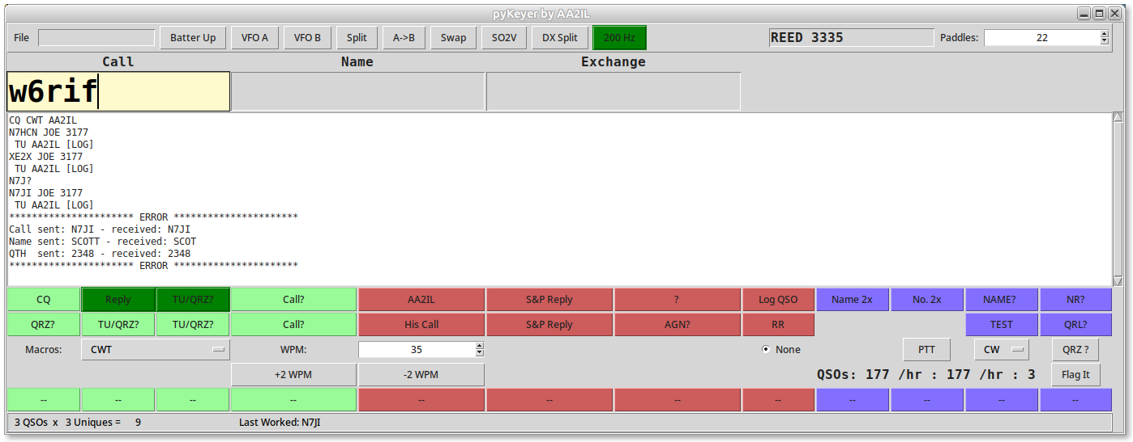
Figure 5.2. A short CWT practice session.

Once the GUI appears, the practice session is initiated by pressing F1 (Call CQ). The computer will respond with a call sign randomly selected from the master CHF. The op then types in the call and presses F2 to send his exchange. If the call was correct, the computer will respond with his exchange. If there was a mistake in the call sign, the call will be repeated prior to sending the exchange. The op then records the exchange and responds by pressing F3 to indicate the end of the QSO. If any repeats/fill are required, you can send a “?” to effect a complete repeat or press the appropriate Blue Function button for a specific fill request. If there was an error in the recorded exchange, this will be noted in the large text box. An short CWT practice session illustrating this is shown in Figure 5.2.

5.10 RTYY and Voice Modes

PyKeyer can be used as the logger for RTTY and voice contests as well.

Discuss pairing with fldigi decoder.

