AI Capstone - Project 1 Report
110611008 許瑋哲

Introduction
In this project, I created land transportation vehicles dataset from internet cooperated with 劉珆睿 (ID: 110550059). Our dataset contained 7 types of vehicles: bicycle, bus, car, carriage, locomotive, motorcycle, truck.
We first use AutoCrawler to collected raw images from Google Chrome search engine. Second, used CLIP to remove images with too low relevant to each class. Third, used GroundingDINO and SAM to extract the object in the images and removed the backgroud that can interfered classified. Finally, we manually remove images that could not be categorized by human eyes.
I use different supervised and unsupervised learning methods try to classified the image in the above 7 classes well. For supervised learning, two methods were employed: Support Vector Machine(SVM) and a deep learning approach using MobileNet. For unsupervised learning, the k-means method was utilized.
In addition, I analyzed result of every methods, and conducted some experiments to test models behavior, and discussed the experimental results for model performance and implications.

Dataset Documentation
Since this dataset was completed cooperated with 劉珆睿 (ID: 110550059), my dataset documentation would be the same as his one.
- Data type
  - All of the images are RGB images in JPEG format.
- Amount
  - We provided 2 formats of dataset
    - In the first format, images are placed in 7 directories according to their class, which can be one of "bicycle", "bus", "car", "carriage", "locomotive", "motorcycle", "truck".
    - In the second format, the dataset is split into 3 parts: train, validate and test with a ratio of 8:1:1 approximately. In each of them are 7 directories, each of them contain images for the corresponding class.
  - The number of images of each class in each part of the dataset is shown below.
- Process of data collection
  - Web crawling
    - We used AutoCrawler , an open source project that can crawl images from google search engine, to obtain images of each classes.
  - Format transforming
    - Since images crawled from internet can be several format, such as PNG, JPEG or WEBP, we first transformed all of the images to the JPEG format.
  - CLIP filtering
    - CLIP (Contrastive Language-Image Pretraining) is a neural network trained on a variety of (image, text) pairs. This model can encode both texts and images into a same feature space, and the cosine similarity of texts and images in that space indicate the degree of how they match.
      - We used pretrained CLIP model ViT-B/32.
      - Part of the code is from CLIP github repo .
      - Since not all of the images obtain from web crawler are relevant the the corresponding, we can utilize the CLIP to filter out the images that do not contain the object we want.
      - Specifically, we encoded images and the text prompt "a photo of a whole {label_name} without any other things", where label_name indicates the class of this image, to the same feature space. Then, we calculate the cosine similarity of each (image, text prompt) pair. Finally, for each class, we filtered out the images that cosine similarity is in the lowest 60% of all images in this class.
        - 60% is a hyper parameter that can be adjusted.
      - For example:
        - This image's cosine similarity is 0.2957954704761505
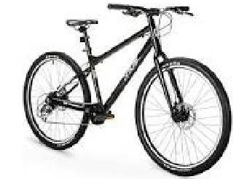

        - This image's cosine similarity is 0.17113284766674042
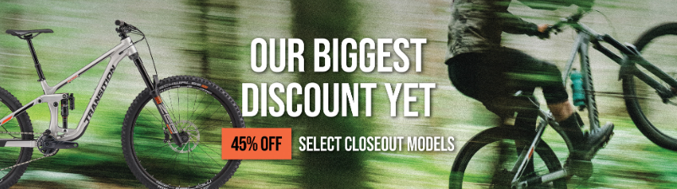

    - GroundingDINO and SAM filtering
      - GroundingDINO is a model that utilize DINO , a transformer-based object detector, to predict the bounding box of the object in the given image by given text prompt. SAM(Segment Anything) is a founding segmentation model that can segment the objects in the image given their bounding box. LangSAM(Language Segment-Anything) is a open-source project that combines these 2 models to extract object from images given text prompt. Specifically, it first utilize DINO to obtain the objects' bounding boxes. Then, they are used as prompt to be fed into SAM along with the image to get the segmentation result.
      - We utilize LangSAM to extract object from images to obtain more clear data. We first use it to obtain the object mask and bounding box. Then, we crop the image into that bounding box, and only retain the value in the object mask. This will make the object occupy most of the image and remove the background, which is better for ML algorithms.
      - For example
        - This is the image before filtering.
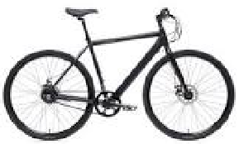

        - This is the image after filtering
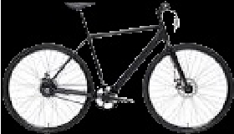

    - Manual filtering
      - We found that above 2 filtering process is still not perfect, so we manually filter out some unrelated or not plausible images.
  - Examples
    - Below are example image of each class.
    - Bicycle
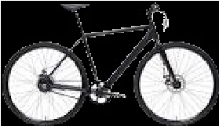

    - Bus
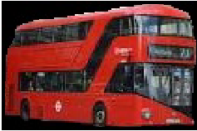

    - Car
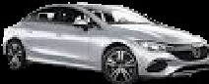

    - Carriage
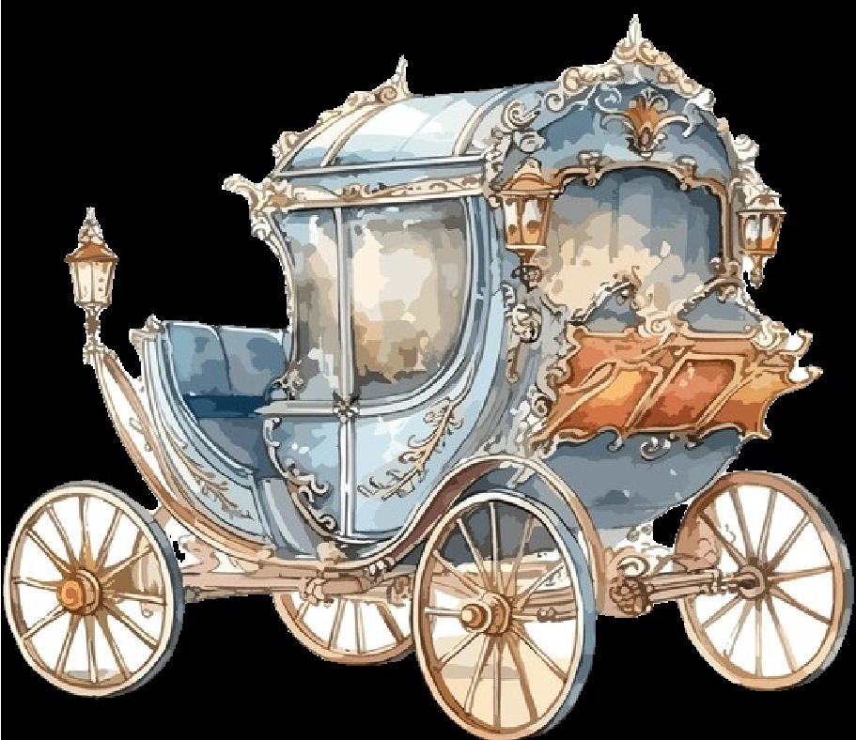

    - Locomotive
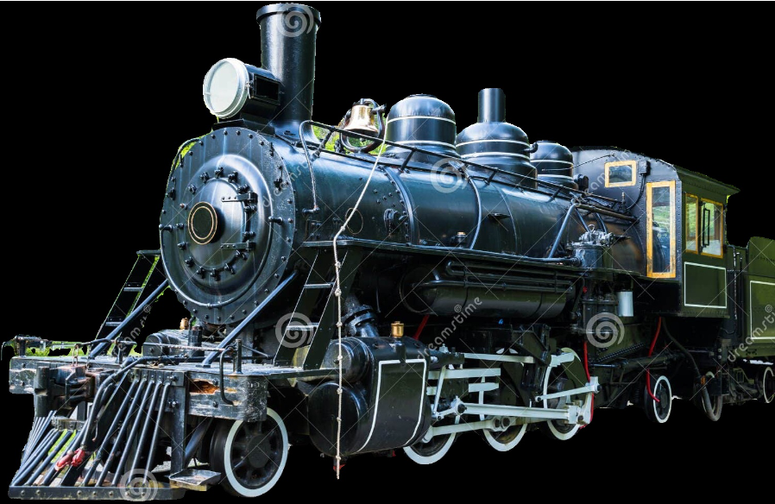

    - Motorcycle
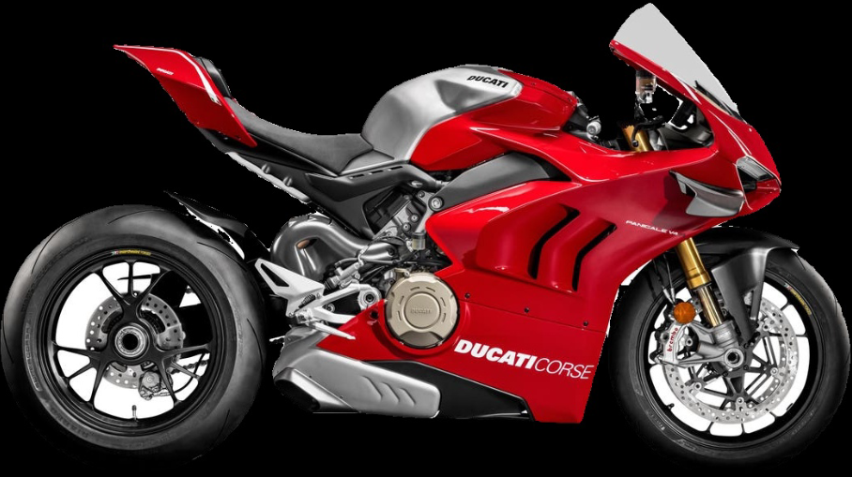

    - Truck
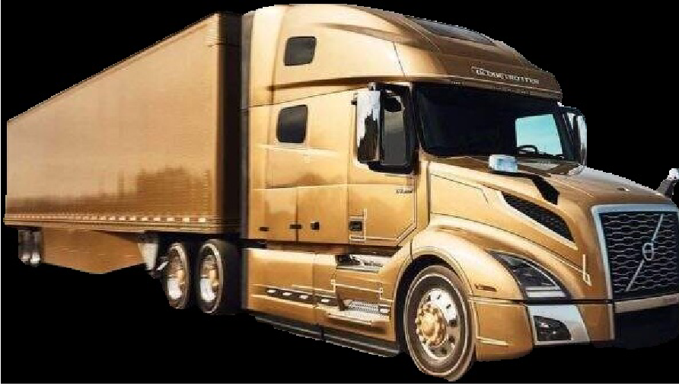

Algorithm
- Some of my code come from pytorch and Scikit-learn's machine learning library, another was generated by chatGPT or Github Copilot, and the other is written on my own.
- Supervised Learning
  - Support Vector Machine:
    - I created SVM classifier using make_pipeline, use SVC (Support Vector Classifier) which constructs a hyperplane in a high-dimensional space from Scikit-learn's machine learning library to perform the image classification, and RBF (radial basis function) kernel, which can handle the case when the relationship between class labels and attributes is nonlinear, and decision_function_shape='ovo' parameter to sets the decision function to a one-vs-one scheme, which is used for multi-class classification.
    - I use hog function to preprocessing input. Used under resampled scheme, K-fold, computed accuracy and drew confusion matrix of each of my experiment.
  - MobileNet:
    - I use mobilenet v2 model and pretrain weight as my basic model for deep learning method. MobileNet models are known for their lightweight architectures, which provide a good balance between speed and accuracy.
    - I use transform including resize, center crop, and nomalize to input, in order to make my data more robust. Used under resampled scheme, K-fold, computed accuracy and drew confusion matrix of each of my experiment.
- Unsupervised Learning
  - K-means:
    - First import data and use hog function or pca method on different experiment. Then I used KMeans, StandardScaler, from Scikit-learn’s model to perform kmeans algorithm. Then predicted labels based on the majority label of each cluster.
    - In terms of evaluation metric, I use accuracy_score to compute total accuracy based on predicted labels and ground truth label, and use silhouette_score to compute silhouette coefficient to specified clustering perfomance.
- K-fold cross validation scheme:
  - I use K-fold cross validation for both of my supervised learning method. Set k equals 10. I use StratifiedKFold from Scikit-learn library images and labels indices of images and labels in each fold. In each fold, there are different part of data used to be validation set. Finally, computed average accuracy of every fold as the metric.
- Hog features:
  - I use hog function from Scikit-learn Library to compute the Histogram of Oriented Gradients (HOG) features for that image. This method can significantly reduce the dimension of input data, help model find underlying relationship of data well, and enhance classification outcomes.
  - The image is resized to 64x64 pixels, and there are 8 orientation bins specified for the histogram. Each cell is a 16x16 pixel block. Therefore this results in 4x4 cells across the image (since 64/16 = 4), and each block consists of 1x1 cell. Total HOG Features = Number of Cells×Orientations per Cell = 4×4×8 = 128, finally return 1d features, shape is equal to (128).
- Resampling:
  - I utilized under resampling to our vehicle dataset which initially containing 2053 images. After resampling, the image count is reduced to 1687, reducing data of 82.2%. This process ensured an equal number of 421 images for each class.
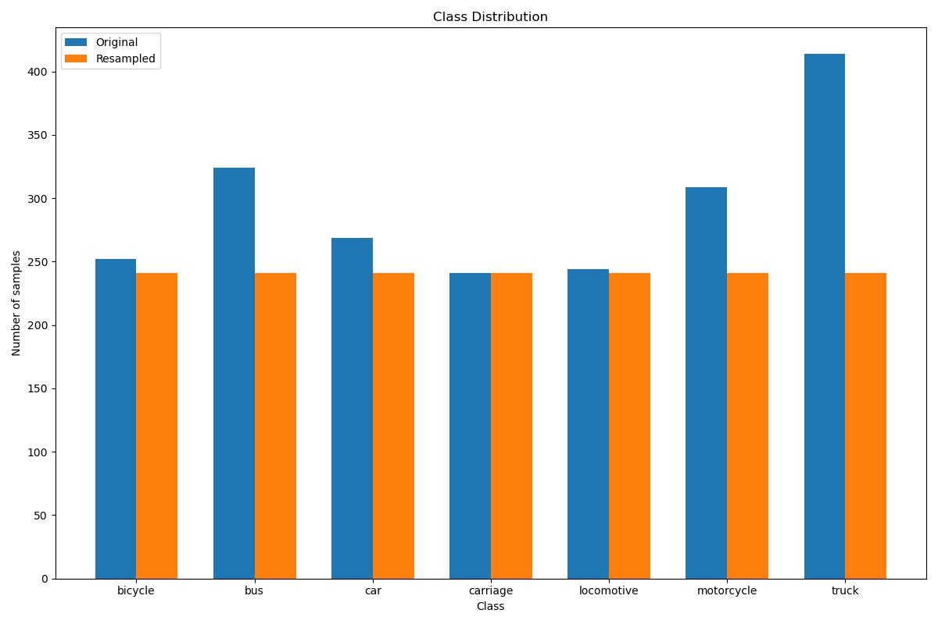

Analysis & Experiments

Support Vector Machine
Method: | Confusion matrix | 10-fold Accuracy
Resampling  +  K-Fold  +  Hog feature | 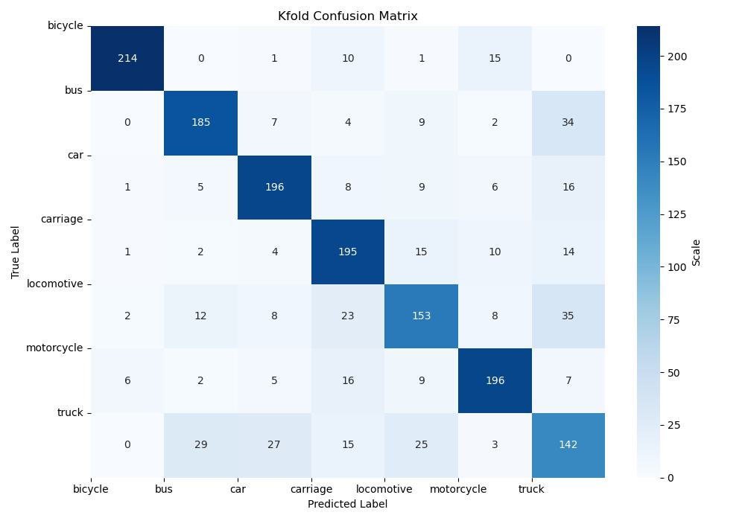 | 0.7593
No resampling  +  K-Fold  +  Hog feature | 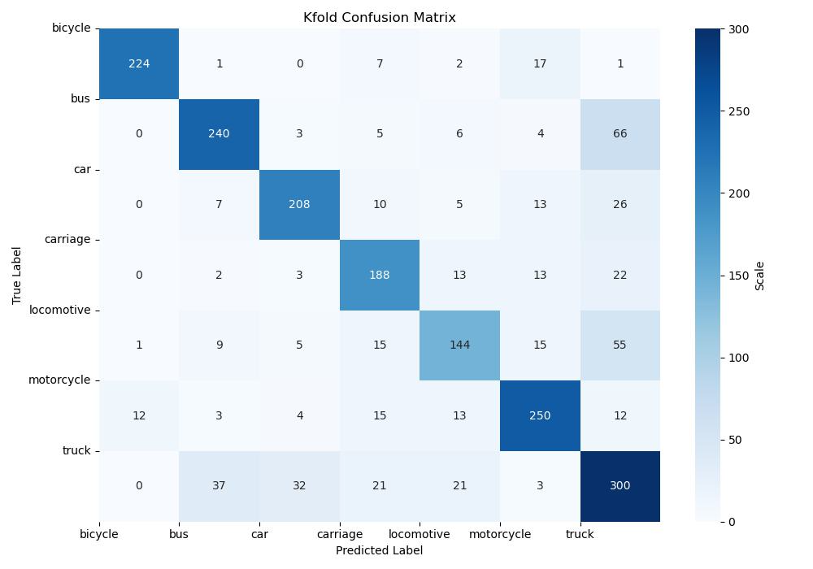 | 0.7569
Resampling  +  K-Fold  +  No Hog feature | 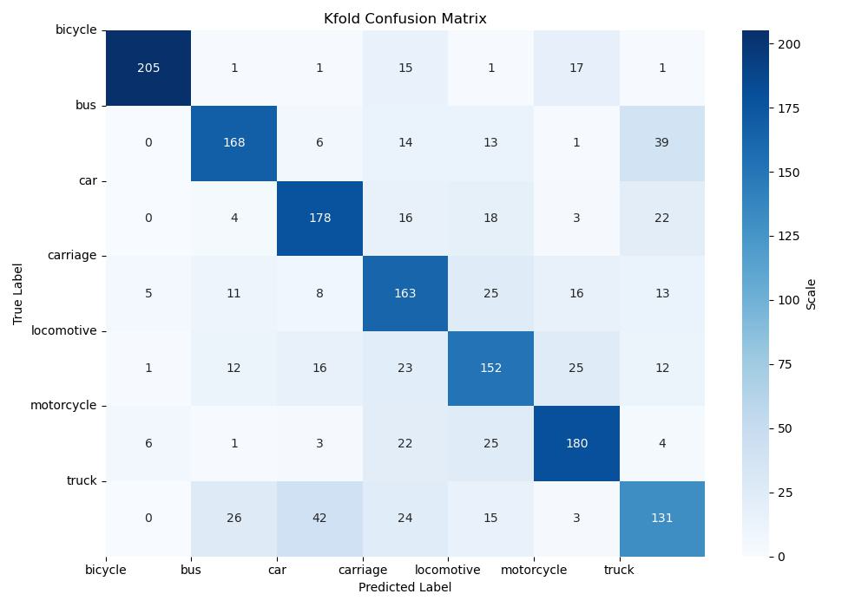 | 0.6976
- I apply 10 fold cross validation scheme to evaluate my SVM model.
- The green row is the example experiment, I choose the one with resampling, K-fold, and hog feature as example. And the example has the best performance among 3 experiments.
- Compare with example, although the second experiment has accuracy similar to the example, the performance across different classes in the confusion matrix varies significantly, with some classes performing well and others poorly.
- The third experiment is much worse than example on accuracy

MobileNet
Method: | Confusion matrix | 10-fold Accuracy
K-fold  +  Resampling  +  Transform | 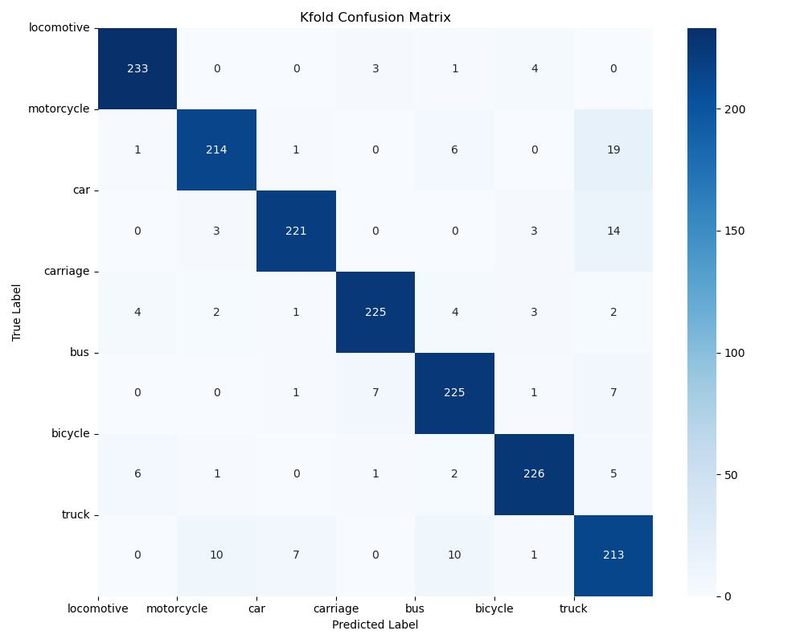 | 0.9306
K-fold  +  No  Resampling  +  Transform | 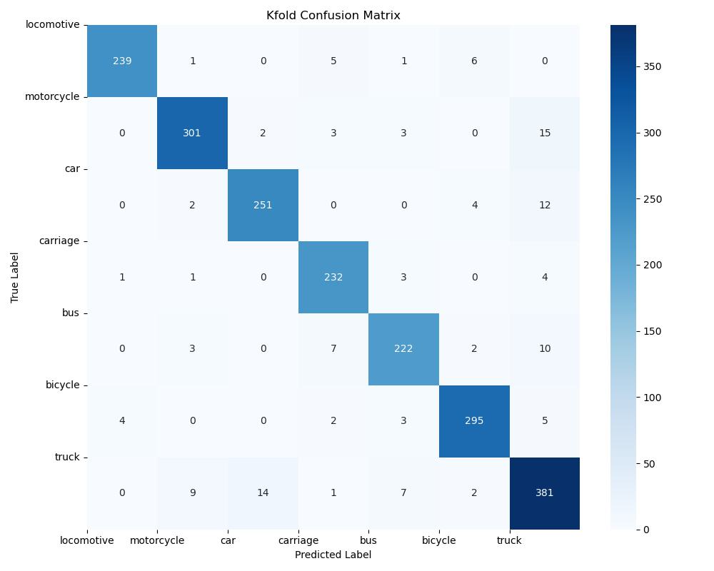 | 0.9357
K-fold  +  Resampling  +  Part of Transform | 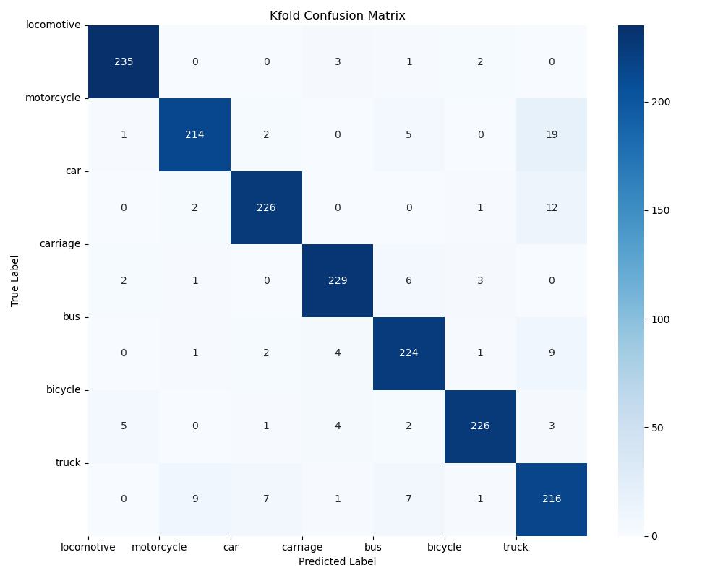 | 0.9229

Kmeans

Method: | Clustering distributed | Accuracy | Silhouette coefficient
Resampling  +  Hog features | 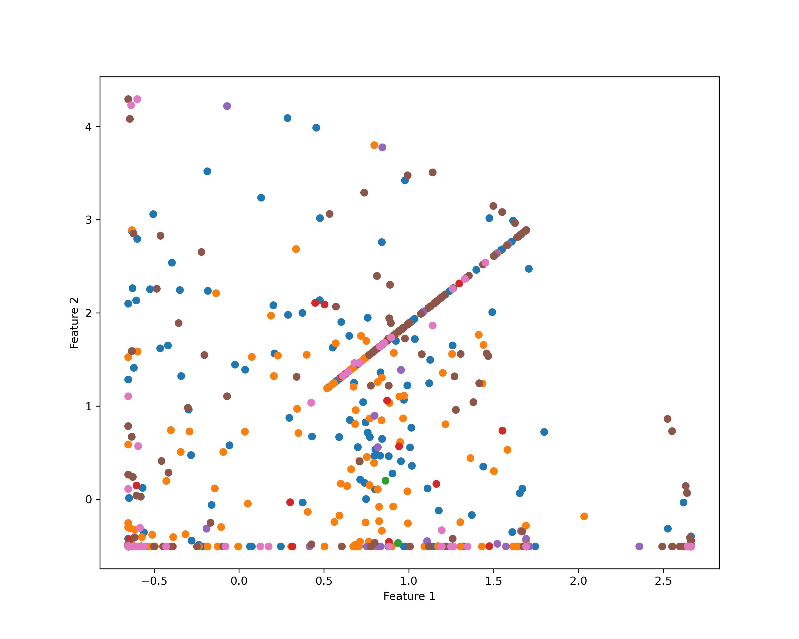 | 0.4878 | 0.0314
Resampling  +  No Hog Feature | 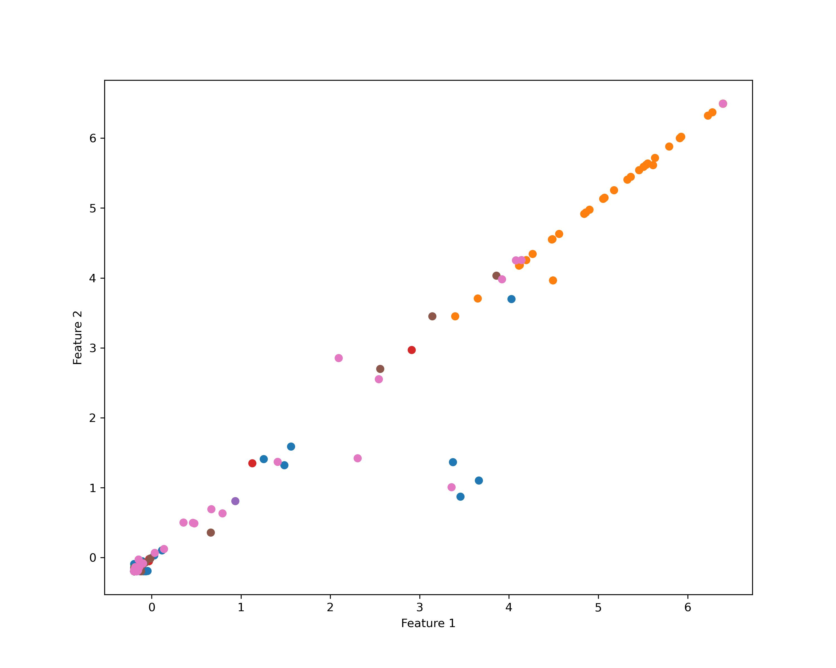 | 0.3989 | 0.0648
No resampling  +  Hog feature |  | 0.

Discussion
- Based on your experiments, are the results and observed behaviors what you expect?
- Discuss factors that affect the performance, including dataset characteristics.
  - Data Quality and Preprocessing: The data preprocessing steps, such as using CLIP for filtering, GroundingDINO and SAM for object extraction, and manual filtering, significantly enhanced the data quality. These steps likely contributed to the higher accuracy in classification tasks by reducing noise and focusing on the relevant features of each vehicle type.
  - Model Characteristics: The choice of model had a profound impact on performance.
  - Class Imbalance: Resampling proved to be crucial in dealing with class imbalance. By ensuring that each class had an equal number of images, the models could learn to recognize less frequent classes more effectively, which was reflected in the improved classification accuracy.
- Describe experiments that you would do if there were more time available.
  - If I have enough time, I will conduct analyzing between hog feature and pca, since I wonder which one can give a better result.
- Indicate what you have learned from the experiments and remaining questions.

Appendix

Code

Reference
1. https://pytorch.org/hub/pytorch_vision_mobilenet_v2/
2. https://github.com/YoongiKim/AutoCrawler
3. A. Radford et al., “Learning Transferable Visual Models From Natural Language Supervision.” arXiv, Feb. 26, 2021. doi: 10.48550/arXiv.2103.00020.
4. S. Liu et al., “Grounding dino: Marrying dino with grounded pre-training for open-set object detection,” arXiv preprint arXiv:2303.05499, 2023.
5. https://github.com/openai/CLIP
6. M. Caron et al., “Emerging Properties in Self-Supervised Vision Transformers.” arXiv, May 24, 2021. doi: 10.48550/arXiv.2104.14294.
7. https://github.com/luca-medeiros/lang-segment-anything
8. https://scikit-learn.org/stable/
9. https://pytorch.org/

Appendix:

Kmeans

resampling + Hog feaute:
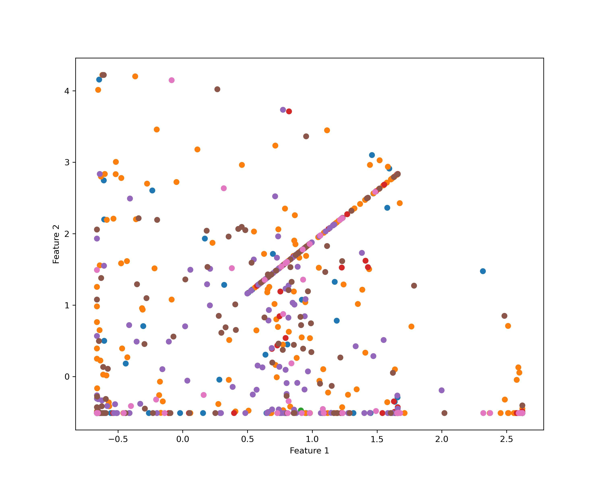
acc: 0.4464
Silhouette coeffieicent: 0.0295

resampling + no hog feature
acc: 0.3734
Silhouette score: 0.0903
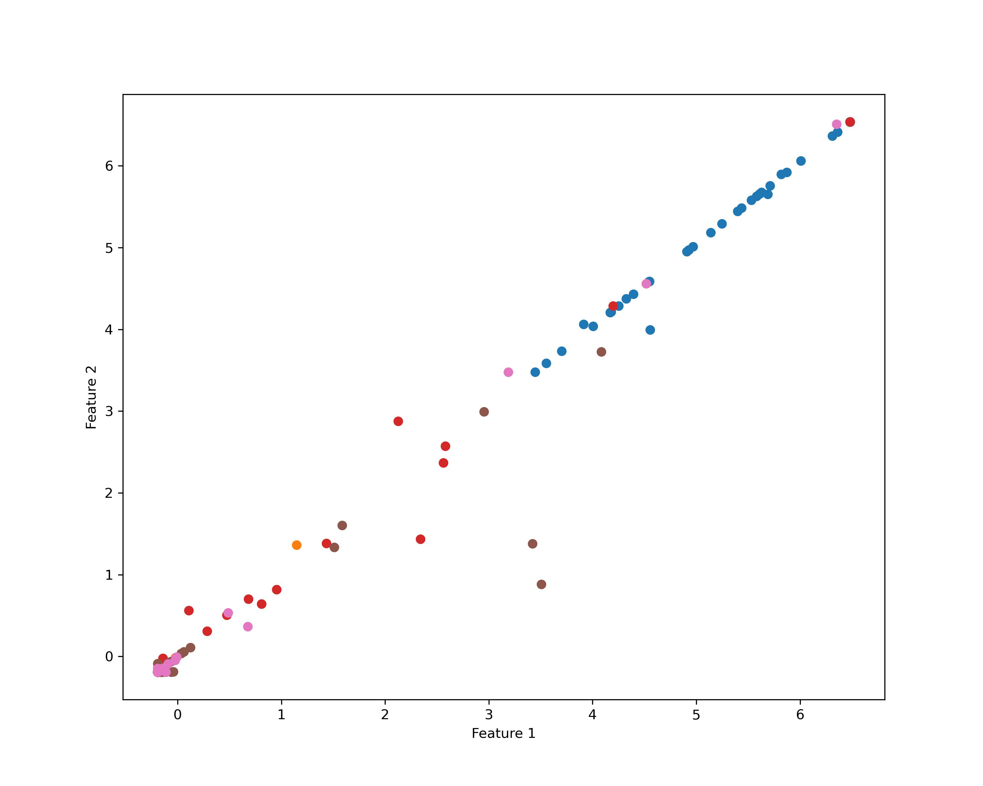

resampling + pca
acc: 0.4132
shilihouette: 0.1013


