
Program of Color Science
Munsell Color Science Laboratory
College of Science
Rochester, NY

Color Constancy in Virtual Environments with Head-Mounted and Flat-Panel Displays Across Different Illuminants and Lightness Levels
By
Andrea Avendano Martinez
April 2025

A Thesis Submitted in
Partial Fulfillment of the Requirements for the
Degree of Master of Science in Color Science

Signature of Author _____________________________________________________________
Accepted by __________________________________________________________________
Dr. Susan Farnand, Graduate Program Director Date



Program of Color Science
Munsell Color Science Laboratory
College of Science
Rochester, NY
CERTIFICATE OF APPROVAL
_____________________________________________________________
MASTER’S DEGREE THESIS
_____________________________________________________________
The Master’s Degree Thesis of Andrea Avendano Martinez
Has been examined and approved by the
Committee as satisfactory for the
Thesis required for the
Master’s degree in Color Science

Name, Advisor

Name, Faculty Member

Date

Abstract
Virtual reality (VR) is commonly used as a tool for enhancing immersion within virtual environments, with one of its primary goals being to approximate real-world perception as closely as possible. In everyday life, variations in lighting conditions significantly influence how colors are perceived across different times and settings. However, the human visual system compensates for these changes, maintaining relatively stable color perception; a phenomenon known as color constancy. This process is driven by chromatic adaptation, the visual system’s adjustment to changes in illumination. Despite the growing use of VR, little research has explored how color constancy operates in virtual environments viewed through a head-mounted display (HMD), particularly in comparison to conventional flat-panel displays. To address this gap, we conducted a psychophysical achromatic adjustment experiment to compare color constancy between VR and flat display conditions. We also examined the influence of secondary factors such as illuminant chromaticity and target lightness, testing five illuminants (white, red, green, blue, yellow) and three lightness levels (L* = 40, 55, 70). Our findings reveal that color constancy is significantly higher in VR than on flat displays across all tested conditions. We also observe significant differences in constancy between illuminants, with the green illuminant yielding the highest constancy and red the lowest. Additionally, higher target lightness levels led to lower constancy. By directly comparing VR to flat displays, our study offers evidence that perceptual measures like color constancy may serve as quantifiable indicators of immersion. This has important implications not only for refining theories of color constancy within virtual environments, but also for the development of more immersive virtual experiences.

Acknowledgments
First, I would like to thank my thesis advisors, Dr. Chris Thorstenson and Dr. Mike Murdoch, for their support and guidance throughout this research project. I appreciate the time and effort they spent working with me. I also want to thank Dr. David Long and Dr. Ricky Figueroa, my undergraduate capstone advisor and program director, for their guidance during my academic journey and for helping me transition into graduate school. A heartfelt thank you to the faculty, staff, and students in the MCSL color science community for creating a supportive environment that helped me grow during my time here. Finally, I want to thank my family and loved ones for their support throughout my undergraduate and graduate studies. I would not be where I am today without your love, belief, and encouragement. I’m excited to continue the next chapter of my journey!

Table of Contents
Abstract 3
Acknowledgments 4
List of Figures 8
List of Tables 13
Chapter 1: Introduction 14
Chapter 2: Background & Literature Review 17
2.1 The Human Visual System 17
2.1.3 Cognitive Mechanisms of Chromatic Adaptation 21
2.2 Measuring Color Constancy 22
2.3 Color Constancy Experiment Methods 26
2.3.1 Asymmetric Simultaneous and Successive Matching 26
2.3.2 Color Categorization 27
2.3.3 Achromatic Matching 28
2.4 Color constancy in VR 29
2.5 Color Constancy Across Media Types 31
Chapter 3: Color Characterization 33
3.1 Color Characterization Methods 33
3.2 VR Head-Mounted Display Architecture 34
3.3 Color Characterization for VR HMDs 35
Chapter 4: Methods 38
4.1 Participants 38
4.2 Stimuli 39
4.2.1 Virtual Environment 39
4.2.2 Target Stimulus 41
4.2.3 Illuminants 42
4.3 Color Characterization 45
4.3.1 VR HMD Characterization 48
4.3.2 Flat-Panel Display Characterization 54
4.4 Apparatus 56
4.5 Experiment Procedure 58
4.6 Data Analysis 61
4.6.1 Recentering 61
4.6.2 Correcting for Off-Illuminant Line Responses 63
4.6.3 Constancy Index Equation 65
Chapter 5: Results 66
5.1 Participant Achromatic Responses 66
5.2 Constancy Index Effects 69
5.2.1 Effect of Display Condition 70
5.2.2 Effect of Illuminant Chromaticity 70
5.2.3 Effect of Target Lightness 72
5.2.4 Interaction of Condition and Illuminant 73
5.2.6 Interaction of Condition and Lightness 75
5.3 Projection Analysis 76
Chapter 6: Discussion 78
6.1 Display Condition 78
6.2 Illuminant Changes 80
6.3 Target Lightness Changes 81
6.4 Future Work and Limitations 83
Chapter 7: Conclusion 85
Bibliography 86

List of Figures
Figure 1. (Berns, 2019) Spectral sensitivities of the human visual system cone fundamentals. (Adapted from Smith & Pokorney, 1975) 18
Figure 2. (Foster, 2011) Example illustration of color constancy data in CIE 1931 (x, y) chromaticity space (Data adapted from Arend and Reeves 1986). The open circle represents the chromaticity of a test stimulus under a reference illuminant (6500K). The solid square shows the observer’s match to that stimulus under a different test illuminant (10,000K). The open square indicates the ideal match, corresponding to the chromaticity of the stimulus’ reflectance under the test illuminant. Color constancy is quantified using two common metrics: the color constancy index (CI = 1 – b/ a) and the Brunswik ratio (BR = c/ a), where a, b, and c are Euclidean distances between these points. 23
Figure 3. (WebVR) Schematic illustrating the creation of stereoscopic 3D images in a virtual reality head-mounted display. 34
Figure 4. Unreal Engine screenshot showing a preview of the experimental 3D environment. 40
Figure 5. Top, wireframe view of the experimental scene with four point lights equally spaced. 41
Figure 6. Experimental scene as seen from the point of view of the participant in Flat mode. The target is the circular red patch in the center (red color is for illustration purposes only). 42
Figure 7. Chromaticity plot of aim illuminant chromaticities (black circle) and measured chromaticities of illuminants using VR (blue asterisk) and Flat (red cross) displays. Display gamuts are shown for VR (blue line) and Flat (red line) displays as well as sRGB gamut (black dotted). 44
Figure 8. Experiment scene rendered under each of the five illuminants: white (middle), yellow (top left), red (top right), blue (bottom left), and green (bottom right). 45
Figure 9. Illuminant adjustment grids in CIE 1976 (u’, v’) chromaticity space for each chromatic illuminant (Red, Green, Blue, and Yellow). Each open circle represents a grid step corresponding to a 2-step shift in CIE a*b* space. The colored squares indicate the chromatic illuminants, while the white square indicates the white illuminant. These grids were used to define the adjustment range for achromatic matching under each illuminant. 47
Figure 10. Flowchart detailing the two verification methods of the characterization model. Top (blue) describes the verification of the forward model using a sample of 224 RGB values. Bottom (red) describes the verification of the backward model using a sample 30 points for each of the CIELAB adjustment grids. 48
Figure 11. Measured primary and gray ramps under the white illuminant for the VR HMD. 49
Figure 12. Photo of VR aperture attachment to CS2000 spectrophotometer (left). Measurement setup (right). 50
Figure 13. Gray ramp luminance measurements with and without VR aperture. The corrected measurements taken without VR aperture multiplied by the correction factor are also shown. 51
Figure 14. VR mode ΔE00 color difference values for the 224 verification colors before optimization (top) and after (bottom) under the white illuminant for the VR HMD. 52
Figure 15. VR mode ΔE00 color differences for the 30 randomly selected points in the CIELAB grids for the white illuminant. 53
Figure 16. Measured primary and gray ramps under the white illuminant for the Flat-panel display. 54
Figure 17. Flat mode ΔE00 color difference values for the 224 verification colors under the white illuminant. 55
Figure 18. Flat mode ΔE00 color differences for the 30 randomly selected points in the CIELAB grids for the white illuminant. 56
Figure 19. Flat (left) and VR (right) display conditions. 57
Figure 20. 8Bitdo Micro Bluetooth Mini Controller used to adjust the stimulus in the experiment. 58
Figure 21. Schematic of the experimental procedure. Participants first adapted to the white illuminant for 2 minutes before completing adjustment trials at three lightness levels (L* = 40, 55, 70), with three repetitions per level. Next, they adapted under a randomly assigned chromatic illuminant (red, green, blue, or yellow). For each chromatic illuminant, the same adjustment procedure was repeated. After completing a chromatic block, participants adapted to the white illuminant for 30 seconds, followed by an additional trial under white with a single adjustment at L* = 55. This sequence was repeated for all four chromatic illuminants. 60
Figure 22. Example observer achromatic responses under the white illuminant (white circle) are recentered to the chromaticity of the white illuminant (white square). Then, observer responses under the chromatic illuminant (red unfilled circle) are shifted (red filled circle) accordingly. 63
Figure 23. Example data showing the projection $(rc''-w)$ of the response vector $(rc'-w)$ onto the illuminant vector $c-w$. The $δuv$ is the distance from the recentered response to the projected response $rc'-rc''$. 64
Figure 24. Participant achromatic responses for every trial in the VR and Flat conditions, shown before recentering. Darker areas indicate a higher frequency of responses. The ellipses represent one standard deviation for each illuminant, with the average marked by a black X. 67
Figure 25. Participant achromatic responses under the white illuminant for VR and Flat conditions. Color-coded ellipses are one-standard deviation of the data for different lightness levels of L* 40 (red), L* 55 (green), and L* 70 (blue). 68
Figure 26. The recentered achromatic responses are shown for the VR and Flat conditions. The ellipses represent one standard deviation for each illuminant, with the average marked by a black X. 69
Figure 27. Constancy Index for VR and Flat display conditions, averaged over all illuminants and lightness levels. Lines show the average and standard error bars. Average constancy was higher for the VR than Flat display condition. 70
Figure 28. Constancy Index for each illuminant, averaged over display conditions and lightness levels. Markers show the average for each distribution along with standard error bars. Average constancy was highest for green, lowest for red, and similar for the blue and yellow illuminants. 71
Figure 29. Constancy Index for each lightness level, averaged over display conditions and illuminants. Markers show the average for each distribution along with standard error bars. 72
Figure 30. Constancy Index per illuminant for both display conditions (VR/Flat), averaged over target lightness levels. CI is higher in VR than in Flat within each illuminant, with the largest difference for the yellow and green illuminants. 73
Figure 31. Average recentered achromatic responses for each participant for VR (circles) and Flat (triangles) conditions. One-standard deviation ellipses are shown for each illuminant for VR (solid) and Flat (dashed). Mean responses are shown with a black X for VR and a black star for Flat. 74
Figure 32. Constancy Index per target lightness for both display conditions (VR/Flat), averaged over illuminants. CI is higher in VR than in Flat within each lightness level, with the lowest CI at L* 70 for both display conditions compared to L* 40 and L* 55. 75
Figure 33. Frequency of $δuv$ for VR and Flat conditions. 76
Figure 34. Magnitude of $δuv$ as a function of CI for VR and Flat conditions. R-values indicate low correlation for either display condition (VR: r = -0.1155; Flat: r = -0.1425). 77

List of Tables
Table 1. lluminant aim chromaticities, absolute (x, y) deviations from the aim, and measured luminance values for both VR and Flat display conditions. Chromaticities were measured by setting the target to white (RGB = [1, 1, 1]) and treating it as a perfectly diffuse reflector of the scene's illumination. 43
Table 2. Average ΔE00 values for the verification colors for each of the illuminants before and after model optimization. 52
Table 3. Average, minimum, and maximum ΔE00 color difference for the randomly selected points in the CIELAB grids for each illuminant. 54
Table 4. Average, minimum, and maximum ΔE00 color difference for the randomly selected points in the CIELAB grids for each illuminant. 56

Chapter 1: Introduction
Color constancy is a fundamental aspect of human vision that allows us to perceive the color of objects as consistent across changes in illumination. The mechanisms underlying color constancy can be broadly categorized into sensory and cognitive chromatic adaptation (Fairchild M. D., 2013). Sensory mechanisms of chromatic adaptation are automatic physiological responses to changes in illumination. One theory, proposed by von Kries (1902), suggests that sensory chromatic adaptation works through the normalization of cone signals by the maximum signal, or white. This concept, known as the von Kries model, has served as the groundwork for modern chromatic adaptation transforms (Luo, 2015). On the other hand, cognitive mechanisms of chromatic adaptation rely on past knowledge about the typical colors of objects in different environments. One prominent hypothesis, proposed by Helmholtz (1867), suggests that we learn the typical colors of objects under neutral light and can use this knowledge to discount the illuminant when perceiving object colors under different lighting conditions. This cognitive process is often referred to as "discounting the illuminant” and has been the basis of several modern studies regarding if it’s possible to estimate the illuminant from a scene (Golz & MacLeod, 2002; Granzier et al., 2009; McCann, 2005; Rutherford & Brainard, 2002; Zaidi, 1998). Additionally, Hering (1878) proposed that familiarity with objects, known as "memory color," could aid in achieving color constancy. For instance, when encountering a banana, one may recall its typical yellow hue, using it as a reference to gauge changes in illumination. This estimate of illumination color can then inform the perception of surface reflectance for other objects in the scene, even if their color is unfamiliar or unknown (Gegenfurtner et al., 2024; Granzier & Gegenfurtner, 2012).
Much of the research on color constancy has been conducted in real-world environments, where observers interact with naturally illuminated scenes. Building on this foundation, a significant body of work has used flat-panel displays to simulate these environments in controlled settings. Flat-panel displays, which are conventional emissive screens like LCDs or OLEDs, are widely used in psychophysical experiments because they allow for precise control over stimuli and lighting conditions, making them ideal for studying perceptual phenomena. Studies have found that chromatic adaptation or color constancy on flat-panel displays is often incomplete compared to real-world viewing (Brainard D. H. et al., 1997; M. D. Fairchild, 1993; Katoh, 1995; Zhai & Luo, 2018). One explanation is that cognitive adaptation mechanisms may not fully engage when viewing emissive displays, which are perceived as self-luminous rather than as scenes composed of objects reflecting light from an external illumination source (M. D. Fairchild, 1993). In natural environments, we experience and interact with surfaces that reflect illumination, which may help the visual system estimate the light source and maintain stable color perception. But when viewing a flat-panel display, the image is emitted light, not reflected light, and our brain may not interpret it as a real, illuminated scene. As a result, the usual adaptation mechanisms that support color constancy may not fully engage.
While these studies have advanced our understanding of the mechanisms behind color constancy, relatively little research has explored how these mechanisms operate in virtual reality (VR). VR offers a unique opportunity to present immersive, three-dimensional environments with dynamic lighting and depth cues, yet its use in color constancy research remains limited. Furthermore, how color constancy in VR compares to that observed with flat-panel displays is still not well understood. Unlike flat-panel displays, VR headsets typically offer a much wider field of view (approximately 90–130 degrees horizontally; Angelov et al., 2020), binocular disparity for stereoscopic depth perception, and motion tracking that enables real-time updates to the virtual scene. Together, these features create a highly immersive experience, allowing users to explore virtual environments in ways that more closely resemble real-world perception. This suggests the possibility that VR environments may facilitate color constancy in ways that are more aligned with how it naturally occurs when interacting with physical environments, as compared to viewing scenes on flat-panel displays.
The present study addresses this gap by investigating whether and to what extent adapting to a virtual environment while viewing it in VR works differently than on a flat-panel display. Specifically, we compare color constancy between VR and flat-panel display conditions using a psychophysical achromatic adjustment experiment. We also examine the influence of secondary factors, such as illuminant chromaticity and target lightness, across five illuminants (white, red, green, blue, yellow) and three target lightness levels (L* = 40, 55, 70).
In the following sections, we first review existing literature on the mechanisms underlying color constancy, common methods and measurements, and prior studies that have used VR to investigate color constancy, including how they approached color characterization of VR headsets. We then describe the methods of our own experiment comparing VR HMDs and flat-panel displays, present our results, and conclude with a discussion on how color constancy manifested across the two display types, different illuminants, and lightness of the target.

Chapter 2: Background & Literature Review
Color constancy refers to the visual system’s ability to perceive relatively stable object colors despite changes in illumination. Natural illumination varies dramatically from sunrise to sunset due to the Earth's rotation, atmospheric scattering, and solar angle, with daylight’s correlated color temperature shifting from cool (~12,000 K) to warm (~2000 K) throughout the day (Pastilha & Hurlbert, 2022). These changes in illumination alter the color of objects being illuminated, however the color appearance of objects often seems to remain stable. For instance, a white sheet of paper continues to look white under both daylight and incandescent light, despite the shift in reflected light. Through evolution, the human visual system has developed mechanisms that support this stability, allowing us to reliably identify, discriminate, and locate objects, such as ripe fruit, under varying lighting conditions (Regan et al., 2001). This perceptual stability is largely attributed to chromatic adaptation, the mechanism that allows the visual system to adjust and adapt to changing illumination. To understand the foundations of color constancy, it is essential to consider how the visual system encodes color signals from the environment and examine the physiological and cognitive mechanisms present in chromatic adaptation.

2.1 The Human Visual System
Understanding color constancy requires considering both the physical properties of the environment and the physiological mechanisms of the observer. The light that reaches the retina depends on two key factors: the spectral distribution of the illuminant 𝑆(𝜆), which describes the intensity of light at each wavelength, and the spectral reflectance function of the surface R(λ), which defines the proportion of light reflected at each wavelength. The product of these two functions determines the spectral power distribution of the light entering the eye from a surface. The human visual system then summarizes this spectral information into three signals. The retina contains three classes of cone photoreceptors, each sensitive to different, but overlapping, regions of the visible spectrum: L-cones (with peak sensitivity to long wavelengths), M-cones (medium wavelengths), and S-cones (short wavelengths).
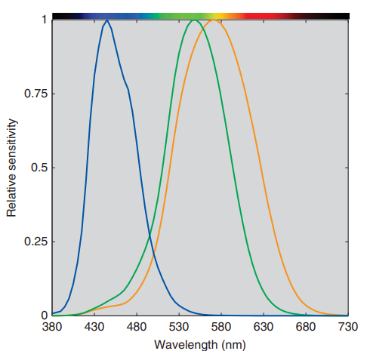
Figure 1. (Berns, 2019) Spectral sensitivities of the human visual system cone fundamentals. (Adapted from Smith & Pokorny, 1975).
Each cone type responds to the incoming light by integrating over a broad range of wavelengths according to its spectral sensitivity function (see Figure 1). The visual system thus reduces the continuous spectral information to just three signals, and the perception of color is constructed from the relative responses of these cone types, a concept called trichromacy. This transformation from a full spectral signal to three cone responses is expressed mathematically by integrating the product of the illuminant spectrum, the surface reflectance, and the cone sensitivity functions, described in equations 1–3:
$$\begin{aligned}L=\int{S\left(λ\right)R\left(λ\right)l\left(λ\right)dλ} \#\left(1\right)\end{aligned}$$
$$\begin{aligned}M=\int{S\left(λ\right)R\left(λ\right)m\left(λ\right)dλ }\#\left(2\right)\end{aligned}$$
$$\begin{aligned}S=\int{S\left(λ\right)R\left(λ\right)s\left(λ\right)dλ}\#\left(3\right)\end{aligned}$$
Where S(𝜆) is an illuminant’s spectral power distribution, R(𝜆) is an object’s spectral reflectance, and l(𝜆), m(𝜆), and s(𝜆) are the spectral sensitivities of the L-, M-, and S-cones, respectively.
Color constancy is challenging because different combinations of illumination and surface reﬂectance can result in the same color signal. For example, the color of two objects may appear identical under one illuminant, but different under another. This phenomenon is known as metamerism. As a result of metamerism, there is an inherent ambiguity in the color signal. Our visual system cannot uniquely determine the exact properties of the surface or the illuminant from the cone responses alone. Therefore, perfect color constancy is theoretically unachievable. That is, the human visual system cannot always predict how the color of an object would appear under a different illuminant. Despite this, humans often perceive stable object colors across changes in illumination due to chromatic adaptation, which involves both sensory and cognitive mechanisms (Fairchild M. D., 2013). Sensory mechanisms refer to automatic responses of the visual system to the stimulus, like adjusting cone signals. Cognitive mechanisms draw on an observer’s knowledge and expectations about scene content. For instance, assumptions about typical lighting conditions or familiar object colors.
2.1.2 Sensory Mechanisms of Chromatic Adaptation
One approach to understanding color constancy is through low-level visual mechanisms that explain chromatic adaptation as a modulation of cone responses. A foundational model is the von Kries transform, which proposes that the responses of the L, M, and S cones are scaled independently by multiplicative gain factors to compensate for the color of the illumination (von Kries, 1902).These gains are set in inverse proportion to the average cone excitation under the current illuminant, allowing the visual system to normalize the incoming signal. The idea is that, after adaptation, a spectrally non-selective surface (white or achromatic) will still appear achromatic under different lighting conditions. In matrix form, von Kries adaptation transform is expressed as the following equation, where L, M, S represents the cone responses under a reference illuminant, $L_{a}$ , $M_{a}$, $S_{a}$represent the adapted cone responses, and $L_{w}$ , $M_{w}$, $S_{w}$ are the cone responses of a stimulus that appears white under the adapting illuminant
$$\begin{aligned}\left[\begin{matrix}L_{a} \\ M_{a} \\ S_{a}\end{matrix}\right]=\left[\begin{matrix}{\frac{1}{L}}_{w} & 0 & 0 \\ 0 & \frac{1}{M_{w}} & 0 \\ 0 & 0 & {\frac{1}{S}}_{w}\end{matrix}\right]\left[\begin{matrix}L \\ M \\ S\end{matrix}\right]\#\left(4\right)\end{aligned}$$
To quantify the effects of chromatic adaptation on perceived color appearance, many chromatic adaptation transforms (CATs) have been developed to predict how the LMS signals of a surface change under different illuminants. These transforms estimate corresponding colors, which are colors that appear the same under different lighting conditions. While simple models like von Kries adaptation can account for changes in neutral (achromatic) surfaces, they are less accurate for spectrally selective (chromatic) colors. Still, the von Kries transform performs reasonably well for predicting corresponding colors (Breneman, 1987). Since chromatic adaptation is often incomplete, more recent CATs incorporate a degree of adaptation parameter (D factor) to scale the adaptation response. This refinement has been adopted in widely used general-purpose CATs like CAT02 and CAT16.

2.1.3 Cognitive Mechanisms of Chromatic Adaptation
Cognitive mechanisms play a key role when chromatic adaptation is incomplete. In states of partial chromatic adaptation (when the ambient illumination does not appear neutral) achromatic surfaces, like white paper, may take on a yellowish tint under warm lighting. Yet, observers might still identify the paper as white based on contextual knowledge or past experiences. This process, known as “discounting the illuminant”, reflects cognitive compensation beyond the sensory adaptation occurring at the retinal level. This term might be misleading since our visual system cannot fully discount the illuminant, especially under spectrally complex lighting (McCann, 2005). However, this limitation opens the door for experimental designs that investigate how observers attempt to compensate for illumination, particularly through color constancy studies. Studies have shown that observers may use certain cues to help estimate the illuminant in a scene, such as specular highlights, shadows, the brightest region of a scene assumed to be white, or adaptation to the average or local scene color (Kraft & Brainard, 1999; Smithson, 2005). These findings support the idea that color constancy arises from multiple mechanisms operating at different levels of the visual system, from low-level retinal processes to higher-order cortical interpretation. As such, constancy is studied both at the sensory level, through appearance-based matching, and at the cognitive level, where observers judge surface identity across lighting changes (Hurlbert, 2019). Interestingly, tasks requiring participants to match stimuli based on perceived material (e.g., “same paper”) rather than color appearance reveal greater constancy (Arend & Reeves, 1986; Radonjić & Brainard, 2016), highlighting the strength of cognitive-level chromatic adaptation. When observers engage with material-based judgments, they may draw on contextual cues, expectations, and prior knowledge about surface properties under varying illumination, resulting in stronger adaptation effects.

2.2 Measuring Color Constancy
Color constancy is typically measured by comparing how much a stimulus appears to change color under different lighting conditions, relative to how much the illumination itself changes. This comparison is often done in color spaces such as the 2D CIE 1931 (x, y) or CIE 1976 (u’, v’) chromaticity spaces, or 3D spaces like CIELAB or CIELUV Foster (2011). Several metrics have been proposed to scale these shifts into a one-dimensional index. Among the most widely used are the Color Constancy Index (CI), introduced by Arend & Reeves (1986), and the Brunswik Ratio (BR), described by Troost & De Weert (1991) and first introduced by Brunswick (1956). Both are derived by taking a ratio of the Euclidian distance between observed chromaticity matches under a reference and test illuminant, to the distance between ideal matches. For achromatic or spectrally non-selective surfaces, this ideal match is simply the distance between chromaticity of the illuminants themselves. A value of 1 indicates perfect color constancy, where perceived color remains stable despite changes in illumination, while a value of 0 reflects no constancy, with perceived color changing entirely in line with the illuminant. Figure 2 (Foster, 2011) illustrates a representative example of such measurements plotted in CIE xy chromaticity space.
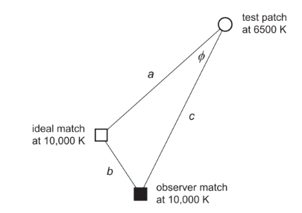

Figure 2. (Foster, 2011) Example illustration of color constancy data in CIE 1931 (x, y) chromaticity space (Data adapted from Arend & Reeves (1986)). The open circle represents the chromaticity of a test stimulus under a reference illuminant (6500K). The solid square shows the observer’s match to that stimulus under a different test illuminant (10,000K). The open square indicates the ideal match, corresponding to the chromaticity of the stimulus’ reflectance under the test illuminant. Color constancy is quantified using two common metrics: the color constancy index (CI = 1 – b/ a) and the Brunswik ratio (BR = c/ a), where a, b, and c are Euclidean distances between these points.
In relation to Figure 1, the Color Constancy Index (CI) is defined as
$$\begin{aligned}CI=1-\frac{b}{a} \#\left(5\right)\end{aligned}$$
and the Brunswik Ratio (BR) is defined as
$$\begin{aligned}BR=\frac{c}{a} \#\left(6\right)\end{aligned}$$
When the observer’s match lies directly along the line connecting the chromaticity of the reference and test illuminants (i.e., when the angle ϕ = 0), and the value is within 0 to 1, the CI and BR produce identical values. However, they differ in how they handle deviations from the illuminant-change direction. The BR is often reported alongside the angle ϕ, which conveys the direction of the deviation relative to the illuminant-change axis. However, since it’s not explicitly accounted for in the BR equation, it is possible for an observer’s match to fall far from the illuminant-change line and still yield a BR > 1, which may misleadingly suggest over-constancy. On the other hand, CI also lacks a term to account for this deviation. This means two observer matches with the same CI can differ greatly in how they deviate from the ideal match, in magnitude, direction, or both. Thus, there are limitations when reducing the dimensionality of the observer matches from two dimensions to a single scalar.
To address this limitation, some researchers have modified the traditional metrics. For example, Olkkonen et al. (2008) introduced a projection-based variant of the CI. They calculate CI by first projecting the observer’s match onto the illuminant-change vector, then computing the ratio between the length of this projection and the illuminant line
$$\begin{aligned}CI =\frac{\left(c · a\right)}{a^{2}} \#\left(7\right)\end{aligned}$$
This method accounts for observer matches that stray from the illuminant-change line, which may help to normalize CI data. Even then, the direction of the observer match is lost. To address this in our study, we introduce an additional measure, $δ_{uv}$, which captures the Euclidean distance of the observer’s match from the illuminant-change line. This metric provides insight into the magnitude and direction of deviation. The exact implementation of this measure will be described later in the Methods section.
It is also important to note a limitation in the assumptions underlying Figure 1. For achromatic stimuli, it assumes that the observer’s match under the reference illuminant is identical to the chromaticity of the stimulus under that illuminant. In practice, this is often not true. Brainard (1998) found that observers may exhibit color constancy even when their achromatic matches do not coincide with the chromaticity of the reference illumination. This occurs because the internal definition of "achromatic" can vary. For example, Aston et al. (2019) and Weiss et al. (2017) found that there was a “blue-bias” in which observers were less sensitive to detecting blue-direction illumination changes. This suggests that some individuals may perceive bluish chromaticities as achromatic, reflecting a perceptual bias in what is considered neutral. To correct for this, Brainard (1998) used a re-centering method based on the von Kries adaptation model, which adjusts the observer’s data to simulate what their test illuminant matches would have looked like if they had exactly matched the reference illuminant. This approach normalizes the observer’s responses such that the match under the reference illuminant is treated as identical to the stimulus chromaticity, allowing for more consistent comparison of shifts across illuminants and across observers.
Over time, various versions of the color constancy index and Brunswik ratio have been developed. While early studies established baseline definitions, later work has introduced variations in projection methods, distance metrics, and color spaces to better suit specific tasks. As a result, there is no universally accepted standard for measuring color constancy. Therefore, the magnitude of CI should only be interpreted within the context of a given study. In the following section, we discuss how different experimental methods influence the measure of color constancy and analyze trends in the constancy indices.

2.3 Color Constancy Experiment Methods
Psychophysical experiments evaluating color constancy under varying illumination conditions typically involve color matching tasks. These can be broadly categorized into three types: asymmetric matching (simultaneous or successive), color categorization, and achromatic matching. Laboratory measurements reveal wide variability of color constancy from as low as 20% to as high as 80% depending on the method, task, and available cues (Gegenfurtner et al., 2024; Kraft & Brainard, 1999)

2.3.1 Asymmetric Simultaneous and Successive Matching
Asymmetric matching has been a foundational approach in color constancy research. In this paradigm, observers match the color of a surface under one illuminant to that of another surface under a different illuminant, typically presented side-by-side (simultaneous) or sequentially (successive). Simultaneous matching has the drawback that adaptation to the two scenes will be affected by eye movements back and forth between the two parts of the scene. Successive matching allows more control of the adaptation to the two illuminants, but results will depend on the observer’s ability to remember colors from previous scenes.
Early simultaneous asymmetric matching studies often used one-dimensional, computer-simulated stimuli presented on uniform backgrounds. For example, Arend & Reeves (1986) and Reeves et al. (1991) used Mondrian patterns of simulated Munsell papers displayed on CRT monitors under different illuminants. These experiments typically reported low color constancy, partly due to the simplified scene geometry and lack of natural viewing cues. Troost et al. and Bäuml replicated these setups and found similarly low constancy indices (e.g., BR = 0.4 and CI = 0.21, respectively). Interestingly, Reeves et al. (1991) found that by asking observers to adjust the stimuli so it appeared to come from the same piece of paper as the target improved constancy. This might be because observers perceived the stimulus as illuminated pieces of paper rather than an emissive image on the screen. Later studies implemented this task with real illuminated scenes. Brainard et al. (1997), for instance, used physical surfaces in a room with multiple lighting conditions and found higher constancy (CI = 0.60), suggesting that real lighting and surface interactions can significantly enhance performance in asymmetric tasks.
In successive asymmetric matching, observers view the same object under two different illuminants one after the other. Foster & Amano (2001) reported higher constancy for successive (CI = 0.75) than simultaneous (CI = 0.66) matching. However, their design involved alternating the stimuli condition every second, minimizing the impact of color memory. In contrast, studies where observers adapt to a stimulus for longer periods may be more susceptible to memory-related effects. Ling & Hurlbert (2008) highlighted this challenge, finding that even without a change in lighting, memory alone caused systematic matching errors between stimuli after adapting for one minute. These errors significantly varied with the illumination conditions, reference surface, and their interaction. Additionally, these color memory shifts are not easily predictable. While Newhall et al. (1957) found that memory tends to increase saturation of the recalled color, Jin & Shevell (1996) showed that memory errors in color constancy studies are not limited to one color dimension, especially in more complex, naturalistic scenes.

2.3.2 Color Categorization
Other studies have used color categorization tasks to evaluate constancy. These approaches emphasize color identification and better reflect real-life perceptual goals, such as identifying ripe fruit or familiar objects across illuminants. Granzier & Gegenfurtner (2012) investigated the role of familiar or “memory colors” in color constancy using different scene types: real objects with typical colors (e.g., red strawberries, yellow banana), and the same objects painted incongruently (e.g., blue strawberry). Observers matched Munsell samples from the Munsell Book of Color to the color of Munsell papers placed within each scene. Color constancy was highest in the first scene, suggesting that familiar, correctly colored objects enhance constancy for unfamiliar surfaces in the same scene. In a similar task, Díaz-Barrancas et al. (2024) asked participants to recall the color of personal objects under different illuminants and match them using Munsell chips. Under natural lighting and with familiar stimuli, participants showed high constancy up to 90%. Another study, Olkkonen et al. (2010), had observers sort 450 Munsell samples into basic color categories across five daylight conditions and reported high constancy as well (CI = 0.92–1.2). These results show how realistic stimuli, rich with contextual cues, supports stronger color constancy. It is important to note that the studies mentioned were conducted with real stimuli only.

2.3.3 Achromatic Matching
In the achromatic matching task, observers adjust a test patch until it appears neutral gray under various illuminants. This task is relatively simple for observers to understand compared to other methods, and the data from the task is straightforward to analyze since the chromaticity of achromatic matches may be directly used to compute CI. Brainard (1998) found high levels of constancy (CI = 0.80–0.90) using this method, with varying background colors. Kraft & Brainard (1999) confirmed that constancy increases when scenes contain multiple valid cues to the illuminant, reaching 0.83 in conditions where all cues were present. Other studies support this claim as well (Jin & Shevell, 1996; Kraft et al., 2002; Kraft & Brainard, 1999; Yang & Maloney, 2001) Olkkonen et al. (2008) studied the effect of memory colors on color appearance by presenting photographs of fruit on a monitor under various simulated illuminations and by asking observers to make achromatic matches. They found that achromatic settings for fruit were systematically biased toward the opposite direction of a fruit’s memory color, indicating the shape of the stimulus matters for constancy. Although achromatic matching only evaluates the constancy of gray stimuli, Speigle & Brainard (1999) demonstrated that such data, when modeled appropriately, can be used to predict chromatic constancy as well.

2.4 Color constancy in VR
Color constancy has been a topic of interest in virtual reality (VR) research due to its implications for creating immersive experiences that mimic real life. It also overcomes many of the physical and logistical limitations of traditional lab setups, making it useful for conducting visual experiments. However, little research has been done to evaluate color constancy in a head-mounted display with real-time rendering engines. Gil Rodríguez et al. (2022) demonstrated that high levels of color constancy (CI = 0.85 to 0.94) can be achieved in VR using a head-mounted display (HTC Vive Pro Eye) with Unreal Engine in a successive forced-choice matching task. Observers viewed a gray lizard under neutral illumination in a complex virtual office scene, then selected the matching lizard from five options after the scene was rendered with a different colored light. A follow-up study (Gil Rodríguez et al., 2024) further examined how different visual cues contribute to constancy in VR, using both indoor and outdoor environments. Mirroring the foundational work of Kraft & Brainard (1999), they tested the effects of silencing key illuminant cues and found that constancy declined when removing the local surround (background color), maximum flux (the brightest region of the scene), and spatial mean (average scene color). These findings support the idea that constancy in VR relies on the same fundamental mechanisms as in real-world scenes and highlight VR’s potential for systematically studying these mechanisms in controlled but immersive contexts.
Duay & Nagai (2025) investigated how field of view (FoV) in VR affects color constancy using a Meta Quest Pro HMD and Three.js rendering software. Scenes were rendered with three horizontal FoVs: 27°, 48°, and 105°. To assess surface color perception, they used a ratio scaling method. Observers judged the colorfulness of a test patch on a scale from 0 to 10, identified its dominant hue pair (red-green or blue-yellow), and estimated the relative proportion of the two hues. These responses were converted into opponent color coordinates and plotted on a polar diagram similar to the CIE a*b* space to calculate color constancy indices. Results showed that color constancy significantly improved with larger FoVs, with the highest CI observed at 105°. These findings align with previous studies in real environments and those using flat-displays, which also reported increased color constancy with wider fields of view. M. D. Fairchild & Lennie (1992) found that increasing the adapting field size from 0.5° to 10° on CRT displays led to more complete chromatic adaptation. Murray et al. (2006) reported improved constancy with a 120° horizontal FoV and longer presentation times using simulated Munsell samples on a flat-panel display. Ma et al. (2020) observed similar effects in a real illuminated scene, with greater chromatic adaptation at larger field sizes (80° × 66°) under constant luminance.
While some studies were not conducted in VR, they examined features relevant to VR environments, such as binocular disparity. For example, Yang & Shevell (2002) found that introducing binocular disparity, which provides depth cues through separate images to each eye, significantly improved color constancy. Using an achromatic adjustment task with dichoptic viewing, they reported higher constancy indices across all observers compared to standard viewing. Similarly, Delahunt & Brainard (2004) used stereo image pairs to present a 3D-rendered scene modeled after Kraft & Brainard (1999). They reported moderately high constancy indices (CI = 0.67–0.81) for scenes with valid cues, only slightly lower than values observed in real environments (CI = 0.83).

2.5 Color Constancy Across Media Types
Several studies have investigated how chromatic adaptation and color constancy differ across media types such as real illuminated scenes, flat-panel displays, and, more recently, VR. These comparisons aid our understanding of how perceptual mechanisms operate in different environments; especially as digital media increasingly aim to replicate real-world experiences. Although no current color constancy studies have directly compared all three (real, flat, VR) or both flat and VR viewing conditions, several have compared real scenes with flat displays.
Studies show that color constancy and chromatic adaptation tend to be lower when scenes are viewed on CRT or flat-panel displays compared to real-world surfaces. M. D. Fairchild (1993) explains that hard-copy images are perceived as illuminated objects, engaging both sensory and cognitive mechanisms for chromatic adaptation. In contrast, displays appear self-luminous, so only sensory mechanisms are involved. His experiment investigated whether image content could make a CRT display appear as illuminated surface rather than self-luminous stimuli, which could enhance chromatic adaptation. He found that when observers adjusted test stimuli to appear achromatic under varying illuminants, the presence of hands in the image improved chromatic adaptation, possibly making the displayed image appear illuminated. However, adaptation remained less complete than with real, hard-copy images. In another study, Brainard et al. (1997) used an achromatic matching task with both projected real images and flat displays, finding that observers achieved 83% color constancy in the real condition versus only 58% on the display. Zhai & Luo (2018) investigated chromatic adaptation using different neutral whites with reflective and self-luminous colors. Observers identified the most neutral patch under various illuminants using NCS patches and a phone display. Results indicated higher chromatic adaptation for surface colors compared to display colors, highlighting differences in adaptation states between viewing media.
While color constancy research has not yet compared all media types directly, a lightness constancy study by Patel et al. (2024). provides a comparison across real-world, flat-panel, and VR conditions. Using an asymmetric lightness matching task, participants adjusted a patch under one illuminant to match another across three setups: physical surfaces and lights, a VR headset, and a flat-panel display. The scenes in VR and flat conditions were rendered using Unity. Results showed mean Thouless ratios of 0.87 (real), 0.83 (VR), and 0.79 (flat). The Thouless ratio is a common measure of lightness constancy, similar to the Brunswick ratio, but it is calculated using the logarithm of the reflectance matches. While flat-panel displays showed slightly lower constancy, there was no significant difference between VR and real-world performance. These findings suggest that VR may approximate lightness constancy in real environments, while flat displays also support relatively high levels of constancy, though slightly lower. However, these results are specific to lightness constancy; extending them to color constancy remains an open question. In our study, we aim to bridge this gap by directly comparing color constancy in VR and flat displays to determine whether, and by how much, performance differs across these viewing conditions.

Chapter 3: Color Characterization

3.1 Color Characterization Methods
Color characterization is essential for maintaining consistency in psychophysical experiments where precise control over stimulus appearance is critical. Traditional color characterization for displays builds on foundational methods developed for CRTs, where the electro-optical transfer function (EOTF) was modeled using gain, offset, and gamma parameters, collectively known as the GOG model (Berns, 1996). M. Fairchild & Wyble (1998) extended this framework by replacing the GOG parameters with one-dimensional look-up tables (LUTs) to more accurately describe flat-panel displays such as LCDs.
Display characterization typically involves two key components: the EOTF and a primary transformation matrix. First, a 3×3 matrix, M, is derived from CIE XYZ measurements of the display's RGB primaries. Then, one-dimensional look-up tables (LUTs) are constructed for each channel to describe the EOTF. The LUTs are derived by measuring the XYZ values of a grayscale ramp and using the inverse primary matrix to convert to R’G’B scalars
$$\begin{aligned} M= \left[\begin{matrix}X_{r} & X_{g} & X_{b} \\ Y_{r} & Y_{g} & Y_{b} \\ Z_{r} & Z_{g} & Z_{b}\end{matrix}\right] \#\left(8\right)\end{aligned}$$
$$\begin{aligned}\left[\begin{matrix}X \\ Y \\ Z\end{matrix}\right]=M\left[\begin{matrix}R^{'} \\ G^{'} \\ B^{'}\end{matrix}\right] \#\left(9\right)\end{aligned}$$
In use, device-dependent display RGB values are first linearized to R’G’B’ scalars via the LUTs, then transformed to XYZ using the primary matrix. The model can be used for both forward (XYZ → RGB) and backward (RGB → XYZ) transformations.

3.2 VR Head-Mounted Display Architecture
Compared to regular flat-panel displays, VR HMDs introduce several unique features that affect how images are displayed and perceived. These include a wider field of view, stereoscopic vision for depth perception, and motion tracking systems that dynamically adjust the rendered scene based on the user's head movements.
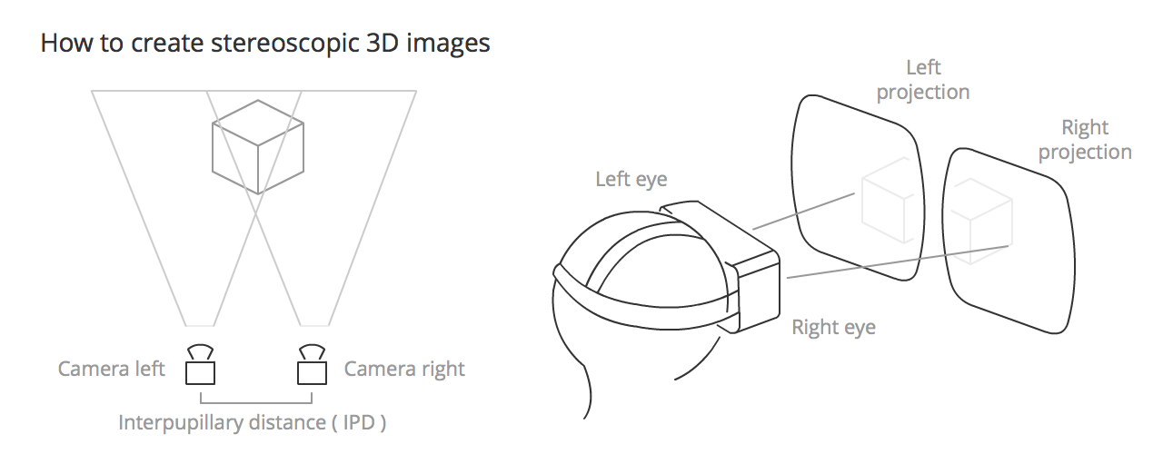
Figure 3. (MDN contributors, 2025) Schematic illustrating the creation of stereoscopic 3D images in a virtual reality head-mounted display.
To create the experience of depth, VR systems present slightly different images to each eye. This mimics how our eyes naturally perceive depth through binocular disparity Palusova (2023). Because the displays are positioned close to the eyes, HMDs include lenses that assist with image convergence and correct geometric distortions. Modern VR headsets also provide a much wider field of view than standard displays, typically between 90 and 130 degrees horizontally (Angelov et al., 2020).

3.3 Color Characterization for VR HMDs
While traditional display characterization methods are well-established, extending these techniques to VR HMDs introduces new challenges such as special measurement apertures to mimic a pupil looking into the device and accounting for non-uniformities of the display. There are no such standard approaches to color characterize VR HMDs, particularly those that make use of real-time rendering engines such as Unreal Engine or Unity to display a virtual environment. In game engines, materials can be rendered using either Lit or Unlit shaders. Lit shaders simulate physically based light interactions, meaning the appearance of an object depends on both its material properties and the lighting environment. Unlit shaders, on the other hand, display objects at fixed RGB values regardless of scene illumination, effectively treating them as emissive surfaces. This distinction is especially important for visual psychophysics, where experiments may rely on stimuli appearance changes under different lighting conditions. Recent efforts have focused on establishing a reliable mapping between the RGB values used in rendering engines and the corresponding XYZ tristimulus values measured by colorimeters, to linearize and characterize the VR display pipeline.
Some efforts to characterize VR HMDs focus primarily on display calibration for content production rather than for perceptual experiments. Pouli et al. (2018) developed a workflow for calibrating devices such as the Oculus Rift, HTC Vive, and Samsung Gear VR using a piecewise linear EOTF and a 3×3 matrix to map RGB values to the sRGB color space. Their system used Unity and SDKs provided by OpenVR and Oculus to render patches directly to the display. This approach was sufficient for production-oriented calibration but did not account for how materials interact with light in realistic 3D environments, an essential aspect for studies involving human visual perception. Zaman et al. (2023) aimed to bridge this gap with a dual path rendering strategy. One path preserved Lit scene rendering for immersion, while the other displayed isolated visual stimuli using Unlit materials unaffected by lighting. This allowed simultaneous presentation of realistic lighting in the virtual environment and accurate colorimetry for chosen stimuli. However, like Pouli’s approach, their use of emissive shaders meant that stimuli did not interact with scene lighting, making the method unsuitable for experimental tasks such as color constancy, where lit shaders must be used to simulate changes in appearance due to varying lighting conditions.
More current research has focused on using Lit shaders to support psychophysical experiments that depend on realistic lighting conditions. Toscani et al. (2019) compared VR HMD behavior when controlling the headset through Psychtoolbox 3, MATLAB, and Unreal Engine 4. They demonstrated that the HMD could behave similarly to a standard monitor when Unreal’s post-processing routines (tone mapping, auto-exposure, etc.) were disabled. This allowed them to implement a standard characterization pipeline and control RGB output via reflectance parameters on 3D objects rendered with lit shaders and illuminated by a virtual light source. Their approach was later used in color constancy experiments by Gil Rodríguez et al. (2022).
Expanding on this methodology, Díaz-Barrancas et al. (2023) compared Lit and Unlit shaders in Unity and Unreal, using MATLAB-rendered patches as a reference. They found that Unreal’s Standard Lit shader produced the lowest color differences (ΔE00). In a more comprehensive follow-up study, Díaz-Barrancas et al. (2024) evaluated three HMDs (HTC Vive Pro Eye, Pimax 8K X DMAS, and Varjo Aero) and achieved ΔE00 values below 1 across all conditions. A key feature of their approach was the use of a MATLAB-to-Unreal TCP connection, which allowed the synchronized control of rendering RGB values and making spectral measurements. The characterization process involved aligning the measurement instrument to the center of the HMD using a target, disabling post-processing in the rendering engine to maintain linearity, and measuring primary and grayscale ramps to derive the display’s 3×3 primary matrix and LUTs. This framework was later adopted and validated in a color constancy experiment by Díaz-Barrancas et al. (2024), demonstrating its applicability for psychophysical research in VR environments. The authors have also made their implementation publicly available via GitHub, supporting reproducibility and further research. Due to the availability of the source code and documentation for this approach, we implemented this method for characterizing our own VR HMD. In the next section, we will detail precisely how we achieved this along with other details about our setup and experimental methods.

Chapter 4: Methods
In this section, we present the color characterization procedures, setup, and the experiments we conducted to measure color constancy. We used a Konica Minolta CS2000 spectrophotometer with a VR aperture to characterize a virtual scene rendered in Unreal Engine and displayed it on a VIVE XR Elite VR HMD and a Dell UltraSharp 27 4K PremiereColor Monitor. In the experiment, participants used the method of adjustment to change the color of a stimulus to appear achromatic under various illuminants within a virtual scene. The same experiment was repeated in both the VR HMD and the monitor, which we will refer to as the “VR” and “Flat” conditions.

4.1 Participants
A total of 42 participants were recruited from the Munsell Color Science Laboratory and the undergraduate and graduate student population at Rochester Institute of Technology. The mean age was 24 years (SD = 5.2), with an age range of 18 to 38 years. The sample included 18 males, 22 females, and 2 non-binary individuals. Ethnic self-identification was as follows: 19 White, 2 Hispanic, 12 Asian, 2 Black, 3 Multiracial, and 4 who identified as Other or preferred not to respond. Some participants received course credit through the SONA system as compensation. Seven participants were excluded from the final analysis: two due to self-reported red-green color blindness, one who did not complete a full session, three who were naïve observers and did not appear to understand the task based on experimenter observation and performance patterns, and one whose data was identified as an outlier, falling more than three standard deviations from the mean across key measures. This resulted in a final sample of 35 participants included in the data analysis. The primary experimenter completed CITI training, and the study was approved by the Human Research Subjects Office (HRSO) at RIT.

4.2 Stimuli

4.2.1 Virtual Environment
Our scene was modeled in Unreal Engine 4.27 (Epic Games Inc, 2021) and consisted of a realistic room environment with a table at the center, chairs, and silverware. The scene was rendered using Unreal’s Default Lit shader. On the table, there were multiple 3D models of fruits and vegetables (tomato, cucumber, plum, banana) comprising primarily of their four typical hues (red, green, blue, and yellow, respectively). The target stimulus that participants adjusted was located at the center of the table, surrounded by these reference objects. The objects were positioned around the table to correspond with the directions in which participants adjusted color. For example, the tomato (representing red) was placed on the right side of the table, matching the direction a participant would move the controller to make the color of the target stimulus appear redder. We also incorporated realistic textures, such as wood grain for the table, specular wood tiles for the floor, and patterned wallpaper for the walls. All 3D models and textures were freely downloaded from Fab, Epic Games’ open marketplace and library for digital assets (Fab.Com, 2024).
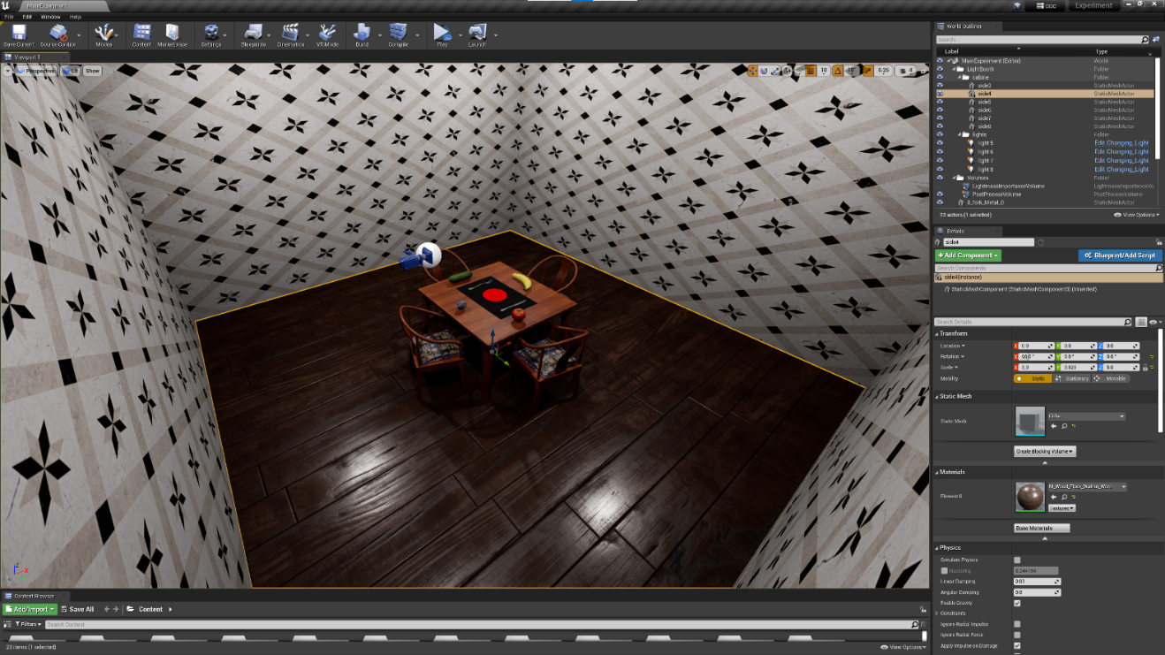
Figure 4. Unreal Engine screenshot showing a preview of the experimental 3D environment.
For the lighting we used a total of four point light sources, which emit light equally in all directions, located near the corners of the room to provide uniform illumination around the scene. A Lightmass Importance Volume was also placed around the table in the scene. This makes use of Unreal’s photon mapping algorithm, which precomputes light interactions by tracing photons and storing them in lightmaps. This reduces real-time rendering costs while maintaining realistic lighting, with smoother noise patterns compared to pure Monte Carlo ray tracing (Gil Rodríguez et al., 2024).
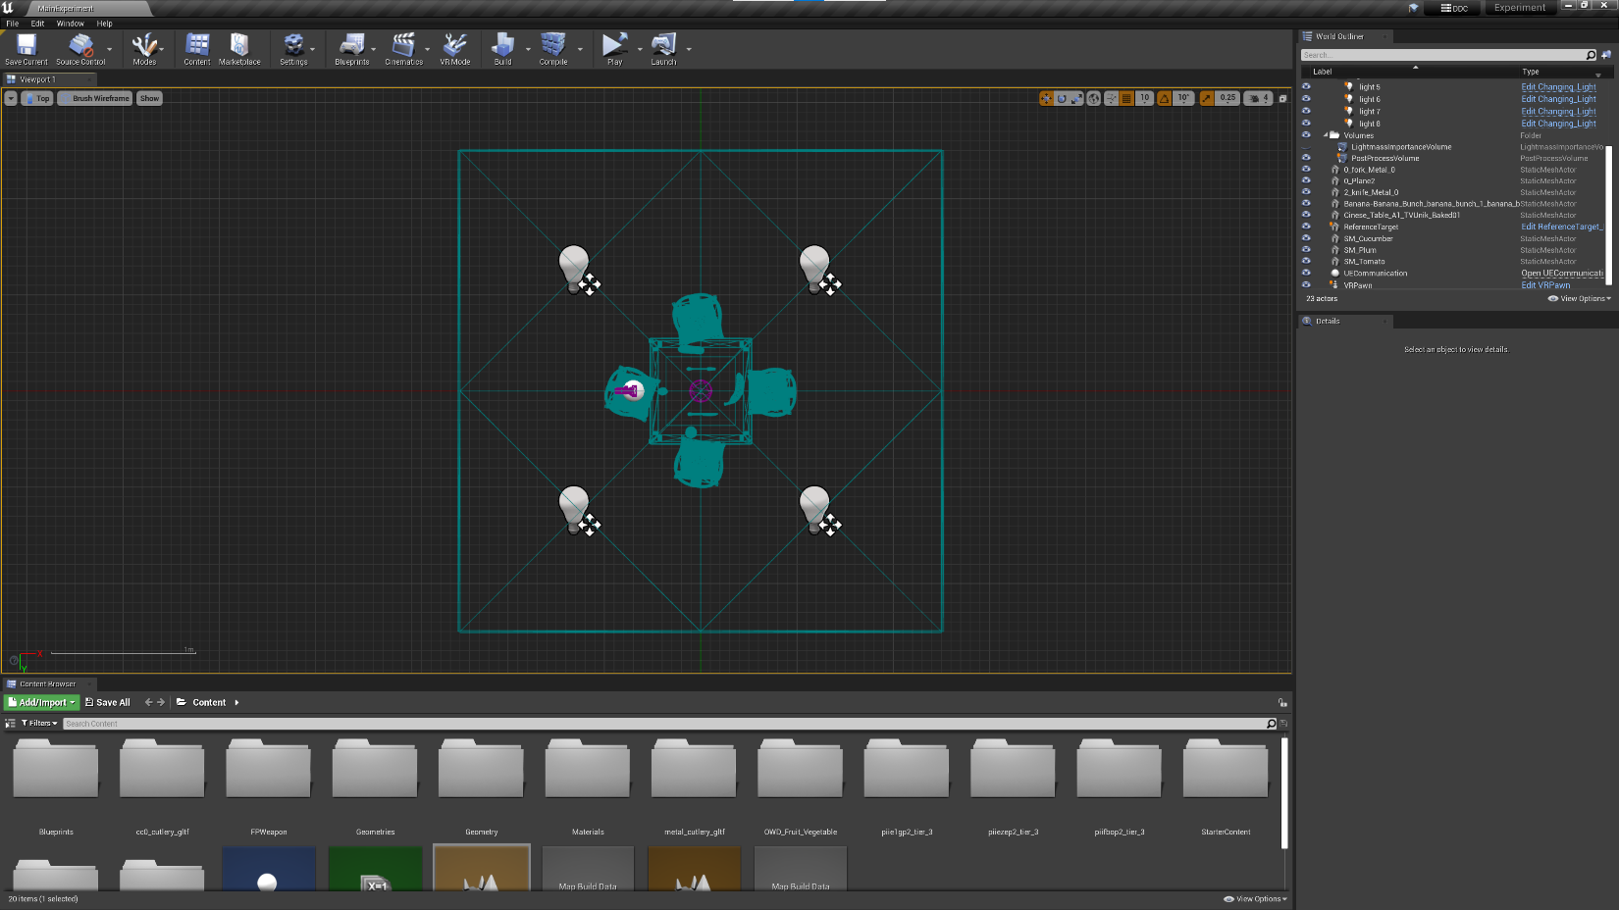
Figure 5. Top, wireframe view of the experimental scene with four point lights equally spaced.
Our goal was to create a naturalistic scene while also limiting the number of achromatic objects with similar lightness to the main stimulus, preventing participants from directly matching their adjustments to them. Fruits and vegetables were chosen as a reference to further provide cues of natural stimuli and memory colors, as they may increase color constancy (Olkkonen et al., 2008).

4.2.2 Target Stimulus
The stimulus that participants adjusted was a circular object positioned on the table in the scene, subtending roughly 10 degrees of visual angle from the observer’s viewpoint. This was estimated by panning a spectrophotometer with an internal aperture of 1-degree across the diameter of the stimulus. In Unreal Engine, the material properties were set to a roughness factor of 1 and a specular factor of 0. This prevented variations in color appearance based on the viewing angle, ensuring that the perceived color remained constant across all perspectives. The same object was used for color characterization measurements for both display modes. Moving forward, we will refer to the target stimulus as the “target.”
Directly behind the target, we placed a rectangular achromatic and textured background. This ensured that the stimulus had a constant background while preventing the wood color of the table from influencing adaptation. The texture served as a noise pattern to discourage participants from matching the stimulus directly to the background. We also set its lightness to be darker than the target, with an L* value of approximately 20 under the white illuminant.
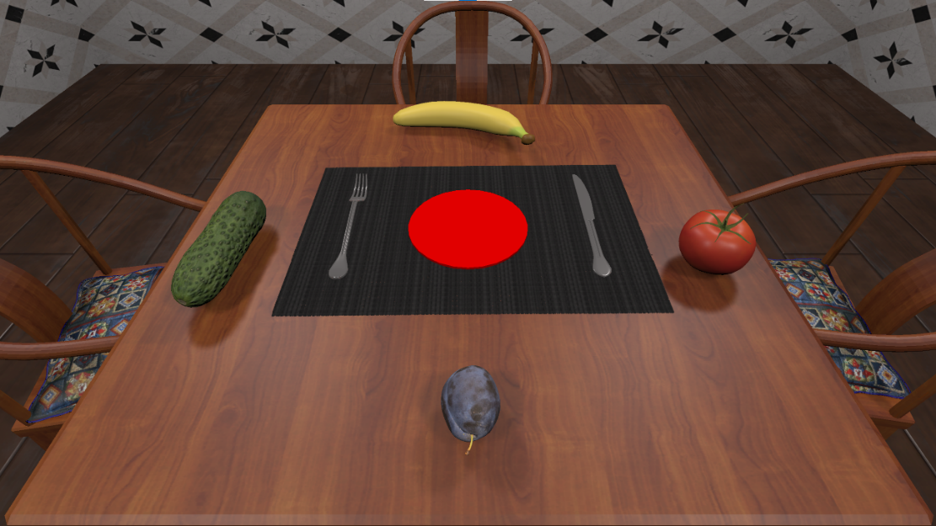
Figure 6. Experimental scene as seen from the point of view of the participant in Flat mode. The target is the circular red patch in the center (red color is for illustration purposes only).

4.2.3 Illuminants
We rendered each scene under five illuminants, following Aston et al. (2019). Three illuminants were along the Planckian locus (neutral, blue, and yellow), while two were orthogonal (red and green). Table 1 lists their CIE xy chromaticities along with measured values from a spectroradiometer for both the VR and Flat modes.

Illuminant | Aim (x, y) | Display Condition | ΔMeas (x, y) | Meas Luminance (cd/m^2)
White | 0.312, 0.329 | VR | 0.002, 0.001 | 68.78
 |  | Flat | 0, 0.003 | 71.43
Red | 0.32, 0.26 | VR | 0.001, 0.002 | 44.52
 |  | Flat | 0.001, 0.002 | 45.33
Green | 0.30, 0.38 | VR | 0.003, 0.001 | 63.84
 |  | Flat | 0.005, 0.004 | 66.39
Blue | 0.25, 0.26 | VR | 0.001, 0.001 | 40.56
 |  | Flat | 0.002, 0.001 | 41.51
Yellow | 0.39, 0.39 | VR | 0, 0.003 | 49.38
 |  | Flat | 0.002, 0.003 | 51.60
Table 1. Illuminant aim chromaticities, absolute (x, y) deviations from the aim, and measured luminance values for both VR and Flat display conditions. Chromaticities were measured by setting the target reflectance parameter to white (RGB = [1, 1, 1]) and treating it as a perfectly diffuse reflector of the scene's illumination.
Since Unreal Engine requires color values to be specified in RGB, we converted the aim illuminant chromaticities to CIE xyY using a reference luminance of 100 cd/m² for Y, then transformed them to sRGB using the standard sRGB matrix transform (IEC, 1999). To measure the illuminant chromaticities, we set the patch in the scene to have a reflectance of 1.0 across all RGB channels, simulating a perfect diffuse reflector. The color parameter of the light actors in Unreal were assigned the computed RGB values from the previous step and we then measured the chromaticity of the patch under each illuminant. While the measured illuminants were very close to the aim illuminant chromaticities, a few required minor adjustments. These were refined through an iterative process in which the RGB values were slightly modified, and the target was re-measured after each adjustment. This was repeated until the measured chromaticities closely matched the aim. Figure 7 presents a chromaticity plot of the illuminants as measured in both the VR and Flat modes, along with their respective display gamuts. Figure 8 depicts the scene rendered under each of the five illuminants.
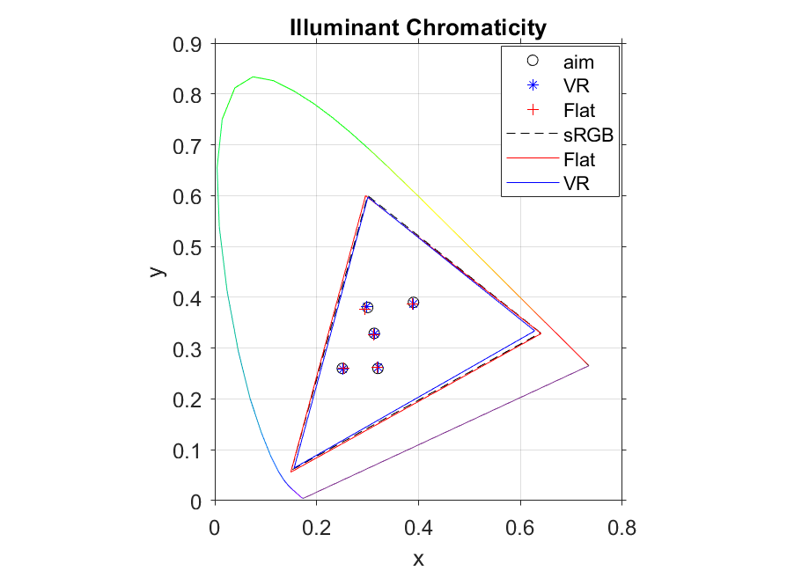
Figure 7. Chromaticity plot of aim illuminant chromaticities (black circle) and measured chromaticities of illuminants using VR (blue asterisk) and Flat (red cross) displays. Display gamuts are shown for VR (blue line) and Flat (red line) displays as well as sRGB gamut (black dotted).
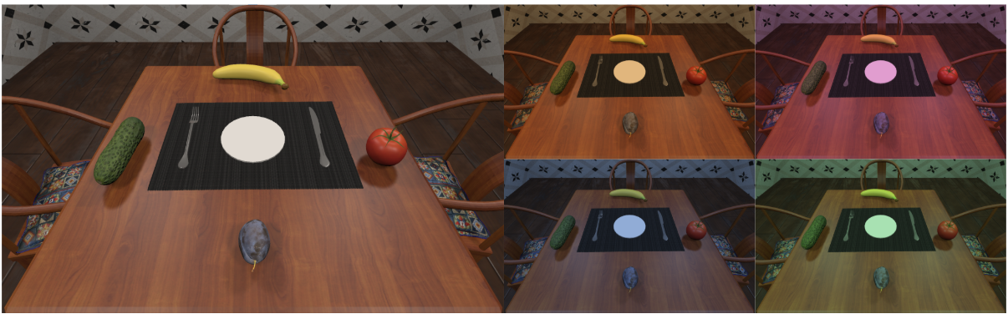
Figure 8. Experiment scene rendered under each of the five illuminants: white (left), yellow (top left), red (top right), blue (bottom left), and green (bottom right).

4.3 Color Characterization
Our experiment required color characterization of both a VR HMD and a flat panel display to ensure accurate colorimetric values for the stimuli given display-dependent RGBs. We used a VIVE XR Elite and a Dell UltraSharp 27 4K PremiereColor Monitor. Rather than characterizing the displays’ native color reproduction, we aimed to characterize the entire color pipeline within Unreal Engine. This was necessary to model how lighting changes in Unreal would affect a simulated reflective object inside the engine. In this case, the characterization depended on the scene’s lighting, geometry, and the radiometric properties of object interactions within the environment. Since we used Unreal’s Default Lit shaders for characterization, the results were strongly influenced by lighting conditions. Because these shaders dynamically respond to lighting, any changes to the scene could significantly impact the characterization.
To change the color of the patch for the characterization, we adjusted its reflectance RGB parameter within Unreal and measured the output under all illuminants. The remaining characterization process followed the approach described in M. Fairchild & Wyble (1998). We used a Konica Minolta CS-2000 spectroradiometer controlled by a MATLAB (The MathWorks Inc., 2024) script to measure gray, red, green, and blue RGB ramps in 16 steps from 0 to 1 under each scene illumination. For measurements with the VR HMD, we used a VR aperture attachment on the lens for more accurate measurements. Using the measured XYZ values of the display primaries, we constructed a primary matrix. The gray ramp was used to derive the electro-optical transfer function (EOTF), which we applied as three 1-D lookup tables (LUTs) to convert reflectance parameters to output luminance. This resulted in a display model for each of the five illuminants, capable of both forward (RGB to XYZ) and backward (XYZ to RGB) transformations. This procedure was repeated for both display modes.
To validate the models, we tested 125 equally spaced RGB values within the display gamut using a 5 × 5 × 5 grid, along with 99 near-achromatic values for a total of 224 validation colors. The 99 near-achromatic values were generated in CIELAB space by varying a* and b* from −20 to 20 in steps of 2, at three lightness levels (L* = 40, 60, 80). These CIELAB values were then converted to XYZ and then to RGB using the sRGB whitepoint and transformation matrix. The forward model was used to convert RGB values to predicted XYZs, which were then compared to actual XYZ measurements taken with the spectroradiometer. We performed a color difference analysis between the measured and predicted values using ΔE00 (CIE, 2001), which required converting XYZ values to CIELAB using the appropriate whitepoint for each illuminant condition.
For our experiment, we used these models to generate CIELAB grids that the program used to adjust the patch color in response to participant key presses under each illuminant. The grids’ size was determined such that they covered the entire distance between the corresponding chromatic illuminant and the white illuminant in chromaticity space. An example of the adjustment grids for each illuminant for the L* 55 lightness level are shown in u’v’ chromaticity in Figure 9.
Figure 9. Illuminant adjustment grids in CIE 1976 (u’, v’) chromaticity space for each chromatic illuminant (Red, Green, Blue, and Yellow). Each open circle represents a grid step corresponding to a 2-step shift in CIE a*b* space. The colored squares indicate the chromatic illuminants, while the white square indicates the white illuminant. These grids were used to define the adjustment range for achromatic matching under each illuminant.
As additional verification, we tested the accuracy of the models when converting from the aim CIELAB values (used in the grids) to the predicted RGB values sent to Unreal. First, we selected 30 random points in the grids for each illuminant and used the backward model to calculate RGBs. Then, we set the patch to the predicted RGB values and measured the resulting XYZs. The verification was a ΔE00 color difference computed between the measured CIELAB values (converted from XYZs) and the target CIELAB values. Since this process introduced an additional conversion step, we expected a larger color difference error due to accumulated computational approximations. Figure 10 shows a flowchart of the verification methods for the forward and backward models.
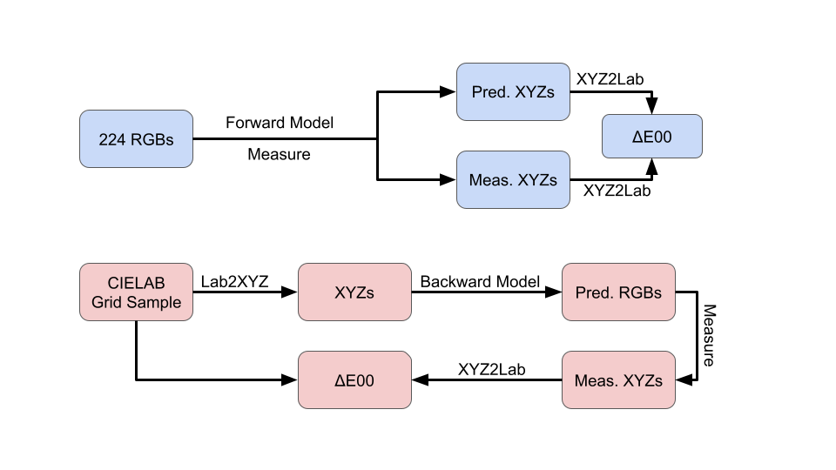
Figure 10. Flowchart detailing the two verification methods of the characterization model. Top (blue) describes the verification of the forward model using a sample of 224 RGB values. Bottom (red) describes the verification of the backward model using a sample 30 points for each of the CIELAB adjustment grids.

4.3.1 VR HMD Characterization
To setup the VR characterization, we followed the method described in Díaz-Barrancas et al. (2024), "High-fidelity color characterization in virtual reality across head-mounted displays, game engines, and materials." Their study provides a GitHub repository containing code for characterizing VR Head-Mounted Displays using both Unity and Unreal Engine across various VR devices. We used their code as a template for our characterization of the VIVE XR Elite. Their method relies on a function that establishes a TCP connection between Unreal Engine and MATLAB, allowing automated control over the patch color by setting specific RGB values and measuring the resulting output. We implemented this function in our finalized scene, ensuring that all post-processing effects were disabled via an unbounded post-processing volume in Unreal. Disabling post-processing allowed us to confirm a near-linear relationship between reflectance values and output luminance when measuring primary and gray ramps (see Figure 11).
Figure 11. Measured primary and gray ramps under the white illuminant for the VR HMD.
To measure the VR HMD, we placed the CS-2000 as close to the right lens as possible and we also attached a VR aperture to the front of the spectrophotometer (Figure 12). The aperture had a 4 mm diameter, closely matching the size of a human pupil. This ensured more accurate luminance measurements corresponding to what the observer perceived. Díaz-Barrancas et al. (2024) also provided a calibration scene in Unreal designed to help center the measurement pupil of the spectroradiometer with the VR HMD. This scene consisted of black and white concentric circles resembling a bullseye target. We first displayed this scene on the VR HMD to align the instrument’s pupil to the center of the target before taking any measurements. This step was important due to the non-uniformity of off-center measurements and ensured that we consistently measured the same spot each time.
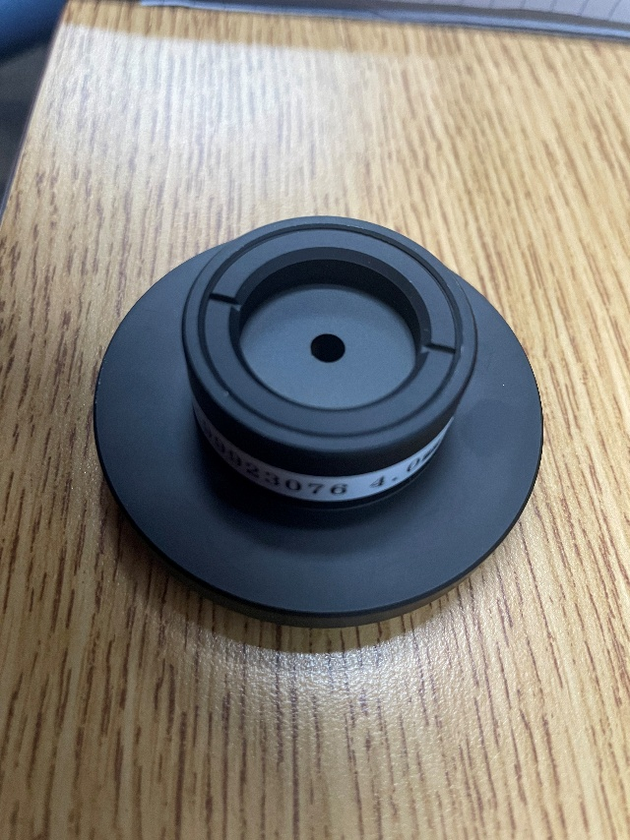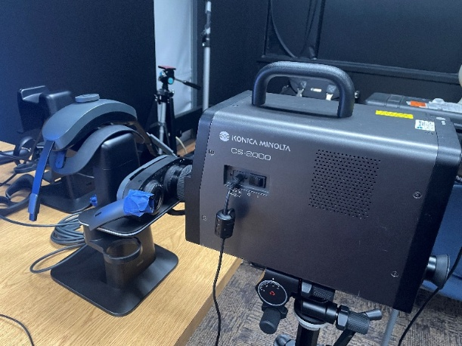
Figure 12. Photo of VR aperture attachment to CS2000 spectrophotometer (left). Measurement setup (right).
However, the reduction of light going into the instrument resulted in very slow measurements. Since our characterization and verification required hundreds of measurements, we first conducted all measurements without the VR aperture. We then measured a gray ramp with the VR aperture and derived a correction factor by comparing these measurements to the same gray ramp without the VR aperture. Since the aperture primarily affected the overall luminance magnitude (Figure 13), we concluded the difference between the two ramps could be modeled as a scaling factor to the slope of the ramp. To determine this factor, we used MATLAB’s fminsearch to minimize the sum of squared errors (SSE) between the gray ramp measured without and with the aperture. The optimal factor (1.62) was the one that minimized the SSE. Once derived, we applied this correction factor to all measurements taken without the aperture, allowing us to approximate the results we would have obtained with the aperture, but without the excessive measurement time.
Figure 13. Gray ramp luminance measurements with and without VR aperture. The corrected measurements taken without VR aperture multiplied by the correction factor are also shown.
Our model performed well in the validation of the forward model (Figure 14), but we aimed to reduce ΔE00 color differences as much as possible, ideally below 1, since a ΔE00 below 1 is generally considered imperceptible to the human eye (Sharma et al., 2005). To achieve this, we applied an optimization method based on Day et al. (2004), using MATLAB’s fminsearch function to minimize the average ΔE00 across all the validation colors. This was done by adjusting the coefficients of the 3×3 primary matrix and dynamically recalculating the LUTs at each iteration. As a result, the overall ΔE00 error decreased, improving model accuracy. Figure 14 (bottom) shows the optimized model results for the white illuminant. The mean, minimum, and maximum ΔE00 for all the illuminants is shown in Table 2.
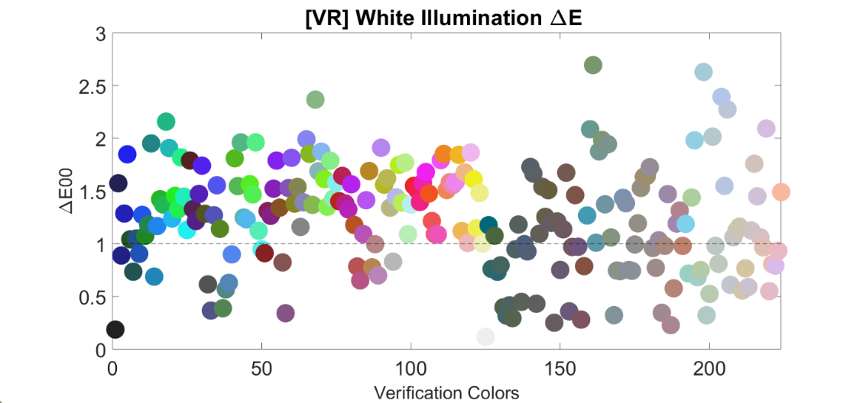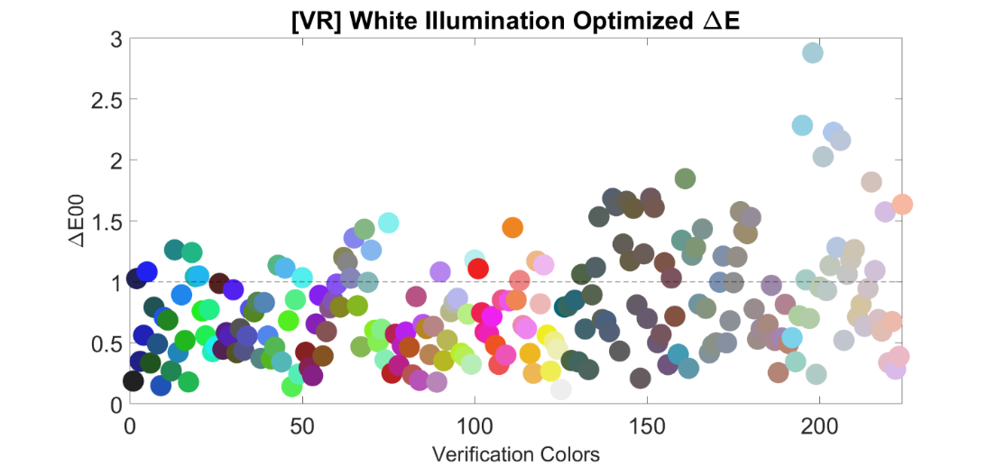
Figure 14. VR mode ΔE00 color difference values for the 224 verification colors before optimization (top) and after (bottom) under the white illuminant for the VR HMD.
Average ΔE00 | White | Red | Green | Blue | Yellow
Before | 1.24 | 1.22 | 1.45 | 1.28 | 1.68
Optimized | 0.80 | 0.85 | 0.89 | 0.75 | 1.02
Table 2. Average ΔE00 values for the verification colors for each of the illuminants before and after model optimization.
In the case of backward model validation using the CIELAB grids, the models exhibited higher errors (Figure 15). This could be due to the additional computation required to convert the aim CIELAB values to XYZ, which was not explicitly accounted for in the original model. Also, the quantization in 8-bit linear RGB space has limitations on how closely these colors can be reproduced. Another possible factor is the use of near-neutral colors, as the human visual system is more sensitive to small color differences in low chroma regions compared to highly chromatic colors (MacAdam, 1942). However, this was not a major concern since we primarily used the forward model to predict XYZ data from participant-selected RGB values in the experiment. From Table X we can see that the average ΔE00 for the optimized forward model predicted XYZs and measured XYZs was at or below 1 under all the illuminants, which included 99 near-achromatic colors. Even if the CIELAB grids were not perfectly centered, they still covered a sufficient chromaticity range, allowing participants to adjust colors freely without feeling constrained by the grid edges. Table 3 shows the mean, minimum, and maximum ΔE00 for the rest of the illuminants for the backward model verification.
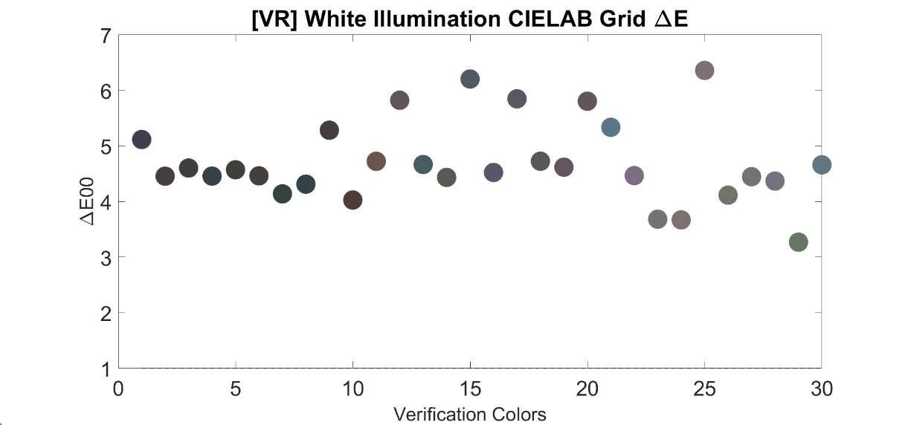
Figure 15. VR mode ΔE00 color differences for the 30 randomly selected points in the CIELAB grids for the white illuminant.

[VR] CIELAB Grid ΔE00 | White | Red | Green | Blue | Yellow
Minimum | 3.27 | 2.19 | 2.54 | 1.66 | 2.52
Average | 4.70 | 3.45 | 3.64 | 2.77 | 4.08
Maximum | 6.35 | 4.80 | 5.30 | 3.96 | 6.54
Table 3. Average, minimum, and maximum ΔE00 color difference for the randomly selected points in the CIELAB grids for each illuminant.

4.3.2 Flat-Panel Display Characterization
For the flat panel display, we followed the same methodology as in the previous section, but instead of the VR HMD, we displayed the scene on a Dell PremierColor monitor. We again used the CS-2000 spectroradiometer to measure the primary and gray ramps as well as the 224 verification patches. The spectrophotometer was positioned at the same viewing distance as the participants in the experiment and was centered on the patch in the virtual scene. The ramps (Figure 16) showed approximately linear behavior as before.
Figure 16. Measured primary and gray ramps under the white illuminant for the Flat-panel display.
Figure 17 shows the ΔE00 verification for the forward model. The results indicate that the optimization step was not necessary for this display mode, as the model already performed well, with most ΔE values below 1.
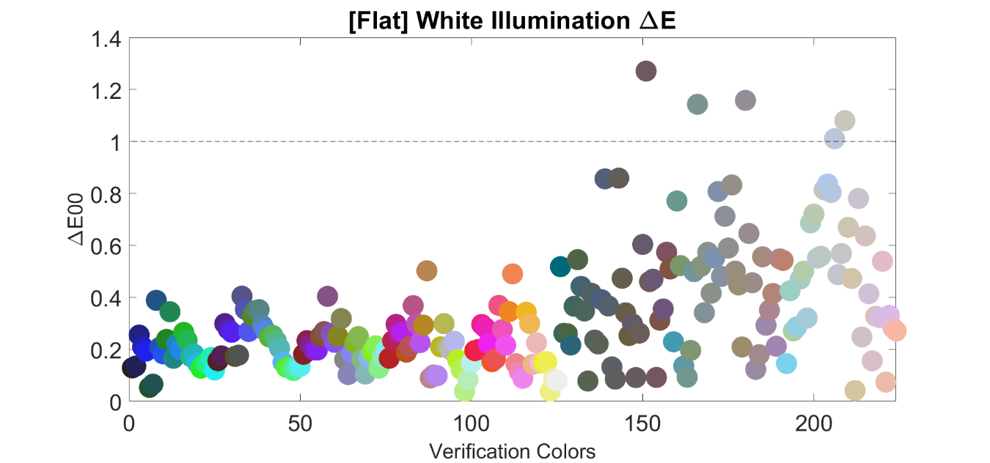
Figure 17. Flat mode ΔE00 color difference values for the 224 verification colors under the white illuminant.
For the backward model verification (Figure 18), errors also remained low, with ΔE values under 1. Table 4 summarizes the average, minimum, and maximum ΔE values across the different illuminants.
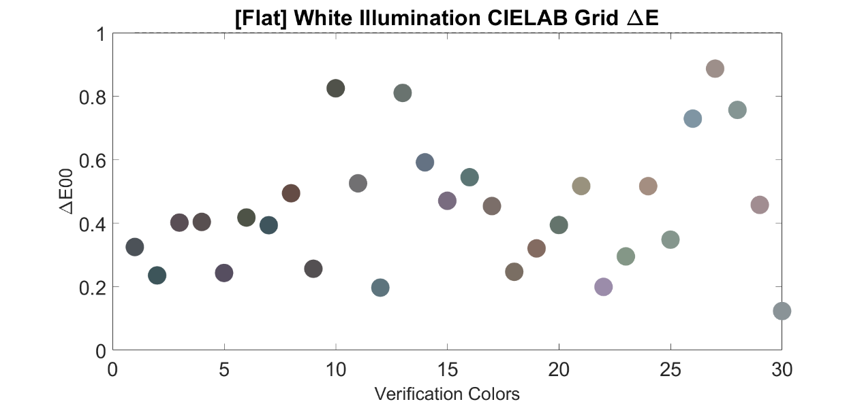
Figure 18. Flat mode ΔE00 color differences for the 30 randomly selected points in the CIELAB grids for the white illuminant.
[Flat] CIELAB Grid ΔE00 | White | Red | Green | Blue | Yellow
Minimum | 0.12 | 0.24 | 0.12 | 0.12 | 0.13
Average | 0.45 | 0.56 | 0.67 | 0.67 | 0.52
Maximum | 0.89 | 1.02 | 1.63 | 1.63 | 1.28
Table 4. Average, minimum, and maximum ΔE00 color difference for the randomly selected points in the CIELAB grids for each illuminant.

4.4 Apparatus
There were two separate display conditions: VR and Flat. In the VR condition, participants viewed the virtual environment on a VIVE XR Elite HMD. The target subtended approximately 10 degrees of visual angle from the center of the scene. During the experiment, participants were able to freely move their head around to look around the entire scene. For the Flat condition, the virtual environment was viewed on a 27-inch 4K Dell PremierColor Monitor. Participants were seated 20 inches away from the screen to ensure that the target matched in visual degrees the as the VR setup. The display height was adjusted so that participants could look straight at the patch without tilting their heads, and the viewing angle was fixed. The lights in the room were turned off so the room was completely dark except for the display light. A photo of the Flat condition and a screenshot of the VR scene are shown in Figure 19.
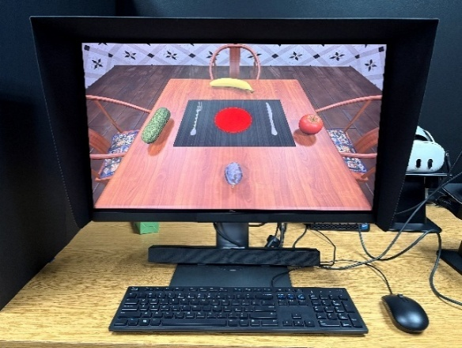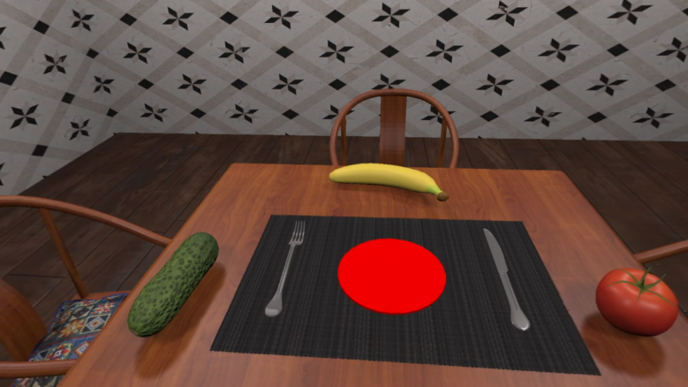
Figure 19. Flat (left) and VR (right) display conditions.
Participants were able to adjust the target stimulus color using an 8Bitdo Micro Bluetooth Mini Controller (Figure 20). Adjustments were made in four directions using the controller keys on the left-hand side (up, down, left, right). They entered their final selection using any of the buttons on the right-hand side of the controller. The controller was particularly useful in the VR condition due to being unable to simultaneously see a keyboard outside of the headset.
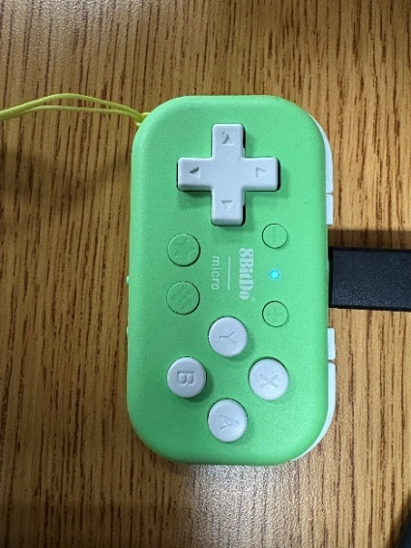
Figure 20. 8Bitdo Micro Bluetooth Mini Controller used to adjust the stimulus in the experiment.

4.5 Experiment Procedure
Before beginning the experiment, participants read and signed a consent form and completed the Ishihara color vision test (Ishihara, 2004) to screen for color blindness. Each participant completed both the VR and Flat display versions of the experiment. For the VR condition, we used the VIVE XR Elite, which allows for adjustments to both diopter and interpupillary distance (IPD). Prior to starting the VR session, participants were instructed to adjust the IPD to match their eye spacing and, if they wore corrective lenses, to adjust the diopter settings until the image appeared sharp. The order of which condition was completed first was counterbalanced across participants so we could determine whether starting one or the other first influenced adaptation. In the experiment, participants completed trials under five illuminants (white, red, green, blue, yellow), three target lightness levels (L* = 40, 55, 70), and two display conditions (VR, Flat). Since L* depends on the reference white, the white point used for calculating L* was the white point of the illumination under which the scene was rendered.
In the experiment, participants were asked to adjust the target until it appeared achromatic or without any hue. While we acknowledge that this type of task (appearance match) tends to yield lower color constancy indices compared to “same paper” matching tasks, it was more intuitive and easier for participants to understand. Adjustments were made using a controller: the left and right keys moved along the a* axis and the up and down keys moved along the b* axis in CIELAB space. They were reminded of the color directions by the placement of the fruits in the scene. For each trial, the RGB values corresponding to the participant's final achromatic match were recorded and later converted to XYZ values using the forward display models for subsequent analysis.
For either display condition, the experiment always began with the scene rendered under the white illumination. This choice was made practically since it helped familiarize participants with the task, and because the white illuminant always served as our reference for calculating constancy under each of the chromatic illuminants. At the start of the white illuminant block, participants underwent a two-minute adaptation period, during which they were free to look around the scene. Several studies have shown that chromatic adaptation to a scene is almost complete (up to approximately 90–95%) after about 1 to 2 min and that color appearance remains stable after this (M. D. Fairchild & Lennie, 1992; M. D. Fairchild & Reniff, 1995). We wanted to give ample time for participants to maximize their adaptation to the scene. In the VR condition, they could move their heads to explore the virtual room, while in the flat-panel condition, they were limited to moving their eyes across the screen. The start of the adaptation period was signaled by the target turning black and an audible beep, then a second beep marked the end of adaptation. Following this, the target changed to a random color sampled from the entire range of the CIELAB adjustment grid for the given lightness level and illuminant. Participants were instructed to adjust the color of the target until it appeared achromatic, or without hue. Adjustments were made using a controller, where left and right keys moved along the a* axis and up and down keys moved along the b* axis in CIELAB space. There was no time limit for their adjustments. The placement of colored fruit models (tomato, cucumber, plum, and banana) in the scene provided directional cues for the color directions. The target was presented at three different lightness levels (L* = 40, 55, 70), each repeated three times in randomized order, resulting in nine trials for the illuminant block. The RGB values corresponding to the achromatic match were recorded for each trial and later converted to XYZ values using the forward display models for later analysis.
Once all trials under the white illuminant were completed, the scene changed to one of the four chromatic illuminants (red, green, blue, yellow), randomly selected for each block. Before making matches in each chromatic block, participants underwent another two-minute adaptation period, following the same procedure as before. They then completed nine trials in that illuminant condition, again spanning the three lightness levels and repeated three times each. Since the experiment always began with a full white illuminant block, the first chromatic illuminant was always preceded by white. To ensure consistency, we interjected a single trial under the white illuminant that served to return participants to a neutral adaptation state before each new chromatic illuminant. This also prevented the order of the chromatic illuminants to influence the adaptation to the next illuminant. These trials included a 30-second adaptation period under the white illuminant followed by one trial at target lightness L* 55, which was excluded from analysis. We used a shorter adaptation period here because these trials were not part of the main dataset, and we wanted to limit the overall experiment duration while still allowing for sufficient adaptation to neutral. Participants then continued the same procedure for the remaining randomly selected chromatic illuminants. Figure 21 shows a diagram detailing the flow of the experiment.
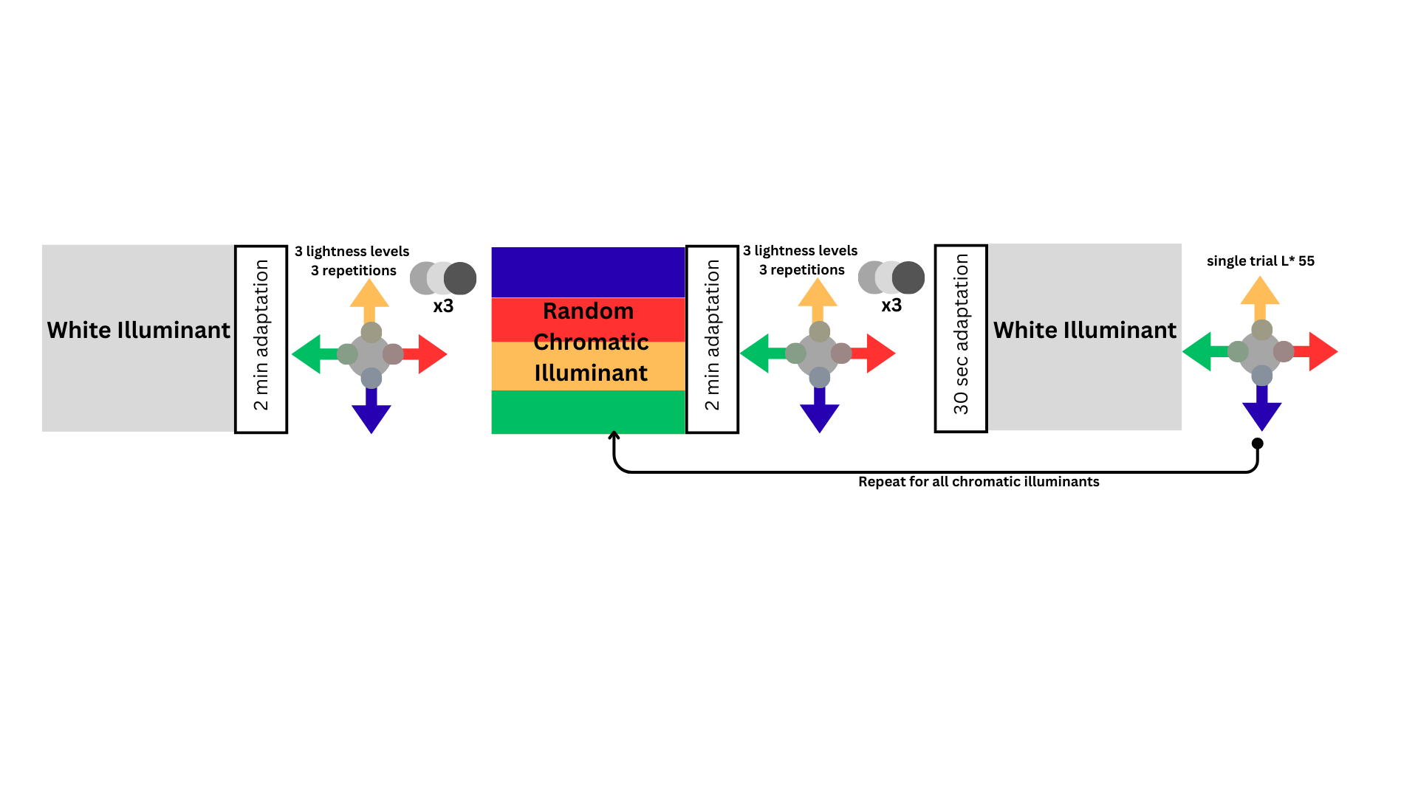
Figure 21. Schematic of the experimental procedure. Participants first adapted to the white illuminant for 2 minutes before completing adjustment trials at three lightness levels (L* = 40, 55, 70), with three repetitions per level. Next, they adapted under a randomly assigned chromatic illuminant (red, green, blue, or yellow). For each chromatic illuminant, the same adjustment procedure was repeated. After completing a chromatic block, participants adapted to the white illuminant for 30 seconds, followed by an additional trial under white with a single adjustment at L* = 55. This sequence was repeated for all four chromatic illuminants.
In total, there were 45 trials (3 target lightness x 3 repetitions x 5 illuminants) plus 3 interjected white trials between the chromatic illuminants for a total of 48 trials. Participants repeated the same experiment in both the VR HMD and Flat conditions, for a total of 96 trials which took approximately 60 minutes. After the experiment, participants were asked to complete a short survey to collect demographic information.

4.6 Data Analysis
To evaluate color constancy, we compared the achromatic selections made by observers under the white illuminant to their selections under each chromatic illuminant. First, the RGBs of the achromatic responses were converted to XYZs using the corresponding display model. Then, we converted the XYZs to chromaticity in the CIE u’v’ color space. We chose u’v’ for its greater perceptual uniformity than CIE xy (ISO/CIE, 2016). Lastly, we computed a color constancy index (CI) that quantifies the degree of constancy, where a higher index indicates more adaptation to the illuminant. Computing the CI consisted of three main steps: recentering the data, projecting the data onto the illuminant line, and using the projected data to calculate the ratio of change in observer selections to the illuminant change.

4.6.1 Recentering
Due to the nature of the achromatic adjustment task, individual observer differences in what appears achromatic under the white illuminant can occur. For instance, one observer may perceive a different chromaticity as achromatic under the white illuminant compared to another observer. To focus on the magnitude of the achromatic shifts under different illuminants rather than perceptual differences between observers, we applied a recentering procedure to normalize the data. This simulates how each observer’s responses to the chromatic illuminants would appear if their response under the white illuminant matched the exact chromaticity of that illuminant (D65). Recentered data allowed us to more clearly interpret participants’ responses under the chromatic illuminants by removing individual differences in their perception of achromatic under white, making it easier to compare results across participants.
We applied the recentering method described by Brainard (1998), which is based on the von Kries hypothesis (von Kries, 1902), which assumes that the primary effect of illuminant changes can be modeled as a gain applied to the three cone signals. The recentering process involves deriving a diagonal transformation matrix, 𝐷, from the LMS cone responses of the observer and using it to calculate the recentered chromatic response. Specifically, 𝐷 is computed as the element-wise ratio of the LMS responses under the chromatic and white illuminants (equation 10). The recentered chromatic response is then obtained by multiplying 𝐷 with the LMS of the reference illuminant, D65 (equation 11). The Smith-Pokorny Cone Fundamentals (Smith & Pokorny, 1975) were used to convert observers’ XYZ responses to LMS.
$$\begin{aligned}D= {{diag(LMS}_{C}}/{{LMS}_{w})} \#\left(10\right)\end{aligned}$$
$$\begin{aligned}{LMS}_{recenter}=D* {LMS}_{D65} \#\left(11\right)\end{aligned}$$
This transformation is repeated for all responses under the chromatic illuminants, ensuring that the entire dataset is consistently shifted. Figure 22 shows an example of the recentering procedure for an example observer’s data.
Figure 22. Example observer achromatic responses under the white illuminant (white circle) are recentered to the chromaticity of the white illuminant (white square). Then, observer responses under the chromatic illuminant (red unfilled circle) are shifted (red filled circle) accordingly.

4.6.2 Correcting for Off-Illuminant Line Responses
While the recentering procedure normalized the data, it did not guarantee that all chromatic responses would lie on the line connecting the white and chromatic illuminants. Since participants selected chromaticities on a 2D grid, some responses naturally fell off the illuminant line, and the recentering process could further shift previously on-line responses slightly off-line. Brainard (1998) acknowledged this limitation in their constancy index equation, noting that “it behaves reasonably” only if the recentered response lies on the illuminant line. Additionally, reducing the data to a single constancy index meant losing information about how far responses were from the line. For instance, a response far from the white point but perpendicular to the illuminant line could still yield a high CI, which would be misleading. To account for these deviations, we applied a projection step to correct for off-line responses, as described by Olkkonen et al. (2008). In this step, we projected the recentered observer responses onto the illuminant line before computing the constancy index. We treated the vector from the white illuminant to the recentered chromaticity as the response vector $(r_{c}'-w)$ and the vector from the white illuminant to the chromatic illuminant as the illuminant vector $\left(c-w\right)$. We projected the response vector onto the illuminant vector to yield the projected response.
To further investigate the impact of off-line responses, we computed the $δ_{uv}$, representing the Euclidean distance between the recentered response and its projected counterpart on the illuminant line. This distance was positive if the recentered response fell clockwise of the illuminant line and negative if it was counterclockwise. By tracking $δ_{uv}$, we could assess whether there was a correlation between off-line responses and CI. Figure 23 shows an example of the projection and $δ_{uv}$ computations.
Figure 23. Example data showing the projection $(r_{c}''-w)$ of the response vector $(r_{c}'-w)$ onto the illuminant vector $\left(c-w\right)$. The $δ_{uv}$ is the distance from the recentered response to the projected response $\left(r_{c}'-r_{c}''\right)$.

4.6.3 Constancy Index Equation
In summary, for each participant, we first recentered their responses so that their achromatic selection under the white illuminant aligned with the chromaticity of D65. Next, we projected their achromatic responses under each chromatic illuminant onto the illuminant line and calculated the $δ_{uv}$, which measured the Euclidean distance between their recentered response and the projection. Finally, the constancy index (equation 12) was computed as the ratio of the magnitude of the projected response vector $(r_{c}''-w)$ to the length of the illuminant vector $\left(c-w\right)$.
$$\begin{aligned}CI= \frac{\left(c-w\right)⋅\left(r_{c}^{'}-w\right)}{{\left\|c-w\right\|}^{2}}=\frac{\left\|r_{c}^{''}-w\right\|}{\left\|c-w\right\|} \#\left(12\right)\end{aligned}$$
If the projected response under a chromatic illuminant matched the chromaticity of the white illuminant, this indicated zero constancy (CI = 0), meaning the observer did not adapt to the chromatic illuminant, and their perception of neutral remained unchanged from the white reference. On the other hand, if the projected response matched the chromaticity of the chromatic illuminant, it indicated perfect constancy (CI = 1), meaning the observer fully adapted and perceived the chromatic illuminant itself as neutral. A CI greater than 1 indicated that the observer’s response shifted beyond the chromatic illuminant, while a CI less than 1 indicated the observer’s response shifted the opposite direction beyond the white illuminant.

Chapter 5: Results
We conducted a series of analyses to address our primary research questions regarding color constancy in virtual environments. Specifically, we asked whether the extent of color constancy differs between display modes (VR and Flat), chromaticity of the illuminant (red, green, blue, yellow), and target lightness (L* = 40, 55, 70). To answer these questions, we compared constancy indices (CIs) computed from participants’ achromatic matches under each condition. Below, we report the results of these analyses, including effects of display mode, illuminant chromaticity, and target lightness, as well as interactions among these factors.

5.1 Participant Achromatic Responses
We began the analysis by examining the raw participant responses to assess the spread of distributions across illuminants and display conditions. This provided a quick check for any major biases or discrepancies in the data that might require closer attention during analysis. Figure 24 shows all participants’ achromatic responses for every trial in the VR and Flat conditions before recentering, with responses color-coded by illuminant. The distributions appear similar across both display conditions and illuminants.

Figure 24. Participant achromatic responses for every trial in the VR and Flat conditions, shown before recentering. Darker areas indicate a higher frequency of responses. The ellipses represent one standard deviation for each illuminant, with the average marked by a black X.
Since we intended to recenter all white responses to a single chromaticity for data normalization, we first verified that there were no significant differences across target lightness levels. To confirm this, we plotted the average responses for each lightness per participant under the white illuminant (Figure 25).
Figure 25. Participant achromatic responses under the white illuminant for VR and Flat conditions. Ellipses are one-standard deviation of the data for different lightness levels of L* 40 (red), L* 55 (green), and L* 70 (blue).
The figure shows no clear trend between lightness levels, though the responses between lightness levels seem to be slightly more variable under VR. Therefore, we recentered all responses to the same white illuminant (D65) without separating by lightness. Only the initial block for white illuminant in the experiment was used for recentering, while the intermediate white trials were excluded. These intermediate trials could be used in separate analyses to examine whether observers reset to white adaptation after each chromatic illuminant change. Figure 26 shows the data for all participants after recentering all their responses.
Figure 26. The recentered achromatic responses are shown for the VR and Flat conditions. The ellipses represent one standard deviation for each illuminant, with the average marked by a black X.
Next, we evaluated whether there were any statistically significant differences in CI between the two display conditions, illuminants, and target lightness levels.

5.2 Constancy Index Effects
We calculated the constancy index (CI) for all responses (after recentering and projecting) for each participant using Equation 3. We converted the CI variable into z-scores and considered responses +/- 3 standard deviations from the mean as outliers, which were removed prior to subsequent analyses (18/2574 observations removed). We then ran a repeated-measures ANOVA with display condition (Condition: VR vs. Flat), illuminant (Color: red, blue, green, yellow), and lightness of the achromatic patch (Lightness: L*=40, 55, 70) as within-subject variables. The dependent variable was constancy index (CI). To preface, we found no influence of which display condition participants took first on their CI results (p > 0.05).

5.2.1 Effect of Display Condition
The results showed a significant main effect of condition, F(1, 34) = 22.26, p < .001, indicating that CI was higher in VR (M = 0.569, SE = 0.010) than in Flat (M = 0.527, SE = 0.009). Figure 27 shows a violin plot of the CI distribution for the VR and Flat conditions. Both distributions have a similar shape and are normally distributed, but the mean CI is higher in VR. Although the difference is not large, it is statistically significant, suggesting that participants were, on average, more adapted to the environment when using the VR HMD than when viewing the Flat-panel display.
Figure 27. Constancy Index for VR and Flat display conditions, averaged over all illuminants and lightness levels. Lines show the average and standard error bars. Average constancy was higher for the VR than Flat display condition.

5.2.2 Effect of Illuminant Chromaticity
Next, we found a significant main effect of illuminant, F(3, 102) = 165.38, p < 0.001, indicating that CI varied across illuminants. CI was highest under the green illuminant (M = 0.620, SE = 0.015), followed by yellow (M = 0.554, SE = 0.014), blue (M = 0.532, SE = 0.019), and red (M = 0.485, SE = 0.012). All pairwise comparisons between illuminants were significant (ps < 0.012), except for blue versus yellow (p = 0.386). Figure 28 shows a violin plot of the CI distributions for the different illuminants, averaged across both display conditions and lightness levels.
Figure 28. Constancy Index for each illuminant, averaged over display conditions and lightness levels. Markers show the average for each distribution along with standard error bars. Average constancy was highest for green, lowest for red, and similar for the blue and yellow illuminants.
We can see that the distributions for each illuminant are roughly normally distributed, though the blue and yellow illuminants show a wider spread compared to the red and green. This means that perhaps there was a greater variability in the participant responses under the blue and yellow illuminants. From figure 28, we can also compare the illuminants along the Planckian axis with those perpendicular to it. The blue and yellow illuminants had nearly identical CI means, while the red and green illuminants showed the highest and lowest values, respectively.

5.2.3 Effect of Target Lightness
Thirdly, we found that there was a significant main effect of lightness, F(2, 68) = 13.69, p < 0.001, indicating that CI was lower for lightness L* 70 (M = 0.528, SE = 0.010), than for both lightness L* 55 (M = 0.554, SE = 0.010) and L* 40 (M = 0.561, SE = 0.008). Figure 29 shows the CI distribution for each lightness level averaged across both conditions and illuminants.
Figure 29. Constancy Index for each lightness level, averaged over display conditions and illuminants. Markers show the average for each distribution along with standard error bars.
The CI differences per lightness level, while relatively small, suggest that participants may have had more difficulty adapting to the chromatic illuminants when judging the lighter target. However, the effect of lightness on CI suggests that higher lightness may lead to lower adaptation. There is limited evidence supporting this from previous literature, and potential speculative explanations will be explored further in the discussion section.

5.2.4 Interaction of Condition and Illuminant
We did not find a significant interaction effect of Condition*Illuminant, F(3,102)=1.16, p = 0.329, suggesting that the effect of Condition did not significantly vary as a function of illuminant. In other words, the difference between Flat and VR was consistent for different illuminants. Figure 30 shows a bar plot of the mean CI for each illuminant in both display conditions. While the interaction was not statistically significant, we observe similar trends across illuminants within each display condition. Specifically, the green illuminant had the highest CI for both display conditions and the red the lowest. Between display modes, the green (VR: M = 0.641, SE = 0.017; Flat: M = 0.598, SE = 0.011) and yellow (VR: M = 0.597, SE = 0.017; Flat: M = 0.512, SE = 0.024) illuminants had the largest difference in CI. Overall, the CI for both conditions follows a consistent pattern, reinforcing the ANOVA findings of a significant main effect of display condition, but no significant interaction between mode and illuminant.
Figure 30. Constancy Index per illuminant for both display conditions (VR/Flat), averaged over target lightness levels. CI is higher in VR than in Flat within each illuminant, with the largest difference for the yellow and green illuminants.
To investigate this further, we looked at the actual participant responses before calculating CI, but after recentering them. We averaged the achromatic responses across all repetitions and lightness levels for each participant and illuminant. This resulted in one response per participant per illuminant for each display condition. Figure 31 shows the average recentered responses for each participant in both conditions.
Figure 31. Average recentered achromatic responses for each participant for VR (circles) and Flat (triangles) conditions. One-standard deviation ellipses are shown for each illuminant for VR (solid) and Flat (dashed). Mean responses are shown with a black X for VR and a black star for Flat.
Figure 31 shows that the dashed ellipses (Flat condition) are slightly closer to the white illuminant than the solid ellipses (VR condition) for all chromatic illuminants. The means are similar for the blue and green illuminants, with slightly larger differences for the red and yellow illuminants. Overall, this suggests a lower degree of constancy to the chromatic illuminants in the Flat condition, which was supported by the ANOVA results.

5.2.6 Interaction of Condition and Lightness
We also found that the Condition*Lightness interaction was not significant, F(2,68)=0.26, p = 0.771, suggesting that the effect of display condition did not significantly vary as a function of lightness. This means the difference between Flat and VR remained consistent regardless of the target’s lightness. Figure 32 shows a bar plot of the mean CI for each lightness level in both display conditions. As in previous findings, the CI for VR is generally higher than for Flat for each lightness level. For the target lightness L* 70, the CI is lower (VR: M = 0.549, SE = 0.011; Flat: M = 0.508, SE = 0.012) than for L* 40 (VR: M = 0.585, SE = 0.010; Flat: M = 0.538, SE = 0.001) and L* 55 (VR: M = 0.574, SE = 0.013; Flat: M = 0.534, SE = 0.011) in both display conditions.
Figure 32. Constancy Index per target lightness for both display conditions (VR/Flat), averaged over illuminants. CI is higher in VR than in Flat within each lightness level, with the lowest CI at L* 70 for both display conditions compared to L* 40 and L* 55.

5.3 Projection Analysis
Lastly, we analyzed the $δ_{uv}$ term which was the distance between the recentered observer response and the one projected onto the illuminant line. A higher $δ_{uv}$ indicates a greater deviation from the illuminant line. Positive values indicate that the recentered response is clockwise of the illuminant line, while negative values indicate it is counterclockwise of the illuminant line. We first created a frequency graph to examine how far participants' responses were from the illuminant line. Figure 33 shows the frequency of $δ_{uv}$ for both VR and Flat conditions. The data is normally distributed, with most responses clustered around 0, indicating that many were close to the illuminant line even before projection. The VR condition shows a slightly narrower distribution, suggesting less variation from the illuminant line compared to the Flat condition.
Figure 33. Frequency of $δ_{uv}$ for VR and Flat conditions.
Next, we examined whether there was any correlation between $δ_{uv}$ f and CI to determine if the projection might have biased the CIs. Figure 34 shows the magnitude of $δ_{uv}$ versus CI plots for both VR and Flat conditions. There is no apparent trend in either graph (VR: r = -0.1155; Flat: r = -0.1425), suggesting that projecting responses with high $δ_{uv}$ does not result in artificially high or low CIs.
Figure 34. Magnitude of $δ_{uv}$ as a function of CI for VR and Flat conditions. R-values indicate low correlation for either display condition (VR: r = -0.1155; Flat: r = -0.1425).

Chapter 6: Discussion
In Chapter 3, we presented a psychophysical experiment designed to evaluate whether and to what extent color constancy varied when adapting to virtual scenes while viewing different displays (VR vs flat), under different chromatic light sources (red, green, blue, yellow), and with different target lightness (L* = 40, 55, 70). Our findings demonstrated that color constancy was significantly greater when participants viewed the scene through a VR headset compared to a flat-panel display, providing support for our hypothesis that the increased immersion of VR enhances chromatic adaptation. This main effect of display type was consistent across different illuminants and lightness levels. While we did not observe strong interactions between display condition and the other factors, we did uncover some unexpected differences between specific illuminants and lightness levels. In the following sections, we discuss these findings in more detail, considering possible interpretations and connecting them to prior research in the field.

6.1 Display Condition
We found that CI was significantly higher in VR compared to the flat-panel display. Although this difference was statistically significant, the effect size was small, indicating that while VR offers improved color constancy over flat-panel displays, it may still fall short of replicating real-world visual experiences. Color constancy indices (CI) vary widely depending on experimental conditions. In achromatic adjustment tasks on monitors, CI values can range from 0.28 to 0.87 (Foster, 2011) while real illuminated scenes often yield higher constancy, typically at or above 0.8 (Díaz-Barrancas et al., 2024) However, because CI is not a standardized measure, its magnitude is best interpreted relative to other conditions within the same experiment. Cross-study comparisons are challenging due to differences in task type, color space, and computational methods. For example, our average CI in the VR condition (0.569) was lower than that reported by Gil Rodríguez et al. (2024), that found a CI of 0.96 in a VR indoor scene. However, their study used a forced-choice selection task instead of achromatic adjustment, and calculated CI in CIELAB space using a different method. Despite both studies using the same color characterization protocol, same chromaticity of illuminants, and Unreal Engine for rendering, differences in scene content, VR hardware, and experiment procedure make direct comparisons difficult.
Nevertheless, in our case, the characteristics of VR, such as a larger field of view, binocular disparity, and depth cues, appear to support constancy. Several prior studies reinforce this: Murray et al. (2006) showed that a wider adapting field of view increases constancy, Hedrich et al. (2009) found improvements in constancy when viewing 3D objects rather than 2D, and Yang & Shevell (2002) demonstrated that binocular disparity enhances constancy. More recently, Gil Rodríguez et al. (2024) reported high color constancy across both indoor and outdoor virtual environments rendered in Unreal Engine. Our results are consistent with these findings, showing higher color constancy in VR than on a flat-panel display.
Similarly, this type of comparison can be found in lightness constancy research. Patel et al. (2024) conducted a study comparing lightness constancy across real environments, VR, and flat displays. They found that VR was not significantly different from the real environment, and both were significantly better than the flat-panel display. However, the differences among all three were relatively small, with mean Thouless ratios of 0.87 for the physical environment, 0.83 for VR, and 0.79 for the flat display. Similar to our finding of small but significant differences between VR and flat displays, this suggests that flat displays can still support relatively high levels of constancy. Kuriki et al. (2024) further support this pattern, although their differences were higher, reporting high lightness constancy in VR around 74.2% compared to around 65% on flat displays. Though our study did not include a real-world baseline, these comparisons reinforce the idea that VR lies somewhere between flat displays and physical environments in its ability to support stable perception under changing illumination.
Overall, while VR appears to enhance constancy relative to flat-panel displays, the small effect size suggests there is still a discrepancy between VR and real-world viewing conditions. Future work should aim to directly compare color constancy in VR with real stimuli under the same experimental task and conditions.

6.2 Illuminant Changes
In our study, we found statistically significant differences in color constancy between illuminants. The green illuminant had the highest CI, followed by yellow and blue, which were similar, and the red illuminant had the lowest CI. This pattern revealed differences between illuminants aligned with the Planckian locus (yellow and blue) and those orthogonal to it (red and green) but did not support the notion that Planckian locus-aligned illuminants yield better constancy. This finding is in line with many prior studies across real scenes, flat displays and VR, which show no clear evidence that participants adapted better to illuminants on the Planckian locus compared to those off-axis (Brainard, 1998; Delahunt & Brainard, 2004; Gil Rodríguez et al., 2024; Gupta et al., 2020; Hansen et al., 2007; Hedrich et al., 2009).
Specifically, our results show similarity with Gil Rodríguez et al. (2024), that found significantly higher constancy for green in an outdoor VR scene. They also align with numerical trends reported by Delahunt & Brainard (2004) who observed the second-highest CI for green and the lowest for red, though their findings were not statistically significant. The high color constancy under green illumination may reflect the effect of ecological familiarity in the visual system, as Delahunt & Brainard suggest, given the prevalence of green in our natural environment due to foliage.
Another reason for the observed CI differences between illuminants could be their unequal luminance due to the display's gamut limitations. The aim chromaticity of the chromatic illuminants could not be achieved at the same luminance as the white illuminant because they would be out of gamut for the display to reproduce within the virtual scene in Unreal Engine. This was especially true for the blue and red illuminants. We decided to use different luminance levels for the chromatic illuminants so that they would be able to be as close to the aim chromaticities as possible. Green had the highest luminance (~65 cd/m²), followed by yellow (~51 cd/m²), red (~45 cd/m²), and blue (~42 cd/m²; see Table 1). However, there is no clear trend on how luminance may have contributed to the observed CI differences. For example, green had the highest luminance and the highest CI. However blue had the lowest luminance but not the lowest CI. More research needs to be done to better understand whether the observed differences in color constancy between the lighting conditions were due to illuminant color, luminance, or both. Altogether, our results suggest we adapt more to green illuminants compared to red regardless of the display type. This adds nuance to the broader understanding that the human visual system does not consistently show better constancy for illuminants aligned with the Planckian locus.

6.3 Target Lightness Changes
We found that the highest lightness level (L* = 70) produced slightly higher color constancy indices on average compared to lower lightness levels. However, the magnitude of this difference was small. Previous studies have not reported consistent effects of lightness on color constancy, and in some cases, this factor was not directly analyzed. For example, Brainard (1998) included achromatic adjustments at multiple L* values (50, 70, 90, 110) but did not report significant differences in constancy across them. Similarly, Kraft & Brainard (1999) used targets of different luminance (4.6 and 10.7 cd/m²) but did not focus on lightness effects due to finding no significant difference. In our study, lightness was defined relative to the white point of each illuminant, meaning that the actual luminance of a target at a given lightness level varied across illuminants. In other words, L*70 under the green illuminant had a higher luminance than L*70 under the blue illuminant. This variation limits our ability to attribute CI differences directly to lightness alone.
In lightness constancy literature, Patel et al. (2024) found a higher constancy for a middle reflectance patch (R = 0.39), compared to the lower (R = 0.18) and higher (R = 0.55) reflectance bounds. Patel et al explain that because it was closest in reflectance to the background (R = 0.35), observers naturally adjusted the luminance of the target to be higher than the background to avoid matching it. However, our study differs in that our targets always had greater lightness contrast against the background (L* = 20). Despite that, it raises the possibility that lightness contrast with the background could still play a role. Another limitation was that we only tested three lightness values, which restricts the ability to generalize the effects of lightness on color constancy. A broader sampling would make it easier to draw concrete conclusions and may reveal stronger or more consistent patterns.

6.4 Future Work and Limitations
A key limitation of our study is the challenge of comparing constancy across experiments due to differences in task design, analysis methods, and scene characteristics. While our VR condition showed improved constancy compared to the flat-panel display, it remains unclear how these values relate to those measured in real-world environments. Previous studies have reported a wide range of color constancy indices, even within the same viewing conditions, depending on the experimental approach. For instance, differences in CI values have been observed between studies using achromatic adjustment tasks versus forced-choice, and asymmetric matching. These variations limit our ability to make direct comparisons across experiments. The choice of color space for computing CI is another important factor that influences outcomes and complicates cross-study comparisons. While Gil Rodríguez et al. (2024) and Gegenfurtner et al. (2024) used CIELAB, others have employed cone-opponent spaces (Olkkonen et al., 2008; Yang & Shevell, 2002). We computed CI in the CIE 1976 u’v’ space, which is also widely used (Brainard, 1998; Delahunt & Brainard, 2004; Kraft & Brainard, 1999; Murray et al., 2006). We found this space to be well-suited for our data, as responses clustered along the illuminant line with a high frequency of near-zero $δ_{uv}$ values (Figure 33). However, no consensus exists on the optimal space or metric for computing CI, limiting the comparability of results across studies Future work should aim to bridge these gaps by directly comparing constancy across VR, flat-panel, and real illuminated scenes under the same experimental procedure and constancy calculation methods.
It’s also worth noting the role of realism in virtual scene design. Our VR environment, while rendered with physics-based lighting, was not photorealistic. The assets used were free models from the Epic Games FAB library, featuring simple textures and geometry that did not offer a highly realistic appearance (Fab.Com, 2024). Additionally, participants sometimes reported discomfort with the headset. Commercial VR headsets introduce conflicting cues for depth through the vergence-accommodation conflict, a common issue in VR where our eyes attempt to focus on simulated distances beyond the physical screen, which can cause visual discomfort or "VR sickness" (Hoffman et al., 2008). These factors may limit the effectiveness of VR as a fully immersive medium for color constancy experiments.

Chapter 7: Conclusion
This study investigated color constancy in virtual environments viewed through head-mounted displays (VR HMDs) compared to conventional flat-panel displays, using an achromatic adjustment task across different illuminants and target lightness levels. Our findings demonstrate that color constancy is significantly higher in VR than on flat-panel displays, suggesting that the immersive qualities of VR may support perceptual processes more similar to real-world viewing conditions. This advantage likely stems from VR’s ability to present scenes as three-dimensional illuminated environments rather than as flat, emissive images, potentially engaging cognitive chromatic adaptation mechanisms. In addition to display type, we found that color constancy varied with both illuminant chromaticity and target lightness. Among the illuminants tested, the green illuminant yielded the highest constancy index, the blue and yellow illuminants yielded about the same, and the red the lowest. Furthermore, constancy decreased at the highest target lightness level tested (L* 70), highlighting a potential interaction between simulated surface reflectance and adaptation mechanisms. Together, these results offer new insight into how immersive display technologies like VR can affect perceptual processes such as chromatic adaptation. They also support the idea that color constancy may serve as a useful metric for evaluating the realism and effectiveness of virtual environments. Future work should explore how color constancy in VR compares not only to flat displays, but also to real-world environments under different illuminations. Establishing this baseline would clarify how closely VR approximates natural perception and would help identify specific visual or cognitive mechanisms that VR successfully replicates or fails to replicate. Such comparisons will be essential for refining VR systems intended to simulate real-world tasks or environments where accurate color perception is critical.

Bibliography
Angelov, V., Petkov, E., Shipkovenski, G., & Kalushkov, T. (2020). Modern Virtual Reality Headsets. 2020 International Congress on Human-Computer Interaction, Optimization and Robotic Applications (HORA), 1–5. https://doi.org/10.1109/HORA49412.2020.9152604
Arend, L., & Reeves, A. (1986). Simultaneous color constancy. In J. Opt. Soc. Am. A (Vol. 3, Issue 10). https://doi.org/10.1364/OA_License_v1#VOR
Aston, S., Radonjić, A., Brainard, D. H., & Hurlbert, A. C. (2019). Illumination discrimination for chromatically biased illuminations: Implications for color constancy. Journal of Vision, 19(3). https://doi.org/10.1167/19.3.15
Berns, R. S. (1996). Methods for characterizing CRT displays. Displays, 16(4), 173–182. https://doi.org/10.1016/0141-9382(96)01011-6
Berns, R. S. (2019). Billmeyer and Saltzman’s Principles of Color Technology. Wiley. https://doi.org/10.1002/9781119367314
Brainard, D. H. (1998). Color constancy in the nearly natural image. 2. Achromatic loci.
Brainard, D. H., Brunt, W. A., & Speigle, J. M. (1997). Color constancy in the nearly natural image. I. Asymmetric matches. https://doi.org/10.1364/OA_License_v1#VOR
Brainard D. H., Rutherford M. D., & Kraft J. M. (1997). Color constancy compared: experiments with real images and color monitors. Invest. Ophthalmol. Visual Sci., 38, 2206–2206.
Breneman, E. J. (1987). Corresponding chromaticities for different states of adaptation to complex visual fields. Journal of the Optical Society of America A, 4(6), 1115. https://doi.org/10.1364/JOSAA.4.001115
Brunswick, E. (1956). Perception and the representative design of psychological experiments (2nd ed.). University of California Press.
CIE. (2001). Improvement to industrial colour-difference evaluation. Central Bureau of the CIE.
Day, E. A., Taplin, L., & Berns, R. S. (2004). Colorimetric characterization of a computer-controlled liquid crystal display. Color Research and Application, 29(5), 365–373. https://doi.org/10.1002/col.20046
Delahunt, P. B., & Brainard, D. H. (2004). Does human color constancy incorporate the statistical regularity of natural daylight? Journal of Vision, 4(2), 57–81. https://doi.org/10.1167/4.2.1
Díaz-Barrancas, F., Gil Rodriguez, R., Bayer, F., Aizenman, A., & Gegenfurtner, K. (2024). High-Fidelity Color Characterization in Virtual Reality Across Head Mounted Displays, Game Engines, and Materials. Optics Express. https://doi.org/10.1364/oe.520168
Díaz-Barrancas, F., Gil-Rodríquez, R., Aizenman, A., Bayer, F., & Gegenfurtner, K. (2023). Color calibration in virtual reality for Unity and Unreal. Proceedings - 2023 IEEE Conference on Virtual Reality and 3D User Interfaces Abstracts and Workshops, VRW 2023, 733–734. https://doi.org/10.1109/VRW58643.2023.00209
Duay, K., & Nagai, T. (2025). Impact of field of view on color constancy in virtual reality. Journal of the Optical Society of America A, 42(5), B199. https://doi.org/10.1364/JOSAA.544170
Epic Games Inc. (2021). Unreal Engine (Unreal Engine (4.27)). Epic Games, Inc. https://www.unrealengine.com/en-US
Fab.com. (2024). Epic Games Inc. https://www.fab.com/
Fairchild, M. D. (1993). Chromatic adaptation in hard copy/soft copy comparisons. In J. Bares (Ed.), Proceedings of SPIE (pp. 47–61). https://doi.org/10.1117/12.146279
Fairchild M. D. (2013). Color appearance models (3rd ed.). John Wiley & Sons, Ltd.
Fairchild, M. D., & Lennie, P. (1992). Chromatic adaptation to natural and incandescent illuminants. Vision Research, 32(11), 2077–2085. https://doi.org/10.1016/0042-6989(92)90069-U
Fairchild, M. D., & Reniff, L. (1995). Time course of chromatic adaptation for color-appearance judgments. Journal of the Optical Society of America A, 12(5), 824. https://doi.org/10.1364/JOSAA.12.000824
Fairchild, M., & Wyble, D. (1998). Colorimetric characterization of the Apple studio display (Flat panel LCD). http://scholarworks.rit.edu/article
Foster, D. H. (2011). Color constancy. In Vision Research (Vol. 51, Issue 7, pp. 674–700). https://doi.org/10.1016/j.visres.2010.09.006
Gegenfurtner, K. R., Weiss, D., & Bloj, M. (2024). Color constancy in real-world settings. Journal of Vision, 24(2), 12. https://doi.org/10.1167/jov.24.2.12
Gil Rodríguez, R., Bayer, F., Toscani, M., Guarnera, D., Guarnera, G. C., & Gegenfurtner, K. R. (2022). Colour Calibration of a Head Mounted Display for Colour Vision Research Using Virtual Reality. SN Computer Science, 3(1). https://doi.org/10.1007/s42979-021-00855-7
Gil Rodríguez, R., Hedjar, L., Toscani, M., Guarnera, D., Guarnera, G. C., & Gegenfurtner, K. R. (2024). Color constancy mechanisms in virtual reality environments. Journal of Vision, 24(5), 1–28. https://doi.org/10.1167/JOV.24.5.6
Golz, J., & MacLeod, D. I. A. (2002). Influence of scene statistics on colour constancy. Nature, 415(6872), 637–640. https://doi.org/10.1038/415637a
Granzier, J. J. M., Brenner, E., & Smeets, J. B. J. (2009). Can illumination estimates provide the basis for color constancy? Journal of Vision, 9(3). https://doi.org/10.1167/9.3.18
Granzier, J. J. M., & Gegenfurtner, K. R. (2012). Effects of memory colour on colour constancy for unknown coloured objects. I-Perception, 3(3), 190–215. https://doi.org/10.1068/i0461
Gupta, G., Gross, N., Pastilha, R., & Hulbert, A. (2020). The time course of chromatic adaptation under immersive illumination. https://doi.org/10.1101/2020.03.10.984567
Hansen, T., Walter, S., & Gegenfurtner, K. R. (2007). Effects of spatial and temporal context on color categories and color constancy. Journal of Vision, 7(4). https://doi.org/10.1167/7.4.2
Hedrich, M., Bloj, M., & Ruppertsberg, A. I. (2009). Color constancy improves for real 3D objects. Journal of Vision, 9(4). https://doi.org/10.1167/9.4.16
Helmholtz, H. v. (1867). Handbuch der physiologischen Optik (1st ed.). Leopold Voss.
Hering, E. (1878). Grundzüge der Lehre vom Lichtsinn. Springer.
Hoffman, D. M., Girshick, A. R., Akeley, K., & Banks, M. S. (2008). Vergence-accommodation conflicts hinder visual performance and cause visual fatigue. Journal of Vision, 8(3). https://doi.org/10.1167/8.3.33
Hurlbert, A. (2019). Challenges to color constancy in a contemporary light. Current Opinion in Behavioral Sciences, 30, 186–193. https://doi.org/10.1016/j.cobeha.2019.10.004
IEC. (1999). Multimedia systems and equipment – Colour measurement and management – Part 2-1: Colour management – Default RGB colour space - sRGB. IEC 61966-2-1:1999.
Ishihara, S. (2004). Ishihara’s Tests for Colour Deﬁciency. Kanehara Trading Inc.
ISO/CIE. (2016). Colorimetry — Part 5: CIE 1976 L*u*v* Colour Space and u’, v’ Uniform Chromaticity Scale Diagram. ISO/CIE 11664-5:2016(E).
Jin, E. W., & Shevell, S. K. (1996). Color memory and color constancy.
Katoh, N. (1995). Appearance Match between Soft Copy and Hard Copy under Mixed Chromatic Adaptation. https://www.researchgate.net/publication/245437149
Kraft, J. M., & Brainard, D. H. (1999). Mechanisms of color constancy under nearly natural viewing (Vol. 96). www.pnas.org.
Kraft, J. M., Maloney, S. I., & Brainard, D. H. (2002). Surface-illuminant ambiguity and color constancy: Effects of scene complexity and depth cues. Perception, 31(2), 247–263. https://doi.org/10.1068/p08sp
Kuriki, I., Sato, K., & Shioiri, S. (2024). The Reality of a Head-Mounted Display (HMD) Environment Tested via Lightness Perception. Journal of Imaging, 10(2). https://doi.org/10.3390/jimaging10020036
Ling, Y., & Hurlbert, A. (2008). Role of color memory in successive color constancy.
Luo, M. R. (2015). CIE Chromatic Adaptation; Comparison of von Kries, CIELAB, CMCCAT97 and CAT02. In Encyclopedia of Color Science and Technology (pp. 1–8). Springer Berlin Heidelberg. https://doi.org/10.1007/978-3-642-27851-8_321-1
Ma, S., Hanselaer, P., Teunissen, K., & Smet, K. A. G. (2020). The effect of adapting field size on chromatic adaptation.
MacAdam, D. L. (1942). Visual Sensitivities to Color Differences in Daylight. Journal of the Optical Society of America, 32(5), 247. https://doi.org/10.1364/JOSA.32.000247
McCann, J. J. (2005). Do humans discount the illuminant? (B. E. Rogowitz, T. N. Pappas, & S. J. Daly, Eds.; p. 9). https://doi.org/10.1117/12.594383
MDN contributors. (2025, April 3). WebVR concepts - Web APIs | MDN. Developer.Mozilla.Org. https://developer.mozilla.org/en-US/docs/Web/API/WebVR_API/Concepts
Murray, I. J., Daugirdiene, A., Vaitkevicius, H., Kulikowski, J. J., & Stanikunas, R. (2006). Almost complete colour constancy achieved with full-field adaptation. Vision Research, 46(19), 3067–3078. https://doi.org/10.1016/j.visres.2006.03.011
Newhall, S. M., Burnham, R. W., & Clark, J. R. (1957). Comparison of Successive with Simultaneous Color Matching. JOSA, 47(1).
Olkkonen, M., Hansen, T., & Gegenfurtner, K. R. (2008). Color appearance of familiar objects: Effects of object shape, texture, and illumination changes. Journal of Vision, 8(5). https://doi.org/10.1167/8.5.13
Olkkonen, M., Witzel, C., Hansen, T., & Gegenfurtner, K. R. (2010). Categorical color constancy for real surfaces. Journal of Vision, 10(9). https://doi.org/10.1167/10.9.16
Palusova, P. (2023, June 12). Stereoscopy and Depth Perception in XR — Utilizing Natural Binocular Disparity. Petrapalusova.Com. https://petrapalusova.com/articles/stereoscopy-in-extended-reality-utilizing-natural-binocular-disparity
Pastilha, R., & Hurlbert, A. (2022). Seeing and sensing temporal variations in natural daylight (pp. 275–301). https://doi.org/10.1016/bs.pbr.2022.04.013
Patel, K. Y., Wilcox, L. M., Maloney, L. T., Ehinger, K. A., Patel, J. Y., Wiedenmann, E., & Murray, R. F. (2024). Lightness constancy in reality, in virtual reality, and on flat-panel displays. In Behavior Research Methods (Vol. 56, Issue 6, pp. 6389–6407). Springer. https://doi.org/10.3758/s13428-024-02352-0
Pouli, T., Thiebaud, S., Morvan, P., & Mitchell, N. (2018, April 4). Color management for VR production. ACM International Conference Proceeding Series. https://doi.org/10.1145/3234253.3234286
Radonjić, A., & Brainard, D. H. (2016). The nature of instructional effects in color constancy. Journal of Experimental Psychology: Human Perception and Performance, 42(6), 847–865. https://doi.org/10.1037/xhp0000184
Reeves, A., Arend, L. E., Schirillo, J., & Goldstein, R. (1991). Simultaneous color constancy: paper with diverse Munsell values Simultaneous color constancy: papers with diverse Munsell values. https://www.researchgate.net/publication/21109982
Regan, B. C., Julliot, C., Simmen, B., Viénot, F., Charles–Dominique, P., & Mollon, J. D. (2001). Fruits, foliage and the evolution of primate colour vision. Philosophical Transactions of the Royal Society of London. Series B: Biological Sciences, 356(1407), 229–283. https://doi.org/10.1098/rstb.2000.0773
Rutherford, M. D., & Brainard, D. H. (2002). Lightness Constancy: A Direct Test of the Illumination-Estimation Hypothesis. Psychological Science, 13(2), 142–149. https://doi.org/10.1111/1467-9280.00426
Sharma, G., Wu, W., & Dalal, E. N. (2005). The CIEDE2000 color-difference formula: Implementation notes, supplementary test data, and mathematical observations. Color Research & Application, 30(1), 21–30. https://doi.org/10.1002/col.20070
Smith, V. C., & Pokorny, J. (1975). Spectral sensitivity of the foveal cone photopigments between 400 and 500 nm. Vision Research, 15(2), 161–171. https://doi.org/10.1016/0042-6989(75)90203-5
Smithson, H. E. (2005). Sensory, computational and cognitive components of human colour constancy. Philosophical Transactions of the Royal Society B: Biological Sciences, 360(1458), 1329–1346. https://doi.org/10.1098/rstb.2005.1633
Speigle, J. M., & Brainard, D. H. (1999). Predicting color from gray: the relationship between achromatic adjustment and asymmetric matching.
The MathWorks Inc. (2024). MATLAB (MATLAB Version R2024b). MathWorks. https://www.mathworks.com
Toscani, M., Gil, R., Guarnera, D., Guarnera, G., Kalouaz, A., & Gegenfurtner, K. R. (2019). Assessment of OLED head mounted display for vision research with virtual reality. Proceedings - 15th International Conference on Signal Image Technology and Internet Based Systems, SISITS 2019, 738–745. https://doi.org/10.1109/SITIS.2019.00120
Troost, J. M., & De Weert, C. M. M. (1991). Naming versus matching in color constancy. In Perception & Psychophysics (Vol. 50, Issue 6).
von Kries, J. (1902). Chromatic adaptation. Festschrift der AlbrechtLudwig-Universität. [Translation: D.L.MacAdam, Sources of Color Science, MIT Press, Cambridge, (1970)].
Weiss, D., Witzel, C., & Gegenfurtner, K. (2017). Determinants of Colour Constancy and the Blue Bias. I-Perception, 8(6). https://doi.org/10.1177/2041669517739635
Yang, J. N., & Maloney, L. T. (2001). Illuminant cues in surface color perception: tests of three candidate cues. Vision Research, 41(20), 2581–2600. https://doi.org/10.1016/S0042-6989(01)00143-2
Yang, J. N., & Shevell, S. K. (2002). Stereo disparity improves color constancy. Vision Research, 42(16), 1979–1989. https://doi.org/10.1016/S0042-6989(02)00098-6
Zaidi, Q. (1998). Identification of illuminant and object colors: heuristic-based algorithms. Journal of the Optical Society of America A, 15(7), 1767. https://doi.org/10.1364/JOSAA.15.001767
Zaman, N., Sarker, P., & Tavakkoli, A. (2023). Calibration of head mounted displays for vision research with virtual reality. Journal of Vision, 23(6). https://doi.org/10.1167/JOV.23.6.7
Zhai, Q., & Luo, M. R. (2018). Study of chromatic adaptation via neutral white matches on different viewing media. Optics Express, 26(6), 7724. https://doi.org/10.1364/oe.26.007724

