**CS 623 Summer I**

**Exercise on GitHub and Git**

In this project, we will be using GitHub for assignment submissions and code versioning.

The goal of this exercise is to get you started with Git and GitHub. Even if you are using Git and GitHub regularly you need to do this exercise and submit it. If you already did it, you need to create the required repository and fill out the required documents.

Please follow the instructions completely. Work that does not follow the instructions (including naming conventions) will NOT be accepted and will result in a grade of 0.

**Part 1:** Create a GitHub account (if you do not have one)

https://www.github.com/awadalaa

**Part 2:** Install Git bash <http://git-scm.com/downloads> and browse the documentation.

**Part 3:** Answer the following questions.

What is GitHub?

Github is a hosting service for git version control repositories. In addition to hosting git repositories, it provides a suite of tools for issue tracking, wikis, forking and merging code. Github also helps keep a changelog of transactions from collaborators and includes some social networking tools.

When was it created? Why? By who?

GitHub was developed by Chris Wanstrath, P.J. Hyett, Tom Preston-Werner, and Scott Chacon. GitHub, Inc. has existed since 2007 but the service was released in early 2008. Linus Torvalds invented the git version control system but it was difficult to use which is why Github was created.

What similar platforms exist? Why would you use such a platform? (Answer between 2 and 3 lines)

GitLab and BitBucket, and SourceForge are similar platforms to Github. GitLab is the most similar but it is open source software so you can install it on your own server. BitBucket is a hosting service from Atlassian which is tightly integrated with its other services like Jira and Confluence which is preferred for enterprise use. SourceForge is popular with the open source projects since many linux distributions are free

Answer these questions in a Word file called *LastnameFirstnameGitTutorial-mm-dd-yyyy.docx*. Please respect the naming conventions!

**Part 4:**

Go through the Git tutorial here: <https://try.github.io> (Git It). While doing the tutorial, save your work the *LastnameFirstnameGitTutorial-mm-dd-yyyy.docx* file.

While there is a GUI to use Git and GitHub, developers use the command line!

<https://github.com/aa69940n/hello-world>

<https://github.com/aa69940n/patchwork>

<https://github.com/jlord/patchwork/commit/49d624692e4181d30b57f5d389fbae0e4848b2e3>

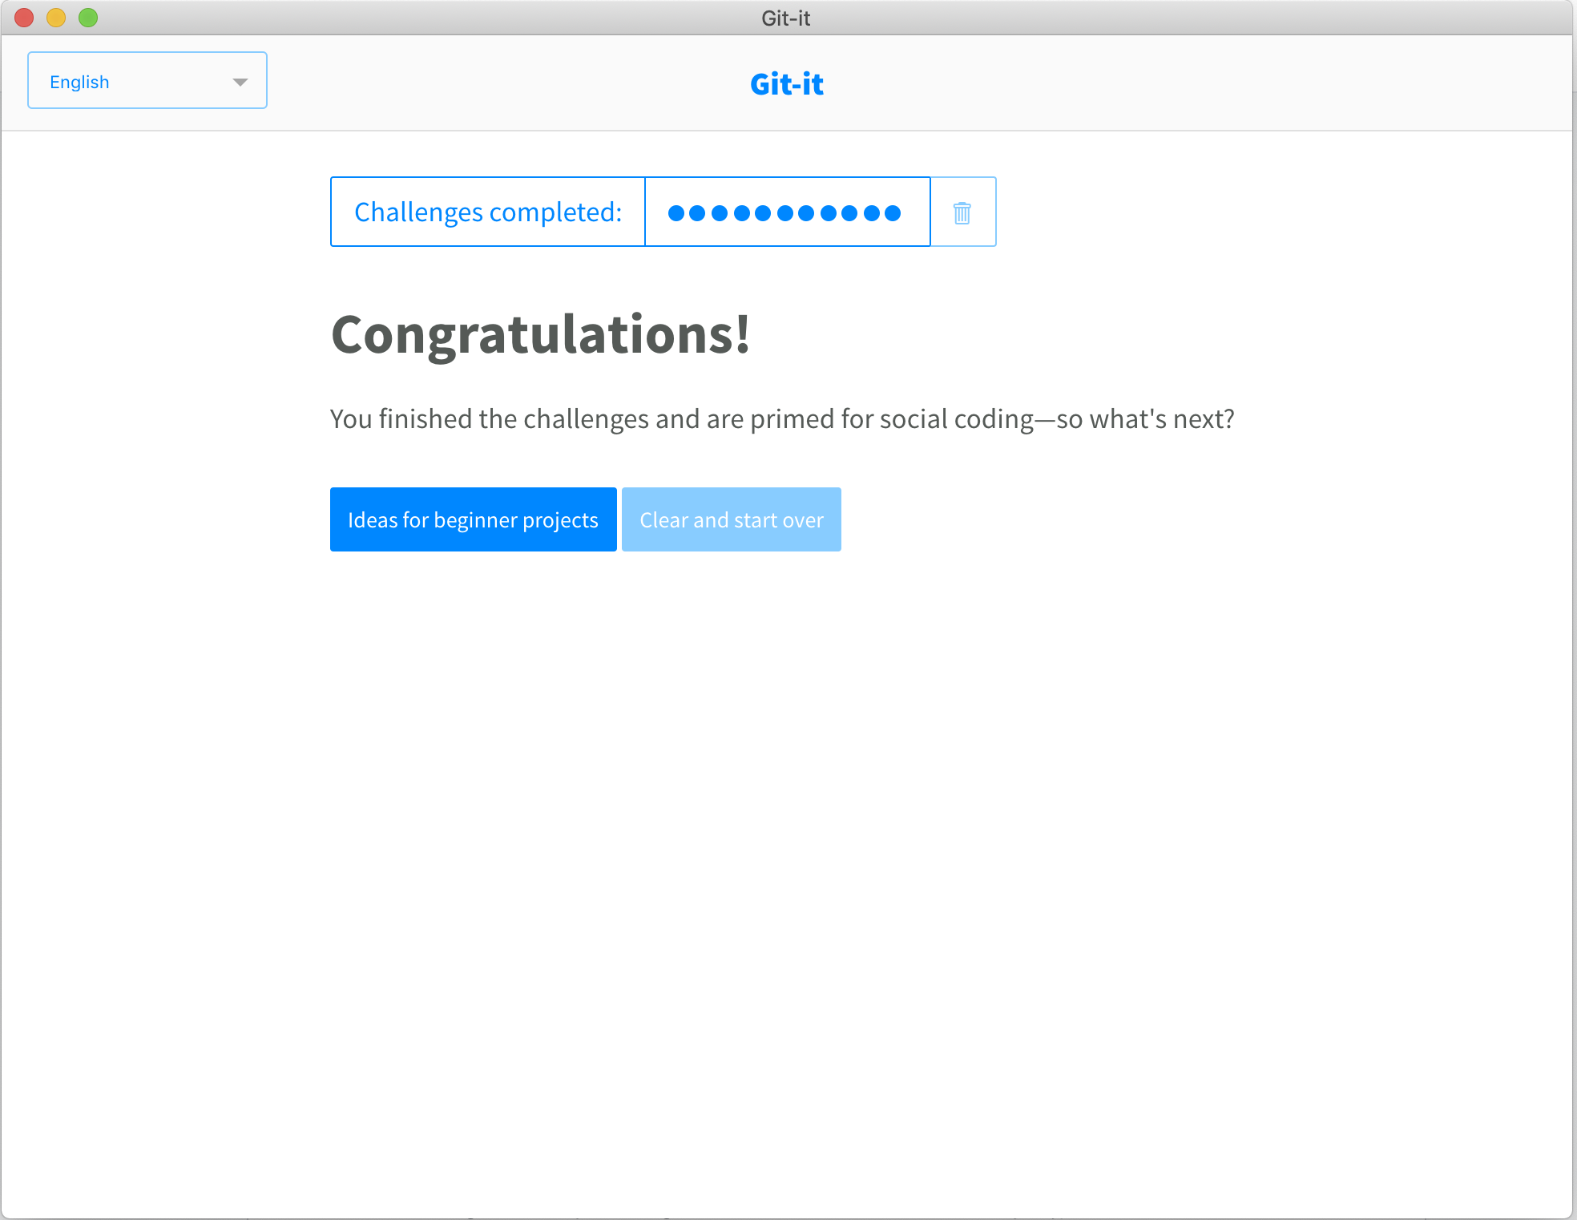

**Part 5:**

Become familiar with the following terms:

* Repository – an object database containing files, and all revisions of those files.
* Commit – the commit command is used to save your changes to the local repository
* Push – the push command is used to publish new local commits onto a remote server
* Branch – a branch is a pointer to a snapshot of the repository. Developers use branches to commit new code. When ready branches can be merged into the original code from which they branched.
* Fork – a fork creates a copy of a repository. Usually it is intended to collaborate and merge back into the original repository
* Merge – a git merge comman lets you take independent lines of code from a branch and integrate back into a single branch.
* Clone – a clone creates a copy of a repository locally
* Pull – pulls the snapshot of the repository from a remote server
* Pull request – a pull request tells other about changes you intend to push. Once a pull request is opened collaborators can comment so that you can add any changes before merging your changes.

**Part 6:**

Push the Word file in **YOUR** GitHub account in a repository called ***CS6232019***. Please respect the naming conventions! You will use this repository for the project. Your repository will be accessible at: <https://github.com/yourpseudo/CS6232019>.

<https://github.com/aa69940n/CS6232019>

**Part 7:**

Add an issue with title “GitHub training” in your repository called CS6232019. Issues are used for tasks and bug reports.

<https://github.com/aa69940n/CS6232019/issues/1>

**Part 8:**

Edit the main page of the wiki in your repository called CS6232019. Add the title “CS 623 2019” to the page (if you decide to do so).

You can also override Readme.md to document your work.

<https://github.com/aa69940n/CS6232019/wiki/CS-629-2019>