articulateWeb7

1. Untitled Scene

1.1 cover

Notes:

Untitled Layer 1 (Slide Layer)
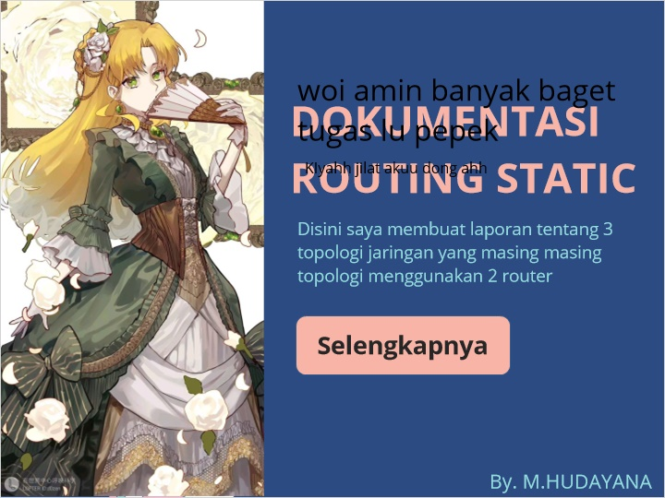

1.2 Untitled Slide
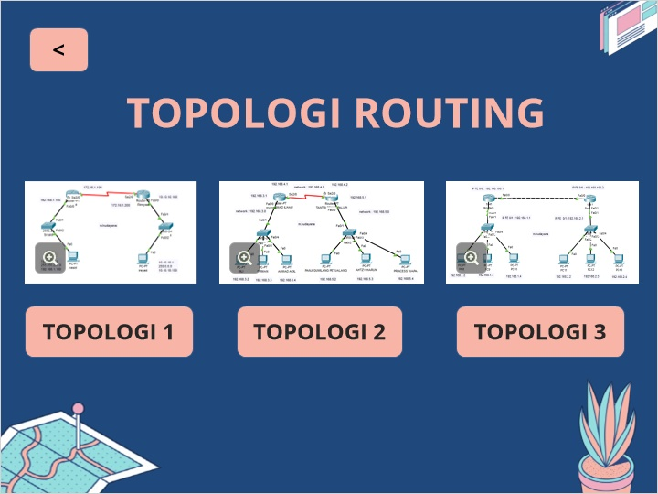

1.3 Untitled Slide
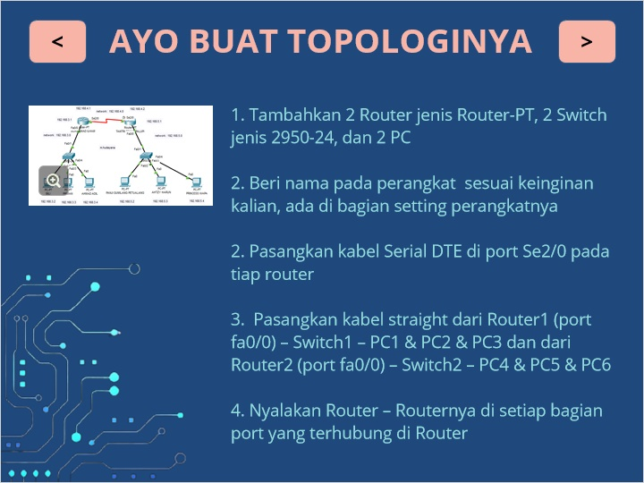

1.4 Untitled Slide
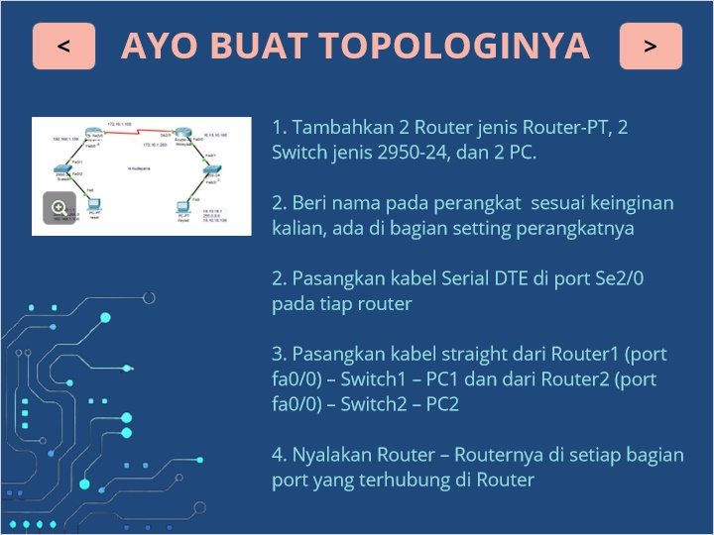

1.5 Untitled Slide
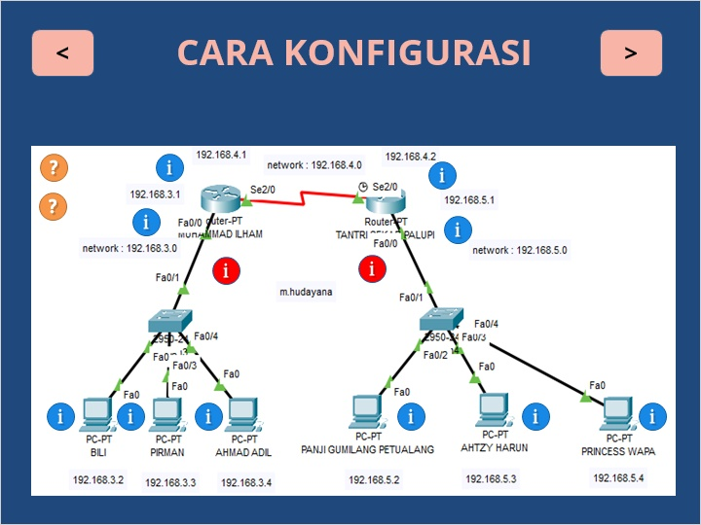

1.6 Untitled Slide
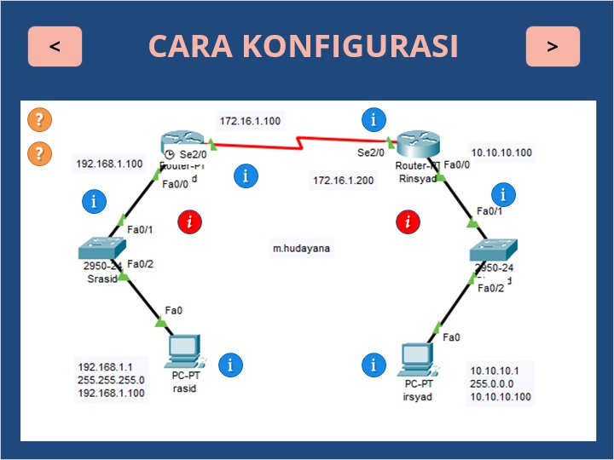

1.7 Untitled Slide
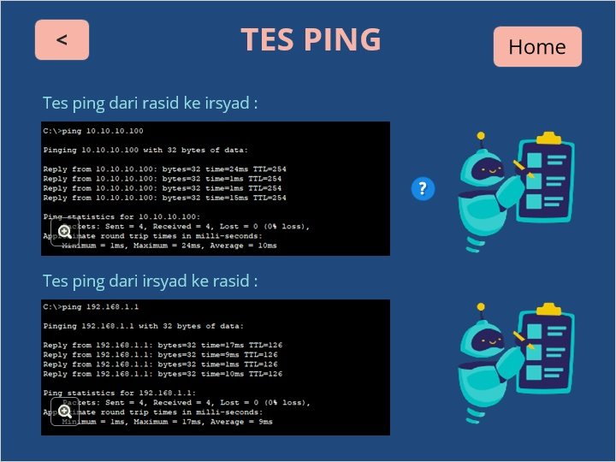

Untitled Slide - Copy (Slide Layer)

1.8 Untitled Slide
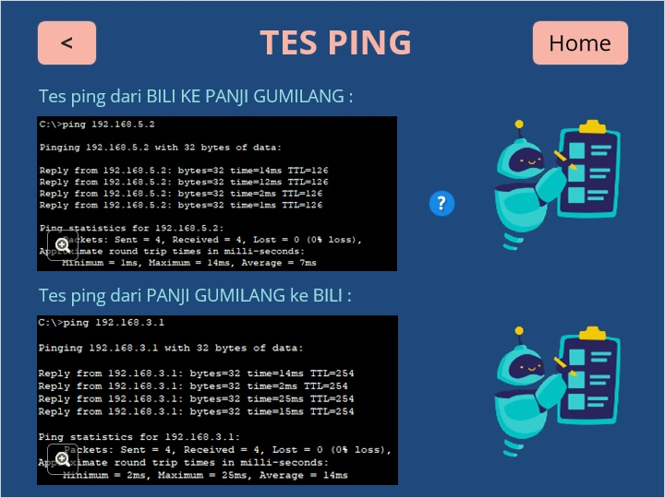

Untitled Slide - Copy (Slide Layer)

1.9 Untitled Slide
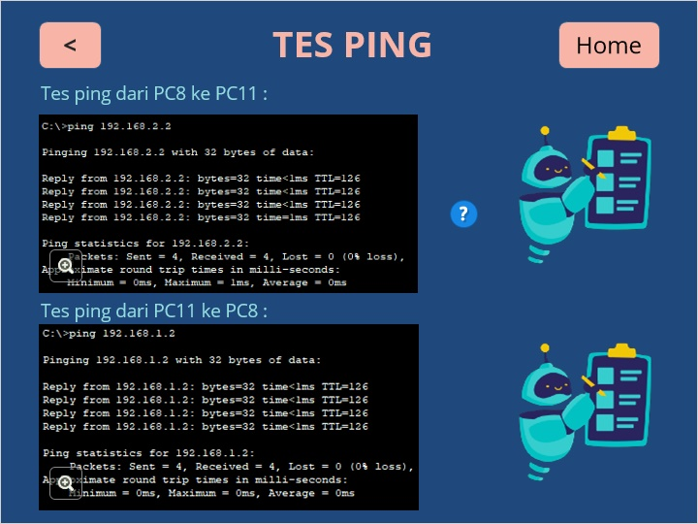

Untitled Slide - Copy (Slide Layer)

1.10 Untitled Slide
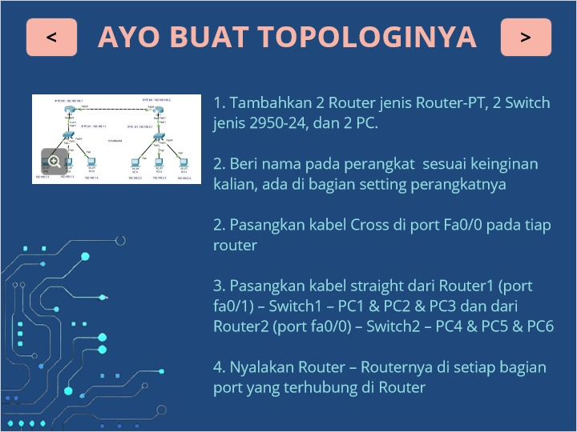

1.11 Untitled Slide
