# Overall Components Diagram

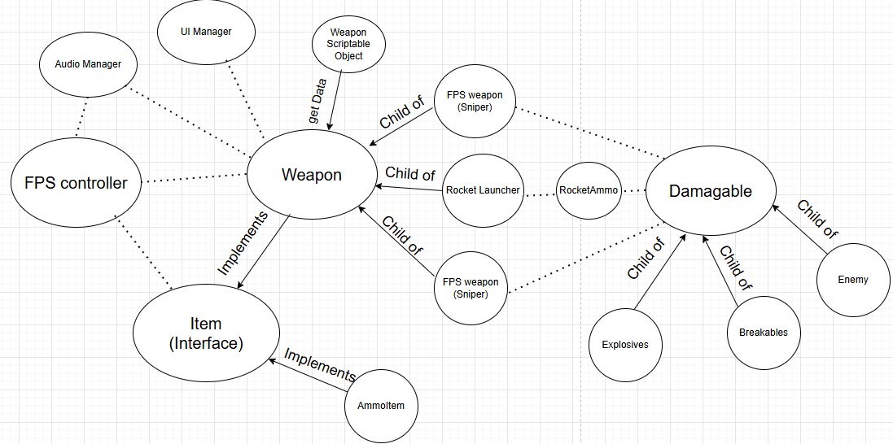

# Software Design

**Using Scriptable Objects:**  
each weapon’s data is stored in a scriptable object and is accessed by the weapon class  
  
**Using abstraction:**  
some methods in the weapon and the Damageable class have abstract functions and the child objects are forced to use them as a template. This makes the code neater

**Using interfaces:**The item class is an interface class and is implemented by the AmmoItem class and the weapon class as both can be picked up by the player and be used. One example is, the item interface has a use() method, and this allows me to only to call the **item.use(this);**  in the FpsController for picking up both weapons and ammo, which simplifies the code.

**Using observer pattern:**  
The UI Manager is subscribed to the weapon class which has events for things like ammo change, reload, gun change, etc. Whenever the event is called the UI Manager automatics updates itself without the need to call it from another class, which reduces and simplifies the coding process.

**Using Object Pooling:** The Audio Manger is implementing an object pool of 10 audio Sources, so whenever an audio plays, instead of creating and destroying a new object with an audio source for just a sound effect, it activates an audio source from the pool and deactivates it once its done, this will improve the game optimization.

**Using Inheritance:**

The 3 weapons are inherited from the parent weapon class since some of them have the same behaviors.

**Single Responsibility:**Separated out the methods in classes like FpsController, so that each method handles a specific role.

**Singleton Design:**The Audio Manager is a singleton which allows it to be accessed from anywhere with ease as only one instance of it exists. This allows other classes to easily call its methods and saves its own data in-between scenes.  
  
**Manager Pattern:**The Audio Manager and UI Manager allows the management of a group of related functionalities. This allows the classes that use these managers to be simpler as it’s all handled in the manager.

# Key Binds

WASD - moving around

hold SHIFT - sprint

hold CTRL - crouch

SPACEBAR - Jump

F / F + (WASD) - slide

E - pick up

G - drop weapon

R - reload

LEFT CLICK MOUSE - Shoot weapon

RIGHT CLICK MOUSE - Scope weapon