SEED-VIG ?? EEG/EOG ?????????
?????PERCLOS ?? + ???????? + ???????

??????
????? SEED-VIG ?????????? EEG/EOG ?????? PERCLOS ???????????????????????????????? Acc?F1 ? BalAcc ??????????????????
???????????? group-subject ???????????? Raw EEG/EOG Reliability-Gated Conformer????????????????????? PERCLOS ????????

??????
??? EEG/EOG ?? CNN patch encoder ????? token?EEG ?????? Conformer ????? query?? EOG token ?? cross-attention???????????? EOG ????????????????????? PERCLOS ?????????? PERCLOS ??????
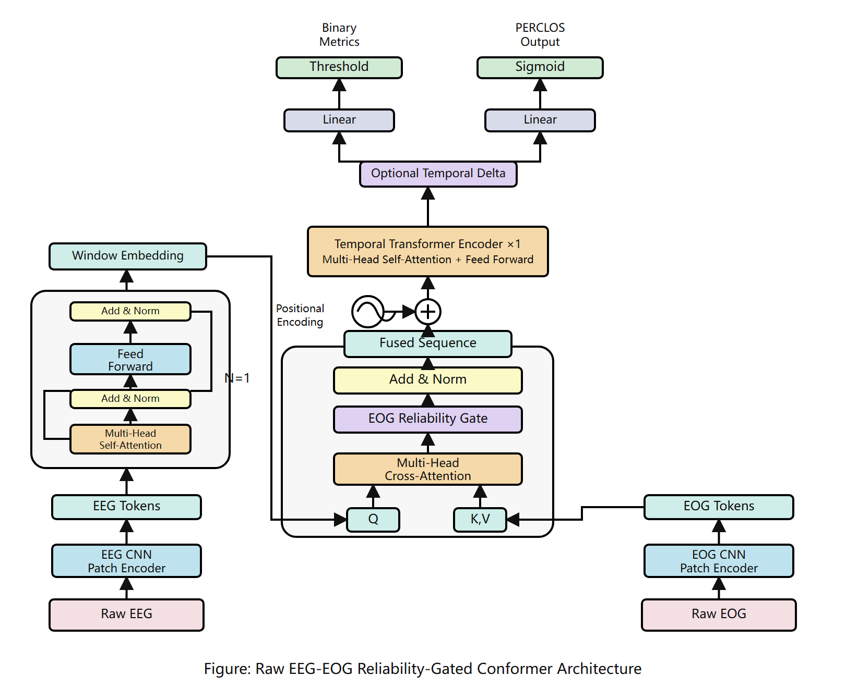
? 1 Raw EEG-EOG Reliability-Gated Conformer ?????

????????
??????????? group-subject ?????????????????????????????RMSE ? Pearson ??????????????Anchor Residual No-Delta ????????????????
???? | Acc | F1 | BalAcc | RMSE | Pearson | ??
???????? | 0.4912 | - | - | 0.2563 | 0.5746 | ????
Raw EEG/EOG Cross-Attention | 0.7233 | 0.7241 | 0.7332 | 0.1652 | 0.8145 | ??????
Delta/Gate Regression | 0.8233 | 0.7995 | 0.7977 | 0.1483 | 0.8406 | ????
Anchor Residual + Delta | 0.8027 | 0.7894 | 0.7993 | 0.1471 | 0.8398 | ????
Anchor Residual No-Delta | 0.8263 | 0.8043 | 0.8017 | 0.1433 | 0.8508 | ??????
????????????????????? Transformer ??????????????????????????????????????????

???????????
- ?????? PERCLOS regression-only?????? SmoothL1?
- Softmax ???????????????????????????????
- CE-only ?????????????????????????????????
- ???? Optional Temporal Delta ?????????????????/????????? no-delta ????

????????
??? | ???? | ????
???? | ??????? | PERCLOS ?????????????? SmoothL1????????????????
Temporal Delta | ?????? | ?????? no-delta ????????????????????????
???? | ????????? | ??????????????????????????????
???? | ????? | group-subject ??????????????????????

??????????
??????????????????????????????????????????? EEG/EOG ???????????????? PERCLOS ?????????????? cross-attention ??????????????????? raw fusion ?????????
?????? EI ?????????????????????????????????????????? EOG ????????????????????

?????????
- ?????????????? temporal delta ???????????
- ?? 1 ????????????????????????????
- ?? SEED-VIG ??????? EEG/EOG ??????????????
- ???????????????????????????????

