?????????????????????????
A Raw EEG-EOG Reliability-Gated Fusion Method for Driver Fatigue Detection
[???????]?[?????]?[??] [??]?

??
?????????????????????????SEED-VIG ?????????????EEG?????EOG????? PERCLOS ?????????????????????????????????????????????????????????????????????? EEG/EOG ???????????????????? CNN patch encoder ?????????????????? EEG ???????EOG token ????????????????????????????????????????? PERCLOS ???????????? PERCLOS ????????????????????????????????????????????? group-subject ???????????? no-delta ??????????? Acc 0.8263?Macro-F1 0.8043?Balanced Accuracy 0.8017?RMSE 0.1433 ? Pearson 0.8508??????????? raw fusion ???????????????????????????????????????????????????
?????????????????PERCLOS???????????????????

Abstract
Driver fatigue detection is important for intelligent transportation and human safety monitoring. The SEED-VIG dataset provides synchronized electroencephalography (EEG), electrooculography (EOG), and continuous PERCLOS vigilance labels, making it a public benchmark for physiological fatigue estimation. To reduce the dependence on handcrafted features and avoid naive multimodal concatenation, this paper proposes a raw EEG-EOG reliability-gated fusion method. The model extracts window-level representations from raw EEG and EOG using lightweight CNN patch encoders, lets EEG query EOG tokens through cross-modal attention, and introduces a reliability gate to control the contribution of ocular evidence adaptively. Since PERCLOS is a continuous vigilance label, PERCLOS regression is used as the main training objective, while binary classification metrics are computed by thresholding the regression output. Under a strict group-subject protocol, the recommended no-delta reliability-gated model achieves Acc 0.8263, Macro-F1 0.8043, Balanced Accuracy 0.8017, RMSE 0.1433, and Pearson 0.8508. Ablation results show that the simple temporal delta module is unstable in the current setting, so it is treated as an ablation rather than a core component.
Keywords: driver fatigue detection; EEG; EOG; PERCLOS; cross-modal attention; reliability gate; cross-subject evaluation

1 ??
???????????????????????????????????????????????????????EEG ???????????EOG ????????????????????????????????SEED-VIG ?????????? PERCLOS ??????????????????????????
??????????????????????????????????????????????????????????????????????? EEG ? EOG ?????????????????????? PERCLOS ????????EOG ?????????????????????? EEG-only????????????????????????????
????????????????????????? PERCLOS ????? group-subject ??????????????????????????
???????? EEG/EOG ??????????????????????
?? EEG-query/EOG-key-value ????????? EEG ??????????????????
? PERCLOS ???????????????????????????????????????????
?????????????????????????????????????????????????

2 ????
SEED-VIG ??? Zheng ? Lu ??????? EEG ? forehead EOG ???????PERCLOS ???????????????????? EEG?EOG ????????????????????????????????HMS-TENet ??????????? EEG/EOG ??????????????????????GE-LSTM-Net ????? EEG ?????????-?????????????????????????????????????????????????????????????
???????SEED-VIG ? PERCLOS ??????????EOG ????????????????????????????????????????????????????????????????????????????????????

3 ??

3.1 ??????????
??? 8 ??? 8 ??????????EEG ????? [B, 8, 17, 1600]?EOG ????? [B, 8, 7, 1000]??????????? CNN patch encoder ?? token ???EEG ????????????? Transformer ?? token ????????????EOG ???? token ?????????????????

3.2 ????????????
???????????? EEG ?????? Query?? EOG token ?? Key ? Value ????????????? EEG ????????????????????????????? EEG ?????????? EOG ????????????? 0 ? 1 ????????????? EOG ????????????????? H = LayerNorm(EEG + gate ? AttendedEOG)?

3.3 ???????
???? 8 ????????????????? temporal Transformer ??????????????????????? PERCLOS ??????????????????????????????????????????????????????
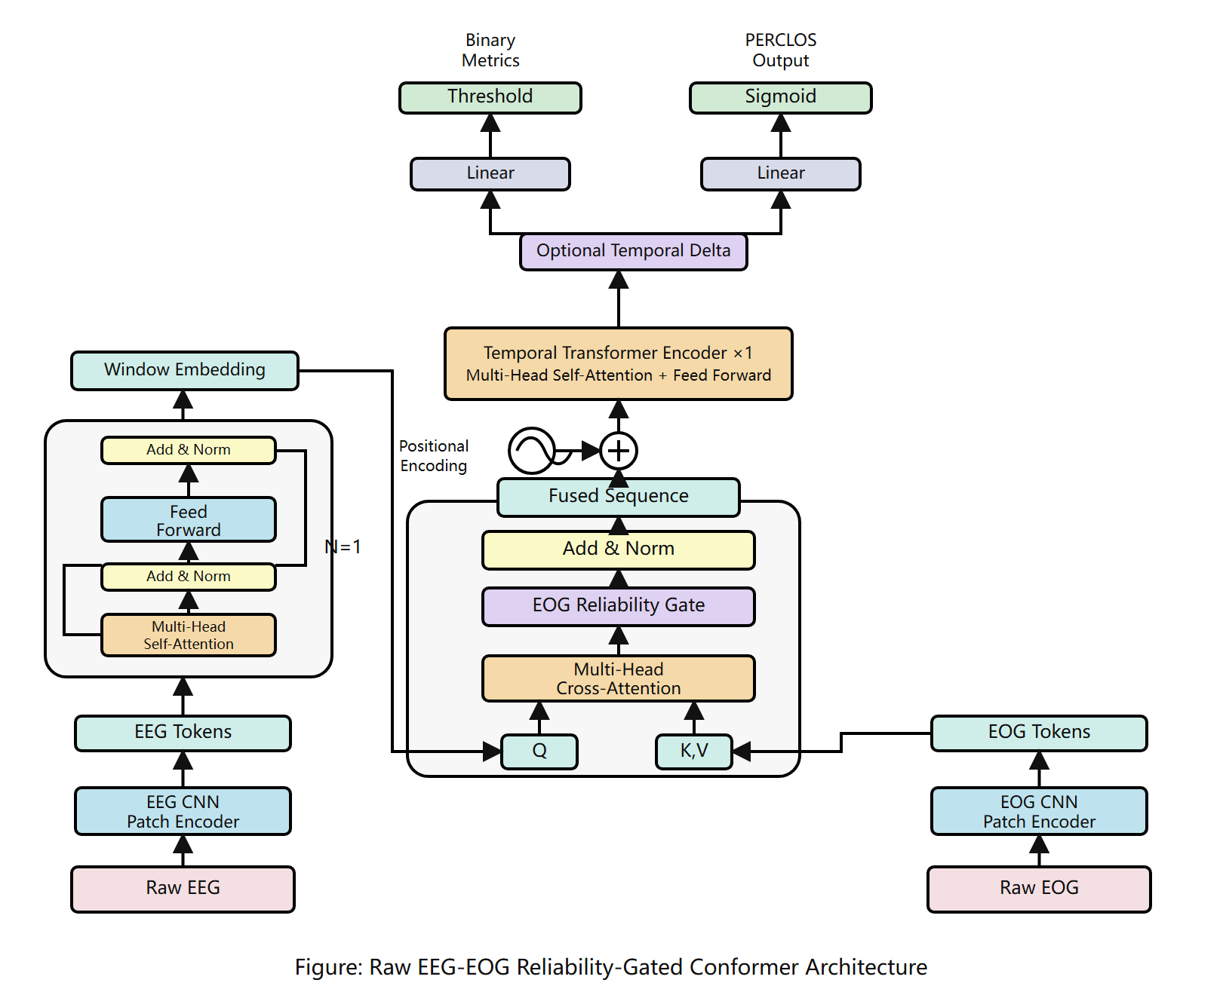
? 1 ?? EEG/EOG ????????????????? PERCLOS ??????????Temporal Delta ????????

3.4 ????
?????????? PERCLOS ????????? SmoothL1?Lreg = SmoothL1(?, yperclos)?????????????? 0.35 ????????? CrossEntropy ???-?????????????????????????? PERCLOS ?????????????? CE-only ???????????????????????

4 ????
???? SEED-VIG ????EEG ???? 200 Hz??? 17 ????EOG ???? 125 Hz??? 7 ????? 8 ????????? 8 ??????? 64 ????????? group-subject 5 ????????????????????????? Accuracy?Macro-F1?Balanced Accuracy?RMSE ? Pearson ?????????? 20?batch size ? 4????? AdamW?

5 ???????

5.1 ???
? 1 ?????????????????????????? raw cross-attention ?????????????? RMSE ??? Pearson?no-delta ??????????????????????????????????
?? | ???? | Acc? | F1? | BalAcc? | RMSE? | Pearson?
?????? | - | 0.4912 | - | - | 0.2563 | 0.5746
Raw EEG/EOG Cross-Attention | regression | 0.7233 | 0.7241 | 0.7332 | 0.1652 | 0.8145
Delta/Gate | regression | 0.8233 | 0.7995 | 0.7977 | 0.1483 | 0.8406
Anchor Residual + Delta | regression | 0.8027 | 0.7894 | 0.7993 | 0.1471 | 0.8398
Reliability-Gated No-Delta | regression | 0.8263 | 0.8043 | 0.8017 | 0.1433 | 0.8508
EOG-only strong baseline | regression | 0.8250 | 0.7883 | 0.7820 | 0.1432 | 0.8536
????????????????????? clean average ???????????????????????????????????????????????? F1 ? Balanced Accuracy ??????????????????? raw fusion ??????

5.2 ??????
? 2 ?????????????CE-only ???????????? RMSE ?? 0.30 ???Pearson ??????????????? PERCLOS ????????????? regression-only ???????classification ? multitask ???????
?? | ?? | Acc | F1 | BalAcc | RMSE | Pearson
EOG-only | classification | 0.8261 | 0.8118 | 0.8191 | 0.3070 | -0.4279
Delta-Gate | classification | 0.8080 | 0.7926 | 0.8020 | 0.3105 | -0.7082
EOG-only | regression | 0.8250 | 0.7883 | 0.7820 | 0.1432 | 0.8536
Delta-Gate | regression | 0.8233 | 0.7995 | 0.7977 | 0.1483 | 0.8406

5.3 ??????
? 3 ?? within-experiment ????????????? group-subject ???????????????? group-subject ????????????????????????????
?? | Acc | F1 | BalAcc | RMSE | Pearson
within-experiment | 0.7732 | 0.7700 | 0.7802 | 0.1320 | 0.8637
group-subject seed0 | 0.7233 | 0.7241 | 0.7332 | 0.1652 | 0.8145
group-subject seed1 | 0.7068 | 0.7098 | 0.7143 | 0.1533 | 0.8370

5.4 ???????
??? EOG ?????????? mask ????????????????? EOG ????????????????????EOG ???? RMSE ? 0.3394????? EEG ?????????????????????????????????? clean average ????????????????? EOG ????????????

6 ??
?????????????? EEG/EOG ????????????????????????? Delta ??????????????????????????????????????????????????????????????????? PERCLOS ???????????????????????????
???????????????? clean average ????????????????????????????????????EOG ??????? mask ??????????????????????????????????? subject-invariant ?????????????

7 ??
?????????? EEG/EOG ????????????? SEED-VIG ?????????????? PERCLOS ?????????? EEG-query/EOG-key-value ?????????????????????? EOG ????????????? group-subject ????no-delta ????????? Acc 0.8263?F1 0.8043?RMSE 0.1433 ? Pearson 0.8508????????? raw fusion ???????????????????? CE-only ??? PERCLOS ?????Temporal Delta ??????????????????? EOG ????????????????

????
[1] Zheng W.-L., Lu B.-L. A multimodal approach to estimating vigilance using EEG and forehead EOG. Journal of Neural Engineering, 14(2):026017, 2017.
[2] SEED-VIG Dataset. Brain-like Computing and Machine Intelligence Lab, Shanghai Jiao Tong University. https://bcmi.sjtu.edu.cn/home/seed/seed-vig.html
[3] Tang M., Li P., Zhang H., Deng L., Liu S., Zheng Q., Gao D. HMS-TENet: A hierarchical multi-scale topological enhanced network based on EEG and EOG for driver vigilance estimation. Biomedical Technology, 8:92-103, 2024. DOI: 10.1016/j.bmt.2024.10.003.
[4] Lan H., Tang M., Ju X., Li M., Hu D. GE-LSTM-Net: A global-enhanced LSTM network with attention for spatiotemporal feature extraction in EEG-based vigilance estimation. CAAI Artificial Intelligence Research, 5:9150001, 2026. DOI: 10.26599/AIR.2026.9150001.

