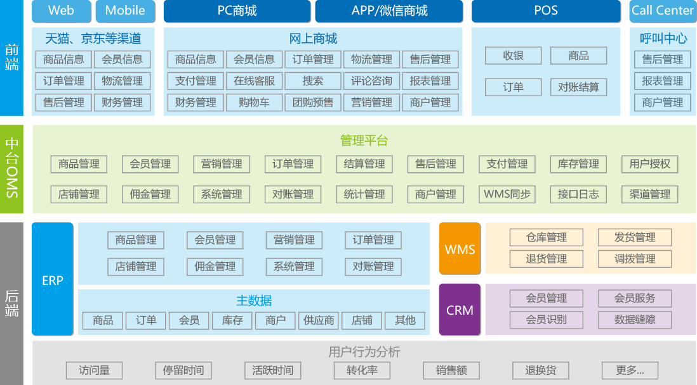

Mui.js

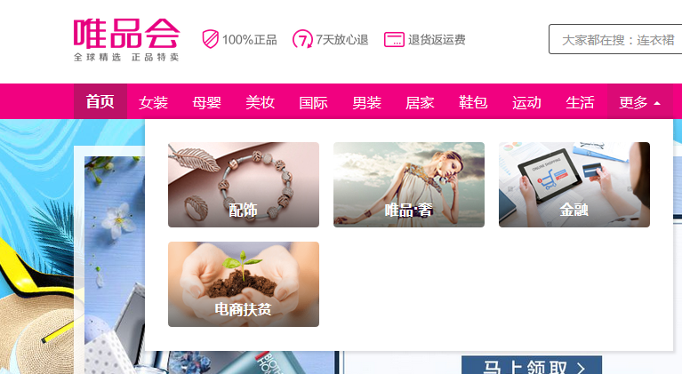

Ui效果

在线支付

<https://pay.weixin.qq.com/wiki/doc/api/native.php?chapter=2_1>

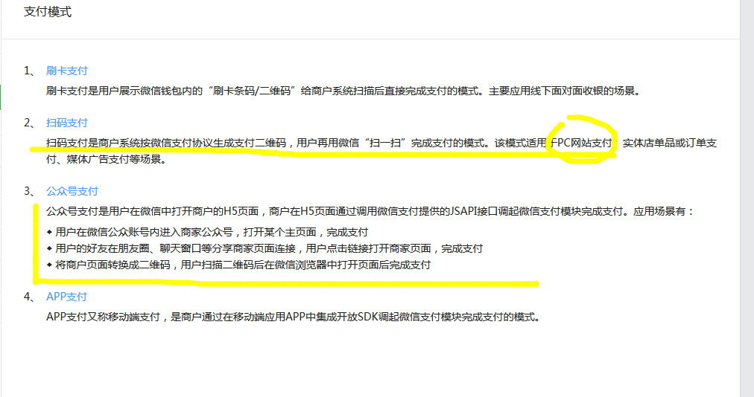

:

public static String phoneusr = "890033";

public static String phonepwd = "by2016";

public static String phonebaseUrl ="http://120.27.218.68:9091/smhttphandle.aspx";

:

String param = "usr=" + usr + "&pwd=" + pwd + "&mobile=" + phone + "&sms=" + message + "&priority=9&extdsrcid=";

String res = HttpRequest.sendGet(url, param);

:

String message = "【快e捷】尊敬的用户，您的验证码：" + code;

:

/**

* 微信支付app appid

*/

public static final String weixinpayAPP_ID = "wxcc20425e17550ed7";

/**

* 微信支付app 商户号

*/

public static final String weixinpayMch_ID = "1423465802";

/**

* 微信支付app API密钥

*/

public static final String weixinpayKey = "Zjbinya2017Zjbeiou8505020571sgpj";

:

/** 支付宝支付业务：入参app_id */

public static final String APPID = "2016010601067425";

// 合作身份者ID，签约账号，以2088开头由16位纯数字组成的字符串，查看地址：https://b.alipay.com/order/pidAndKey.htm

public static String partner = "2088121336419794";

// 商户的私钥,需要PKCS8格式，RSA公私钥生成：https://doc.open.alipay.com/doc2/detail.htm?spm=a219a.7629140.0.0.nBDxfy&treeId=58&articleId=103242&docType=1

/** 商户私钥，pkcs8格式 */

public static final String private_key = "MIICdwIBADANBgkqhkiG9w0BAQEFAASCAmEwggJdAgEAA"

+ "oGBAM/6T8jPRXq/27SXoraqgPw4Qrhkm7ZsXK219Lx9/rq4OsZzVV6Dx"

+ "C4I5Ank3+Q906g+OndhaDUqHO9IGhMj5OYjVCY+yc5UoiP3mYPWh+"

+ "iuAinbQYoc1W/sBGXS6NjEW5aSmI+uWLMKSsYCkK//CLgERe71l+5ttajL"

+ "+ZG9i+eXAgMBAAECgYBlgxO2PBT5mPOv7eNprUdP1FYckl6+Z53E2+8"

+ "coZLXqFxnyJt+imoS3hwQCDqPuO26TMVUx6KJcIi28kZn2Tk7iTWTHbvLi"

+ "uAB+3uklKfMFQszjAxMgZlwHgv2NE/u74ebyBy5nGxA8imX1c9V5I+96nz"

+ "oSTonQvfzu+RlwouTgQJBAPqhzW9/fV+Jou6VmbGpkDNhpr9EJ7dKfnOz+r"

+ "X3N0N8k2/GM0Lx+IwM5CDF2+Z4hJsO2r1tr+OX77UH56c/sycCQQDUbq"

+ "OQNA7EaLghx5JM+f+Cy7k/ZXNxoLKaPwisiFly3I2GsfN5mYVFFHmPRaEBc"

+ "AJJZ5ZEX8OzUmSkqPvi4C4RAkEA2Q0PEKRkOzzDMcO1Grsx+o1zDulDS+T"

+ "jpegUE0pJPdTBCmenNS7AhOkVF5zCV9G/ZVlz7eD0FjIakbiK0bjEuQJABGow"

+ "OAT88ZQDj6AoKDVh3AQD249uMMRYMeBxe7Rxt3Nh9ZSpLLPGE0Nzq"

+ "0iVKgR7566hbtZWqNljghCI+5QRIQJBAMISLT0qy4yNL3bNiGWssyYqwBw"

+ "rFHIfG/BAXojbta/mMoSOE4qdXWQoLfX38g5G64q8kvssXkuoaBoYvRKg/8U=";

// 收款支付宝账号，以2088开头由16位纯数字组成的字符串，一般情况下收款账号就是签约账号

public static String seller_id = "13738387078@139.com";

// 支付宝的公钥,查看地址：https://b.alipay.com/order/pidAndKey.htm

public static String alipay_public_key = "MIGfMA0GCSqGSIb3DQEBAQUAA4GNADCBiQKBgQDDI6d"

+ "306Q8fIfCOaTXyiUeJHkrIvYISRcc73s3vF1ZT7XN8RNPwJxo8pWaJMmvy"

+ "Tn9N4HQ632qJBVHf8sxHi/fEsraprwCtzvzQETrNRwVxLO5jVmRGi60j8Ue1"

+ "efIlzPXV9je9mkjzOmdssymZkh2QhUrCmZYI/FCEa3/cNMW0QIDAQAB";

想法框架2.0

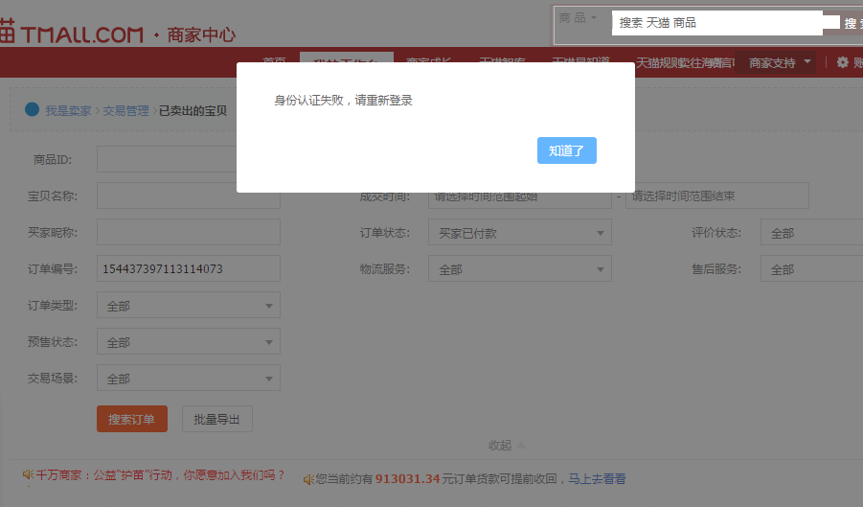

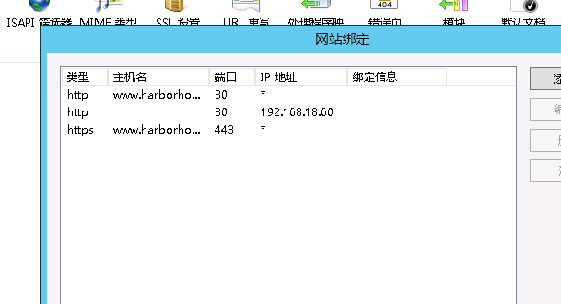

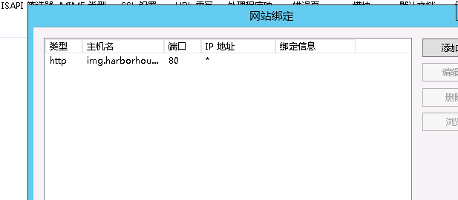

Pc端ui

http://www.zhaoxinnian.com/tree_view.html  
http://amazeui.org/getting-started/layouts

@Html.Action("MenuPartial", "Partial", new { Area = "", SceneCode = "default", Module = ViewBag.Module, Menu = ViewBag.Menu })

jQuery WeUI 手机端

上线前准备 索引

促销活动

~~运费计算~~

Sqlserver 备份计划

https://www.cnblogs.com/sygwin/p/6157029.html

~~2018.3.31~~

~~下周重点 购物流程~~

~~后台权限看一下 特别是异步权限的控制~~

这周核对商品和订单功能

跨站访问图片

是否是线上线下的

Webapi 授权

未实现功能

1. ~~上传缩略图~~
2. ~~上传路径不同~~

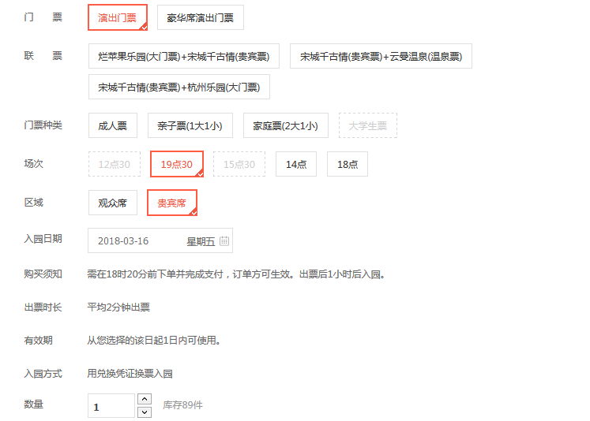

产品类型 只能由后台统一定义 属于平台分类

商品分类对应于自定义的分类 属于商家分类

商品分类 对应特定 商品类型

商品类型 对应特定商品规格

