10个城市：
 | A | B | C | D | E | F | G | H | I | J
A | 0 | 93 | 49 | 51 | 46 | 58 | 93 | 68 | 69 | 127
B | 93 | 0 | 45 | 52 | 111 | 141 | 67 | 25 | 154 | 90
C | 49 | 45 | 0 | 28 | 69 | 97 | 72 | 21 | 114 | 105
D | 51 | 52 | 28 | 0 | 86 | 108 | 46 | 29 | 102 | 80
E | 46 | 111 | 69 | 86 | 0 | 33 | 132 | 90 | 100 | 167
F | 58 | 141 | 97 | 108 | 33 | 0 | 152 | 118 | 86 | 186
G | 93 | 67 | 72 | 46 | 132 | 152 | 0 | 60 | 124 | 34
H | 68 | 25 | 21 | 29 | 90 | 118 | 60 | 0 | 128 | 90
I | 69 | 154 | 114 | 102 | 100 | 86 | 124 | 128 | 0 | 151
J | 127 | 90 | 105 | 80 | 167 | 186 | 34 | 90 | 151 | 0

十个城市的相对位置：
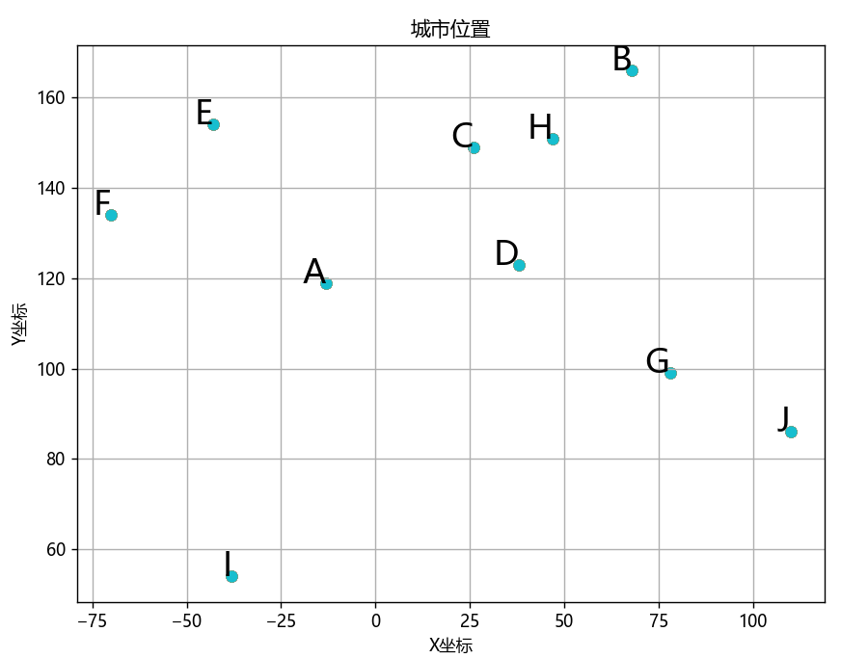
图1：城市分布

