VOLLEY | Final B.Tech Project Review
Evaluated Gen5, selected FM08-R3 feeder and physical development
Adityavardhan Mishra
Pratham Chawla
23 October 2026
Table of Contents

Guide: Vikas Gulia Student PRNs: Adityavardhan Mishra — 23070125054; Pratham Chawla — 23070125029 Department: Mechanical Engineering, Symbiosis Institute of Technology Review type: Final Project Presentation & Demonstration
Scope of the completed thesis. VOLLEY is a system-level engineering design and computational research project. The Gen5 evaluated configuration and adverse numerical findings are documented; decisive force and mission closure remain open. The results are predictions, with numerical cross-checks where identified. Physical prototype testing, CubeSat qualification and provider accommodation belong to a later development phase. Gen6 is presented separately, including the selected FM08-R3 academic feeder design and its physical development requirements.
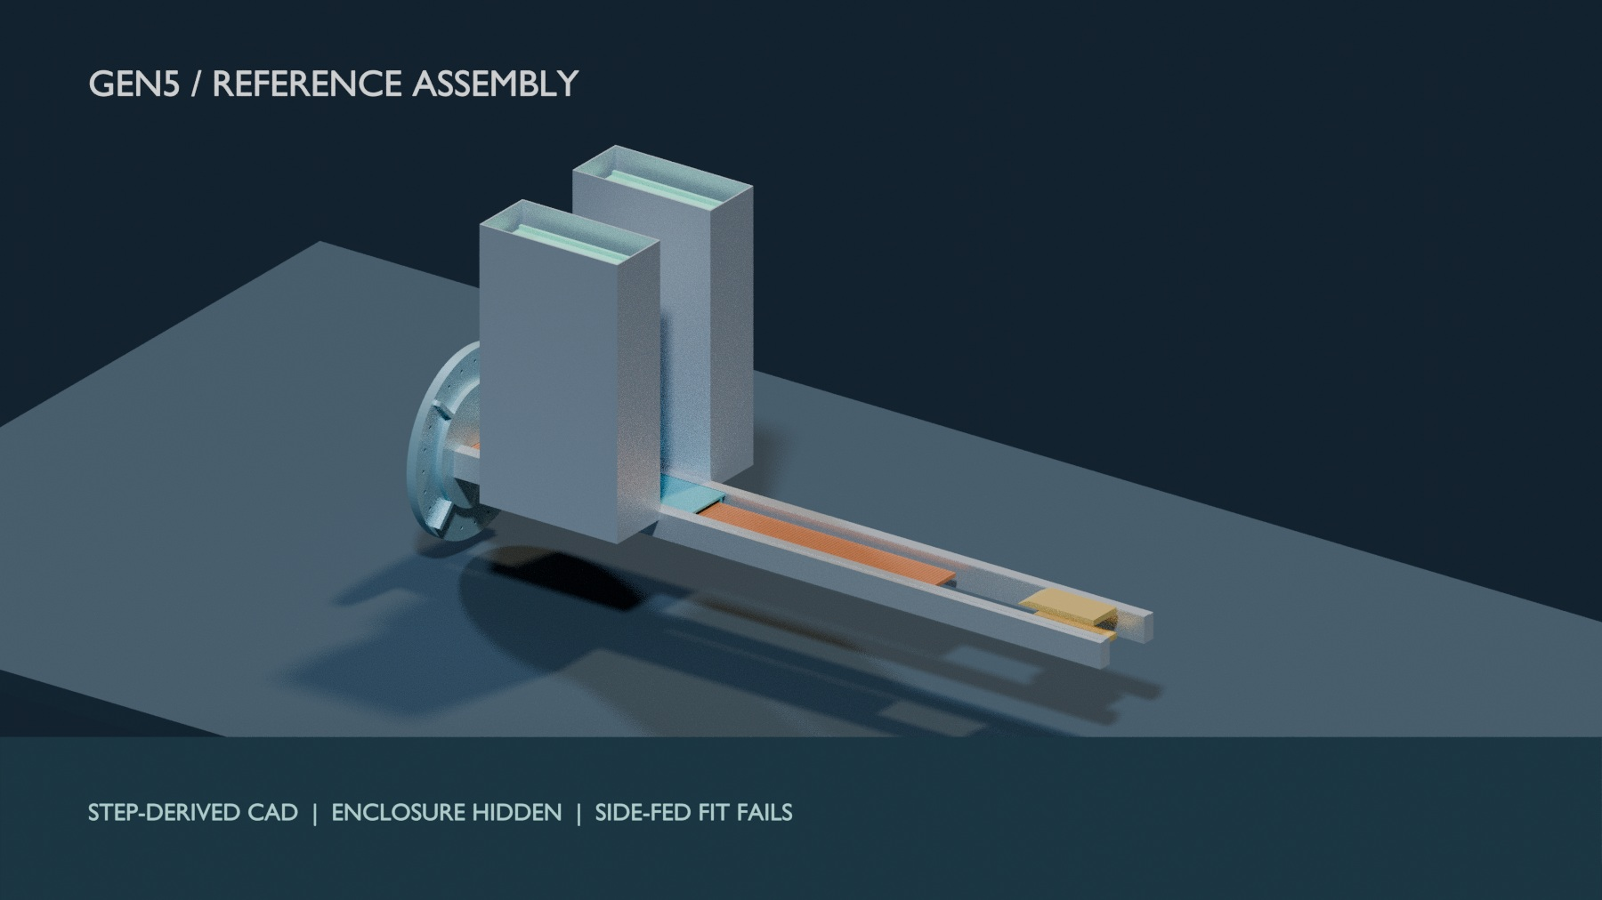
Gen5 reference FreeCAD/STEP assembly visualized in Blender with enclosure hidden. Known side-fed clash remains; no physical article exists.

Executive summary
VOLLEY investigates a last-mile problem in rideshare launches: a secondary CubeSat reaches orbit but ordinarily receives the orbit selected for the primary payload. A spring deployer separates it safely, often at roughly 1–2 m/s; that relative impulse, later drag differences, or host maneuvering can change its in-track phase. Deployment time by itself does not create persistent phase separation from an otherwise unchanged co-orbital host. A larger, deliberately commanded release velocity can also change orbital energy. The thesis evaluates whether that added capability justifies a complete deployer system. The mission model splits responsibilities between a maneuvering host, which performs coarse repositioning, and a deployer, which supplies each satellite’s commanded release condition.
The authored thesis analyses one Gen5 solution: a magazine-fed, linear synchronous motor driving a reusable magnetic sled. The historical periodic-force 3U model predicts 16.0 m/s exit speed at 10.07 g. Its modeled dry-mass rollup is 126.6 kg, and the power model predicts 2.782 kJ gross electrical draw per shot. A closed-loop simulation predicts 0.0274 m/s ($3σ$) exit-speed dispersion at a 15.8 m/s setpoint. For an assumed historical 16.029 m/s input, the orbit model raises semi-major axis by 28.8 km, with a 1.60× modelled lifetime multiplier at mean solar activity. The lifetime result is atmosphere-sensitive and is numerically reproduced by P134 under the same static atmosphere; actual environmental lifetime remains unvalidated.
Gen5 also produced a decisive negative result. With twelve 3U satellites, its deployer mass is 10.55 kg per customer, versus about 6 kg for the spring canister comparator used in the thesis. This is 1.76× as much hardware per 3U payload and fails the preset 15% mass-parity band. The study therefore reaches a decision: the conditional modelled orbital benefit does not make this Gen5 configuration a defensible 3U selection. The result completes the analytical comparison; it does not require a prototype to know that the modelled mass criterion failed. Physical payload loads, magnetic cleanliness, cycle life, and provider interfaces remain questions for a different evidence phase.
The later Gen6 programme retains the hosted sequential-deployment mission while reopening mechanism choice. It investigates an approximately 1–2 m/s to 1 km/s release-speed envelope across electromagnetic, mechanical, stored-energy, gas/fluid, hybrid and conventional options. The high end is a requirement to examine and may prove infeasible. The near-term goal is one named, reproducible, independently reviewable test-article configuration with a corresponding build/test release decision.

Finite-force, feeder-route and mission findings
The 16.029 m/s shot result assumes periodic thrust throughout a 1.3 m powered stroke. A new 3-D analytic integration of the exact cuboid field over the CAD’s finite 162-belt stator finds 1.042 kJ ideal work, corresponding to 12.448 m/s only under optimal phase with switching, voltage and friction losses omitted. The modeled mover array and stator stop directly overlapping after 1.066 m travel. The 336 mm magnetic model and 340 mm CAD envelope also disagree. Cross-section quadrature refinement changes the three checked station forces by at most 0.369%; halving station spacing changes work by 0.096%. The magnetic field law is shared with the earlier model, so this is an adverse analytic screen, not an independent 3-D FEM or a hardware test. The historical 16.029 m/s remains in older tables for traceability and must not be called demonstrated performance. See P118.
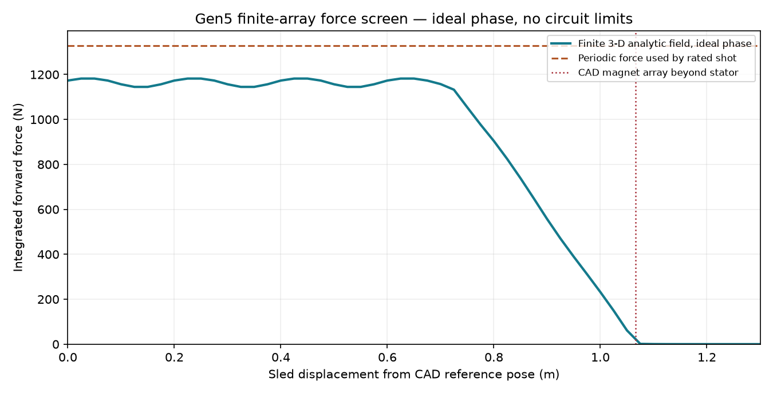
Finite-array/stator model force versus position; no physical measurement.
A separate 2-D finite-element magnetostatic solve of the finite magnet array gives 1.082 kJ ideal work on its finest 1 mm mesh, compared with the 3-D analytic screen’s 1.042 kJ. The 2-to-1 mm mesh change is 0.59%; a larger air boundary changes the 2 mm work by 0.0004%. The solver uses a different field formulation but omits magnet-depth end effects, so the two absolute results must not be combined into an achieved speed. P119 records meshes, convergence and assumptions.
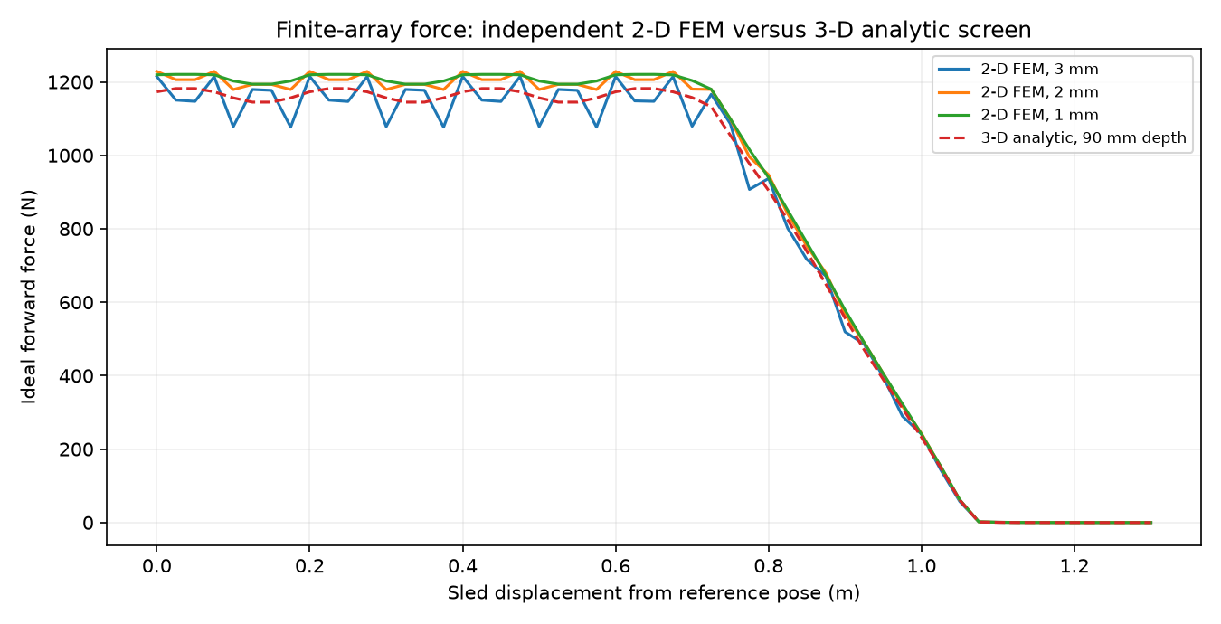
Independent 2-D finite-element force screen, not a measurement.
A separate depth-resolved 3-D numerical surface-charge implementation integrates the full 90 mm magnet depth and all 162 stator belts. It independently returns 1.042 kJ ideal work, matching P118 under shared geometry, remanence and ideal-phase assumptions. Face quadrature refinement from 16 to 24 nodes changes work by 0.00002%; halving the station spacing changes work by 0.096%. This checks the numerical formulation, not a selected motor or physical thrust. An illustrative 14 mm face gap gives 0.907 kJ rather than 1.042 kJ at 12 mm, a 13.0% ideal-work reduction. A 10 mm copper-depth offset gives 0.961 kJ. These are deterministic sensitivity cases, not tolerance specifications. See P121 and P122.
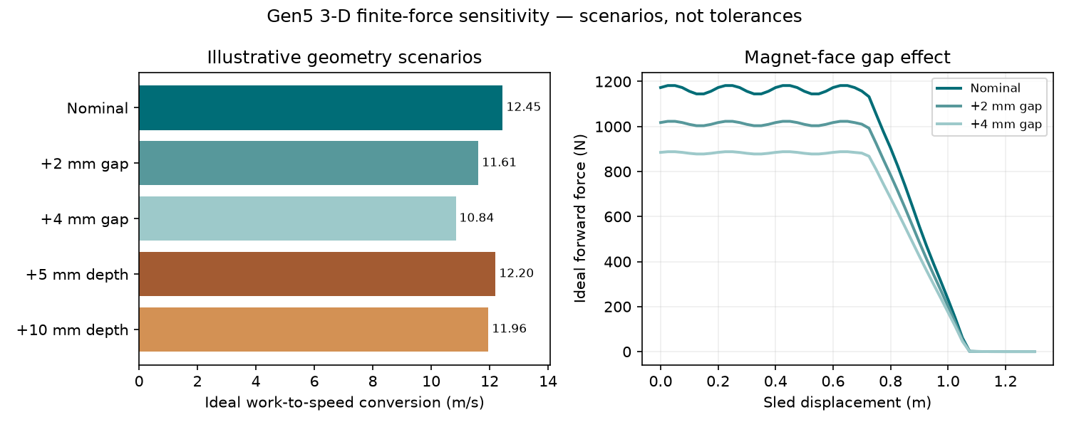
Ideal gap/depth sensitivity; scenarios rather than measured tolerances.
A conditional finite-force bank/trajectory rerun retains the historical 96 V, 6 F, 12 mΩ source and assumed converter. With the full 1.3 m winding energized it computes 2.099 kJ gross capacitor draw and 927 J copper heat; an illustrative 0.34 m active-copper branch gives 1.394 kJ gross and 243 J copper heat. Both report 12.448 m/s because the force curve is imposed at ideal phase; no voltage-limited switching law or selected winding/inverter exists. The old 2.782 kJ, brake and control outputs are not revised ratings. P120 gives the time history and energy ledger.
P125 now tests that finite force under an ideal quasi-steady phase-voltage/current bound. The old assumed 12 mΩ source reaches 12.448 m/s conditionally; a single source string in the older distributor-data 116–185 mΩ ESR range fails source power before release. Ideal parallel strings complete numerically only by increasing cells and mass. No selected motor rating exists. P126 also finds that an assumed 0.5° R1 alignment band consumes its 5 mm nominal side gap. P127 requires at least 37.6 g mean sled arrest over the provisional 210 mm brake; peak force and heat remain open.
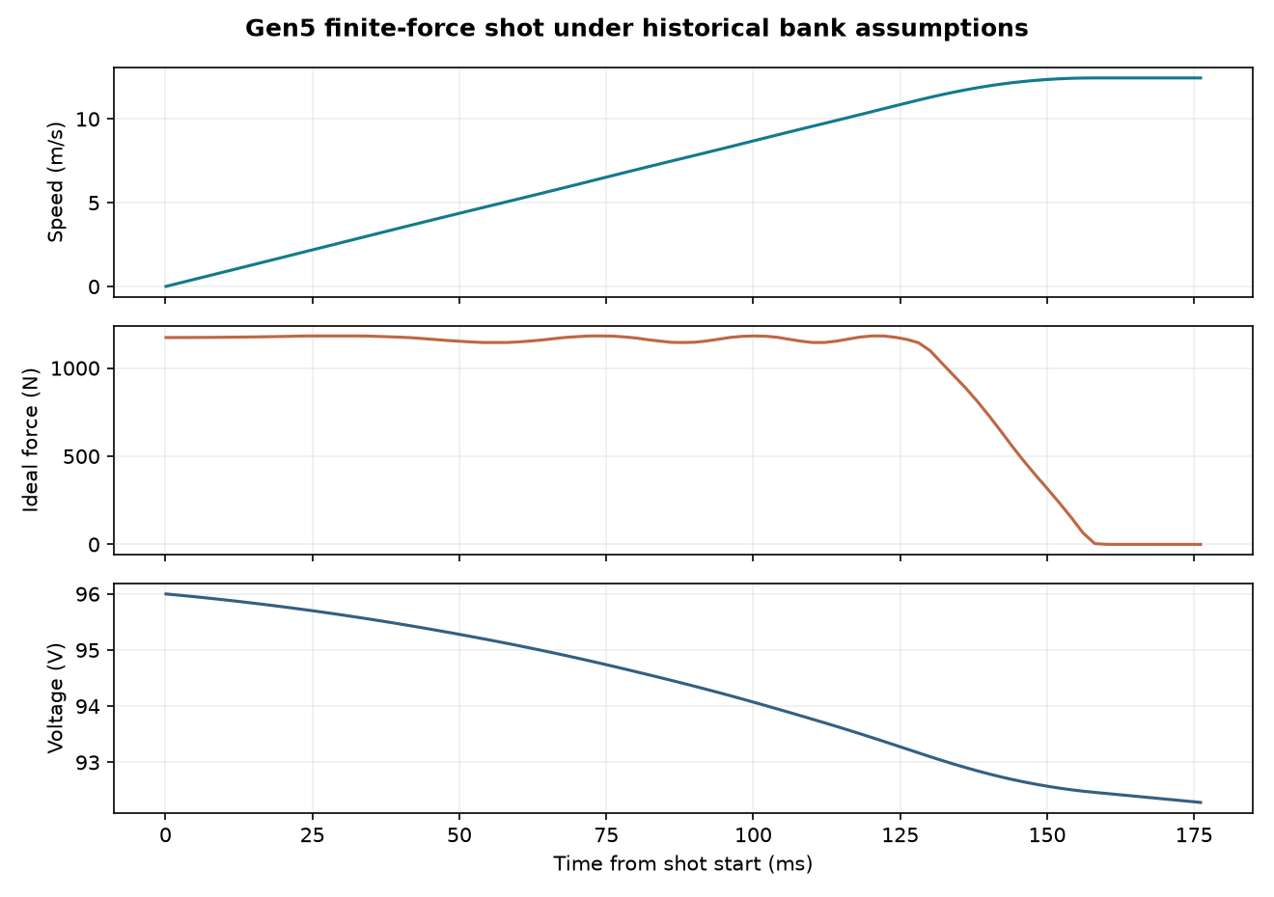
Finite-force speed and assumed bank energy histories.
An unselected R1 geometry candidate uses a 570 mm wide enclosure. Its native FreeCAD document and STEP parts clear the original cassette/track overlap and scripted 3U envelope transfer paths against selected fixed parts. An expanded exact-solid pair census retains five other intersecting pairs, including sled/track and sled/stator conflicts. It lacks a complete lift/carriage, launch restraint, actuation, tolerances, fault recovery and revised installed mass. Its increased envelope has no approved host. This candidate does not alter the evaluated Gen5 configuration or repair the performance discrepancy. See R1 CAD record.
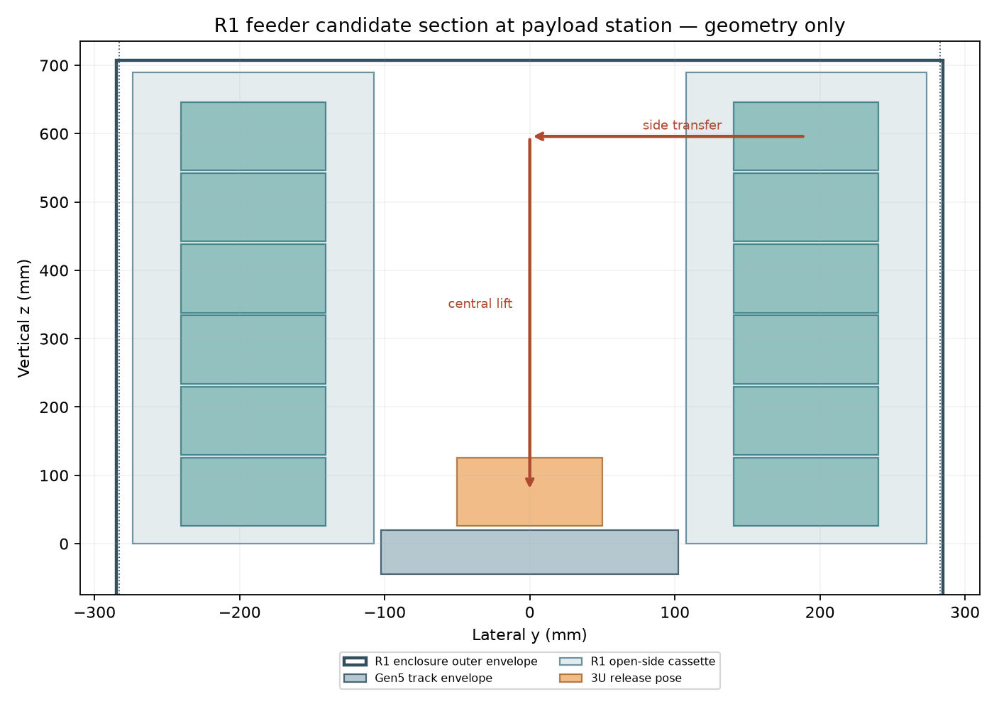
R1 candidate section; geometry drawing, not a qualified mechanism.
A matched reference comparison uses twelve identical 4 kg payloads at 450 km, the same 300 kg base host with 10 kg assumed fuel and 220 s specific impulse, and installed device masses of 72 kg for a spring class versus 126.562 kg modeled Gen5. To meet one common +16.029 m/s inertial payload target at the same epoch, ideal host preburn takes 2.693 kg of propellant with 2.5 m/s spring release and 0.827 kg with the 12.448 m/s finite Gen5 estimate. The subsequent common-input, assumed-100 N twelve-shot optimizer accepts prefixes of 4/12 spring, 1/12 finite Gen5, 1/12 historical Gen5. None closes. These are bounded numerical cases, not a supplier quote, proof of infeasibility or product advantage. Onboard propulsion, transport services and long-horizon drag remain unmodeled. See matched mission inputs.
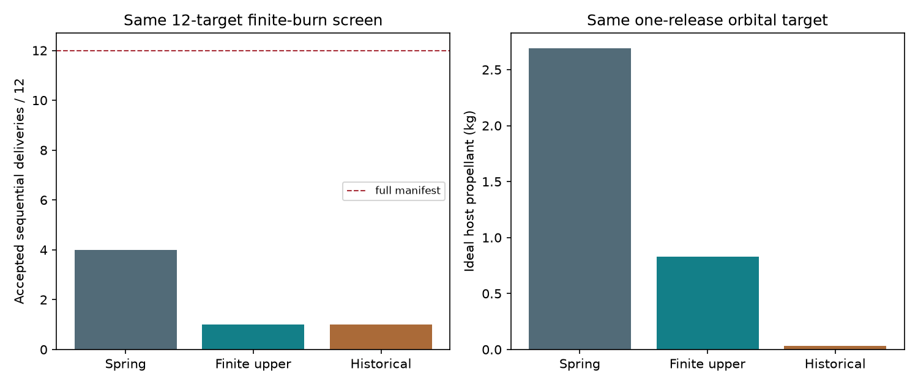
Matched reference results; assumed host and device classes.

New installed-burden and precision-delivery screens
P123 resizes initial fuel to one ideal release plus an equal 2 kg reserve: despite saving 1.866 kg of host propellant in the fixed-fuel event, Gen5’s device plus resized fuel is 52.717 kg heavier than the spring reference. The mass penalty does not by itself price a tailored delivery service, but it sets a serious burden for a buyer-backed mission to justify.
P124 converts an explicitly assumed 450 km orbit target into ideal tangential increment and load requirements. A 20 km immediate axis rise takes about 11.149 m/s; a ±0.1 km axis tolerance leaves about 0.0555 m/s for the entire tangential-error allocation on its smaller side. A real delivery accuracy budget must include host state, vector, timing, propagation and tracking. At 1 km/s over Gen5’s 1.3 m stroke, an ordinary 4 kg 3U would face about 39,220 g ideal mean acceleration and 2 MJ payload kinetic energy. The first Gen6 prototype should be scoped from a named payload and mission, with the 1 km/s objective held as separate research. None of these calculations measures VOLLEY precision.
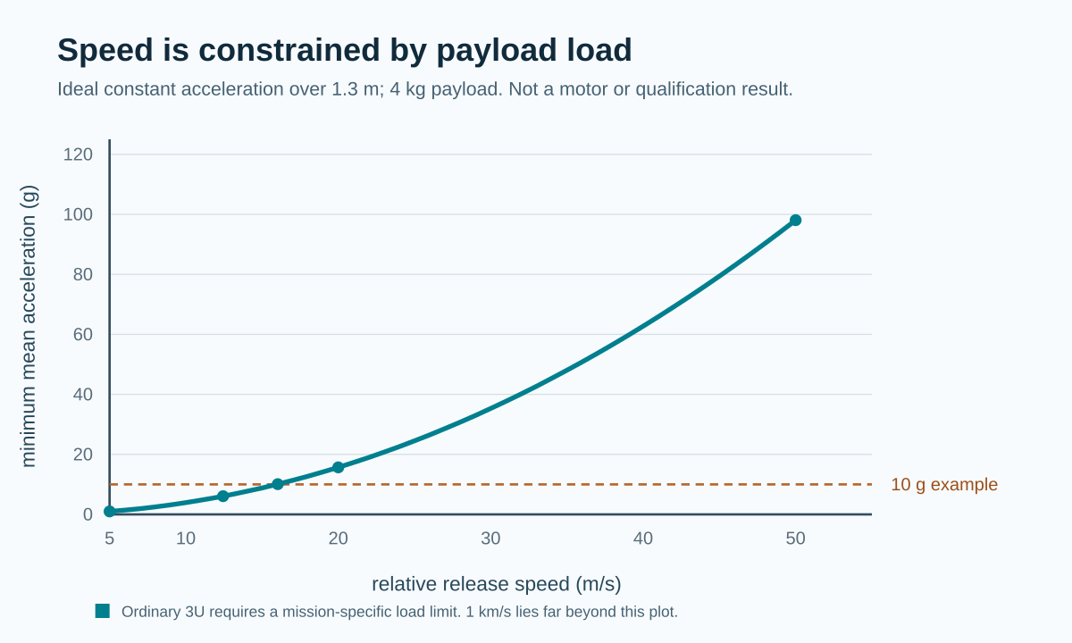
Ideal stroke/load requirements, not a measured VOLLEY command envelope.

1. Introduction

The deployment problem
The primary mission determines the launch vehicle’s delivered orbit. Secondary CubeSats may have limited onboard propulsion, mass, power, or programmatic freedom to correct that orbit. Standard canisterised spring systems are mature and effective at clearance and separation. Their release conditions, however, are governed by spring energy, payload mass, and the device rather than a separately commanded velocity profile for every satellite.
The distinction between release timing and relative-state change is central. Waiting alone between zero-relative-impulse releases from an unchanged host does not produce persistent in-track phase spacing. Spring impulse, differential drag or a host maneuver can produce a relative state; a commanded velocity along or against orbital motion can change the satellite’s orbital energy and semi-major axis. VOLLEY studies the latter capability while retaining a clear comparison with spring release and other alternatives. It does not claim that all constellation phasing requires a motor.
The host is an active participant in the mission model. After its primary mission, a suitable hosted platform would need attitude control, available resources and permission to operate. It could perform coarse orbital repositioning; VOLLEY would assign each secondary payload a local release state. No specific upper stage has been selected or approved for that role.

Buyer and spacecraft fit
The audited market and customer-fit report checks the relevant Drive market thesis and independent business-case review against current primary sources. Planet’s FY2026 filing and Spire’s 2025 filing show repeatable, configurable smallsat production. NASA’s 2026 launch review confirms that a primary mission can constrain the orbit available to rideshare payloads. Together, these support a mission hypothesis, not customer demand.
The likely party that could pay for individualized release states is a carrier, rideshare integrator or constellation operator responsible for a delivered manifest. A standardized satellite-bus maker may specify interfaces but need not buy the system. Replenishment batches and mixed-payload rideshare are candidate jobs. A one-satellite mission already in a suitable orbit is a poor fit and should favor a qualified conventional dispenser. The analyzed Gen5 system carries twelve 3U spacecraft but fails its own 3U mass screen; a PocketQube batch is a future interface redesign, not an accommodated or qualified Gen5 payload class. Payloads sensitive to magnetic fields need an explicit exclusion or design remedy. No buyer, payload or provider has confirmed these requirements.
For an economic result, price and simulate the same manifest delivered with ordinary spring impulse, spring plus host manoeuvres, onboard propulsion, an orbital-transport service and VOLLEY. The published SpaceX rideshare starting price cannot stand in for an installed VOLLEY cost or savings quote. A three-to-five-year replacement cycle and a 5–50 m/s release range are research hypotheses from the Drive market report, not Gen5 operating requirements or established market demand. The Gen6 1 km/s upper objective is a different, unvalidated regime.
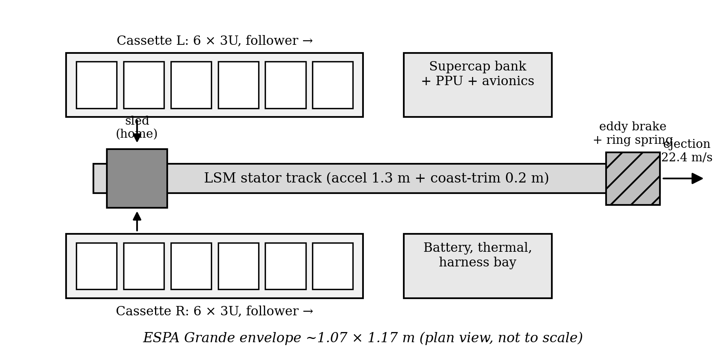
Gen5 layout and mission hardware elements. Diagram from the thesis analysis.

2. Literature review
Approach | Established capability | Relevance and limit
Spring deployers | Flight heritage and simple separation near the low-m/s range [1] | Strong benchmark for reliability and installed mass; release energy is largely built into the device.
Spring release and differential drag | In-track spacing and gradual orbital adjustment [3] | A relative impulse or drag difference creates the separation; waiting alone from an unchanged co-orbital host does not.
Orbital transfer vehicles | Coarse orbital repositioning through a propulsive carrier | Valuable comparator for whole-mission delivery; greater spacecraft and integration burden must be counted.
Electromagnetic CubeSat studies | Magazine transport and electromagnetic launch have already been studied [4–6] | Some configurations impose conductive armatures, high acceleration or different maturity; novelty cannot be claimed for electromagnetic deployment alone.
The most relevant high-speed electromagnetic comparison in the manuscript is Feng et al. [4], which models a 321.56 m/s launch of a 20 kg CubeSat but at acceleration on the order of thousands of g and with an armature/interface issue. Zhao et al. [5,6] study stacked CubeSat transfer and storage, including measured transport behavior in a related mechanism. These works establish that electromagnetic delivery and magazine transport are prior art. VOLLEY’s more limited question is whether a commandable release can be delivered to an unmodified satellite at a much lower acceleration while accounting for the whole installed system. No universal CubeSat quasi-static acceleration qualification is assumed; the launch provider and payload-specific limits must govern a real design [2,8].

3. Research gap
The analytical gap is not “no one has considered electromagnetic deployment.” It is the coupled trade between: (i) commanded release, (ii) payload-side interface and acceleration, (iii) a reusable feed/release architecture, (iv) host reaction and mission utility, and (v) installed system mass and faults. A speed-only comparison can make a concept appear attractive while omitting its sled, power bank, brake, magazine, enclosure, control, and retained mass after each shot.
The thesis addresses that gap by constructing a documented Gen5 reference configuration and testing its own claims against explicit comparisons. It also records when those tests weaken the concept. Physical viability remains a separate research gap: numerical model agreement cannot establish manufactured tolerances, actual force, payload cleanliness, cycle reliability or provider compatibility.

4. Objectives and outcome
Analytical research objective | Completed outcome | Interpretation
Model a commandable 3U system | Gen5 CAD, magazine, sled, motor, arrest and power architecture | System-level design record, not manufactured hardware
Quantify the release | Historical shot, circuit and closed-loop simulations | Predicted performance under stated assumptions
Evaluate orbital value | Orbit model and selected independent numerical cross-checks | Conditional energy and lifetime benefit
Test whole-system competitiveness | Mass rollup, spring/alternatives comparison and preset criteria | Gen5 fails the 3U mass target
Challenge model credibility | Numerical verification, defect corrections and provenance record | Scope and remaining physical uncertainties made explicit
These objectives summarize the completed analytical research for this final-review presentation. They are a presentation synthesis, not a claim that the university approved this exact list in advance. The physical development tasks are shown later under future work.

5. Research methodology
The project follows an engineering evidence chain:
- Mission/use-case framing: specify the payload, host responsibilities, target orbital change, safety limits and competent conventional comparators.
- Architecture trade: examine force production, loading, restraint, guidance, arrest, reset and fault behavior, rather than only ideal acceleration.
- Geometry and installed mass: build CAD geometry and count the sled, arrays, enclosure, feed, power, controls and other installed parts.
- Coupled models: compute magnetic field and thrust, shot dynamics, power/circuit behavior, control dispersion, structural/flow responses and orbital consequences.
- Challenge the claims: use alternate numerical methods and acceptance bands, preserve misses and update the baseline only with a recorded reason.
- Decision: compare orbital benefit against mass, reliability, payload/host compatibility and the available alternatives.
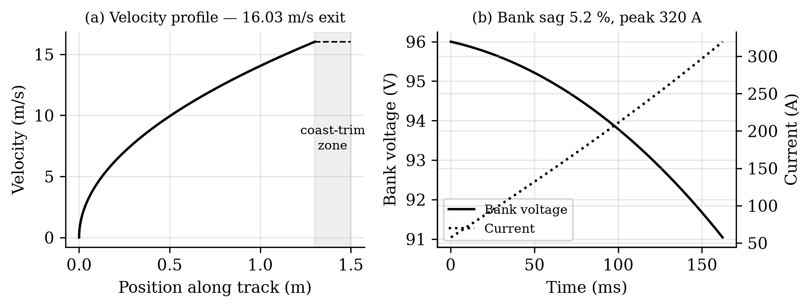
Historical modeled shot: velocity, bank voltage and current.

Numerical checks and their limits
The magnetic field was compared across an analytical representation, magpylib, and 2-D/3-D finite-element calculations. A 3-D midgap FEM solve supports the field model at its tested location; P121 separately checks the ideal depth-integrated thrust by numerical surface-charge integration. Neither is a motor measurement. Shot and circuit predictions were compared with ngspice at stated assumptions. Structural calculations use CalculiX; airflow calculations use OpenFOAM. Orbital calculations include Cowell and GMAT cases. The independent orbit work rejected an earlier assertion that lifetime benefit was invariant across solar activity. Each check applies to its declared case and boundary conditions; none is a hardware test.
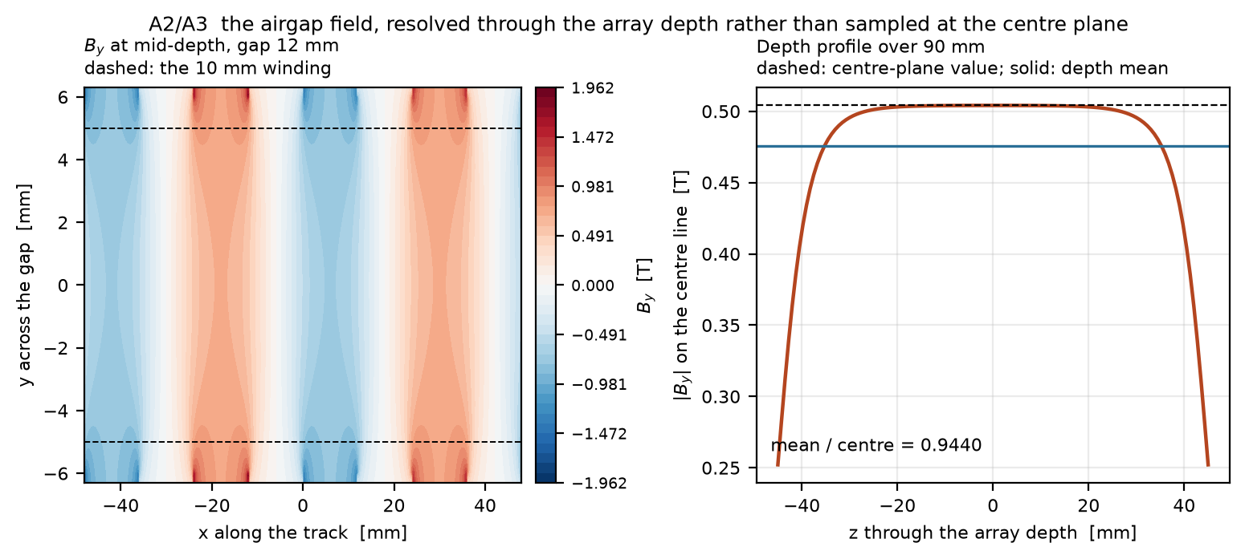
Representative magnetic-field model output. Source: thesis figure A02.

6. Timeline

Documented evolution
Period | Milestone | Confidence in date
2023 | Free-flyer idea reframed around a host platform | Documented design decision
Mid-2025 | Coilgun concept shifted toward a linear synchronous motor | Approximate historical milestone
2025–July 2026 | CAD generations and mass model developed | Some dates reconstructed/approximate
July–September 2026 | Gen5 analysis, numerical checks, defects and thesis record | Dated repository/analysis records
October 2026 | Gen5 findings and design decision presented for final review | Review package dated 10 October 2026
The thesis repository’s reconstructed history expressly marks several early milestone dates as approximate. The analytical baseline was revised as evidence improved: a CAD-derived sled mass displaced a lighter parametric estimate; a depth-resolved thrust calculation lowered the historical periodic-model speed; an enclosure buildup exposed the 3U mass penalty; and an independent orbit check rejected an overbroad solar-invariance claim. These revisions form the documented computational record. The selected Gen6 feeder and its physical development requirements are described separately in Section 10.

7. Work progress
The thesis deliverables are in hand: an authored manuscript, CAD renders and model geometry, analysis scripts/results, numerical verification run sheets, figures, a baseline record, a defect register, and a provenance statement. Numerical investigations cover the motor field, shot dynamics, bank/circuit, mass, orbit propagation, separation and selected structural, airflow and reliability issues. The study closes by retaining failed criteria and superseded results rather than silently replacing them.
The deliverable here is a completed computational thesis, not a flight article. The later long gas-guide and independent spring-cell studies are historical comparators. Gen6 has a mission direction and investigation envelope but is not a result of the Gen5 thesis. Its mechanism and exact payload/provider cases remain future choices.

8. Results

Gen5 configuration
The analysed system uses a double-sided Halbach-array linear synchronous motor to propel a reusable permanent-magnet sled to a release station 1.5 m from the breech on 1.8 m structural longerons. Two transverse cassettes are intended to feed twelve 3U satellites, but the present side-fed placement fails the fit check. A capacitor-based bank supplies the modeled pulse, and a brake is intended to arrest the sled after payload release. The 9.45 kg sled input comes from historical Gen3 CAD solid volumes; this value reduced the exit speed relative to an earlier optimistic parametric estimate. The CAD render conveys a concept, not manufactured or assembled hardware.

Historical nominal 3U shot
Model output | Rated result | Interpretation
Exit velocity | 16.029 m/s | Modelled 3U reference shot
Payload acceleration | 10.07 g | Not a payload qualification claim
Pulse duration | 162.3 ms | Modelled motor actuation
Peak current | 320 A | Component implementation unverified
Electrical energy drawn, gross | 2,782 J | Bank/circuit model
Recovered after release | 47 J | 39 mm available recovery zone
Sled energy to brake | 1,162 J | Major loss and arrest burden
Electrical-to-payload efficiency, net | 18.8% | 514 J payload kinetic energy / net draw
The energy flow matters more than the velocity headline. The sled and its arrest hardware are part of the modeled price of avoiding a payload-side drive armature. Regeneration returns only a small fraction of sled energy within the available length. P117 separately checks the reported mass and energy identities and reconciles the historical 124.488 J (4.47%) compact-output remainder to 90.964 J assumed converter loss, 32.460 J auxiliary draw and 1.064 J of forward-Euler step excess, with a rounded residual below 0.001 J. This closes historical model arithmetic only. Selected hardware, switching and installed power verification remain open.

Command precision
The closed-loop Monte Carlo model predicts 0.0274 m/s ($3σ$) exit-velocity dispersion around a 15.8 m/s fleet setpoint. It uses assumed sensing and plant tolerances, with headroom below the open-loop ceiling. This is a simulated distribution, not a measured release repeatability.
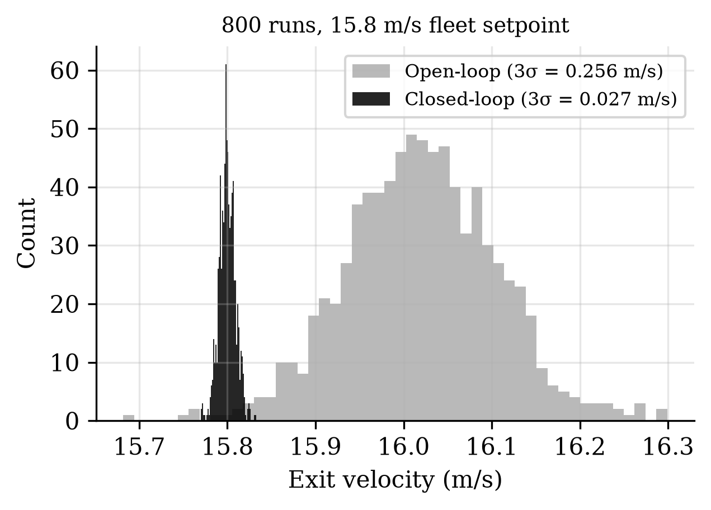
Closed-loop simulation distribution at the fleet setpoint.

Orbital utility
For the stated orbit and mean-solar-activity case, an assumed historical 16.029 m/s release predicts a 28.8 km semi-major-axis increase and a 1.60× lifetime multiplier for a propulsionless satellite. A separate Cartesian two-body integration of that assumed historical state returns 28.800775 km, agreeing within the declared numerical band. This checks only the immediate orbital-energy result. P134 independently integrates the shared static-atmosphere model and gives a 1.602165 ratio; that numerical agreement does not validate real lifetime or solar invariance. Timing alone, with zero relative impulse and no host or drag difference, produces neither persistent phasing nor this semi-major-axis change.
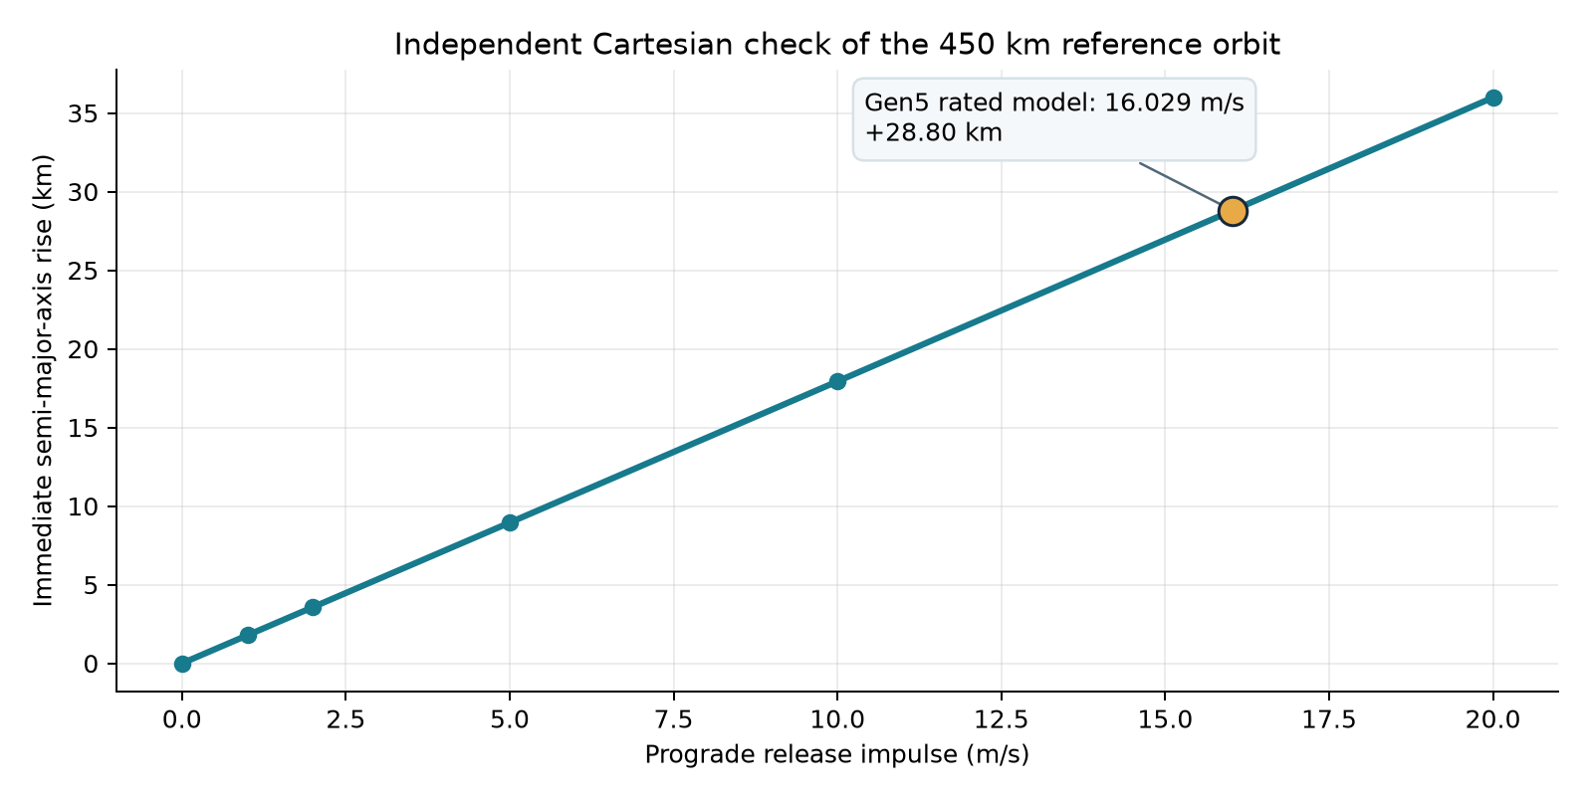
Independent historical-state two-body orbit check. The lifetime claim is outside its scope.
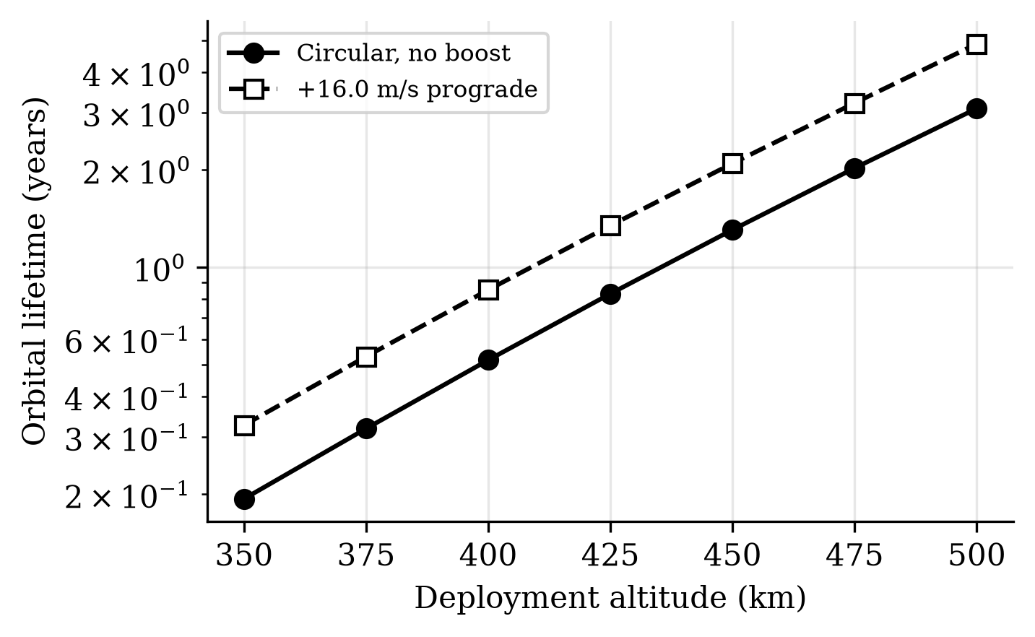
Modelled orbital-lifetime response. Absolute values depend on atmosphere.

Installed mass changes the decision
The modeled Gen5 dry rollup is 126.6 kg and loaded mass 174.6 kg; these include assumed hardware and historical Gen3 sled volume, not a mass extraction from a complete installed Gen5 assembly. At twelve 3U customers, the deployer weighs 10.55 kg per customer, compared with approximately 6 kg for the spring canister comparator used in the analysis. The ratio is 1.758; the preset acceptance band required parity within 15%. That band fails by a large margin. Replacing an 8 kg enclosure placeholder with a 50.04 kg geometry-derived buildup exposed much of the penalty. Even changing structure alone does not recover parity in the studied options. The result is a reason to reopen the architecture, not to conceal the comparison.
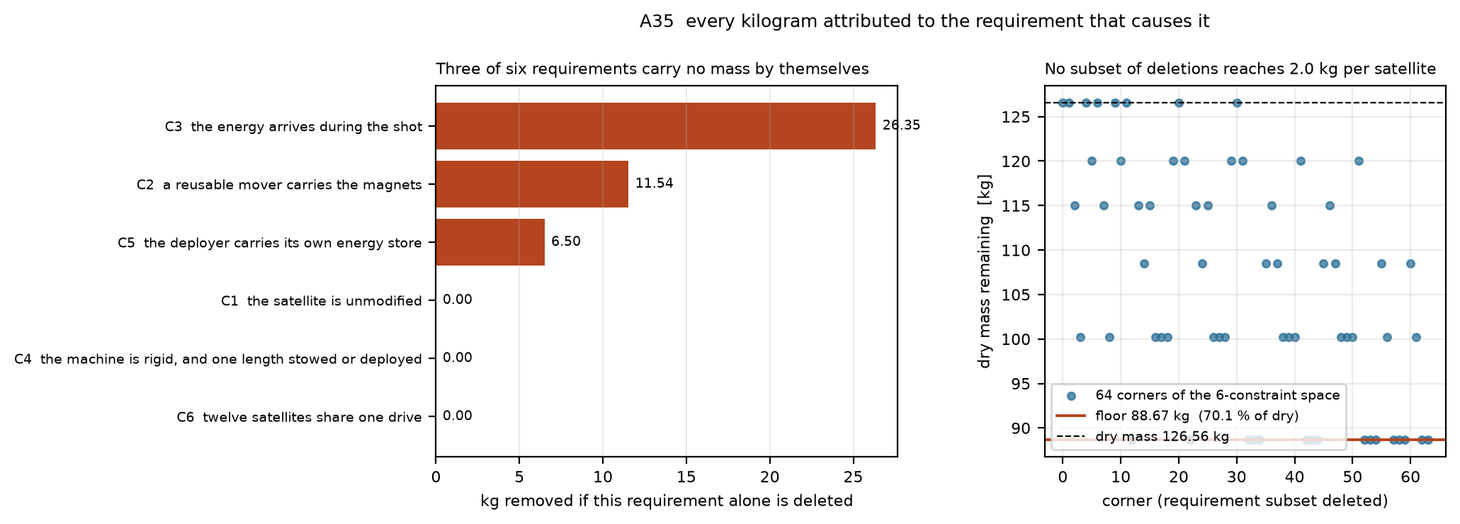
Constraint and mass-attribution analysis; mass is a model rollup.

Native CAD and packaging review
The geometry package now includes a FreeCAD 1.0 native document, eight re-exported STEP parts, and a 20-instance STEP assembly. Each imported solid passed FreeCAD validity and nonzero-volume checks. The source solids were produced in CadQuery; importing them into FreeCAD does not create parametric feature history or prove that the assembly can be manufactured. The CAD review report identifies source revisions and checks, while P116 records the numerical intersection result.
The side-fed reference assembly has 526 mm clear enclosure width. Its 205 mm track plus two 166 mm cassettes require 537 mm, an 11 mm shortfall even before running clearance. The cassette and track solids overlap by 32,915 mm³ per side in this placement. An all-leaf census finds 17 intersecting pairs, including sled/track (82,983 mm³) and sled/stator (6,300 mm³) conflicts. This fails the reference assembly as drawn. A different feed architecture, enclosure or dimension set requires a new configuration and reassessment; the current render must not be presented as an assembled flight article.
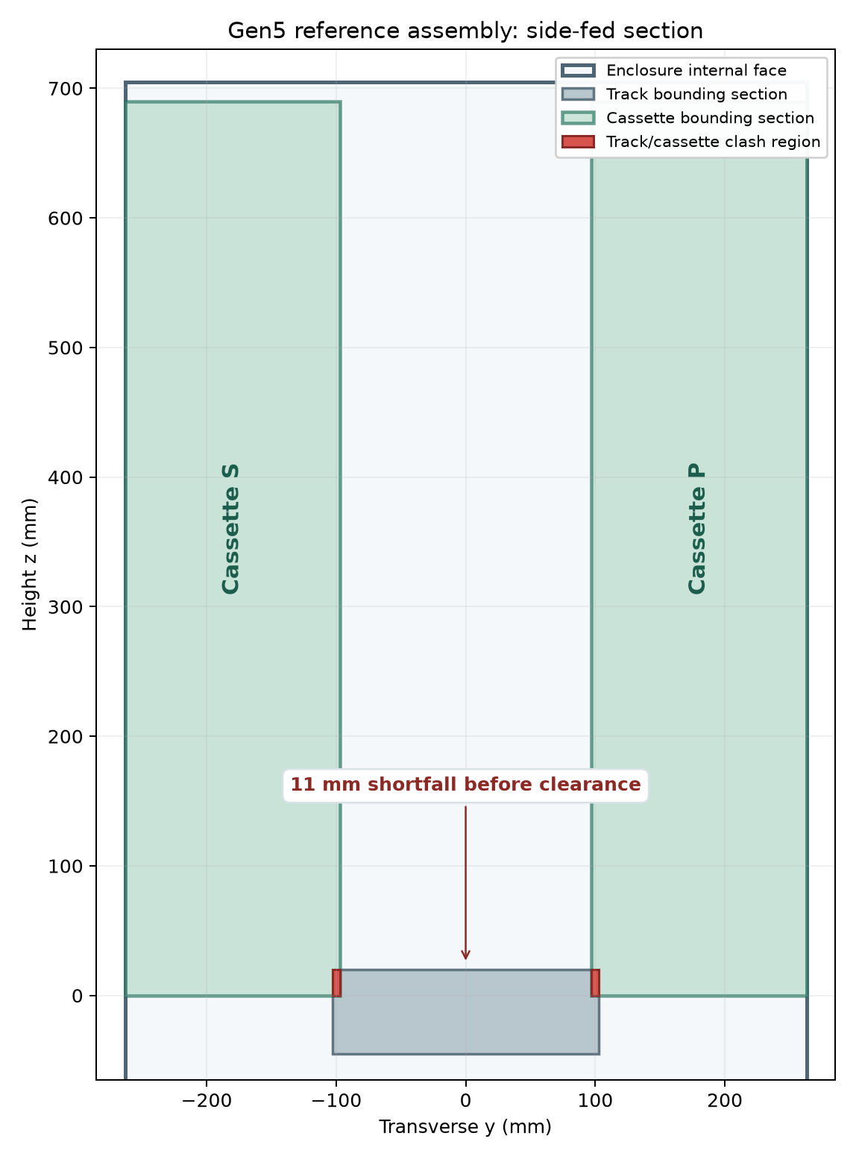
Dimensioned side-fed reference cross-section; this configuration fails the width check.

Decision and evidence boundary
The analytical result has four parts. The historical model represents a proposed commandable release and a conditional orbital-energy benefit, but its speed is challenged by finite geometry; the full-system 3U mass criterion fails; the stated side-fed layout fails its CAD width check; and physical behavior remains unverified. The latter includes release-cycle reliability, shock and arrest loads transmitted to stowed satellites, field exposure near a customer payload, host attitude/control authority and provider approval. The known-problems register ranks several as potentially design-fatal. These findings limit product claims and define the research conclusion.

9. Conclusion
The Gen5 computational thesis reaches a research conclusion within its stated scope. Its model predicts a commandable moderate-acceleration release and a conditional orbital-energy benefit, with a separate check of the immediate two-body orbital change. Installed-mass accounting misses its preset 3U benchmark, and the side-fed reference CAD assembly fails its width check. The current configuration is therefore not a selected flight baseline. Hardware behavior and interfaces remain outside the tested evidence.
The thesis’s strongest engineering contribution is the transparent decision record: system budgets and idealized mechanisms were modelled, independent numerical checks corrected several claims, and an unfavourable mass result was retained. That closes the Gen5 study and provides a defensible input to a separate future architecture trade.

10. Selected Gen6 feeder and physical development
Gen6’s controlling objective is a reusable launch path that sequentially accepts different supported CubeSat sizes and commands each departure condition. The approximately 1–2 m/s to 1 km/s span is an investigation envelope; the upper end may force acceleration, energy, travel, payload or provider constraints that reject candidates. Electromagnetic systems are preferred for comparison but are not preselected. Competent springs, electromechanical/stored-energy, gas/fluid, hybrid and conventional mission substitutes belong in the same comparison boundary.
The near-term milestone is one named test-article configuration that can be independently reviewed. Its package needs controlled geometry and drawings, a bill of materials, host and payload interfaces, full installed mass/energy/thermal accounting, assembly and inspection instructions, instrumented procedures, predetermined pass/fail and stop criteria, uncertainty and model-credibility evidence, retained failures, and an explicit build/test release decision. A rejected candidate is a valid research outcome; it must not be presented as a build-ready survivor.
12 October post-review evidence update. P130 models two passive 1U and two passive 3U spacecraft in a 500 km sun-synchronous surrogate. Both commanded release and spring-plus-host controls reach the same ideal full-state targets 24 hours after the last release. With assumed installed devices of 30 and 16 kg, commanded release saves 3.2823 kg of ideal host fuel but loses by 10.7177 kg on device plus consumed fuel. A +0.1 m/s shot error changes one-day terminal position by roughly 25–27 km. These are not customer tolerances or measured precision. P131 and P132 add two partial FreeCAD/STEP 3U first-article envelopes and necessary mechanical/source bounds. Their approximately 9.93 kg partial material proxy leaves only about 9.35 kg under the narrow surrogate parity ceiling for all omitted installed hardware. At 6 m/s, roughly 82 J of moving kinetic energy and 818 J of bus energy at an assumed 10% efficiency are lower-bound screens; neither motor nor source is selected. G0/G1 remain open, and 1 km/s remains a separate long-range research question.
A later four-cell FreeCAD/STEP packaging study compares two 1U and two 3U surrogate boxes in staggered and paired side cassettes. Both have 13 nominal represented-solid states and sampled transfer and stowed-carrier paths without penetration. Pairing moves the shortest ideal acceleration distance from 330 mm to 900 mm; at 6 m/s this lowers the corresponding ideal mean acceleration from 5.56 g to 2.04 g. Neither is an achievable-speed rating or a selected feed mechanism. Positive locks, contact loads, positioning, tolerances, installed mass and host fit remain open. This finding appears only in the 12 October post-review revision, not in the original 10 October presentation. See the Go 3 gate review.

FM08-R3 selected feeder design
The current academic feeder design uses independent guided lead-screw cassettes and one indexed receiver for two 1U and two 3U envelopes. Fixed 1U spacers remain in their cassettes. A split clutch disconnects the toothed-belt indexer before launch; stopped-carrier proof precedes re-engagement and return. A capped transfer channel, a proved-closed receiver far stop, near-side capture tabs, guides, hard stops and a normally engaged static brake define the intended containment chain. Nominal transfer is a coast operation. The pusher cannot pull a jammed spacecraft; end-stop impact remains unrated. A failed retained cell may be isolated only after independent common-path proof and supervised recovery; a bridge obstruction inhibits the shared path.
The local selected-design package provides native CAD, STEP, calculations and executable sequencing records. The safety-led trade gives the lead screw 7.30/10, rack/pawl 7.10 and spring/two-gate 6.90. These are engineering judgments. Equal weights tie the top three; alternative priorities can change the preferred mechanism. The lead screw is selected for the declared controllability and custody requirements, with rack/pawl retained as runner-up.
The conditional 50 N actuator screen gives 0.01485 N·m local motor demand and 0.02038 N·m receiver demand. At 100 N, receiver demand reaches 0.04058 N·m against a 0.0418 N·m catalog continuous rating. Resistance and 0.50 gear efficiency are assumptions; the small adverse-case margin requires physical correlation. The deterministic sequence model passes its enumerated four- and twelve-cell logical checks, including four-cell progression, empty return/home/reset, power loss, inhibited commands and supervised isolation. This verifies logical contracts, rather than real sensor truth or hardware reliability.
Earlier FM06-R1 rigid-contact convergence remains unestablished and supplies no precision or peak-load rating for FM08-R3. The selected feeder is a controlled academic design baseline. Manufacturing acceptance, environmental qualification, measured repeated releases and provider approval belong to subsequent physical development.

11. References and project records
- JAXA, JEM Payload Accommodation Handbook, Vol. 8, small-satellite deployment interface control document, cited in the VOLLEY thesis.
- California Polytechnic State University, CubeSat Design Specification, Rev. 14.1, 2022.
- C. Foster et al., “Constellation phasing with differential drag on Planet Labs satellites,” Journal of Spacecraft and Rockets, 55(2), 2018.
- H. Feng, Y. Yang and Y. Wu, “Design and reachable domain analysis of on-orbit electromagnetic launcher for CubeSats,” International Journal of Aerospace Engineering, art. 3000765, 2025.
- Y. Zhao et al., “Design and analysis of a new deployer for the in-orbit release of multiple stacked CubeSats,” Remote Sensing, 14(17), 4205, 2022.
- Y. Zhao et al., “Simulation analysis and experimental verification of the transport characteristics of a high-volume CubeSat storage device,” Aerospace, 12(6), 466, 2025.
- K. Halbach, “Design of permanent multipole magnets with oriented rare earth cobalt material,” Nuclear Instruments and Methods, 169, 1980.
- NASA, General Environmental Verification Standard, GSFC-STD-7000A, 2013.
- D. A. Vallado, Fundamentals of Astrodynamics and Applications, 4th ed., 2013.
- A. Mishra, VOLLEY-thesis: authored manuscript, baseline, provenance, figures and validation records, historical technical snapshot b30ffdc, 28 September 2026. Project record, not independent experimental evidence.
- VOLLEY, Controlled programme plan — PLAN-R2 (historical VOLLEY scope), controlled working baseline, 29 September 2026. Project plan, not achieved performance.

Reconciled engineering record, 16 October 2026
The 23-line historical mass model sums to 126.561588 kg dry, with an assumed axial CG of 0.457690 m. This is not a complete Gen5 material extraction or full inertia tensor. Potential enclosure/thermal/bracket allocation overlap remains unresolved; no unverified mass credit is taken. The original mass failure is retained.
All 17 evaluated Gen5 and five widened-R1 intersections are classified as confirmed conflicts or unresolved adapter/payload proxy intersections. None is accepted as intentional contact without an interface definition; no geometry repair is claimed. Historical isolated FE results do not qualify the failed assembly.
P134 uses a separate orbit-averaged DOP853 integration of the shared static atmosphere. At imposed inertial increments of 2.5, 12.448437 and 16.029 m/s it gives lifetime ratios of 1.082110, 1.451222 and 1.602165. The maximum refinement change is 0.000145%, below its 0.5% numerical band. Space weather, ballistic coefficient history and actual achieved release remain outside that evidence.
The corrected A15 R1 archive was executed in GMAT R2026a on 30 September and reparsed on 16 October. Its circular RAAN span is 14.558545°; the focused window minimum sampled separation is 190.149944 m. No continuous-clearance, coupled sequential host or complete mission verdict follows. The 367° historical span is withdrawn.
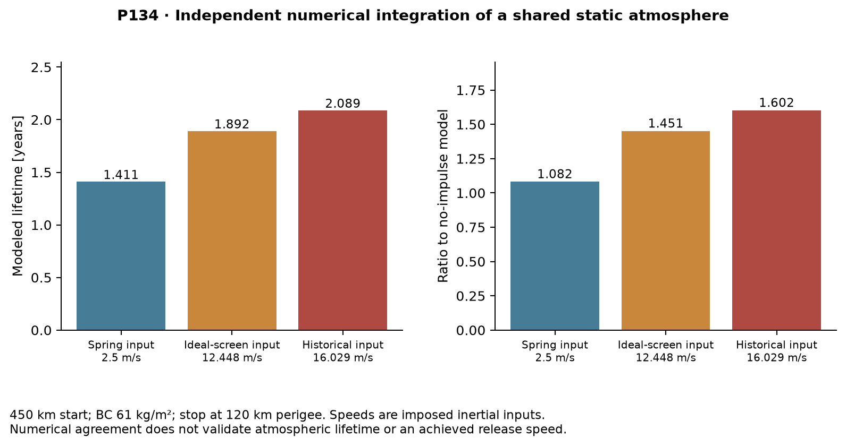
Independent numerical lifetime check under a shared static atmosphere; imposed input speeds, no environmental validation.
Mass and interface ledger · Uncertainty and acceptance · Solver boundary.

