System Design for University MIS
Designing a University Management Information System (MIS) involves creating an integrated platform that automates essential academic and administrative processes across the institution. A well-structured university MIS enhances efficiency by centralizing student records, grades, information, registration form, schedules, important school announcements and department workflows into a system that is accessible and easy to manage. It improves overall coordination between departments and provides a seamless experience for students and administrative staff. In this article, we explore the essential components and design considerations of a university MIS, highlighting best practices and technical principles required to build an efficient, scalable, and user-friendly system.

Requirements for University MIS Design
- Functional Requirements
- Calendar & Announcements
- Allows admin to posts announcements (e.g. enrollment dates, suspension of classes, holidays, events, and exam dates).
- Allows students to view calendar containing important dates.

- Academic Records & Grade Management
- Allow admins to post grades and update grades when necessary
- Allow students to view grades on each course
- Provide automatic computation of GWA.

- Payment & Billing Management
- Generate payment fees
- Allow students to view billing statements

- Non- Functional Requirements
- Performance
  - Fast response time for accessing records and grade submissions.
  - The system should efficiently handle peak-load events.
- Availability
- System should be accessible 24/7 with minimal downtime.
- Security
- Protect sensitive student information using encryption.
- Ensure secure login and session handling.
- Reliability
- Ensure accuracy and consistency of data (information, grades, payments).
- Guarantee that no data is lost during sudden failures or power interruptions.
- Usability
- Intuitive and user-friendly interface for students and administrators.
- Accessible on mobile and desktop devices.
- Follow UI/UX standards suitable for academic systems.
- Scalability
- Horizontal Scalability: Add more servers to handle increased user load.
- Vertical Scalability: System should benefit from upgrades in CPU, RAM, or storage.

Use Case Diagram for University MIS Design
Actors in our System
- Students: Can log in, can edit information (only personal details), change password, view announcements and dashboard, view schedules, view grades, view billing statements and registration form.
- Admin: inserts announcements, total billing statements, inputs the student’s academic information, inserts the students’ schedule by section, inserts student subjects (depending on the section or course), and inserts billing statements.
- System: responsible for sending of important announcements, inputs announcements in the calendar, calculate students general weighted average (GWA), inserts students’ grades.
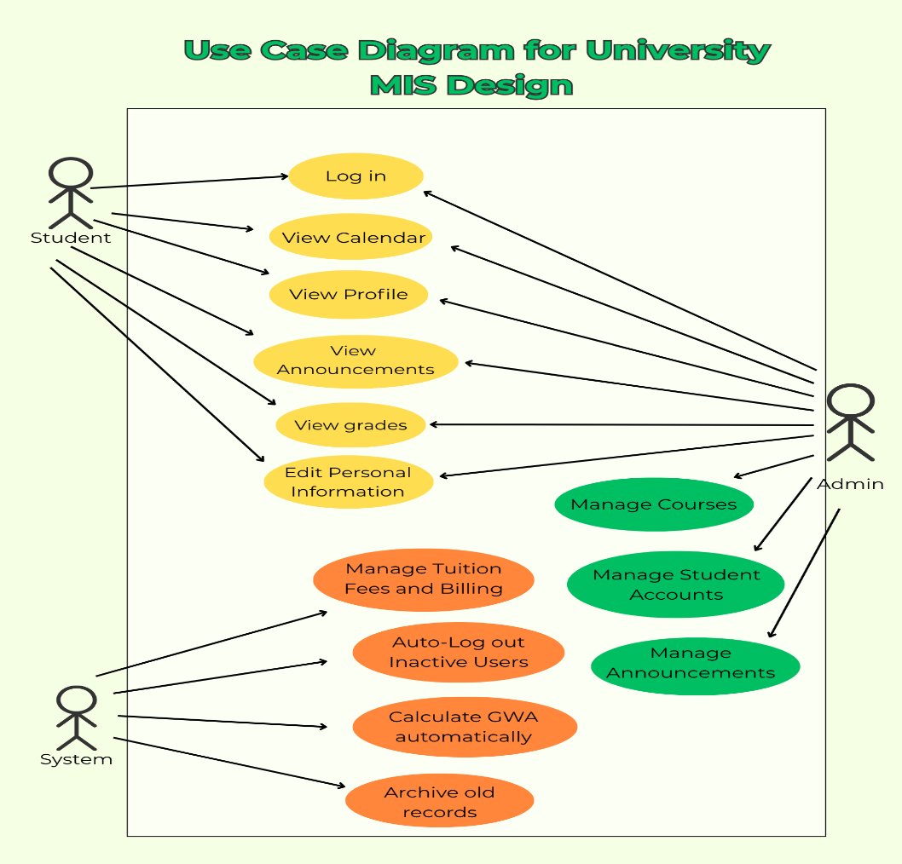

Capacity Estimation for University MIS Design
Capacity estimation for the University MIS involves identifying the required computing resources to support expected user activity, data volume, and system performance across all modules (students, admins, grades, schedules, billing, calendar, announcements, and registration forms). The goal is to ensure the MIS operates smoothly during peak academic periods and can scale as the student population increases.

1. Concurrent Users
Estimate the maximum number of users who may be logged in and performing operations at the same time.
- Concurrent Users: 3,000
- This includes:
  - Students accessing grades, billing, schedules, and announcements
  - Admins updating student records, managing schedules, entering grades, and posting announcements
Peak usage typically occurs during:
- Viewing of grades
- Exam weeks

2. Transactions per Second (TPS)
Estimate the number of transactions the MIS can handle per second.
- Transactions per Second (TPS): 5
- Given 3,000 daily transactions spread over 12 hours of operation, the system is expected to handle a peak load of around 5 transactions per second.

3. Data Storage
Estimate the amount of storage needed for student records, grades, schedules, billing, and announcements.
Student Records (example estimation)
- Number of Students: 8,000
- Size per Student: 1 KB
- Total Storage for Students: 8 MB

Admin Accounts
- Number of Admins: 200
- Size per Admin: 0.5 KB
- Total Storage for Admins: 100 KB
Grades
- Total grade entries across all students: large volume
- Size per entry: 200 bytes
- Total Storage for Grades: 64 MB
Schedules
- Total schedule entries for all sections and instructors
- Size per entry: 300 bytes
- Total Storage for Schedules: 6 MB
Billing
- Billing entries for all students
- Size per entry: 250 bytes
- Total Storage for Billing: 10 MB
Announcements & Calendar Events
- Photos and event descriptions
- Total Storage: 15 MB per year
Total Estimated Storage
- Approximately 100 MB of raw data
- With indexes, logs, backups, and media files, this may increase to 200–300 MB.

4. Network Bandwidth
Determine the bandwidth needed for smooth system operation.
- Daily Data Transfer: 50 MB
- This includes student dashboard views, grades checking, schedule loading, billing statements, and admin updates.

High-Level Design for University MIS Design
In the image below the main component of a University MIS is shown with the interaction with each other: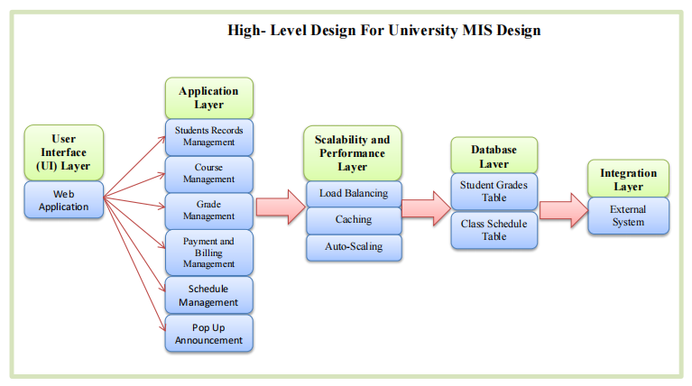
Designing a University Management Information System (MIS) involves multiple components working together to handle student records, course scheduling, grades, and finances. Here’s a high-level design that outlines the primary components and their functions.
- User Interface
- Web Application - an interface for students, system, and admin to manage academic records, courses, grades and finances. Built using HTML, CSS and hp.
- Application Layer
- Controller Services: Handle incoming requests from students or admins, process them and send response back to the UI layer.
- Business Logic Services: Implement the core functionalities such as student management, course registration, grade processing, and finance management.
- Data Layer
This Layer is responsible for data storage, retrieval, and management.
- Database Management System (DBMS): Stores all the data related to students, courses, schedule, grades and finances.

- Integration Layer
This Layer manages interaction with external system to extend the functionality to the University MIS.
- Middleware: Facilitates communication between different components and services, ensuring data consistency, reliability and security.
- Scalability and Performance Layer
This Layer ensures the system can efficiently handle increasing workloads and maintain fast response times.
- Evenly distributes incoming traffic across multiple servers to prevent performance constraints.
- Caching: Speeds up data retrieval by storing frequently use information in memory.
- Auto-Scaling: Dynamically adjusts computing resources based on demand to maintain performance during peak usage.

Low-Level Design for University MIS Design
It provides detailed information on the components and their interactions.
Modules
- User Managements – student and admin accounts, login, profile settings.
- Academic Records - student records, grades, GWA computation.
- Course and Schedule Management – courses, prerequisites, sections, class scheduling, instructor assignments.
- Billing Statements – fee entries inserted by admin, student billing display.
- Student Scheduling – student class schedule viewing, admin assignment of schedules.
- Announcements – reminders, class suspensions, exam schedules, school events, holidays with calendar integration.

This includes:
- Class diagram: Showing classes, their attributes, methods, and relationship.
- Sequence Diagram: Illustrating interactions between objects for specific use cases.
- Algorithm and Pseudo Code: Important algorithms or workflows, a pseudocode or flowcharts.

- Class Diagram
Here, we give an example of a class diagram that help in visualizing how we can see the interaction between the classes including User, Student, Admin, StudentSchedule, RegistrationForm, StudentGrades, Subject, Announcement, BillingStatement, and Calendar.
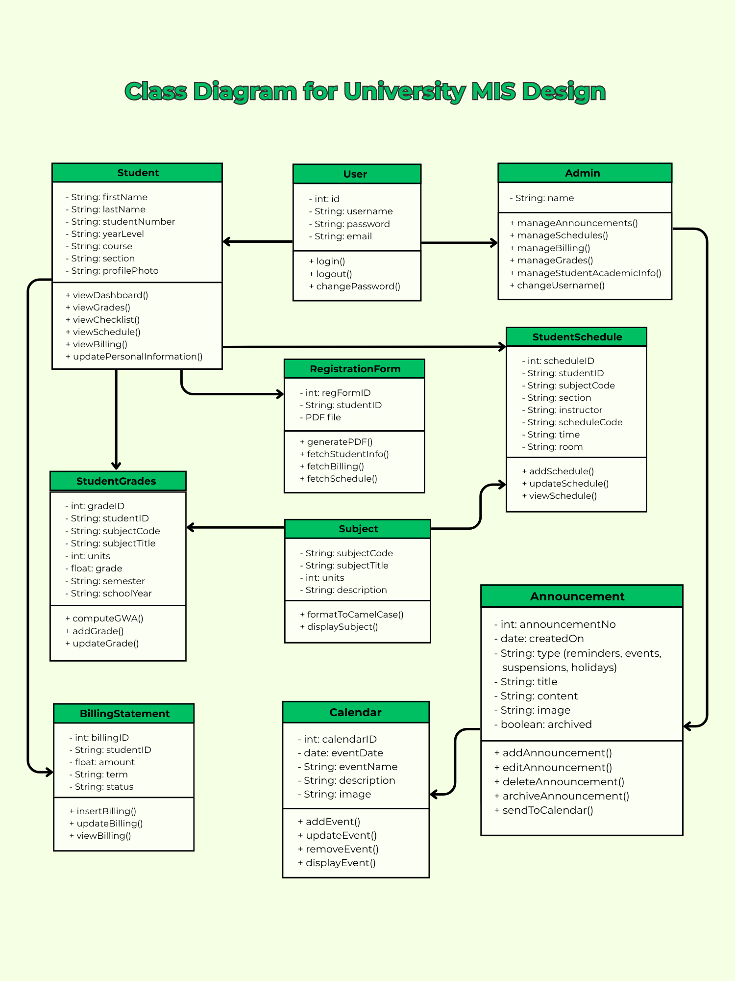

- Sequence Diagram
- To show how User (Admin and Student) will communicate with the system and the database in a sequence.
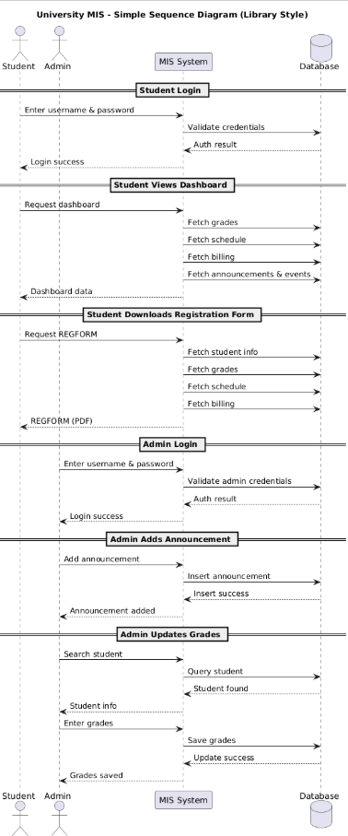

Sequence Diagram for
University MIS Design

Low-Level Design Diagram
Below is the low-level design diagram for the University Management Information System (MIS):
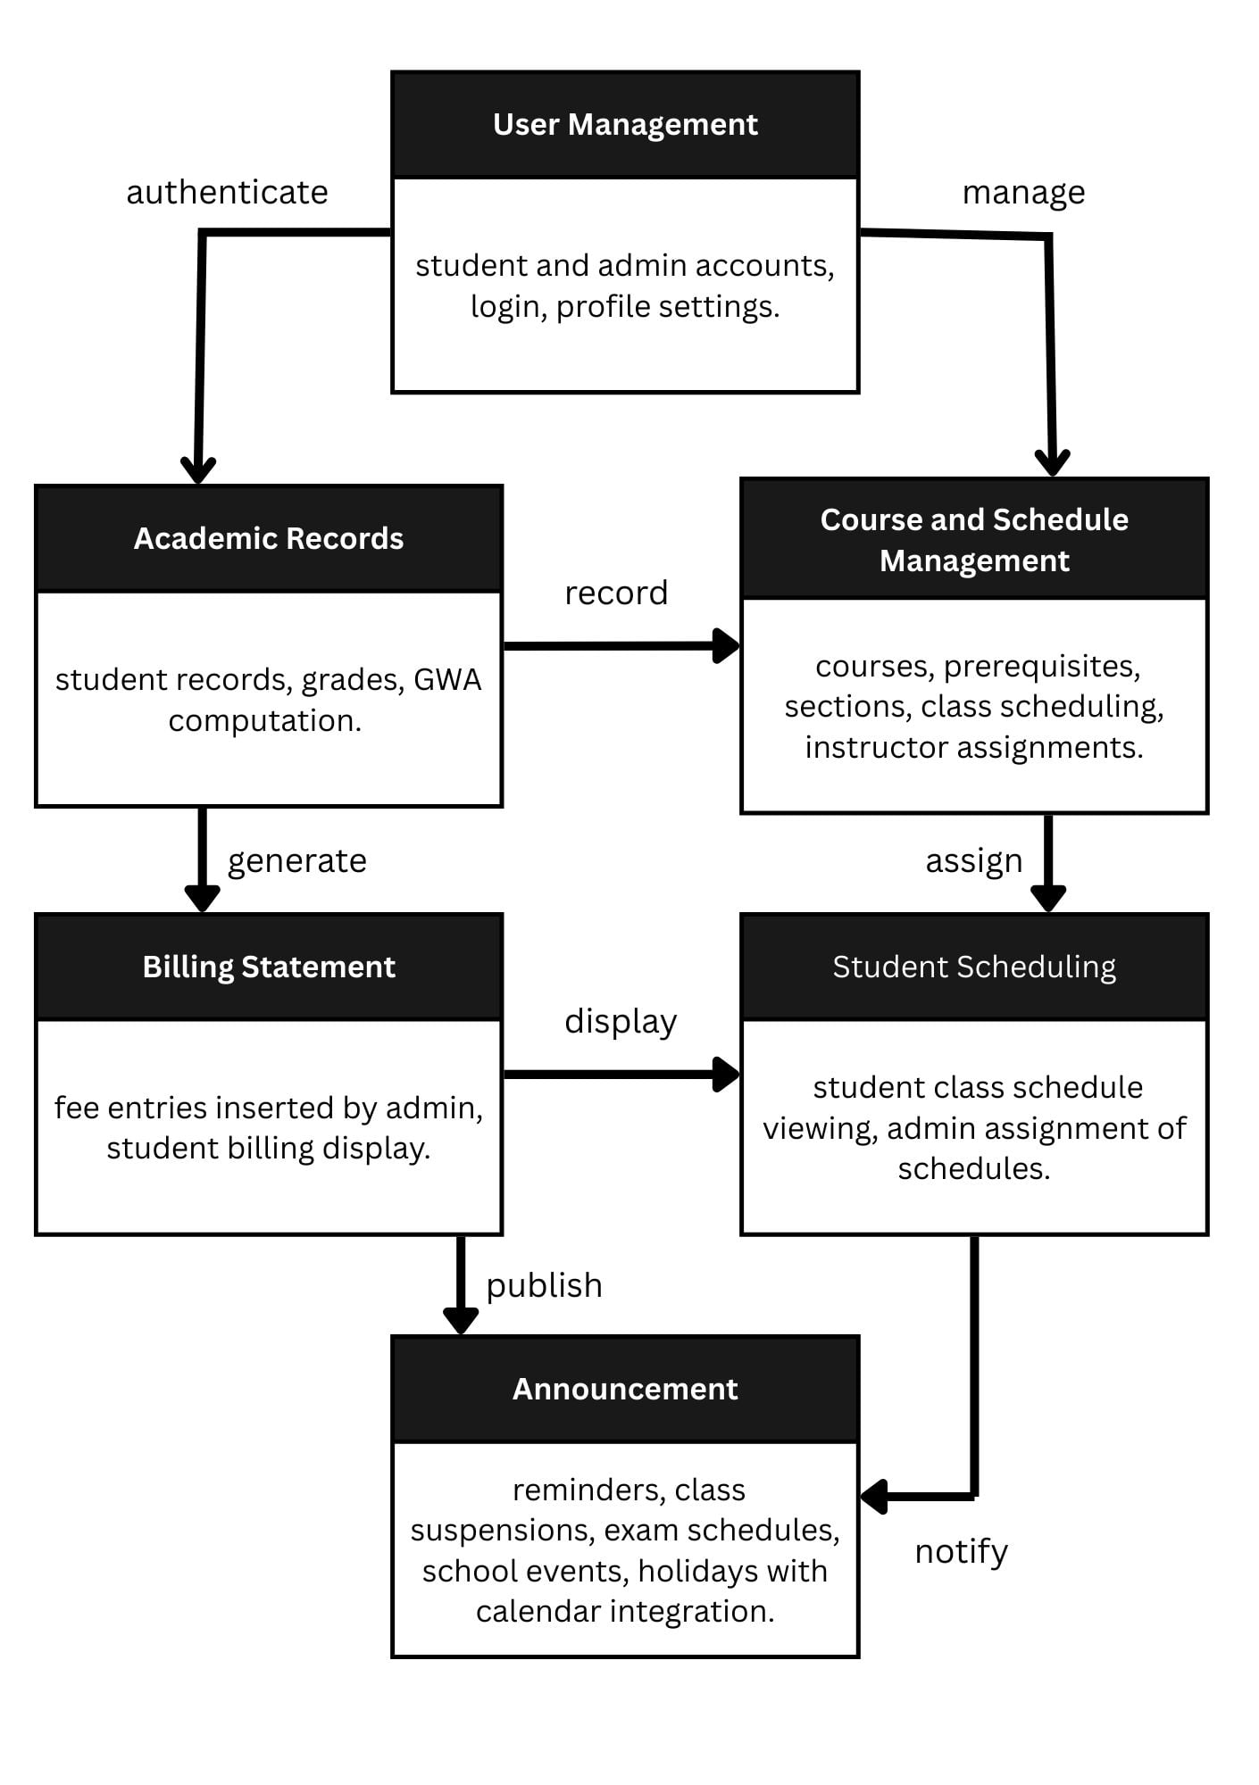
Database Design for University MIS Design:
The database design ensures the resulting university database is efficient, scalable, and maintains high data integrity across complex academic operations.
1.Visualizing the Structure (ER Diagram)
- First, we create an Entity-Relationship Diagram (ERD). This serves as a visual map, identifying all the essential data components (entities) and clarifying how they relate to one another within the system.
- University MIS Entities include Student, User, Admin, Subject, Billing Statement, and Announcement.
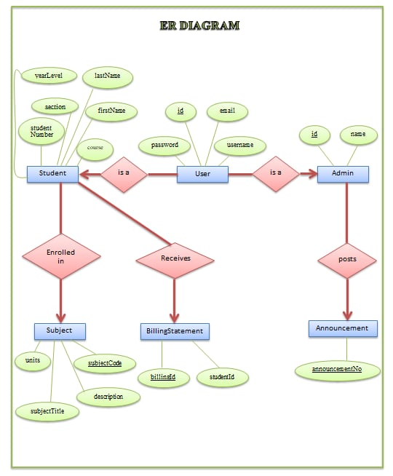
2. Organizing and Refining the Data (Normalization)
Next, we perform Normalization to structure the data optimally.
This is a multi-step process designed to eliminate data duplication and guarantee data consistency (integrity):
- Identify dependencies: Determine which attributes rely on the primary key.
- Simplify: Apply normalization rules to break down complex data sets into simpler, focused tables.
- Link tables: Establish formal relationships between these new tables using foreign keys.
- Cut redundancy: Ensure data, such as a Course and phone number, is stored only once in the Course table, preventing unnecessary duplication.
- Creating the Implementation Blueprint (Schema)
Finally, we build the detailed Database Schema, which is the actionable structure for creation:
- Define components: Clearly list all required tables and their specific columns, based on the normalized data.
- Set rules: Assign data types and specify constraints.
- Establish integrity: Use foreign keys to formally link the related tables and ensure referential integrity.
- Optimize performance: Add indexes to key columns to dramatically improve the speed of searching for records and executing academic queries.

These are the tables we create while creating out database schemas of University Management Information System (MIS).
1. Table for Users (Superclass for Login Credentials)
(Students and Admins extend from this conceptually)
CREATE TABLE Users (
UserNo INT PRIMARY KEY,
Username VARCHAR(50) UNIQUE,
PasswordHash VARCHAR(255),
Role ENUM('Student', 'Admin')
);
2. Table for Students (Personal Information)
CREATE TABLE Students (
StudentNo INT PRIMARY KEY,
UserID INT,
FirstName VARCHAR(50),
LastName VARCHAR(50),
Birthdate DATE,
Address VARCHAR(255),
Phone VARCHAR(20),
Email VARCHAR(100),
FOREIGN KEY (UserID) REFERENCES Users(UserID)
);
3. Table for Student Academic Information
(Students cannot modify this)
CREATE TABLE StudentAcademicInfo (
AcademicID INT PRIMARY KEY,
StudentNo INT,
Program VARCHAR(100),
YearLevel INT,
Section VARCHAR(20),
FOREIGN KEY (StudentID) REFERENCES Students(StudentID)
);
4. Table for Admins
CREATE TABLE Admins (
AdminID INT PRIMARY KEY,
UserID INT,
FirstName VARCHAR(50),
LastName VARCHAR(50),
Email VARCHAR(100),
Phone VARCHAR(20),
FOREIGN KEY (UserID) REFERENCES Users(UserID)
);
5. Table for Courses (Subjects)
(Used across grades & schedules (ONE TABLE as required))
CREATE TABLE Courses (
CourseCode VARCHAR(20) PRIMARY KEY,
CourseTitle VARCHAR(255),
Units INT CHECK (Units > 0),
Category VARCHAR(50)
);
6. Table for Student Schedules
CREATE TABLE StudentSchedule (
ScheduleID INT PRIMARY KEY,
StudentID INT,
CourseCode VARCHAR(20),
Section VARCHAR(20),
Instructor VARCHAR(100),
Day VARCHAR(20),
Time VARCHAR(20),
FOREIGN KEY (StudentID) REFERENCES Students(StudentID),
FOREIGN KEY (CourseCode) REFERENCES Courses(CourseCode)
);
7. Table for Grades
(Admin enters grades for students)
CREATE TABLE Grades (
GradeID INT PRIMARY KEY,
StudentID INT,
CourseCode VARCHAR(20),
Semester VARCHAR(20),
SchoolYear VARCHAR(20),
Grade DECIMAL(4,2),
FOREIGN KEY (StudentID) REFERENCES Students(StudentID),
FOREIGN KEY (CourseCode) REFERENCES Courses(CourseCode)
);
8. Table for Billing Statements
CREATE TABLE BillingStatements (
BillingID INT PRIMARY KEY,
StudentID INT,
Description VARCHAR(255),
Amount DECIMAL(10,2),
DueDate DATE,
FOREIGN KEY (StudentID) REFERENCES Students(StudentID)
);
9. Table for Announcements
(With calendar integration)
CREATE TABLE Announcements (
AnnouncementID INT PRIMARY KEY,
Title VARCHAR(255),
Description TEXT,
Category ENUM('Reminder', 'Event', 'Suspension', 'Holiday'),
Date DATE,
ImagePath VARCHAR(255),
IsArchived BOOLEAN DEFAULT FALSE
);
10. Table for Calendar Events
(for events/suspensions/holidays/exam schedule)
CREATE TABLE CalendarEvents (
EventID INT PRIMARY KEY,
AnnouncementID INT,
EventDate DATE,
FOREIGN KEY (AnnouncementID) REFERENCES Announcements(AnnouncementID)
);
11. Table for Registration Form Records (PDF logs)
CREATE TABLE RegistrationForms (
RegFormID INT PRIMARY KEY,
StudentID INT,
GeneratedAt DATETIME,
FilePath VARCHAR(255),
FOREIGN KEY (StudentID) REFERENCES Students(StudentID)
);

Scalability for System Design of University MIS:
This section explains how the Student Portal MIS can continue to work smoothly as the number of users, announcements, academic records, and stored data increases. The goal is to keep the portal stable and available at all times, especially when many students are checking their grades, schedules, or school announcements.
- Horizontal Scalability: The Student Portal is made up of several main modules such as User Management, Academic Records, Course and Schedule Management, Billing Statements, Announcements, and the Student Scheduling. Each module can be scaled independently based on use. For example, the Announcements module can be expanded during times when the school sends many updates.
- Vertical Scalability: The system can also scale by increasing hardware resources like CPU, RAM, and storage. This helps maintain high performance for features that use large amounts of data, such as viewing grades, checking academic records, loading the school calendar, and displaying student profiles.
- Database Sharding / Partitioning: As student records, grade history, announcements, and calendar data grow, the database can be separated into smaller, organized sections. This reduces the load on a single database and allows faster data retrieval when students access their profiles, grades, or school information.
- Load Balancing: To support high traffic, such as when many students check their grades, view announcements, or open the school calendar, the system can distribute requests across multiple servers. This prevents slow loading times and keeps the portal available even during busy hours.
- Caching Frequently: viewed information, such as the academic calendar, class schedules, announcements, and basic student profile details, can be stored in a cache for faster access. Caching reduces the work of the main database and improves loading speed for students and staff.
- Monitoring and Logging: Monitoring tools track the performance and health of the system, helping the school identify problems early. Logging records important events such as announcement updates, system errors, and user activities. These logs help improve the Student Portal and plan future system improvements.

