Sim-to-Real Reinforcement Learning for a Low-Cost Two-Wheeled Balancing Robot: Measuring the Plant and Tracing Limit-Cycle Shake to Training Payload
[Author 1], [Author 2], [Author 3]
[Course code and title], [Department], [University]
[Supervisor] · [Email addresses] · Project DIP-E026
Abstract—We train a neural-network balance controller for a commercial two-wheeled robot (Yahboom, STM32F103) with proximal policy optimisation in MuJoCo and run it on the robot's 72 MHz microcontroller. Early policies fell within two seconds on hardware; we traced this to firmware faults and to an actuator model that ignored the motor dead zone. We then measured the drive train on the robot (a dead zone with stiction, a 0.75 N·m torque limit, Coulomb and viscous friction, about 2° of gear backlash and up to 15 ms of delay) and validated the resulting simulator in closed loop against three controllers. With random pushes in training, a policy survived 3 N shoves as often as the stock PID, but stood 3–4× less calmly. The residual wobble is a 7–10 Hz limit cycle in which motor reversals cross the gear backlash, and four runs of reward-weight tuning did not remove it. A controlled ablation of the training curriculum identified the cause: randomised payload (0–1 kg) teaches a stiff controller that shakes the empty robot. Removing it gives PID-level calm (4.6–10.2 deg/s) but loses push recovery and fails to drive with loads of 2 kg or more. We report the measurement, validation and ablation methodology, and discuss adaptive and smoothness-regularised alternatives.
Index Terms—reinforcement learning, sim-to-real transfer, two-wheeled inverted pendulum, backlash, domain randomization, embedded control.

I. INTRODUCTION
Two-wheeled self-balancing robots are a standard benchmark for underactuated control: the body is an inverted pendulum that must be held upright by accelerating the wheels beneath it. Commercial kits ship with a cascaded PID controller that balances well. That makes them a useful test of whether a learned controller, trained only in simulation, can match a tuned classical one on cheap hardware: no floating-point unit, 64 KB of usable flash, and geared DC motors with backlash.
Deep reinforcement learning (RL) has transferred locomotion and manipulation policies from simulation to real robots when the simulator models the actuator faithfully and randomises what cannot be measured [1]–[4]. Low-cost platforms are a harder case: their drive trains have dead zones, stiction and gear play that a generic simulator does not capture, and their sensors leave much of the state unobserved. This paper reports what it took to make a PPO policy balance on such a robot, and why its behaviour still differed from the stock controller after the simulator matched the hardware.
Our contributions are:
- A measured actuator model for a geared DC-motor balancing robot, including a speed-dependent dead zone (stiction) and gear backlash, validated in closed loop against three controllers on the real robot.
- Identification of a measurement artifact, a crash-time flight recorder that captured the final hand push instead of the balancing, which had overstated hardware wobble by 3–5×.
- A characterisation of the residual failure mode, a 7–10 Hz limit cycle in which motor reversals cross the gear backlash, with evidence that reward-weight tuning alone does not remove it.
- A controlled curriculum ablation showing that training-time payload randomisation, not pushes or command range, produces the stiff, high-gain behaviour; and a payload sweep that quantifies the resulting trade-off between calm standing and driving under load.

II. RELATED WORK
Sim-to-real transfer. Domain randomisation trains a policy on a distribution of simulators so that the real system appears as one more sample [1], [4]. Peng et al. randomised dynamics to transfer an object-pushing policy to a robot arm without real-world training [4]. Tan et al. showed that transfer for a quadruped required both an identified actuator model and simulated latency, and noted that controllers with large gains can be stable in simulation yet oscillate on hardware [2]. Hwangbo et al. instead replaced the analytic actuator model with a network fitted to measured data [3]. We follow the identification route of [2]: the actuator is measured on the robot, modelled analytically, then randomised around the measured values.
Learning algorithm. We use proximal policy optimisation (PPO) [5] as implemented in Stable-Baselines3 [6], with the MuJoCo physics engine [7]. Potential-based reward shaping [8] guides learning without changing the optimal policy, under conditions discussed in Section IV.
Smooth control and backlash. Backlash in a drive train is a classical source of limit cycles in feedback control [9]. For learned controllers, high-frequency oscillation has been addressed by regularising the policy itself rather than the reward: CAPS adds temporal and spatial smoothness terms to the policy loss and reduced a quadrotor controller's power use by almost 80% [10].
Adaptation. Where a robot's dynamics vary, as with an unknown payload, rapid motor adaptation infers the latent parameters from recent history [11], and residual RL learns a correction on top of a conventional controller [12]. We discuss both as alternatives to the robust, payload-blind policy studied here.

III. SYSTEM

A. Hardware
The robot is a Yahboom balance car: an STM32F103 microcontroller (72 MHz Cortex-M3, no FPU), an MPU6050 IMU, an AT8236 motor driver and two JGB37-520 geared DC motors with quadrature encoders. The simulated body mass is 0.94 kg. The stock firmware runs a cascaded PID (balance, velocity and turn loops) on a Kalman-filtered pitch angle. We added a firmware mode that runs the learned policy at 200 Hz in place of the PID, using the same sensors and motor driver.

B. Simulator and policy
The simulator is a MuJoCo model built from the team's measured mass and inertia parameters, with each wheel driven through a rotor joint and a gearbox with configurable play. The policy is a multilayer perceptron, 34 → 64 → 64 → 2 with tanh activations (6,530 parameters). Its 34 inputs are computed exactly as the firmware computes them: IMU attitude and rates, encoder-derived speed, a short history of attitude, rate and speed, leaky integrals of position and heading error, and the speed and turn commands. Yaw is pinned to zero, since the IMU has no magnetometer. The two outputs a ∈ [−1, 1] map to PWM as PWM = sign(a)·(|a|·1500 + 1300), clamped at 2800 counts; the 1300-count offset is the firmware's dead-zone compensation.

C. Deployment
The trained network is exported to C as float and int16 weight tables. The microcontroller has no FPU, so tanh is replaced by a rational approximation (worst-case output error 1.9 × 10⁻² against a test tolerance of 5 × 10⁻²). Network inference and the firmware's observation builder are each checked on a PC against the training code (worst observation error 2.4 × 10⁻⁷). The final image leaves 288 bytes of the 64 KB of flash free.

TABLE I
Measured drive-train parameters (robot, 2026-10-08)
Parameter | Value | Source
Torque limit | 0.75 N·m | motor reversal test
Dead zone at rest | 1485 counts | low-PWM step test
Dead zone when moving | 1400 counts (above 0.96 rad/s) | low-PWM step test
Coulomb friction | 0.011 N·m | step and reversal fits
Viscous friction | 0.00054 N·m·s/rad | reversal fit
Rotor armature (reflected) | 1.5 × 10⁻³ kg·m² | step test (92–97 ms time constant)
Gear backlash | ≈2° (≈4° on a later day) | hand measurement; closed-loop fit
Sense-to-act delay | ≤ 15 ms | closed-loop fit

IV. METHOD

A. Actuator identification
Policies trained on the original actuator model, which counted the firmware's 1300-count compensation as useful torque, fell within 0.2–2 s on the robot. Firmware logs showed the motors produced almost no torque below about 1460 counts. We therefore measured the drive train on the robot with three open-loop tests (PWM steps, rapid reversals, and low-PWM steps near the dead zone) and fitted the model in Table I. The low-PWM test showed stiction: from rest the wheel did not turn below about 1500 counts, but once turning it kept turning at 1420. We model this as a dead zone that falls linearly from 1485 counts at rest to 1400 counts at 0.96 rad/s. Gear backlash is modelled as free play between rotor and wheel.

B. Training
Policies are trained from scratch for 30 million steps with PPO [5]: 19 parallel environments, 2,048 steps per environment per update, minibatch 512, a learning rate of 3 × 10⁻⁴ decaying linearly, entropy coefficient 0.01 and an initial action standard deviation of 0.25. Fine-tuning runs continue from a checkpoint for 10 million steps at 1 × 10⁻⁴. A 30M-step run takes about 1.6–1.8 h on a 20-thread desktop CPU.
A three-stage curriculum first trains standing only (0–15% of training), then ramps the speed and turn commands (up to 0.3 m/s and 0.5 rad/s) together with random pushes (15–50%), then ramps the payload (50–100%). Each episode randomises the motor parameters around Table I, gear backlash (0–4°, later 0–6°), delay (5–15 ms), IMU bias and the pitch-zero error (±4°). Pushes are horizontal forces of up to 3–4 N for 0.05–0.15 s, 5–15 cm above the axle, every 1.5–4 s. The payload is a point mass 10.5 cm above the axle.

C. Reward
The per-tick reward (Table II) combines an alive bonus with tilt, effort and command-tracking terms, a potential-based shaping term [8], station-keeping terms on the leaky position and heading integrals, and smoothness terms. The shaping potential uses a low-pass-filtered yaw rate that is not part of the observation, so the policy-invariance guarantee of [8] holds only approximately. A fall (|pitch| or |roll| above 0.70 rad) ends the episode with a reward of −10.

TABLE II
Per-tick reward terms (200 Hz)
Term | Expression | Note
Alive | +2
Tilt | −3·|θ| | θ: pitch (rad)
Effort | −0.1·Σ(τ/τₘₐₓ)² | at most −0.2
Forward tracking | −2·|v − vᵣ|
Turn tracking | −2·|ω̄ − ωᵣ| − 0.2·|ω − ωᵣ| | ω̄: low-pass-filtered yaw rate; ᵣ: commanded
Shaping | 0.99·Φ(s′) − Φ(s) | potential-based [8]
Action rate | −0.2·Σ(aₜ − aₜ₋₁)² | since run 8
Position hold | −2.5·|eₓ| | position error, leaky, τ = 2 s
Heading hold | −3·|eₕ| | heading error, leaky, τ = 30 s
Wobble | −min(1.5·q², 1) | q: pitch rate; paused 1 s after a push (run 15 on)
Motor reversal | −0.3 per wheel sign change | run 16: 0.5; run 17 on: 0.3
Fall | −10, episode ends | |θ| or |roll| > 0.70 rad

D. Evaluation
Each policy is evaluated in the simulator with deterministic actions, at 2° and 4° of backlash and 5, 10 and 15 ms of delay, over two to three seeds. We report four measures. Standing wobble is the standard deviation of pitch rate (deg/s) over seconds 2–10 of a 10 s stand. Push survival is the number of 18 trials (3 seeds × 3 delays × 2 directions) that survive a 0.1 s push 10 cm above the axle. Tracking is steady-state speed as a fraction of the command. Reversals counts sign changes of each wheel command per second. The target is the stock PID run through the same simulator: 6.6–6.9 deg/s and 17 of 18 at 3 N. On the robot, wobble is measured from a 200 Hz serial stream, away from the start and from the final push.

V. RESULTS

A. Simulator validation and a measurement artifact
Early hardware wobble figures (57–95 deg/s) came from the firmware's flight recorder, which keeps the last 0.6 s before a stop. Each run was ended by pushing the robot over, so this window recorded the push, not the balancing. Measured mid-run from the 200 Hz stream, run 11 swayed at 12–22 deg/s, which the simulator with the measured actuator reproduces (13.5–21). Fig. 1 shows the agreement for three controllers on the original robot, and on a later, worse day, when the stock PID's own wobble rose from 7.6 to 11.7 deg/s, consistent with about 4° of backlash. Only after this check did we use the simulator to compare policies.

B. Push robustness
Run 11, trained with a wobble penalty but no pushes, was the calmest policy on the robot (12–22 deg/s) but survived only 1 N pushes. Adding random pushes of up to 4 N (run 12) raised 3 N survival to 14/18, and fine-tuning with a mild wobble penalty (run 13) reached 18/18, matching the stock PID, at 24–33 deg/s standing in simulation and 26–36 deg/s on the robot. Two firmware changes accompanied run 13. The pitch and roll zero was fixed at 0°, so calibration only measures gyro bias; in simulation each degree of zero error causes about 1 cm/s of creep, and on the robot creep was 0.000–0.003 m/s. The turn-rate limit was raised from 0.5 to 1.0 rad/s, after the policies tracked up to 1.5 rad/s in simulation. Fig. 2 shows training convergence for runs 12–17.

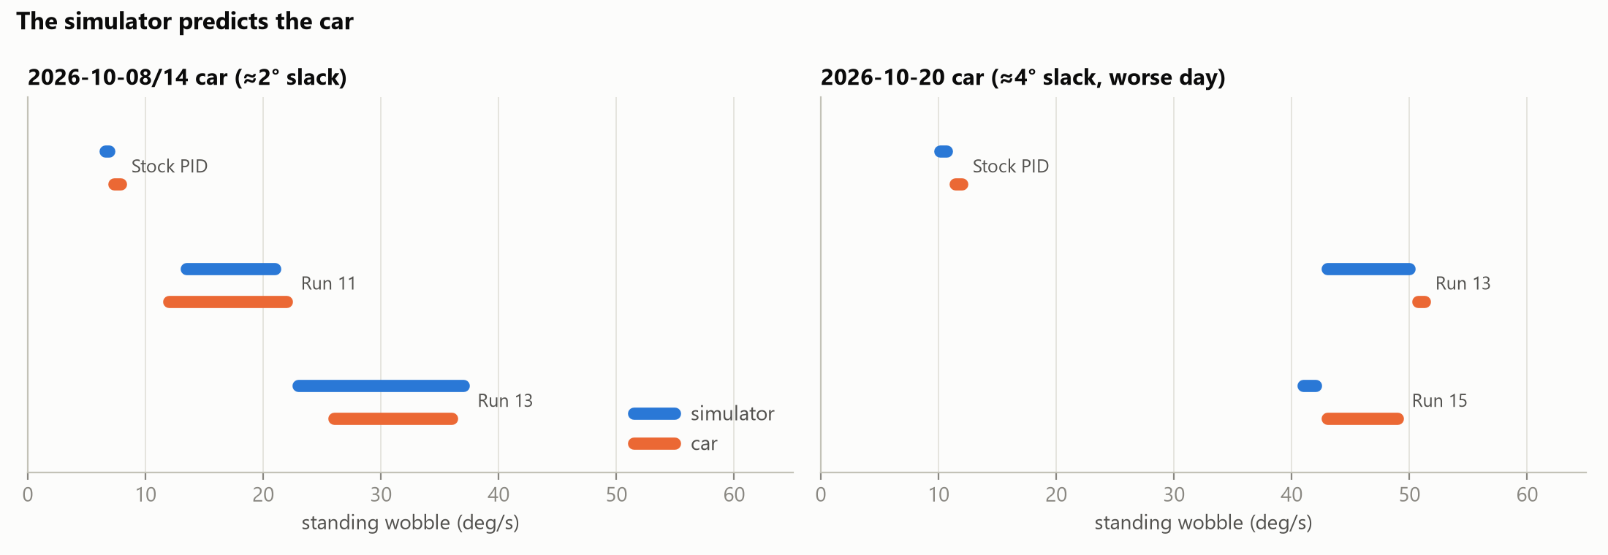
Fig. 1. Standing wobble in the simulator (blue) and on the robot (orange). Left: the original robot (≈2° backlash). Right: a later session on a worse robot (≈4° backlash, battery 11.8 V).
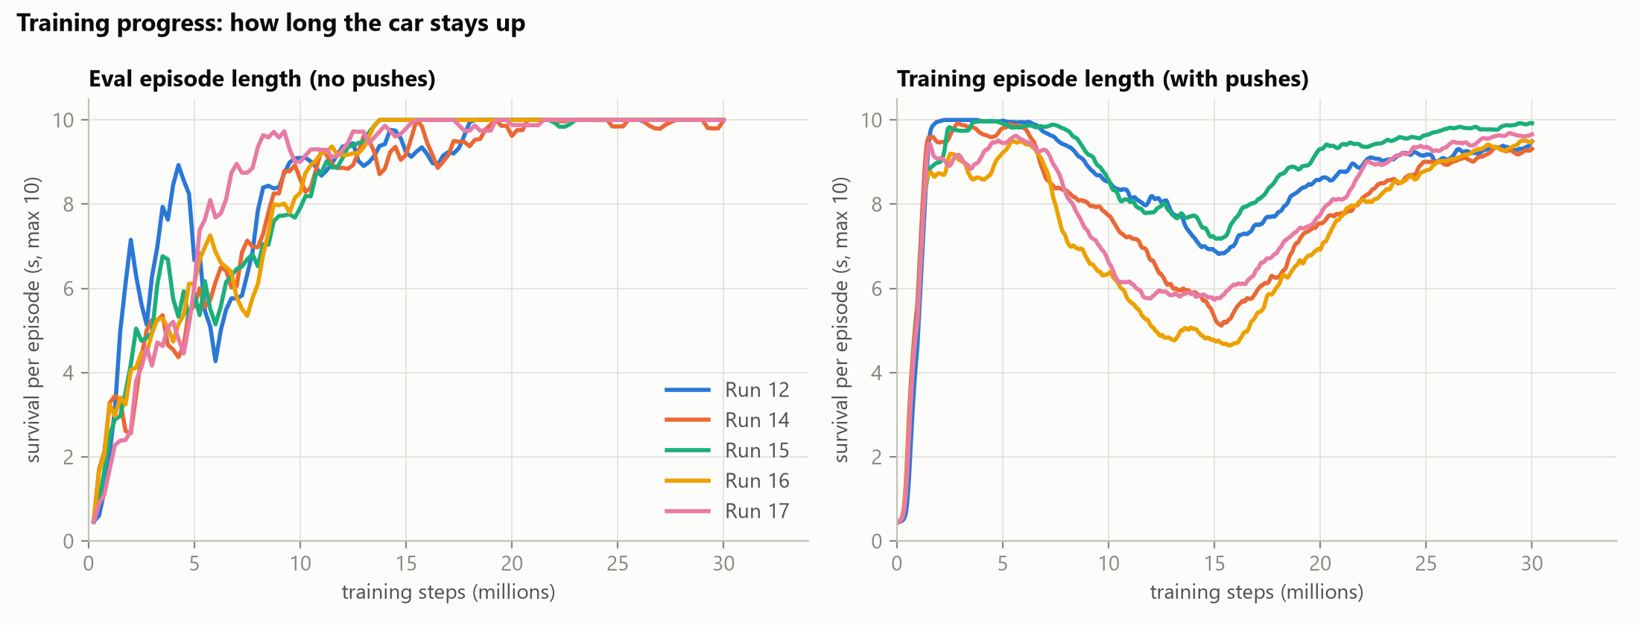
Fig. 2. Training progress, runs 12–17: mean episode length (survival, maximum 10 s). Left: periodic evaluation without pushes. Right: training episodes, which include pushes; the dip near 15M steps is where pushes, commands and payload reach full strength. Rolling means over 3 and 25 points.
TABLE III
Calm against push-proof, runs 13–17 (simulator)
Run | Change from the previous run | Wobble 2° / 4° (deg/s) | 3 N survived | Fwd / rev tracking
Stock PID | — | 6.6–6.9 / 51 | 17/18 | —
13 | pushes ≤ 4 N, wobble penalty 0.5 | 24–33 / 35–48 | 18/18 | 99 / 90 %
14 | penalty 1.5, from scratch | 17–28 / 22–37 | 5/18 | 91 / 98 %
15 | pushes ≤ 3 N; penalty paused 1 s after a push | 20–25 / 35–44 | 18/18 | 93 / 87 %
16 | + reversal penalty 0.5; backlash 0–6° | 15–30 / 38–45 | 0/18 | 86 / 79 %
17 | reversal penalty 0.3 | 15–28 / 27–42 | 0/18 | 101 / 103 %

C. Calm and push-proof together
Runs 14–17 sought PID-level calm without losing push recovery (Table III, Fig. 3). Raising the wobble penalty to 1.5 (run 14) made the policy calmer but cut 3 N survival to 5/18. About 10–23% of training pushes delivered more impulse than the stock PID can absorb, so run 15 capped pushes at 3 N and paused the wobble penalty for 1 s after each push. It recovered 18/18 survival at 20–25 deg/s, the best combination so far, and was deployed. A penalty on motor reversals (runs 16 and 17) did not lower the final wobble and removed 3 N survival; those runs also widened the backlash range to 6°, so the two causes are confounded.
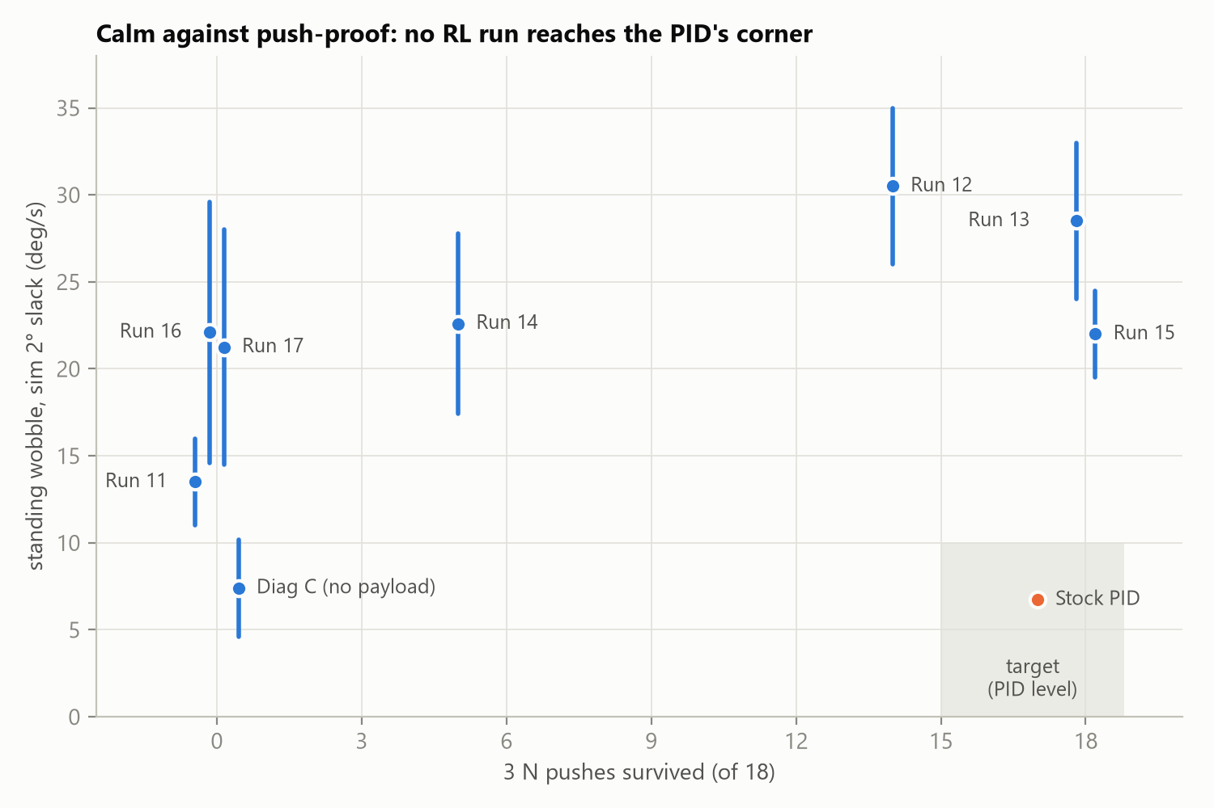
Fig. 3. Standing wobble (bars: min–max over delays and seeds) against 3 N push survival. The shaded corner is the target set by the stock PID. Runs with equal survival are offset horizontally for legibility.
A consistent pattern runs through runs 14–16 (Fig. 4). Mid-training, while the curriculum is still ramping, every run stood calmly: run 16 at 10M steps stood at 2.6–5.0 deg/s with 1–4 reversals per second, calmer than the stock PID even at 4° of backlash. Once the curriculum reached full strength, wobble rose to 15–30 deg/s. The network can represent a calm controller, so its size and activation function are not the limit. Something in the full-strength training distribution makes the stiff controller pay off.

D. Mechanism
Frequency analysis of the robot's 200 Hz stream and of the simulator shows that over 95% of the policies' wobble is above 3 Hz, peaking at 7–10 Hz, with 10–30 motor reversals per second per wheel. Each reversal drives the rotor across the backlash; the impact on the far side of the gap appears on the gyroscope, and the policy reverses again. The stock PID changes its PWM by about 13 counts per tick and rarely reverses, so it stays on one side of the gap. The action-rate penalty barely registers a 0.1 → −0.1 flip, although the dead-zone compensation turns it into a 2,600-count swing. Low-pass filtering the policy output in firmware cut reversals to 6–10 per second but did not reduce wobble, because the added lag makes the loop slower and larger. These are the backlash limit cycles of classical control [9], and the high-gain hardware oscillation described in [2].

E. Curriculum ablation
Three training factors reach full strength at the same point: pushes, command range and payload. Four 10M-step runs each held one factor back, plus a control with nothing held back (Table IV, Fig. 5). The control shook as much as run 15, confirming that the compressed schedule reproduces the effect. Halving pushes or commands left the shake unchanged. Removing the payload alone brought standing wobble to 4.6–10.2 deg/s with 5–13 reversals per second, about the stock PID's level at 2° of backlash. At 4° it still shook (21–30 deg/s), but less than the control (37–45).
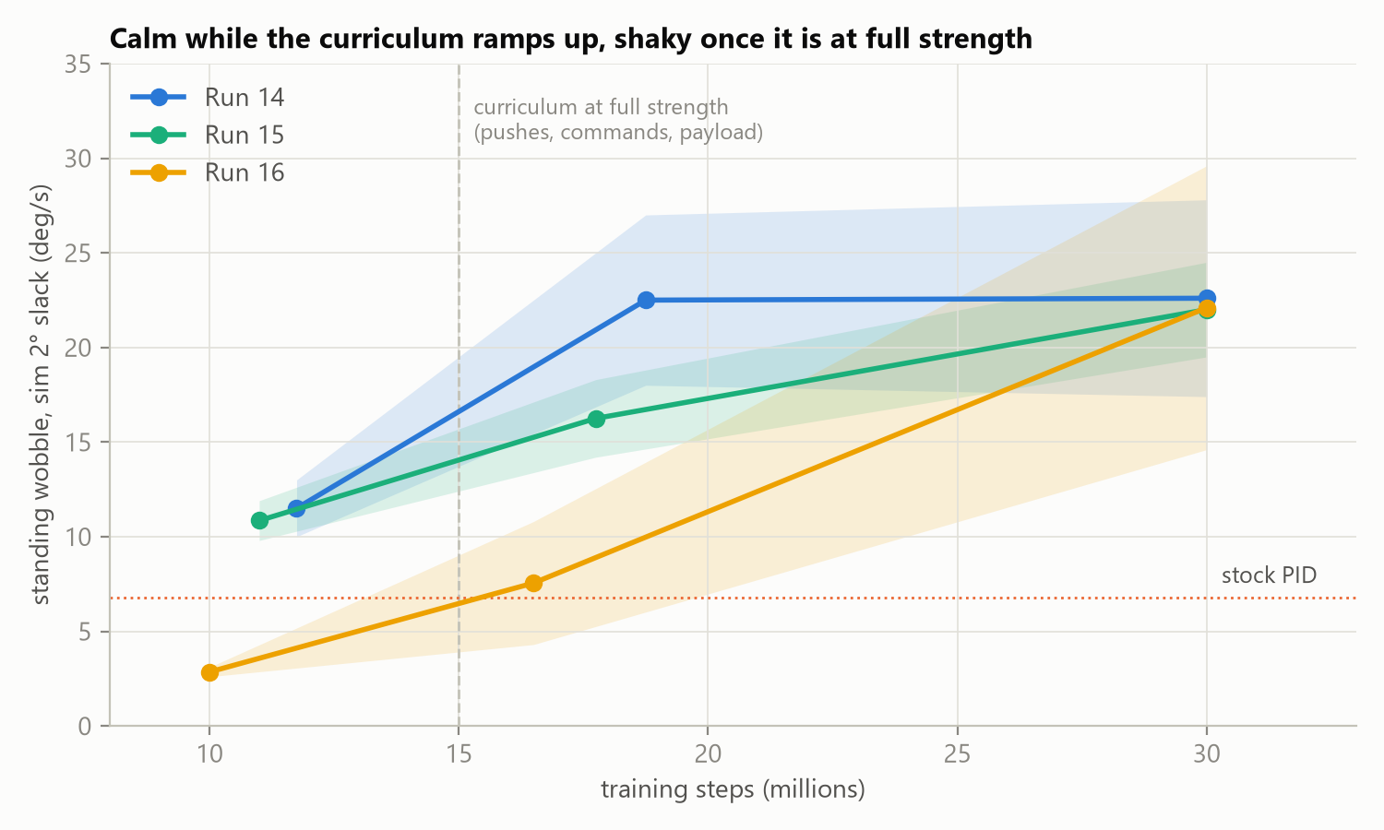
Fig. 4. Standing wobble at checkpoints of runs 14–16 (bands: min–max). All are calm while the curriculum ramps up and shake once it reaches full strength (dashed line).

TABLE IV
Curriculum ablation, 10M steps each (simulator)
Run | Held back | Wobble 2° / 4° (deg/s) | Reversals per s (2°) | 2 N survived
D | nothing (control) | 19.5–30.1 / 37–45 | 20–29 | 11/18
A | pushes at 50 % | 18.7–27.0 / 25–35 | 20–24 | 0/18
B | commands at 50 % | 14.4–22.7 / 29–36 | 19–28 | 10/18
C | no payload | 4.6–10.2 / 21–30 | 5–13 | 0/18

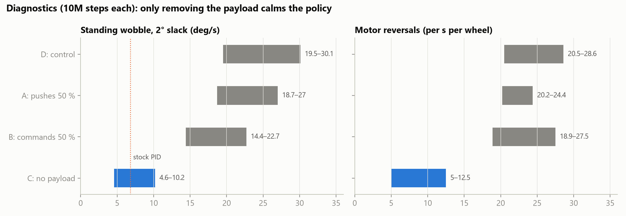
Fig. 5. Curriculum ablation (Table IV): standing wobble and motor reversals for the control (D) and with pushes (A), commands (B) or payload (C) held back. Only removing the payload calms the policy.

F. Payload trade-off
Adding payload makes standing easier for every policy (Fig. 6, left): extra mass slows the body's motion, so the same control effort produces a gentler response. A policy trained for loads up to 1 kg is therefore too stiff for the empty robot, which is the configuration we actually tested. Conversely, the policy trained without payload stood with 0–4 kg on board, but failed to drive at ±0.25 m/s with 2 kg or more (Fig. 6, right). It also survived no 2 N push, against 11/18 for the control, so the stiffness learned for payload was also what gave the push recovery.

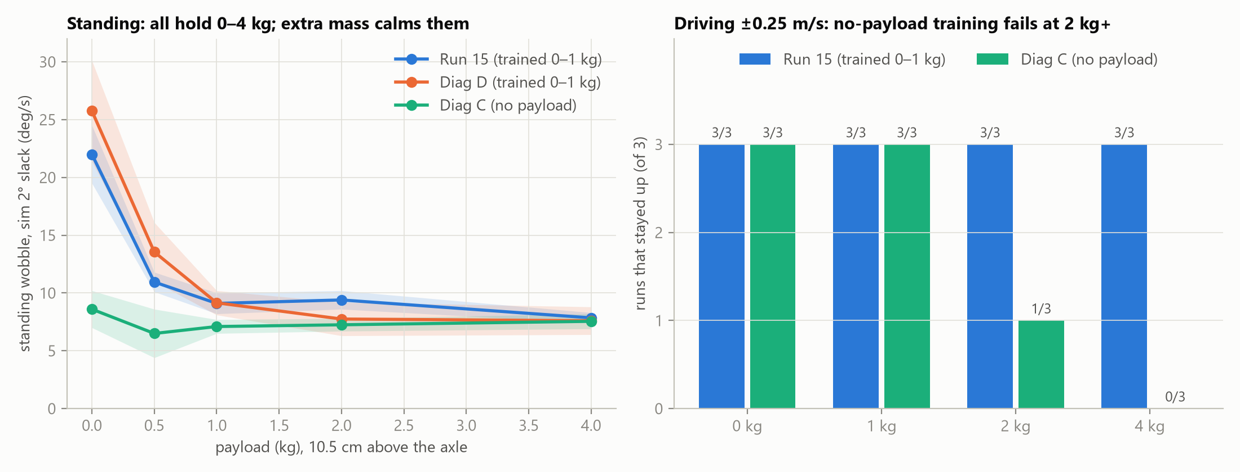
Fig. 6. Payload sweep in simulation. Left: standing wobble against payload for two policies trained with 0–1 kg and one trained without payload. Right: runs (of 3) that stayed up while driving forward then back at 0.25 m/s.

VI. DISCUSSION
The payload result reframes the problem. A single policy that does not observe its payload must be robust to the heaviest case, and robustness bought with gain shows up in the lightest case as shake through the backlash. The stock PID shows that one moderate gain can be both calm and push-tolerant on this robot when unloaded, so the trade-off was set by the training distribution, not by the hardware. Three remedies follow, differing in cost. The training payload range can be matched to the robot's actual use, which needs no code change. The payload can be given to the policy as an input, so that it is calm when empty and firm when loaded, at a small flash cost. Or the payload can be inferred from recent history, as in rapid motor adaptation [11], at a memory and compute cost the microcontroller may not afford. Independently, smoothness can be imposed on the policy itself rather than through the reward, for example with CAPS [10]; a penalty on the change in actual post-compensation PWM, active only near upright, would target the reversal mechanism directly.
Threats to validity. Most comparisons use two to three seeds of a single training run each, so differences under about 5 deg/s are within noise; the ablation conclusions rest on effects four to six times larger. The ablation runs compress the curriculum into 10M steps, leaving 5M steps at full strength. The control run reproduces the full-length shake, but push recovery may need longer training. The robot itself varied between sessions (the stock PID's wobble ranged from 7.6 to 11.7 deg/s), so hardware comparisons are made only within a session. The payload is simulated as a point mass at a fixed height.

VII. CONCLUSION
A PPO policy trained in simulation balances, drives, turns and survives 3 N pushes on a low-cost STM32 robot. The decisive steps were measuring the drive train on the robot, validating the simulator in closed loop against the stock controller, and removing a measurement artifact before comparing policies. The policies' residual shake is a backlash limit cycle driven by motor reversals; a controlled ablation traced it to payload randomisation in training rather than to the reward weights tuned over four runs. A full-length run without payload (run 18) is in progress. Next steps are matching the payload range to the robot's actual use or observing it, and smoothness regularisation of the policy.

REFERENCES
[1] J. Tobin, R. Fong, A. Ray, J. Schneider, W. Zaremba, and P. Abbeel, "Domain randomization for transferring deep neural networks from simulation to the real world," in Proc. IEEE/RSJ IROS, 2017, pp. 23–30.
[2] J. Tan, T. Zhang, E. Coumans, A. Iscen, Y. Bai, D. Hafner, S. Bohez, and V. Vanhoucke, "Sim-to-real: Learning agile locomotion for quadruped robots," in Proc. Robotics: Science and Systems (RSS), 2018.
[3] J. Hwangbo, J. Lee, A. Dosovitskiy, D. Bellicoso, V. Tsounis, V. Koltun, and M. Hutter, "Learning agile and dynamic motor skills for legged robots," Science Robotics, vol. 4, no. 26, eaau5872, 2019.
[4] X. B. Peng, M. Andrychowicz, W. Zaremba, and P. Abbeel, "Sim-to-real transfer of robotic control with dynamics randomization," in Proc. IEEE ICRA, 2018, pp. 3803–3810.
[5] J. Schulman, F. Wolski, P. Dhariwal, A. Radford, and O. Klimov, "Proximal policy optimization algorithms," arXiv:1707.06347, 2017.
[6] A. Raffin, A. Hill, A. Gleave, A. Kanervisto, M. Ernestus, and N. Dormann, "Stable-Baselines3: Reliable reinforcement learning implementations," J. Machine Learning Research, vol. 22, no. 268, pp. 1–8, 2021.
[7] E. Todorov, T. Erez, and Y. Tassa, "MuJoCo: A physics engine for model-based control," in Proc. IEEE/RSJ IROS, 2012, pp. 5026–5033.
[8] A. Y. Ng, D. Harada, and S. Russell, "Policy invariance under reward transformations: Theory and application to reward shaping," in Proc. ICML, 1999, pp. 278–287.
[9] M. Nordin and P.-O. Gutman, "Controlling mechanical systems with backlash—a survey," Automatica, vol. 38, no. 10, pp. 1633–1649, 2002.
[10] S. Mysore, B. Mabsout, R. Mancuso, and K. Saenko, "Regularizing action policies for smooth control with reinforcement learning," in Proc. IEEE ICRA, 2021.
[11] A. Kumar, Z. Fu, D. Pathak, and J. Malik, "RMA: Rapid motor adaptation for legged robots," in Proc. Robotics: Science and Systems (RSS), 2021.
[12] T. Johannink, S. Bahl, A. Nair, J. Luo, A. Kumar, M. Loskyll, J. A. Ojea, E. Solowjow, and S. Levine, "Residual reinforcement learning for robot control," in Proc. IEEE ICRA, 2019, pp. 6023–6029.

