EE3180 DIP video: an LLM that keeps a PID tuned in any scenario
Oct 24, 2026 · @Tze
A 3-minute video. The message: a PID keeps the robot upright every few milliseconds, but its gains only suit one situation; an LLM, running slowly beside it, can read the robot's data, recognise a new situation and retune the PID, so the same electronics stay robust on a ramp, with a load or on a flat battery.

Storyboard
Eight scenes, about 3 minutes. The arc: it works → the world changes → why PID struggles → the LLM tuning loop → it works everywhere → why it matters.
Time | Scene | On screen | Narration
0:00–0:15 | Hook | The robot balancing calmly on a table. A hand places a bag on it; it starts to rock, then topples. | "This robot balances itself. Until the world changes."
0:15–0:40 | How it stays up | Close-up of the board; a simple animation of P, I and D pushing the tilt back to zero, 200 times a second. | "A PID controller corrects the tilt every 5 milliseconds. Three numbers, its gains, decide how hard it reacts."
0:40–1:10 | The problem | Quick cuts: a ramp, a 2 kg load, a flat battery, a carpet, a worn gearbox. Each with the robot wobbling or creeping. | "Those gains are tuned by hand for one situation. Add weight, tilt the floor, drain the battery, and the right gains change. Today an engineer retunes them, case by case."
1:10–1:35 | The idea | The two-loop diagram (next section) builds up: fast PID on the robot, slow LLM on a laptop or phone. | "What if the robot had a tuning engineer built in? Not in the 5 ms loop, but beside it, thinking in seconds."
1:35–2:15 | The tuning loop | Screen recording: the robot's live data streams in; the LLM explains what it sees ("rocking at about 7 times a second, slow to recover") and proposes new gains within safe limits; the robot steadies. | "It reads the robot's data, recognises the situation, explains the problem in plain words and suggests new gains, tested before they are applied."
2:15–2:35 | Any scenario | Split screen: ramp, load, low battery, each with its saved gain set and a calm robot. A spoken command: "I'm carrying shopping up a ramp." | "Each situation gets its own tuned settings, saved and recalled. You can even just tell it what you're doing."
2:35–2:50 | Why it matters | Footage or stills: a walking aid for an elderly person, a delivery robot, a wheelchair base. | "For a mobility aid, a fall is not a failed test. Electronics that retune themselves stay safe in situations nobody tuned them for."
2:50–3:00 | Close | The robot balancing on the ramp with the bag; title card. | "The PID keeps it upright. The LLM keeps the PID right. EE3180 DIP."

The idea in one picture
Two loops at two speeds: the PID never leaves the robot, and the LLM only changes its three numbers. Build this diagram up piece by piece in scene 4.
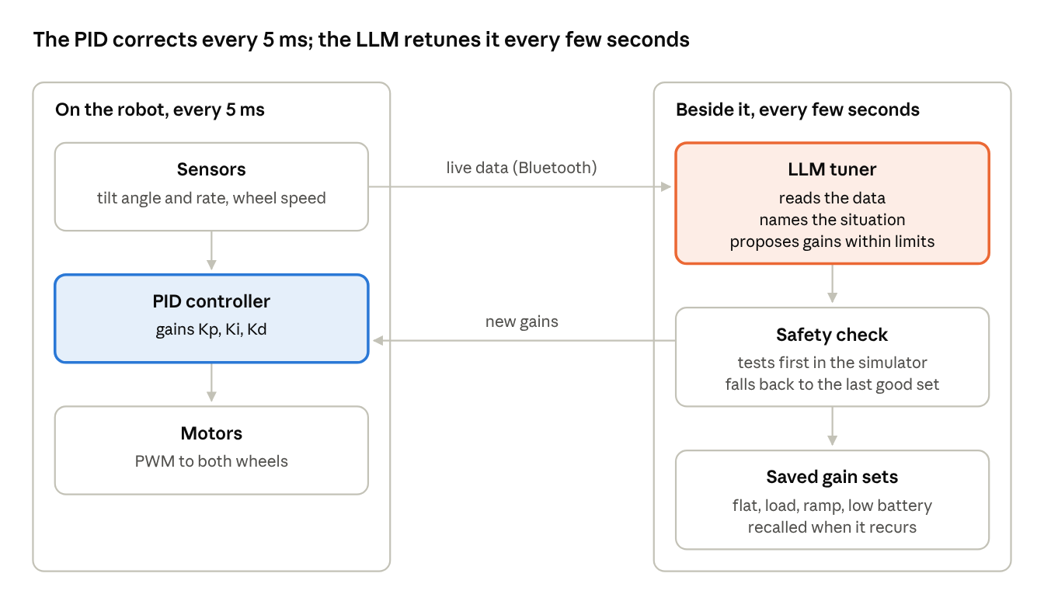
two loops · fast PID, slow LLM tuner
A spoken or typed situation ("I'm carrying shopping up a ramp") enters at the LLM tuner, which picks or adjusts the matching saved gain set.

What to film on our robot
Film real scenarios on our own car, and show one real LLM tuning step rather than a mock-up.
Scenario shots (the car in its factory PID mode, with the same gains every time):
- Flat table, empty: the calm baseline.
- A 2 kg load on top: it leans and creeps, because the load moves its balance point.
- A ramp: a wooden board, angle read with a phone level.
- A flat battery: it rocks more, because a weaker motor answers the same gains more slowly.
- Carpet against tile.
- A gentle push in each case.
The opening fact for scene 3: the manufacturer's own firmware already keeps separate, hand-tuned gain sets per mode (Balance_Kp 9,600 in one mode, 9,900 in another, an older 8,400 commented out in app_mode.c). Show that code on screen: proof that PID gains are retuned by hand for each use.
One real tuning demo, two ways:
- On the car: record the robot's data stream in a hard scenario (our logger already does this), give the log to the LLM, ask it to diagnose and propose gains, rebuild with those gains, film the before and after. Each change means reflashing; the 64 KB chip has no room left for a live gain-setting command in the current build.
- In our simulator (faster, safer): the simulator already reproduces the factory PID. Set a scenario (2 kg, low battery), let the LLM propose gains from the logged wobble, run them, show the wobble drop. Label it as simulation on screen.
Film the screen of the LLM conversation itself: the explanation in plain words is the most convincing part of the video.

Keep it honest
Present the LLM as a tuning assistant beside the PID, not as the controller, and label anything not yet built as a concept.
Claim | Say it? | Why
The LLM balances the robot | No | Too large and too slow: the loop needs an answer every 5 ms on a 64 KB chip; an LLM needs gigabytes and seconds.
The LLM retunes the PID between situations | Yes, as a concept or a filmed demo | It works on logged data at the pace of seconds to minutes, which is what tuning needs.
PID gains change with load, slope, battery and wear | Yes | We saw it on our own car, and the factory firmware ships several hand-tuned gain sets.
It works in any scenario | Qualify it | "Any scenario we can recognise and test"; an unseen situation still needs a safe default.
The LLM's gains go straight to the motors | No | New gains must stay inside safe limits, be tested first (simulator or a small step) and fall back to the last good set.
It detects an elderly person falling | Not yet | That needs extra sensing; show it as the application that motivates the work.

