Assignment 1 report

108062135 呂佳恩

For this assignment, I chose to use the linear regression with gradient descent approach.

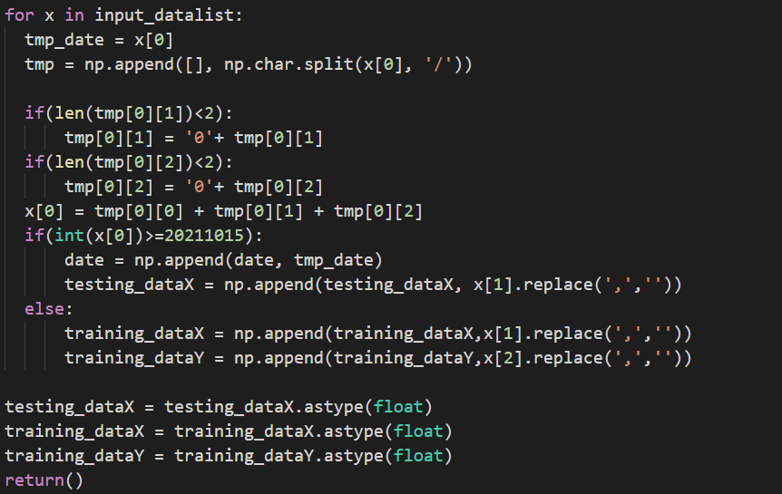The following is my code:

This is the method I used to process the data. I first removed all the ‘/’ from the data. Since it would make it hard for me to compare the dates. Since the date is in a increasing order, another approach would be to use a flag, and when the date 2021/10/15 is reached. Raise the flag. However, if the date is not in a increasing order, this would not work.

I then padded 0s for the months and dates with under two digits, so that January would be 01 and not 1. This is also for comparing the dates.

I then appended the dates. 2021/1/3 would be 20210103. This made it easy for me to compare the dates.

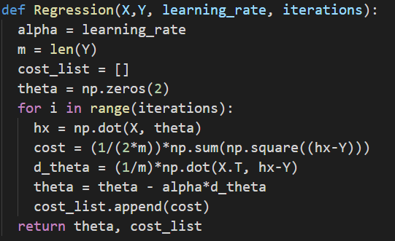

This is my model for training. The function receives four variables. The training data X and the training data Y, with the learning rate and iterations we want to train. Then we apply the functions of gradient descent and cost. I store the cost into a cost list so that I could be sure that the training is converging. The learning rate I used was 0.000005 with 1000000 iterations. I found out that a learning rate around 0.0001 would cause it to diverge. Therefore, I went with a learning rate I found that would converge and used more iterations for the training.

I used the data from 9/15 to 10/14 to validate the result of my training, the result were quite similar to the market stock prices of TSMC.