ML_HW4 report

108062135 呂佳恩

Basic :

For the basic part, since I have to consider the Bonus implementation. Therefore, after reading the paper for the Keras model, I chose the Functional API over the sequential API to build the model since it offered more flexibility and is able to combine image data and demographical data.

The parameters I tuned for improving the model:

1. set a fixed epoch and changed the filter size
2. set a fixed epoch and changed the kernel size
3. changed the # of conv2D layers
4. added dropout layers with different dropout values

I found out that if the # of epoch is too large and the filters/con2D layers were too much, the model would overfit and lose performance.

Difficulties I encountered:

I have to read a lot of articles to find information about CNN with functional API since most tutorials are built with sequential model.

Also, since the random seed is different, the partition of training/eval data varies time to time, making it difficult to evaluate the parameters I set for the models, to solve this, I tried to train for 3~5 times and using the average f1 score calculated to be an evaluation for the parameters

Bonus:

For the bonus part, since I already built my model with the functional method, I could just build another two NN with Keras and concatenate the two models with the CNN I built, the image of my model is as below

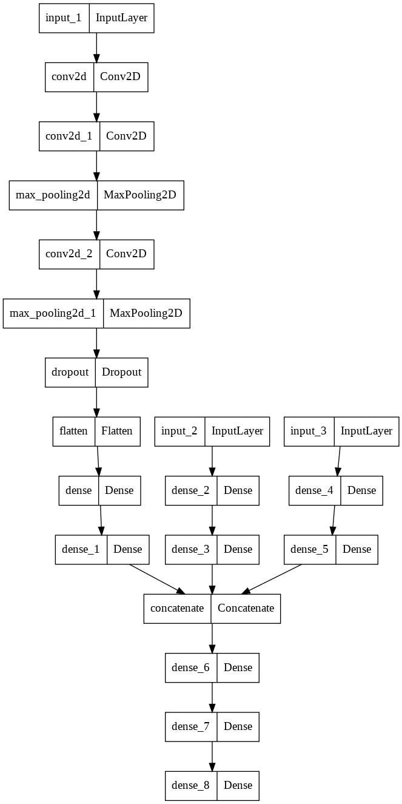

Advanced:

For the advanced part, the model I used was similar to the bonus model, with the CNN and two NN built with age and gender data.

The optimizer I used was Adam since it was computationally efficient and was widely used by other people.

I just changed the output nodes into the 7 labels that I wanted to obtain the outputs.