Task_id: 86exyfme9
Done_by: ABDULLAH BIN KHALID SAID ALHOSNI
Submession_Name : Submitting solution for Employee Management system project
Submitted_on: 17/06/2026

01 ERD Design & Mapping
Task1
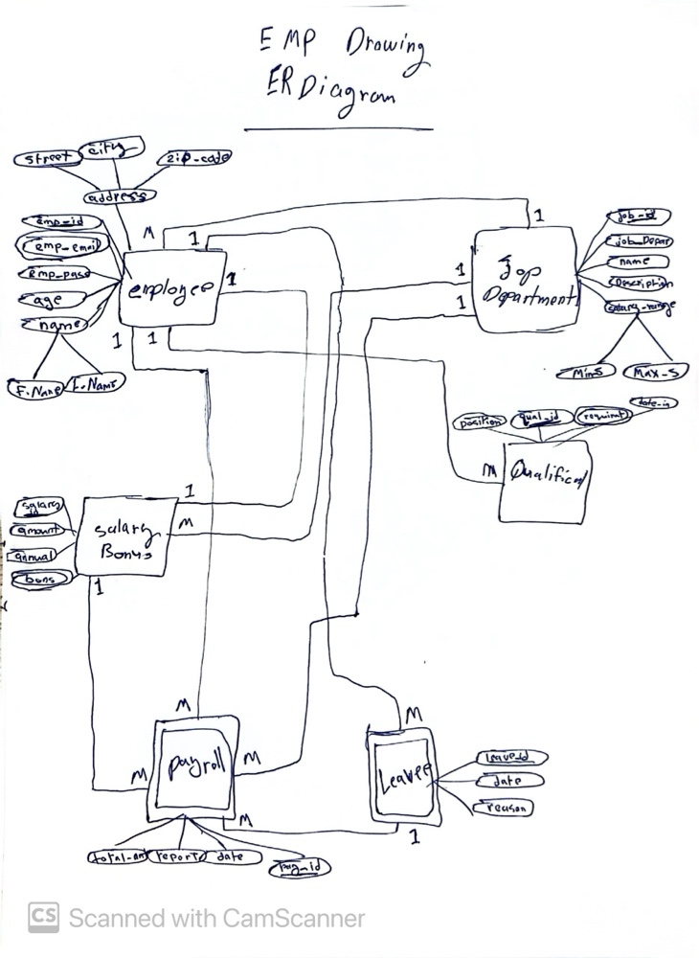
Task2
I'm converting the ER diagram into a relational schema, marking primary and foreign keys per table for referential integrity. This ensures data consistency and reliable querying. I followed ER-to-relational mapping rules and normalization, deriving each FK from its entity relationship.

Relational Schema with Keys Marked tables
EMPLOYEE Table: ( emp_id(PK) , emp_pass , age , F_Name , L_Name , street , city ,
zip_code , job_id(FK) , salary_id(FK) )
EMP_EMAIL Table : ( emp_email(PK) , emp_id(PK, FK) )
JOB_DEPARTMENT Table : ( job_id(PK) , job_Depar , name , Description , MinS ,
Max_S , mgr_emp_id(FK) )
SALARY_BONUS Table : ( salary_id(PK) , amount , annual , bons )
QUALIFICATION Table : ( qual_id(PK) , position , requirmt , date_in , job_id(FK) )
PAYROLL Table: ( pay_id(PK) , total_am , report , date , emp_id(FK) , salary_id(FK) ,
leave_id(FK) )
LEAVEE Table : ( leave_id(PK) , date , reason , emp_id(FK) )

Explicit Foreign Key Declarations
EMPLOYEE.job_id references JOB_DEPARTMENT(job_id)
EMPLOYEE.salary_id references SALARY_BONUS(salary_id)
EMP_EMAIL.emp_id references EMPLOYEE(emp_id)
JOB_DEPARTMENT.mgr_emp_id references EMPLOYEE(emp_id)
QUALIFICATION.job_id references JOB_DEPARTMENT(job_id)
PAYROLL.emp_id references EMPLOYEE(emp_id)
PAYROLL.salary_id references SALARY_BONUS(salary_id)
PAYROLL.leave_id references LEAVEE(leave_id)
Task3
I implemented Oracle DDL for the eight 3NF tables, adding primary keys, foreign keys, NOT NULL and CHECK constraints, and one sequence per table, while resolving the JOB_DEPARTMENT/EMPLOYEE circular reference with a deferred ALTER TABLE.
I created the eight tables in dependency order: the lookup and reference tables ZIP_LOCATIONS, SALARY_BONUS, and JOB_DEPARTMENT first, then QUALIFICATION, EMPLOYEE and its two dependents EMP_EMAIL and LEAVEE, then PAYROLL last since it needs the most foreign keys, pairing each surrogate-key table with its own sequence, and finishing with the ALTER TABLE that closes the JOB_DEPARTMENT/EMPLOYEE circular reference.
I used VARCHAR2 for variable-length text, reserving CHAR(1) for gender's single-letter codes. I sized every ID as NUMBER(6) and every currency field as NUMBER(10,2) to guarantee exact cent precision rather than risk FLOAT's rounding, used DATE for real calendar validation, and kept zip_code as VARCHAR2(10), not NUMBER, to preserve leading zeros and hyphens
DDL:
--- ------------------------------------------------------------------
-- 1. ZIP_LOCATIONS (no foreign keys -> created first)
-- -----------------------------------------------------------------
CREATE TABLE ZIP_LOCATIONS (
zip_code VARCHAR2(10) NOT NULL,
city VARCHAR2(50) NOT NULL,
CONSTRAINT pk_zip_locations
PRIMARY KEY (zip_code)
);

-- -----------------------------------------------------------------
-- 2. SALARY_BONUS (no foreign keys)
-- -----------------------------------------------------------------
CREATE SEQUENCE seq_salary_bonus
START WITH 1
INCREMENT BY 1
NOCACHE
NOCYCLE;

CREATE TABLE SALARY_BONUS (
salary_id NUMBER(6)
DEFAULT seq_salary_bonus.NEXTVAL NOT NULL,
amount NUMBER(10,2) NOT NULL,
annual NUMBER(10,2) NOT NULL,
bons NUMBER(10,2),
CONSTRAINT pk_salary_bonus
PRIMARY KEY (salary_id),
CONSTRAINT chk_salary_bonus_amount
CHECK (amount > 0)
);

-- -----------------------------------------------------------------
-- 3. JOB_DEPARTMENT (mgr_emp_id is a plain column for now;
-- its FK to EMPLOYEE is added in step 9, after EMPLOYEE
-- exists)
-- -----------------------------------------------------------------
CREATE SEQUENCE seq_job_department
START WITH 1
INCREMENT BY 1
NOCACHE
NOCYCLE;

CREATE TABLE JOB_DEPARTMENT (
job_id NUMBER(6)
DEFAULT seq_job_department.NEXTVAL NOT NULL,
job_Depar VARCHAR2(50) NOT NULL,
name VARCHAR2(50) NOT NULL,
Description VARCHAR2(300) NOT NULL,
MinS NUMBER(10,2) NOT NULL,
Max_S NUMBER(10,2) NOT NULL,
mgr_emp_id NUMBER(6),
CONSTRAINT pk_job_department
PRIMARY KEY (job_id)
);

-- -----------------------------------------------------------------
-- 4. QUALIFICATION (depends only on JOB_DEPARTMENT, so it is
-- created here -- right after its one dependency -- rather
-- than later next to the EMPLOYEE-related tables)
-- -----------------------------------------------------------------
CREATE SEQUENCE seq_qualification
START WITH 1
INCREMENT BY 1
NOCACHE
NOCYCLE;

CREATE TABLE QUALIFICATION (
qual_id NUMBER(6)
DEFAULT seq_qualification.NEXTVAL NOT NULL,
position VARCHAR2(50) NOT NULL,
requirmt VARCHAR2(200) NOT NULL,
date_in DATE NOT NULL,
job_id NUMBER(6) NOT NULL,
CONSTRAINT pk_qualification
PRIMARY KEY (qual_id),
CONSTRAINT fk_qualification_job
FOREIGN KEY (job_id)
REFERENCES JOB_DEPARTMENT(job_id)
);

-- -----------------------------------------------------------------
-- 5. EMPLOYEE
-- (depends on ZIP_LOCATIONS, JOB_DEPARTMENT, SALARY_BONUS)
-- -----------------------------------------------------------------
CREATE SEQUENCE seq_employee
START WITH 1
INCREMENT BY 1
NOCACHE
NOCYCLE;

CREATE TABLE EMPLOYEE (
emp_id NUMBER(6)
DEFAULT seq_employee.NEXTVAL NOT NULL,
emp_pass VARCHAR2(50) NOT NULL,
age NUMBER(3) NOT NULL,
gender CHAR(1) NOT NULL,
F_Name VARCHAR2(30) NOT NULL,
L_Name VARCHAR2(30) NOT NULL,
street VARCHAR2(100) NOT NULL,
zip_code VARCHAR2(10) NOT NULL,
job_id NUMBER(6) NOT NULL,
salary_id NUMBER(6) NOT NULL,
CONSTRAINT pk_employee
PRIMARY KEY (emp_id),
CONSTRAINT chk_employee_gender
CHECK (gender IN ('M','F')),
CONSTRAINT fk_employee_zip
FOREIGN KEY (zip_code)
REFERENCES ZIP_LOCATIONS(zip_code),
CONSTRAINT fk_employee_job
FOREIGN KEY (job_id)
REFERENCES JOB_DEPARTMENT(job_id),
CONSTRAINT fk_employee_salary
FOREIGN KEY (salary_id)
REFERENCES SALARY_BONUS(salary_id)
);

-- -----------------------------------------------------------------
-- 6. EMP_EMAIL
-- (depends on EMPLOYEE; composite key, no sequence since
-- neither column is a generated surrogate value)
-- -----------------------------------------------------------------
CREATE TABLE EMP_EMAIL (
emp_email VARCHAR2(100) NOT NULL,
emp_id NUMBER(6) NOT NULL,
CONSTRAINT pk_emp_email
PRIMARY KEY (emp_email, emp_id),
CONSTRAINT fk_emp_email_employee
FOREIGN KEY (emp_id)
REFERENCES EMPLOYEE(emp_id)
);

-- -----------------------------------------------------------------
-- 7. LEAVEE (depends on EMPLOYEE)
-- Note: "date" is a non-reserved keyword in Oracle and is
-- legal as a column name; kept here only because it matches
-- the normalized schema exactly as written.
-- -----------------------------------------------------------------
CREATE SEQUENCE seq_leavee
START WITH 1
INCREMENT BY 1
NOCACHE
NOCYCLE;

CREATE TABLE LEAVEE (
leave_id NUMBER(6)
DEFAULT seq_leavee.NEXTVAL NOT NULL,
leave_date DATE NOT NULL,
reason VARCHAR2(200) NOT NULL,
emp_id NUMBER(6) NOT NULL,
CONSTRAINT pk_leavee
PRIMARY KEY (leave_id),
CONSTRAINT fk_leavee_employee
FOREIGN KEY (emp_id)
REFERENCES EMPLOYEE(emp_id)
);

-- -----------------------------------------------------------------
-- 8. PAYROLL
-- (depends on EMPLOYEE, SALARY_BONUS, LEAVEE)
-- -----------------------------------------------------------------
CREATE SEQUENCE seq_payroll
START WITH 1
INCREMENT BY 1
NOCACHE
NOCYCLE;

CREATE TABLE PAYROLL (
pay_id NUMBER(6)
DEFAULT seq_payroll.NEXTVAL NOT NULL,
total_am NUMBER(10,2) NOT NULL,
report VARCHAR2(200),
pay_date DATE NOT NULL,
emp_id NUMBER(6) NOT NULL,
salary_id NUMBER(6) NOT NULL,
leave_id NUMBER(6),
CONSTRAINT pk_payroll
PRIMARY KEY (pay_id),
CONSTRAINT fk_payroll_employee
FOREIGN KEY (emp_id)
REFERENCES EMPLOYEE(emp_id),
CONSTRAINT fk_payroll_salary
FOREIGN KEY (salary_id)
REFERENCES SALARY_BONUS(salary_id),
CONSTRAINT fk_payroll_leave
FOREIGN KEY (leave_id)
REFERENCES LEAVEE(leave_id)
);

-- -----------------------------------------------------------------
-- 9. Close the circular reference:
-- JOB_DEPARTMENT.mgr_emp_id -> EMPLOYEE
-- (EMPLOYEE now exists, so this FK can finally be declared)
-- -----------------------------------------------------------------
ALTER TABLE JOB_DEPARTMENT
ADD CONSTRAINT fk_job_department_mgr
FOREIGN KEY (mgr_emp_id)
REFERENCES EMPLOYEE(emp_id);

02 Normalization
Task1
Why my schema satisfies 1NF:
According to rules of 1nf I followed, every cell must hold exactly one atomic
value, with no repeating groups. In my Task 2 mapping, I ensured this by doing the
following:
- I flattened the composite attributes (like Name and Address) into atomic
columns (F_Name, L_Name, street, city, zip_code).
- I explicitly extracted the multivalued attribute (emp-email) and placed it into its
own separate table (EMP_EMAIL), guaranteeing one fact per cell.
Task2
Why my schema satisfies 2NF:
According to task01_2, a table in 2NF must be in 1NF, and every non-key
column must depend on the whole composite primary key. The guide explicitly
states: "If PK is a single column, 1NF -> 2NF automatically."
- Almost all of my tables (EMPLOYEE, JOB_DEPARTMENT,SALARY_BONUS, QUALIFICATION, PAYROLL, LEAVEE) have single-column Primary Keys. Because of this, they are automatically in 2NF.
- The only table where I used a composite Primary Key is EMP_EMAIL
(emp_email, emp_id). Because this table contains no non-key columns, a partial
dependency is impossible. Therefore, it is also perfectly in 2NF.

Task3
for a table scheme task01_2 to be in 3NF, it must already be in 2NF and have no transitive dependencies. This means non-key attributes must depend only on the Primary Key, and not on other non-key attributes.
Most of my mapped tables naturally satisfied 3NF because I correctly used Foreign
Keys instead of embedding parent data (e.g., I didn't put Department Name inside the Employee table). However, as a database engineer, I spotted a classic transitive
dependency hiding in my EMPLOYEE table:
- emp_id -> zip_code -> city
- The city attribute depends on the zip_code (which is a non-key attribute),
not directly on the emp_id.
The instructions state that if A -> B -> C, then C is transitively dependent on A
through B, and I must move C into a separate table keyed by B. To strictly enforce
3NF, I have moved city into its own separate table keyed by zip_code, exactly as
the instructions dictate.
Verified Normalized Schema (1NF, 2NF, 3NF)
ZIP_LOCATIONS ( zip_code(PK) , city )
EMPLOYEE ( emp_id(PK) , emp_pass , age , F_Name , L_Name ,
street , zip_code(FK) , job_id(FK) , salary_id(FK) )
EMP_EMAIL ( emp_email(PK) , emp_id(PK, FK) )
JOB_DEPARTMENT ( job_id(PK) , job_Depar , name , Description ,
MinS , Max_S , mgr_emp_id(FK) )
SALARY_BONUS ( salary_id(PK) , amount , annual , bons )
QUALIFICATION ( qual_id(PK) , position , requirmt , date_in ,
job_id(FK) )
PAYROLL ( pay_id(PK) , total_am , report , date , emp_id(FK) ,
salary_id(FK) , leave_id(FK) )
LEAVEE ( leave_id(PK) , date , reason , emp_id(FK) )

03 SQL DML – INSERT/UPDATE / DELETE / SELECT
Task1
This task populates all database tables with realistic seed data using Oracle sequences while preserving referential integrity.
Seed data covers 5 zip locations, 5 salary records, 5 job departments, 5 qualifications, 10 employees, 10 emails, 5 leave records, and 8 payroll records, inserted in dependency order using sequence-generated keys.
Example Queries
INSERT INTO ZIP_LOCATIONS (zip_code, city) VALUES ('100', 'Muscat');
INSERT INTO SALARY_BONUS (salary_id, amount, annual, bons) VALUES (seq_salary_bonus.NEXTVAL, 1500, 18000, 500);
INSERT INTO JOB_DEPARTMENT (job_id, job_Depar, name, Description, MinS, Max_S, mgr_emp_id) VALUES (seq_job_department.NEXTVAL, 'Human Resources', 'HR Manager', 'Oversees recruitment, employee relations, and HR policy', 1200, 2200.
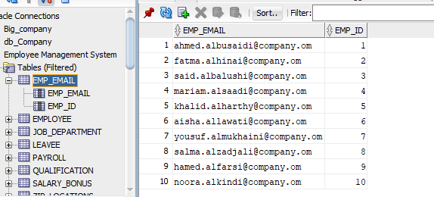
EMP_EMAIL table in Sql developer.

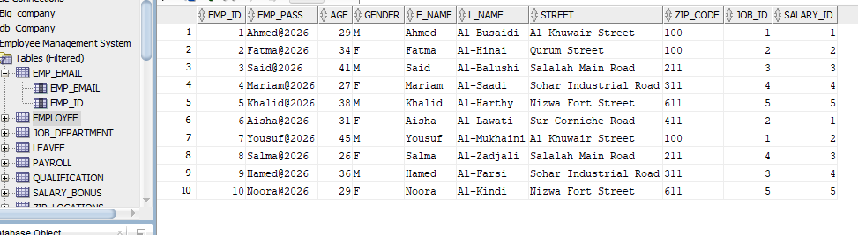
EMPLOYEE table in Sql developer.
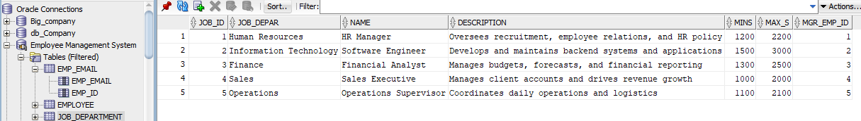
JOP_Department table in Sql developer.
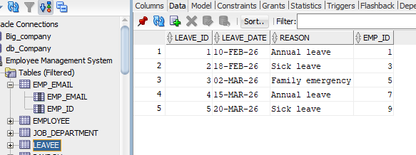
LEAVEE table in Sql developer.
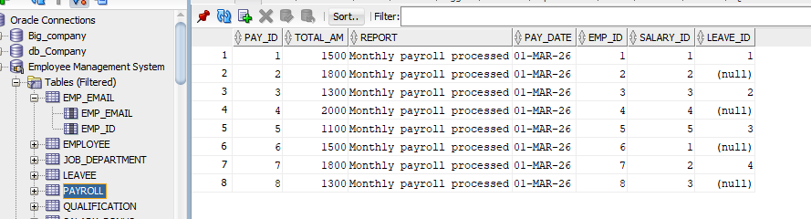
PAYROLL table in Sql developer.
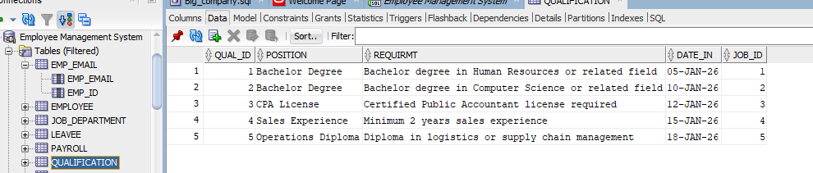
QUALIFICATION table in Sql developer.
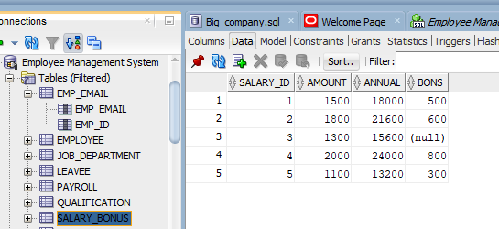
SALARY_BONUS table in Sql developer.
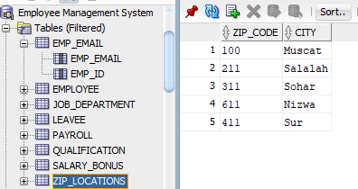
ZIP_LOCATION table in Sql developer.

Task2
This task writes four conditional SELECT queries demonstrating range filters, joins, case-insensitive pattern matching, and anti-join logic. Queries retrieve employees aged 25 to 40 ordered by last name, payroll records exceeding 5000 with employee and department details, employees who took sick leave, and departments with zero employees, using joins, LIKE pattern matching, and NOT EXISTS.
Example Queries
(a) Employees aged 25-40, ordered by last name
SELECT emp_id, F_Name, L_Name, age
FROM EMPLOYEE
WHERE age BETWEEN 25 AND 40
ORDER BY L_Name ASC;

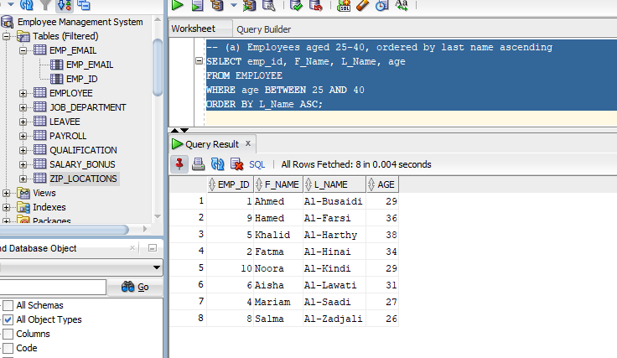
(b) Payroll over 5000 with employee and department
SELECT e.F_Name, e.L_Name, jd.job_Depar AS department,
p.total_am
FROM PAYROLL p
JOIN EMPLOYEE e ON p.emp_id = e.emp_id
JOIN JOB_DEPARTMENT jd ON e.job_id = jd.job_id
WHERE p.total_am > 5000;
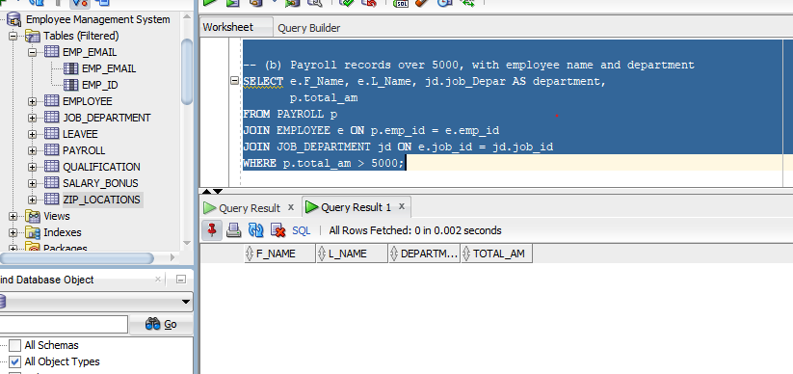
(c) Employees who took sick leave
SELECT DISTINCT e.emp_id, e.F_Name, e.L_Name
FROM EMPLOYEE e
JOIN LEAVEE l ON e.emp_id = l.emp_id
WHERE UPPER(l.reason) LIKE '%SICK%';
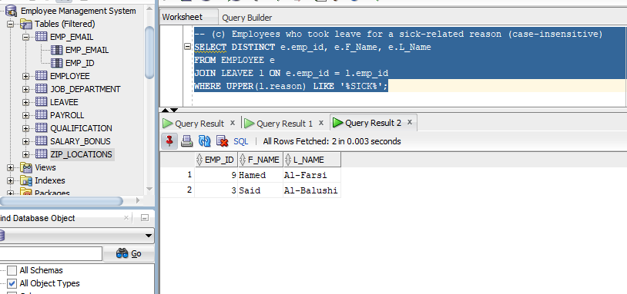

(d) Departments with no employees (NOT EXISTS)
SELECT jd.job_id, jd.job_Depar, jd.name
FROM JOB_DEPARTMENT jd
WHERE NOT EXISTS (
SELECT 1 FROM EMPLOYEE e
WHERE e.job_id = jd.job_id
);
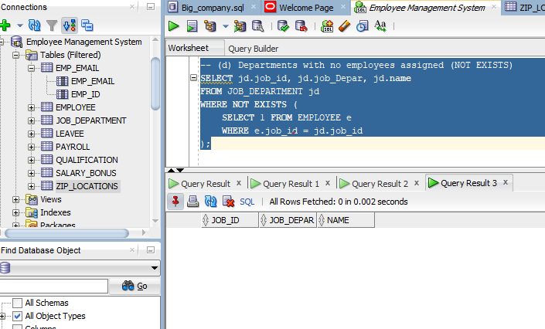

Task3

