GADGET SEVA HUB
Enterprise Service Operations

ROLE: ADMIN

Admin Portal User Guide
Complete step-by-step guide for administrators
to operate the Gadget Seva Hub Ops Console

Version: April 2026 | Gadget Seva Hub Ops Console

1. How to Log In
Open the portal URL in your browser. You will see the Sign in to Ops Console screen.
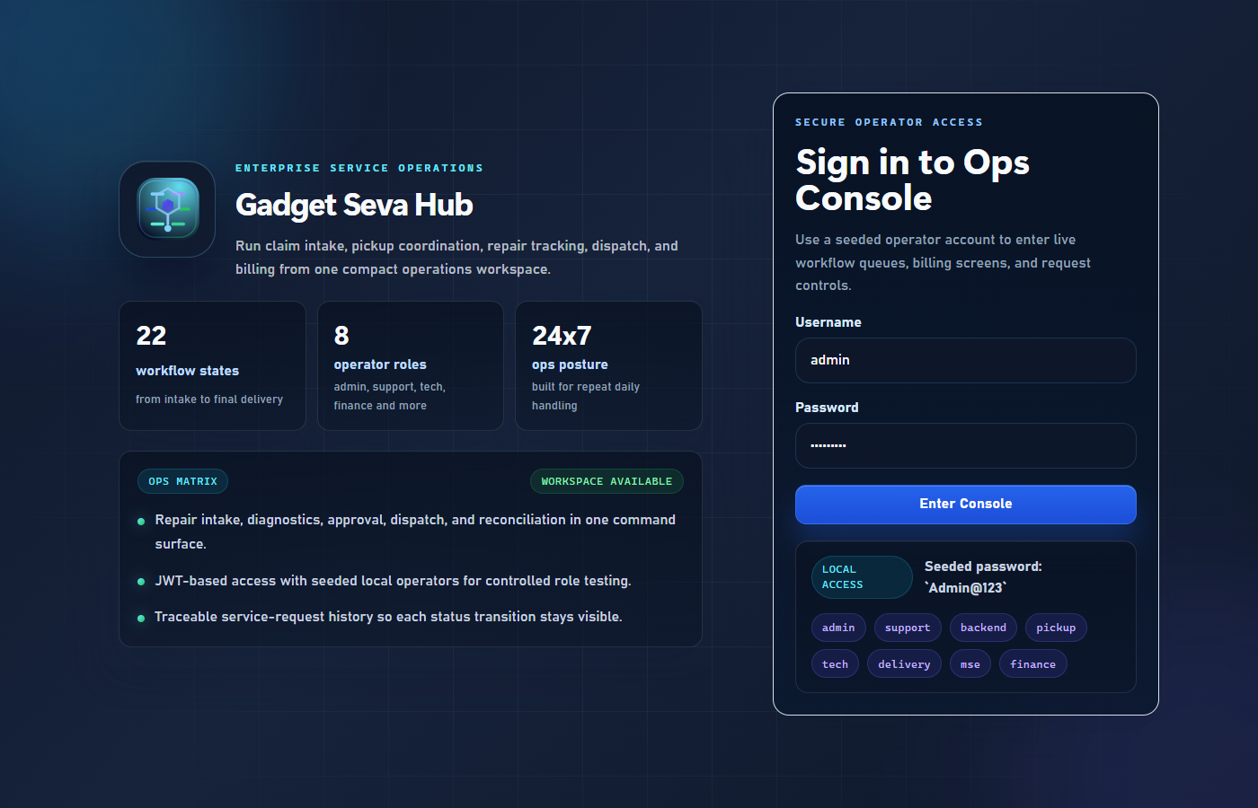
Figure 1 — Login Screen

Step | Action
1 | Open browser and navigate to the portal URL
2 | Enter your Username (e.g. admin)
3 | Enter your Password (e.g. Admin@123)
4 | Click the Enter Console button

Note: The login page shows all seeded usernames and the default password Admin@123 in the LOCAL ACCESS tile.

2. Dashboard — Your Home Screen
After logging in you land on the Dashboard — your operational overview showing live KPIs across all workflow stages.
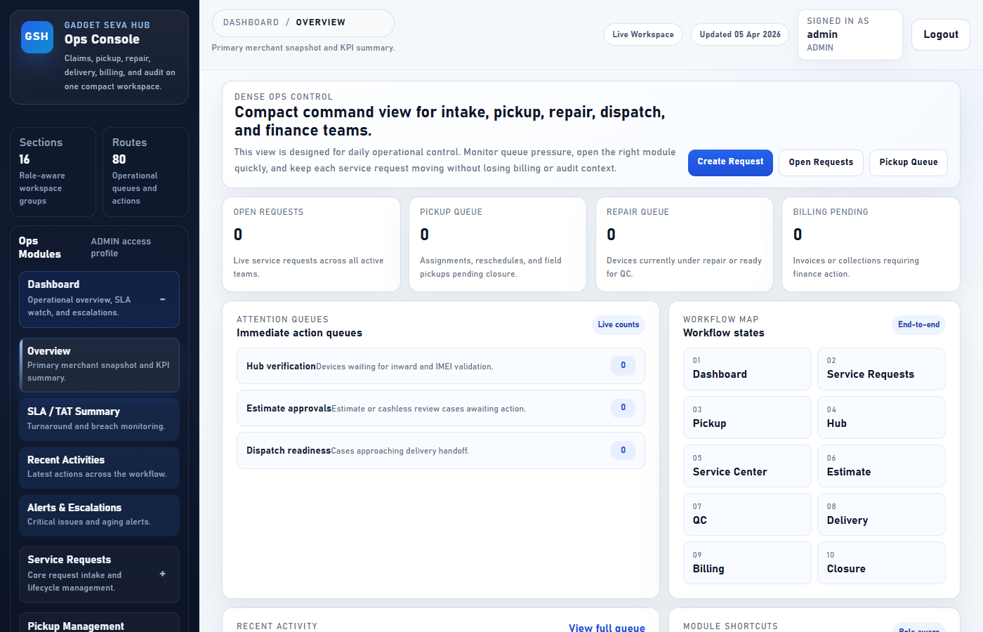
Figure 2 — Admin Dashboard

Section | Purpose
KPI Cards (top row) | Total requests, open, in-progress, and completed counts at a glance
SLA Status | How many requests are within SLA vs breached
Recent Activity | Latest status changes across all claims
Left Sidebar | Full navigation — expand any section to go to that module

Note: Click any section in the left sidebar to expand it, then click a sub-item to navigate.

3. Creating a Service Request
Register a new customer claim. Go to: Service Requests → Create Request
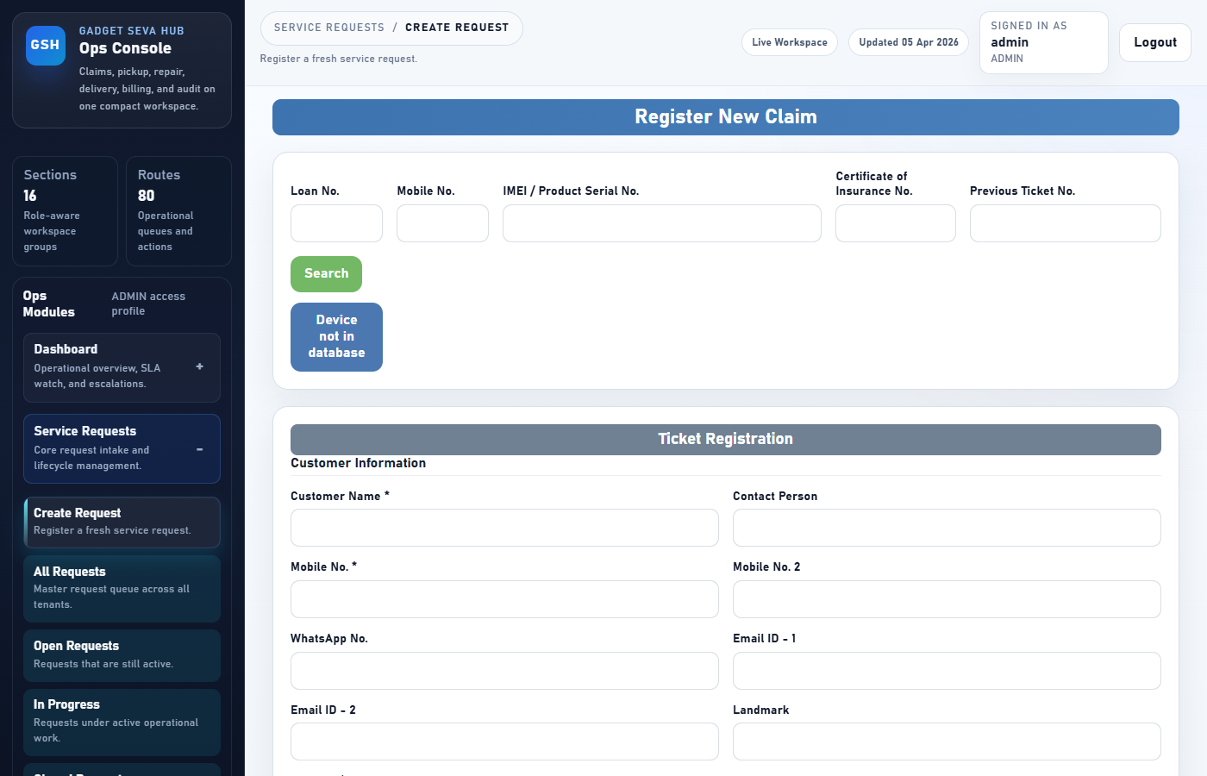
Figure 3 — Create Service Request Form

Step | Field | What to Enter
1 | Customer Name | Full name of the customer or company
2 | Phone | Primary contact number
3 | Address | Pickup address — Line 1, City, State, Postal Code
4 | Device Brand / Model | e.g. Samsung Galaxy S21
5 | Device Category | Select from dropdown (Mobile, Laptop, Tablet, etc.)
6 | Serial Number | Device serial or IMEI number
7 | Issue Summary | Brief one-line description of the problem
8 | Priority | Select LOW / MEDIUM / HIGH / CRITICAL
9 | Source Channel | How the request came in (Walk-in, WhatsApp, Email, etc.)
10 | Submit | Click Submit — ticket created with status: REGISTERED

4. Managing All Requests
Go to: Service Requests → All Requests. Shows every claim across all statuses.
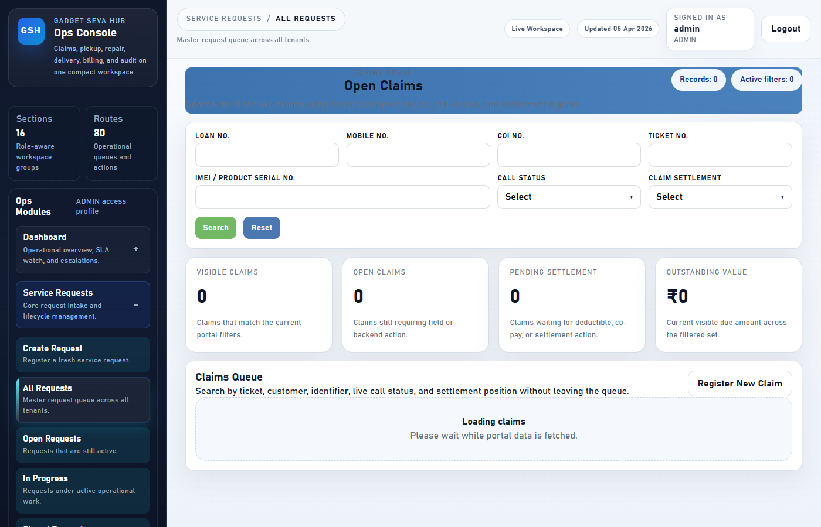
Figure 4 — All Requests Queue

Action | How
Search a claim | Use the search box — by ticket number, customer name, or device
Filter by status | Use the status filter dropdown
Open a claim | Click any request card to open the full details page
View timeline | Inside a request, scroll to the Timeline tab
Upload documents | Inside a request, use the Attachments tab

Request Status Flow
REGISTERED → PICKUP_ASSIGNED → PICKED_UP → RECEIVED_AT_HUB → DIAGNOSIS_IN_PROGRESS → ESTIMATE_SUBMITTED → ESTIMATE_APPROVED → REPAIR_IN_PROGRESS → REPAIR_COMPLETED → QC_PASSED → READY_FOR_DISPATCH → OUT_FOR_DELIVERY → DELIVERED → INVOICED → CLOSED

5. Pickup Management
5.1 Pickup Dashboard
Go to: Pickup Management → Pickup Dashboard. Live count of pickups in each stage.
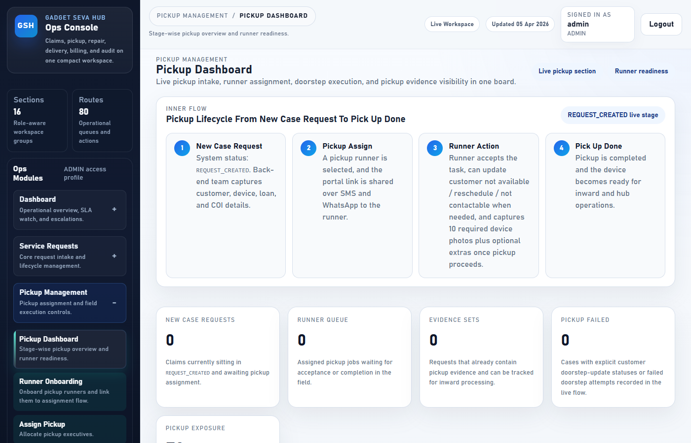
Figure 5 — Pickup Dashboard

5.2 Runner Onboarding
Add new pickup runners before assigning them. Go to: Pickup Management → Runner Onboarding
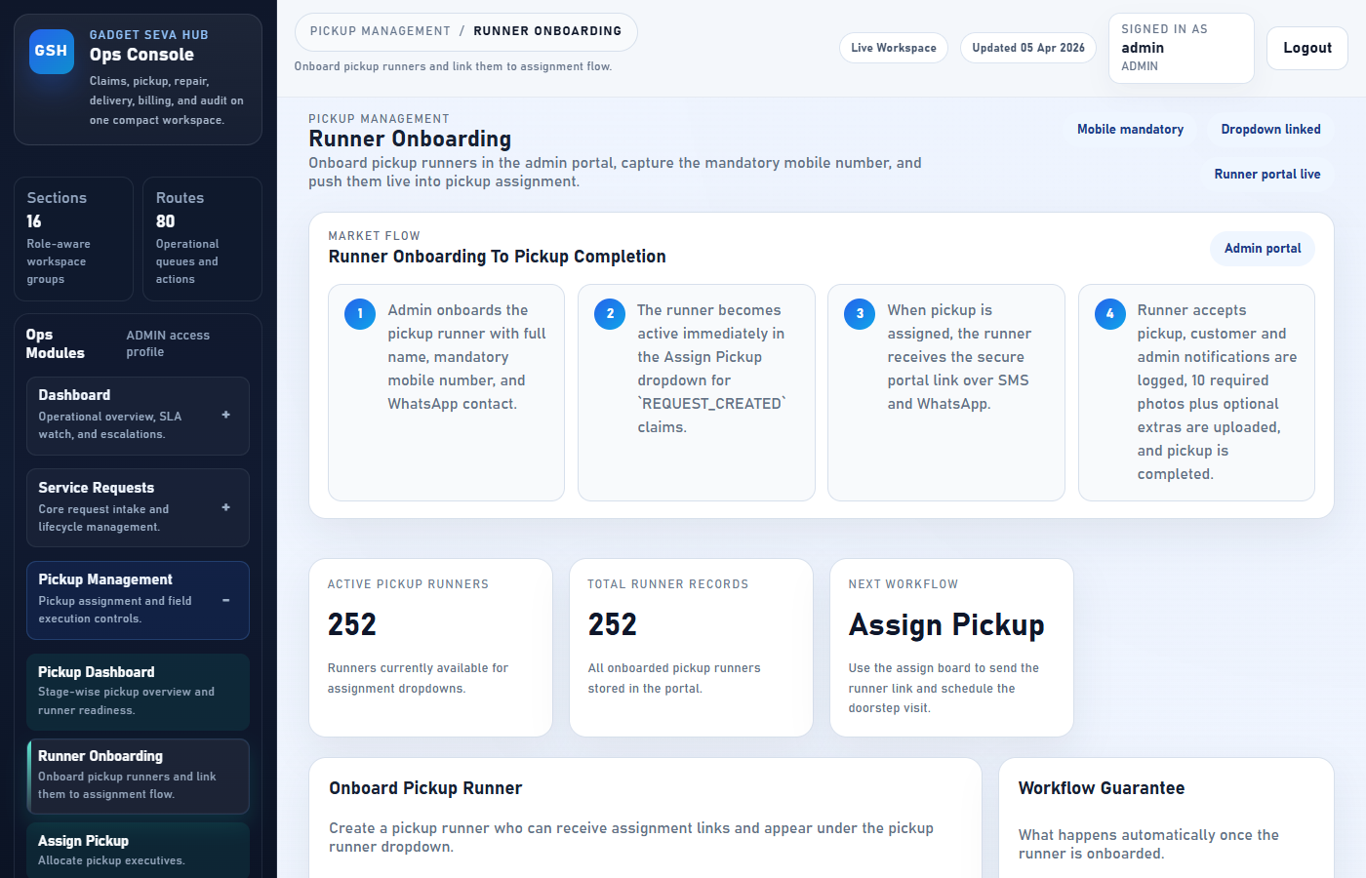
Figure 6 — Runner Onboarding Form

Step | Field | Detail
1 | Full Name | Runner's legal full name
2 | Phone | Mobile number used for WhatsApp link delivery
3 | WhatsApp Number | If different from phone number
4 | Email | Optional contact email
5 | Username | Login username for the runner app
6 | Save Runner | Click to create the account

5.3 Assign Pickup
Assign a runner to a registered request. Go to: Pickup Management → Assign Pickup
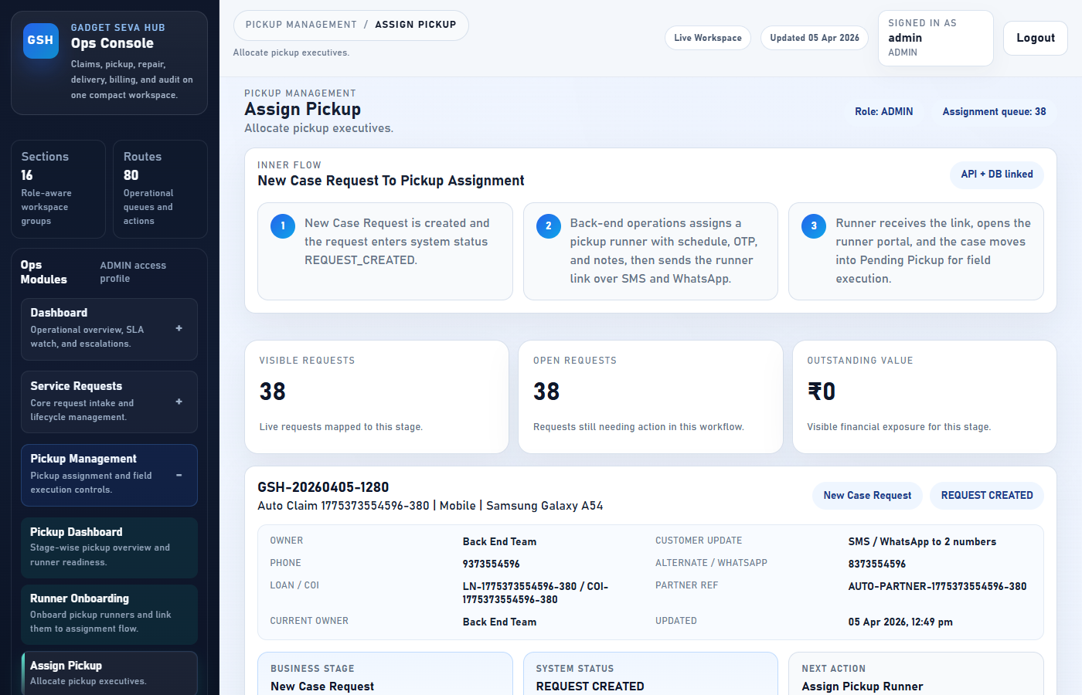
Figure 7 — Assign Pickup

Step | Action
1 | Find the request in the list (use search or scroll)
2 | Click Assign Pickup on the request card
3 | Select the Runner from the dropdown
4 | Set the Scheduled Date and Time for the pickup
5 | Add any Notes for the runner (optional)
6 | Click Save Assignment

Note: The runner receives a WhatsApp link to the pickup portal automatically after assignment.
5.4 Pending Pickup
View all pickups assigned but not yet completed. Go to: Pickup Management → Pending Pickup
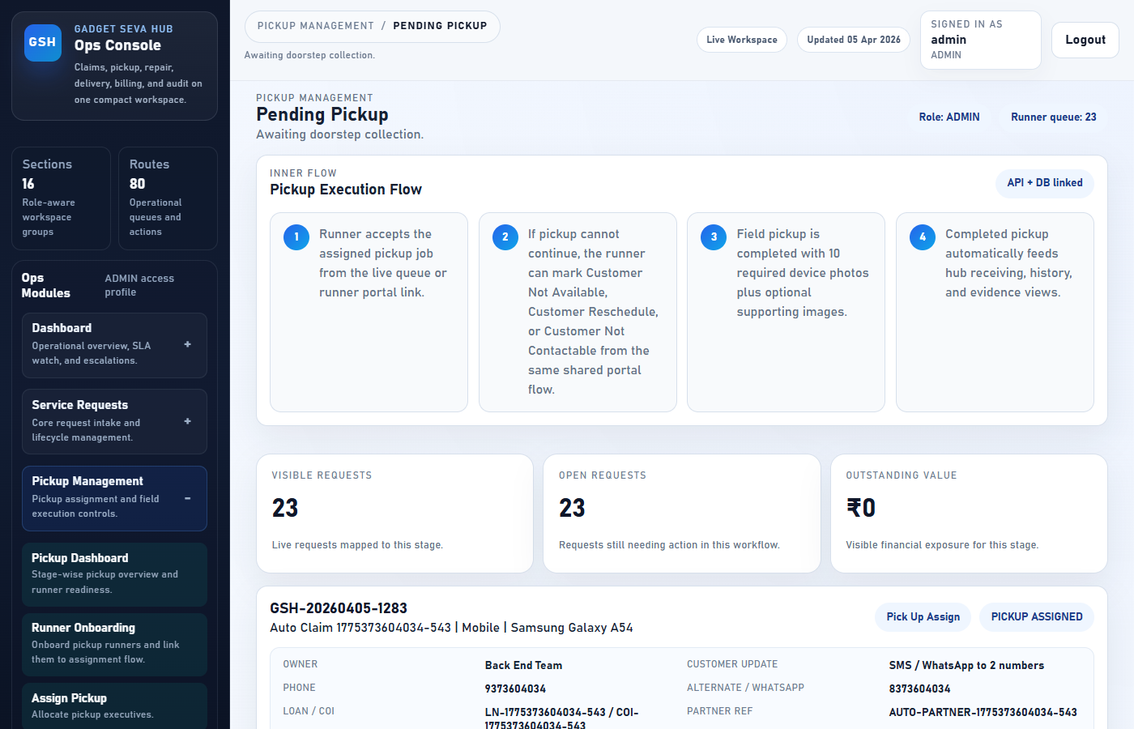
Figure 8 — Pending Pickup Queue

6. User Management
Manage all portal users. Go to: Users section in the left sidebar.
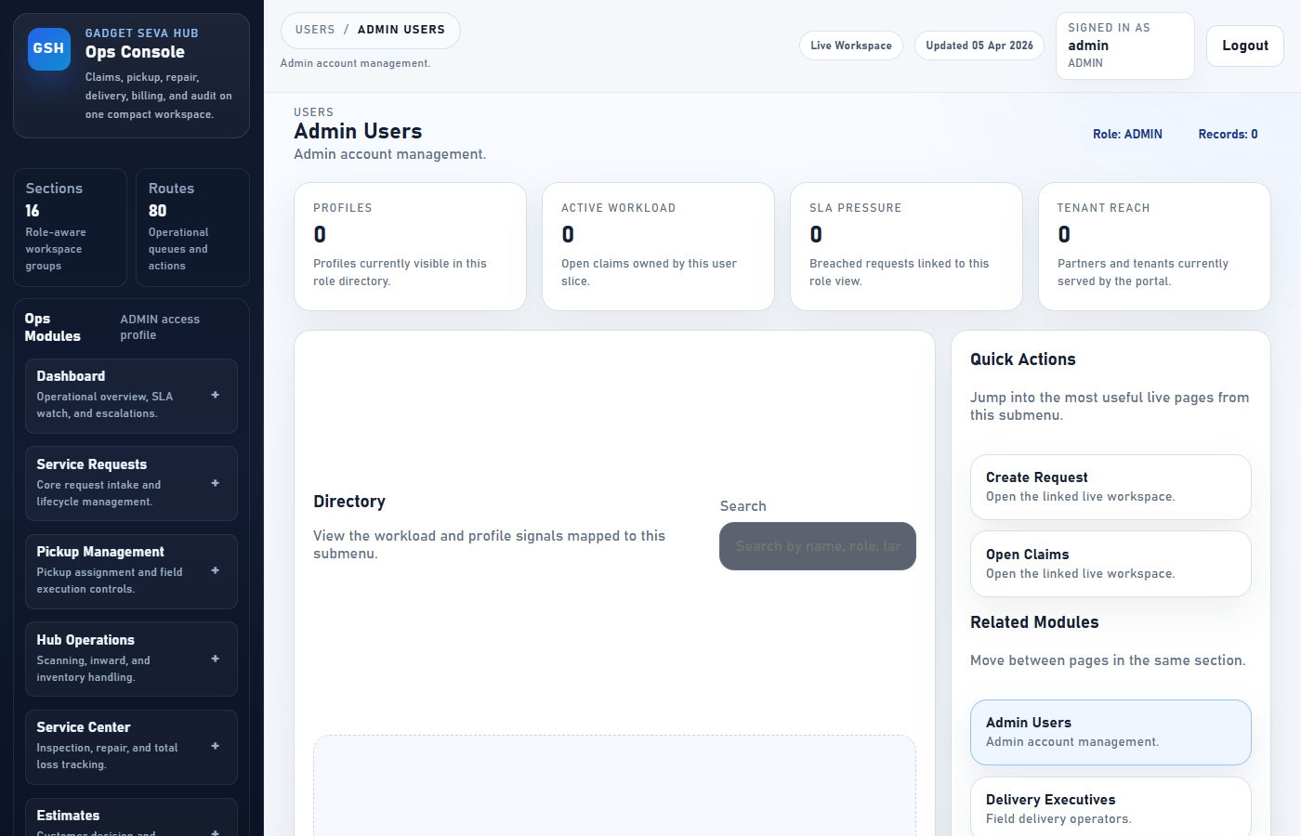
Figure 9 — User Management

Menu Item | Purpose
Admin Users | Create and manage admin accounts
Delivery Executives | Manage delivery agent accounts
Hub Operators | Manage hub inward staff accounts
Service Center Users | Manage technician accounts
Customers | View customer directory and profiles
Roles & Permissions | View the access control matrix per role

Note: To create a user: click the user type → Add User → fill Name, Phone, Username, Role → Save.

7. Billing & Invoicing
Generate GST-compliant invoices and track payments. Go to: Billing section.
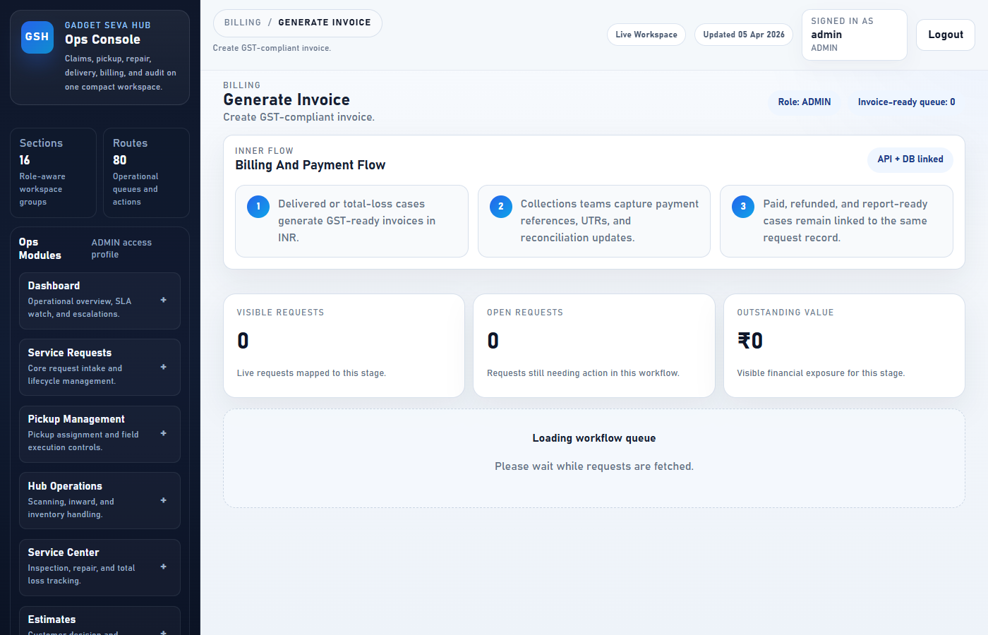
Figure 10 — Billing & Invoicing

Step | Action
1 | Open the request that has been delivered and repair is complete
2 | Go to Billing → Generate Invoice
3 | Select the request from the list
4 | Fill in GST details (State Code, Place of Supply, GST Rate)
5 | Add Labour and Parts descriptions
6 | Click Generate Invoice — PDF is created and linked to the request

Note: For Payment Reconciliation: Billing → Payment Reconciliation → find payment by UTR → mark RECONCILED or MISMATCHED → save.

8. Document Library
Upload and share SOPs, policies, training materials, and reports. Go to: Documents → Document Library
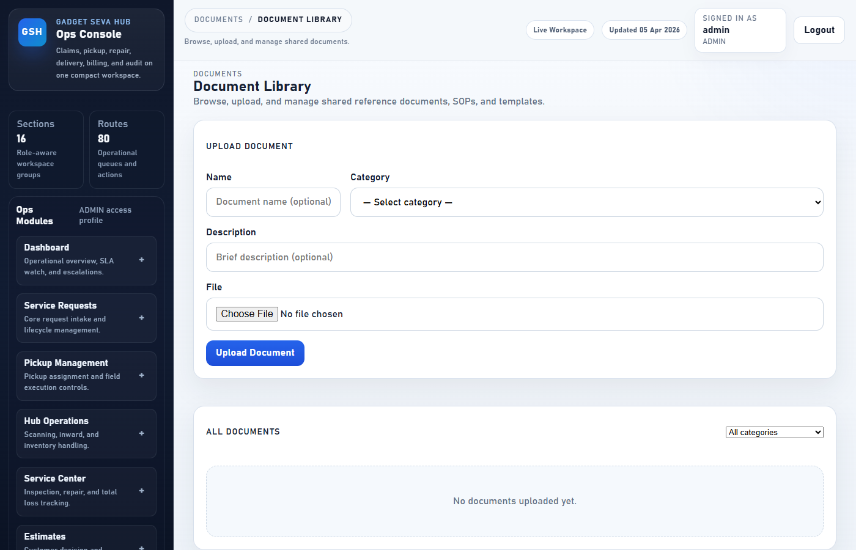
Figure 11 — Document Library

Step | Field | Detail
1 | Name | Document title (e.g. Pickup SOP v2)
2 | Category | Select SOP / Policy / Training / Template / Report / Other
3 | Description | Brief one-line description
4 | File | Click to choose a file (PDF, image, Word, Excel, etc.)
5 | Upload Document | Click to store the file and generate a secure link

Action | How
View | Click View — opens PDF or image in a new browser tab
Download | Click Download — saves the file to your computer
Delete | Click Delete (Admin only) → confirm the prompt
Filter by category | Use the category dropdown at the top of the list

9. Reports
View operational reports. Go to: Reports section in the left sidebar.
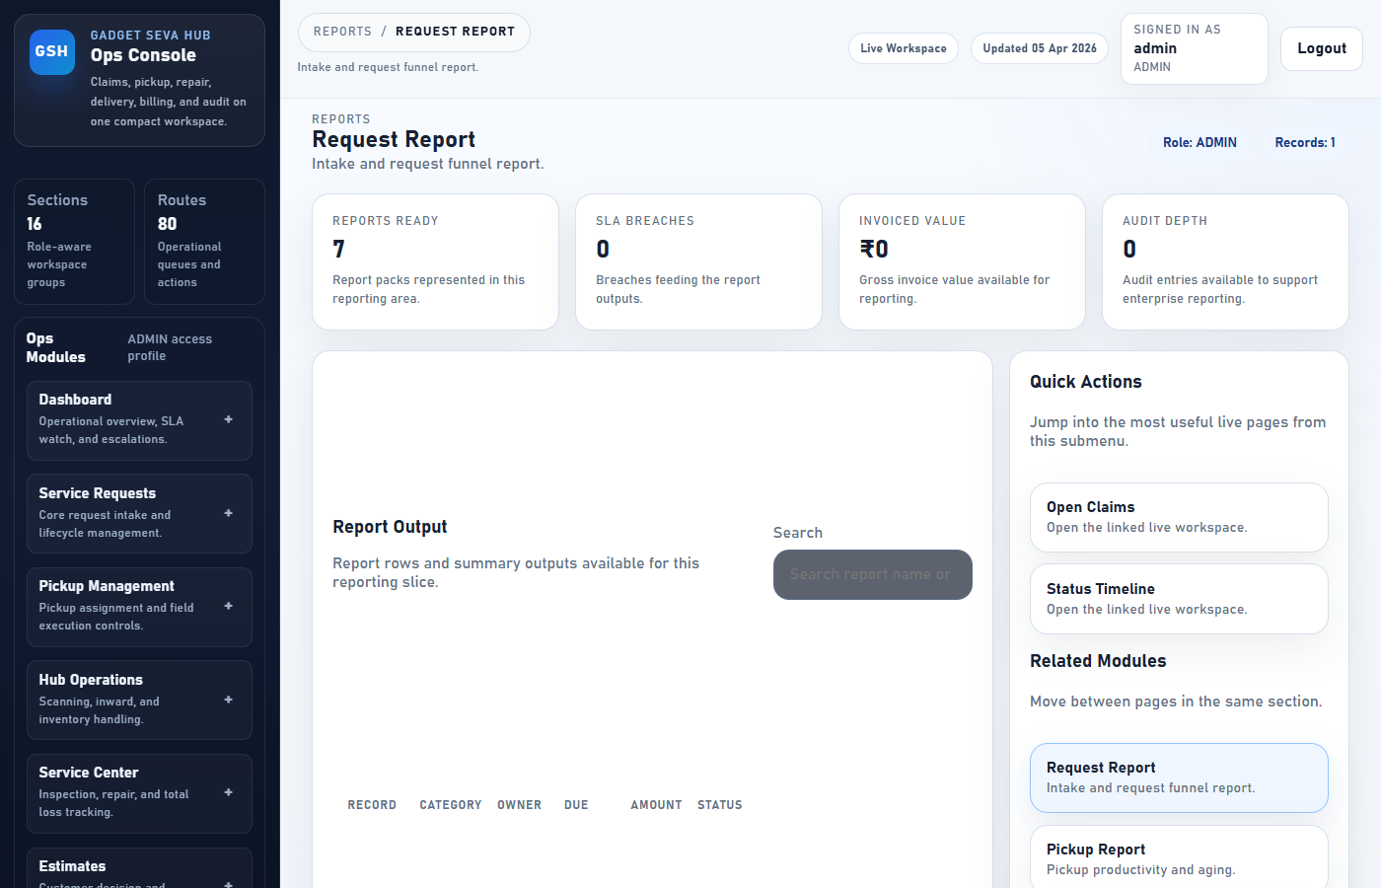
Figure 12 — Reports

Report | What It Shows
Request Report | Intake volume, open vs closed counts by period
Pickup Report | Pickup completion rates and runner performance
Repair Report | Repair throughput and total loss rates
Delivery Report | Dispatch and completion metrics
SLA / TAT Report | Breach counts and average turnaround time
Revenue Report | Collections, outstanding amounts, refunds
Audit Logs | Full enterprise change log

10. Notifications
Monitor SMS and email delivery to customers. Go to: Notifications section.
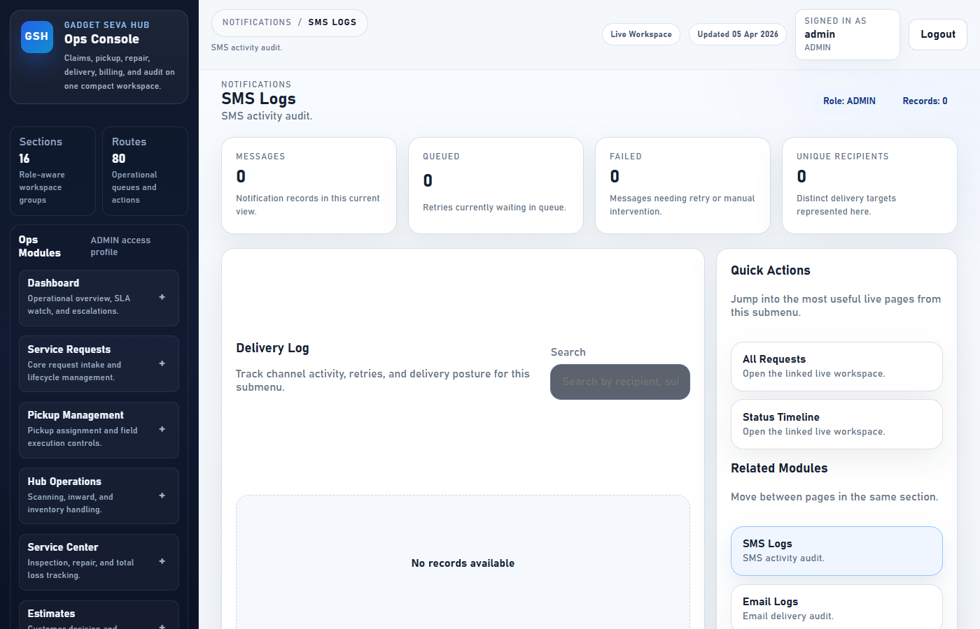
Figure 13 — Notifications

Section | Purpose
SMS Logs | All outbound SMS messages with delivery status
Email Logs | All outbound emails with delivery status
Failed Notifications | Messages that failed — can be retried
Templates | View and manage notification message templates

Note: To retry: Notifications → Failed Notifications → find the message → click Retry.

11. Settings
Configure system-wide behaviour. Go to: Settings section.
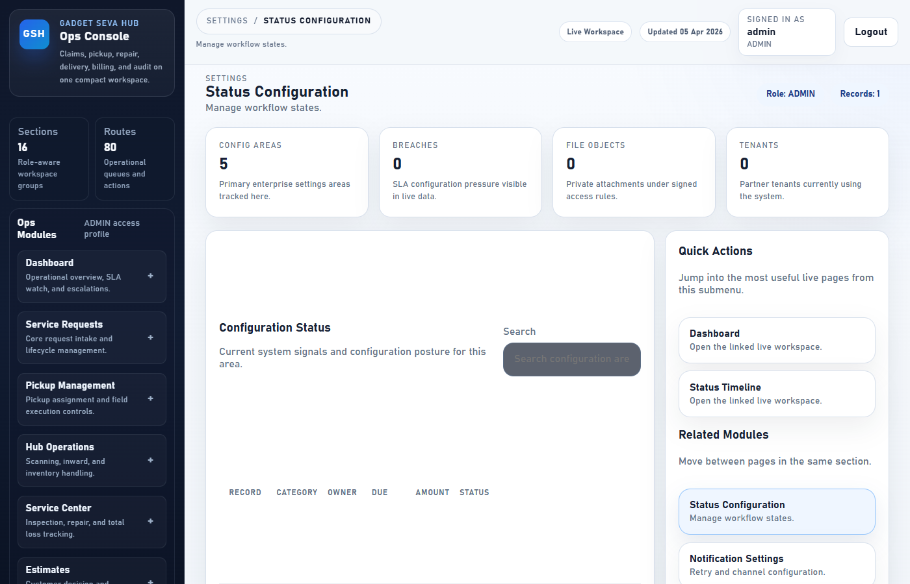
Figure 14 — Settings

Section | Purpose
Status Configuration | Manage workflow states and allowed transitions
Notification Settings | Configure retry intervals and channel priority
SLA Configuration | Set SLA hours per tenant and priority level
File Storage Config | Configure storage paths and signed URL TTL
System Preferences | Global platform preferences

Note: Changes to status configuration affect the entire workflow. Make changes only during non-peak hours.

12. Audit Logs
Full traceability of every action taken in the system. Go to: Audit section.
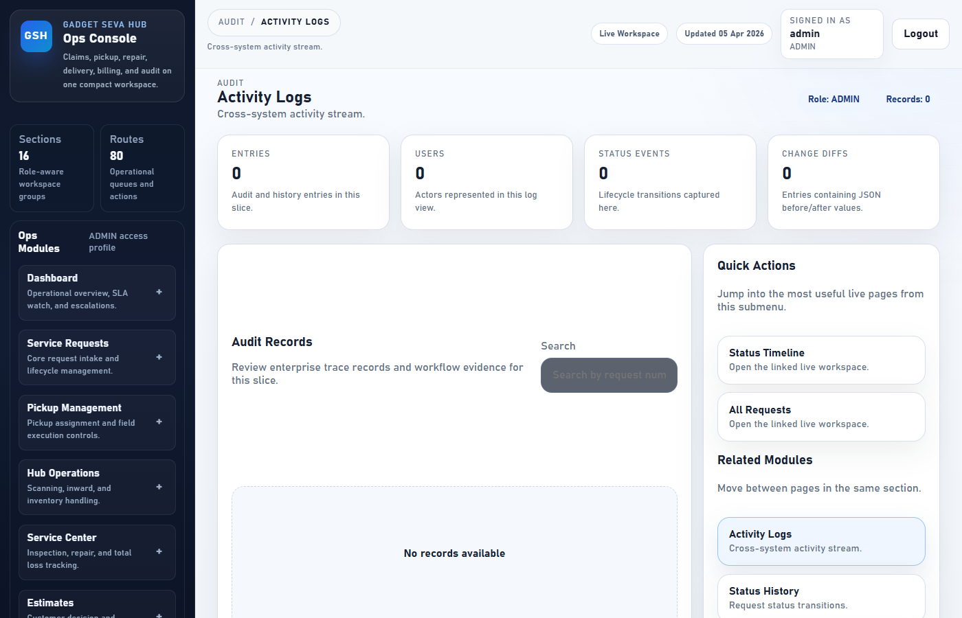
Figure 15 — Audit Logs

Section | What It Tracks
Activity Logs | All actions across every module (create, update, delete)
Status History | Every status transition for every request
User Actions | Actions performed by each individual user
Change Logs | Before and after values for every field change

13. Quick Reference
Task | Where to Go
Create a new claim | Service Requests → Create Request
Find a specific ticket | Service Requests → Search Request
Assign a pickup | Pickup Management → Assign Pickup
Add a new runner | Pickup Management → Runner Onboarding
Generate an invoice | Billing → Generate Invoice
Reconcile a payment | Billing → Payment Reconciliation
Add a new staff member | Users → (select role)
Upload an SOP or policy | Documents → Document Library
Check SLA breaches | Dashboard → SLA / TAT Summary
View audit trail | Audit → Activity Logs
Retry a failed SMS | Notifications → Failed Notifications

