GADGET SEVA HUB
Enterprise Service Operations

ROLE: PICKUP_AGENT

Pickup Runner Portal Guide
Step-by-step field guide for pickup runners
to execute pickups using the Gadget Seva Hub portal

Version: April 2026 | Gadget Seva Hub Ops Console

1. How to Log In
Open the portal in your browser and enter your credentials.
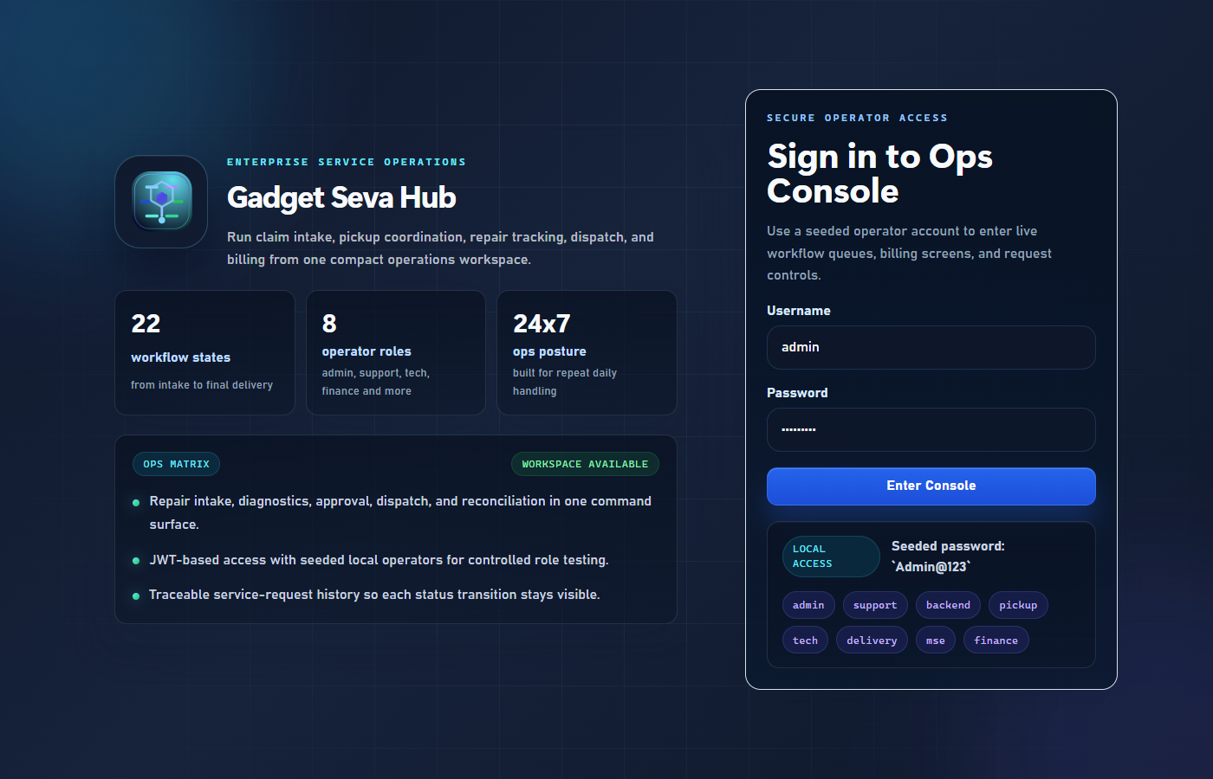
Figure 1 — Login Screen

Step | Action
1 | Open browser and navigate to the portal URL
2 | Enter your Username (given by Admin — e.g. pickup)
3 | Enter your Password (default: Admin@123)
4 | Click Enter Console

Note: If you cannot log in, contact your Admin to verify your account is active.

2. Your Dashboard After Login
After logging in you see the Dashboard. Your main working area is the Pickup Management section in the left sidebar.
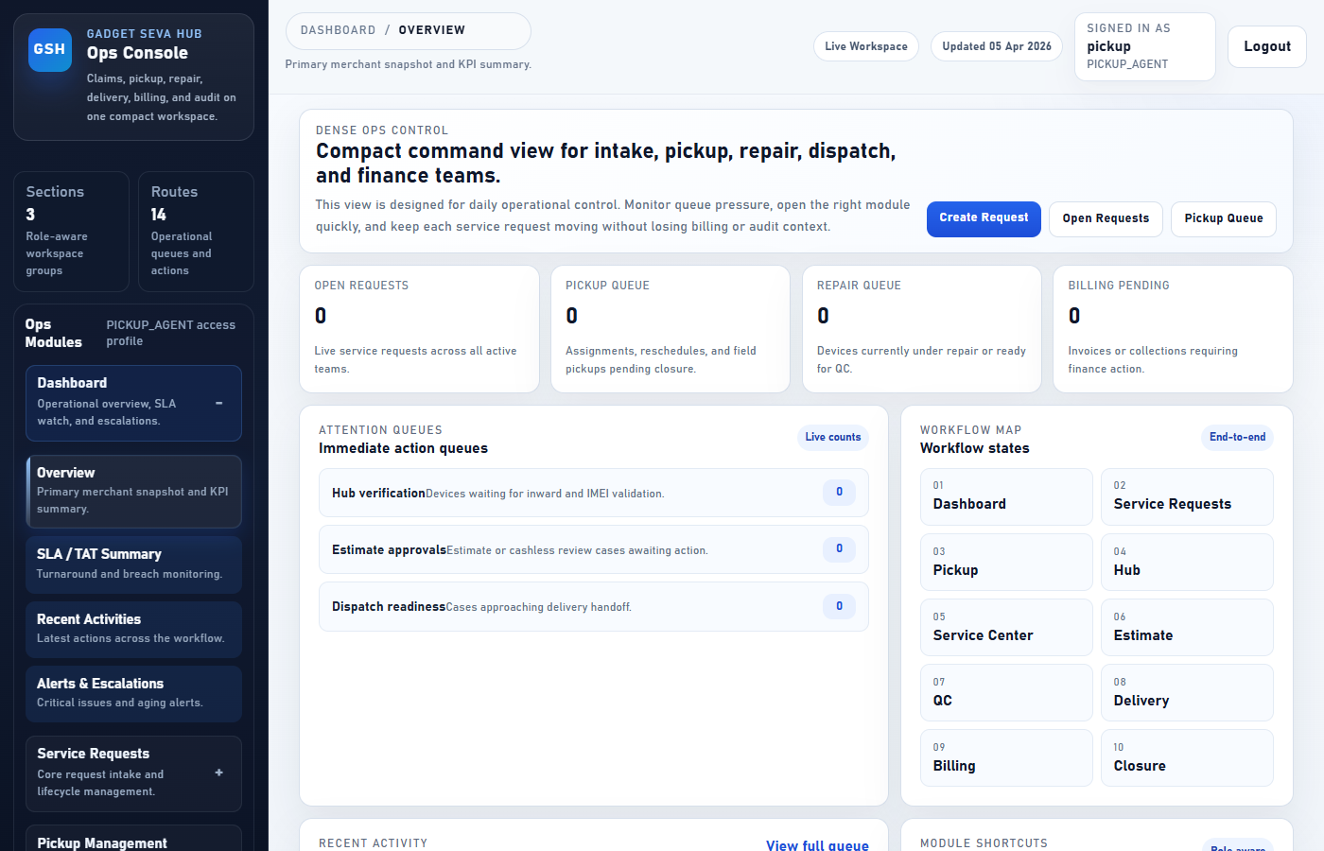
Figure 2 — Pickup Runner Dashboard

Left Menu Section | What You Use It For
Dashboard | Overview and KPI summary
Service Requests | View all requests relevant to your role
Pickup Management | Your active daily workflow — pending, picked up, failed, history

Note: You will only see sections relevant to PICKUP_AGENT role. Billing, Settings, and Admin screens are not accessible.

3. Pending Pickup — Your Active Assignments
Go to: Pickup Management → Pending Pickup. Shows every pickup assigned to you that is not yet complete.
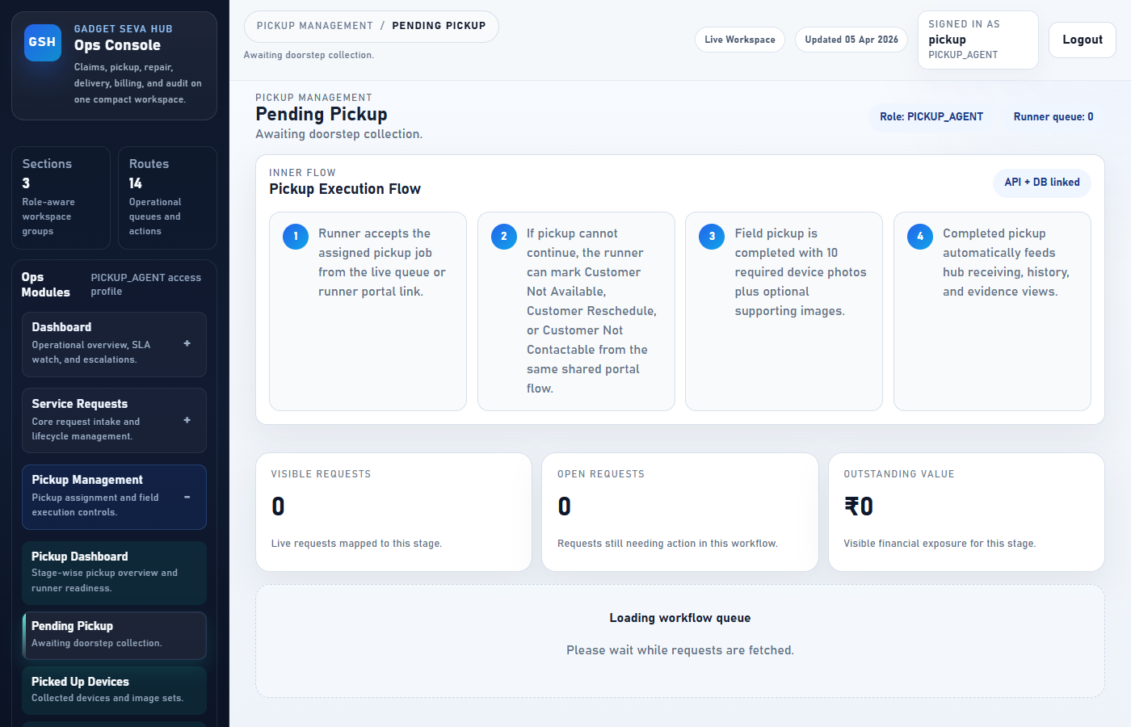
Figure 3 — Pending Pickup Queue

Field | Meaning
Request Number | Ticket reference (e.g. GSH-2026-0001)
Customer Name | Name of the customer you are collecting from
Address | Pickup location
Scheduled Time | When you are expected to reach the customer
Status | PICKUP_ASSIGNED or PICKUP_ACCEPTED
OTP | 4-digit code — verify with customer BEFORE collecting the device

4. Picked Up Devices — Devices You Have Collected
Go to: Pickup Management → Picked Up Devices. Shows all devices you have collected and photographed.
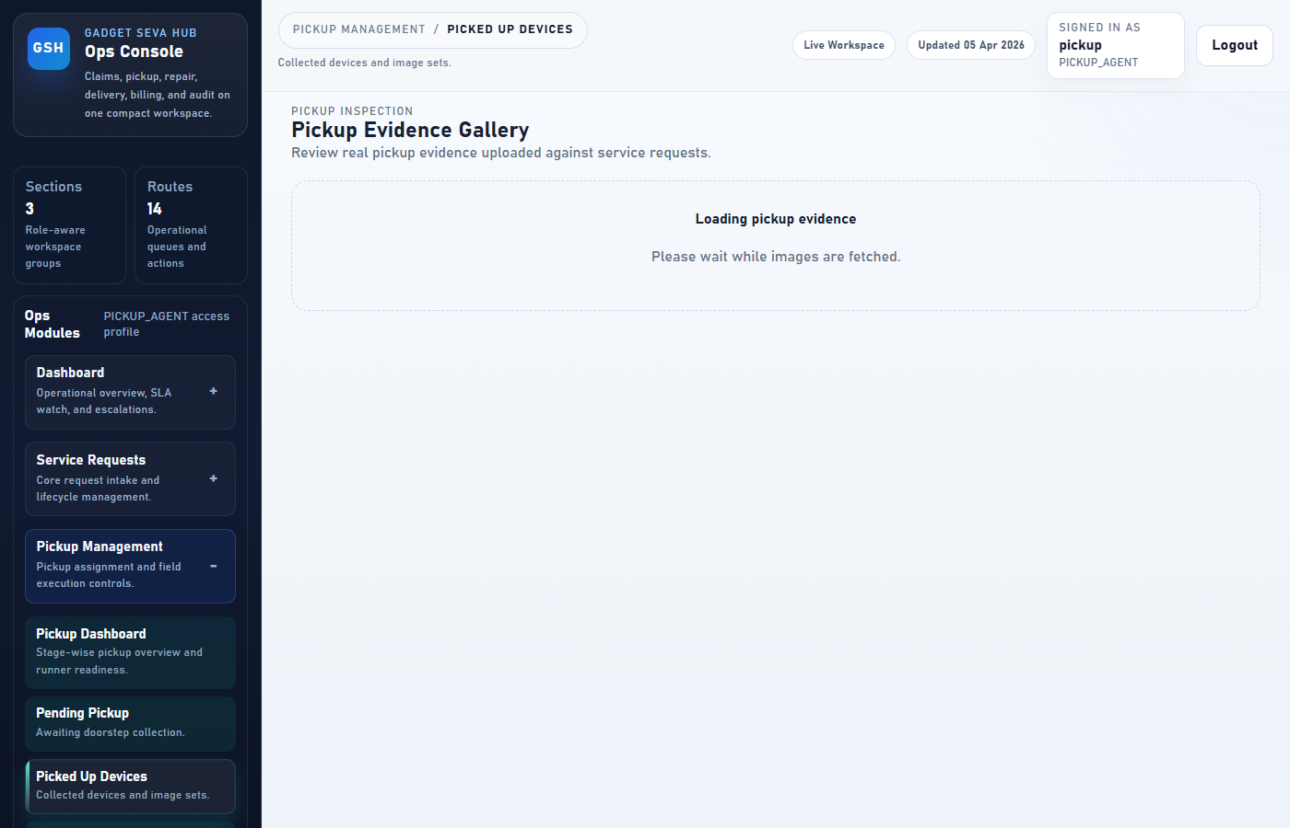
Figure 4 — Picked Up Devices

Note: Once a device shows here, the hub team takes over. No further action needed from you.

5. Pickup Failed Cases — Failed Attempts
Go to: Pickup Management → Pickup Failed Cases. If a pickup attempt fails, it appears here.
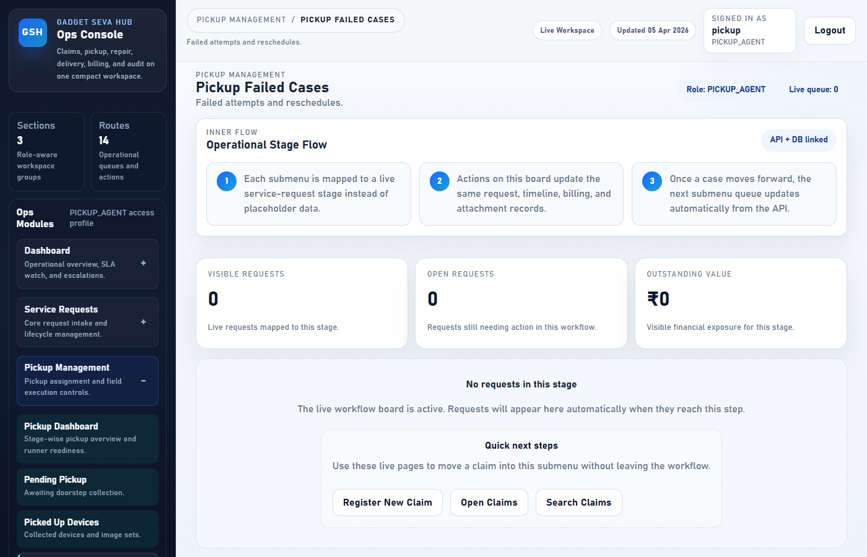
Figure 5 — Pickup Failed Cases

Reason | What to Do
Customer not home | Contact Admin — they will reschedule
Customer refused pickup | Contact Admin — request needs escalation
Wrong address | Contact Admin with the correct address details
Device not ready | Contact Admin — they will update the schedule

6. Pickup History — Your Completed Pickups
Go to: Pickup Management → Pickup History. Your full record of every successfully completed pickup.
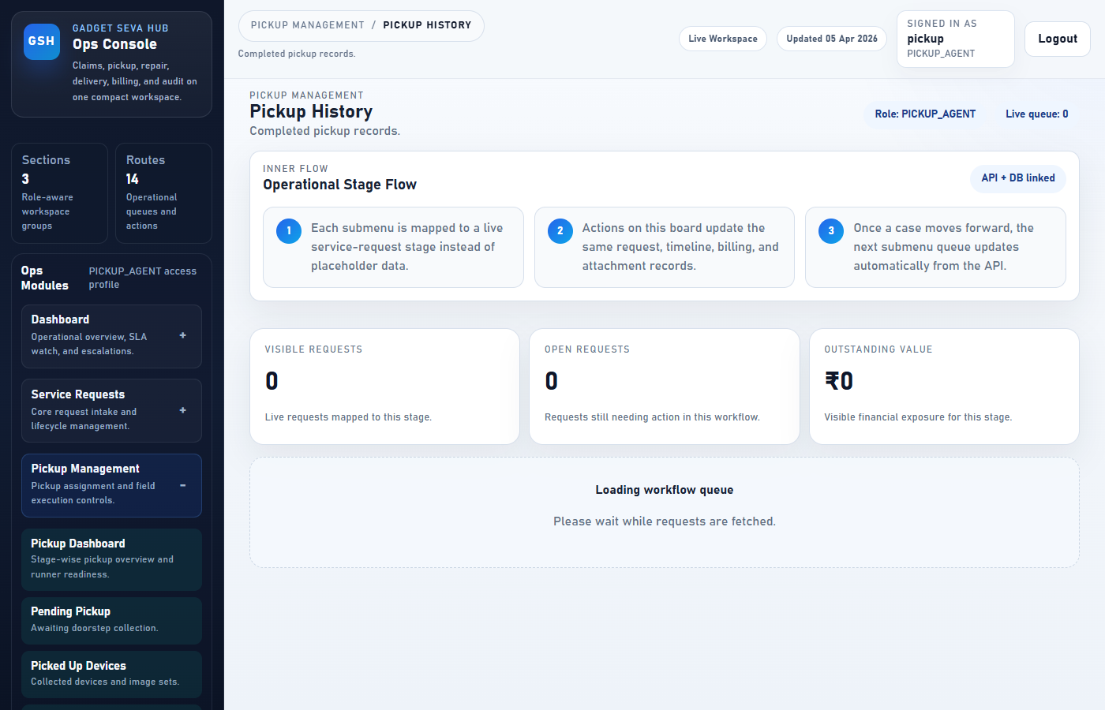
Figure 6 — Pickup History

Use this screen to:
• Verify a pickup was recorded correctly
• Check the date and time of a past collection
• Look up which photos were uploaded for a specific device

7. Runner App — Field Pickup Flow (Step by Step)
The Runner App is your main tool at the customer's location. Works on mobile and desktop browsers.
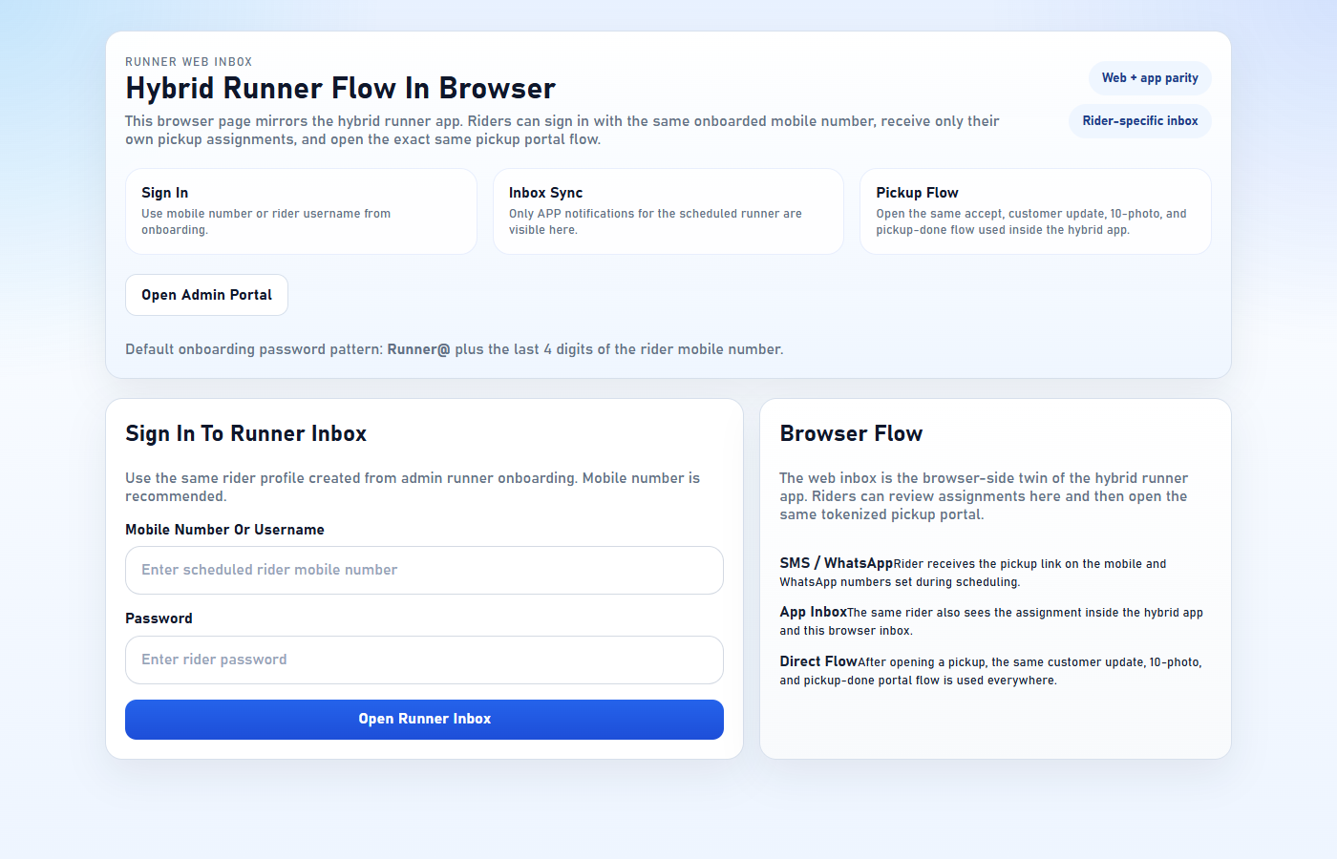
Figure 7 — Runner App

Step 1 — Log in to the Runner App
Open: https://front-end-uat.up.railway.app/runner-app on your phone browser. Enter your username and password.
Step 2 — Accept the Pickup Assignment
Step | Action
1 | Arrive at the customer's location
2 | Open the Runner App on your phone
3 | Find the correct assignment in your list
4 | Tap Accept Pickup — status changes to PICKUP_ACCEPTED
5 | Verify the 4-digit OTP with the customer before touching the device

Note: Ask the customer for the OTP from their SMS/WhatsApp. Match it with the OTP in your portal before proceeding.
Step 3 — Upload 10 Mandatory Device Photos
You must upload ALL 10 photos before you can complete the pickup.
# | Photo Type | What to Capture
1 | Front | Screen facing forward, full device visible
2 | Back | Back panel, full device visible
3 | Left Side | Left edge of the device
4 | Right Side | Right edge of the device
5 | Top | Top edge (power button, headphone jack area)
6 | Bottom | Bottom edge (charging port area)
7 | Display ON | Screen powered on showing the home screen
8 | Serial Label | IMEI sticker or serial number label
9 | Damage Closeup | Any existing visible damage zoomed in
10 | Accessories | All accessories handed over (charger, case, cables)

Note: Do NOT skip any photo. The system will NOT allow you to mark the pickup as complete if any photo is missing.
Step 4 — Complete the Pickup
Step | Action
1 | Verify all 10 photos show green ticks in the portal
2 | Scroll to the bottom of the pickup portal page
3 | Tap Complete Pickup
4 | Confirm the action in the prompt
5 | Status changes to PICKED_UP — you are done

8. Using the Pickup Portal Link (WhatsApp)
When Admin assigns a pickup, you receive a WhatsApp message with a unique portal link.
Step | Action
1 | Open the WhatsApp message from Gadget Seva Hub
2 | Tap the link — it opens the pickup portal in your phone browser
3 | No login required — the link is pre-authenticated for you
4 | Follow Steps 2–4 above (accept → upload photos → complete)

Note: The link is valid for your assigned pickup only. Do not share it with others.

9. What to Do If Pickup Fails
Situation | Action
Customer not available | Mark PICKUP_FAILED, add reason in Notes, contact Admin
Customer refused | Mark PICKUP_FAILED, note 'Customer refused', contact Admin
Address not found | Mark PICKUP_FAILED, note 'Wrong address', share correct location
Device not in condition | Mark PICKUP_FAILED, note the condition issue

How to mark a pickup as failed:
1. Open the pickup portal link or go to Pending Pickup
2. Tap Update Status
3. Select PICKUP_FAILED from the dropdown
4. Add clear notes describing the reason
5. Tap Save
Note: Always call the customer before marking as failed. Wait up to 30 minutes if they need time.

10. Quick Reference & Mandatory Photo Checklist
Task | Where
See my assigned pickups | Pickup Management → Pending Pickup
Accept a pickup on-site | Runner App → Accept Pickup
Upload device photos | Runner App → Photos section
Complete a pickup | Runner App → Complete Pickup
View collected devices | Pickup Management → Picked Up Devices
Report a failed pickup | Runner App → Update Status → PICKUP_FAILED
View my history | Pickup Management → Pickup History
Log in via WhatsApp link | Tap the link in your WhatsApp message

Mandatory Photo Checklist (use at every pickup)
☐ | Front of device
☐ | Back of device
☐ | Left side
☐ | Right side
☐ | Top edge
☐ | Bottom edge
☐ | Screen powered ON
☐ | Serial number / IMEI label
☐ | Any existing damage (closeup)
☐ | All accessories included

Important Rules
# | Rule
1 | Always verify the OTP before collecting any device
2 | Never skip any of the 10 photos — incomplete evidence delays the claim
3 | Report failures immediately — do not leave without updating the portal
4 | Do not share your WhatsApp portal link — it is unique to your assignment
5 | Contact Admin for any disputes — do not make promises to customers about timelines

