**EE 602 Part-1**

**Contents**

1. **What is Radar?**
   1. Basics of Radar
   2. Radar Block Diagram
   3. Range and Velocity Measurement for Pulsed Radars
   4. Propagation of Radar Signals
   5. Applications of Radar Technology
   6. Deriving Radar Parameters from User Requirements
   7. Numerical problems
2. **Understanding Radar Design parameters** 
   1. The Radar Equation
   2. Receiver Sensitivity and Detection of the Signal in Noise
   3. Signal to Noise Ratio, Noise Figure of single and Cascaded Modules
   4. Probability of Detection and False Alarm
   5. Radar Cross-Section
   6. System Resources: Power Aperture Product
   7. Numerical problems
3. **Continuous Wave Radars**
   1. Continuous Wave radar and its applications
   2. Linear FMCW Radars
   3. Range and Doppler Measurement in FMCW radars
   4. Isolation Between Transmitter and Receiver
   5. Applications of FMCW Radars
   6. Numerical problems
4. **Transmitters, Duplexers and Circulators**
   1. Types of RF and microwave sources
   2. Sources for Terahertz frequencies, Sodars and Lidars
   3. Phase Noise considerations
   4. Duplexers and Circulators
   5. Numerical problems
5. **Antennas used in Radar Systems** 
   1. Antenna Radiation Pattern
   2. Effect of Aperture Illumination
   3. Array Antennas
   4. Beam steering: mechanical and electronic
   5. Digital beam forming
   6. Applications
   7. Numerical problems
6. **Receivers**
   1. Receiver Protection
   2. Matched filter detection
   3. Types of radar receivers
   4. Digital receivers
   5. Pulse compression
   6. Signal enhancement techniques
   7. Numerical problems
7. **Radar Target Tracking** 
   1. Tracking with Radars
   2. Conical Scan Sequential Lobing
   3. Monopulse tracking receivers
   4. Tracking Accuracy
   5. Numerical problems
8. **Navigational and Strategic applications of Radars**
   1. Secondary radars: DME VoR and ILS
   2. Radar Beacons
   3. OTH radars
   4. Early warning Radars
   5. Synthetic aperture radars
   6. Passive bi-static radars
   7. Jamming, ECM and ECCM
   8. Example of countermeasure technique for FMCW radar
   9. Numerical problems
9. **Digital realization of radar sub-systems**
   1. Need for sub-system realization using digital components
   2. Numerically controlled oscillator (NCO)
   3. Direct digital Synthesis
   4. Digital down converter (DDC)
   5. Cascaded Integrator Comb filter (CIC) and usage
   6. Numerical problems

**References**

1. M.I.Skolnik, Introduction to Radar Systems, McGraw Hill, 1980.
2. D.K.Barton, Modern radar systems analysis, Artech House, 1988.
3. B,Edde, Radar: Principles, Technology, Applications, Prentice Hall, 1993.
4. [Mark A. Richards](https://www.amazon.com/Mark-A.-Richards/e/B005WWKUH4/ref=dp_byline_cont_book_1) (Ed.), [James A. Scheer](https://www.amazon.com/s/ref=dp_byline_sr_book_2?ie=UTF8&text=James+A.+Scheer&search-alias=books&field-author=James+A.+Scheer&sort=relevancerank) (Ed.), [William A. Holm](https://www.amazon.com/s/ref=dp_byline_sr_book_3?ie=UTF8&text=William+A.+Holm&search-alias=books&field-author=William+A.+Holm&sort=relevancerank) (Ed.), **‘**Principles of Modern Radar: Basic Principles,’**Scitech Publishing Inc,** 2015, ISBN-13: 978-1891121524, ISBN-10: 1891121529
5. Hugh D. Griffiths (Editor), Christopher Baker (Editor), David Adamy (Editor), ‘Stimson's Introduction to Airborne Radar (Electromagnetics and Radar)’, ’Scitech Publishing Inc, 3rd Edition, ISBN-13: 978-161353022, 1ISBN-10: 1613530226
6. William L. Melvin (Editor), James A. Scheer (Editor), Principles of Modern Radar: Radar Applications Har/Psc Edition ’Scitech Publishing Inc, 2014, ISBN-13: 978-1891121548 ISBN-10: 1891121545

**List of Symbols and Abbreviations**

**Symbols**

**ε :** Permittivity

**θ :** Angle of elevation, angle

λ : Wavelength

**μ :** Permeability

**ɸ :** Azimuth angle

σ : Target Cross section

**τ :** Pulse width

**ω :** Angular frequency

**c** : Velocity of electromagnetic waves

***fb*** : Beat frequency

***fc*** : Carrier frequency, mean carrier frequency

***fD fd*** : Doppler Frequency

*Gt,Gt* : Transmit antenna gain and receive antenna gain

*Pt, Pr* : Transmitted Power and received power

*R* : Range of Radar

**Abbreviations**

**IEE** : Institute of Electrical Engineers

**IEEE :** Institute of Electrical and Electronics Engineers

**IF** : Intermediate Frequency

**FFT** : Fast Fourier Transform

**FM** : Frequency modulation

**NF, *Fn*** : Noise Figure

**PRF, *fp* :** Pulse Repetition Frequency

**PRP, *Tp***: Pulse Repetition period

**PW** : Pulse width

**RCS** : Radar Cross section

**RF** : Radio Frequency

**RMS** : Root Mean Squared

**SNR** : Signal to Noise Ratio

**Chapter-1**

**What Is Radar?**

It is well-known that ‘Radar’ is an acronym of **RA**dio **D**etection **A**nd **R**anging. The radar could be understood as an ‘electromagnetic system’ that transmits radio waves in the desired direction. If any target is present, it reflects (or scatters) these radio waves back towards the radar. On receiving these waves, the Radar *detects* the target, analyzes the echoes and determines the *range* of the target; hence the acronym! Modern radars are more complex and offer information about more features of the target(s).

**1.1 Basics of Radar1**

Figure 1.1 shows simplistic block diagram of radar systems of two types. On the basis of system configuration, the radars could be classified into two types. The radar system that uses same antenna for transmission as well as for reception is called ‘mono-static’ system (shown in the upper part of Fig. 1.1). These system need to have a switching arrangement that connects the antenna to the transmitter during the ‘transmit-period’ and connects to the receiver other times. The switching unit is called the ‘Duplexer or Transmit-Receive (T/R) Switch’. Other type of the radars use separate antennas for transmission and reception. They are known as Bi-static radars (shown in the lower half of Fig. 1.1).

Transmitter

Receiver

Modulator

Processing and Display

Transmitter

Receiver

Modulator

Processing and Display

Antenna

Target

Transmit Antenna

Receive Antenna

Duplexer OR

T/R Switch

Bi-static Radar

Mono static Radar

Fig. 1.1 Operating principle for mono-static and bi-static radars.

Successful functioning of the radar requires optimum implementation of four functions. The subsystems and the environmental aspect related to these functions are as follows:

* Transmission : Modulator and the transmitter
* Propagation of the radio waves to the target and back: Antenna and the medium
* Reception of the echoes: Receiver, Medium noise
* Signal processing and display: Control and processing system, display and algorithms

Each of these aspect forms major ‘area of study’ in Radar engineering.

The signal wave form with timing sequence of a typical radar system is shown in Figure 1.2. The transmit waveform timings are shown with darkened rectangles and the received signal s are shown in lightly shaded shapes. In practical radar systems, the transmitted signal power is much stronger (approximately 109 to 1015 times) compared to the receive signal strength.

**1.1.1 Radar operation**

The ‘transmit signal’ is designed considering the application, nature of the target and the medium through which the signal is expected to propagate. This signal is a ‘Known waveform’ with pre-designed ‘amplitude, phase or frequency pattern’ for time duration of ‘τ’. For a pulsed radars, the transmit signal pattern is simply a sinusoidal radio frequency of time duration ‘τ’. This is known as radar pulse and the time duration ‘τ’ is called the ‘pulse-width (PW)’. For more complex radars, one or more parameters of the radio frequency are varied. Phase coding, frequency variation, frequency hopping are some of the established techniques that are used in radars.

Amplitude

Time

τ

*Tp*=PRP= 1/PRF=1/*fp*

Transmit waveforms

Received waveforms

t1

t2

t3

Fig. 1.2 Timing diagram of radar signals

t1

τ

Resolution of two echoes echoes

The transmitted signal travels or ‘propagates’ through the medium between the radar and the target. During the propagation the signal generally travels radially outwards from the radar. It reaches the target and a fraction of the power is reflected back towards the radar. This signal travels back through the same medium to the radar receiving antenna. This signal has the same pattern as the transmit signal. However, it arrives with a time delay equal to the ‘round-trip travel time’ to the target. Fig.2 shows the time durations t1, t2 and t3 corresponding to the different echoes. The received signal is normally sampled with the time interval equal to the pulse width. If the pulse width is τ, the received signal will be sampled at an interval of ‘τ’. As a result, there will be one sample for the time interval of ‘nτ’ to ‘(n+1)τ’, for any integer n. The echo of all the targets present at a distance between ‘c nτ/2’ and ‘c (n+1)τ/2’, will be included in the nth sample corresponding to the said interval. This section of the range is called a ‘Range bin’; nth range-bin in this case.

The transmitted signal is received through the receive antenna. This signal often contains noise and the echoes from unwanted objects. The received signal is amplified and conditioned by removing un-wanted part of the signal in the receiver. After this stage various signal processing techniques are used to detect the echoes from the target. Depending on the application, the signal is further processed to derive other information like target distance (range), its velocity etc.

**1.2 Radar Block Diagram**

In this section we will get introduced to various subsystems or the functional blocks of the radar and understand the basic function of each of the blocks. Figure 1.3 presents a block diagram of a radar system. This block diagram corresponds to typical pulsed radar. Other types of radar have system blocks performing similar functions. Therefore, it could be taken as a representative diagram from all kinds of radars.

Most of the surveillance and aircraft radars require the transmit carrier frequency to be between 1 to 30 GHz. The transmit waveform, typically consists of pulses with duration 1μs to 8μs. Such waveforms are generated by mixing modulated signal with the carrier. This signal is further amplified to the required power level using power amplifier. Harmonic filters and band pass filters are used to ensure that the transmitter does not generate frequencies other than the desired bands. The signal is given to the antenna.

Power Amplifier and filter

Modulator/ Pulse Generator

Carrier Waveform Generator

Video Amplifier

Low Noise RF Amplifier

Antenna

Duplexer OR

T/R Switch

Local Oscillator

IF amplifier and Matched Filter

Second Detector Demodulator

Threshold detector

Fig. 1.3 Block diagram of a pulsed radar. Down-conversion is shown by representative waveforms. forms.ymbolically shown

The antenna selectively directs the RF power in the desired direction. The antennas function in a similar manner as the flood lights which give a well-focused concentrated light beam. These lights have reflectors at the back of the lamp. These reflectors concentrate the light in the desired direction. This results in an intense optical beam for the search operation. Microwave antennas create directed RF beams in the similar manner as the flood lights. Conventional antennas use reflectors to focus the RF energy. It may also be noted that bigger reflector leads to narrower RF beam. Surveillance Radars need to move the antenna beam in the region of interest. Therefore this application demands the capability of steering the beam. Conventional radars use movement of the reflector to steer the beam.

Modern ‘printed circuit antennas’ or the ‘micro-strip’ antennas realize narrow beams by creating large aperture array of radiating elements. These arrays are organized on a surface. Such antennas are called phase array antennas. These antennas are lightweight and prove to be of practical use. Phased arrays antennas are also made of conventional antenna elements. The phase antennas are capable of steering the RF beam by introducing relative phase difference between the feed signals of radiating elements. See section 8.4 for more discussion. The phase array antennas are preferred by many radar engineers as it can steer beam without physical movement of the antenna.

The transmitted signal reaches the target (if it is present in the radar beam) and reflects fraction of the RF power incident on it. The shape of the target and the frequency of the RF radiation determine the fraction of the power travelling back to the radar. Generally if the target dimensions are much larger than the radar wavelength the power is sent back by ‘reflection’ and when the wavelength of RF is comparable to the size of the target the power is ‘scattered’ back. See section 2.5 for detailed discussion.

The signal is then processed by the receiver and information like target range, target velocity etc is determined. This information is presented in user-friendly manner using appropriate displays and graphical user interfaces (GUI).

* 1. **Range and Velocity Measurement for Pulsed Radars2**

Basic information expected from the radars is the estimation of the distance from the radar location (range) and the velocity of the target. More sophisticated radars give information about the direction (bearing) of the target, the shape of the target and some more aspects depending on the application. In this section we shall look into the basic calculation of the range and velocity determination.

**1.3.1. Range determination in pulsed radars**

Fig. 1.2 shows that the echo from the target occurs after some time delay from the transmitting pulse. This delay is due to the ‘round-trip’ time required for the radar signal to travel from the radar to the target and back. Mathematically, the relation could be written as shown in equation 1.1. In this equation, *‘c*’ is the velocity of the electromagnetic waves and *‘t’* is the time delay of the target echo from the transmitter pulse. In free space and in air the value of c is approximately 3x108 ms-1.

(Range)  … (1.1)

With the range in kilometres the relation becomes, *R* (km) = 0.15 *t* (μs).

**1.3.2. Range Resolution in pulsed radars**

Ideally, the envelope of the radar pulse is expected to be of rectangular shape. This means that the transmit pulse should have zero ‘rise-time’. Practically, this is not possible due to the limitation of the transmitter to raise the power instantaneously from zero value to the designed value of the peak transmitter power. This limitation is expressed in terms of the ‘bandwidth’. Maximum frequency of the transmit pulse decides the maximum slope of the radar pulse envelope. Normally the radar systems, both the transmitter and the receiver operate with the bandwidth equal to the reciprocal of the transmit pulse. This means radar with the pulse width of 1 micro-second will have a bandwidth of 1 MHz. Due to the limited bandwidth; the transmitted pulse as well as the receiver echoes have ‘Bell-shaped’ envelope.

The transmitted RF energy is reflected from all the objects in the radar beam. Each object results in an echo of bell shaped envelope. If two objects are too close, their echoes appear to merge into one echo. Due to this it is interpreted as an echo from single object and the radar is not able to ‘resolve’ the two targets as separate objects.

Let two objects with identical reflection properties are separated by a distance. The minimum distance () at which the echoes from these objects can be resolved by radar is known as the range resolution of that radar. The mathematical expression for the radar resolution is as follows:

(Range Resolution)  … (1.2)

**1.3.3. Velocity determination in pulsed radars**

Let two objects be moving with a constant velocity relative to each other. A sinusoidal signal is transmitted from the first object towards the second object. The frequency received by an observer on the second object is perceived to be different than that transmitted by the observer on the first object. This phenomenon is called the ‘Doppler effect’. This phenomenon observed for acoustic as well as electromagnetic signals. Let the transmitted signal frequency be ‘*f’*, the relative velocity be (*v*) and ‘Doppler frequency shift be (*fD*)’. The relation between these three quantities is given by equation 1.2. The wavelength of the signal with frequency ‘*f’* will be ‘λ’ (= *c/f)* The derivation of this expression is presented in section 3.1.

(Doppler Shift frequency) 

(Velocity)  … (1.3)

The velocity of the target with respect to the radar is determined by measuring the frequency shift and then computing the velocity using the equation 1.3.

**1.3.4 Velocity resolution in pulsed radar**

We have seen that the Doppler frequency shift determines the velocity of the target relative to the radar. Velocity resolution of radar is the velocity differentiating capability of two objects moving in the same range bin. In order to appreciate this point we need to understand the processing of the received signal. In radar receivers, the received signal is subjected to ‘frequency down conversion using mixers. This down conversion is often done in two steps. The transmitted RF signal is initially converted to the intermediate frequency (IF) frequency and then finally to the Base band signal (see Fig. 1.3). The frequency shift measurement is done at Base band frequencies. In a few ‘special cases’ the frequency shift is measured at IF level. In most of the cases, the frequency shift is smaller than the PRF of the radar. Therefore, multiple samples from consecutive transmitting pulses need to be considered for the determination of the frequency shift. The processing requires that the echoes from the same target but from different pulses need to be collected for the estimation of the Doppler frequency shift (see Fig 1.4). The amplitudes of these echoes are measured as the time samples of the Doppler signal. These signals are then subjected to ‘frequency estimation’. Let the frequency resolution of the estimation algorithm be Δ*f*. With this data, it is possible to determine the velocity resolution (Δ*v)* as given in equation 1.4.

(Velocity Resolution) … (1.4)

In most of the radars, the Doppler frequency estimation is done by computing the complex fast Fourier transform (FFT), with samples taken once per IPP. If ‘n’ samples are taken, the total observation time becomes *n* X *T*p =*T* (say). In such cases, Δ*f* is equal to the reciprocal of the total observation time (*T*). In other words, Δ*f=1/*(*n* X *T*p). This leads to the velocity resolution of *λ* Δ*f/2= λ /2(n X Tp*)

**1.3.5 Maximum Unambiguous range**

Figure 1.2 shows two targets echoes at the time delay of *t1* and *t2*. These are representative examples of normal target ranging. The radar pulses are repeated transmitted at pre determined pulse repetition frequency (PRF). In other words the radar pulses are transmitted with a time interval of *Tp*. These echoes occur for every transmitted pulse with the same delay as shown in the fig 1.2. Now consider a case of a target present at a range *R’* satisfying relation R’= c (*Tp+t1*) /2. The echo from this target will be detected at time delay of *t1* from the next transmitted pulse (shown as *t3* in Fig.1.2). In a radar with continuous transmit pulse train it will not be possible to determine whether the echo was due to the target from range *R* or *R’*. As a result, target range detection will confusing or ambiguous! This is an inherent problem of fixed PRF pulsed radars. It is clear that the radars ‘unambiguously’ determine the range of targets whose echoes appear with a delay of *Tp* or lesser. This is called ‘maximum Unambiguous range’. Equation 1.5 gives mathematical expression for the same.

(Maximum Unambiguous Range)  … (1.5)

**1.3.6 Maximum unambiguous velocity**

In certain cases, the velocity determination from the Doppler frequency, could be ambiguous in the sense that it could indicate two or more velocity values. There is ‘maximum unambiguous velocity’ associated with pulsed radars. In the earlier part of this section we have seen that the velocity is determined by measuring the Doppler shift in the receiver signal. In other words the frequency difference between the transmit frequency and the receive frequency determines the relative velocity of the target with respect to the radar. Almost all practical cases, the frequency shift is very small compared to the carrier frequency. Consider an airplane approaching the radar with a relative speed of 150ms-1(540K\km.hr-1). Using equation 1.2 we can see that the airplane target will result in the increase of frequency by a fraction of 10-6. Taking some practically significant values, we see that frequency change of 4 KHz will be observed by a radar with the transmit frequency of 4 GHz. It is practically difficult to measure such a small fractional change at the RF carrier frequency. The Doppler frequency estimation is normally done in the video frequency band, also known as the base-band. Figure 1.1 shows that after two down conversions, the carrier frequency is removed and the video band the signal is the envelope of the transmitted pulse. The echoes from one target will appear with the same delay from each of the transmit pulses. Fig 1.4 shows the repetitive echoes from same target. These echoes will appear of the same amplitude if the target is stationary. If the target is moving relative to the radar, the amplitude of the echoes will vary in sinusoidal manner at a frequency equal to the Doppler shift. Fig. 1.4 shows the sinusoidal variation in the echo amplitude.

Amplitude

Time

*Tp*=PRP= 1/PRF=1/*fp*

Transmit waveforms

Received waveforms

t1

Fig. 1.4 Timing diagram of radar echoes from a moving target.

t1

t1

t1

When the echoes from a target (collectively all targets in the range bin) are segregated it forms a sampling sequence of a sine wave corresponding to the Doppler frequency. It is seen from the Fig.1.4 that the sampling rate is equal to the PRF. By Shannon’s sampling theorem it is known that the sampling at the rate of PRF will ‘unambiguously’ (without having aliasing of frequencies) represent frequency band of PRF. For radars, it will be ± (PRF/2). In other words, the maximum Doppler frequency of PRF/2 will be determined unambiguously. When we convert it to relative target velocity, we get Equation 1.6; the expression for ‘maximum unambiguous velocity’.

(Maximum Unambiguous Velocity)  ... (1.6)

(Note: The Doppler frequency could be negative. It indicates that the target is moving away from radar. Complex sampling or ‘I-Q’ sampling of the received signal is necessary to measure the negative frequency. Even in that case, the expression for ‘Maximum Unambiguous Velocity’ remains the same as equation 1.4.)

* 1. **Propagation of Radar Signals**

In the description of the radar function we had implicitly assumed free space between the radar and the target. This means that the radar signal travels in the straight line without a reduction of power. However, in practical situations, the earth’s surface, atmospheric conditions and the medium through the signal travels affect the signal path and the signal strength. These changes in the RF signal can have a major effect on the radar performance. The propagation of radar signal shows deviation from the ideal or the free-space performance due to many factors mentioned below3.

1. **Attenuation:** The radar signal strength reduces due to the absorptions in the media. The attenuation is also known as ‘Bulk Attenuation’. Mathematically, the Electric field strength or the power attenuation is represented as given in Equation 1.7.

 and  ** ...** (1.7)

Where*,*

***E0***, *P0*are electrical field strength and power at the starting point. ***E*** and *P*are the field strength and power at a distance ***d*** from the starting point.

If we take logarithm of both the sides of these expressions, then multiply by 20 to both sides of electrical strength expression and multiply by 10 to both sides of power expression; we get simple algebraic equations expressed in ‘decibels (dB)’ as shown in equation 1.8.

 and  ... (1.8)

The ratio of value of the electric field strength at the source and its value at a distance ‘*d’* is also expressed in unit called ‘Nepers (Np)’. The unit ‘Neper’ is the natural logarithm (to the base ‘e’ Euler’s number) of the ratio of the two quantities. This unit is used in the honour John Napier, the inventor of logarithms. In the example, the electrical field strength (***E***) at a distance *d* is said to be lesser than the source electrical field strength (***E***) by ‘α***d***’ Nepers. Therefore ‘α’ is the attenuation constant expressed in ‘Nepers per unit-distance’. It can also be seen that the relation in dB can be converted to Neper simply by multiplying by a constant ‘0.86858’ approximately.

The calculations in logarithmic scale are preferred used by engineers for computational ease. (See Appendix-1)

1. **Reflection**: In many practical situations the radar waves reach the target via direct path as well as the path involving one or more reflections. Figure 1.5 shows a typical case where the wave can have two distinct paths to reach from point A to point B. This case is refereed as multipath reflections. This phenomenon can make changes in the received signal strength. We would illustrate with the help of a simple example with reference to the diagram in Figure 1.5.

Consider the travel of the wave from the radar located at a point A and the target at point B. The direct ray travels straight from A to B and another ray encounters a reflection and reaches the target via path AMB. The path length of AB and AMB is given in equation 1.9 and 1.10.

(Path Lengths)   ... (1.9)

Radar **A**

Target **B**

Reflecting Surface

Distance (D)

Height (h1)

Height (h2)

**M**

Resultant

Direct

Reflected

φ

1. The direct and the reflected wave (b) Vector addition of direct and the reflected wave

Fig. 1.5 Representative example of the waves from different paths adding with phase difference

(Difference in Path Length)  … (1.10)

If we assume that *(h2+h1) << D,* and after doing binomial approximation the path difference will be *(2 h1h2/D).* Doing Binomial approximations and replacing *D* by popular variable *R*, we get the path difference and the phase difference as given by equation 1.11.

(Path Difference) and hence, (Phase Difference)  ... (1.11)

We assume that the amplitude of the direct vector be‘***d***’ and the reflectivity of the surface is ‘*σ*’ The amplitude of the resultant vector is given by equation 1.12.

(Amplitude of Resultant Vector) ... (1.12)

From the equation it can be seen that the value of the phase difference critically affect the resultant amplitude. Depending on the value of ɸ, the direct wave and the reflected wave could add constructively or destructively. Antenna size, radio wavelength and scintillation due to atmospheric effects also affect the signal strength incident on the target and also on the receiving antenna.

1. **Refraction:** The radarbends or changes the direction due to thechanging refractive index of the medium. This phenomenon is often observed close to the earth’s surface. Due to the atmospheric conditions, a gradient of refractive index is observed with altitude. Due to this phenomenon, the radar ray appears to bend. See Fig 1.6 for the qualitative illustration of the phenomenon.

Figure 1.6 shows a sketch of the radar located at height ‘h’ above the surface of the earth. Under normal circumstances the horizon would appear at a distance PH. This is because the straight line tangent to the earth’s surface passes through ‘H’. Now consider the case when refraction occurs due to the refractive index gradient. The higher refractive index towards the earth’s surface would make the Radar wave bend as shown in the figure. Due to this refraction, the target present at the location H’ would also be seen. This indicates that the distance to the horizon has increased.

H

R

h

H’

Refracted Radar beam

Apparent Direction efracted Ray

H”

Earth’s Surface

Earth’s Apparent Surface

Fig. 1.6 The target appears at different direction due to refraction

P

The phenomenon of increased horizon is mathematically modelled as an increase in earth’s radius! The concept of the increase in earth’s radius is understood with the help of Fig. 1.6. We have seen that the target at point H’ is detectable to the radar due to the refraction. The radar beam appears to have bent due to the refraction. Due to this apparent bending of the radar beam the radar perceives the target direction to be different. Fig. 1.6 shows that the target at H’ will appear at the location H”. The distance PH” is the ‘new’ distance to the horizon! This distance can be associated to larger radius of the earth.

The dependence of the refractive index on atmospheric parameters4 is given by empirical relation presented in Equation 1.13.

(Refractive Index)  ... (1.13)

Where, ‘*p* ‘is the barometric pressure in mbar, ‘e’ is the partial pressure of water vapour in mbar and T is the absolute in 0K.

Under normal circumstances the refractive index goes on reducing with the height and the refractive index gradient (*dn/dh*) is negative. The value of (*dn/dh*) varied between 0 to 70X 10-6/Km. However, the typical vale is 39X 10-6/Km For this value the effective earth’s effective radius increases by a factor of 1.33! Conventionally the ratio by which the radius of the earth increases is denoted by ‘k’. The expression for calculating the horizon is given by equation 1.14.

(Distance to the horizon) ... (1.14)

Where, ‘*a*’ is the earth’s radius. With K= 1.33, distance in Km and the height in m, we have1

(Distance to the horizon)  ... (1.15)

1. **Other issues in propagation of Radar signals:** Other phenomenon like diffraction, scattering, ducting and fading are significant. We shall omit these aspects of the radio wave propagation in this book. More information about these effects is available given by Boithias [3] and Skolnik [1] and other authors. See Appendix-1 for some mathematical expressions and charts.  ***More reading:... Bibl0graphy [5],[6],[7]***

Some chasrts

* 1. **Applications of Radar Technology**

Almost all of the development in Radar technology was done for defence and strategic uses. However, over the last 4 decades engineers and the scientists have come up with many innovative applications of radar technology. Today the radar technology has prominent existence in ‘Process Industry’, ‘Atmospheric Instrumentation’ and security applications. The technology also spans in medical instruments and remote sensing remote sensing. In this section we will introduce ourselves to many such applications. Table 1.1 lists some of the representative applications with corresponding frequency bands.

In early military terminology, the frequency bands were referred by roman letters like S, C X etc. These frequency bands were informally ‘reserved’ for specific applications. These frequency bands are selected from the propagation properties, nature of the target and the size of the equipment. A cursory look at the table 1.1 helps to develop insight to the frequency selection.

We will get introduction to the process of radar system design to meet the user

* 1. **Deriving Radar Parameters from User Requirements**

Successful utilization of any technology requires understanding of the applications and the requirements correctly. The next step is to plan the system configuration with insight of technological limitations. All the applications presented in the earlier section were developed by following these steps. In this section we will try to understand the steps involved in meeting the user’s requirement using radar technology.

**1.6.1 Introduction to the steps in radar design**

1. **Selection of frequency**: The frequency selection depends on the propagation properties of the medium and the nature of the target.

* Generally the lower frequencies have low propagation loss but require larger antennas.
* The reflected / backscattered energy is higher and consistent if the target size and the wavelength of the radiation are comparable. For lower wavelengths, the signal returns are strongly dependent on the target orientation.

The radars for Ionospheric and Mesospheric observations use HF and VHF bands as the target sizes are of a few tens of meters, whereas the low height wind profilers use UHF radars. The aircraft surveillance radars use low wavelengths, therefore the target echoes change in magnitude with change in orientation of the aircraft.

* Most of the RF frequency transmission of frequency requires permission from regulatory authorities. Specific frequency bands are earmarked for specific purpose. It is also necessary to confirm that the frequency is being used for the designated purpose. For India, ‘Wireless Planning Commission (WPC), Ministry of Communication and Information Technology’ is the authority for the usage of Radio frequency. The ‘National Frequency Allocation Plan’ is published every year by the WPC.

|  |  |  |
| --- | --- | --- |
| **Band** | **Frequency** | **Applications** |
| HF | 3 to 30 MHz | Ionosphere Observations, Sea-state monitoring, Over the Horizon |
| VHF | 30 to 300 MHz | Very long range Terrestrial, Ground Penetrating, Clear air wind profiling up to mesosphere, (e.g. ST and MST radars) |
| UHF | 300 to 3000 MHz | Ballistic Missile early warning, foliage penetrating, 'UHF Wind profilers for profiling in troposphere |
| P | < 300 MHz | The band applied retrospectively to early radar systems (P for previous) |
| L | 1–2GHz | long range air traffic Control and Surveillance Atmospheric boundary layer radars, (L for long wavelength) |
| S | 2–4 GHz | Terminal air traffic control, long-range Doppler weather, marine navigational radar (S for short) |
| C | 4–8 GHz | Satellite transponders, Altimeters, weather radars (a compromise, hence 'C,' between X and S bands) |
| UWB | 1.6–10.5 GHz | Concrete penetrating detection, imaging systems, Industrial level measurement. |
| X | 8–12 GHz | Missile guidance, weather/ humidity observations, medium-resolution mapping and ground surveillance; Airport radars (Named X band because the frequency was a secret during WW2) |
| U | 12–18 GHz | high-resolution remote sensing mapping, satellite altimetry; frequency just under K band (hence 'u') |
| K | 18–24 GHz | Ku and Ka were used instead for surveillance. K-band is used for detecting clouds by meteorologists, and by police for detecting speeding motorists. K-band radar guns operate at 24.150 ± 0.100 GHz. |
| Ka | 24–40 GHz | mapping, short range, airport surveillance above K band (hence 'a') Photo radar, cars running red lights, operates at 34.300 ± 0.100 GHz. |
| mm Wave | 40–300 GHz | Millimetre Band, subdivided as below. The frequency ranges depend on waveguide size. Multiple letters are assigned to these bands by different groups. |
| Q | 40–60 GHz | Used for Military communication. |
| V | 50–75 GHz | Cloud Detection |
| E | 60–90 GHz | Collision Avoidance radars, Missile Seeker |
| W | 75–110 GHz | Used as a visual sensor for experimental autonomous vehicles, high-resolution meteorological observation, and imaging. |

Table 1.1: Radar frequency bands and different applications of radar technology

1. **Deciding the transmitter power and the antenna shape**: After finalizing the frequency, the required power is computed using the radar equation (see section 2.1). The transmitter system is then planned (see Chapter 4). The user requirement of angular position accuracy decides the sharpness of the radar beam. The antenna design is done according to this requirement (see chapter 8). Sharper (with lesser beam-width) beams require larger antennas. Operational convenience must also be considered while designing the antenna.
2. **Finalizing the processing scheme**. The radar is expected to provide the required information to the user. The detection scheme and receiver sensitivity is planned to meet the user requirement. Chapter 7 and chapter 10 address these issues respectively. The signal processing strategy is also decided in accordance to the user requirements. Various types of radars and the processing schemes are presented in chapter 2, 3 and 6.
3. **Planning data presentation and communication to the user**: After processing the echo signals the processed data needs to be presented to the user. The surveillance radar users usually prefer display on the Pulse Position Indicator (PPI). The atmospheric scientists prefer the data in terms of wind velocity profiles. Whereas, the microwave level measurement user in the process industry would like display with reference to the process equipment in use. With strong digitization techniques and the developments in information technology, many options are available to the radar engineer. This aspect and the options are not covered in this book.

**1.6.2 Example for the brief illustration of radar design procedure**.

The design procedure described above could be understood better with following example.

**Clear-air Wind Profiling Radar for troposphere**

Users of these radars require wind velocity measurements up to the height of 16 Km. The required height resolution is typically, 300m.

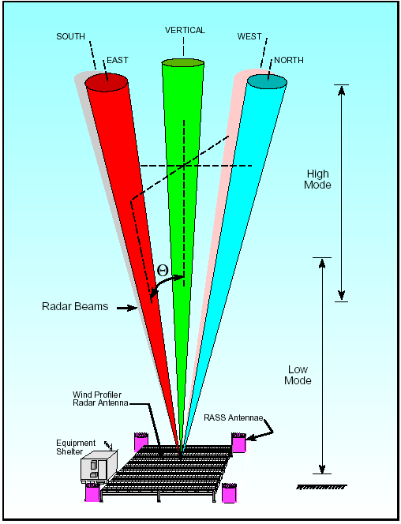

Fig. 1.7 The schematic Diagram of a ‘Clear-air Wind Profiling’ Radar

This radar operated by transmitting the RF signal in three directions and receiving the echoes with the frequency shift corresponding to the wind velocity component in the direction of the beam(s). Figure 1.7 shows the schematic diagram for such radars.

1. The ‘scale of the tropospheric scatterers’ (the physical distance at which the scattering properties of the target in the troposphere change in a perceptible manner) is around a metre. Therefore, frequencies in Lower UHF band (300-900 MHz) are suitable. Frequency allocation for these purpose is 404and 449 MHz. Therefore, any one of the value is chosen.
2. The echoes from the air are very weak. The calculations of the reflectivity indicate the need for approximately 16 KW. From the beam-width requirement is approximately 5 degrees. Antenna size of approximately 12x12 m2 is needed for the beam width. It is difficult to steer the antenna of this size. Phased array antenna configuration will be suitable for this radar.
3. Pulses Doppler processing will be required for this type of radars as the range as well as velocity is required by the user. Therefore the processing scheme would require the segregation of the echoes from each range-bins and the frequency analysis of the echoes for the determination of the Doppler velocity.
4. The data from these radars is used by the atmospheric scientists. The data is best represented as stacked Doppler spectra arranged in the range-bins of increasing heights.

It may be noted that the design process described above is only a gross representation for a beginner in radar design. Design of operational radar is much more complex and involved process.

1.7 **Numerical problems**

**Short Questions:**

(i) In a pulsed radar, transmitter-pulse is 1 µs and the duplexers recovery time is 0.5 µs.

(a) What is the minimum distance at which the target can be detected by the radar?

(b) What is the minimum distance (nmi) between two equal-size targets in order to be completely resolved by the radar.

(ii) What is the Doppler Effect? How are the echoes from approaching target separated from the receding target? What will be the Doppler frequency shift due to a an approaching target with velocity of 100ms-1 for a radar with carrier frequency of 1 GHz?

(iii) A pulsed radar has a duty cycle of 0.016. If the pulsed repeating period (PRP) is 380 ms and the carrier frequency is 2 GHz. What is

(a) Pulse width? (b) Pulse Repetition Frequency? (c) Range resolution and (d) Maximum unambiguous velocity? Assume equal extent for approaching and receding velocities.

1. A certain airborne pulsed radar has peak power Pt = 10KW, and uses two PRFs, fr1 = 10KHz and fr2 = 30KHz. What are the required pulse widths for each PRF so that the average transmitted power is constant at 1500 Watts? Compute the pulse energy in each case.
2. What will be the velocity resolution for the radar operating at 3GHz with PRF of 1 kHz whose echoes from 1000 pulses are analyzed for frequency estimation?
3. A target (aircraft) is travelling radially towards the radar with a relative velocity of 100 knots. The radar transmits continuous wave energy at a wavelength (λ) of 5 cm. What will the Doppler shift observed by the radar? What will the Doppler shift be if the target alters its course (changes direction) by 600? (1 Knot= 1 nautical mile hr-1 = 1.852km.hr-1)

**Multiple Choice Questions (MCQs):**

1. Pulsed radar operating at 10 GHz with transmission pulse width of 2 µs and pulse repetition frequency (PRF) of 1 kHz. If the received signal is sampled at 2 MSPS (mega samples per second). What is the accuracy of range estimate? What is the range resolution?
2. 75,150m (b) 75m, 300m (c) 30 m 150m (d)30m, 300m
3. For the radar in (i), what is the maximum (approximate) unambiguous range in ‘nautical miles’? (1 nmi=1.852 km)
4. 75.2 nmi (b)40.5 nmi (c)150 nmi (d) 81 nmi
5. A pulsed radar uses 8 μs transmit pulse bi-phase coded with 16 bit complementary code. Pulse Repetition Frequency (PRF) is 10 KHz, Peak power is 100 kW. What is the average transmit power?

(a) 2 kW (b) 8 kW (c) 4 kW (d) 800 W

(iv) If the transmission loss of the medium is α=2 Naper.km-1. Transmitter power is 5 Watt. What power will be received at a distance of 2km? Assume that the beam is perfectly collimated (The ‘rays are exactly parallel or radiation does not spread with distance).

(a) 1.68 mW (b) 2 W (c) 91.6 mW (d) 800 W

**Answers**

**Short Questions:**

(i) (a) The target cannot be detected if the echo round trip time is ≤1.5 µs. This gives an equivalent range of 225m.

(b) The range resolution for 1 microsecond is 150 m =resolution 0.08099 nmi

(ii) When radar transmission is incident on a target in relative motion with respect to the radars, the echo frequency is different that the transmit frequency. This phenomenon is known as the Doppler Effect. The echo from the targets approaching to the radar is at higher frequency that the transmit frequency; whereas the receding show echo frequency lesser than that of the transmit frequency. The Doppler frequency shift will be 666.67 Hz. ( 2X 100/ 0.3)

(iii) (a) PRP X Duty Cycle = Pulse Width = 6.08 μs. (b) PRF= 1/ PRP = 2.6315 kHz,

(c) Range resolution= cτ/2=3 X 108 X (6.08 X 10-6/2)= 912m

(d)BW=2.632kHz.🡺*fD*=±1.316kHz🡺Max.Unambiguous Vel= *fD*Xλ/2=± 98.684ms-1.

1. PW = Pav / (PpeakX PRF). Therefore, PW1=150/(103 X 103)= 1.5 μs, similarly for PRF of 30 KHz,the pulse width (PW) is 0.5 μs
2. The observation time of 1 ms X 1000= 1 s.

Hence the frequency estimation will be with a resolution of 1 Hz.

Doppler frequency resolution = 2 ΔV/0.1=1 Hz. @ 3GhHz

Corresponding frequency resolution is = 0.05 ms-1.

1. 1Knot= 1.852km/hr= 1.852/3.6=0.51444ms-1. 1 knot = 0.5144 m/s, so 100 knts = 51.44 m/s or 5144 cm/s (conversion to m/s or cm/s 0.5 marks)

Doppler shift = (2v/λ)= 2 X 5144 cm / 5cm = 2057.6 Hz

For a course change of 60o, the radial velocity component will be

Cos (60o) X 100 knot = 0.5 X 5144 cm/s= 2572 cm/s

Frequency shift = 2(2572cm/s)/(5 cm) = 1028.8 Hz

**Multiple Choice Questions (MCQs):**

1. (b) Accuracy is decided by the least count and resolution by the pulse width.
2. (d) Computed from the PRF (or PRP).
3. (b) PRP= 1/PRF=1/10000 = 100µs

Average power = (PW/PRP) X Pt = (8/100) (μs) X 100 (kW) = 8kW.

1. (a) Power will reduce according to  🡺 5Xe-8= 0.001677W≈ 1.68 mW.

**Chapter 2**

**Understanding Radar Design Parameters**

We have gained some basic understanding of the radar operations. We have also understood the relation between the radar parameters and the radar capability of ranging and the detection. In this chapter, we will try to understand the quantitative requirement of power in transmission and sensitivity in reception.

* 1. **The Radar Equation**

Radar range (the maximum distance at which the target could be detected) is a basic performance parameter of radars. The range depends on system parameters like transmitted power, antenna gain, and receiver sensitivity. The range also depends on the field parameters like distance of the target and the reflectivity of the target. An equation, giving the mathematical relation between these quantities is called ‘the Radar Equation’. Fig 2.1 shows a schematic diagram of reflection of the radar waves from a target. We will understand the radar equation in reference to the Fig 2.1.

1. Radar Transmission and Reception
2. Radar Signal Spread with distance

Fig 2.1 Schematic showing signal travel from radar to target and Back

Reception

Transmission

Target

Radar Antenna

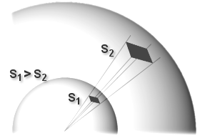

Fig.1 (a) shows a representative picture of the travel of the radar wave to the target and back. The wave initiates from the radar transmitter and travels in form of spherical wave-fronts as shown in Fig. 2.1 (b). This picture assumes ‘omni-directional’ transmitting source that radiates power equally in all directions. This means that when the transmitted wave travels a distance of ‘*R*’ meters (m), the power will spread over the complete surface of the sphere with radius ‘*R*’, on the area of 4πr2 (m2). In most cases, the radars radiate power only in the desired direction. This is because the power radiated in unwanted direction is a waste! Such directional radiation is achieved by an appropriate antenna. We will learn more about the antennas in chapter 8 of this book. The antenna concentrates the power in the desired direction. The directive radiation is shown by an inverted pyramid in Fig 2.1 (b). Concentration of power in a pyramidal or conical shape is an ideal situation. In practice the transmitted power concentrated in a region whose shape approximates to an elongated balloon or a baseball bat (as shown in Fig 1.3). This region is called ‘Radar Beam’ or the ‘main lobe’. There is also some power ‘spill-over in the regions in other directions (known as ‘side-lobes’). The beam region (or the mail lobe) receives more power than it would receive with the ‘omni-directional’ antenna. Let the power in the main beam be ‘G’ times higher than the power receivable by an omni-direction antenna. This increase in radar power is due to the transmitting antenna and the factor ‘G’ is called the ‘antenna gain’. With this understanding we could write a mathematical expression for the transmitted power density.

The power density at range *(R)*  ... (2.1)

Where, *Pt* and *Gt* are the transmitted power and the transmit antenna gains respectively.

The transmitted power is incident on the target. The target reflects a fraction of that power towards the radar receive antenna. Many radars are ‘mono-static’ where that ‘transmit antenna’ and the’ receive antenna’ is the same. The calculation of the reflected power from the target is done in the following manner.

Let the cross section of the target on which the radar power is incident be ‘*A*’ and it reflects a fraction ‘*f*’ of the incident power. The reflected power can be computed by multiplying the power density by ‘*Af*’’. The factor ‘*Af’* is known as the ‘radar cross section’ of the target or simply ‘target cross section’ and is denoted by ‘*σ*’.

The reflected power can be considered as‘re-transmitted’ towards the radar. The power density gets diluted over the range *‘R’* by a factor of ‘*4πR2*’. Let the effective area of the receiving antenna be *Ae.* Hence the received power could be computed as given in equation 2.2.

Received Power by radar  ... (2.2)

Now, consider that the minimum detectable power by the receiver is ‘*Smin’*. This is also referred as receiver sensitivity. Substituting the sensitivity in place of the received power in equation 2.2, we can compute the maximum range (*Rmax*) at which the target is detectable by the radar.

Maximum Range  ... (2.3)

This is known as simple form of ‘The Radar Equation’.

The ‘antenna gain *(G)*’ and the ‘effective antenna area ‘*(Ae)*’ are related by the following expression [5].

Gain of the antenna  ... (2.4)

If the same antenna is used for the transmission and the reception, we could write the radar equation in terms of antenna gain or in terms of antenna effective area as given below:

 OR  ... (2.5)

In the foregone discussion, we have considered a limit on the detection capability of the receiver; namely, signals with lesser power than *Smin* cannot be detected. This limitation is due to the noise observed in the receiver output. In absence of the noise, signal detection could be done at much lower power levels and would only be limited by the capability of the instruments.

In the next section we would discuss on the detection of the signal in presence of noise.

* 1. **Receiver Sensitivity and detection of the signal in Noise**

In any electronic system the presence of noise is inevitable. Noise is often source of concern to almost all the system designers. The noise is created by celestial, natural, and man-made sources. Studies and measurements on noise were initiated early in 20th century [8]. Due to the presence of noise, the detection of signals at low power level becomes difficult. Accurate estimation of noise power and its strength in comparison to the expected signal power determines whether the signal could be detected. The noise power is estimated by accurate statistical modelling of noise generating process [9]. The received signal power is estimated by estimating appropriate values for the propagation loss and the target cross-section.

Knowing the signal and the noise power it is possible to determine the ‘minimum detectable signal power’. The minimum detectable power is also known as the sensitivity (*S*min) of the receiver. We will get introduced to the basic concepts of radar signal detection in this chapter. Some of the practical examples and discussions for the deeper understanding are done in chapter 7.

‘Thermal noise’ or ‘Johnson noise’ [10] is generated due to the thermal agitations at the atomic level. It is the basic noise generating mechanism and is present everywhere. All substances at the temperature greater than absolute zero (-273.170C or 00K) generate thermal noise. The mechanisms, modeling, and computation of different types electronic noise is presented by Gabriel Vasilescu in his book on electronic noise. [11].

In case of microwave radars, the target echoes mainly have to compete with the thermal noise. In addition to that, the receiver electronics adds noise while processing the signal. This noise generated by receiver electronics increases the noise power at every stage of signal processing in the receiver. Though the thermal noise is present everywhere, it becomes insignificant compared to the system noise at later stages on the receiver. Therefore, for the computation purpose, the thermal noise is considered to be present only at the input of the receiver. The thermal noise power is computed by the following expression.

Thermal Noise Power  ... (2.6)

Where, *k* is the Boltzmann’s Constant = 1.38 X 10-23, *T* is temperature in degree Kelvin’ and B is the system bandwidth. The Institute of Electrical and Electronics Engineers (IEEE) defines the standard temperature as 2900K. At the standard temperature (*T0*) of 2900K, the thermal noise power is approximately 4X10-21 Watts (-204 dBW)

It can be seen that the noise is proportional to the bandwidth and temperature. At a particular temperature; it has equal power at all frequencies. Due to this property the noise is also called ‘white’ noise. The term ‘white’ derives an analogy from optics, owing to the fact that all coloured lights in equal strength produce white light.

While calculating the thermal noise power for a receiver the bandwidth of the ‘pre-detection’ stage is considered. Mathematically, it is given by the following expression.

Bandwidth  ... (2.7)

Where,  is the ‘normalized frequency response function’ or the’ transfer function’.

The thermal noise power for the receiver is computed using equation 2.6 and 2.7.

* 1. **Signal to Noise Ratio and Noise Figure**

In the earlier section we have seen that the ratio of signal power and the noise power is the most important number to estimate the deductibility of the signal (target echoes). The popular term for this is the ‘Signal to Noise’; popularly, referred by its abbreviation as ‘SNR’.

In case of the radars simplest computation of the SNR is done as follows:

* Compute the received signal power is using Equation 2.2
* Consider propagation losses of the radar signal and reduce the estimation of the received power. Various phenomena involved in propagation radar signals are introduced in section 1.4.
* Compute the noise power at the input of the receiver using the Equations 2.6 and Equation 2.7.

With this procedure, we get the SNR at the input of the receiver. This signal is then subjected to the processing involving various steps like amplification, filtering, frequency down-conversions etc. During the processing the SNR worsens or reduces. This means that signal strength relative to noise decreases. This can be explained by following example.

Let the signal at the input of the receiver is 0.1 pW (-130 dBW). Let the receiver bandwidth be 2.5 MHz. This will give the noise power of approximately 0.01 pW (-140 dBW). The SNR is 10 dB or the power ratio at the input at the receiver is 10.

For the detector circuitry these signal power levels are very low and the frequency is very high. This signal is amplified, frequency ‘down–converted’, filtered then amplified again (see Fig. 1.3). In all the radars similar processing steps are needed before feeding to the detecting circuit. All the receivers add noise to the signal degrading the SNR.

Let us assume that the signal in example above becomes 0.1mW and the noise 0.03mW after processing. Please note that the noise power relative to the signal has increased by a factor of three! In the ideal situation we would have expected that the processing would make identical modifications in the signal as well as noise. In that case, we would get the signal power of 0.1 mW and the noise power of 0.01 mW. However, in reality all the electronic and microwave circuits show the degradation in SNR. This degradation is quantified by defining a ‘Figure of Merit’ called the ‘Noise Figure’. The definition of the noise figure for a two port system with one port as input and the other as output is as follows:

* + 1. **Noise Figure**

Noise Figure (NF) is the ratio of the measured output power (*N0*) to the output power that would be obtained when the inputs are kept at the standard temperature (2900K).

We will discuss the computation of the ‘Noise Figure’ for radar receiver. A radar receiver could be considered as a system which gives certain gain (amplification) to the input signal power and has a certain bandwidth as defined in Equation 2.7. Let the gain be ‘*G*’ and the Bandwidth be *‘B’*. Then the Noise Figure (NF) is given by following expression.



 ... (2.8)

The noise figure is defined by the above expression for the systems like amplifiers and filters active mixers in terms of Gain and the bandwidth of these systems. etc. For all these systems, if the signal power at the input is ‘*Sin*’, the output will be ‘*G*X*Sin’*. We will multiply the numerator and the denominator of Equation 2.8 by ‘*Sin*’. By rearranging the terms we get...

 ... (2.9)

Equation 2.9 shows that the NF is the ratio of input noise power to the output noise power. This expression brings out that the NF is the quantitative measure of the degradation of SNR. This definition is often used informally. More discussion on noise in the context of receivers is presented in Chapter 10.

By rearranging the terms in equation 2.9, we can relate the output SNR and the input signal.

 ... (2.10)

With equation 2.10, we can express the minimum detectable power (*Smin*) and the corresponding SNR. We will see in the next section that the output SNR and the signal detection could be related mathematically. Therefore, it is more convenient to express the minimum detectable signal (*Smin*) in terms of minimum detectable SNR (SNRmin). The radar equation could be re-written in terms of ‘minimum detectable SN’R as follows:

 ... (2.11)

The advantage of this equation is that it is independent of the system parameters like bandwidth and the NF. Due to this the radar range could be expressed in terms of probability detection and probability of false alarm. The relation of SNR and these probabilities will be discussed in the next section.

**2.3.2 Expressing Noise contribution in terms of temperature**

The noise power is often expressed in terms of the temperature or the noise Temperature. This expression is often used in expressing the ‘sky temperature’. This approach is convenient as the noise contribution of cascaded system could be arithmetically added to compute the noise power of a cascaded system.

 … (2.12)

**2.3.3 Noise figure of the cascaded system**

Consider a cascaded system

F1, G1

F2, G2

F3, G3

Fn, Gn

Fig. 2.2 Cascaded system of RF/ microwave components

The noise figure and equivalent temperature are related by 

Effective Temperature for Cascaded System (*Tsys*)



… (2.13)

Equivalently the noise figure will be



Equivalent Noise Figure … (2.14)

* 1. **Probability of Detection and False Alarm**

In the radar block diagram (Fig 1.3) shows that the IF signal in the receiver is subjected to the ‘second detector/ Demodulator’. An envelope detector that uses a diode is often called the ‘second detector or ‘amplitude demodulator’. Conventionally, the signal detection is done with a diode as an envelope detector on the IF signal. The input to the detector is a vector sum of the noise signal and the received signal. It may be appreciated that the noise is a random signal (as opposed to the deterministic signal). In other words, the amplitude of noise signal could be different at different times under identical situations. The detection of the received signal would require the envelope of the ‘signal-plus-noise’ be higher than the threshold.

The noise waveform is of different amplitudes at different times! Due to this fluctuating amplitude the envelope of the ‘signal plus noise’ waveform also fluctuates. In this sense, the received signal competes with the noise signal to ‘get detected’. As a result, the detection of the signal of known power cannot be predicted with certainty. It is appropriate to express the detection of the in terms of ‘probability’. We will illustrate this concept with the help of Fig. 2.2.

Fig 2.2 shows a typical noise envelope. The figure also shows the ‘Root Mean Squared (RMS)’ amplitude of the noise. The threshold level is suitably higher than the ‘Noise RMS’. We will consider following different cases to understand the result of the detection process.

1. The noise envelope at times goes higher than the threshold level (Fig 2.2 shows three such occasions). The detector will identify these cases as the radar echoes! These instances are called ‘False Alarm’. It is undesirable feature.
2. Figure shows three echo pulses (dashed lines) riding on the noise waveform. The envelope of the ‘signal-plus-noise’ waveform goes higher than the threshold level at two occasions. These two pulses will be correctly identified as ‘echoes’. However, the third pulse will go undetected and will be missed. In this example, the success rate is 2/3. This is often expressed as ‘Probability of detection’.

Time

*Tn*

*Tn+1*

Noise Amplitude

Noise

RMS

Threshold

Missed Pulse

Detected Pulses

Fig 2.2 Noise Waveform and the pulse detection

*tn*

*tn+1*

*tn+2*

False Alarm timings

The performance of the radar receiver is specified in terms of the quantification of the ‘probability of false alarm’ or the ‘false alarm rate’ and the ‘probability of detection’. We will see mathematical expressions corresponding to these terms.

The receiver noise at the input of the IF stage is described by Gaussian probability density function (pdf) [13] as follows:

 ... (2.12)

Where, *v* is the noise voltage and the *σ* is the standard deviation.

This noise is passed through a band pass IF filter. Where, the real and imaginary components are independent and normally distributed, with same variance. The probability density function of the output signal envelope ‘*A*’ (or amplitude) has the form of the Rayleigh pdf [8] as shown in equation 2.13.

 ... (2.13)

When the noise envelope exceeds the voltage threshold (*vT*), it is wrongly detected as echo signal. This is the ‘False Alarm’ condition. In order to compute the probability of the ‘False Alarm’ (*Pfa*), we need to integrate this probability density function with limits *vT* to infinity.

 ... (2.14)

Equation 2.14 gives the probability of false alarm. However, it does not indicate whether will have frequent false alarms or the radar will be ‘troubled by’ many false alarms! The ‘time between the false alarms’ is more accepted performance criterion. The average time between ‘false alarm’ (*Tfa*) or the threshold crossings given by

 ... (2.15)

Where, *Tn*is the time between *n*th and *(n+1)*th false alarm.

The average duration for which the noise voltage crosses the threshold is approximately equal to the reciprocal of the IF bandwidth (*B*). Using this fact, false alarm probability and the ‘false alarm time’ can be related by the following expression.

 ... (2.16)

In operational radars the false alarm probabilities are very low; of the order of ‘10 e-9’. The IF value of 1 MHz and the false alarm probability of 1.11 X 10 -9 would give a false alarm, time equal to approximately 15 Minutes!

It can be seen that if the ‘Signal to Noise’ ratio is good, the detection threshold could be kept well above the noise power. In equations 2.12 to 2.16 we have used ‘*σ2*’ for ‘noise variance’ or the ‘noise power’. If the signal to noise ratio is good the threshold voltage could be higher and the ratio (*vT/2 σ2*) is numerically high. This gives very low probability of false alarm. To achieve good SNR, many radars signal processing schemes use a technique of ‘Pulse Integration’.

In Many radar applications the radar target is often a slow moving compared to the Pulse Repetition Frequency (PRF). This means that the target does not move significantly in one IPP of the radar. In such cases, one can get multiple identical echoes from consecutive radar pulses. Using the digital processors the echoes are sampled and then added to enhance the signal to Noise Ratio (SNR).

The signal samples also contain the noise. Noise, being a ‘Gaussian Random process’ adds in power (or Variance, *σ2*). This means that if *N* noise samples are added, the added value can be treated as a sample of random process with *N* times the power (or Variance = *Nσ2*). On the other hand,the signal is deterministic, add in amplitude. When *N* samples of the signal are added, the amplitude of the sample becomes *N* times and the signal power Becomes *N2*times! We can see that the SNR of the integrated sample is *N* times the SNR of Individual pulse. This advantage improves the ‘Signal detection capability of the radar substantially!

We will now understand the mathematical expression for computing the ‘probability of detection’. S.O. Rice showed [8] that in presence of the signal amplitude (*S*), the probability density function of the envelope detector output (*ps(S)*) is given by the following expression. Mathematically, this is a case of a bivariate random variable with normal distribution and non-zero mean, also known as Rician distribution.

 ... (2.17)

Where, *I0(z)* is the modified Bessel function of zero order[12][14] with argument *Z*. At *Z=0*, *I0(z)=1* and at large Z, the pdf could be approximated with asymptotic series expansion. It may be noted that when the signal is absent (*S=0*), equation 2.17 reduces to 2.13; an expression for the noise alone. The probability of detection (*Pd*) of the signal could be computed by integrating the pdf from *Vt* to infinity. However, the computations become complex and need the use of numerical and empirical methods. It is appropriate to relate *SNR, Pfa and Pd.* Albersheim[15] developed following simple empirical formula which is used by many radar engineers.

*SNR=A+0.12AB+1.7B* ... (2.18)

Where, A= *ln [0.62/Pfa] and B=ln [Pd/(1-Pd)]*

This mathematical expression is found very useful by the radar designers and engineers.

* 1. **Radar Cross-Section (RCS)**

At a particular frequency, the ‘radar cross section’ or the ‘target cross section’ is the property of a scattering object or the target. At large distance the radar wave-front is considered as a planer surface (rather than spherical) and the target is considered to occupy ‘fictional’ area parallel to the ‘radar wave-front’. This ‘fictional’ or ‘imaginary’ area is called radar cross section! If we multiply this area with the radar power density, we get the re-radiated power towards the radar. Thus, it is a measure of the power reflected (or scattered) back to the radar. Conventionally, it is denoted by ‘*σ*‘. Estimating the value of RCS of the desired targets is a very important aspect of radar design. The expression for it is as follows:

 ... (2.19)

Where, *Prd*is the re-received power density.

The fraction of the backscattered power depends on the target orientation with respect to the radar beam, the reflectivity of the target material and the target size relative to the radar wavelength. The radar designer does not have control on the first two factors. The third aspect could be addressed by choosing the radar frequency appropriately for the expected targets.

The reflection of the target and it dependence on the radar wavelength could be understood by dividing complete frequency range in three regions. It is known that the product of the frequency and the wavelength of the electromagnetic waves is 3X 108 ms-1.

1. When the radar wavelength is larger compared to the target size, the fraction of the reflected (or re-radiated) power is less and increases linearly as the wavelength becomes comparable to the target size. This region of frequencies (low frequencies, where the corresponding wavelengths are substantially larger than the target) is called the Rayleigh region, in the honour of Lord Rayleigh.
2. When the wavelength is comparable to the target size, the reflected power value shows fluctuations as a function of the wavelength. This region is called the ‘Mie Region’, in the Honour of Gustav Mie. The Mie region is also called the resonance region. The change in the reflection in this region is observed because of the interference between two waves. One wave is the direct reflection from the front surface and the other is the creeping wave going around the sphere.
3. The high frequency region where the target size is larger than the wavelength is called the optical region. In this region, the target reflections could be understood with ray optics.

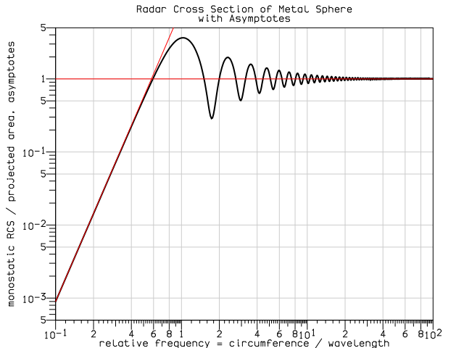

Mie Region

Optical Region

Rayleigh Region

Fig 2.3 Wavelength dependence of RCS for a Metal Sphere [16]

The radar cross section also depends on the shape of the target. A sphere is the simplest shape to be considered as a target. Fig. 2.3 shows the radar cross section values showing the three regions with a metal sphere as the target. Often gross estimation of the RCS is done based on the two asymptotes shown in Fig 2.3. This simplistic approach assumes a constant RCS if the circumference to wavelength ratio is more than 0.6. The RCS linearly degraded for the wavelengths giving the lower ratios. Mathematical expressions for the computation of the RCS are available for simple shapes like cylinder, cone, plate etc. The RCS of complex objects is computed by considering the objected as a combination of many simple objects. More complex objects are tackled by using advanced numerical techniques like ‘Finite Element Method (FEM)’

Some of the preliminary issues of the RCS are presented by Skolnik in chapter 2 of his book [1].

* 1. **System Resources: Power Aperture Product**

In this chapter we have understood the spreading of the radar energy as a spherical wave front reducing the power density as the square of the range. We have also discussed the Signal to Noise ratio (SNR) and its relation to the detection of the target. The re-radiation of the transmitted power in terms of RCS is also discussed to get an estimate of the received power. With this basic knowledge, we get an idea of designing a radar system for specific application.

The design process should ensure that it puts in the enough resources so that the echo (or the back-scattered signal) from the target should stronger (more in power) than the minimum detectable signal by the receiver. We will have a quick look at various factors that are not part of the radar system, but affect the received signal strength.

1. The reflectivity of the target (or the radar cross section) is decided by the nature of the target.
2. The receiver sensitivity is mainly limited by the thermal noise.
3. The propagation losses are decided by medium. For most of the radars, the medium is the atmosphere and the losses and various effects on the radar signal depend on atmospheric conditions.

It could be easily seen that the radar designer has no control on these parameters. Therefore, appropriate planning of system resources is necessary to achieve the desired results.

From the radar equation, it is understood that the main system resource parameters are Two. First parameter is the ‘transmitted power’ and the other parameter is the ‘gain of the transmitting and receiving antennas’. It is also shown in equation 2.4 that the gain of the antenna is proportional to the area of the antenna. The transmitted power and the antenna area are called ‘System Resources’ of the radar. The product of the two terms is referred as the ‘Power aperture product’ of the radar. This is a parameter on the basis of which the radars are grossly categorized as ‘Big’ or ‘Small’. The average transmitted power (*Pav*) is often of interest in radars. For the pulsed radars it is given by multiplying the peak power (*Pt*) by the ratio of the pulse-width (τ) and the pulse repetition period (*Tp*).

 ... (2.20)

The Indian MST radar located at Gadanki in the state of Andhra Pradesh is one of the largest radars in the world for the study of atmosphere. This radar transmits 2.5 MW of peak (250 KW average) power and the antenna is spread over the area of about 40,000 m2. This radar has a power aperture product of 1010 W.m2. Some of the smallest radars are used in missile borne electronics. These radars typically transmit 10 mW and the antennas have the area of 0.01 m2. The PA product of these radars is approximately 10-4W.m2. The two examples almost span the complete ‘Power-Aperture Product’ range of radars.

**2.6.1 Particulate Scattering due to Relative Size of the Scatterers [21]**

It is seen that the size of the scatterer relative to the RF wavelength determines the scattering mechanism. In case of atmospheric radars, due to the particle sizes, the scattering mechanisms occur into two categories, namely Rayleigh scattering and Mie scattering. As an example, the cloud detecting radars operating at 30 to 60 GHz have the RF wavelength of 5 to 10 mm. The scatterers of interest for this radar are the rain-drops, hail, icicles etc. The size of these scatterers is comparable to the RF wavelength. Therefore the Mie scattering will be predominant in this case. Equation 2.21 gives the expression for the reflection coefficient.

 (2.21)

Where,

*a* is the radius of the scatterer and αis a shape factor, =*2π a/λ* for spherical objects.

*an*and *bn* are constants which describe the effects of magnetic and electric dipoles, (and quadruples) in the scattering volume.

When the diameter ‘*D’* of the scatterers is less than 0.1 λ, the scattering mechanism is Rayleigh. The reflection coefficient for Rayleigh scattering is given by the following expression.

 (2.22)

Where,

m is the complex index of refraction,

D is the target diameter and K= (m2-1)/(m2+2).

In order to compute the received power to particulate scatterers, the value of σ, obtained from 2.21 or 2.22 can be substituted in radar equation

* 1. **Numerical problems**

1. A C-band radar with the following parameters: Peak power G = 45dB, operating frequency f0=5.6 GHz, antenna gain G=45dB, effective temperature Te=290 K, pulse width τ= 0.2μs. The radar threshold is (SNR) min = 20 dB. Assume target cross section σ=0.1 m2. Compute the maximum range. (make convenient assumptions)
2. An airport surveillance radar operating at a frequency of 2.9 GHz (S-Band).Its maximum range is 60 nmi for the detection of target with a radar cross section of 10,000 m2(σ=10,000 m2). Its antenna is 5m wide and 2.7 m high, antenna aperture efficiency ρa of 0.7 and minimum detectable signal Smin equal to 10-9 W. What will be it’s peak power?
3. Compute the power aperture product for an X-band radar with the following parameters: signal-to-noise ratio SNR=15dB; losses L=8dB; effective noise temperature Te= 900 degree Kelvin; search volume Ω=20 ; scan time TSC=2.5 seconds; noise figure F=5 dB . Assume a –10dB m2 target cross section, and range R=250 km. Also, compute the peak transmitted power corresponding to 30% duty factor, if the antenna gain is 45 dB.
   1. The atmospheric attenuation can be included in the radar equation as another loss term. Consider X-band radar whose detection range at 20 km includes a 0.25 dB/km atmospheric loss. Calculate the corresponding detection range with no atmospheric attenuation.
   2. Let the maximum unambiguous range for low PRF radar be Rmax. (a) Calculate the SNR at ½ Rmax and ¾ Rmax. (b) If a target with σ=10 m2 exists at ½ Rmax, what should the target RCS be at ¾ Rmax, so that the radar has the same signal strength from both targets.
4. A Milli-Meter Wave (MMW) radar has the following specifications: operating frequency f0=94GHz , PRF fr=15 KHz , pulse width τ=0.05ms, peak power Pt=10W , noise figure F=5 dB , circular antenna with diameter D=0.254 m, antenna gain G=30 dB , target RCS σ=1m2, system losses L=8dB, radar scan time TSC=3s, radar angular coverage 2000 and atmospheric attenuation 3 dB/km. Compute the following: (a) wavelength (b) range resolution ; (c) bandwidth ; (d) the SNR as a function of range; (e) the range for which SNR=15dB ; (f) antenna beam width; (g) antenna scan rate; (h) time on target; (i) the effective maximum range when atmospheric attenuation is considered.
5. An X-band airborne radar transmitter and an air-to-air missile receiver act as a bistatic radar system. The transmitter guides the missile toward its target by continuously illuminating the target with a CW signal. The transmitter has the following specifications: peak power Pt=4KW; antenna gain Gt=25dB; operating frequency f0=9.5GHz . The missile receiver has the following characteristics: aperture Ar=0.01m2; bandwidth B=750Hz; noise figure F=7dB ; and losses Lr=2dB . Assume that the bi-static RCS is σB=3m2. Assume Rr=35 km, Rt=17km ; . Compute the SNR at the missile.
6. Consider a low PRF C-band radar operating at f0=5000 MHz. The antenna has a circular aperture with radius 2m. The peak power is Pt=1MW and the pulse width is τ=2μs . The PRF is fr=250 Hz, and the effective temperature is T0=600K . Assume radar losses L=15 dB and target RCS σ=10m2. (a) Calculate the radar’s unambiguous range; (b) calculate the range R0 that corresponds to SNR=0dB; (c) calculate the SNR at R=0.75R0.
7. Non-contact level based measurement system is installed on a cylindrical petroleum reservoir. This system is expected to measure liquid level from 1ft (≈ 0.3m) to 30 ft (≈ 9m). The measurement must be done with the resolution of 0.5 ft.
8. What is the bandwidth of the RF system?
9. Design a transmit wave pattern?
10. Can the accuracy of the measurement be increased keeping the resolution same?

**Multiple Choice Questions**

1. The signal strength of the echo received from a point target at a distance ‘R’ is ‘P’ Watts. What will be the echo power from the same target when it is at a distance of ‘2R’?
2. 0.5 P Watts (b) 0.0625 P Watts (c) P mW (d) 0.25P dBm
3. Mono-static radar was operated with a parabolic dish antenna. This antenna was replaced by a similar dish antenna with twice the diameter. If the echo strength from a typical target was ‘P’ watts with original antenna, what would be the received signal strength with the new antenna?
4. 16 P watts (b) 4 P watts (c)1/4 P watts (d) P watts
5. If the transmission pulse width of radar is halved and subsystems like matched receiver, modulator were accordingly modified for optimum performance. How will the ‘signal to noise ratio (SNR)’ of the ‘single pulse echo’ change?
6. Remains the same (b) becomes half (c) becomes double (d) becomes 1/4

**Answers and discussions**

**Problems :**

(i) **Parameter computations:**

Wavelength @ 5.6 GHz= 3X108/5.6X 109= 0.05357 m= -12.7 dB(meter)

Optimum Bandwidth at 0.2 μs pulsewidth = 5 MHz

**Assumptions:**

We assume that the noise Figure is 0dB (=1) ideal amplifier.

also the signal with strength equal to noise will be detected. Therefore Smin= kTB



This calculation with a reasonable approximation becomes much easier in dB.

Rmax= 0.25 (45+90-25.4-10-33+107)=43.4 dB(meter)=21.877 km

(ii) Parameter computations:



Rmax= 111120 m = 50.45 dB(meter)

**Assumption**: Minimum detectable signal is received from Rmax.



Rearranging the terms we have Transmitted peak power is 22.950 kW.

This calculation is much easier in dB

Pt(dB)=-90+33+201.6 -80.90-40+19.7=43.4= 21.877 kW

1. We need to derive the equation for the relation between SNR and power aperture product



Assumption: There is only one pulse per beam spot while scanning. We have

*Tsc= TPRF X No. of beam spots*= (Ώ/dθdϕ) Where dθ and dϕ are the beam-widths in orthogonal direct ions. We also know that Gain (G=4π/ dθdϕ) and B=(1/τ). The expression becomes…



Re-arranging and substituting, we have



Computing in dB terms

Power Aperture Product= 11+215.9-199.08+8+5+15-14.5-4+10= 47.32dBWm2=53951.03 Wm2.

Now, we compute Peak Transmitted power

Antenna gain 45 dB=31622.77 Hence the area (Ae)will be = 31622.77 X (0.03)2/ 4 π=2.26 m2

Pav= 53951.03/2.26=23.821 kW, with 30% duty, we have Pt=79.403 kW

1. With the loss of 0.25 db/ km, we have round trip loss of 2 X 20 X 0.25=10 dB

For radar with no atmospheric losses an advantage of 10 dB is available.

This will improve the range by 2.5 dB ( a factor of 1.778)

Hence the range will be 35.56 km.

(b)The SNR at

½ Rmax will be 16 times (12 dB)

¾ R max will be 3.16 ( 5 dB) times higher.

By taking the target at the range of 1.5 times, the signal becomes weaker by 5.0625 times. Hence the target RCS should be5.0625 times bigger (i.e 50.625 m2)

Appreciate that the value of the Gain is not required!!

**(iv)**

1. Wavelength= 3.125 mm
2. Range Resolution= 7.5 m. ( with pulse width of 0.05 ms = 7.5 km)
3. Bandwidth = 1/τ= 20 MHz (20 kHz)
4. Following expression



But this is represented better in dB terms.

SNR (dB) = 70-50-33-9+140-8-5-4R (km,dB)-120-3R (km, Because it appears as exponent the expression)

=-15 -4R (dB,km)- 3 R (km) …. = 45 -4R (db(km))-3 R(km)

1. Range at which SNR =15 dB is 0 dB(km)≈ 0.183 km. (3.22km)
2. Beam width= 70 X0.003125/0.254=0.86 degrees
3. Scan rate 200/3 =66.67 degrees per second
4. Target is assumed to be a point target. Time on target= 0.86/200s= 4.3ms.
5. We assume that 1 dB SNR is required for detection. Therefore, therefore maximum range is

2 dB(km)= 1.6 km. ( 3dB SNR, 42/7= 6 (dBkm)= 4 km.)

This problem becomes interesting if we take the pulse width to be 0.05 ms (resolution does not play role)

(v)



Solving in dB terms,

SNR=36+25-20+5-33-90-84.6+175= 13.64

(vi)

1. Unambiguous range=1/ fr=4 ms=> 600 km.

(b)



Assuming that noise figure is 0dB,

In dB terms, SNR= 60+92.84-24.43+10-33+144-15= 234.6 – 4 R (dB(m)) = 707.9 km.

This is higher than unambiguous range

1. At 0.75 R0, the SNR will be5 dB.

**(vii)** (a) 0.5 ft (≈0.15m) Resolution will require bandwidth of 1 GHz.

1. A typical pulsed radar modulation waveform is planned with a pulsewidth of 1ns with PRP of > 60ns. (say 100ns). This is possible (and preferred) with FMCW radar.

see section 3.6, problem (i).

(c) Yes. accuracy can be in creased by having a good SNR.

**Multiple choice Questions (MCQs)**

1. (b) The echo strength is proportional to R-4. Hence the Prec becomes 1/16 times.
2. (a) Doubled diameter will make the gain 4 times. Prec α G2. 🡺Received power is 16 times higher!
3. (d) Matched receiver correlates the echo. Average power is halved and the noise BW is doubled. Hence SNR reduces by 4 times.
4. (b)The Pulse width will

**Chapter3**

**Continuous Wave Radar**

Most of the discussion in earlier chapters was with reference to the pulsed radars. Main reason for this is that the earlier operational radars were pulsed radars. Also it is simple to perceive the concept of the radar in its pulsed form. Continuous radars were initially used for the ‘Velocity Only’ detection. **In** these applications, the velocity of the target is the only parameter of interest; e.g. detecting the speeding cars on the highways. Subsequently, continuous wave radars were used in the applications were small distances were involved; e.g. snow layer thickness measuring radars, liquid level measurement radars etc. Today the continuous wave radars are operational for numerous applications. We will discuss types of ‘continuous wave radars’, their working and their applications in this chapter.

* 1. **Continuous Wave Radars and its Applications**

There two types of continuous-wave radars; ‘un-modulated continuous-wave’ and ‘modulated continuous-wave’.

### Un-modulated continuous-wave radars: These radars normally used for Doppler detection or velocity determination. These radars could be effectively used in applications like ‘speed Guns used by the traffic police for the measurement of the speed of vehicles. They are also used in ‘on-board’ electronics of the missile to gauge the self-speed of the missile.

### [http://upload.wikimedia.org/wikipedia/commons/thumb/f/f7/Doppler_effect_diagrammatic.png/400px-Doppler_effect_diagrammatic.png](http://en.wikipedia.org/wiki/File:Doppler_effect_diagrammatic.png)

Fig.3.1: The sketch showing the Doppler frequency change for moving targets

### Fig 3.1 shows the sketch of the wave-fronts that if the target is moving relatively with respect to the radar. Let *ft* and *fr*are the transmit and receive frequencies. *v* being the target velocity and *c* the velocity of the radar wave, we have the received frequency as shown in equation 3.1.

### The frequency change will be *fD*= *ft- fr* … (3.1)

### Re-arranging the terms and approximating *c-v = c* (as *v*<<*c*), we have the same expression as equation 1.3; .

It can be seen that if the receiver signal processing scheme is capable of measuring the frequency change, the velocity of the target can be determined.

Another application of un-modulated continuous radar is for homing application. ‘Homing’ is the term used when a moving platform seeks a desired location.

In co-operative homing, a moving platform needs to reach the base; e.g.an helicopter desires to land on helipad. In this application, the transmitter (on the helipad) transmits un-modulated continuous signals. This signal is received by mono-pulse receivers (on the helicopter). The mono-pulse receivers have direction finding capability and can determine the direction of the destination (helipad). The receiver directs the helicopter towards the base. The working of the mono-pulse receivers is discussed in sections 6.3 and 6.4. The schematic is shown in Fig. 3.2 (a).

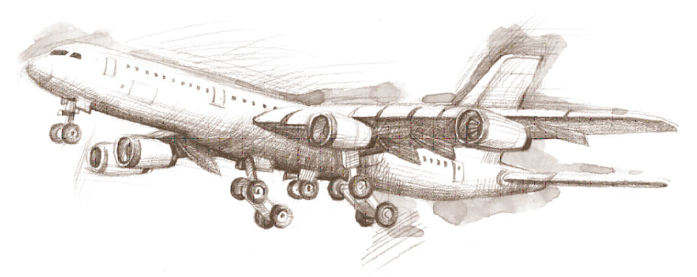

On-Board system for Homing

Homing Receiver On-board

Target

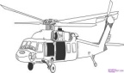

Processor

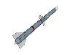

Missile Seeking the target

Helipad

Transmitter

Base Station

Fig 3.2 (b) Hostile Homing

(With schematic of missile electronics)

Fig 3.2 (a) Cooperative Homing

The same concept is used for hostile homing. In this case the moving platform is required to reach a non-cooperative target; e.g. surface to air missile seeking and enemy target (see Fig. 3.2(b)). For this application a transmitter transmits a continuous signal from the base station. This works like a flood-light in the region. The missile (moving platform) has two receiving antennas. One of the antennas gets the reflected signal from the target. This shows Doppler shift due to the two relative motions; namely, between the base-station and target and between target and the missile. The other antenna gets the signal from the base station. This signal also shows the Doppler shift due to the relative motion between the missile and the base station.

Knowing these Doppler frequencies and own velocity with respect to the base station the missile electronics computes the target direction and the velocity. With this information it can ‘home (move towards)’ to the target.

Because of simplicity, CW radar are inexpensive to manufacture, relatively free from failure, cheap to maintain, and fully automated. Some are small enough to carry in a pocket. However, well designed sophisticated CW radar systems are deployed for tactical defense applications and are capable achieving accurate detections exceeding 100 km.

However, there are limitations on the applications of these radars. Continuous wave radar cannot measure distance, and the antenna beam is usually broad (the sector in which the transmitted power is transmitted) with side-lobes (the radiated power in unwanted direction) that extend to the side and behind the radar antenna.

One of the popular applications of continuous wave radar is traffic speed-gun, used to determine the speed of the automobiles. For antennas of these units, with 20dB side-lobes (one hundredth power in unwanted directions) a truck or tree with 1,000 square feet of reflecting surface behind the antenna can produce a signal as strong as a car with 10 square feet of reflecting in front of a small hand held antenna. This is likely to create confusion in target determination. Such situation occurs for the operation of ‘Hand-held’ devices like speed-gun. Therefore area survey is required to ensure reliable operation of such hand held devices.

Another nuisance for such units is birds flying near objects in front of the antenna. Reflections from small objects directly in front of the receiver can give stronger reflections than the cars, busses, trucks etc.

1. **Modulated continuous-wave radars:** Frequency modulated versionsof continuous radars are used for variety of applications. These radars are popularly known as ‘Frequency modulated Continuous wave (FMCW) radars. The modulation could be any of the following types:
2. Sine wave, like air raid siren
3. Saw-tooth wave, like the chirp from a bird
4. Triangle wavelike siren indicating Industrial hazard situation
5. Square wave, like police siren in the India, United Kingdom

Linear Frequency modulation is the most popular modulation used in the continuous wave radars. More than 80 % of the continuous radars use linear frequency modulation. In the Next section, we will discuss the working of the linear FMCW radar with the ‘Sawtooth modulation’ and the ‘Triangular Modulation’.

In FMCW radars the receiver is expected to function when the transmission is on! Therefore, for FMCW radars, the specification of great concern is the isolation between the transmitter and receiver. Inadequate isolation leads to reduced sensitivity of the receiver. More discussion on this topic is presented in section 3.3. Most of the FMCW radars are bi-static as it is easy to get the transmitter-receiver isolation. Some mono-static configurations are also possible for continuous wave radars. Fig 3.3 shows schematic diagrams for mono-static and Bi-static continuous wave radars.

RF Generator

Amplifier Filter

Receiver Processor

Directional Coupler

Circulatorr

Directional Coupler

Mixer

Mixer

Amplifier Filter

Receiver Processor

RF Generator

Fig. 3.3 (a) Continuous Wave Radar:

Mono-static configuration

Fig. 3.3 (b) Continuous Wave Radar:

Bi-static configuration

FMCW radars are preferred in following situations.

1. Application allows radar operation in ‘bi-static’ mode with a large distance between transmit and receive antennas.
2. The transmit power requirement for the pulse mode option is impractically high.
3. Measuring distance (range) is small; typically distance lesser than 150 meters.

From these preferences, it could be understood that the FMCW radar technology is used in miniature radars like altimeters, non-contact level sensors. This technique is also used in very large HF radars used for Sea-state monitoring and for ‘Over the Horizon (OTH)’ detection [20].

* 1. **Linear FMCW Radars**

‘Linear Frequency Modulated Continuous Wave’ radars are capable of estimating the range of the target as well as the velocity of the target. Most of the radars use linear frequency modulation as it serves the purpose and is simpler to realize compared to the sinusoidal or non-linear frequency modulation.

The principle of the range determination could be understood by considering the ‘Sawtooth Modulation’. Fig. 3.4 illustrates the sawtooth modulation scheme. In this scheme, the frequency of the transmitted signal is increased linearly with time. This signal is represented graphically with time on ‘*x*’ axis and frequency on ‘*y*’ axis. It is called sawtooth as the frequency-time graph has a shape of a saw-tooth. One spell of increasing frequency is often referred as one ‘frequency sweep’ of frequency. The ‘frequency sweep’ is repeated in the same way as the pulse modulation is repeated in the pulsed radars. Radar modulating signal often have an ‘off period’ (shown as TOFF in Fig. 3.4) between two sweeps. The frequency sweep signal is transmitted repeatedly by FMCW radars.

The transmitted signal gets reflected from the target and returns back. This signal is shown as an identical sawtooth waveform, shifted in time corresponding to the round-trip delay (shown by a dashed line in Fig. 3.4). This received signal is given as an input to the mixer. The other input to the mixer is the transmitted signal. The two signals are ‘mixed’ to give output that contains the ‘sum frequency (*ftranmit*+ *freceive*)’ and the ‘difference frequency (*ftranmit*- *freceive*)’. The sum frequency is filtered out in the next block and the difference frequency is taken for the processing. The difference frequency is also referred as ‘Beat Frequency’. This beat frequency is proportional to the range of the target. The derivation for this is given in section 3.3.

Time

Frequency

A

B

C

D

E

F

Modulation time (*T*) Time

Bandwidth

(*ΔF*)

DF- Round trip time (*t*)

EF- Beat Freq (*fb*)

TOFF

(Off Period)

Windows where Beat frequency signal is available

Fig. 3.4: Range determination by FMCW radar concept diagram

* 1. **Range and Doppler Measurement in FMCW radars**

Determination of the range and the Doppler (or the velocity relative to the radar) of the target is the main function of the radar. In this section, we shall derive the expressions for the range of the target and the velocity of the target for the linear FMCW radars.

**3.3.1. Range determination in linear FMCW radars**

Linear FMCW radars use sawtooth modulation as shown in Fig. 3.4. The echo signal is mixed with the transmitted signal to get the difference frequency or the ‘Beat Frequency’ by the procedure described in section 3.2. We will calculate the beat frequency in terms of the modulation parameters. Consider triangle DEF and ABC in Fig. 3.4. This is a pair of similar triangles. Therefore the ratio of EF to DF is equal to the ratio of BC to AC. The segment DF represents the round trip time equal to ‘2*R/c*’; where, *R* is the range (distance to the target) and *c* is the velocity of the electromagnetic waves. The segment EF represents the beat frequency*, fb*.

 Rearranging the terms

(Range)  … (3.2)

It is seen from the equation 3.2 that the beat frequency (*fb*) is proportional to the range. Therefore, FMCW processing involves the measurement (or estimation) of the beat frequency. An FMCW radar used as altimeters in helicopters has modulation bandwidth () of 150MHz, The sweep time is approximately 1ms. This type of radar would have beat frequency of 1 KHz per meter. The height of 100 m would be indicated by 100 KHz. For pulsed radar, 1 meter would correspond to about 6ns. Using electronic circuitry, frequency measurement of 1 KHz is easier than time duration measurement of 6ns. It is evident from these typical numbers that the measurement of lower heights is easier in FMCW radars. Thus FMCW radars are preferred for low range measurement applications like altimeters and non-contact liquid level measurement systems.

**3.3.2. Range Resolution in linear FMCW radars**

In the section 3.3.1 we have seen that range determination is done by the measurement of the beat frequency. It is therefore clear that the resolution of frequency measurement would directly reflect in the range resolution.

From Fig. 3.4 it is seen that the beat frequency is almost available for the complete sweep time. This means that the maximum time for which the beat frequency could be observed is the sweep time (*T*). Therefore the resolution with which *fb* could be estimated is ‘*1/T*’. In other words, ‘Δ*fb’* equals (1/*T*).

Using this information we compute the range resolution as

(Range Resolution)  … (3.3)

This means that two identical targets could be identified as two separate targets by the radar, if they are separated by distance more than ‘*c/2ΔF*’. It is interesting to note that the range resolution of the radar only depends on the modulation bandwidth. Other parameters like sweep rate do not affect the resolution capability.

Here, the reader is cautioned to have clear appreciation of ‘range resolution’ and ‘accuracy of range determination’. The term resolution is significant when two targets are present and to be identified separately. Whereas, the ‘accuracy of range determination’ is the term used for a single target. IN FMCW case, the accuracy depends on the accurate estimation of the beat frequency. The accuracy could be arbitrary high if the ‘signal to noise’ ratio is very good.

**3.3.3. Velocity determination in pulsed radars**

We have seen that the target velocity manifests itself as Doppler frequency. We have also seen in section 3.3.2 that in case of Linear FMCW radars, the range determination depends on the difference of frequency between transmit and receive frequency. It is clear that the Doppler shift in the receive frequency will cause error in the range determination.

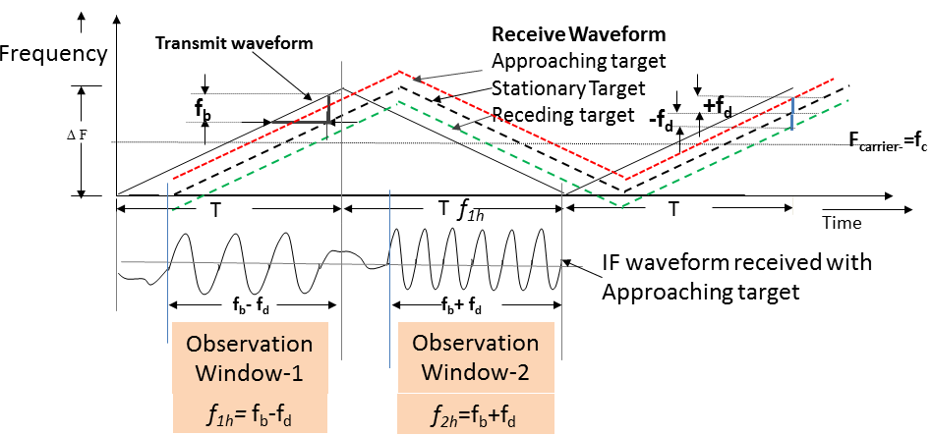

Fig. 3.5: Range and velocity determination by triangular waveform modulation

This ambiguity and confusion likely to arise in sawtooth modulation is resolved by the use of triangular modification. In triangular modification, the transmit frequency is increased in the first part and the frequency is decreased at the same rate during the second part of the modulation cycle. Fig. 3.5 presents the schematic diagram of the triangular modification. The figure shows the triangular modulation and the echo waveforms in different cases.

1. *Stationary target*: The ‘bold dashed’ line shows the echo of a stationary target. This waveform is shifted only in time. This waveform will lead to beat frequency proportional to the range of the target as given in the section 3.3.2.
2. *Approaching target*: Approaching target would give rise to positive Doppler shift. This means that the frequency will be higher than that of the stationary target. The echo of the approaching target is indicated with dotted line in Fig. 3.5.Fron the figure, It is seen that during the first half (rising frequency portion) the frequency difference between transmit and receive signal will be lesser that that obtained in case of the stationary target. Similarly, in the second half (decreasing frequency portion) the frequency difference will be more than the beat frequency of the stationary target. Carefully analysing the situation we see that the frequency in the first half will be *fb*-*fd*; where *fd* is the Doppler frequency as computed in equation 1.3. In the second half, we get the difference frequency as *fb*+*fd*! A sketch, representing the beat frequency for the approaching target is also shown in Fig 3.5.
3. *Receding target*: Receding target would result in negative Doppler or frequency lesser than that would be obtained in stationary target. The echo of the receding target is shown with faint dashed line in Fig. 3.5. In this case, the difference frequency in the first half will be *fb*+*fd* and the frequency during the second half will be *fb*-*fd*.

In the literature*, fb* is also referred as *fR* and *fd* is also referred as *fD*. These subscripts convey the physical significance of these terms. From the above description, we understand that in FMCW radars, the range and frequency estimation is done simultaneously by measuring the ‘difference frequencies’ during the first half (*f1h*, say) and during the second half (*f2h*, say). The range and velocity of the target will be given by the following expressions. In equation 3.4, *fc*is centre frequency of transmission as shown in the Fig 3.5.

(Range)  ... (3.3)

(Velocity)  ... (3.4)

**3.3.4 Velocity resolution in pulsed radar**

We have seen that the range and velocity determination is inter-linked and simultaneous in FMCW radars. While considering the velocity resolution, it must be assumed that both the targets are present in the same range-bin and the frequency corresponding to the range is accurately measured. If these assumptions are valid, we could compute the velocity resolution by substituting 1/T in the frequency measurement term. In other words, we get the expression for the velocity resolution simply by replacing ‘(*f2h*-*f1h*)/2’ term by ‘1/*T*’’. It may be noted that in triangular modulation, the duration of the modulation cycle is ‘2*T*’’ (see Fig. 3.5). It is ‘half the modulation cycle time’.

(Velocity Resolution) … (3.5)

**3.4 Isolation between the Transmitter and Receiver**

In the earlier sections, we have seen that the receiver of continuous radar(s) of the continuous wave radars operate when the transmitter is on! Due to this simultaneous operation, on many occasions part of the transmitter power ‘leaks’ into the receiver. This is a major practical problem of continuous wave radars.

Small FMCW radars have transmitter power ranging from 10dBm (10 mW) to 33 dBm (5 W). The receiver sensitivity is in of the order of -90dBm to -110 dBm. These numbers indicate that ‘transmitter to receiver’ isolation of approximately 80db is required. In simple terms only 10-8 times the transmit power should reach the ‘decision making stage of the receiver! In operational radars, isolation of approximately 40 dB to 50 dB is realised between transmit and receive antennas. Approximately 40 dB is realised by filtering or by null technique.

In almost all the applications, of FMCW radars that transmitter is located near to the receiver. Therefore, the transmitter leakage appears as ‘zero or very low frequency signal’ after the frequency mixing stage. The filter approach relies on using a very narrow ‘band-reject filter’ that will eliminate low frequency signals. In this approach the unwanted signals from near-by objects are also rejected.

The null approach is aimed at specifically rejecting the transmitter signal. In this approach, the receiver takes two signals:

* A signal from the target containing the transmitter leaking
* A sample of the actual transmit signal

The transmit signal is inverted (phase shifted by 1800), attenuated, and fed into the receiver for cancellation of the transmitter component from the target signal. The phase shift and attenuation are set using feedback obtained from the receiver to cancel most of the leakage. Typical improvement is on the order of 30dB to 50dB. The rejection up to 70 dB is also observed in some cases.

Another technique called ‘Interruption is also used. In this technique, the transmitter is switched off for a very short duration (before and during the receiver sampling). The transmitter is ‘off’ during the receiver sampling!! This technique is strictly not a ‘continuous wave’ technique. It could be implemented where the target range of interest allows such interruptions.

* 1. **Applications of FMCW Radars**

The FMCW radars have been popular in Industries as level measurement radars for process tanks. FMCW radars are used in strategic applications as altimeters for aeroplanes, helicopters and missiles etc. Fig 3.6 (a) and Fig 3.6 (b) show representative pictures of these applications.





Fig. 3.6 (a) FMCW radar for Liquid level measurement (b) FMCW radar altimeter operational

In both the applications described above the FMCW radar radiates the beam downwards towards the surface. This surface is the material surface in case industry application and the land or water in case of altimeter application. In these applications, there is target is a stationary target with very small movement with respect to the radar platform. These units operate in C or X band for airborne applications. For Industrial applications any one of X, Ku, Ka, V or W band is chosen depending on the available space tank geometry and economics.

Another application of FMCW radar is for sea state monitoring radars. These radars operate in HF band and transmit vertically polarized transmission over the sea surface. At HF frequencies the HF waves travel to distances up to about 300 Km and receive echoes. This range is much larger than the Line of Sight (LoS). Therefore these radars are also known as Over the Horizon (OTH, ground wave) radars. There is another type of OTH radar. These radars use the ionosphere as a ‘mirror’ for target detection. In this type the RF energy is directed towards the ionosphere. The radar wave reflects from ionosphere; reach a distant target and the reflected wave travels back to the radar. Range up to 4000Km is possible by these radars.

These types of HF radar are expected to detect the targets from very high ranges. The target reflectivity is also low. Such requirement calls for transmission with high average power. Therefore, FMCW radars are preferred over the pulsed radars.

* 1. **Numerical Problems.**

1. Non-contact FMCW based radar level based measurement system is installed on a cylindrical petroleum reservoir. This system is expected to measure liquid level from 1ft (≈ 0.3m) to 30 ft (≈ 9m). The measurement must be done with the resolution of 0.5 ft.
2. What is the bandwidth of the RF system?
3. Design linear FMCW transmit wave pattern. What is the period of frequency Chirp?
4. Can the accuracy of the measurement be increased keeping the resolution same?
5. An FMCW radar transmits n-different frequencies (equally spaced in the frequency band of ΔF) over time interval of T (equal intervals for n different frequencies). The echoes are processed by phase comparison with the sine wave signal coherent with the corresponding transmit frequency. Rate of phase change determines the beat frequency. Prove that it gives exactly same results as the conventional FMCW linear chirp radar. What is the advantage of the method described above?
6. If an FMCW radar altimeter operating in “X band maritime navigation frequencies” (9.3-9.5 GHz). Design the waveform if the system is expected to use vertical velocity as well as the height at which the radar is flying? Give measurement range of height and the vertical velocity. If the system in complete frequency band will the echoes result in OFF-band transmission?

If the altimeter antenna tilts by an angle of 10 degrees, what is the error in the height measurement? (This is discussion type question. Solve yourself with discussion on multiple practical aspects)

**Answers and discussions**

**Problems:**

**(i)** (a)0.5 ft (≈0.15m) Resolution will require bandwidth of 1 GHz.

(b) Any saw tooth with 1 GHz sweep (ΔF) is fine.

This radar could be designed with pulsed waveform or Design any suitable chirp. The beat frequency and the proportionality constant shall change accordingly.

e.g. Sweep tiome(T)= 1 second will proportionality rate of fb=6.67 Hz per meter

(c) Yes. accuracy can be in creased by having a good SNR.

(ii)

Let the ‘*n*’ frequency steps be denoted by frequencies, *f1, f2, …fn*. and the target range be *H*. The phase shifts of the down converted signal at first step and the next will be

, 

These signals will present at the complex receiver as ***cosϕk+j sinϕk*** (for the *kth* step)

The phase difference between any two consecutive steps (say *kth*)will be

 and the angular frequency or the rate of phase change is  (1 mark)

 Same as the expression for the linear chirp FMCW radar.

**References**

1. Skolnik Merrill, “*Introduction to Radar Systems*”, Tata Mc Graw Hill Pvt. Ltd, 3rded. New Delhi, 2001, ISBN 10: 0-07-044533-8.
2. Blake, LV, “*Radar Range- Performance Analysis*” 2nd ed. Norwood, MA, Artech House, 1986.
3. Boithias Lucien' *Radiowave Propagation'*, North Oxford Academic Publisher Ltd. 1987. ISBN 0-89006-021-5.
4. Bean, B.R.and E.J. Dutton, “*Radio Meteorology*.” National Beauro of Standards Monograph 92, March 1, 1966.
5. Kraus JD, Ronald J Marhefka, Ahmad S Khan**, “***Antennas and Wave Propagation”***,** 4th ed. Tata Mcgraw Hill Education Private Limited,2010. ISBN 0070671559**,** Chapter 2
6. Silver S., “*Microwave Antenna Theory and Design*”, MIT Radiation Laboratory , Vol 12, Section 6.4, Mc Graw Hill New York Series
7. Schleher, DC, “Solving Radar Detection Problem using simulation”, *IEEE AESS Systems Magazine*, 10 (April 1995), pp 36-39,
8. Rice, S.O. “Mathematical Analysis of Random Noise”, *Bell System Technical Journal*, Vol. 23 pp282-332, 1944 and Vol. 24 pp 46-156, 1945
9. Davenport, W.B., W.L. Root, “*Introduction to the theory of random Signals and Noise”*, IEEE Press, New York, 1987.
10. Johnson, J.B., “Thermal Agitation of Electricity in Conductors” *Physics Review*, Vol 32 pp 97-109, July 1928,
11. Gabriel Vasilescu, “Electronic Noise and Interfering Signals: Principle and Applications”, Springer, 2005, ISBN-10: 3540407413, ISBN-13: 978-3540407416
12. Kreyszig Edwin, “*Advanced Engineering Mathematics*” Wiley Estern Ltd, 5th Ed. P183, 1983. ISBN-10: 0-47-115496-2 ISBN-13: 978-0471154969
13. Papoulis Athanasios, S. Unnikrishna Pillai, “Probability, Random Variables and Stochastic Processes”,Tata Mc Graw Hill 4th Ed. 2002, Ch. 4 and 5, ISBN 10 0-07-048658-1, ISBN 13-978-0-07-048658-4.
14. Hazewinkel, M. (Ed.), “*Encyclopaedia of Mathematics”,* Kluwer Academic Publishers, 1994 ,[ISBN 1-55608-010-7](http://en.wikipedia.org/wiki/Special:BookSources/1556080107)
15. Albersheim, W.J. “A closed form Approximation to Robertson ‘s Detection Characteristics,” *Proceedings of IEEE*, Vol 69, No.7, p 839, 1981.
16. [http://en.wikipedia.org/wiki/File:Radar cross section of metal sphere from Mie theory.svg](http://en.wikipedia.org/wiki/File:Radar_cross_section_of_metal_sphere_from_Mie_theory.svg)
17. Crispin. J.W., Jr. A.L. Maffett, “ Radar Cross-section Estimation for Simple Shapes”, *Proceedings of the IEEE*, Vol. 53, No.8 pp 833-848, 1965.
18. Weber Charles L., “*Principles of Radar System Design*”, Chapter 10, Video course manual, Univ. Of South California, 1984, web: [*http://csi.usc.edu/Courses/Weber.EE551/Book_Chapters/A-Introduction.pdf*](http://csi.usc.edu/Courses/Weber.EE551/Book_Chapters/A-Introduction.pdf)
19. <http://www.radartutorial.eu/02.basics/rp07.en.html>,
20. Kolosov, A.A. et al., “*Over the Horizon Radar*”, Artech House 1987, ISBN 10- 0-89-006233-1, ISBN 13-978-0-89-006233-3.
21. Battan, L. J. Radar Observation of the Atmosphere, The University of Chicago Press, Chicago, pp. 324, 1973.

**Biblography**

1. Brookner Eli ed., “*Aspects of Modern Radar*”, Artech House, 1988, ISBN-10: 1580531288, ISBN-13: 978-1580531283.
2. Skolnik, Merrill, “*Fifty Years of Radar*,” *Proc. of the IEEE*, Vol.12, p.p. 182-197, 1985,
3. Scott, Allan W, “Understanding Microwaves”, John Wiley New York, 199**3.** ISBN-10: 0-47-174533-2, | ISBN-13: 978-0471745334
4. Brookner Eli, 'Radar Technology'; Artech House, 1978. ISBN 0-89006-012-5
5. Lucien Boithias, *Radio Wave Propagation,* North Oxford Academic (Div. of Kogan Page) 1984, Rev. 1987, ISBN 0-046536-06-6
6. John Griffith**,** *Radio wave Propagation and Antennas, An Introduction,* Prentice-Hall International, 1987, ISBN 0-13-752312-2
7. MPM Hall, LW Barclay (ed)- *Radio Wave Propagation,* Peter Peregrinus Ltd. 1989, ISBN 0-86341 156 8

**Appendix 1**

**Charts and expressions on EM propagations**

Source: Lucien Boithias *Radio Wave Propagation,* North Oxford Academic (Div. of Kogan Page) 1984, Rev. 1987, ISBN 0-046536-06-6

The electromagnetic waves undergo different types of modifications. Section 4(a) of chapter 1 mentions these effects in brief. However, engineering estimates require quantities estimate of the change of the signal strength. Classically this was given by Charts and graphs. This appendix presents these charts and the approximate mathematical expressions suitable for radar system design. Modern day engineers use computerized information. However, the graphs are useful to develop an insight on this aspect of EM wave propagation.

1. The expressions for the atmospheric loss were given by equations 1.7 and 1.8.However, the value of ‘α’ depends of the RF frequency and the atmosphere. Fig A1.1 presents the absorption coefficient in dBkm-1 for different frequencies.

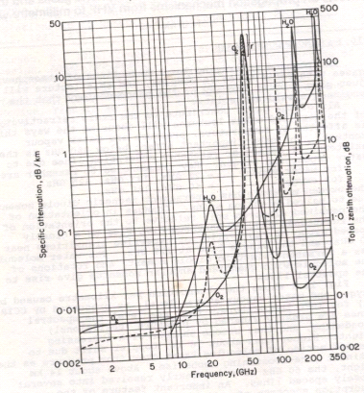

Fig A1.1 Terrestrial atmospheric loss for electromagnetic radiation at different frequencies

Fig A1.2 and Fig A 1.3 show the graphs for the loss due to the mist, cloud (of different densities) and rain at different precipitation rates.

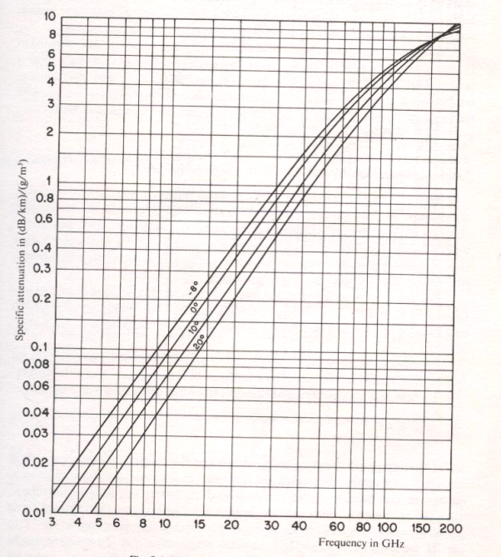

Fig A1.2 The RF propagation loss oss due to the mist/ cloud

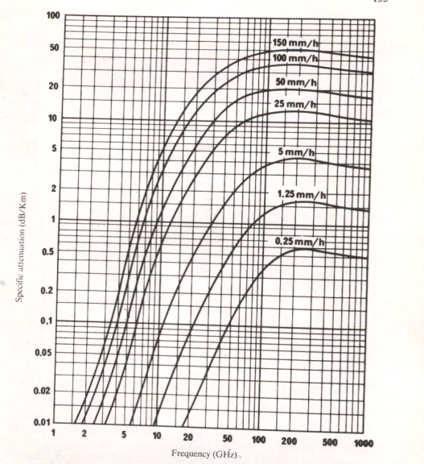

Fig A1.3 The RF propagation loss due to the rain

1. The expressions for single ‘ground reflection’ were derived in section 1.4 (b). However, in reality, the RF radiation undergoes multiple reflections. In most practical situations the conditions change dynamically. Therefore, the amount of loss in signal and the fluctuations in signal strengths are computed statistically. The system design is carried out by providing for adequate margins. Equation A1.1 presents an approximate expression for multipath fading.

A=10 log F+35 log d - 10 log p-78.5 … ( A1.1)

Where, **F**- frequency in GHz; **d** -Distance in Km.

At signal strength lesser than the free space signal level,

**p**- Probability of failure **A**-The ratio (**S**freespace/ **S**min) in dB

**e.g 1:** 10 GHz 20 Km, 1 % failure (A= 10+105+20-78.5= 56.5 dB)

**e.g.2:** 1 GHz, 40 Km, 0.05 % failure (A= 10+ 108 + 23- 78.5= 62.5 dB)

Fig A1.4, A1.5 and A 1.6 are the graphs for multipath losses, signal varistion due to ground reflection and scintillation in the signal due to reflections respectively.

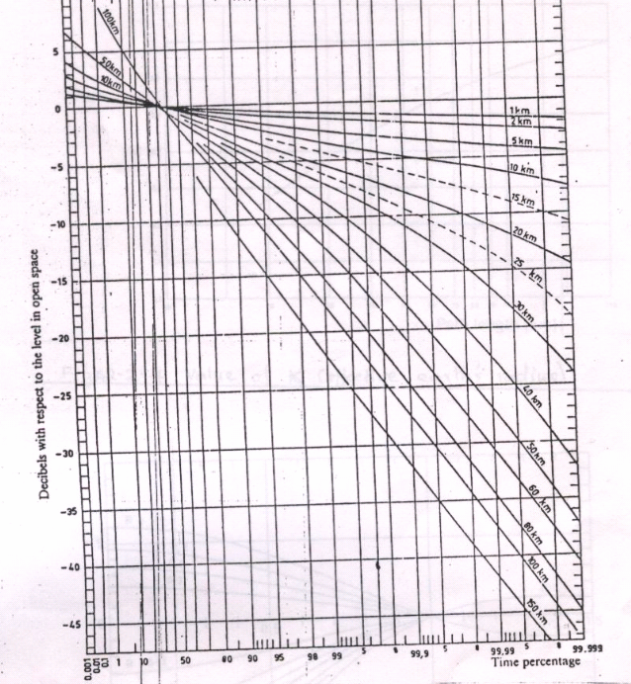

Fig A1.4 Fading loss due to terrestrial multipath

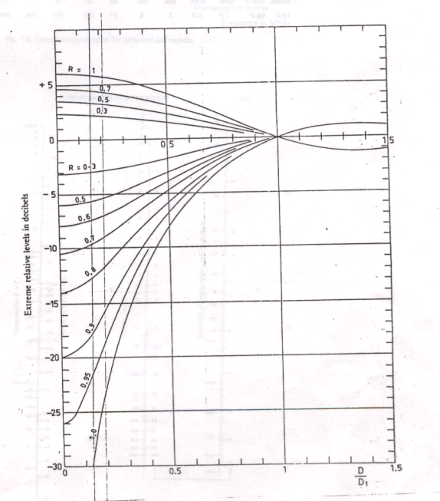

Fig A1.5 Fading loss due to ground reflection

The curves are for different values of ground reflection coefficients (R)

**D**-Diameter of the antenna

Antenna is mounted at height ‘**h**’ from the ground.

**d**- link distance

**Di** =0.61 **λd/h**

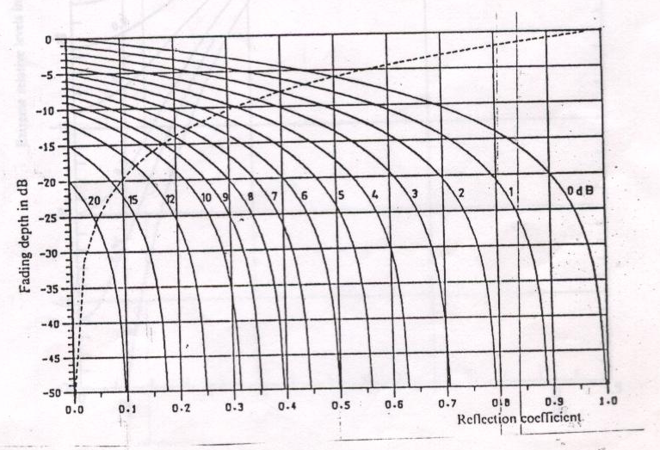

Fig A1.6 Combined effect of fading and reflections leading to Scintillations

(e.g. At refl. Coeff =0.7, with fading of 2 dB, required margin increases from 10.7dB to 20.5 dB)

1. Refraction changes the direction of the RF beam in long distance communication links and long range radars. The loss due to the change in pointing direction is given by A1.2.

Loss (dB) = 1.28 **Goϕ**2 … (A1.2)

Where, (**ϕ= d/2a**), **Go**- Gain along the axis **d** -path length, ‘a’- earth’s effective radius.

1. Diffraction is another phenomenon where the RF beam reached at the targets behind some obstacles. However there is signal loss. Fig A1.7 , A1.8 and A1.9 give illustrative pictures of the diffraction phenomenon.

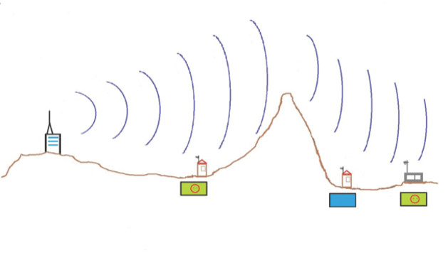 

Fig A1.8 Diffraction due to a building

Fig A1.7 Diffraction due to a hill

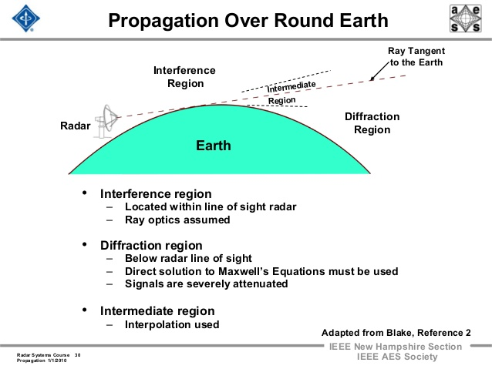

Fig A1.9 Diffraction due to earth’s surface

For radar signal computation diffraction is modeled with simplistic model of ‘knife edge diffraction. The concept diagram is given in Fig A1.10 and the mathematical expression is given in schematic expression id given in A 1.3, A 1.4.

θ

Radius of Fresnel Zone= Rx={(λd1d2)/(d1+d2)}0.5

**υ** = 1.414 Xθ= 1.414 X(h/Rx) =h {2(d1+d2)/ λd1d2}0.5 = Diffraction parameter … (A1.3)

Loss in dB = 6.9 - 20 log [ {( υ-0.1 )2 + 1} 0.5 +υ - 0.1 ] … ( A1.4)

(Source: Deygout J (1966) Multiple knife-edge diffraction of microwaves, IEEE Transactions on Antennas and Propagation vol AP-14, 4: 480-489)