EE 602 Part-3
Contents
- What is Radar?
  - Basics of Radar
  - Radar Block Diagram
  - Range and Velocity Measurement for Pulsed Radars
  - Propagation of Radar Signals
  - Applications of Radar Technology
  - Deriving Radar Parameters from User Requirements
  - Numerical problems
- Understanding Radar Design parameters
  - The Radar Equation
  - Receiver Sensitivity and Detection of the Signal in Noise
  - Signal to Noise Ratio, Noise Figure of single and Cascaded Modules
  - Probability of Detection and False Alarm
  - Radar Cross-Section
  - System Resources: Power Aperture Product
  - Numerical problems
- Continuous Wave Radars
  - Continuous Wave radar and its applications
  - Linear FMCW Radars
  - Range and Doppler Measurement in FMCW radars
  - Isolation Between Transmitter and Receiver
  - Applications of FMCW Radars
  - Numerical problems
- Transmitters, Duplexers and Circulators
  - Types of RF and microwave sources
  - Sources for Terahertz frequencies, Sodars and Lidars
  - Phase Noise considerations
  - Duplexers and Circulators
  - Numerical problems
- Antennas used in Radar Systems
  - Antenna Radiation Pattern
  - Effect of Aperture Illumination
  - Array Antennas
  - Beam steering: mechanical and electronic
  - Digital beam forming
  - Applications
  - Numerical problems
- Receivers
  - Receiver Protection
  - Matched filter detection
  - Types of radar receivers
  - Digital receivers
  - Pulse compression
  - Signal enhancement techniques
  - Numerical problems
- Radar Target Tracking
  - Tracking with Radars
  - Conical Scan Sequential Lobing
  - Monopulse tracking receivers
  - Tracking Accuracy
  - Numerical problems
- Navigational and Strategic applications of Radars
  - Secondary radars: DME VoR and ILS
  - Radar Beacons
  - OTH radars
  - Early warning Radars
  - Synthetic aperture radars
  - Passive bi-static radars
  - Jamming, ECM and ECCM
  - Example of countermeasure technique for FMCW radar
  - Numerical Problems
- Digital realization of radar sub-systems
  - Need for sub-system realization using of digital components
  - Numerically controlled oscillator (NCO)
  - Direct digital synthesis
  - Digital down conversion (DDC)
  - Cascaded Integrator comb filter (CIC) and usage
  - Numerical problems

References
- M.I.Skolnik, Introduction to Radar Systems, McGraw Hill, 1980.
- D.K.Barton, Modern radar systems analysis, Artech House, 1988.
- B,Edde, Radar: Principles, Technology, Applications, Prentice Hall, 1993.
- Mark A. Richards (Ed.), James A. Scheer (Ed.), William A. Holm (Ed.), ‘Principles of Modern Radar: Basic Principles,’Scitech Publishing Inc, 2015, ISBN-13: 978-1891121524, ISBN-10: 1891121529
- Hugh D. Griffiths (Editor), Christopher Baker (Editor), David Adamy (Editor), ‘Stimson's Introduction to Airborne Radar (Electromagnetics and Radar)’, ’Scitech Publishing Inc, 3rd Edition, ISBN-13: 978-161353022, 1ISBN-10: 1613530226
- William L. Melvin (Editor), James A. Scheer (Editor), Principles of Modern Radar: Radar Applications Har/Psc Edition ’Scitech Publishing Inc, 2014, ISBN-13: 978-1891121548 ISBN-10: 1891121545

Chapter-7

Radar Target Tracking

Radars detect the target as their basic function. We have seen that estimation of relative velocity estimation is an extension of this functionality. Subsequently, radar users have started demanding target tracking. Tracking of the target is extremely important for strategic applications. In early days, the targets were tracked by analysing series of radar observations. This was done manually by human experts. However, target movements have become faster and immediate/ automatic tracking such targets have become a necessity. Early radars used to adapt analog processing and controls for target tracking. With advent of digital technology tracking of the tergtes have become convenient and easier.

7.1 Tracking with Radars:
In order to track the target, it must be detected. Additionally, the direction of the target movement must be determined. Determining the direction of target movement is the key functionality of tracking radars. This is done by following techniques.
- Sequential lobbing.
- Conical scan
We need to take the target echoes from ‘off-axis’ beam directions to estimate the direction target movement. These are conventional methods where the antenna beam is moved in the neighbouring area of the target. These multiple observations capture small movement of the target. With this as an indicator (or a clue) the antenna beam is steered in the ‘predicted direction’. Using this strategy, the subsequent position of the target falls in the receiver beam spot. As a result, the target does not move out of the receiver beam. There is no need to search for the target or capture the target again. Such tracking capability offers great strategic advantage.
It may be noted that conventional technique need data from multiple beams before the direction of target motion is detected. The time required for this analysis often becomes unacceptable considering modern fast moving targets. In this view, a novel technique was designed in 1960’sand was called ….
- Mono-pulse
We shall study the working principle of these techniques in section 7.2

7.2 Conical Scan and Sequential Lobing
Conical scan is a technique in which the antenna beam is made to rotate around the target. Most of the early radars had parabolic dish antennas or Sector of a parabolic dish (see Fig 7.1 and Fig 7.2. A Signal feed is located at focal point to get the radiated beam along the axis of the dish. This signal feed is rotated (moved in precessional motion) around the axis of the parabola. This arrangement results in the movement of the antenna beam tracing conical path. This method is therefore called ‘conical scan’. In this method, if the target is on the antenna axis the receive amplitude remains same. If the target goes to ‘off-axis’ position, the received echo amplitude varies in sinusoidal manner. Maximum echo amplitude is received at the moment when the beam is nearest to the target (or tilted in the same direction as the target).
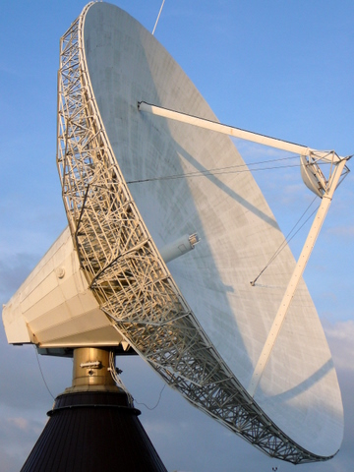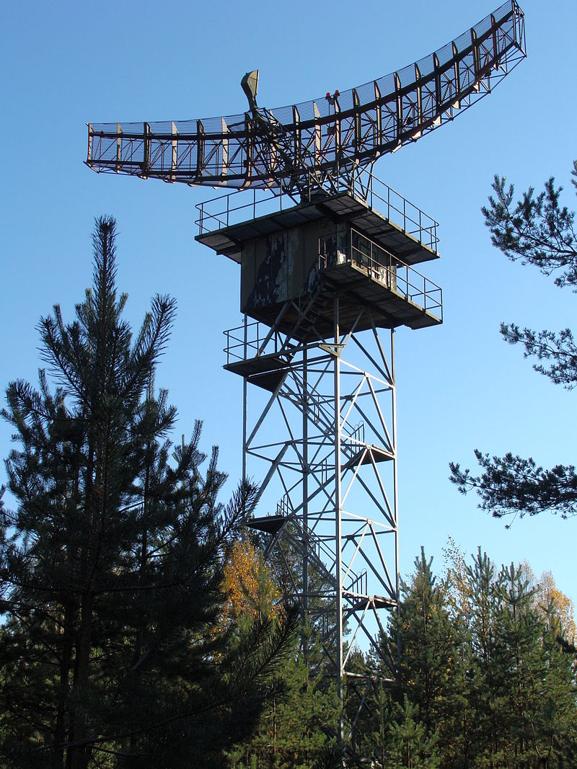
Fig. 7.2 Antenna with sector of a paraboloid and focal feed
Fig. 7.1 Antenna with parabolic reflector and focal feed

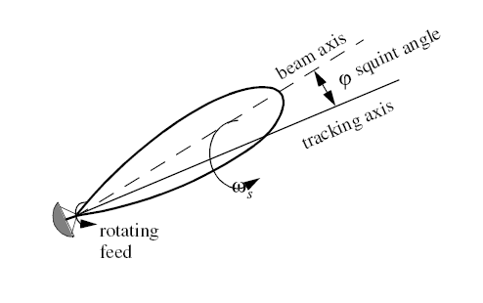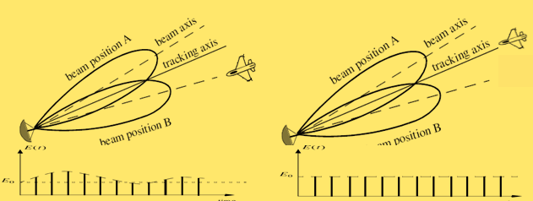
- (b) (c)
Fig. 7.3 (a) Pressional motion of the radar beam around the dish axis. (b) Target in OFF-axis position and associated signal with sinusoidal amplitude variation (c)Target on the axis (on the antenna pointing direction) associated signal of equal amplitude.
(b) Antenna with parabolic reflector and focal feed

The process can be explained with following example.
Consider conical scam tracking is performed by implementing antenna beam movement in anti-clockwise direction at 5 rpm (revolutions per minute). The time referencing is done from the instance when the beam is positioned towards the zenith. 7.5 seconds after the reference position. Estimate the direction of the with respect to the current position.
Interpretation: The scan completes one precession cycle in 12 s. The time difference of 7.5 seconds indicates that the target movement is at 210⁰ = {(7/12) X 360⁰ = β (say)} in the anti-clockwise direction. This prompts the movement of antenna with by
φ = 0.5 Δ {= Δ Sin (210⁰)} in the azimuth direction and
Ɵ = 0.866 Δ {= Δ Cos (210⁰)} in the elevation direction.
Where Δ is the angle in which the antenna can be steered in azimuth as well elevation directions. In most of the practical cases, the steering steps (or rates) in azimuth and elevation direction is the same. It may be appreciated that the azimuth movement (φ) and elevation movement (Ɵ) are in the ratio of ‘tan (β)’; the tangent of the angle indicated by the instance at which the maxima is observed. This process is continues while tracking.
Sequential lobbing is another popular method of obtaining the off-beam target echoes. In this method, Echoes from four beam positions around the antenna axis are obtained. Let the antenna pointing directions is (Φ, θ). Then the tracking antenna beams are oriented in following beam positions, namely, (Φ+Δ, θ), (Φ-Δ, θ), (Φ, θ+Δ) and (Φ, θ-Δ). This is done by dividing the antenna in 4 parts. Each of these parts has independent feed with a phase shifting arrangement (See Fig.7.4). This figure shows formation of 4 beams by introducing the phase shifts in respective channels as shown. Consider the distance between the centres of these antenna sections is ‘d’. We need to introduce a phase shift ‘ψ’ in respective antenna sections to create antenna beam with ‘off-axis angle of Δ’. Knowing Δ, the value of ψ is calculated using expression 7.1.
… (7.1)

Antenna divided in 4 parts
4 phase shifters in each channel

up (1,2 ψ and 3,40)
2

Power Combiner/ Splitter
left (2,4 ψ and 1,30)
1
right (1,3 ψ and 2,40)
4
down (3,4 ψ and 1,20)
3

Fig. 7.4 Generating 4 ‘off-axis’ beams for target tracking by sequential lobing technique techniqueint Angle

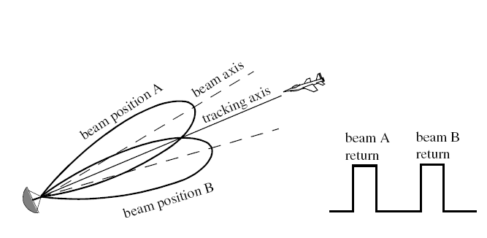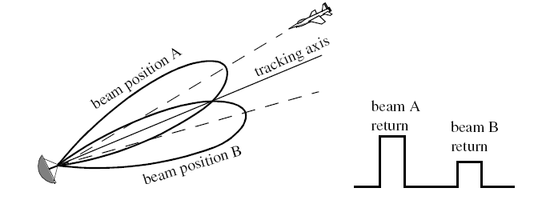
Fig. 7.6 Target off-tracking axis
Fig.7.5 Target on antenna (tracking) axis

The received echo power obtained from all the beam positions is recorded. The difference between the received power by the right beam and left beam gives the azimuth offset of the target. This means that the target is on the right of tracking axis if the power received by the right beam is morethan that of the left beam. Similarly, the target is towards the zenith compared to the tracking axis if the power received by the up beam is more than the power received by the down beam.
Let the azimuth and elevation offset angles of the target (‘off-axis’ angle or the angle with respect to the tracking axis) are δφ δƟ respectively. The mathematical expression for they are computed by equations 7.2 and 7.3.
(7.2)
Similarly, (7.3)
Where, k is the constant of proportionality.

Both these techniques discussed in this section are effective and accurate. However, they require data from multiple beam positions to determine the target movement. As an example, conical scan requires one period of precession of the beam. The typical duration is 10 to 12 seconds. The sequential lobbing technique uses electronic techniques for the beam position switching. This technique requires approximately 10ms for the computation of the angular error. Considering the manoeuvring ability of the modern targets such processing times are not acceptable. This limitation is overcome by the tracking technique known as mono-pulse tracking.

7.3 Mono-pulse tracking receivers
Mono-pulse technique, as the name indicates requires target echo as well as the error information from a single pulse. It is possible to determine the angular errors and process the complete echo from the target. Mono-pulse tracking is done is by a specific configuration of the antenna system and the receiver. We shall discuss configuration of 2 dimensional mono-pulse ‘antenna and receiver system. Antenna is divided into 4 sections. Let these sections be indicated by A,B,C and D. Each can be considered as forming 4 independent beams by the same name (see Fig 7.7). The received signals are combined using microwave network to generate these signals; namely, Sum (A+B+C+D), Azimuth error (A+D)-(B+D) and Elevation error. These signals are formed using 4 units of ‘Magic-Tee’s.

B
A
D
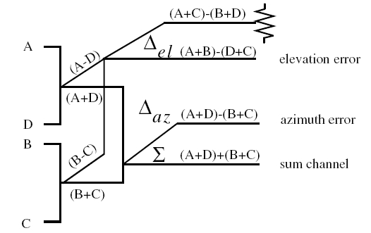
C

Fig. 7.7 Mono-pulse receiver configuration

Magic Tee is a 4-port component. When 2 signals are inputted, the combined (sum) signal is available on the third port and the difference signal is available on the 4th port. The configuration shown in Fig. 7.7 creates the three signals as mentioned above.
The Sum signal is an addition of the signals from all parts of the antenna. Effectively, it is the signal received by the complete antenna and used for the echo analysis and estimation. The azimuth error signal is the difference of the echo received by the beams on the left and those on the right. This signal shall indicate the target ‘offset’ in the azimuth direction. Similarly the elevation error signal is the difference of the echo received by the upper beams on the lower beams. The processing of the error generation in one dimension is illustrated in Fig 7.8. In this manner, the single pulse echo generates angular error signals and gathers the signal received by the complete antenna. The error signals are used to steer the antenna in the desired angle.

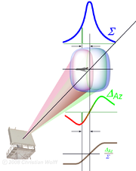

Fig. 7.8 combining the antenna beams to generate the error signal for mono-pulse tracking

We have seen that in mono-pulse receivers, the signal received from one section of antennas is subtracted (phase difference, ψ= 180⁰). Using the equation 7.1 we can calculate the extent of beam steering corresponding to ψ= 180⁰. This is the angular tracking range of mono-pulse radar; as given in the equation (7.4).
(7.4)
If the least count of the receiver phase shifter is Δψ and ‘d’ is the distance between the two sections of the antenna. The beam pointing error is given by (7.5).
(7.5)

7.4 Tracking in range
The radar estimates the range and the angular position to determine the target location. In section 7.3, we have discussed tracking in angular direction. However, for the determination of the target location the object must also be tracked in the range.
Range tracking is done using the concept of range gating. Pre-defined time interval in the inter-pulse period (IPP) is called the range window. This window corresponds to certain ‘Range-slice’ in the volume of interest. When the target is identified, a “range- window is planned around the target (typically corresponding to certain distance around it. This window is larger for more agile targets and smaller for slow moving targets. For successful tracking, the target echo must lie in this window. Raneg window is split into two parts, namely ‘Early Gate’ and Range gate. The range gate tracking is done by one of the following method.
- Leading gate Method: Fig. 7.9 illustrates the Leading gate tracking. In this method, the demarcating line between early gate and the late gate is placed on the rising edge of the target.
- Split gate tracking: Fig 7.10 illustrates split range-gate tracking. The range tracking is also done using split range-gate tracking method.
Fig. 7.9 Leading gate Method of range tracking
Fig. 7.9 Range Tracking: Leading Edge Tracking Method

Fig. 7.10 Leading gate Method of range tracking
Fig. 7.11 Schematic diagram of Range tracking system Method of range tracking

In both methods the edge between the early gate and the late gate defines the range. In both the methods, an ‘error signal’ is generated by subtracting the signal in the late gate from the early gate signal. The range gates are advanced (or retracted) depending on the instance at which the error signal changes its sign.

7.5 Numerical problems
1. ‘X band scanning radar’ operates at 10GHz. It scans the solid angle sector of a solid angle Ω =1sr (Steradian). This angular sector is covered by adjacently placed radar beams. Total number of beam spots (N) being Ω/dθdϕ, where dθ(=2⁰) and dϕ(=2⁰) being the widths of radar beam in orthogonal directions. The scanning to be performed in total time of T_{SC}=1 s.
(a) Compute the number of beams required to cover the desired solid angle in the said scan
(b) The radar acquires the echoes from ‘n=3’ pulses for each beam spot. What will be the maximum range of targets this radar can address? Comment on the trade-off of various parameters.

Multiple Choice Questions (MCQs)
- A ‘Doppler radar’ tracks the targets using ‘sequential lobbing (SL) technique’. Four beams, making an angle of 5.7⁰ with the antenna axis, are generated for SL tracking. Main beam width is 5.7⁰. Signal is received for 10ms from each beam position and also requires 10ms for the main receive beam. Two targets A and B are at a distance 0f 1 km from the radar. Target A has speed of 1100 ms⁻¹ and target B has speed of 110 ms⁻¹. Target misses the track if angular travel is half the beam width. Which of the following statements is true about angle tracking of the targets at the distance of 1 km?
(a) Both A, B will be always be tracked by the radar
(b) A will be tracked, but B will never be tracked.
(c) A will be tracked, but B will be tracked depending on the direction of its motion.
(d) The tracking mechanism is slow; both the targets cannot be tracked.
- For the SL-tracking radar in MCQ-1 above’, if the target distance is 10 km, which option will correctly describe the tracking ability? Will the situation change with target distance? How?

Answers to the numerical problems

- The beam-widths are 2⁰ is both orthogonal directions. Hence dθ=dϕ= 0.0349 radians
Hence we have the number of beam spots is (N)=Ω/dθdϕ=1/(0.0349)²≈ 821.
Therefore, time on each beam spot is Tsc/N= 0.001218s= 1.218ms.
3 Pulses for each spot PRP = 1.218/3= 406μs. Max range= cX PRP/2 =60900.5m≈60km.
The user demand on scan rate is decided by target agility faster targets require low T_{sc}. And T_{sc}= PRP X n X N. hence the Max. range, angular resolution and echo-integrations time are interrelated!
MCQs
- (c) 5.7⁰ is ≈0.1 radian
At 1 km, transverse distance of 50m would mean an angle of 0.05 radian (half beam-width) Processing time is 50ms. In 50 ms, Target-A travels 55 m and target-B travels 5.5 m. Target B will always be tracked, while target A will not be tracked only if it travels transverse to radar beam.
- (a) At a distance of 10 km, half beam-width will cover 500m. at that coverage distance, target-A travelling in transverse direction also will not escape the scan.

Chapter-8

Navigational and Strategic Applications of Radars

Radars are mainly used for detecting, ranging (this includes obtaining the bearing) and estimating the movements (this includes the tracking) the targets. Such capabilities are very important for the strategic applications. These capabilities are also utilized in many other applications. We shall have a brief discussion on these aspects in this chapter.

8.1 Secondary radars: DME VoR and ILS
The instruments required for navigations were called ‘secondary radars’. These systems are not radar in the strict sense of the word as they do not operate in the ‘transmit-receive’ mode to locate/ observe the target. These systems are generally navigational gadgets often operate in coordination with radars. Following systems are commonly in use.

8.1.1 Distance Measuring Equipment (DME): It is a transponder based radio navigation technology which computes the ‘slant Range’ using the propagation delay of VHF/UHF radio signals. This distance is required for ‘homing’ to a pre-designated location. A transponder is present (commissioned) at the pre-designated location. The radar sends an ‘interrogating pulse pair’ (Typically 150 per second, or after every 6.67 ms. These pulses are spaced with a pre-designated interval, typically, around 12 μs.). The ground based transponder being ‘co-operative’, sends response of pulse pair with exactly same time spacing as the radar pulses. This response is after a precise delay of 50 μs.
The radar looks for the identical echo and estimates the slant range of the destination/ target. The computations are straight forward as the round trip delay minus 50 μs. Classically, it is presented in nautical miles (12.36 μs per nautical mile). If radar receives of approximately 30 responses to its interrogating pulses (say, over a second) it is considered good enough for establishing a track. Conventional DME transponder operates in 962 -1213 MHz (both inclusive) band. Whereas the air-borne radars operate in 1025-1150 MHz (both inclusive) this band of 126 MHz is divided into 126 channels, each with bandwidth of 100 kHz. The rest of the frequency band is allotted for the transponder reply. There are 126 channels for the reply. These channels are paired to the transmit frequencies and differ by + or – 63 MHz. The transponder responds in the frequencies differing by 63 MHz. In other words, if the radar operates in 1025 MHz it will get the response at 962 MHz. In this manner, radar channels at 1025-1087 MHz get response at 962-1024 MHz respectively and the radar channels at 1088-1150 MHz get response 1151 to 1213 MHz respectively. This is description of “X” similar arrangement is for ‘Y’ Channel
Typical accuracy of DME systems is 0.25 nmi ± 1.25% (≈3μs time error)
Long range DME facilities are generally associated with VoR facilities (see section 8.1.2) and Low range DMEs are generally associated with ILS systems (see section 8.1.3).

It may be appreciated that the transponder responds to all the legitimate (in the frequency band and with appropriate spacing) pulses. As a result, radar could receive the response to other radars. However, this response will not be synchronous and therefore can be is neglected. Such spurious echoes are called Squitter.

8.1.2 VHF Omni-directional Range (VoR):

It is a type of short-range radio navigation system for aircraft, enabling aircraft with a receiving unit to determine their position and stay on course by receiving radio signals transmitted by a network of fixed ground Radio Beacons.
A VOR ground station sends out an omnidirectional master signal, and a highly directional second signal is propagated by a phased antenna array and rotates clockwise in space 30 times a second. It is achieved by a monopole antenna at the centre and an array of antennas arranged in a circle (see picture in Fig. 8.1). Every antenna in the circle is fed with the appropriate phase difference so that the antenna beam is sharp in azimuth. This beam rotates at 30 revolution per second.
(https://aviation.stackexchange.com/questions/33834/what-causes-the-phase-to-change-in-a-vor)
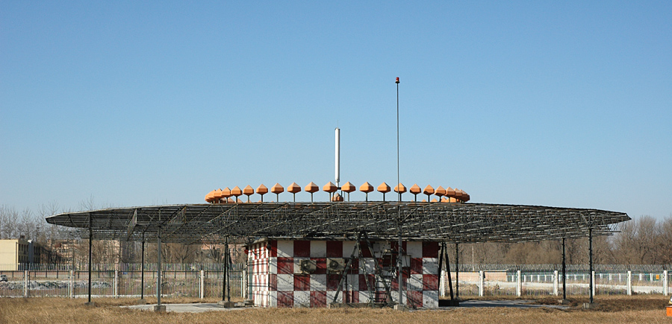
Fig. 8.1 Photograph of a VoR system

This signal is timed so that its phase (compared to the master) varies as the secondary signal rotates, and this phase difference is the same as the angular direction of the 'spinning' signal, (so that when the signal is being sent 90 degrees clockwise from north, the signal is 90 degrees with respect to the master). By comparing the phase of the secondary signal with the master, the angle (bearing) to the aircraft with respect to the station can be determined.
VORs are assigned radio channels in the VHF range, between 108.0 MHz and 117.95 MHz (with 50 kHz spacing). The first 4 MHz is shared with the Instrument Landing System (ILS) band. To leave channels for ILS, in the range 108.0 to 111.95 MHz, the 100 kHz digit is always even, so 108.00, 108.05, 108.20, 108.25, and so on are VOR frequencies but 108.10, 108.15, 108.30, 108.35 and so on, are reserved for ILS in the United States.
Thus the VOR system encodes azimuth (direction from the station) as the phase relationship between a reference signal and a variable signal. This is done as follows:
The omnidirectional signal contains an amplitude modulated continuous wave 7 words per minute (WPM) Morse code station identifier. In addition to it,VoR system usually have an AM voice channel. The conventional 30 Hz reference signal is frequency modulated (FM) on a 9,960 Hz subcarrier. The variable amplitude modulated (AM) signal is conventionally derived from the lighthouse-like rotation of a directional antenna array 30 times per second. Although older antennas were mechanically rotated, current installations scan electronically to achieve an equivalent result with no moving parts. This is achieved by a circular array of typically 60 directional antennas, the signal to each one being amplitude modulated by the 30 Hz reference signal delayed in phase to match the azimuthal position of each individual antenna. When the composite signal is received in the aircraft, the AM and FM 30 Hz components are separated and the relevant information is extracted. The DME system identifies 1350 Hz Morse code whereas VoR and ILS identify themselves in 1020 Hz Morse code. If they are co-located the combined system is identified by the Morse code of the parent (VoR/ ILS) system.
DME and VoR together are often are considered as a ‘TACtile Air Navigation (TACAN )system.

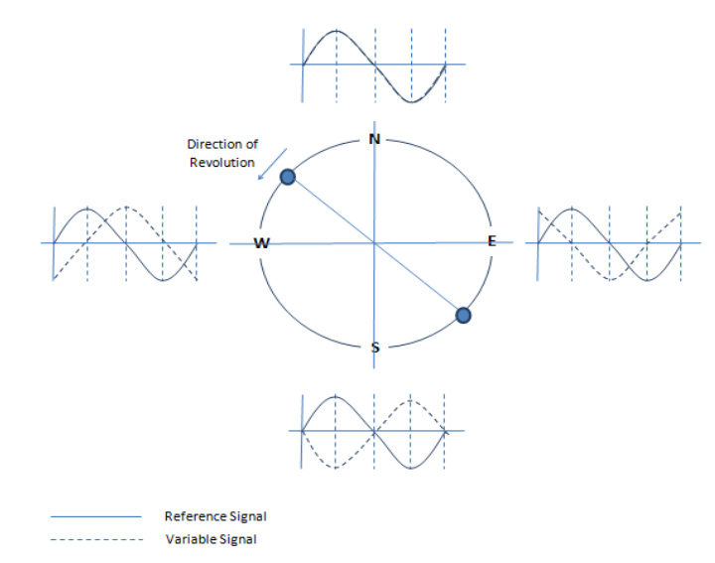
Fig 8. 2 Phasing of the VoR antenna elements

8.1.3 Instrument Landing System
An instrument landing system (ILS) is a ground-based set of instruments that provides precision lateral and vertical guidance to an aircraft approaching and landing on a runway. This system uses a combination of radio signals and often high-intensity lighting arrays to enable a safe landing.
This system consists of radio guiding instrumentation as well as optical system for fine angular guidance as shown in Fig. 8.3. Here, we shall limit the discussion to the radio instrumentation of the ILS. As discussed in section 8.1.2, the ILA system uses the same frequency band as the VoR and operates in channels between 108 -112 MHz

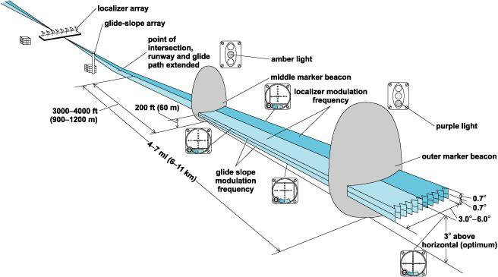

Fig 8. 3 Schematic diagram of Instrument Landing system

The Radio ILS consists of a Localizer and a glide slope system.
- Localizer
A localizer (LOC, or LLZ) is an antenna array normally located beyond the approach end of the runway and generally consists of several pairs of directional antennas. The localizer will allow the aircraft to turn and align the aircraft with the runway. This antenna array creates two beams as shown in the upper part of Fig. 8.4. The beam on the right of the aircraft has a signal modulated with 150 Hz. While the beam on the left has a signal modulated with 90 Hz. While landing the pilot is expected adjust his approach so that the signal received by the two beams is exactly equal in amplitude.
- Glide slope (G/S)
The glide scope operates on the similar principle by creating two beams in vertical plane. The lower beam is modulated with 150 Hz and the upper is by 90 Hz. Equalizing the amplitudes of the signal received from these beams ensures that the aircraft is on the correct gliding path, typically at 3⁰ elevation.

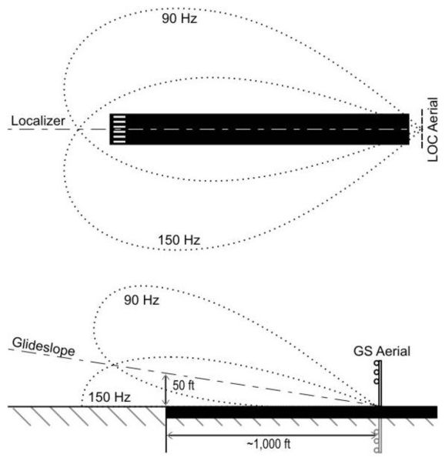
Fig 8.4 Schematic diagram of Instrument Landing system

However, there are some of the limitations of the ILA systems are as follows:
Localizer systems are sensitive to obstructions in the signal broadcast area, such as large buildings or hangars. Glide slope systems are also limited by the terrain in front of the glide slope antennas. If terrain is sloping or uneven, reflections can create an uneven glidepath, causing unwanted needle deflections. Additionally, since the ILS signals are pointed in one direction by the positioning of the arrays, glide slope supports only straight-line approaches with a constant angle of descent. Installation of an ILS can be costly because of siting criteria and the complexity of the antenna system.

8.2 Radar Beacons
Radar Beacons or the RACONs are navigational transponders for the ships. They operate in maritime navigation bands; 2.9-3.1 GHz and 9.3-9.5 GHz. They respond to the ship borne radars with an identifier Morse code. When a RACON receives a radar pulse, it responds (within 700ns) with a signal on the same frequency which puts an image on the radar display. This takes the form of a short line of dots and dashes forming a Morse character radiating away from the location of the beacon on the normal plan position indicator radar display. The length of the line usually corresponds to the equivalent of a few nautical miles on the display. Fig. 8.5 show a picture of a RACON and the Display it puts on the radar screen.

Fig 8. 2 A picture of Radar Beacon (Tideland) and its code on PPI indicator of a radar

8.3 OTH radars
It is known that all the conventional radars operate in the ‘line of sight’. This is because the RF/ microwave signal transmitted towards the target travels in the straight line and it requires a clear path to its journey towards the target and back. However, it is possible to see the targets beyond the horizon. These radars are called ‘Over The Horizon (OTH) radars. OTH detection capability is very special and has great strategic advantage. There are two types of OTH radars.
- Sky wave OTH radar: These radar use the ionosphere as a mirror (also referred ‘mirror in the heavens’). HF radiation is directed towards the ionosphere. These wares get reflected from the ionosphere, get backscattered and traverse the same path back to the radar. Fig. 8.3 shows the operating scheme of the Sky wave OTH radar. It is seen in Fig. 8.3 that the observable range of the OTH sky wave has a skip distance. In other words it means that some range near the radar is not observable. This is due to the fact that the HF waves with near-normal (perpendicular to the ionospheric layers) incidence are not reflected by the ionosphere. Due to this, these radars can view targets located at the ranges of 600-3000 km. This limitation becomes an advantage as the radar location could be located deep in the territory of a country and can have an vigilant eye on the strategic boarders.
Bin-Li-Liu’ doctoral thesis (2007) presents the operational principles with good illustrations and systematic study of various operating systems. (www.dtic.mil/dtic/tr/fulltext/u2/a474069.pdf)
Angular resolution of any radar depends on the width of the beam and the range to the target. For example; a radar with 1 degree beam width and a target at 1200km range will show the target as 20 km wide. These radars operate in HF ranges (2MHz to 25 MHz). To produce a 1 degree beam at the most common frequencies, an antenna 1.5 kilometres (0.93 mi) wide is required. Due to the physics of the reflection process, actual accuracy is even lower, with range resolution on the order of 30 to 50 kilometres and bearing accuracy of 20 to 40 kilometres, these radars are useful for early warning and not for weapons fire.

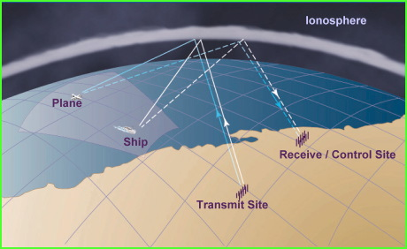
Fig 8. 3 OTH Sky wave radar

It is worthwhile to understand the properties for the ionosphere for HF reflectivity. Fig 8.4 shows a typical ionogram explaining the HF reflections from the ionosphere. It is seen that the Maximum utilizable frequency (MUF, The maximum frequency that reflects from various ionospheric layers is different. It also depends on the density of ionization which changes during the time of the day. Due to this behaviour, advance frequency management is required. Fig 8.5 shows the path of the radar waves, dimension of typical beam spots and mapping in range-and bearing. These are radars with large radars with typical transmit power of 1 MW, receiver antenna gains antenna gain of 28 dB.
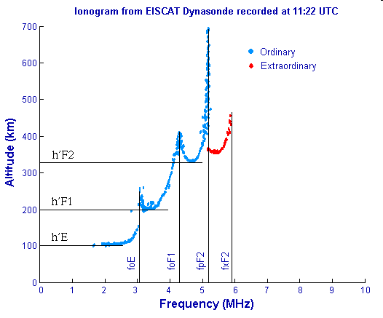
Fig 8.4 A representative picture of the ionogram by EISCAT, a group of European observatories
(Maximum ion density of 3.309e +11/ m³ at 247.1 km)

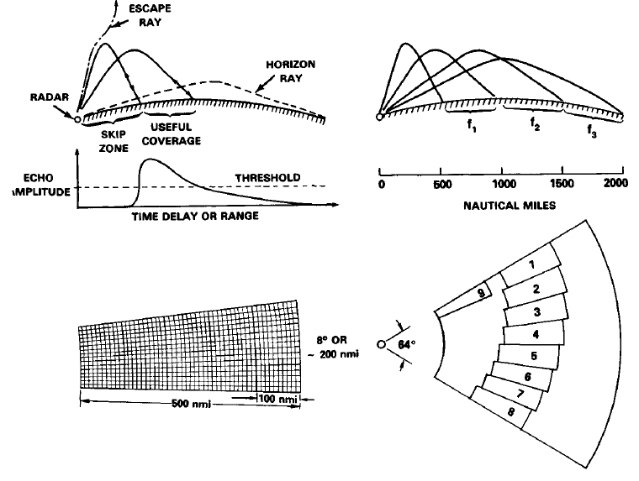
Fig 8.4 A representative picture of the ionogram by EISCAT, a group of European observatories
(Maximum ion density of 3.309e +11/ m³ at 247.1 km)

- Sea wave OTH radar: These types of radars are also known as ‘ground wave’, surface wave OTH. Sea-wave OTH uses vertically polarized HF waves over sea surface. Over the horizon detection is achieved as vertically polarized HF waves travel along the water surface to distance much beyond the horizon due to refraction in atmospheric layers and diffraction due to the sea surface (see Fig. 8.5) It is possible to obtain detection up to about 300 km. These radars were developed as large radars for the strategic purpose. Earlier radars used to have large antennas spanning over a kilometre.
However, due to modern signal processing techniques, HF OTH radars operate in bi-static modes with small antennas with a cosine pattern in azimuth. These radars prove out to be very useful for observation of wave patterns and sea state monitoring.

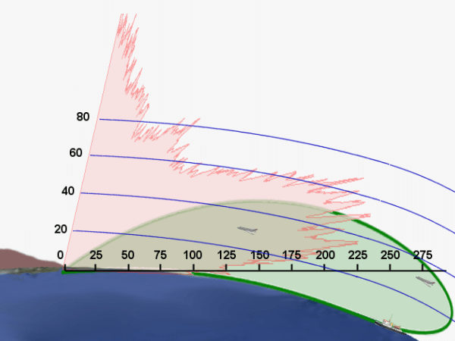
Fig 8.5 Propagation of HF waves over the sea surface Red pattern corresponds to the frequencies in GHz range and green pattern illustrates the diffraction of HF waves and propagation along the water surface surfaceadartutorial.eu/07.waves/wa51.en.html)

8.4 Early warning radars
Initial early warning radars were developed with a purpose of detection of the threat and communication own vessels. These are the large radars and formed complete air-defence system with the support of communication links and ‘Identification of Friend or Foe (IFF)’ system on aircraft.
Early warning for the missile detection is done by long range HF radars. These radars observe the atmospheric layers. The missile firing creates ionization of the air increasing HF reflectivity. This leads to large echoes prompting the warning.
Airborne EWS deploy the radars on an aircraft and perform the surveillance of the distant territory. Modern Indian early warning system is developed by the research laboratories of the DRDO is called ‘Airborne Early Warning and Control System (AEWACS)’ also known as NETRA AEW&CS. This system has Two radiating planar arrays assembled back-to-back in an active antenna array unit (AAAU) will provide 240° vision. Additionally, aircraft has other capabilities like identification friend or foe (IFF), electronic and communication support measures, C-band line-of-sight and Ku-band SATCOM data-links. (Ref: https://en.wikipedia.org/wiki/DRDO_AEW%26CS). Fig 8.6 shows a picture of the aircraft with EWS.

Fig 8.6. DRDO AEWACS, on an Embraer ERJ 145. 2013

8.5 Synthetic aperture radars
Angular resolution depends on the effective area of the radar antenna. Strategic and surveillance radar operations often encounter the situation where the desired angular resolution is much finer than possible antenna size. In such situations, the effect of larger ‘antenna aperture’ (effective area) is artificially created. This leads to the detection of the target with finer resolution. The radar systems that employ such technique are called “synthetic aperture radars.
Artificial enhancement in aperture is done by moving the radar (with respect to the target) and performing collaborative analysis of the echoes received at multiple positions. This arrangement is similar to the echo reception by a phased array. This type of aperture enhancement is possible only in the situations where the target movement is very slow compared to the radar movement. In other words, the target is considered ‘stationary’ during one epoch of antenna aperture synthesis. This technique finds its applications in strategic surveillance, remote sensing satellite imagery and astronomy. Fig.8.7 shows the basic concept of the synthetic aperture.
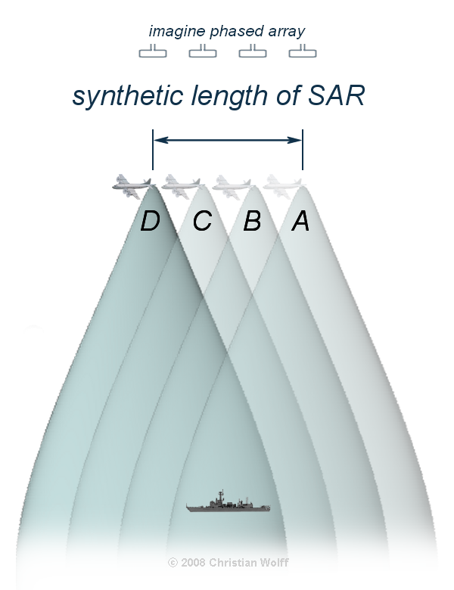
Fig 8.7 Synthetic aperture creation by reception at multiple locations.
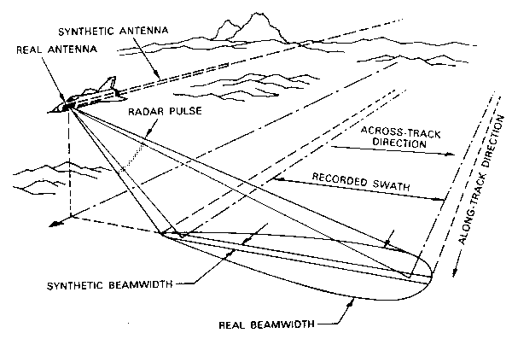
Fig 8.8 Surveillance of the land territory using synthetic aperture technique

Fig. 8.8 shows an example of strategic surveillance. Surveillance with this arrangement has strategic advantage and the aeroplane carrying the radar can travel in friendly territory and can observe the targets in hostile/ enemy territory. This arrangement facilitates the surveillance of land region along a broad strip. The width of the strip is called the ‘ground’ swath or ‘recorded swath’. High resolution satellite remote sensing images are also captured using similar technique, see Fig. 8.9 (a).
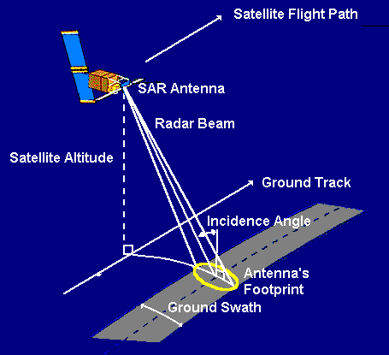
(a) (b)
Fig 8.9 Satellite remote sensing using synthetic aperture technique
Θ
ΔΘ
h

The distance of the near-edge of the swath (also called ‘minimum range’) and the distance to the far edge (also called ‘maximum range’) and the swath width is computed as follows.
Let the height of the flight is h, the radar beam angle be Ɵ from the nadir and the beam width be ΔƟ.
Then
(8.1)
(8.2)
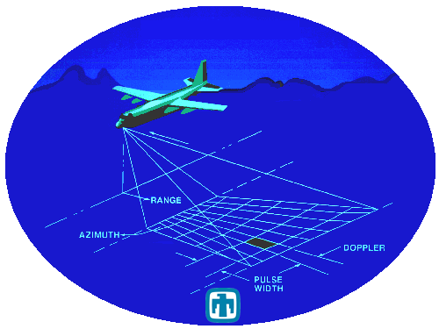
Fig 8.10 Creating Dividing the beam spot area into range-bins

The signal processing scheme discriminates the echoes coming from the different area-units in the surveillance region. Fig. 8.10 shows the grid of different area-units. The radar demarcates the area-units in the transverse direction using the classical technique of ranging (round-trip time of the echoes). In other words the regions in the transverse directions are demarcated by forming range-bins in the ‘slant range’. The narrow beam-width of the synthetic aperture gives narrow resolution in the bearing. This demarcates the area under surveillance into sections in the direction of radar motion. If the radar collaboratively processes the echoes obtained during the straight line distance of ‘L’, then the beam-width corresponding to the synthetic aperture (φ) is
(8.3)
Further demarcation with finer resolution in bearing is achieved by processing the Doppler. Here we assume that the transverse motion will lead to zero (negligible) Doppler. Let the SAR processing gets Doppler resolution of Δf_{D}= 1/(observation time)Δv_{D}= (Δf_{D} Xλ/2). If the radar velocity is ‘v_{radar}’, the cross-range angular resolution (Δφ) is = Sin⁻¹(Δv_{D} / v_{radar}). Using Doppler discrimination, the beam width of φ degrees is divided into ‘φ/ (2n+1)’ parts, each with angular width of Δφ. The ‘n’ sections in the direction of radar motion, show increasingly higher +ve Doppler frequencies. On the other hand, ‘n’ section the opposite direction, show –ve Doppler frequencies. The Doppler velocity for the objects in ‘k^{th}’ section is
(8.4)
Modern cross-range processing is done with processing the of individual narrow beam echoes as shown in Fig 8.10(a).

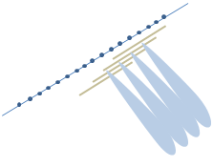
Fig 8.10 (a) Cross- range viewing with narrow beams formed by combining echoes of certain duration
Direction of Radar motion

8.6 Passive Bi-static Radars (PBR)
All the conventional radars use own (part of their system) transmitters to illuminate the target. Though the radars are not specifically referred as ‘active systems’, they are inherently ‘active’ as they transmit. In the recent years, there has been a trend of using ‘passive radars’. These radars do not transmit any EM radiation. They use the EM signals transmitted by other like Cellular phone towers, navigational radars, beacons and so on. These radars are called ‘passive radars’ as they do not transmit any signal and bi-static as the Tx and Rx antennas are different. This is in contrast to all the conventional radars with transmitters. It may be noted that for passive radars require the presence of multiple (at least 3) external transmitting antennas. It is also necessary that the transmissions of the system to be repetitive and operate almost round the clock. Due to the multiple cell phone towers and beacons and navigational radars use of passive radars has become a possibility.
Passive radars have obvious advantage of ‘not being detected’ by the enemy. Therefore, they cannot be jammed!! This is tremendous strategic advantage. On the other hand the passive radars require frequency agile receivers with advanced signal processing capabilities. It may be appreciated that such capabilities have started becoming implementable by the last decade of 20th century CE. Fig. 8.11 shows a representative picture of a PBR operating with 3 external transmitters. The PBR receiver captures the signals from these transmitters, stores co-relate with the signals received. With this processing, the time instance of the target echoes due to all 3 transmitters can be determined.
Bi-Static
Passive radar

Target
Tx1
Tx2
Tx3
Target Locus 1
Target Locus 2
Target Locus 3
Fig 8.11 Typical scenario with three external transmitting sources for BPR
(Ellipsoidal loci 1, 2 and 3 are computed from each transmitter. Target position is at the intersection)
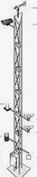

Knowing the transmitter location, and the time of arrival (ToA) of its target echo, the locus of possible target location is an ellipsoidal shape with Tx and PBR at the foci. Similarly, the loci of the target location determined from other transmitter are computed. The target location is at the intersection of these ellipsoids. More transmitters add to the redundancy. To make the estimation robust.

8.7 Jamming and Electronic Counter measures (ECM)
Radars play a vital role in warfare and strategic applications. Therefore, efforts are always made to make the enemy radars nonfunctional. This is known as radar jamming. Formally such techniques are known as electronic countermeasures (ECM). There are always efforts to protect radars from ECM attacks. They are referred to Electronic counter countermeasures (ECCM).
Different techniques are used for ECM and ECCM.
A brief account of these techniques is as follows.

- Passive Jamming or Mechanical Jamming
These techniques involve introducing multiple spurious reflecting objects in the area of radar surveillance. These objects reflect radar waves and create echoes which create hurdles/ noiselike signals in radar processing, thereby degrading the radar performance.
- Chaff: is made of different length metallic strips, which reflect different frequencies, so as to create a large area of false returns. These make it difficult to detect the target of interest. Modern chaff is usually aluminum coated glass fibers of various lengths. Their extremely low weight and small size allows them to form a dense, long lasting cloud of interference. This population of aluminum objects forms a cloud (sometimes called a non-maneuverable decoy). This cloud is only effective in the range cell that it occupies. Another limitation of the chaff is that the slow movement of the chaff (compared to the flying target) makes it easily discriminated based on the Doppler Shift. The slow moving chaff is effective to hide the echoes due to the ships. The strategy is as follows: The cloud is released within the resolution cell of the ship, and moves with the wind in one direction. The ship then escapes in another direction. It is desirable for the chaff cloud to have a larger RCS than the target.
- Corner Reflector: This is a structure of light metallic material and has the same effect as chaff. Generally corner reflectors are many-sided objects that re-radiate radar energy mostly back toward its source. An aircraft cannot carry as many corner reflectors as it can chaff.
- Decoy: These are maneuverable flying objects that are intended to deceive a radar operator into believing that they are actually the target. They are especially effective (dangerous to the radar) because they can clutter up a radar with false targets making it easier for an attacker to get within weapons range and neutralize the radar. Corner Reflectors can be fitted on decoys to make them appear larger than they are, thus furthering the illusion that a decoy is an actual aircraft. Some decoys have the capability to perform electronic jamming or drop chaff. Decoys also have a deliberately sacrificial purpose i.e. defenders may use firearms at the decoys, thereby depleting their stocks of expensive weaponry.

- Active Jamming or Electronic Jamming:
Electronic jamming are essentially transmitters capable of radiating interfering signals towards the radar. This blocks/ saturates the radar receiver preventing it from processing any other signals.
- Spot jamming: It transmits the power on a single frequency. This is generally countered by the radars by deploying a either notch filter in the receiver. Or steering a null of the antenna pattern in the direction of the Jammer.
- Sweep jamming: This type of jammer has better nuisance value due to the dynamically changing frequency transmission. Though it has advantage of jamming multiple frequencies, it does not affect them all at the same time, and thus limits the effectiveness of this type of jamming.
- Barrage Jamming: It is the jamming of multiple frequencies at once by a single jammer. The advantage is that multiple frequencies can be jammed simultaneously; however, the jamming effect can be limited because this requires the jammer to spread its full power between these frequencies, as the number of frequencies increases the affectivity of the jammer gets limited.
- Pulse Jamming: This system produces noise pulses with period depending on radar mast rotation speed thus creating blocked sectors from directions other than the jammer, making it harder to discover the jammer location.
- Cover pulse jamming creates a short noise pulse when radar signal is received thus cancealing any aircraft flying behind the EW craft (escort) with a block of noise.
- Digital Radio Frequency Memory (DRF) jamming, also known as Repeater Jamming technique that manipulates received radar energy and retransmits it to change the return the radar sees. This functionality is similar to the repeater (with very fast latency time). Some of the advanced jammers are capable of introducing Doppler frequency in its response. This creates “false targets for the radar. It is often introduced from different location than the target., Often from non-active area of surveillance. As a result, this signal enters the radar receives through antenna side-lobes.
- Delay Jamming: This technique can change the range the radar detects by changing the delay in transmission of pulses. This gives false indication of the range.
(c) Space based Jamming: In these techniques, a cooperative object (often a air-plane with a large cross-section) accompanies the target aircraft. Fig. 8.12 illustrates these techniques.
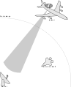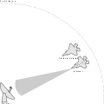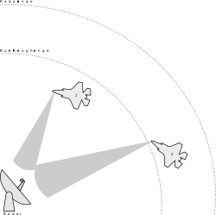
- Escort Jamming (b) Protective Jamming (c) Burn through the range Jamming
Fig 8.12 Different types of Space Jamming Techniques

- Escort Jamming. In this case the enemy radars views bigger object and the target escapes.
- Protective jamming: A dummy target is intentionally made to be seen by the enemy radars and the “real/ important target flies through the same resolution volume and escapes the radar.
- Burn through the range: The cooperative object occupies the same range as the target and provides a strong echo signal to enemy radar. This helps the target to escape the radar.
Inadvertent Jamming: In some cases, jamming of either type may be caused by friendly sources. Inadvertent mechanical jamming is fairly common because it is indiscriminate and will affect any nearby radars; hostile or not. Electronic jamming can also be inadvertently caused by friendly sources, usually powerful EW platforms operating within range of the affected radar. Unintentional electronic jamming is most easily prevented by good planning and common sense, though sometimes it is unavoidable.
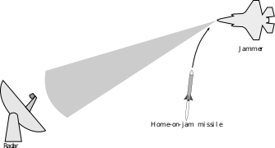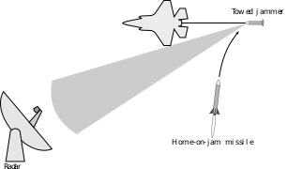
- Target detects the firearm attack. (b)Leaves a home on Object’ (repeat transponder) Fig 8.13 Home on Jamming countermeasure

Home on jamming countermeasure: This technique involves detecting mechanism of an firearm attack. This is generally done by detecting two interrogating signals; one is from the radar and the other is from the firearm. Simultaneous presence of two signals is taken as situation ‘under attack’. In such situation the flying target releases a passive jammer/ ‘repeater-transponder’ to deceive the guided weapon.
Operational techniques/ Signal processing techniques as counter measures.
- Frequency agile operation: Change of operating frequency in near random manner.
- Spread spectrum transmission: This technique occupies a large bandwidth making it difficult for the jammer to execute effective jamming. Pulse compression and Pseudorandom signal transmissions are most popular techniques of this type. The radars can operate equally effectively as the ‘key’ to decode the spread spectrum lies only with the radar. .
- Cloaking the outgoing signal with random noise : This technique makes it more difficult for a jammer to figure out the frequency that a radar is operating on. Such noise is always out of radar band.
- Active electronically scanned array (AESA): These radars have electronically steerable antenna arrays. This capability with suitable adaptive algorithm facilitates the radar to point the ‘null of antenna pattern towards to the jammer. This makes it ineffective.
- Quantum Radar: A quantum uses a pair of ‘entangled photons (Single and Idler)’. One member (single) of the photons is converted into waves and transmitted while other is put in the quantum memory. The echo from the target is passed through “electro-opto-mechanical’ detector. This arrangement responds to the single-idler photon combination. It is capable of interpolate the response and reject any other wave-alike echoes. Therefore, it can win over the ‘stealth objects’ and immune to Jamming! A few successful demonstrations have been claimed.

Stealth techniques:
These techniques are directed towards, reducing the radar cross section. This is achieved by
- Using paints which absorb the radar transmissions.
- Designing the aircrafts so as to hide the most reflecting objects from the radar ‘look direction’.
- Making a surface structure to scatter the radiation especially away frein the radar.

8.8 Example of countermeasure technique for FMCW radar:
This example illustrates the modification in the linear FMCW operations leading to spread spectrum operation. The radars with this scheme are difficult to jam.
B
DF- Round trip time (t)
EF- Beat Freq (f_{b})

Frequency
E
Bandwidth
(ΔF)
D
F

A
C
T_{OFF}
(Off Period)
Modulation time (T)
Fig. 8.14 FMCW radar with stepped frequency transmission

Fig. 8.14 shows the scheme of stepped FMCW radar, as described in Fig. 3.4. This radar operated in the similar manner as the linear FMCW radar. However, the radar generated increasing frequency waveform in discrete steps (n steps, say). The echo signal shown by the lines in Blue color.
When mixed with the replica of transmitted waveform, the output will be DC values (as the frequency is the same. The mathematical expressions will be as follows:
Let the ‘n’ frequency steps be denoted by frequencies, f₁, f₂, …f_{n}. and the target range be H. The phase shifts of the down converted signal at first step and the subsequent steps will be
These signals will present at the complex receiver as cosφ_{k}+j sinφ_{k} (for the k^{th} step)
The phase difference between any two consecutive steps will be
and the angular frequency or the rate of phase change is
Hence, the beat frequency is
This is exactly equal to the linear FMCW. Hence both the methods lead to identical results. However, the advantage in the stepped frequency method is that the echoes can be independently processed. This means that the transmission and the down conversion of the frequencies can be done in one sequence and then the next frequency can be transmitted.
This allows the transmission of any step frequency ate any time! Hence the transmit waveform need be increasing or decreasing! The frequencies, may be frequencies transmitted in a random manner! This method gives spread spectrum capability and makes the radar robust against the jamming attacks.

8.9 Numerical Problems
1. Synthetic aperture radar:
A aircraft travels in a straight line at a height 0f 10,000m and performs a vigilance survey of a territory parallel to the track (See the diagrams shown in Fig. 1 and 2). The speed is 100ms⁻¹. The radar operates at 10 GHz and its antenna makes an angle of 45⁰ from the nadir (direction directly down). The beam widths Δθ and Δϕ are equal 4⁰.
- Calculate ‘Swath’ (width of the land strip under surveillance)
- How many range bins shall be accommodated if the transmission pulse width is 0.25µs?
- If the air craft collects the data for the period of 300ms, what is the angular resolution (in azimuth or within Δφ )
(d) Considering computations in (b) and (c) what is the typical size of the ‘resolution module’ in the Swath area. See the diagram in Figures below. Illustrate by drawing the grid and mention approximate dimensions.

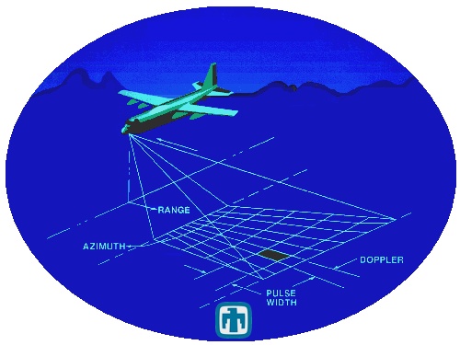
Δφ
Δθ
θ
2. A radar beacon is a navigational transponder. It responds to the interrogating pulse from ‘On-board (located on ships and airplanes)’. This response is transmitted by the beacon with a delay of 20ns after the reception of the radar pulse. Due to this, what is the displacement (distance and direction) of the beacon location as seen by the ‘on-board’ radar?

Explain How?
3. DME system provides the slant range, VoR provide bearing (angular position/ direction) from a known DME/VoR station. An altimeter provides height from the MSL/ground. What combination of these Instruments would facilitate an aircraft to fix its own 3-D location? (Explain with only diagram or diagram and a couple of lines.)
4. How do the glide scope and the localizer antenna array help the aircraft to align itself while landing? Explain with only diagram or diagram and a couple of lines
5. Delay jamming technique involves detecting the radar transmission and re-transmitting the replica of radar pulses with random delays. How does this technique give false indication of the target range?

Answers and Discussions

- Synthetic Aperture radar:
- The ‘Swath’ =10,000(tan 47⁰-tan 43⁰)= 10723.68-9325.15 = 1398.5 m ~(1.4 km)
If BW are 8⁰: 10,000(tan 49⁰-tan 41⁰) = 2.81 km
If BW are 16⁰, 10,000(tan 53⁰-tan 47⁰) = 5.734 km.
- How many range bins shall be accommodated if the transmission pulse width is 0.25µs?
The distance on which range bins are available is calculated as
No of range bins = (989.52)/ 37.5= 26.38
We can say that 26 (or 27) range bins are present

Fig 8.16
(c) If the air craft collects the data for the period of 300ms, what is the angular resolution (in azimuth or within Δφ )
The aircraft travels 30m in 300ms (=100ms⁻¹ X 0.3s)
This will make the beam width of the “synthetic aperture”
Hence, angular resolution = 0.07 deg
(d) Considering computations in (b) and (c) what is the typical size of the ‘resolution module’ in the Swath area. See the diagram in Fig15. Illustrate by drawing the grid and mention approximate dimensions
Now we calculate the size on the land surface. The resolution grid is as shown in Fig 17, which shows the land footprint in Fig.15.
17.27
17.9
54.98
51.27
53.03
16.7
Fig 8.17.
From (b) we know that the range bins in the radial direction is 37.7m. Its projection on the horizontal plane will be
in the near region will be (37.5/ Sin 43= 54.98m)
in the central region(37.5/ Sin 45= 53.03m)
in the far region (37.5/Sin 47= 51.27m)
These are the dimensions in the transverse direction.
------------------------------------------------------------------------------
From C we have the dimensions as follows: 0.07 deg= 0.0012217 radian
Hence in the near region, we have (10,000/Cos 43)X 0.0012217= 16.7m
In the central region (10,000/Cos 45)X 0.0012217= 17.27m
In the far region (10,000/Cos 47)X 0.0012217= 17.91m
These sectioning of the region is in the direction of the flight
---------------------------------------------------------------------------------
- Due to the delay, the radar will perceive the range of beacon more (away from radar) by
3m, away for the radar.
- VoR, DME and altimeter Or 2 VoRs and Altimeter Both methods are OK.
From Altimeter
N
E
Aircraft Location
DME/VoR station
From Altimeter
From DME
Angle
From VoR
DME/VoR station
Aircraft Location
Angle
From VoR1
DME/VoR station
Aircraft Location
N
Angle
From VoR2
N

E
Fig 8.18
- Refer Fig 8.4 The glide scope creates two beams with different modulation frequencies in the vertical plane and localizer in the horizontal plane. The aircraft tries to align at the null. This means it performs the movements such that the response in 90 Hz channel and 150 Hz channel is of equal magnitude (and cancel each other).

- The ‘delay jammer’ introduces random delay before re-transmitting the radar pulse. Thus making the radar (under jamming attack) receives these re-transmitted pulses from the ‘delay-jammer’ with random delays.
The radar generally estimates the target range by measuring the round-trip time. This estimation is erroneous/ chaotic due to this random delay as the delays are not related to target(s).

Chapter-9

Digital Realization of Radar Sub-Systems

Modern digital electronics is capable of handling signals up to a few tens of gigabits per second. With these advances, it is possible to represent GHz signals with digital representations. There has been a trend to build the radar system components with digital electronics. Modern radars have only a few analog components; namely, high power amplifiers, low noise amplifiers and components operating at frequencies higher than UHF bands. Fig. 9.1 is simply reproduced version of Fig. 1.3 indicating the sub-systems which could be replaced by digital electronics.
Power Amplifier and filter
Modulator/ Pulse Generator
Carrier Waveform Generator
Video Amplifier
Low Noise RF Amplifier
Antenna
Duplexer OR
T/R Switch
Local Oscillator
IF amplifier and Matched Filter
Second Detector Demodulator
Threshold detector
Fig 9.1 The radar sub-system covered by grey shade can be realized by digital electronics

  - Need for low power sub-system realization in terms of digital components

There is great drive to convert all low power radar sub-systems into digital form. This is mainly due to the following advantages.
- The realization of the system is much lighter (in weight)
- The frequencies and the algorithm can be updated by simply changing embedded program.
(This is true in most of the cases. So the upgrades and improvements can be adapted easily. On the other hand for conventional analog components, the modules need to be changed.)
- Amplitude degradation, phase drift is absent. In other words, the problem of aging and temperature dependent changes etc. are avoided.
- In many cases, radars use receiving antenna is in form of array of elements. The signal received by these elements is combined to form the receiver signal. In such cases, the signal received by each element, is digitized (using analog to digital converter, ADC) before combining to form receive channel. Thus the signal is converted to an array of complex numbers. In practice, two ADCs are used to sample ‘in-phase’ and ‘quadrature’ components of the signal received by each element. At this stage, it is possible to form multiple beams. The formation of multiple beams enables the detection and tracking multiple targets. This is a great advantage for strategic radars.
- Multiple channels can be operated with single ‘modulator or pulse-coding’ signal. In other words, same signal line can be used as input to many sub-systems without ‘fan-out’, reactive loading’ or ‘impedance matching’ problems.
- Security features can be easily embedded on the sensitive data and signals. Being in digital form, they can be archived and coded for authorized access.

However, there are a few disadvantages.
- The ‘near carrier phase noise of the RF signals like frequency reference, local oscillators (Stalo, Coho) etc, is generally better in analog-signals compared to the digital realizations. This could be matter of serious concern for atmospheric radars.
- It is difficult (if not impossible) to realize filters with customized specifications at RF and IF frequencies. The filtering is generally done using CIC filters. A discussion on these filters is presented in section 9.4 of this chapter. However, it is also the fact that specialized filters, with strong restrictions on specifications like ‘magnitude ripple’, ‘roll-off’ etc. are generally not required in radar applications. Therefore it is not a serious disadvantage.
- It introduces Quantization Noise (QN). Assuming that the quantization error is uniformly distributed, the SNR (in dB and also as ratio) w.r.t. full scale signal, is given by

SNR (dB) = 6.02 N + 1.76dB and … (9.1a)
Where, N is No of bits in ADC. This is the ratio V_{RMS}/V_{Noisestd.dev.} Also, .
The same can be converted to ‘Relative phase noise’ using approximate expression
… (9.1b)
The same can be expressed in terms of ‘dBc.Hz⁻¹ @ offset of 1Hz’
… (9.1c)
- Introduces frequency aliasing
- Digital realization is not possible at high power (typically more than a watt) and at microwave frequencies. With current technology, for some application, digitization is possible up to the frequencies of a few GHz.

In following sections the techniques of realizing various radar subsystems are presented

  - Numerically controlled oscillator (NCO)

All the radars require a stable frequency source. Conventionally it is realized using a phase locked oscillator. In a typical radar, there are two to three frequency up-conversions in the transmit systems and equal number of down conversions in the receive systems. It is well known that heterodyne receivers have one conversion and ‘super-heterodyne’ systems have 2 frequency conversions, each in transmitter and the receiver. Modern radars operating in ‘Severely High Frequencies (SHF, 3GHz to 30 GHz)’ and ‘Extremely High Frequencies (ESH, extremely high frequencies)’ often have more than two frequency conversions.
A Numerically Controlled Oscillator (NCO) can be used to generate a wide variety of periodic waveforms. However in the context of radars, generation of sinusoidal waveform at desired frequency is presented. This waveform generation is in the form of a series of samples indicated by the index ‘n’. The mathematical expression for the desired sequence y[n] is given in (9.1). Here, f₀ and θ₀ are frequency and initial phase of the waveform. It may be noted that in the generalized case, the waveform may have time varying frequency and phase, the variables f₀ and θ₀ in (9.1) will be replaced by time varying functions and the instantaneous values of the frequencies would be indicated by f_{i}[n] and φ_{i}[n]. Where, f_{i}[n] = f_{s} / f_{ck}; ratio of the signal frequency to the clock frequency.
A generalized version of the NCO (capable of generating arbitrary periodic waveform) consists of two functional blocks, ‘Phase accumulator’ and ‘phase to amplitude converter’. The functional diagram of NCO is shown in Fig. 9.2.
Phase Accumulator
+
+
φ_{n-1}
z⁻¹
2πf_{i}[n]
(f_{i} = f_{s} / f_{ck} )
φ_{n}
Phase to Amplitude Converter
φ_{i}[n]
y[n]
Phase Control
Frequency Control
Fig. 9.2(a) Generalized Functional Block Diagram of DDS
Phase to Amplitude Converter
Memory with
Cosine table of ‘N’ points

Modulo N counter
Digital to Analog Converter (DAC)+Filter
y[n]
Address
data
Clock with
Frequency =N X f
Fig.9.2 (b) NCO for Sinusoidal Wave generation

Initial Value

It is seen that the phase accumulator gets two inputs of incremental phase, one due to instantaneous frequency and other direct addition due to instantaneous phase. They combine as shown in Fig. 9.2(a) to output the phase at n^{th} instance. This is subjected to the next block ‘phase to amplitude converter’. This block is simply a table that consists of pre-calculated values of function ‘Cos(θ)’. Any periodic wave form can be generated in this manner. In the test and measurement (T&M) instrumentation domain such technique is known ‘Arbitrary Waveform Generation (AWG)’ technique. Many ‘T&M’ equipment manufacturers use this acronym in the model name of their products.

  - Direct Digital Synthesis (DDS)

In the context of radars, there is need to generate sinusoidal waveforms at different frequencies. Generating sinusoidal waveform is a special case of periodic waveform generating using NCO. It may be appreciated that sinusoidal waveform can be generated simply by a memory block and a ‘digital to analog converter (DAC)’ as shown in Fig. 9.2(b). The clock operating at N times the ‘NCO output frequency’ is fed to the ‘modulo N’ counter. The counter output number is used as the ‘address’ to the memory block. The cosine value, being the ‘data’ at the addressed location, is available at the data port, works as an input to DAC. The DAC output is the desired sinusoidal waveform. It is advisable to use a low pass filter (LPF) to remove ripple and glitches on the DAC output. The initial value input of the counter can be used to add any ‘pre-set’ phase. It is straightforward that initial value of 0 gives the cosine waveform and +3/4 N, (giving phase difference of –π/2) can be used as sine waveform at NCO frequency. This is a special case of NCO and also known as ‘Direct Digital Synthesis (DDS)’ technique.

  - Digital Down Conversion (DDC)

Another important operation in radar instrumentation is ‘frequency conversion’ using a mixer. In the modulator/ transmitter sub-systems, frequency is ‘up-converted’ to reach the transmission frequency. In communication domain it is referred as ‘carrier frequency’. In some cases, multiple ‘frequency up-conversions’ may be needed. On the other hand, in the receivers the signal is subjected to ‘frequency down conversion’. The received signal at near-transmission frequency is converted to the ‘intermediate frequency’ using mixer. Usually additional down-conversion(s) are done to get the signal to the ‘base-band frequency’.
A mixer is a 3 port module with a square-law device as the main functional element. It is generally realized using a semiconductor junction diode(s). The principle of operation of a mixer is as follows Fig.9.3 shows the expanded view of a forward bias V-I characteristics of a typical p-n junction diode. It is known that mathematical expression describing V-I characteristics is as given in (9.2). The current can be expressed as a power series of ‘forward bias voltage’ (multiplied by a constant). It can also be appreciated that at different values of ‘V (forward voltage)’, different term of the power series is dominant. This means that around specific values of V, only one of the terms has value much higher compared to the other terms. Fig 9.3 shows expanded view of the V-I characteristics of the diode and it is felt that different sections of the curve show, dominance of different power terms.
… (9.2)
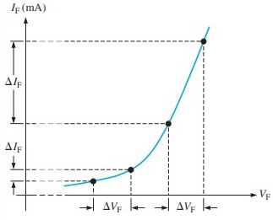
Fig. 9.3 Forward bias V-I curve of a diode
Bias point
B
C
D
A

One may appreciate that section BC of the curve, shows predominantly show square-law characteristics; while section AB shows of the linear term and the section CD show dominance of the cubic/ higher order term. This ‘square-law characteristic’ is significant for the frequency mixing operation. This can be explained in the context of frequency mixing operation with the received signal (RF) and the local oscillator (LO) signal. Generally the RF signal is very low in magnitude. In order to operate the mixer in the ‘square-law region’, the power of the LO signal need to be adjusted at bias point. Due to this arrangement, the forward bias offered by the combined signal (LO+RF) remains in the ‘square-low region. The relevant mathematical expressions are given in (9.3) and (9.4).

The signal across the nonlinear device (diode) is (V_{RF} +V_{LO}). The output current is given by (9.3). Without the loss of generality, the initial phase is referenced to the initial phase of LO signal.

… (9.3)
On expansion, we have,
… (9.4)
It is seen that the frequency contents of the terms are 2f_{RF}, 2f_{LO}, f_{RF}+ f_{LO} and f_{RF}- f_{LO} respectively. In radar systems, the mixing operation is used in modulators in transmitter system and for frequency down conversions in receiver systems. For the modulation operation, components indicated by both 3rd and 4th term of (9.4) are required. The receiver system uses the component indicated by 4th term of (9.4). The unwanted components are filtered out. In practice, these components are clearly separated in frequency. The desired component can be easily selected using filter with appropriate pass band.
The Digital down converter (DDC) implements these mathematical operations in the hardware. The mathematical operation indicated in (9.3) is performed by mixer operation between the LO signal generated by the NCO and the receiver signal. In fully digital receivers, it is implemented by performing a ‘point-to point multiplication’. Generally the data output of the ‘memory block of the NCO, see Fig 9.2(B), is used as Local Oscillator (LO) signal. The received RF (echo signal in case of radars) is sampled synchronously with the NCO clock. Subsequently, ‘point-to point multiplication’ is performed with the LO data sequence and the sampled RF. The DDC performs the ‘complex multiplication’ operation. It does not generate unwanted 3 components like the analog ‘square-low device’ mixer. However, there is possibility of misinterpretation of the component frequency due to ‘frequency aliasing’.
Next step performs filtering to pass the desired component with appropriate frequency assignment. Such filter does not require any special characteristics of ripple roll-off etc. Due to this relaxation, it is possible to implement them without ‘multipliers’ and using delays and adders. It is known that ‘multiplication operation’ requires 6-8 clock cycles of the processors. On the other hand, the delays and additions require one cycle. Therefore, the filter implementation without using multipliers proves out to be computationally simple. Therefore, they have low execution time. Due to this advantage the ‘higher cut of frequency’ of such filters is substantially higher than that of conventional filters. In radar receivers this advantage, digital processing can be extended to RF stages.
The filtering operation is performed by combination of two types of simple building blocks; the ‘integrator’ and a ‘comb filter’. Appropriate ‘cascading and sequencing’ of these two blocks fulfils almost all the practical requirements of frequency conversions in radar systems. The class of filters formed by the combination of ‘comb and integrator’ is known as ‘Cascaded Integrator-Comb (CIC) filter.

  - Cascaded Integrator Comb filter (CIC) and usage

As mention in the earlier section there are two building blocks of the CIC filter; namely, ‘Integrator’ and the ‘Comb filter’.
The first block, an integrator is simply a single-pole IIR filter with a unity feedback. The difference equation (time domain representation) and the transfer function (Z-domain representation is given in (9.5). Considering z=e^{jω}, it can be derived that the magnitude of (1-z⁻¹)² is equal to (1-cosω)² +sin²ω.
The Power and phase transfer function with respect to the frequency is given in (9.6). In this discussion the amplitude response is more significant. Important aspect of the phase response is only the linearity which automatically leads to ‘distortion-less’ filtering.

and … (9.5)
and … (9.6)
Due to the pole at z=1, the power response has infinite gain at ω=0. Nevertheless, the power response is basically a low-pass filter with a roll off of 20 dB per decade (6 dB per octave). This can also be seen from the mathematical expression in (9.6), by considering the power series expansion of the cosine function and neglecting the higher order terms. Fig 9.4 shows the response of the integrator.
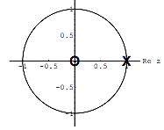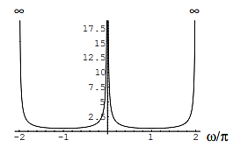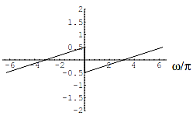
(a)Pole Zero diagram (b) Amplitude response (c) Phase response
Fig. 9.4 Frequency response of a single pole unity feed-back integrator

The functional block diagram is given in Fig 9.5.
Fig 9.5 Functional block diagram of digital integrator. Forward bias V-I curve of a diode

The second block, a comb filter is an FIR filter that adds or subtracts delayed version of a signal to itself, causing constructive and destructive interference. In most ‘multi-rate processing’ applications, a comb filter is generally operated at high sampling rate f_{s} (say). The ratio of the High and low sampling rates is R, and the M is designed parameter called differential delay, always a positive integer. Assuming that the comb is implemented on Low sampling side, the difference equation and the transfer function can be written as given in (9.7).

and … (9.7)

The Power and phase transfer function with respect to the frequency is given in (9.8)
and … (9.8)
For the basic understanding of the comb filter, not considering the rate change (R=1). The basic structure of the CIC filter is shown in Fig. 9.5(a). With the similar argument as was done for integrator, it is seen that, the basic comb filter has a response of a ‘high-pass filter with gain of 20 dB per decade (6 dB per octave). On ‘z’ plane the function has a pole at the origin and a zero at (1,0). Thus it can be considered as inverse of the integrator! The power response for RM=1 is shown in Fig. 9.5 (b). It has a shape of raised cosine. With RM≠1 the power response shall have RM cycles from 0 to 2π.
0
4
-π
-2π
2π
-π
ω=2πf
│H(e^{-jω})│²
+
z^{-M}
+
-

Fig 9.5 (a) Functional block diagram of a comb filter and (b) the power response

A CIC filter is built by cascading these building blocks. Consider N integrator sections followed with N comb blocks with same clock rate. The transfer function of such arrangement will be equal to 1. Therefore, it does not have any practical significance.
However, it has interesting properties when comb operates at lower rate (say, by a factor of R). This is conceptualized by introducing a ‘rate changer’ at the starting end of the cascade and pushing the integrator to the high sampling rate side! Mathematics ‘multi-rate analysis’ addresses transferring of a functional block through a rate changer of linear time-invariant (LTI) systems ^{[9.1]}. For the case in discussion, the difference equation for the comb filter before the ‘down sampler (or decimator)’ and after (at a slower sampling rate ‘f_{s} /R’) are given in 9.9 (a) and 9.9(b) respectively
- and after the down sampler (b) … (9.9)
Using such arrangements we achieve a slow-down the comb filter(s). It can also be seen that the ‘rate changer’ makes the ‘integrator part’ independent of the ‘comb filter’ when the sampling rates are considered. In practice this rate factor is kept programmable keeping the structure same.
With this philosophy, two types of CIC filters can be constructed.
- Decimating CIC filter:- This type of CIC filter has N cascaded stages of integrator clocked at f_{s} followed by a rate changer (clock divider) to f_{s}/R. This is achieved by taking only one sample out of R samples. This stage is flowed by N cascaded ‘comb filter’ at low sampling rate.
- Interpolating CIC filter:- This type of CIC filter has N cascaded stages of comb filter clocked at f_{s}/R followed by a ‘zero-stuffer (introduces ‘R-1’ zeroes after every sample). This stage is flowed by N cascaded integrator stages running at f_{s}.
Fig. 9.6 (a) and 9.6(b) shows the schematic of these two types.

Fig 9.6 (a) Three stage Decimating CIC Filter schematic

Fig 9.6 (b) Three stage Interpolating CIC Filter schematic

The utility of the CIC filters in radar receivers can be seen by the following example. The transfer function of a CIC filter with difference equation of the comb as in (9.8) is given in (9.10).
… (9.10)
It may be noted that even though the CIC has IIR component (integrator), the complete transfer function has a mathematical form of an ‘N-stage FIR’ filter! Each of these filters has rectangular frequency response.
Since all the coefficients of these FIR filters are unity, they are symmetric.
This CIC filter also has ‘linear phase response’ and constant ‘group delay’. These two properties ensure that there is no distortion in the ‘wave-shape’ and therefore it preserves the ‘signature’ of the echo. This aspect is very important in radar receivers
The magnitude response can be shown to be as shown in (9.10). This mathematical expression can be easily derived by substituting ‘2 cos(ω) = 1-2 sin²(ω/2)’. This followed by ‘small angle approximation (sinx≈x)’ leads to the amplitude response of the form of ‘Sinc function’. In most of the radar applications, the RF signal is sampled at more than the Nyquist rate(f_{s} > max(f_{RF}, f_{LO})) In almost all practical applications, the down converted frequency, known as IF (or the baseband frequency (f_{IF} or f_{BB}) is much smaller (generally by a factor >5) than f_{RF}, f_{LO}. Therefore, it is reasonable to use the small angle approximation.
for 0≤f<1/M … (9.11)
Consider a case when integrator and the comb filters are cascaded before the decimator. Fig. 9.7 shows the amplitude response of the filter with N=3, and M=8. The response can be computed by putting R=1 in 9.11.
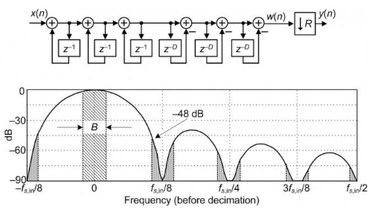
-M
-M
-M
Fig 9.7 The CIC filter structure and the amplitude frequency response for N=3, M=8,

In most cases of frequency down conversions, the IF (or baseband) frequencies are much smaller than sampling frequency (f_{s}) at RF. As a result they occupy the band shown by ‘B’ in Fig. 9.7. The frequencies indicated by the areas shown in vertical strips shall interfere with the desired RF frequencies due to ‘frequency aliasing’. It is seen that the components are 48 dB weaker than the desired component. The component can be further supressed by increasing number of stages (N). These components can be reduced in number by pusher away in frequency by reducing M. Dashed line with in red shows the amplitude response with M=4.
When the comb filter is ‘pushed’ after the ‘decimator’ to get structure as shown in Fig. 9.6(a), the equivalent performance is obtained using comb filter with delay M/R. This means that if we put R=8, the delay of one clock period (M=1, at lower frequency) shall give same performance.
It is seen from equation 9.10 that the gain of the filter is (MR)^{N}. By classical operations, this leads to increase the number of bits as
Bus-width (out) = Bus-width (in) + N log₂ (RM) … (9.12)
However, in CIC implementation, we see that the bit increase may take place with each addition. Therefore we have maximum increase in number of bits is 2N.
Bus-width (out) = Bus-width (in) + 2N … (9.13)
It is clear that CIC filter offer lesser bit increase for the cases, (RXM)> 4.

In the foregone discussion, we have seen that the ‘decimating CIC filters’ are effectively used for enhancing desired frequency component (while rejecting unwanted high frequency components) in frequency down conversion applications. Almost every radar and communication system receivers need the frequency down conversions.
In the similar manner, the ‘interpolating CIC filter’ can be used to selectively choose a desired component in presence of low frequency components. This filter, as shown in Fig. 9.6 (b) implements same operations in the reverse sequence; namely comb filter, up-sampling and Integration.
The operation features can best be explained by an example. Two frequencies of 36MHz and 39MHz (say) are mixed to create up sampled frequency of 75 MHz. This is done by ‘point to point multiplication’ of complex samples at 40 MSPS. In addition to the desired component at 75 MHz (in Blue), the multiplication sequence may contain frequency components at 36, 39 MHz and their images at 41 and 44 MHz (all in red).
If the interpolating CIC filter with parameters M=4 and R=2 is used, we get the frequency characteristics that supresses both the unwanted components. Fig. 9.8 shows the characteristics of comb and the integrator filters. The combined characteristics of CIC filter supresses the unwanted frequency components substantially. Thus appropriate selection of parameters can result in selective filtering.
│H(e^{-jω})│²
f(MHz)
0 20 40 60 80
Fig 9.8 Comb filter characteristics (in black) and integrator characteristics (in red)
Parameters f_{s}=40MSPS, M=4 and R=2
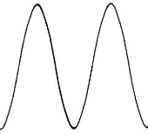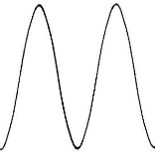
Fig 9.8 Comb filter characteristics (in black) and integrator characteristics (in red)
Parameters f_{s}=40MSPS, M=4 and R=2

Sometimes the up-sampling rate is made intentionally high (say 14). This choice of up-sampling rate allows higher number of samples in one cycle of the desired frequency. This adds to the fidelity of the signal. In this case, R=14 shall give the sampling rate of 560 MSPS (8 samples per wavelength of 70 MHz signal). However, the integrator filter response may offer lesser gain at 70 MHz compared to that offered at R=2.

  - Numerical problems

- Refer to the figure 9.7 and explain the features (Bandwidth, suppression of unwanted signals and the normalization in the light of the mathematical expression (9.11)
Assigning process parameters to the physical parameters of the signals
The Decimation CIC filters are generally while frequency down conversion. The process is explained with following Example. Consider an echo of the radar with carrier of 900 MHz and a pulse width of 100ns. This signal must be sampled at f_{s}> 900 MHz; Complex sampling.
We take f_{s} =1GHz (say). This selection gives unambiguous definition of ±500 MHz One can map these values in Fig. 9.7. In this case the baseband bandwidth is 10 MHz (or 16 MHz depending on the feasibility requirement). The value of N is chosen depending on the suppression of other components Expression 9.11 shows that the response is (Sinc)^{N} hence the side lobe magnitude is are (13.3X N) dB w.r.t the main lobe. The value of M is chosen depending the number of lobes in the normalized frequency response. This may be chosen to suppress extra-system frequency sources.
References:
[9.1] Ronald E. Crochiere, Fredrick J. Harris and Lawrence R. Rabiner ‘Multi-rate Digital Signal Processing” Printice Hall Signal Processing Series. Prentice Hall, Englewood Cliffs, 1983. ISBN0136051626, 9780136051626

