Histogram Gradient Boosting: Performance and Robustness
1. Experimental design
We evaluated a shallow HistGradientBoostingClassifier on ECG-derived measurements for binary atrial fibrillation (AFIB) classification. The shared dataset contains 21,799 ECG recordings from 18,869 patients, including 1,514 AFIB-positive recordings (6.95%). The input workflow retained 504 original lead features and, where specified, 63 engineered cross-lead features. Patient identifiers were used only to define non-overlapping folds, not as predictors.
All four arms used the same ten outer patient-grouped folds and three inner folds within each outer training partition. Hyperparameters were selected by mean inner-validation macro-F1; the selected model was then refit on the outer training partition and assessed on held-out patients. The initial max_depth candidates were {2, 3, 4}; an inner-only boundary refinement tested depth 5 when depth 4 won. Common settings were 150 boosting iterations, learning rate 0.05, at most 16 leaves, at least 30 observations per leaf, L2 regularisation 1, no early stopping, and random_state 42. Fold-specific data preparation and shared sample weights were applied using the project loader. A probability threshold of 0.5 was used for primary classification metrics.
Arm | Engineered features | Training augmentation
A | No | No
B | Yes | No
C | No | Yes
D | Yes | Yes

2. Observed-data performance
Arm | Macro-F1 ± SD | Sensitivity ± SD | Specificity ± SD | AUROC ± SD
A | 0.9213 ± 0.0158 | 0.9514 ± 0.0243 | 0.9795 ± 0.0035 | 0.9930 ± 0.0032
B | 0.9230 ± 0.0143 | 0.9496 ± 0.0198 | 0.9803 ± 0.0037 | 0.9935 ± 0.0035
C | 0.9156 ± 0.0122 | 0.9549 ± 0.0209 | 0.9771 ± 0.0034 | 0.9931 ± 0.0040
D | 0.9179 ± 0.0126 | 0.9583 ± 0.0190 | 0.9776 ± 0.0031 | 0.9934 ± 0.0041
Table 1. Mean ± sample standard deviation across ten outer test folds. The class imbalance motivated macro-F1 as the primary model-selection metric.
Arm B had the highest observed-data macro-F1 (0.9230), but its paired mean advantage over A was small (B − A: +0.0018 ± 0.0047). Augmentation reduced observed macro-F1 (C − A: −0.0057 ± 0.0048; D − B: −0.0051 ± 0.0045), while Arm D achieved the highest AFIB sensitivity (0.9583).

3. Robustness to missing leads and perturbations
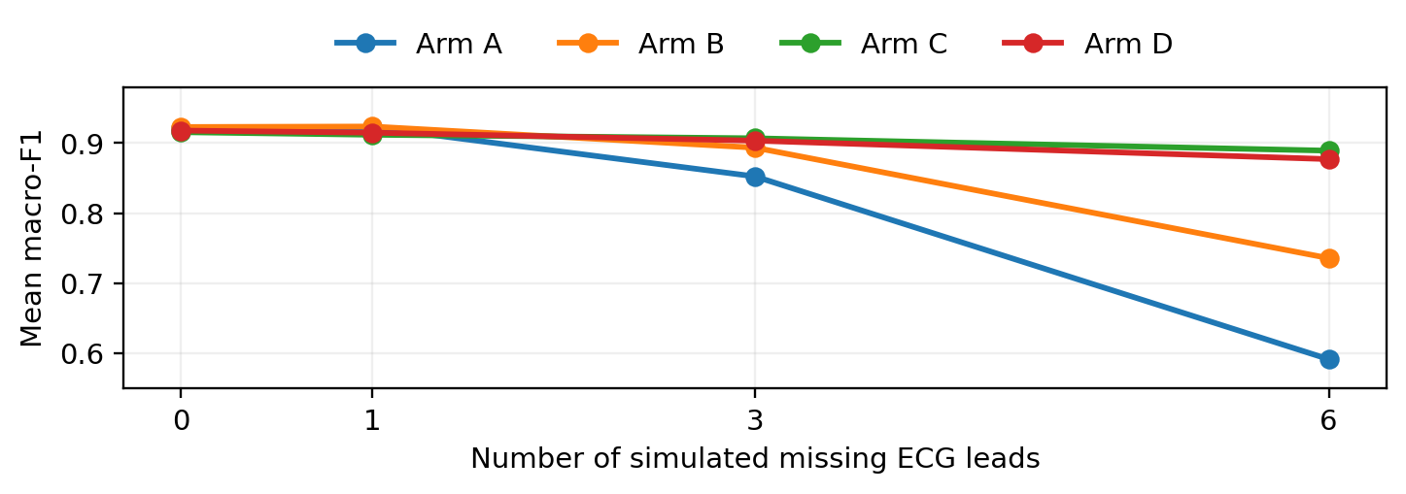
Figure 1. Mean macro-F1 by number of simulated missing ECG leads. For perturbed scenarios, three matched repeats were averaged within each outer fold before averaging across ten folds.
Arm | Observed | 1 missing | 3 missing | 6 missing
A | 0.9213 | 0.9226 | 0.8524 | 0.5912
B | 0.9230 | 0.9237 | 0.8935 | 0.7356
C | 0.9156 | 0.9119 | 0.9069 | 0.8892
D | 0.9179 | 0.9149 | 0.9035 | 0.8771
Table 2. Ten-fold mean macro-F1 under missing-lead simulations.
With six leads missing, Arm A fell to 0.5912 and Arm B to 0.7356; augmentation-trained Arms C and D retained 0.8892 and 0.8771, respectively. Within-fold paired losses (observed minus perturbed) were 0.3301 ± 0.0242 for A, 0.1874 ± 0.0405 for B, 0.0264 ± 0.0115 for C, and 0.0408 ± 0.0051 for D. These descriptive results indicate substantially better tolerance to simulated missing leads after augmentation.
Isolated measurement noise (σ = 0.05, 0.10, 0.20 times training IQR) and multiplicative gain perturbations (log-scale σ = 0.05, 0.10, 0.20) changed mean macro-F1 only modestly. Under combined three-lead missingness and noise 0.10, mean macro-F1 was 0.8493 (A), 0.8876 (B), 0.9062 (C), and 0.9019 (D). Corresponding paired drops were 0.0719 ± 0.0162, 0.0354 ± 0.0149, 0.0094 ± 0.0067, and 0.0160 ± 0.0058.

4. Interpretation and limitations
The principal trade-off was between performance on observed ECGs and robustness under missing measurements. Engineered features slightly improved unperturbed macro-F1, whereas augmentation made performance considerably more stable when multiple leads were hidden. The extra engineered features did not further improve missing-lead robustness once augmentation was applied (C outperformed D for three and six hidden leads).
These findings are limited to the specified dataset, predefined patient-grouped folds, and simulated perturbations; the reported standard deviations describe fold-to-fold variability, not clinical confidence intervals. No claim of statistical significance or external clinical generalisation is made. The experiment does not establish performance on a separately recruited population. Additional group-project baselines, quality-flag subgroup analyses, and controls should be integrated by the full team before final submission.

Reproducibility and source note
Results were transcribed from the user-provided output of the project’s verified 40-fold, four-arm experiment. The result checker reported 31 recorded scenarios per fold. Source artefacts: algorithms/histogram_gradient_boosting/{model.py, run_experiment.py, check_results.py, README.md}; reports/histogram_gradient_boosting/formal/. Dataset and preprocessing specifications follow the team’s project plan and shared input workflow. This document covers the HGB component only, not the full group’s four-page integrated report.

