ECG preprocessing for model inputs
Aaditya Pathak 1704373 | Siwen Wang 1721961 | Jiayi Huang 1668763
COMP90051 Statistical Machine Learning | 8 October 2026
Run notebooks/01_preprocessing.ipynb to prepare one shared input folder named processed_data. The notebook validates and packages the data. The shared loader then completes preprocessing inside each training fold before the selected classifier is fitted.
This document covers data preparation only. Dataset findings are in Data_Insights.docx; model comparisons and evaluation are in Project_Plan.docx.

Data flow
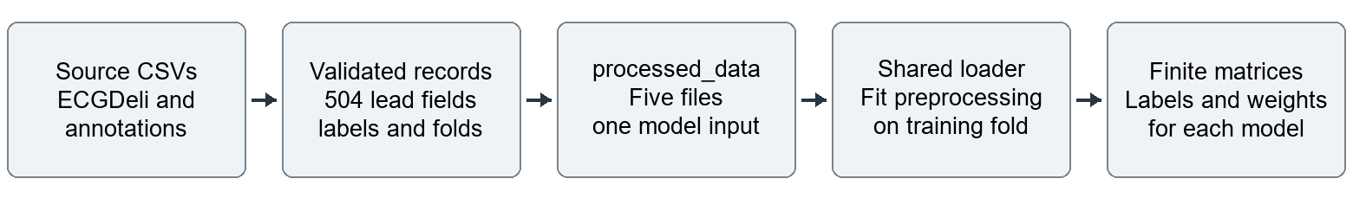

Input data and retained fields
Read ECGDeli ecgdeli_features.csv from PTB-XL+ 1.0.1, its ptbxl_statements.csv labels, and ptbxl_database.csv from PTB-XL 1.0.3. Match records by ECG ID and retain all 21,799 ECGs from 18,869 patients. AFIB is positive when the AFIB code is present, including a recorded likelihood of zero; absence of AFIB does not mean healthy.
Keep the 504 lead fields in their canonical order: 480 numerical fields and 24 categorical P morphology fields. Keep original values and natural gaps. Exclude the 27 Global fields and all labels, IDs, reports, supplied folds and quality flags from predictors. Quality flags are retained separately for later subgroup analysis.

The output folder
File in processed_data | Contents
lead_features.npz | 504 selected fields with original missingness and record alignment
targets.csv | ECG ID, patient ID and binary target_afib
folds.csv | Ten outer folds and three inner folds for each outer training set
metadata.csv | ECG ID and four recorded quality flags for evaluation only
manifest.json | Schema, source hashes and preparation policy

The notebook creates no plots, reports, model files or additional output folders. Natural gaps remain in the package so medians and scaling are learned separately for each training partition.

Notebook steps in execution order

Process flow
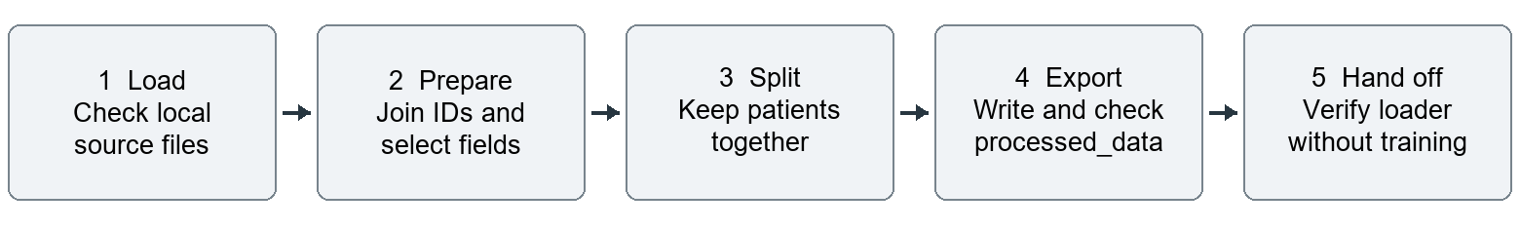
1 Set up local sources. Locate the project root and required source CSVs. Stop with a clear error if an input is missing.
2 Join select and validate. Require unique ECG IDs, matching records, patient IDs and consistent labels. Validate feature types and retain missing values without silently deleting records or clipping measured values.
3 Assign patient folds. Create the shared manual ten outer and three inner folds. All recordings from a patient stay together. Inner folds use only the current outer training patients.
4 Export the package. Write the five files into processed_data and record source hashes and field order. Verify IDs, row counts, labels, feature schema and patient separation.
5 Verify the hand off. Call the shared loader on one training and validation split to confirm finite arrays, aligned labels and consistent columns. This check does not fit a classifier or write a second output.

Final preprocessing before each model fit
Each model calls afib.data_preparation.load_prepared_split(processed_dir, outer_fold=..., inner_fold=..., arm='A'). Use inner_fold=None for the outer test split. The loader returns X_train, X_valid, y_train, y_valid, sample weights and split metadata.
For the enhanced view, construct 63 features from available measurements before filling: 52 cross-lead summaries and contrasts, seven relative variability measures and four products or squares. Undefined summaries remain missing. The original view uses the 504 lead fields.
Within the selected training partition, fit numerical medians, mean and standard deviation; fill gaps and standardise. Use zero for an entirely missing training column and scale one for a constant column. Add numerical missingness flags and one-hot encode morphology with explicit missing and unknown categories. Apply the frozen mapping to validation records.
When a model requests augmentation, create one corrupted training copy per ECG, rebuild its features and apply the observed-training mapping. The original and copy each receive half the original class weight. No validation record influences fitted preprocessing. Stress settings and experiment choices belong in the project plan.

Implementation: src/afib/data_preparation.py and src/afib/preprocessing.py. All model folders consume the same processed_data contract.

