AFIB classification project plan
Aaditya Pathak 1704373 | Siwen Wang 1721961 | Jiayi Huang 1668763
COMP90051 Statistical Machine Learning | 8 October 2026
We will compare three selected classifiers to determine whether cross-lead features and training with corrupted examples improve AFIB classification when ECG measurements are noisy or missing. We will report missed AFIB cases, false alarms and probability reliability, including outcomes where a method does not help.

Research questions
1 Constructed features. Do 63 cross-lead summaries, variability measures and interactions improve prediction over the original 504 lead fields?
2 Training augmentation. Does one corrupted training copy per ECG reduce performance loss under missing leads and measurement noise without sacrificing observed-data performance?
3 Learned filling. In a separate logistic-regression comparison, do estimates from other measurements improve prediction over training-median filling?

Data flow
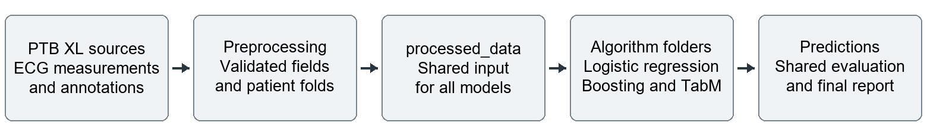

Process flow
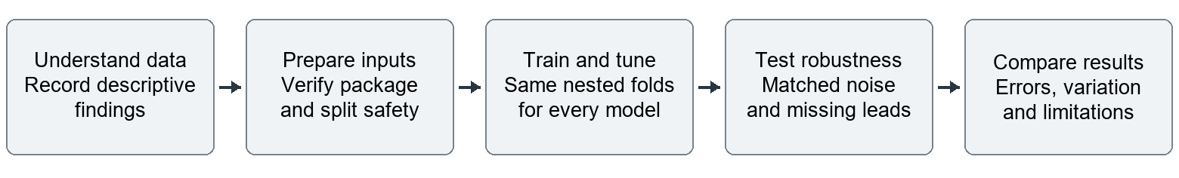

Inputs and file responsibilities
Use PTB-XL+ 1.0.1 ECGDeli features and PTB-XL 1.0.3 annotations: 21,799 ECGs, 18,869 patients and 1,514 AFIB records. The target is presence of AFIB, including codes with likelihood zero. Other records may have other conditions.
Data_Insights.docx records dataset findings. Preprocessing.docx and notebooks/01_preprocessing.ipynb define data preparation and processed_data. The shared loader completes training-fold transformations. The logistic_regression, histogram_gradient_boosting and tabm folders under algorithms hold the model-specific implementation work; training entry points will be added there. Prediction analysis stays in the evaluation notebooks.
The study uses extracted measurements. Hiding fields is not physical electrode removal or waveform denoising. The results will identify research candidates and limitations; they will not establish clinical benefit.

Selected algorithms
Algorithm | Role | Initial tuned values
L2 logistic regression | Linear reference | C = 0.01, 0.1, 1
Shallow histogram gradient boosting | Constrained nonlinear model | Maximum depth = 2, 3, 4
TabM neural ensemble | Recent neural method | Blocks = 2, 3, 4

Start logistic regression with L-BFGS and 2,000 iterations. Start boosting with 150 iterations, learning rate 0.05, at most 16 leaves, at least 30 rows per leaf, L2 strength 1 and no automatic early stopping. Resolve convergence issues before interpreting results.
For TabM, start with width 128, 16 ensemble members, dropout 0.1, AdamW learning rate 0.0003, weight decay 0.0001, batch size 256 and 100 epochs without numerical embeddings. Average member losses for training and member probabilities for prediction. Confirm that this ICLR 2025 method was not covered in class.

Main experiment
Arm | Feature view | Training records
A | Original 504 fields | Observed only
B | Original plus 63 features | Observed only
C | Original 504 fields | Observed plus one corrupted copy
D | Original plus 63 features | Observed plus one corrupted copy

Run all four arms for each classifier. Build constructed features from available measurements before filling and rebuild them after corruption. Fit medians, scaling, category mappings, noise scales and class weights only on the current observed training partition.
Allocate training copies evenly, without labels, among three hidden leads, noise 0.10, gain 0.10 and the combined condition. Give original and copy half the original inverse-frequency class weight. Include an availability-only feature control and a duplicate-observed-copy control to separate feature values and corruption from their accompanying changes.

Matched stress conditions
Evaluate observed records; 1, 3 and 6 hidden leads; additive numerical noise at 0.05, 0.10 and 0.20 training IQR; positive amplitude gain with log standard deviation 0.05, 0.10 and 0.20; and three hidden leads plus noise 0.10. Use three matched repeats and separate augmentation and evaluation random streams.
Preserve natural gaps. Protect counts and categories from numerical noise and durations from amplitude gain. Audit generated clipping and achieved changes. These doses are study assumptions, not medical tolerances.

Separate learned filling comparison
Restrict the comparison to arm A with logistic regression. Compare median filling with a fixed ridge filler (strength 1), using up to eight training-selected continuous predictors per target and at least 20 supporting observations. Learn 216 non-P continuous targets; leave 96 P-related continuous fields and all count and morphology fields on their baseline rules.
Preserve observed entries and missingness flags. Exclude labels, metadata, Global fields, counts and morphology from filler predictors. Never use generated values to predict other targets. Fall back to the training median when support or selected inputs are unavailable.

Training and selection procedure
1 Use the same patient folds. Run manual ten outer folds and three inner folds. Refit every learned preparation step inside each inner training split. Every ECG from one patient stays in the same partition.
2 Select on inner validation. Choose the highest mean observed-data macro-F1; ties favour simpler settings. Test at least three values per model. Permit one equal three-value grid refinement towards an endpoint winner, based only on inner data. Record whether the middle value is selected most often; do not force that outcome.
3 Refit and test. Refit the selected pipeline on outer training patients and evaluate its frozen model on the outer test patients under every planned stress. Never revise choices from outer scores. Use manual split, search and metric code; library estimators are allowed.
The main twelve combinations require 1,200 fits initially and at most 2,280 with the stated refinement allowance. Budget controls and learned filling separately. Keep threshold 0.5 primary. Any secondary threshold targeting 0.90 inner-validation sensitivity must be frozen before outer testing and remains exploratory.

Evidence to report
Report macro-F1, AFIB sensitivity and specificity with confusion counts, then precision, NPV, balanced accuracy, AUROC, average precision and unweighted Brier/reliability results. Compare absolute outcomes, paired stress losses and paired method differences. Fit any recalibration only from training-side out-of-fold predictions.
Average stress repeats within each outer fold, then report ten-fold means and sample-SD error bars. Include patient-weighted summaries and quality-flag group counts. Repeats are not independent patients; fold variation is not a clinical confidence interval.
For learned filling, hide a nominal 10% of observed cells and 1, 3 or 6 complete leads with three matched repeats. Score only originally observed eligible targets using per-feature MAE, training-IQR-scaled error, target counts, coverage and fallbacks. Report achieved masking and zero-IQR fields. Natural gaps have no known recovery answer. Observed data and three hidden leads are the main downstream comparisons; lower recovery error alone does not establish better prediction.

Work sequence and completion criteria
Complete and verify the shared data package first. Implement each classifier in its own folder, run a small training check, then complete the shared nested experiments, controls and filling comparison. Save actual out-of-fold probabilities and tuning selections. Produce at least three manually calculated experimental results with error bars and discuss successes, failures and alternatives.
Classifier training and complete comparisons remain pending. Finish the group agreement and at least three meetings. Submit the required four-page A4 single-column report, including references and appendices, with 10-point text and 1.5 to 2 cm margins; submit code and Readme.txt as a ZIP without data. The brief lists 16 October 2026 at 11:59 pm as the deadline.

References
Dataset papers: Strodthoff et al. (2023), PTB-XL+, doi:10.1038/s41597-023-02153-8; Wagner et al. (2020), PTB-XL, doi:10.1038/s41597-020-0495-6. Dataset attribution is CC BY 4.0.
Model: Gorishniy, Kotelnikov and Babenko (2025), TabM, ICLR; official implementation github.com/yandex-research/tabm. Missing data: Sisk et al. (2023), doi:10.1177/09622802231165001. The final report must cite the datasets and at least two additional relevant papers. Course requirements: Project.pdf, pages 1 to 4.

