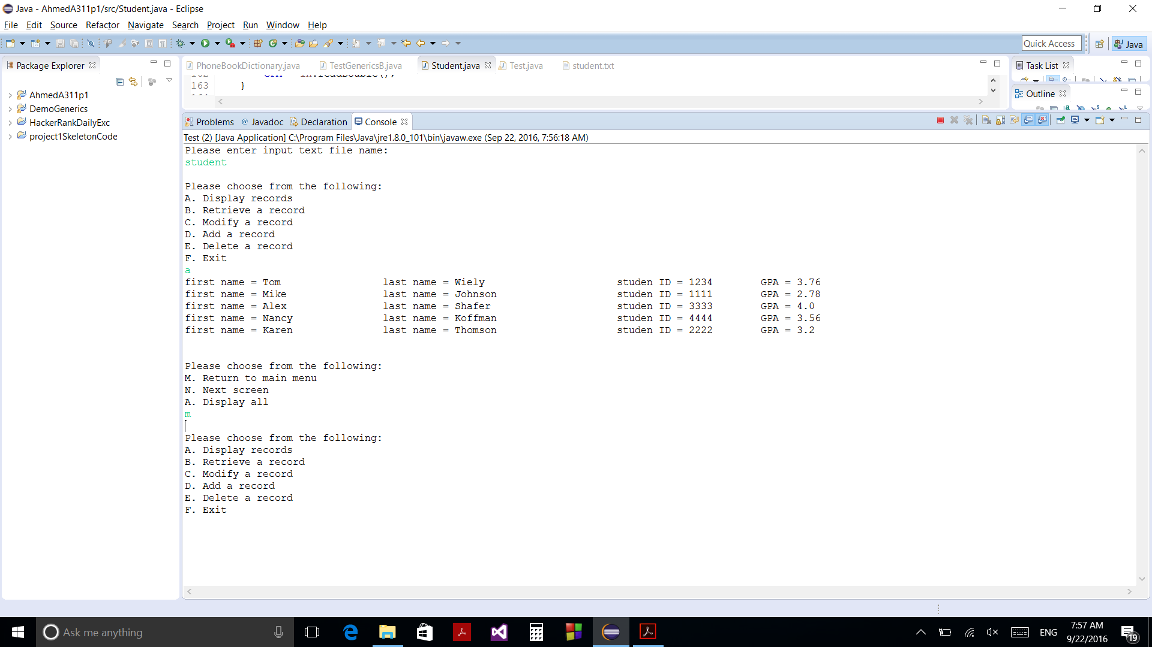

Displays 5 records per screen and return to main menu

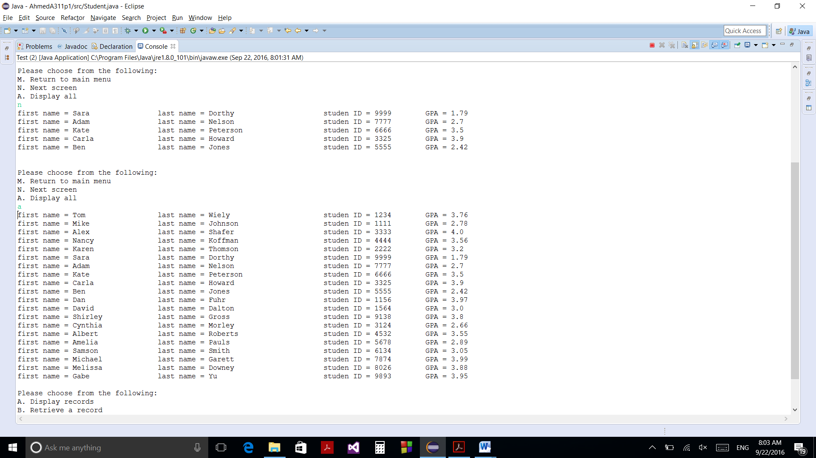

Displays the next 5 records on screen, and displays all records

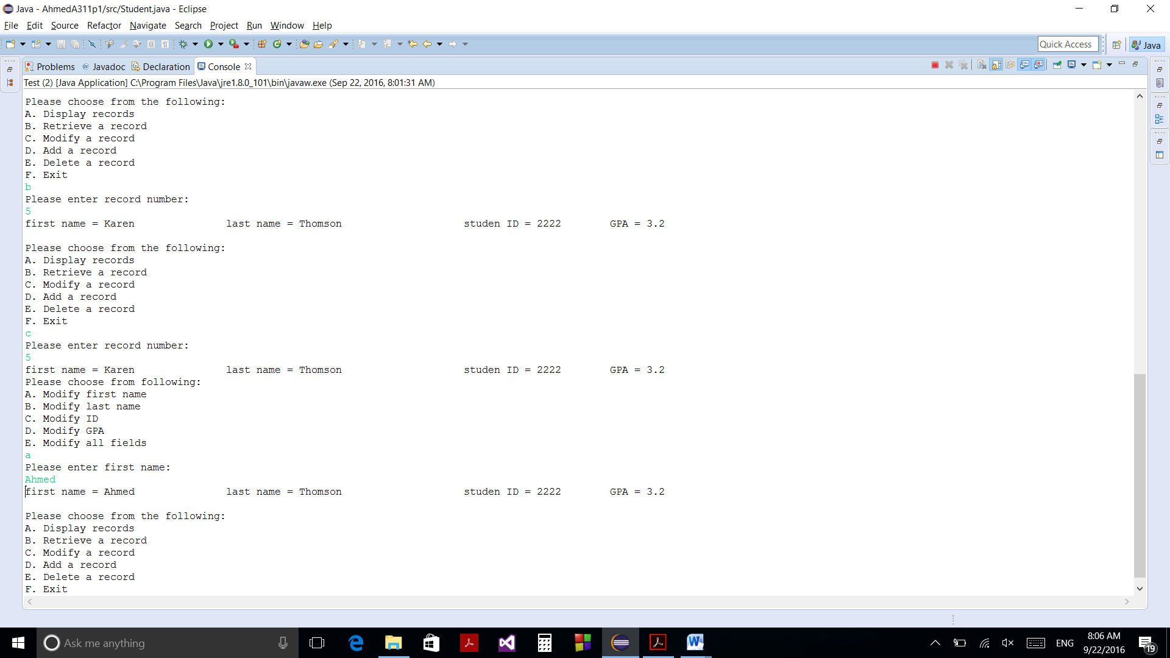

Retrieves and Modifies record number 5.

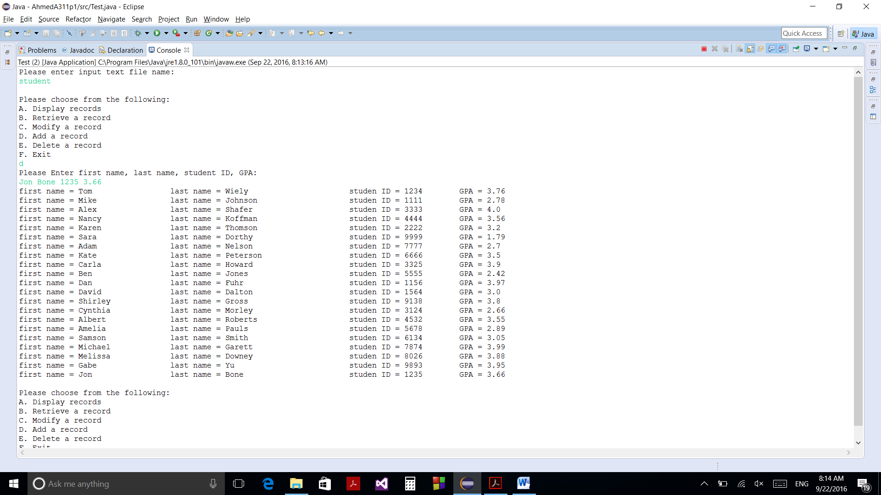

Adds a record to the random access file

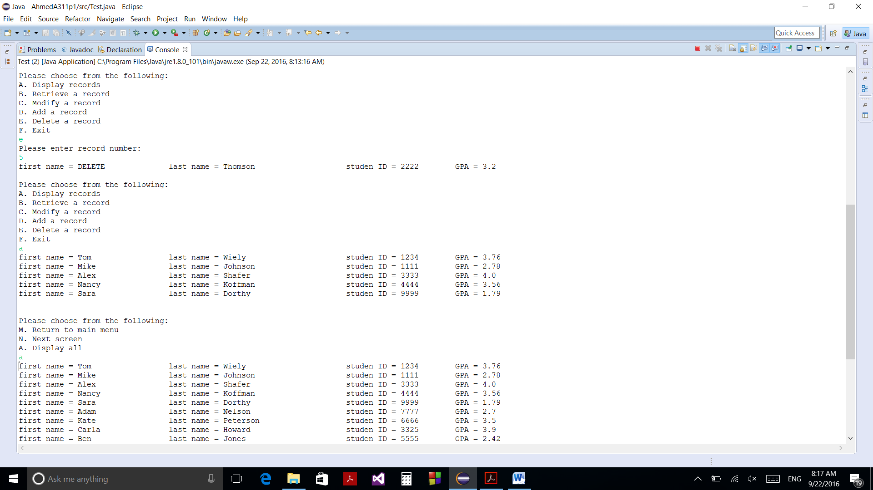

Delete record number 5 (Karen Thomson) as outputted after deletion, first name has value (DELETE). When printing, it skips record 5 and prints record 6 (Sara Dorthy).

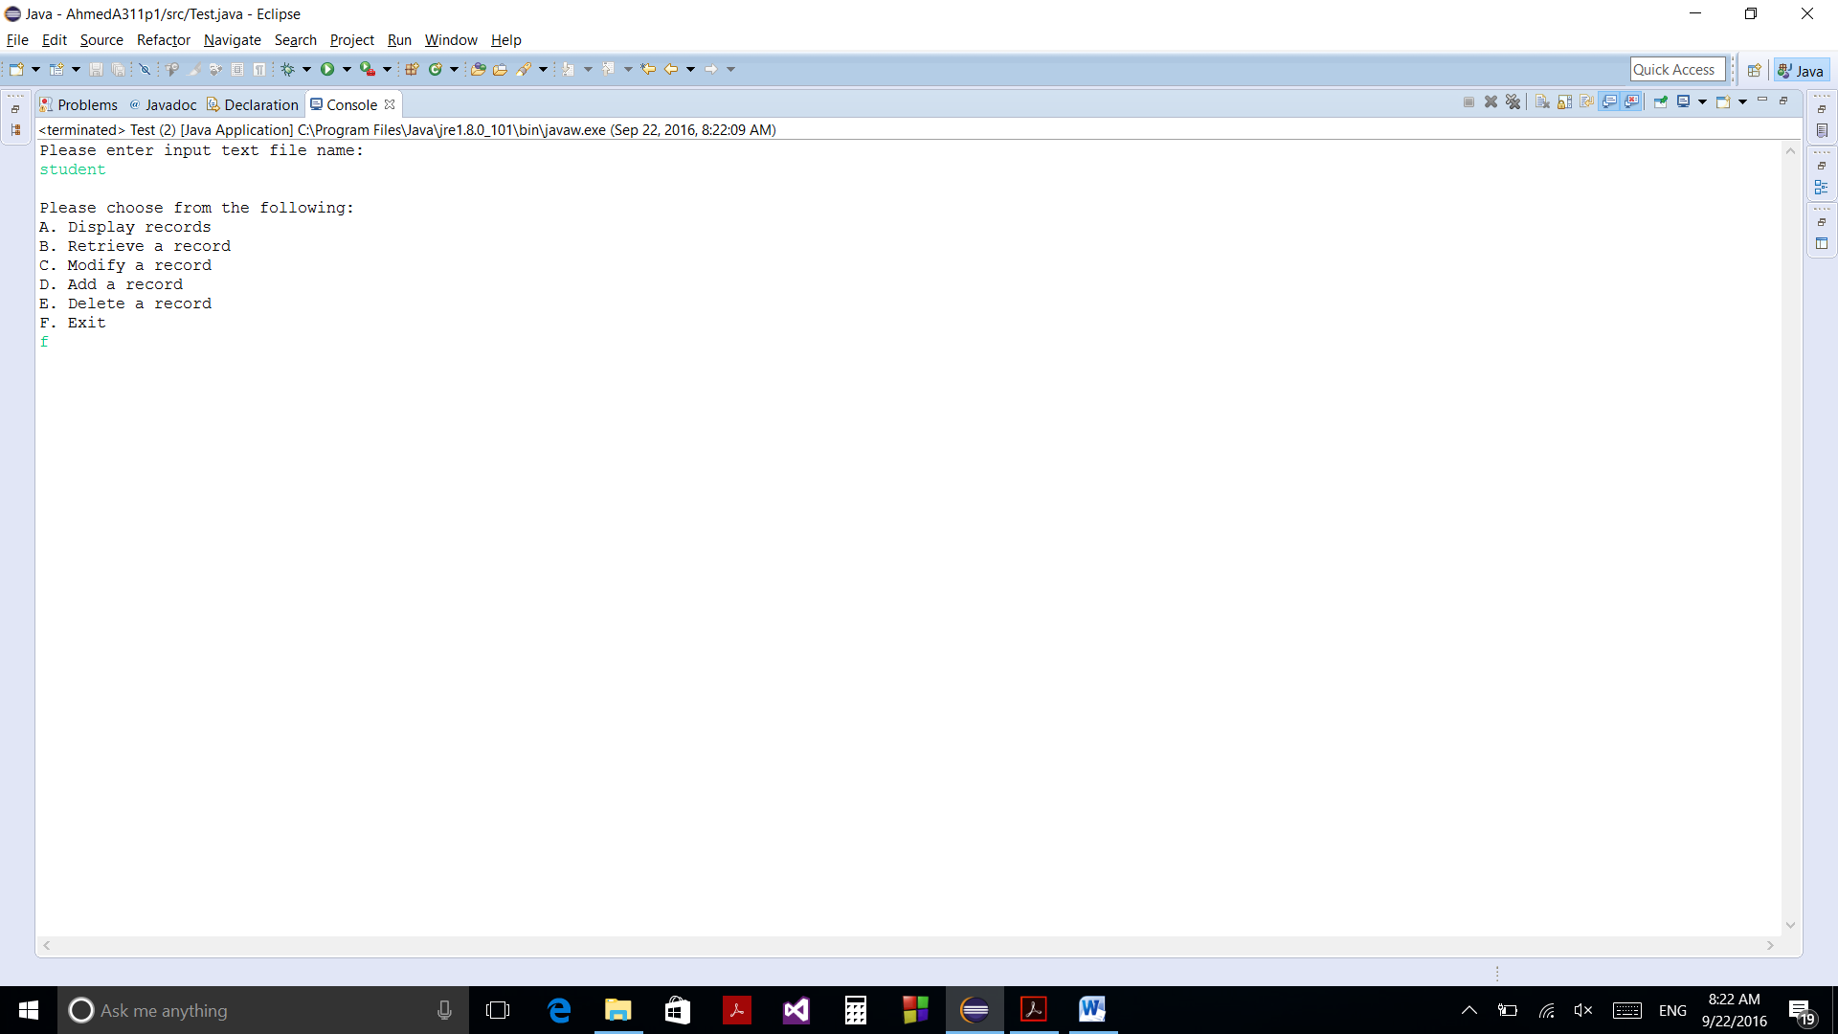

When f clicked it halts program