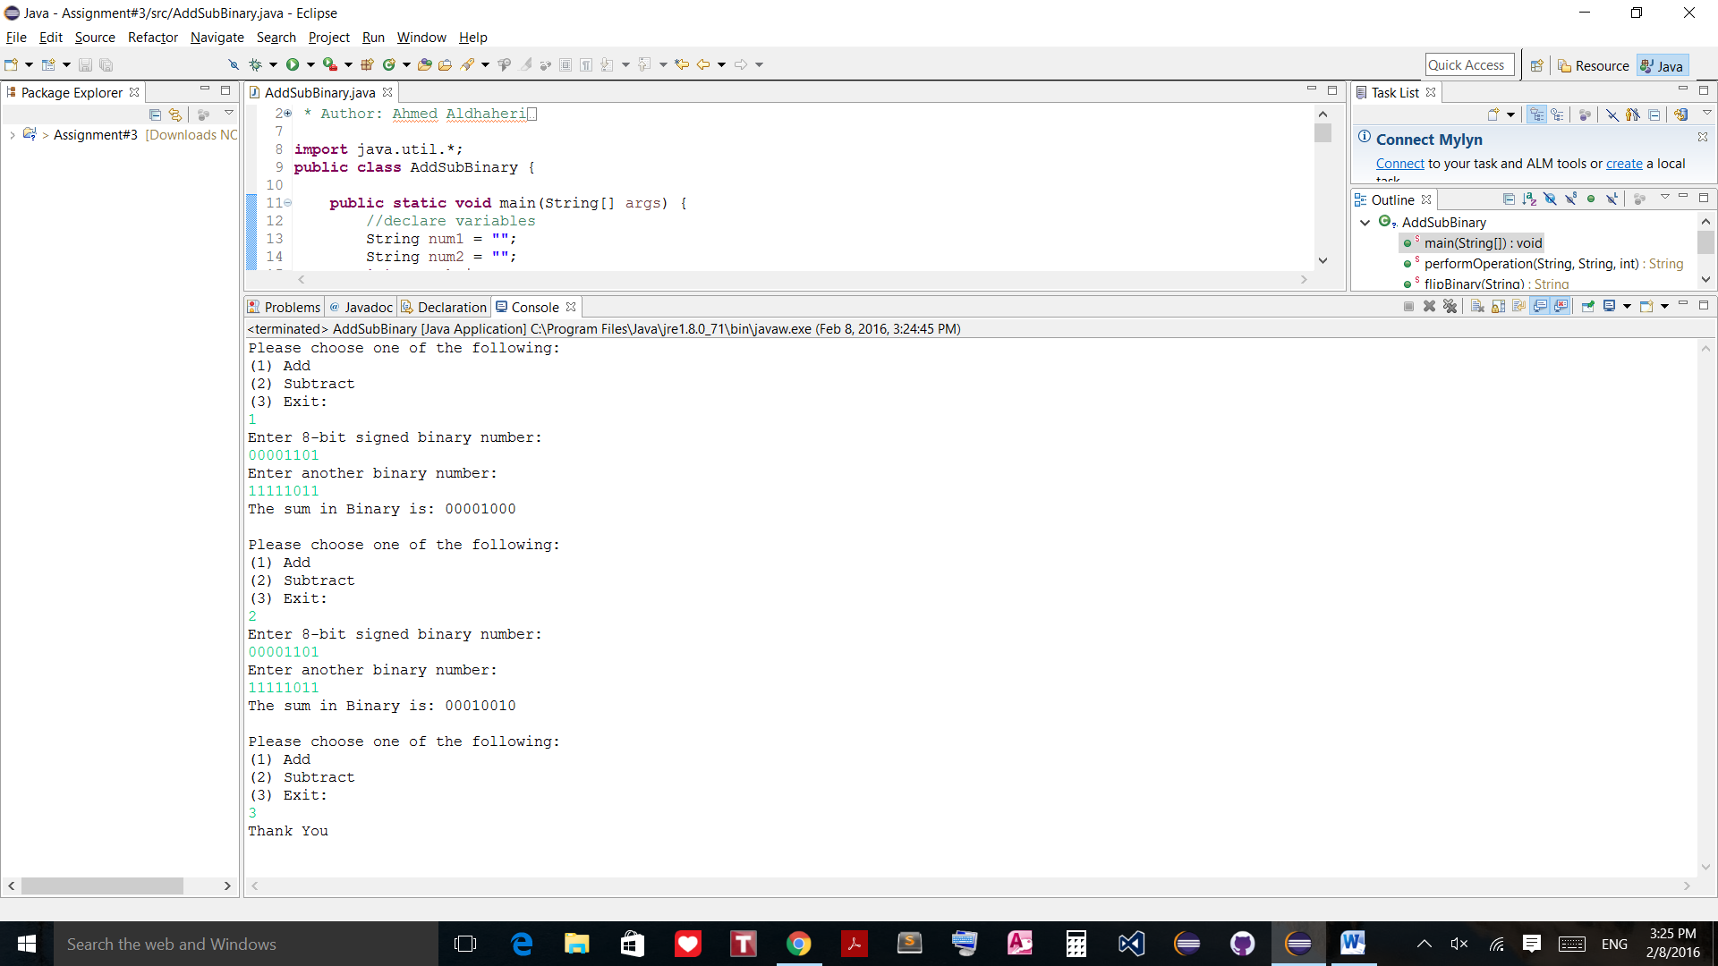

/*

* Author: Ahmed Aldhaheri

* Course#: COSC 221 MW 10am - 11:50

* Semester: Winter 2016

* Description: purpose of the program is to add and subtract two 8-bit binary numbers

*/

**import** java.util.*;

**public** **class** AddSubBinary {

**public** **static** **void** main(String[] args) {

//declare variables

String num1 = "";

String num2 = "";

**int** userChoice;

String result = "";

**boolean** isNeg1, isNeg2;

Scanner input = **new** Scanner(System.***in***);

//Ask user for operation choice

System.***out***.println("Please choose one of the following:\n(1) Add\n(2) Subtract\n(3) Exit: ");

userChoice = input.nextInt();

input.nextLine();

//start do while

**while**(userChoice != 3){

//Ask user for two 8-bit binary numbers

System.***out***.println("Enter 8-bit signed binary number: ");

num1 = input.nextLine();

System.***out***.println("Enter another binary number: ");

num2 = input.nextLine();

//check if numbers are 8-bit binary

**if**(num1.length() != 8 || num2.length() != 8){

System.***out***.println("Please enter 8-bit binary number!\n");

**continue**;

}

//check if addition or subtraction

**if**(userChoice == 1){

//pass to operation method to return result

result = *performOperation*(num1, num2, userChoice);

}//end if statement

//check if subtraction

**else**{

//check if one of the numbers or both are negative

isNeg1 = *isNegative*(num1);

isNeg2 = *isNegative*(num2);

**if**(isNeg1 && isNeg2)

num2 = *flipBinary*(num2); //if both negative flip second one

**else** **if**(isNeg2)

num2 = *flipBinary*(num2); //if second number is negative flip it

**else** **if**(isNeg1){

num2 = *flipBinary*(num2); //if first number is negative flip second number

}

**else**

num2 = *flipBinary*(num2); //if both positive flip second number to subtract them

//pass to operation method to return result

result = *performOperation*(num1, num2, userChoice);

}//end else

System.***out***.println("The sum in Binary is: " + result);

System.***out***.println("\nPlease choose one of the following:\n(1) Add\n(2) Subtract\n(3) Exit: ");

userChoice = input.nextInt();

input.nextLine();

}//end while

input.close();

System.***out***.println("Thank You");

}//end main

**public** **static** String performOperation(String num1, String num2, **int** userChoice){

//takes two 8-bit bianry numbers and adds them

String result = "";

**int** temp1 = 0, temp2 = 0, carry = 0, sum = 0;

//loop through two numbers to add them

**for**(**int** i = num1.length() - 1; i >= 0; --i){

//assign numbers to temp variables to perform addition

**if**(num1.charAt(i) == '0')

temp1 = 0;

**else**

temp1 = 1;

**if**(num2.charAt(i) == '0')

temp2 = 0;

**else**

temp2 = 1;

//add the two temp variables

sum = temp1 + temp2 + carry;

**if**(sum == 3){

result += '1';

carry = 1;

}

**else** **if**(sum == 2){

result += '0';

carry = 1;

}

**else** **if**(sum == 1){

result += '1';

carry = 0;

}

**else**{

result += '0';

carry = 0;

}

}//end for loop

//create a buffer object to reverse numbers

StringBuffer buffer = **new** StringBuffer(result);

result = buffer.reverse().toString();

**return** result;

}//end method

**public** **static** String flipBinary(String num){

//Negation of binary number

String temp = ""; //temp variable to store result

**int** index = 0;

//look for first one in the binary number and save it

**for**(**int** i = num.length() - 1; i >= 0; --i){

**if**((num.charAt(i)) == '1'){

index = i;

**break**;

}

}//end for loop

//add sub of Array to index place to the temp variable

**for**(**int** i = num.length() - 1; i >= index; --i){

temp += num.charAt(i);

}

//flip the rest of the numbers

**for**(**int** i = index - 1; i >= 0; --i){

**if**(num.charAt(i) == '1')

temp += "0";

**else**

temp += "1";

}

//since started from end of string we need to reverse temp to have correct result

StringBuffer buffer = **new** StringBuffer(temp); //reverse temp

temp = buffer.reverse().toString();

**return** temp;

}//end method

**public** **static** **boolean** isNegative(String num){

//checks if any of the numbers is negative to perform subtraction

**if**(num.charAt(0) == '1')

**return** **true**;

**else**

**return** **false**;

}//end method

}//end class