;Assignment #7

;Ahmed Aldhaheri

;Kaden Highgate

;COSC221

;Description: Multiply two arrays and add them to each other.

;Due Date: 3/21/2016

.ORIG x3000

LEA R0, arr1 ;R0 = first array

LEA R1, arr2 ;R1 = second array

LD R6, negasc ;negasc

AND R5, R5, #0

AND R4, R4, #0

start LDR R2, R0, #0 ;R2 load first array address

LDR R3, R1, #0 ;R3 load second array address

BRz result

JSR multTwo

ADD R1, R1, #1 ;point to the next element in array2

ADD R0, R0, #1 ;point to the next element in array1

BRp start

result

HALT

multTwo AND R5, R5, #0

ADD R2, R2, R6 ;add -48

ADD R3, R3, R6 ;add -48

ADD R5, R5, R2 ;R5 = R2

ADD R3, R3, #-1 ;decrement R3

BRn return ;if negative go to return

BRz assign ;if zero dont loop just add number to R4

loop ADD R2, R2, R5 ;multiplication

ADD R3, R3, #-1 ;decrement counter

BRp loop

assign ADD R4, R4, R2 ;store product

return RET

msg .STRINGz "the sum of multiplication of '"

msg2 .STRINGz "' and '"

msg3 .STRINGz " is: "

arr1 .STRINGz "0123456789" ;array 2

arr2 .STRINGz "9876543210" ;array2

posasc .FILL #48

negasc .FILL #-48

.END

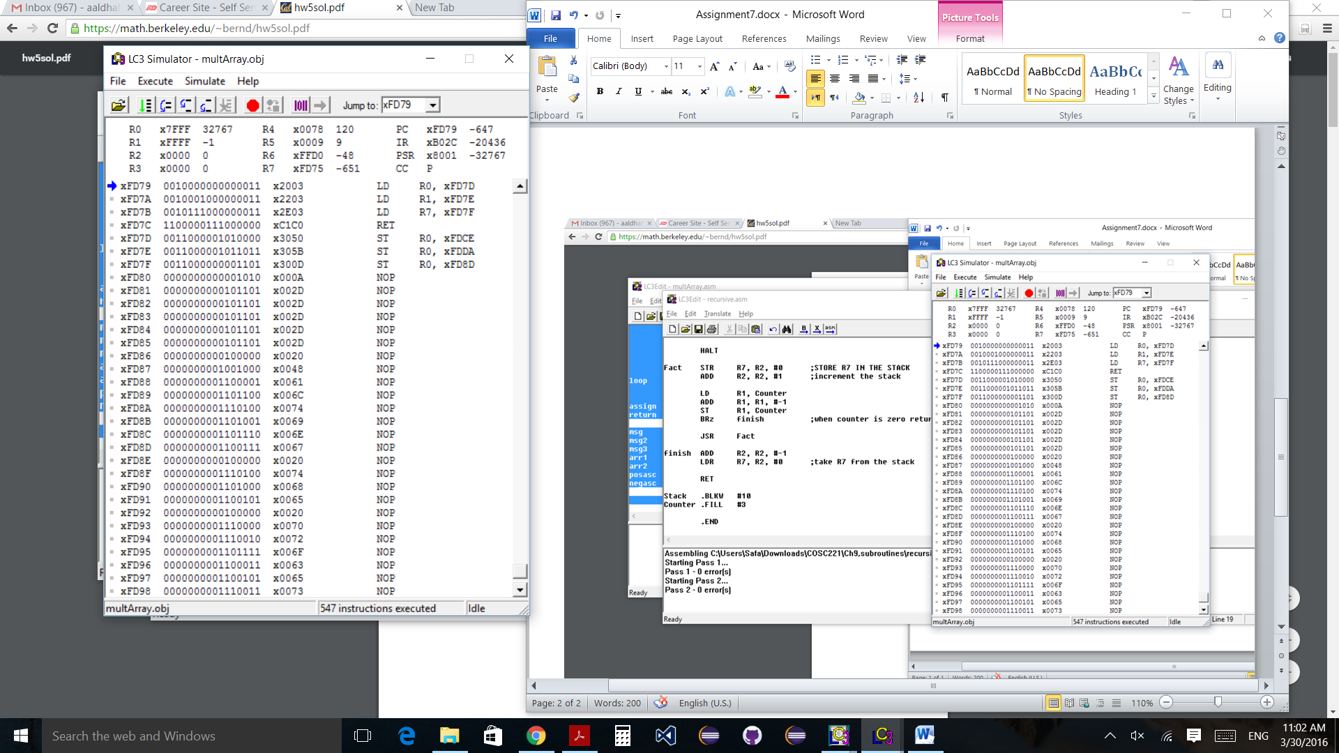R4 has the result which is 120.