# 

Intel® System Health Inspector  
Version 2.2

User Guide

*February 2023*

Contents

Quick Start 3

User Guide 4

Overview 4

Running the Intel® System Health Inspector 5

Global Arguments 6

Report Arguments 7

Benchmarking Arguments 8

Additional Data Collection Arguments: -profile 9

Additional Data Collection Arguments: -analyze 10

Additional Data Collection Arguments: -megadata 10

Remote Target Arguments 11

Collecting data from one remote server 12

Collecting data from multiple remote servers 13

Micro-benchmarks 15

Report Formats 17

HTML 17

Configuration tab 18

Benchmark tab 18

Profile tab 18

Analyze tab 18

Insights tab 18

Microsoft Excel* (xlsx) 19

JSON 20

Advanced Data Collection 21

Customizing Report Templates 21

Configuration Files 22

Example: Removing sensitive data 22

Using the Reporter independently 24

Using the Collector independently 27

Advanced Topics 29

Inspecting the Public Cloud 29

Measuring Frequencies 29

Single-Core Turbo, All-Core Turbo, and Core Frequency 30

Record of Updates 31

Feedback 32

# Quick Start

Use the Intel® System Health Inspector (svr-info) to check system configuration, performance, and profile metrics for one or more Intel® Xeon® servers running Linux* operating systems.

|  |  |
| --- | --- |
| Download | Download svr-info-*<version>*.tgz from Github Releases. |
| Inspect | Follow these commands to unpack svr-info-*<version>*.tgz, go to the svr-info folder, and run your first system health inspection:  tar zxvf svr-info-2.2.0.tgz  cd svr-info  ./svr-info |
|  |  |
| Collect data | Data is limited without elevated privileges.  user-mobl ⢿ finished creating report(s)  Reports:  svr-info_2022-06-01_18-33-25/user-mobl.html  svr-info_2022-06-01_18-33-25/user-mobl.xlsx  svr-info_2022-06-01_18-33-25/user-mobl.json |

# User Guide

## Overview

The Intel® System Health Inspector helps you extract peak performance from your Intel® Xeon based server. It investigates your system profile and tests performance to catch issues and recommend improvements. Inspect one or more nodes. Choose your depth of inspection from quick to detailed. Get reports in HTML, json, or Excel formats. All software dependencies are built-in for a “batteries included” installation.

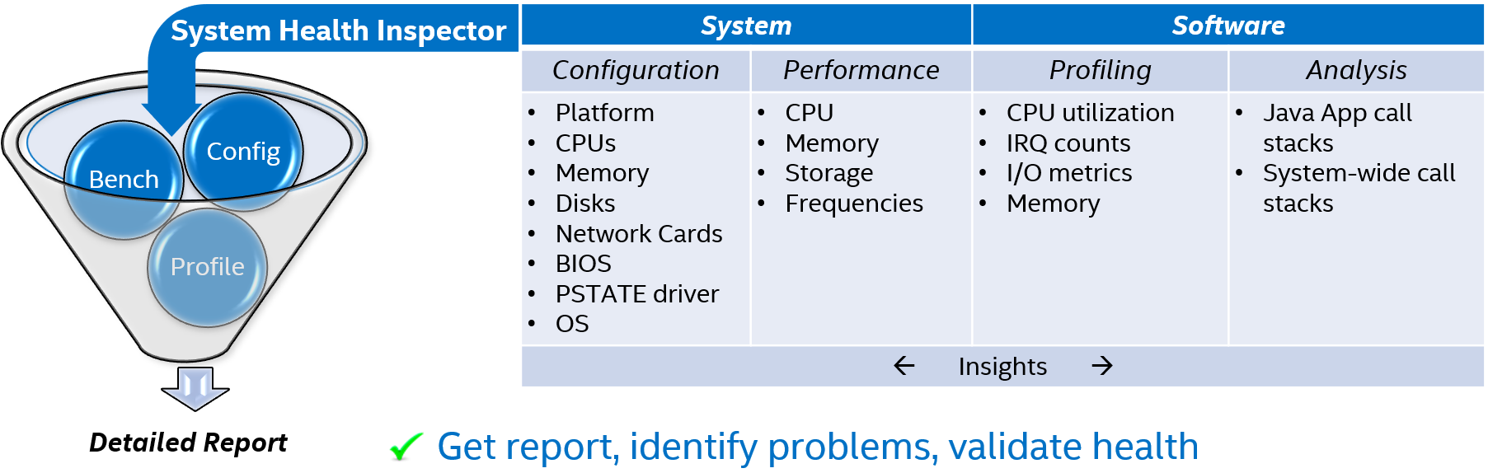

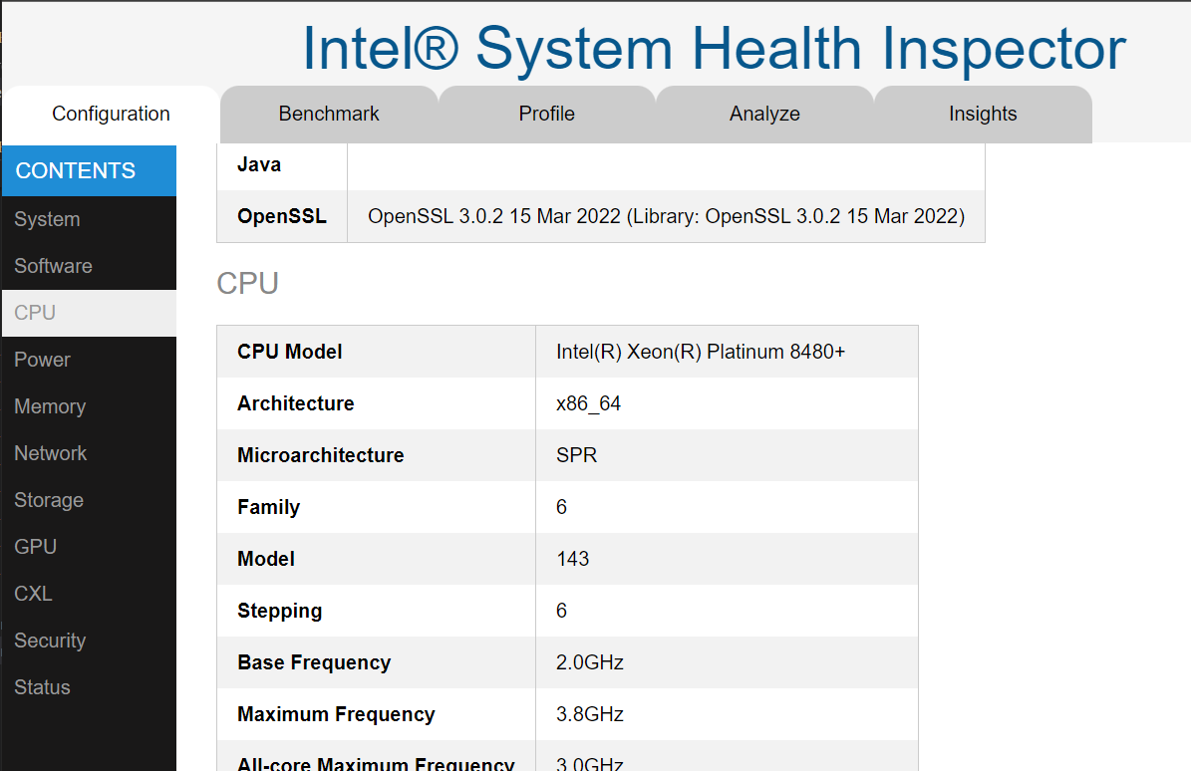

## Running the Intel® System Health Inspector

Intel® System Health Inspector has been tested with the CPU architectures shown in the table below. It may run with limited functionality on other architectures. The tar utility must be installed in order to unpack svr-info-<version>.tgz. All dependencies are included.

|  |  |
| --- | --- |
| Architecture | Operating System |
| **Supported Servers** | |
| SPR, SNR, CPX, ICX, CLX, SKX, BDX, HSX | Ubuntu16.04 or newer, Centos7 or newer |
| **Supported Clients** | |
| TGL, RKL, CFL, KBL, SKL, BDW, HSW | Ubuntu16.04 or newer, Centos7 or newer |

*Note: svr-info may work on other architectures or other Linux distributions, but has not been thoroughly tested.*

Follow these commands to unpack svr-info-<version>.tgz. Navigate to the svr-info folder and run your first system health inspection:

$ tar zxvf svr-info-2.1.0.tgz

$ cd svr-info

$ ./svr-info

The Intel® System Health Inspector supports arguments for gathering data and evaluating your system. Create the types of reports you need, from human-readable management reports to machine-readable data for automated analysis. Add the arguments explained below to the basic svr-info command:

svr-info [-h] [-v]

[-format SELECT]

[-benchmark SELECT] [-storage_dir DIR]

[-profile SELECT] [-profile_duration SECONDS] [-profile_interval N]

[-analyze SELECT] [-analyze_duration SECONDS] [-analyze_frequency N]

[-megadata]

[-ip IP] [-port PORT] [-user USER] [-key KEY] [-targets TARGETS]

[-output OUTPUT] [-temp TEMP] [-dumpconfig] [-cmd_timeout] [-debug]

The following sections explain each parameter and offer usage examples.

### Global Arguments

| Argument | Description |
| --- | --- |
| -h | Intel® System Health Inspector comes with a built in help file that you can access at any time from the command line:  $ ./svr-info -h |
| -v | Show the version number of svr-info  $ ./svr-info -v  2.2.0 |
| -output OUTPUT | By default, reports are output to the current folder. To change the output folder, make a new folder or use an existing folder, then specify the path:  $ ./svr-info -output /mnt/c/experiments  stacyn1x-mobl ⢿ finished creating report(s)  Reports:  experiments/stacyn1x-mobl.html  experiments/stacyn1x-mobl.xlsx  experiments/stacyn1x-mobl.json |
| -temp TEMP | When svr-info runs, dependencies are extracted into a temporary folder. When the run is complete, this temporary folder is deleted. By default, the temporary folder is the folder assigned to the $TMPDIR environment variable. If $TMPDIR is empty, then /tmp is used. To change the temporary folder, make a new folder or use an existing folder, then specify the path:  $ ./svr-info -temp /mnt/c/experiments  stacyn1x-mobl ⢿ finished creating report(s)  Reports:  svr-info_2022-06-09_13-04-25/stacyn1x-mobl.html  svr-info_2022-06-09_13-04-25/stacyn1x-mobl.xlsx  svr-info_2022-06-09_13-04-25/stacyn1x-mobl.json |

### Report Arguments

|  |  |
| --- | --- |
| Argument | Description |
| -format FORMAT | By default, html, xlsx, and json report formats are generated, txt is not. The "-format all" option will produce all four formats. To select one or more, add each format in a comma separated list. Report formats include:  html, xlsx, json, txt, all  Suppose you want to receive only html and json formats, use this command:  $ ./svr-info -format html,json    stacyn1x-mobl ⣽ finished creating report(s)    Reports:  svr-info_2022-06-09_12-30-32/stacyn1x-mobl.html  svr-info_2022-06-09_12-30-32/stacyn1x-mobl.json  *Note: xlsx denotes the Microsoft Excel* format* |

### Benchmarking Arguments

Choose the depth of inspection by selecting one or more of these performance benchmarking arguments. Micro-benchmarks will run when these arguments are selected. These should only be run when your system is idle.

| Argument | Description |
| --- | --- |
| -benchmark all | Use the ‘all’ argument to conduct a complete health and performance assessment. Selecting ‘all’ is equivalent to selecting all of these:  cpu,frequency,memory,storage,turbo  $ ./svr-info -benchmark all  stacyn1x-mobl ⣽ finished creating report(s)  Reports:  svr-info_2022-06-09_12-47-18/stacyn1x-mobl.html  svr-info_2022-06-09_12-47-18/stacyn1x-mobl.xlsx  svr-info_2022-06-09_12-47-18/stacyn1x-mobl.json |
| -benchmark cpu | Measure CPU performance |
| -benchmark frequency | Measure turbo frequencies |
| -benchmark memory | Measure memory performance |
| -benchmark storage | Measure storage device performance |
| -storage_dir STORAGE_DIR | (Optional) The micro-benchmark that measures storage creates a file on the target machine. By default it will be stored in the /tmp folder. Use this argument to specify another folder, possibly on another disk |
| -benchmark turbo | Measure TDP and turbo frequencies |

### Additional Data Collection Arguments: -profile

Chart system profile data by inspecting the behavior of the system while it is running a workload. Select the number of samples to be collected along with the time interval in seconds.

|  |  |
| --- | --- |
| Argument | Description |
| -profile <options> | Options are cpu,network,storage,memory,all. |
| -profile_interval | Set the number of seconds between each data sample. Default 2. |
| -profile_duration | Set the number of seconds to collect profiling data. Default 60. |
| In this example, the IRQ Rate chart shows samples collected at a frequency of 3 seconds.  $ ./svr-info -profile all -profile_interval 3 -profile_duration 40  IRQ Rate | |

### Additional Data Collection Arguments: -analyze

Collect software call stacks to be displayed as Flamegraphs in the HTML report.

|  |  |
| --- | --- |
| Argument | Description |
| -analyze <options> | Options are system,java,all. |
| -analyze_frequency | The frequency at which to collect samples. Default 11 ms. |
| -analyze_duration | Set the number of seconds to collect data. Default 60. |

### Additional Data Collection Arguments: -megadata

Megadata is an alternative way to collect and present data. You can use the default megadata collection script in the config folder or customize it as needed

|  |  |
| --- | --- |
| Argument | Description |
| -megadata | Collect the additional data specified in the megadata template file. Ouput individual text files in a folder named <*IP Address>*_megadata. |

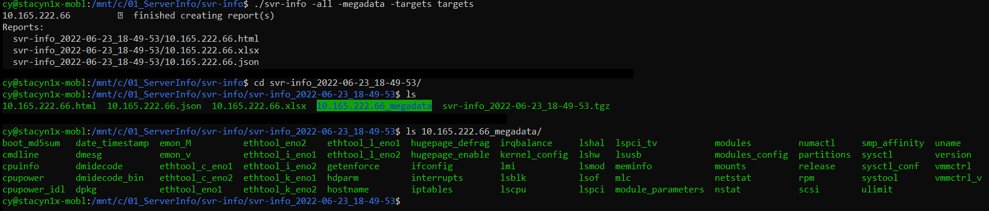

Each megadata file contains raw output in text format, for example, **meminfo** contains memory statistics:

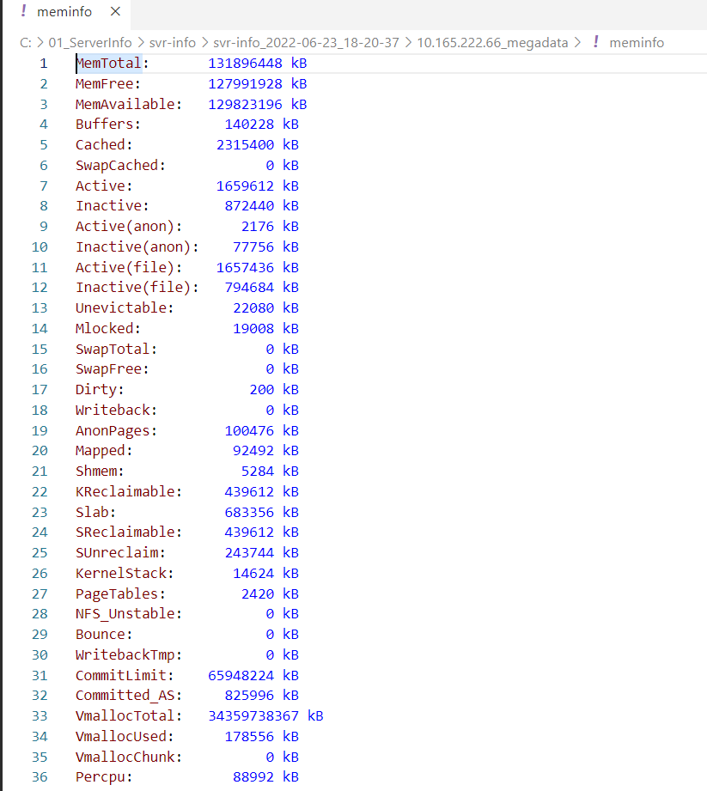

### Remote Target Arguments

Intel® System Health Inspector can connect and collect data from one or more remote servers through SSH. To collect data from one server, setup and share your SSH keys then run svr-info from the command line. To collect data from one or more servers, store the connection parameters for each server in the targets file. The targets file may contain either the SSH password or the SSH key.

|  |  |
| --- | --- |
| Argument | Description |
| -ip IP | Default: localhost. Enter the IP address or hostname for the target server |
| -port PORT | Default: 22. Enter the SSH port number for the target server |
| -user USER | Default: Nil. Enter the username used to access the remote target |
| -key KEY | Default: Nil. Enter the local path to SSH private key file |
| -targets TARGETS | Default: Nil. Enter the remote connection data necessary to connect to one or more remote servers. |

#### Collecting data from one remote server

Add the IP address, port, username and the local path to the private SSH key. Depending on how you setup your SSH keys, you may be prompted to enter your passphrase.

$ ./svr-info -all -ip 10.165.222.169 -port 22 -user sdp -key /home/username/.ssh/id_rsa

10.165.222.169 ⡿ finished creating report(s)

Reports:

svr-info_2022-06-07_13-51-18/10.165.222.169.html

svr-info_2022-06-07_13-51-18/10.165.222.169.xlsx

svr-info_2022-06-07_13-51-18/10.165.222.169.json

#### Collecting data from multiple remote servers

Collect data from multiple servers simultaneously by creating a targets file with connection parameters for each remote server. Use one line for each server. Use a colon ( : ) to separate each argument. List either the private_key_path or the ssh_password. Sudo_password is optional. If not provided, all data will be collected if remote user is configured for password-less sudo. Otherwise, data collected will be limited.

'ip_address:ssh_port:user_name:private_key_path:ssh_password:sudo_password'

In the following example, the first line in the targets file contains this data:

IP address: 10.165.222.169

Port: ::  
*(two colons appear because the port is not specified. The default port 22 will be used)*

Username: username

Private key path: ::  
*(no private key path is specified)*

SSH Password: Passw0rd

Sudo password: Passw0rd

Optional:

Label The connection parameters may be proceeded by a label.

Comment The connections parameters may be followed by a comment.

$ cat targets

#ip:port:user:key:pwd:sudo

10.165.222.169::username::Passw0rd:Passw0rd # an optional comment

MY_SERVER:10.165.222.66::username::Passw0rd:Passw0rd # has an optional label

$ ./svr-info -all -targets ./targets

MY_SERVER ⣟ finished creating report(s)

10.165.222.66 ⣟ finished creating report(s)

Reports:

svr-info_2022-06-07_12-24-59/MY_SERVER.html

svr-info_2022-06-07_12-24-59/10.165.222.169.html

svr-info_2022-06-07_12-24-59/all_hosts.html

svr-info_2022-06-07_12-24-59/MY_SERVER.xlsx

svr-info_2022-06-07_12-24-59/10.165.222.169.xlsx

svr-info_2022-06-07_12-24-59/all_hosts.xlsx

svr-info_2022-06-07_12-24-59/MY_SERVER.json

svr-info_2022-06-07_12-24-59/10.165.222.169.json

svr-info_2022-06-07_12-24-59/all_hosts.json

**Output for Multiple Nodes**

A health assessment report is created for each remote server along with a full report containing data from all the servers. These are stored in files named “all_hosts” plus the report suffix.

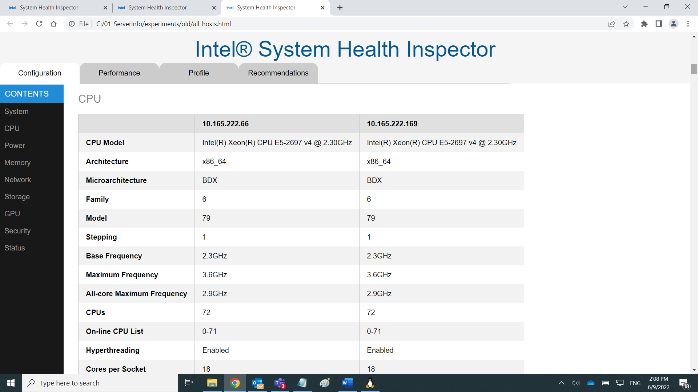

### Micro-benchmarks

Micro-benchmarks are used to assess the health of a system. They should be run when the system is idle. Running a micro-benchmark on a production system can cause applications to perform badly because resources are being taken to run the benchmark.

Micro-benchmarks measure memory bandwidth and latency, CPU frequency, turbo frequencies, and disk bandwith. To run all the micro-benchmarks, use the -benchmark all command line argument:

$ ./svr-info -benchmark all

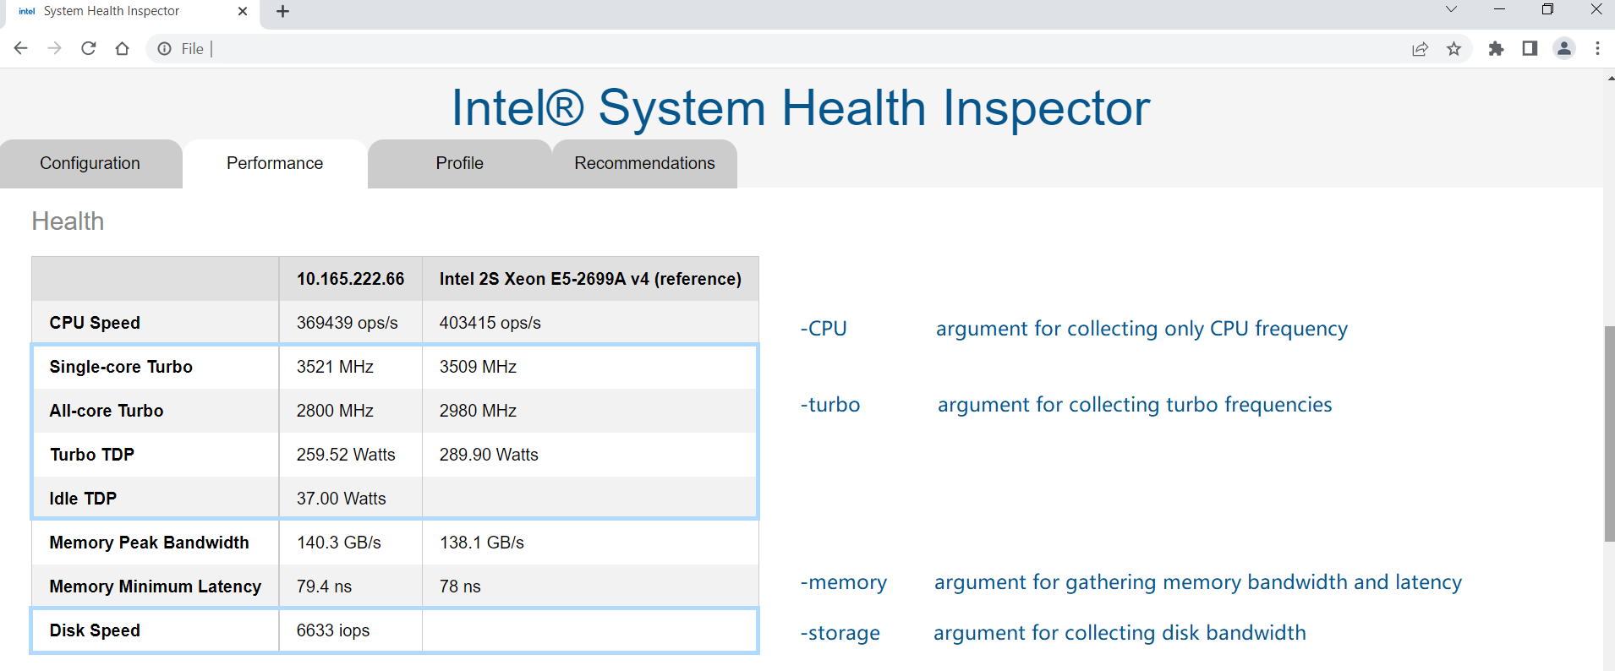

Use the -CPU option to run a micro-benchmark that assesses the processing speed of the CPU.

Use the -turbo option to run micro-benchmarks that measure turbo frequencies and TDP.

Use the -memory option to view the peak memory bandwidth and the optimum latency.

Use the -storage to show disk bandwidth

##### Micro-benchmark: Memory Bandwidth and Latency

Memory latency and bandwidth are measured when the -memory argument is present. The red line shows the mapping from your node. The green line shows the Intel® Xeon® reference mapping.

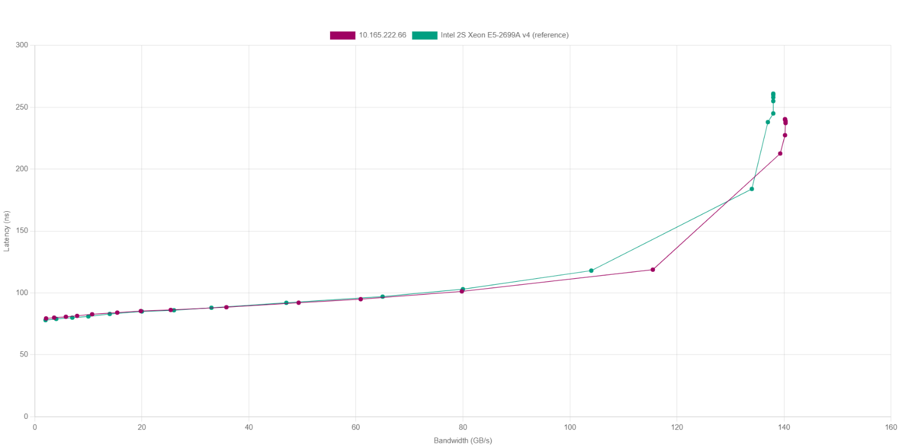

##### Micro-benchmark: Core Frequency

Maximum frequency for increasing core counts is measured when the -frequency argument is present. The red line shows the CPU’s frequency specification, and the green line shows the measured frequencies.

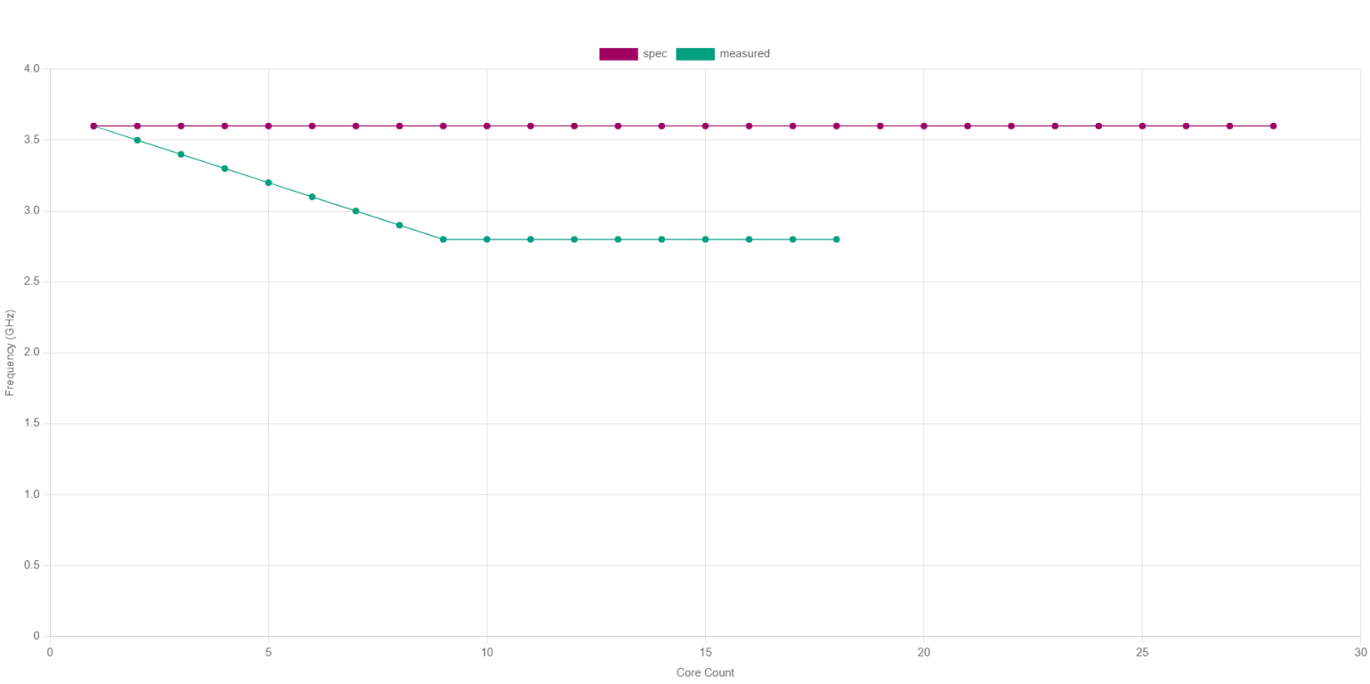

## Report Formats

The Intel® System Health Inspector outputs a health status report in three formats: html, xlsx, and json. You can also output a text only version. Report files are named with either the local machine name or the IP address. By default, each set of reports is saved in a folder with a unique name. When you use the -output argument, take care to change the output folder name every time so you do not inadvertently overwrite your reports.

$ ./svr-info

stacyn1x-mobl ⣯ finished creating report(s)

Reports:

svr-info_2022-06-06_16-58-54/stacyn1x-mobl.html

svr-info_2022-06-06_16-58-54/stacyn1x-mobl.xlsx

svr-info_2022-06-06_16-58-54/stacyn1x-mobl.json

### HTML

HTML reports contain categories of data that are shown in HTML as tabs: Configuration, Performance, Profile, and Recommendations.

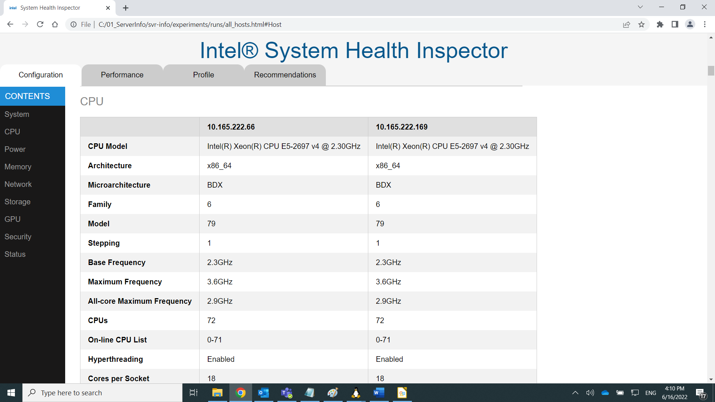

Figure 1: Intel® System Health Inspector Report in HTML format

#### Configuration tab

The configuration tab includes information about the platform, CPU, software installed, etc.

#### Benchmark tab

The benchmark tab shows micro-benchmark results, if collected.

#### Profile tab

The profile tab shows system profiling telemetry, if collected.

#### Analyze tab

The analyze tab shows software call stacks, if collected.

#### Insights tab

The insights tab shows recommendations based on data collected and the rules defined in svr-info/config/insights.grl.

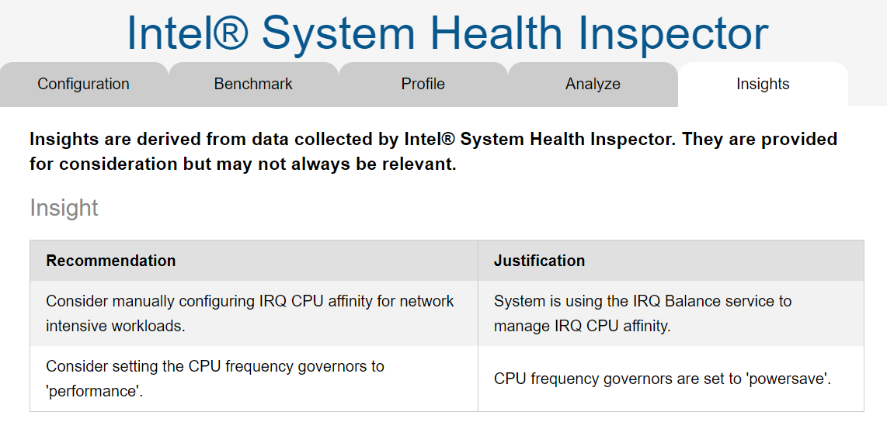

### Microsoft Excel* (xlsx)

Excel* shows system health data in six worksheets: Configuration, Brief, Benchmark, Profile, Analyze, and Insights.

The Configuration worksheet contains one column for each system.

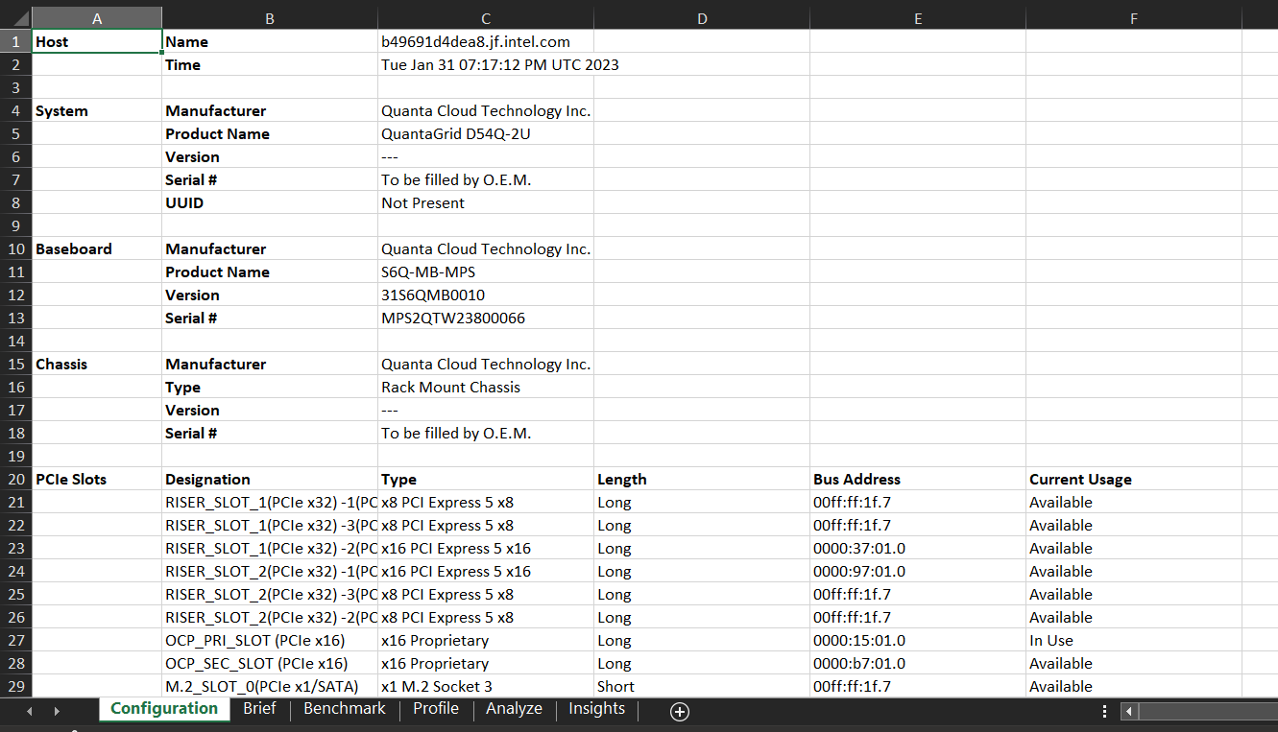

The Brief worksheet provides a summary view useful for copy/paste into presentations and reports.

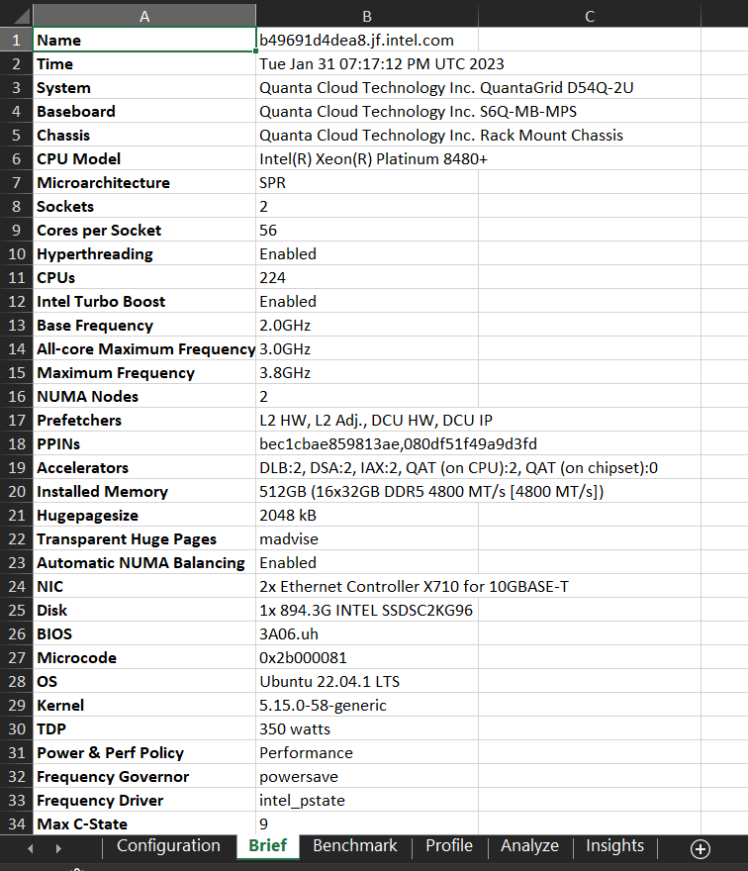

### JSON

The json schema contains the hostname and the data collected for each host. Each command that was run to gather data has a name and category along with the type of data gathered and the actual data. In this example, BIOS data is collected including the release date, vendor, and version. Baseboard data includes Manufacturer, Product Name, Serial #, and Version. The final example shows the recommendations.

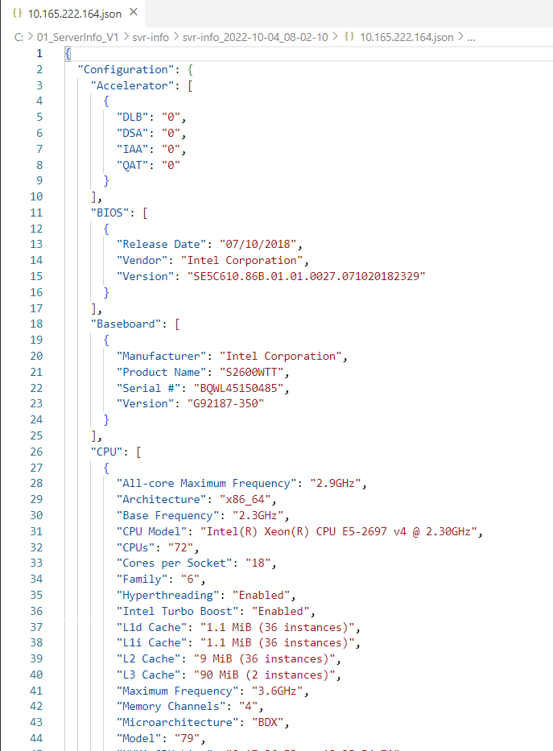

View the entire json file for each run in the folder named svr-info_*timestamp*.

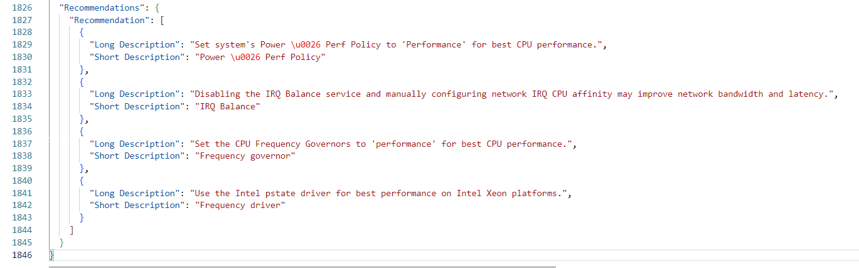

## Advanced Data Collection

Customize the Intel® System Health Inspector to perform the health checkup reports containing only the data you need. If privacy is a concern, do not collect sensitive data.

Note: Proceed with caution because some changes can result in svr-info failing to run properly. It is a good idea to keep a copy of the original configuration files so you can revert back to them if necessary.

### Customizing Report Templates

The following tables describes three templates used for health inspection reports.

|  |  |
| --- | --- |
| File | Description |
| collector_reports.yaml.tmpl | For various reasons, such as privacy concerns, you may not want to collect or share specific elements of system configuration data. Modify this template to prevent commands from running.  Commands are used to collect data. Here is one example:  $ uname -a  This bash command gathers kernel information, machine name, hardware platform and operating system. The template allows you to select optional parameters indicating whether to run with privileges or to run in parallel with other commands. You can add a comma separated list of kernel modules required to run the command. You can even decide whether to execute the command or not.  Network data collection uses a variable $NIC that has a handler implemented. Network data will be collected for all physical network interfaces.  Micro-benchmark commands can contain shell scripts to record data samples at prescribed time intervals. You can indicate if the system CPU idle percentage should be collected before running. |
| collector_megadata.yaml.tmpl | This template describes the commands executed when the -megadata argument is present. Add or remove commands as desired. Use existing commands as examples. |
| report.html.tmpl | This template contains the HTML headers, styles, and scripts used to produce the HTML report. |

#### Configuration Files

These configuration files contain information about Intel CPUs along with performance data from reference servers.

|  |  |
| --- | --- |
| File | Description |
| cpus.yaml | Known versions of Intel Client CPUs and Intel Xeon Server CPUs are listed in this file along with their architecture name, family number, model number, minstepping and maxstepping values, and number of channels. Additional Intel CPUs can be added here. |
| reference.yaml | Performance data from reference servers are defined in the reference.yaml file. Performance data from additional server configurations can also be defined. |

#### Example: Removing sensitive data

This example explains how to remove sensitive data from health inspection reports. By default the report shows the network node name in the Host section. Suppose you do not want to publish network node names for security or privacy reasons.

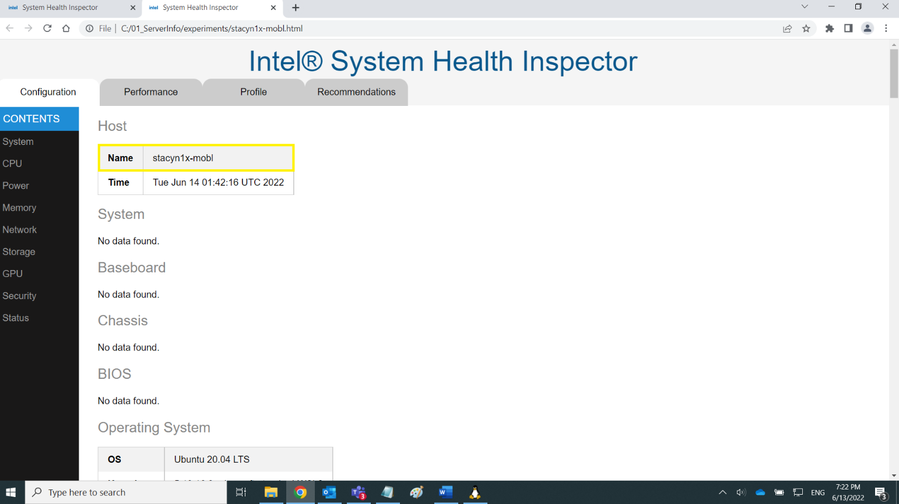

Navigate to the config folder and use your favorite text editor to open the collector_reports.yaml.tmpl. Look in the commands section near line 64 to find the uname -a command. You will see two parameters: command and parallel. The parallel parameter is set to true. This command will run in parallel with other commands.

############

# commands --

############

commands:

- uname -a:

command: uname -a

parallel: true

Add the **run: false** parameter telling svr-info not to run this command.

############

# commands --

############

commands:

- uname -a:

command: uname -a

parallel: true

run: false

Run svr-info again and the name is no longer shown.

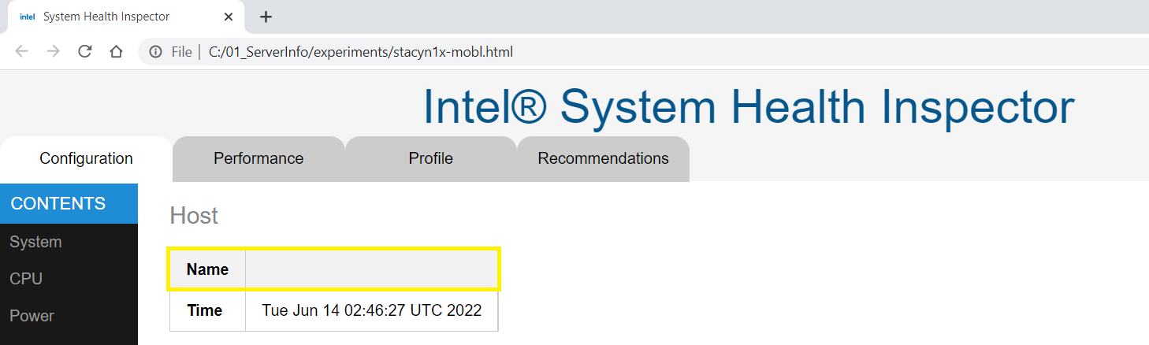

### Using the Reporter independently

Suppose you initially ran the reports in HTML format and now you need reports in json format, too. The reporter makes it easy to run reports from a prior collection in one or more report formats. Reporter is in the Tools folder. Add the global arguments to the basic reporter command to select the format, the raw input file(s) and your output folder.

reporter [-format FORMAT] [-input *.raw.json] [-output OUTPUT ]

**Reporter Global Arguments**

| Argument | Description |
| --- | --- |
| -h | The reporter comes with a built in help file that you can access at any time from the command line. Navigate to the /tools folder and run:  $ ./reporter -h |
| -format | By default, all report formats will be output. To select one or more, add each format in a comma separated list. Report formats include these: html, xlsx, json, all |
| -input INPUT | Add a comma separated list of input files or a folder containing the input files. Input files follow this naming convention: *.raw.json |
| -output OUTPUT | By default, reports are output to the current folder. To change the output folder, make a new folder or use an existing folder, then specify the path |

**Finding raw health inspection data**

The Intel® System Health Inspector stores raw data from each inspection in a .tgz file with the same date and time stamp as the report folder, for example: svr-info_2022-06-16_17-40-12.tgz. Navigate to the report folder and unzip the tgz file to find the *.raw.json file(s).

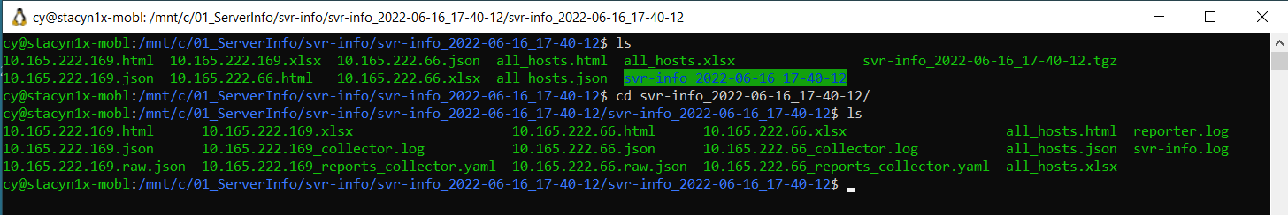

Contents of Intel® System Health Inspector raw data tgz file:

10.165.222.169.html

10.165.222.169.json

**10.165.222.169.raw.json**

10.165.222.169.xlsx

10.165.222.169_collector.log

10.165.222.169_reports_collector.yaml

10.165.222.66.html

10.165.222.66.json

**10.165.222.66.raw.json**

10.165.222.66.xlsx

10.165.222.66_collector.log

10.165.222.66_reports_collector.yaml

all_hosts.html

all_hosts.json

all_hosts.xlsx

reporter.log

svr-info.log

**Running a new report in JSON format**

1. Navigate to the svr-info/tools directory and create a new folder called /reports.

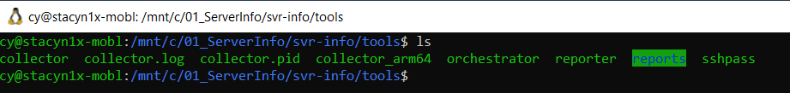

2. Enter the ./reporter command and select the json format. Add the path to the input. Set the output folder to reports. Run the reporter.

$ ./reporter -format json -input /mnt/c/01_ServerInfo/svr-info/svr-info_2022-

06-16_17-40-12/svr-info_2022-06-16_17-40-12/10.165.222.66.raw.json -output

reports

reports/10.165.222.66.json

3. Navigate to the reports folder to find your new report in json format. The following screen capture identifies the host IP address and the name plus the time the report was run.

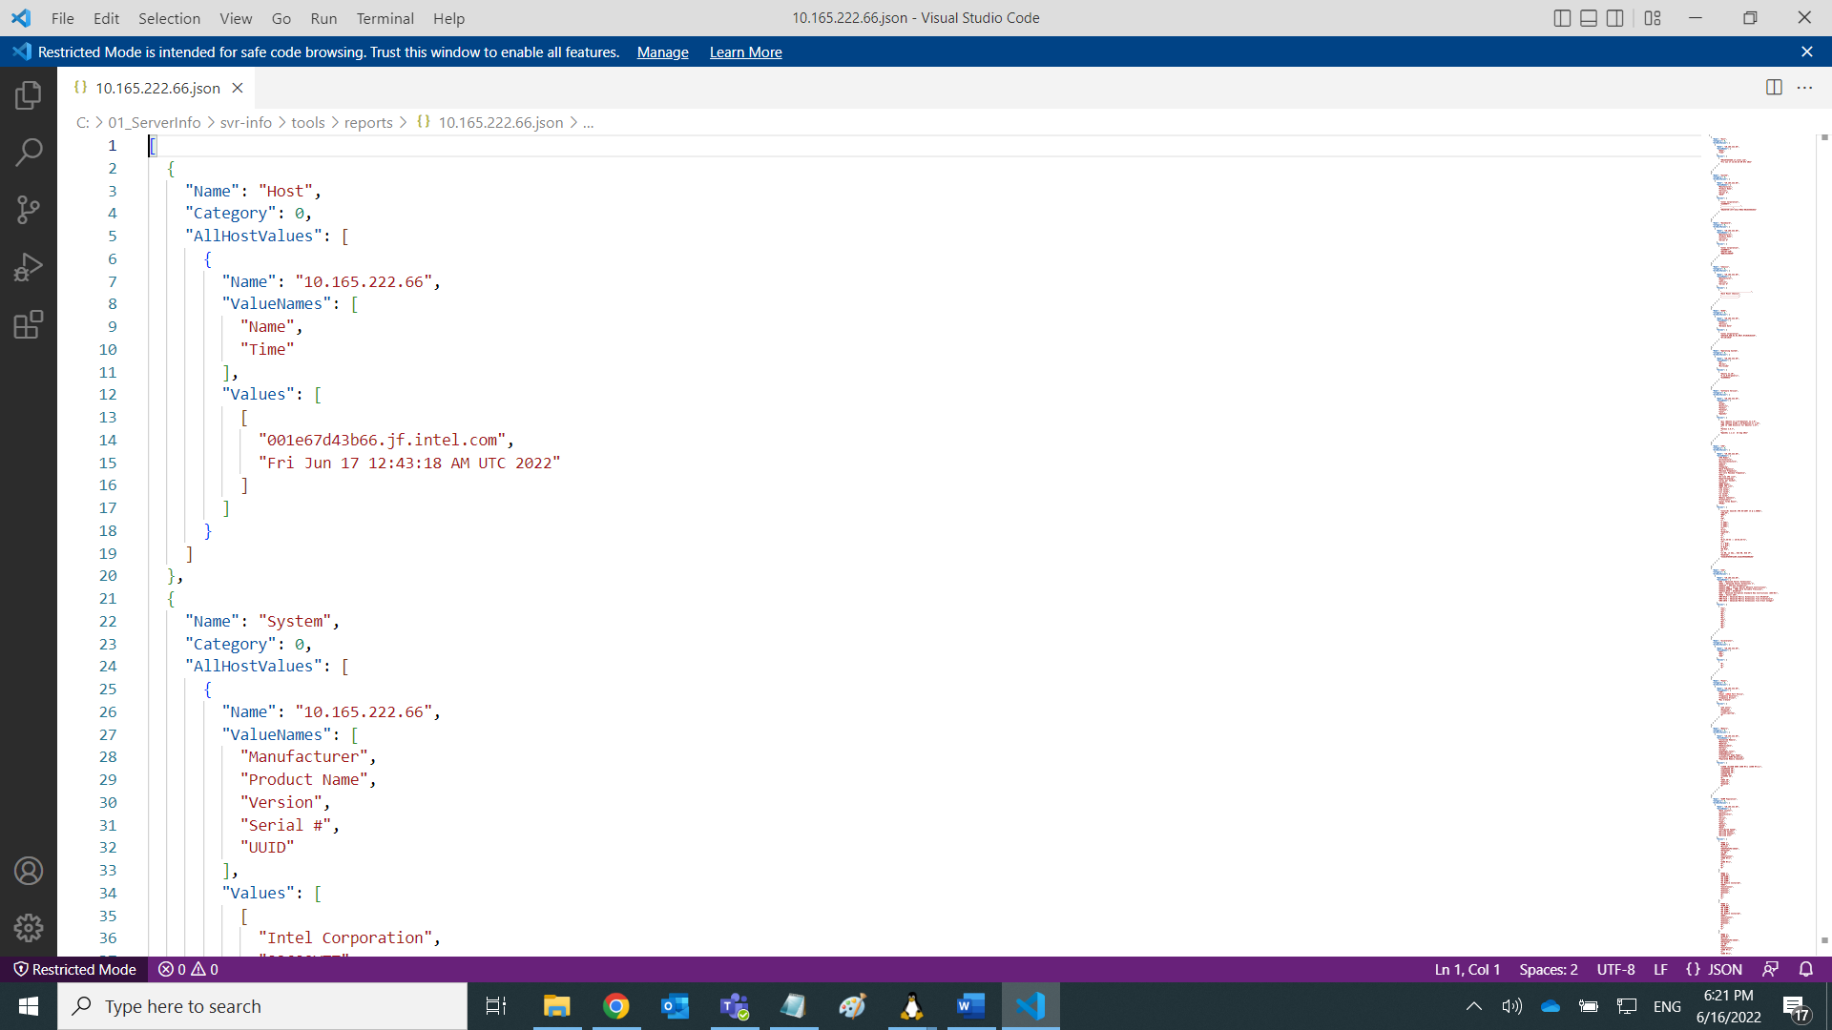

### Using the Collector independently

Suppose you are responsible for maintaining multiple servers in a datacenter. You need to collect system health data from each server as input into another system. Use the collector to gather system health data.

**Collector Global Arguments**

| Argument | Description |
| --- | --- |
| -h | The collector comes with a built in help file that you can access at any time from the command line. Navigate to the /tools folder and run:  $ ./collector -h |
| -v | Show the version number of the collector  $ ./collector -v  2.0.1_2022-05-06_053c29ea |

**YAML File Format**

The YAML format contains both the commands and arguments for the root level keys. Commands used to gather data will be executed by bash. Each command must have a name that is used to label its output. Commands may have required and/or optional arguments . Attributes include:

* **superuser** is a boolean indicating whether to run the command with elevated privileges. The default is false. The collector will read the password from the environment variable SUDO_PASSWORD, if provided.
* **run** is a boolean indicating whether to run the command or not. Often the YAML file will include all available commands. You may set the flag to false if you do not want to collect the data.
* **modprobe** is a comma separated list of kernel modules required to run a command.
* **idle** is a boolean indicating whether the system CPU idle percentage should be collected before running the command. The default is false.
* **parallel** is a boolean indicating whether the command can be run in parallel with other commands. The default is false.

The collector and the YAML file are copied onto the target at runtime. Data collected is stored on the on target in the /tmp folder unless you specify a different folder. $NIC is the environment variable that will be called by commands gathering data from physical network interfaces.

**YAML Example**

Try out the collector by using this simple example. Under arguments, the name is the name for the root key in the json output. In this example, it is “cy_example”. The bin_path is set to “.” (stdout). Do not use tabs for formatting, YAML format requires spaces.

############

# global arguments

############

arguments:

name: cy_example

bin_path: .

############

# commands --

############

commands:

- MAC Address $NIC:

command: cat /sys/class/net/$NIC/address

parallel: true

- date -u:

command: date -u

parallel: true

- cpuid -1:

command: cpuid -1 | grep family

modprobe: cpuid

parallel: true

To run the collector, copy the YAML example into a file. Provide the path to the YAML file as an argument for the collector. Results will be printed to stdout in JSON format. When the collector runs, it also generates a collector.log file and a collector.pid file.

$ ./collector /mnt/c/01_ServerInfo/svr-info/config/example.yaml.tmpl

{

"cy_example": [

{

"command": "date -u",

"exitstatus": "0",

"label": "date -u",

"stderr": "",

"stdout": "Fri Jun 17 19:20:37 UTC 2022\n",

"superuser": "false"

}

,{

"command": "cpuid -1 | grep family",

"exitstatus": "1",

"label": "cpuid -1",

"stderr": "bash: cpuid: command not found\n",

"stdout": "",

"superuser": "false"

}

]

}

## Advanced Topics

This section contains additional information.

### Inspecting the Public Cloud

When the remote server is in the Cloud, make sure the Cloud instance has a public IP address and the inbound firewall rules allow access via port 22. Cloud instances will not report data withheld by the hypervisor and unavailable to the guest operating system.

### 

### Measuring Frequencies

The CPU table in the HTML report has two frequency-related fields: Maximum Frequency and All-Core Maximum Frequency. Maximum Frequency is determined by first looking for the cpuinfo_max_freq file:

/sys/devices/system/cpu/cpu0/cpufreq/cpuinfo_max_freq

If this file does not exist, then data is gathered from MSR 0x1ad. If that fails, the frequency is read from the “Max Speed” field in dmidecode’s output.

All-Core Maximum Frequency is read from MSR 0x1ad.

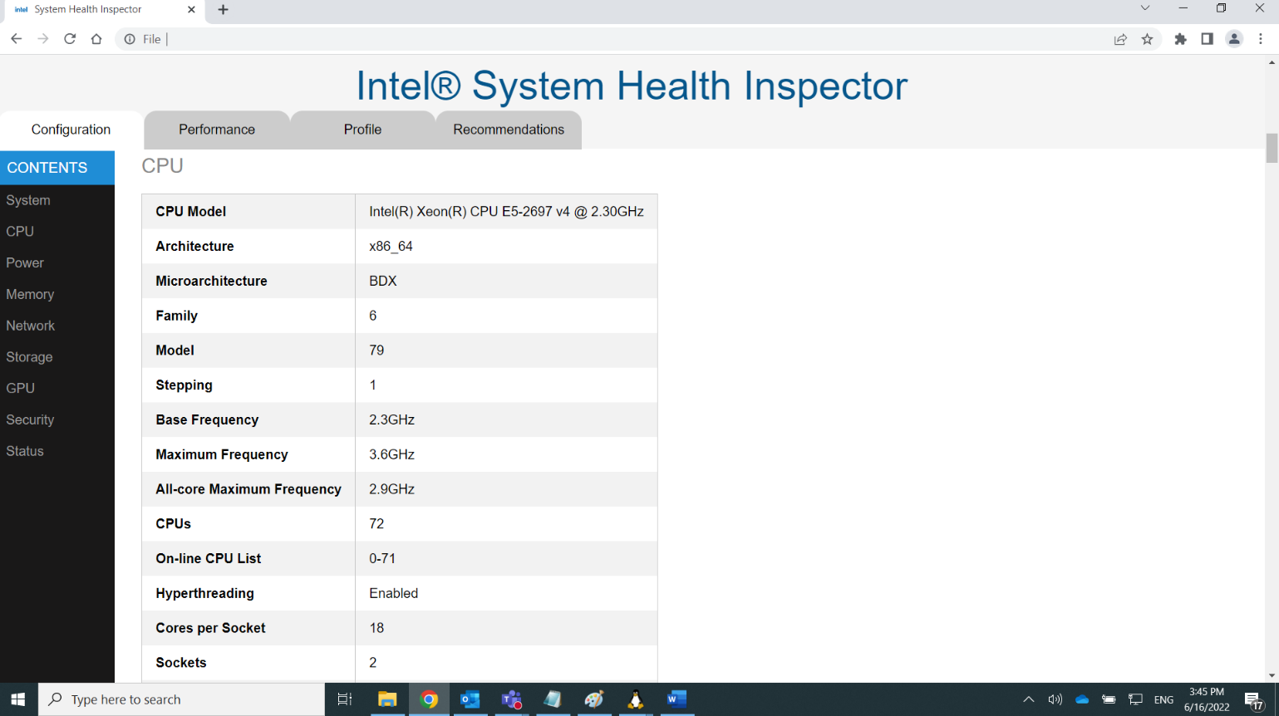

#### Single-Core Turbo, All-Core Turbo, and Core Frequency

If svr-info is run with micro-benchmarks (by using -all) then the Health table in the HTML report will contain measured values for Single-Core Turbo and All-Core Turbo. The Core Frequency data will be shown in a chart.

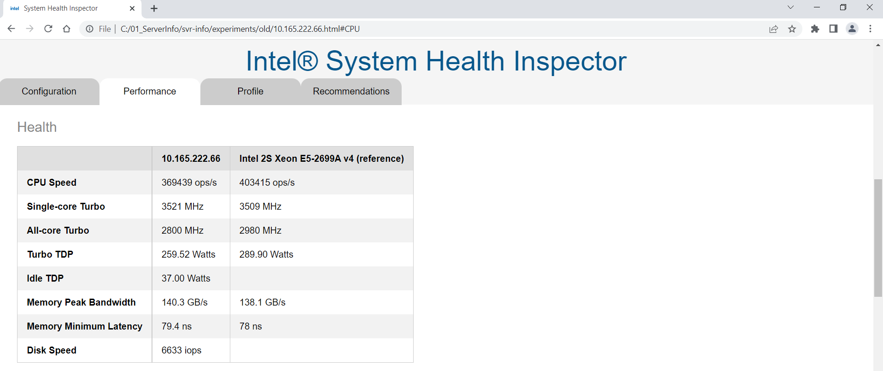

Single-Core Turbo and All-Core Turbo are collected from a standard Linux utility called “turbostat”. Turbostat is executed in the background while a CPU intensive workload is running on one core or all-cores respectively.

There are two lines on the Core Frequency chart. One is the 'spec' frequency per active core which comes from same MSR as turbo values presented in the CPU table. The second line is the measured maximum frequency per active core. An internal utility is used to measure this.

# Record of Updates

User Guide Revisions

|  |  |  |
| --- | --- | --- |
| **Date** | **Revision** | **Description** |
| 06/30/2022 | 1.0 | Initial draft |
| 10/30/2022 | 2.1 | svr-info_internal-2.0.1.tgz was changed to: svr-info-2.1.0.tgz  In order to avoid confusion, the version of this user guide was changed to 2.1 to match the version of the software.  Fully Supported Operating Systems updated on page 5: Ubuntu 16.04 and newer, CentOS 7 and newer. Note: svr-info may work on other Linux distributions, but has not been thoroughly tested  Report formats were clarified on page 7.  When Linux perf is installed on the target system, the new performance charts are available. See page 9.  The JSON format has been updated on page 21  On page 25, clarified that ./reporter is in the /tools folder  On page 28, clarified that ./collector is in the /tools folder |
| 1/31/2023 | 2.2 | Update for 2.2.0 release. |

# Feedback

We value your feedback. If you have comments (positive or negative) on this guide or are seeking something that is not part of this guide, please reach out and let us know what you think.

If you have information about a security issue or vulnerability with Intel® System Health Inspector, please send an e-mail to secure@intel.com. Encrypt sensitive information using our PGP public key.

Notices & Disclaimers

Intel technologies may require enabled hardware, software or service activation.

No product or component can be absolutely secure.

Your costs and results may vary.

Code names are used by Intel to identify products, technologies, or services that are in development and not publicly available. These are not "commercial" names and not intended to function as trademarks

The products described may contain design defects or errors known as errata which may cause the product to deviate from published specifications. Current characterized errata are available on request.

© Intel Corporation. Intel, the Intel logo, and other Intel marks are trademarks of Intel Corporation or its subsidiaries. Other names and brands may be claimed as the property of others.