**User Management Web Application**

***IDEA***

Web application to manage user in the system, allowed operation include view all user list, add new user, update existing user and delete user.

**Technology Stack To Develop Application:**

*Frontend:*

Html, Css, Javascript, Bootstrap and Reactjs.

*Backend:*

Java, Springboot, Hibernate

Database:

PostgreSql

**Softwares Used To Develop The Application:**

1. Eclipse Oxygen.2 Release (4.7.2)

2. Jdk 1.8

3. Springboot 2.5.5

4. Visual Studio Code 1.57

5. Axios library

6.pgAdmin 4 ( PostgreSql 13.4 )

7.Postman 8.12

**Screen Shot Of Application:** Display All Users Page

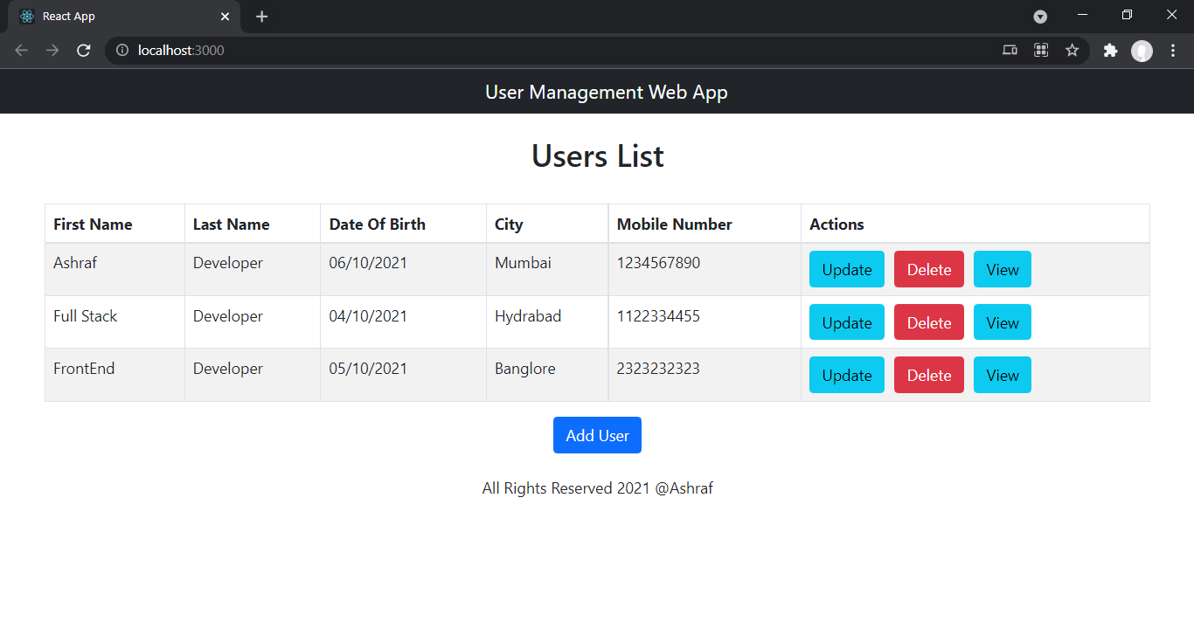

**Add User Page:**

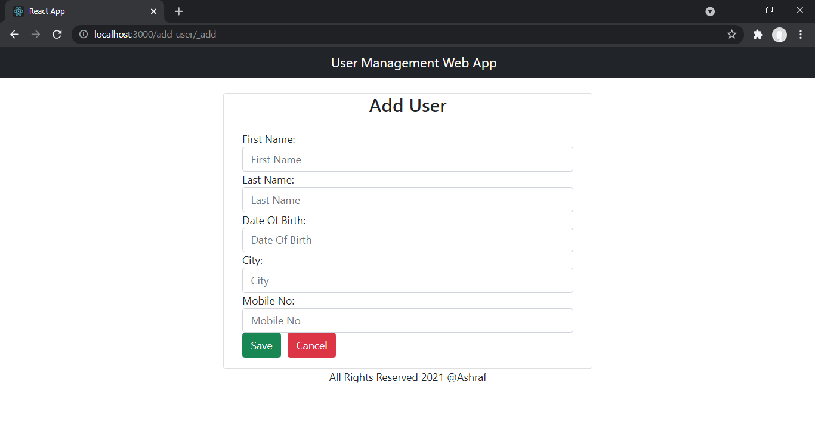

**View User Page:**

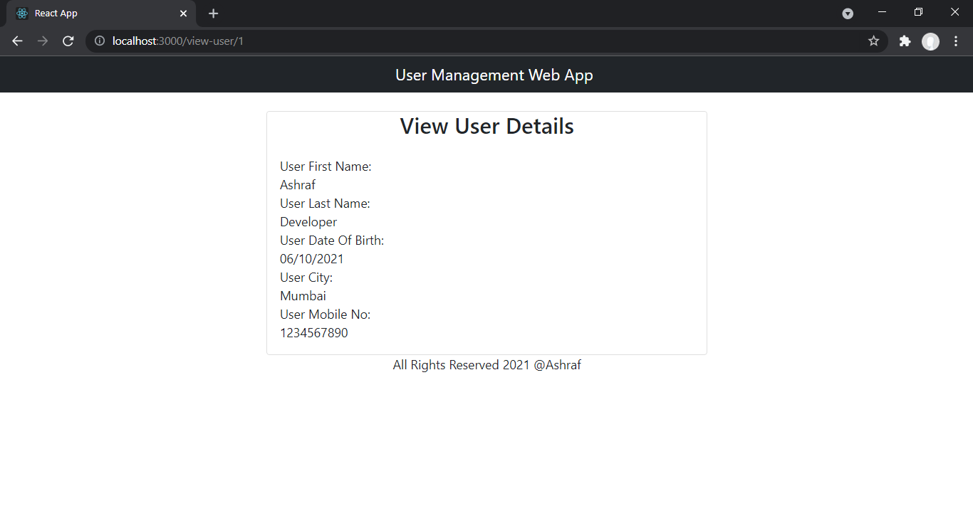

**Update User Page:**

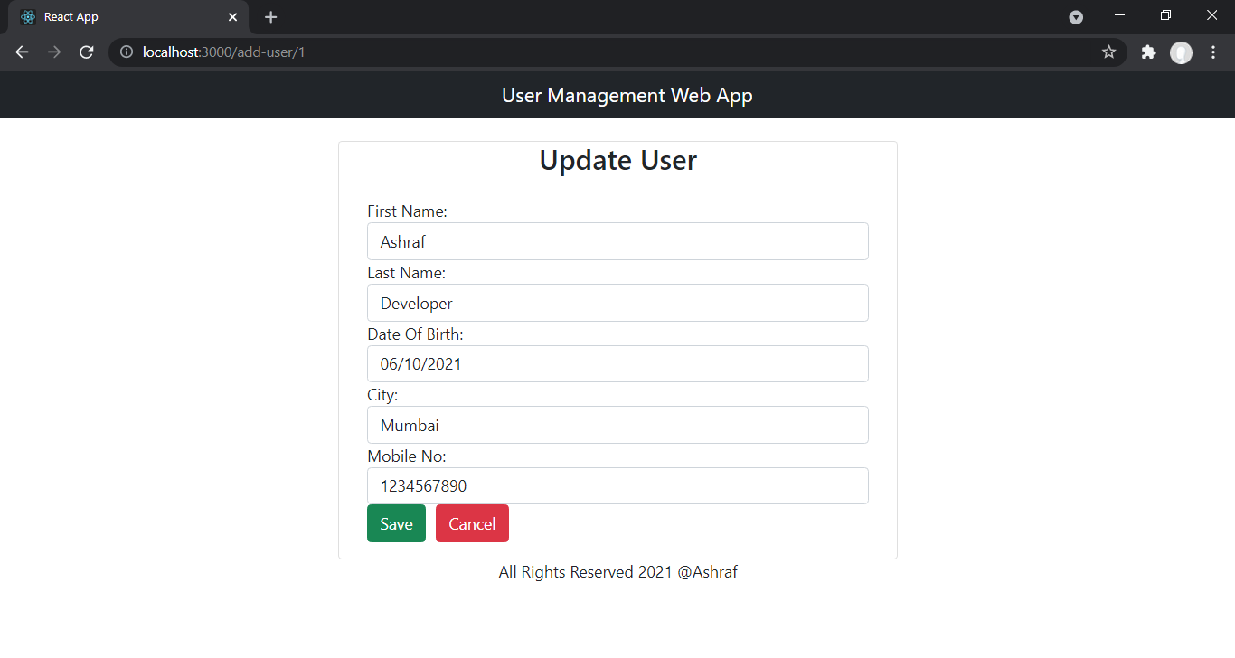

**After Deleting Last Record:**

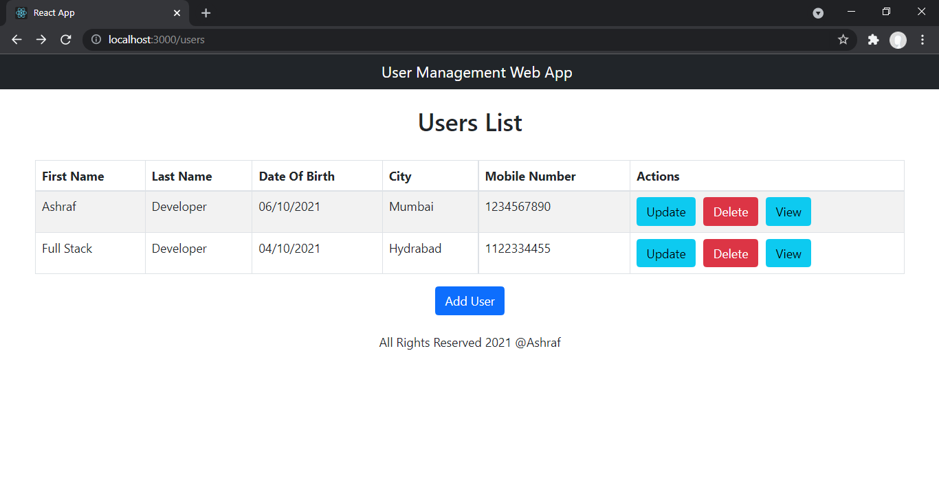

**Future Enhancements:**

1. Validations for input fields

2. Search By Name functionality

3. User Interface can improved

4. Login and logout funtionality

5. Confirmation Message before deleting record of user.

***Author:***

*Mohammad Ashraf Mohammad Salim*

*Email: mhdashraf1999@gmail.com*

Mob**:** 8888336602