This document aims to show and provide background for stqism's actions, so that even someone who is not well-oriented in nuances of Tox could understand the problem.

Events are sorted in ~chronological order. Full quotes are not included in this document, due to some parts of them being irrelevant. For full background, look in the background directory.

Index
Lying about own nick 1
Insisting on using Transifex 1
Using wrong tools and broken formatting on Tox blog 2
Rash actions due to not checking claims → proposing censorship 3
Insisting on using proprietary iCloud for Tox profiles 4
IRC channel #tox-ontopic 5

Lying about own nick

stqism lies about his own nick, e.g.:
[02:23:28] <NikolaiToryzin> lordrev: Neither stqism nor muslimmessenger exist, if I have to be that guy.
[02:23:52] <lordrev> stqism isn't a real dude?
[02:24:02] <lordrev> who is going around posting with that name then?
[02:24:03] <NikolaiToryzin> N... no.
[02:24:25] <NikolaiToryzin> Stqism was someone's old name from a while ago.
[02:24:40] <NikolaiToryzin> lordrev: https://wiki.tox.im/4chan
[02:24:58] <lordrev> i see
2014-07-17, IRC, #tox @ freenode

Insisting on using Transifex

* stqism insists on using a translation service (Transifex), instead of allowing people to make pull requests through Github like it was possible before. Zetok and SylvieLorxu clearly have stated that this service will not be used by them to translate the Tox website. Later on, it seemed like a potential contributor went away due to this very reason:
[08:17:52] <_p4x1> I downloaded beta.tox.im's htm file, translated it to spanish and uploaded it here http://a.pomf.se/shqzyi.htm fucking up the links to the css in the process
[08:22:36] <NikolaiToryzin> _p4x1, We don't edit the html for translations, in the blog post I linked you it had a section for the service we use for translations
[08:22:44] <NikolaiToryzin> We do them via JS
[08:30:12] <_p4x1> yeah I didn't like the policies of the site, I know I'm being a bitch. Meh, you'll get a more useful translator in no time. It's not like I speak some exotic language or something
[08:34:20] *** Parts: _p4x1
2015-04-01, IRC, #tox-dev @ freenode

You may have noticed that the way he goes about providing contributors with informations that they need is one of least efficient ones. I.e. in this case he states that a blog post is the place where a potential contributor can find information about how to contribute.

Blog post instead of information clearly organized in one place, in a way that would allow potential contributor to not only find relevant information on it quickly, but also they should be exposed to it in transparent manner when they would look for information on how to contribute.

Using wrong tools and broken formatting on Tox blog

* stqism uses wrong tools for the job, which results in broken formatting of posts on Tox blog. What is more important, those posts are kept on blog in broken state. ~ @ 2015-04-01 13:28
UPDATE: 2015-04-20 06:16 – Twenty day later, posts are still broken.

[13:02:51] <zetok> NikolaiToryzin: … those posts are horribly broken when it comes to formatting, etc
[13:04:28] <NikolaiToryzin> zetok: Yeah, only on small screens
[13:04:34] <zetok> nope
[13:04:49] <NikolaiToryzin> Pics?
[13:05:14] <NikolaiToryzin> I have some odd issues on my authored posts on mobile but nothing on desktop across 3 browsers
[13:05:22] <zetok> https://img.bi/#/llKSGrG!7jr21Qwy6vhgqv348wgKvhCQ3qrWDgexETBg1Nkr
[13:06:32] <NikolaiToryzin> That's actually how I wanted it to be formatted.
[13:07:37] <NikolaiToryzin> I wrote it like line wrapping didn't exist
[13:10:36] <NikolaiToryzin> Quite dumb on my part though, I wrote it in a text editor without wrapping when I have a really great markdown editor installed.
[13:12:26] <NikolaiToryzin> Problem is, I tested it in gists but githubs markdown fork horribly butchers newlines so I did the formatting and line breaks entirely be hand.
[13:13:58] <zetok> -.-
[13:14:12] <NikolaiToryzin> By*
2015-04-01, IRC, #tox @ freenode

Broken blog post formatting from the link (link content will be deleted after 6 months):
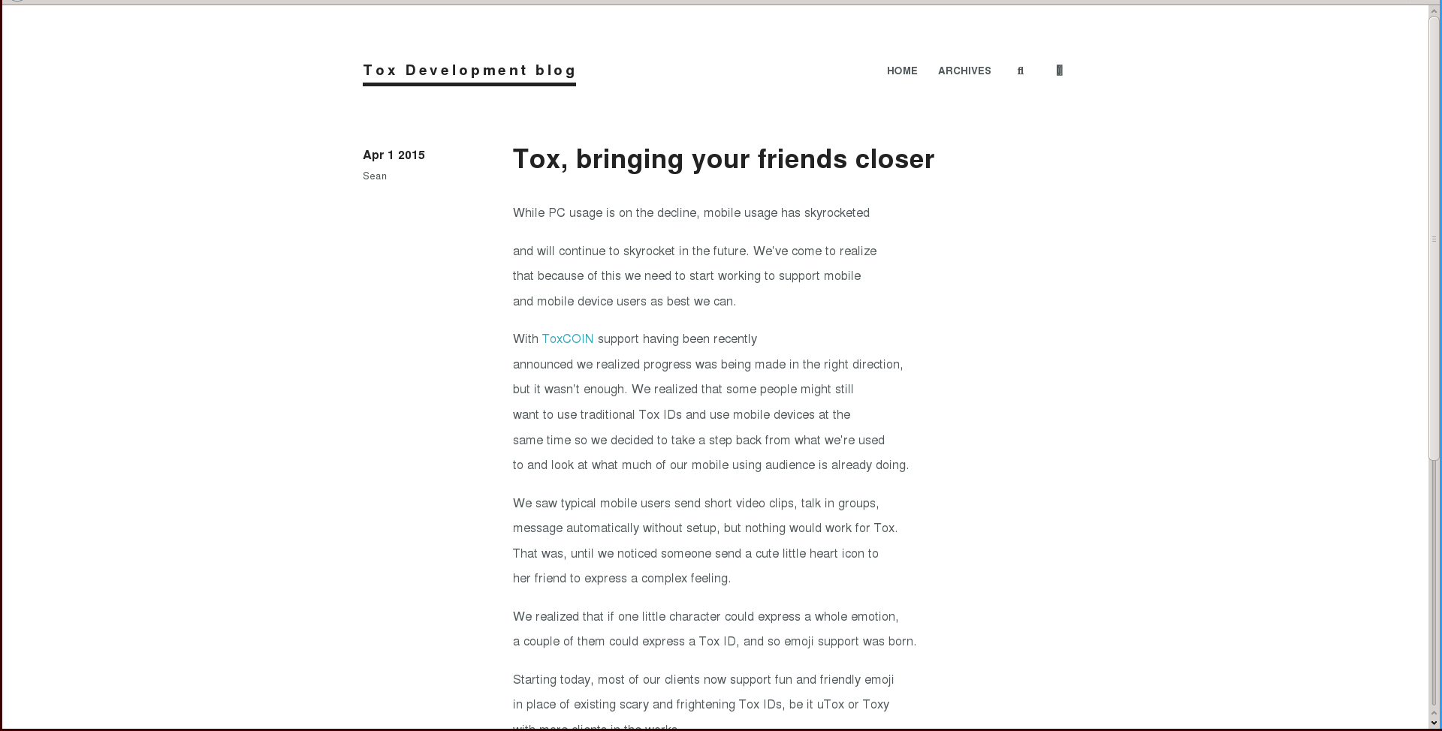
To open outside of LibreOffice: Right-click on image → Save graphic → save as file.png → open file.png with your image browser

Rash actions due to not checking claims → proposing censorship

There are only 2 mailing lists; "general" and "development". Since polluting the "development" mailing list with things that are not strictly related to technical development of Tox is far from good, discussion took place on "general" mailing list. One of developers has mistaken "general" list with "development", and wrote an email in which he said that particular conversation doesn't belong in development mailing list.
Instead of checking whether those claims are accurate, stqism rashly acted upon seeing that message, and proposed censoring the mailing list on IRC as (in his opinion) a valid solution to something which he perceived as a problem, instead of addressing a real problem, which is missing mailing lists for separate purposes. In the process of doing so, he managed to momentarily scare a potential contributor into thinking that it was his email that caused this proposal (no real harm done in the end, and potential contributor was assured that what he wrote is more than welcomed).
Relevant part of mail to the mailing list:
But either way, this isn't development content. I'm close to filtering y'all to spam. Please don't make me do that!
2015-04-03, Tox "General" mailing list: https://lists.tox.im/pipermail/general/2015-April/000017.html

Censorship proposal on IRC:
[21:36:08] <sqt> grayhatter: If the off topic chatter is too much just let me know and I can block them for a day or two
[21:36:32] <sqt> I don't usually pay attention to the lists, but I noticed you make that remark.
[21:37:23] <myroslav> sqt: Is that about my DHT email?
[21:37:31] <sqt> myroslav: No.
[21:38:11] <grayhatter> myroslav: no, that email is actually perfect for dev@list
[21:38:55] <grayhatter> sqt: it's actually not that bad, but the list is still young and emails like that are going to kill it before it get's it's legs
[21:42:04] <sqt> grayhatter: Well, it's still just a probationary trial at this stage.
[21:42:26] <sqt> We're really just waiting to see if it ever becomes properly useful
[21:42:54] <grayhatter> sqt: it needs to be, IRC is great and all but everyone has different times to worry about
[21:45:13] <sqt> grayhatter: This is something being evaluated and tested, though I've heard that github fufils that niche.
2015-04-03, IRC, #tox-dev @ freenode

Insisting on using proprietary iCloud for Tox profiles

As it is known, security requires code of the software to be open, so that everyone could check whether it really does only what it is supposed to do (i.e. doesn't contain backdoors). Tox provides that. Other software, if it's proprietary like iCloud, doesn't provide it, which means that there is no way to check whether it does only what it is said that it does.
Currently Tox doesn't support profile synchronisation across devices (i.e. so you could use the same profile on your every device). Proper support for it is planned, and is one of Tox GSoC 2015 ideas.
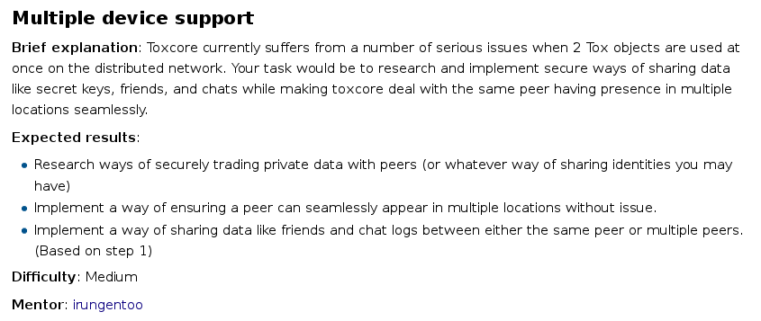
2015-04-11, Tox Wiki: https://wiki.tox.im/GSoC/2015/Ideas#Multiple_device_support
To open outside of LibreOffice: Righ-click on image → Save graphic → save as file.png → open file.png with your image browser

There is a big problem: people are putting unencrypted tox profiles in cloud storage and/or are sending them using unencrypted or otherwise not or poorly secured technology.
To deal with problem stqism made something that relies on proprietary technology (iCloud) and is only available to a small subset of Tox users (people using OS X) who agreed to evil ToS in order to use Apple products. This is obviously wrong.
Not only it doesn't promote open software, which is mandatory to have security, but what is far worse, it doesn't solve the problem.
People are sending most important data through insecure ways. This will not change, given that getting security isn't easy, and... who likes to make their life harder than necessary for no gain, right?
What could be done, is to make sure that data people are sending is secured. This way, even if not secure transport channel is used, encrypted data still should remain secure.
First step when it comes to improving security in this regard would be to adjust the standard (STS – Single Tox Standard) to make profile encryption a required default, with optional way to disable it after explicit consent from user (big red warning or something alike). stqism simply ignores those suggestions, even when they were repeated multiple times.
Instead he insists on using a proprietary service that is known to not care about its users for storing / syncing tox profiles.
…
Out of 4 people who talked with him about this on IRC, 4 were against his way of doing it.

IRC channel #tox-ontopic

Following is a story from point of view of Zetok. That being said, any commentary from people knowledgeable about topic in form of footnotes is welcomed. Provided that there will be enough of interest, creation of proper article that will not be limited to point of view of a single person will be possible.

Story about how stqism tried to distort the truth, and my view of things.
stqism published on an official Tox wiki disclaimer about #tox-ontopic IRC channel. Full of lies and things that have been simply omitted, since they could negatively affect image he wanted to present to people. My guess is that he somehow wanted to justify his actions in regard to me, although I'm not sure why he would think that lying would help.
When I first joined #tox-ontopic, it was shortly after year 2014 happened. Channel at the time was open, and was used to synchronise messages between IRC channel and Tox groupchat. It was treated as offtopic channel.
Part of topic message:
Offtopic? #tox-ontopic >> join via Tox: ^groupbot, message invite || dev questions? #tox-dev || Take few things seriously
2014-02-21, IRC, #tox @ freenode

Time passed. After some, nature of #tox-ontopic started to change, slowly becoming something that wasn't just an offtopic channel, but rather a place that was also at times used to discuss more and less serious stuff, away from eyes of most of people. As long as channel was just an offtopic one, anything from it could be treated as a joke, or simply spam. When serious stuff got mixed in, that was no longer the case, and from that point people who would want to hurt Tox could use logs from #tox-ontopic, saying that they are from an official Tox channel. Situation wasn't good, and things needed to change, and so visible changes in role and structure of #tox-ontopic began to surface.
- no more synchronisation of channel with Tox groupchat
- channel is private, invite-only
- some people got simply kicked out from channel
- people who are trying to join it are redirected to #tox-offtopic
- stqism started to try to convince people "outside" of #tox-ontopic that channel doesn't exist
Even before #tox-ontopic got closed from public, stqism was referring to it as "shitposting" channel. I'm not sure how other people see it, but I can't stop myself from wondering: "How something regarded to as “shitposting” can get better, rather than getting worse quality over time?". Especially, when to channel there are redirected the kind of people that are too "problematic" to keep them in more populated Tox IRC channels…
Relevant part of conversation:
[14:03:26] <NikolaiToryzin> sonOfRa, Think you could watch this channel every now and then, kicking people who join and start shitposting, telling them to join ontopic?
[14:03:54] <sonOfRa> NikolaiToryzin: sure
[14:03:59] *** NikolaiToryzin sets mode: +o sonOfRa
2014-06-30, IRC, #tox @ freenode
Due to that kind of actions, quality of channel dramatically lowered over time. Something that was previously used to communicate nicely between people gradually grew into place of bad, tasteless behaviour full of vulgar wording, filled with bad intentions. It was bad enough to make me feel sick about channel, and because of that I've parted from channel on 2014-12-10. Some other long-time project members parted from channel too, at different dates.
I have wondered how situation could be improved (not only in regard to #tox-ontopic, but in project as whole). After some time spent away from #tox-ontopic, I've decided to to re-evaluate whether situation there is really as bad as I remember it. I have re-joined it after ~2 months, on 2015-02-12. Sadly situation did not improve, and seemed be worse than I remembered (or maybe it just hit me really badly, since I was away from it for quite a while).
Thus I have arrived at conclusion that simplest way to remove part of Tox that was rotting, was to cut it off. Thus I have proposed removing #tox-ontopic, among several other things that in my opinion should have improved situation:
1. Removal of stq from any position(s) from which he hurts Tox.
2. Announce that there is needed person for PR.
3. Announce that there is needed person for dealing with abuse.
4. Announce that there is needed person for managing project.
5. Clear status on who is responsible for what.
6. Removal of #tox-ontopic
7. Code of conduct for Tox
2015-02-15, Gist on GitHub: https://gist.github.com/zetok/4f685582b63c5677bb20
I have announced it on the same day in #tox channel, asking irungentoo what does he think about it:
[13:54:08] * irungentoo (~irungento@unaffiliated/irungentoo) has joined
[13:54:08] * ChanServ gives channel operator status to irungentoo
[13:57:26] <itsrachelfish> mornin' irungentoo :)
[13:57:51] <irungentoo> morning
[13:58:59] <zetok> irungentoo: may I ask for some changes on how Tox operates: https://gist.github.com/zetok/4f685582b63c5677bb20 ?
[14:02:59] <irungentoo> and what would be the: Code of conduct for Tox ?
[14:03:37] <zetok> set of rules that people should abide when using official channels of communication
[14:04:16] <zetok> i.e. IRC channels, github issues, and in future mailing list
[14:04:53] <zetok> I'm not a fan of it, but there has to be some set of rules
[14:05:14] <irungentoo> and what happens if people don't follow these rules?
[14:06:56] <zetok> in short term escalation, i.e.; remind them of rules → kick → ban; in long term community that will simply thwart any attempts to break rules too badly
[14:08:34] <zetok> since everyone should abide those rules, there is a need for someone who will deal with eventual abuse
[14:09:07] <zetok> I'm not saying that it should be exactly as I said, but rather that this is direction in which things should go
[14:09:48] <irungentoo> and what would the managing project person do?
[14:11:42] <zetok> General overview of Tox, direction it takes and future of it → as per doing literally, management & micromanagement of things; like trying to find best possible solution for things people disagree on, and are important for Tox
[14:12:32] <zetok> I think that stq indicated that he wants/does it
[14:13:28] <irungentoo> so you want stq to manage the project?
[14:13:33] <zetok> No.
[14:13:38] <zetok> He fails horribly at it.
[14:14:19] <Yaniel> +1 for the general idea
[14:15:49] <irungentoo> lets wait for stq before discussing this more since the first point concerns him
[14:16:12] <zetok> Sure.
2015-02-15, IRC, #tox @ freenode

Well, I was banned in #tox-ontopic - no surprises there.
Day after that announcement, stqism tried to pretend that #tox-ontopic doesn't exist:
[09:17:12] <zetok> https://img.bi/#/tkLPu1R!DwvEzGPzIGlbUrlNIZu30GUm7Tr1pdUJx3aBeSoo why µTox is worse than qTox when it comes to RAM usage? (it still increases)
[09:18:10] <zetok> >tfw µTox would fail even this "standard" https://github.com/Tox/Tox-STS/commit/20f7e3ae1158f05e0756a3db288878f24ba69053
[09:33:52] <NikolaiToryzin> zetok, Show irungentoo
[09:34:01] <NikolaiToryzin> Also, are you really using 4chan memes again.
[09:34:47] <zetok> NikolaiToryzin: yes, I'm going to show it to him when he comes online
[09:37:19] <zetok> NikolaiToryzin: sadly, as you know I've been banned without a reason from #tox-ontopic, where I could unleash full meme power, so -dev is the only channel that I can actually use
[09:37:55] <NikolaiToryzin> #tox-ontopic?
[09:37:59] <NikolaiToryzin> What's that?
[09:38:04] <zetok> Oh?
[09:38:10] <NikolaiToryzin> Tried to join and it forwarded me to #tox-offtopic
[09:38:15] <NikolaiToryzin> And you're in that channel
[09:38:44] <zetok> [09:38:22] * Now talking on #tox-ontopic
[09:38:44] <zetok> [09:38:22] * Topic for #tox-ontopic is: Call of Duty: Advanced memes || ≻
[09:38:44] <zetok> [09:38:22] * Topic for #tox-ontopic set by NikolaiToryzin!~stqism@freebsd/user/stqism (Mon Feb 16 05:17:45 2015)
[09:38:44] <zetok> [09:38:23] * ChanServ sets ban on *!*@unaffiliated/zetok
[09:38:44] <zetok> [09:38:23] * You have been kicked from #tox-ontopic by ChanServ (Banned: Tox is a no meme-arrow zone.)
[09:38:44] <zetok> [09:38:25] * Cannot join #tox-ontopic (You are banned).
[09:39:01] <NikolaiToryzin> wut
[09:39:20] <NikolaiToryzin> You're crazy
[09:39:55] <zetok> that's what I get from my IRC client when /j #tox-ontopic
[09:40:28] <zetok> Also, from where that "You're crazy" comes from?
2015-02-16, IRC, #tox-dev @ freenode
To this day (2015-04-23) I have no idea from where “You're crazy” came from.

Later that day (2015-02-16), in #tox IRC channel one of Tox users requested me to repeat my proposal from previous day, since stqism seemed to be finally active. This initiated heated debate. Only most relevant parts are included here, since it was rather long. For whole conversation, look in background directory. Visible horizontal separators in tables represent irrelevant parts that were cut off.
[18:00:01] <zetok> irungentoo, NikolaiToryzin: so, proposal for changes in how Tox operates: https://gist.github.com/zetok/4f685582b63c5677bb20#file-gistfile1-txt
[18:01:15] <NikolaiToryzin> That's a horrible idea.
[18:01:36] <zetok> NikolaiToryzin: I'm afraid that many people would disagree with you on that.
[18:03:47] <Yaniel> NikolaiToryzin: what part of it
[18:04:04] <NikolaiToryzin> I like how you hate ontopic shitposting
[18:04:17] <zetok> NikolaiToryzin: I am not shitposting.
[18:04:57] <zetok> NikolaiToryzin: also, I don't hate per se shitposting in #tox-ontopic
[18:10:06] <zetok> NikolaiToryzin: Am I correct that you only see removing #tox-ontopic as a problem?
2015-02-16, IRC, #tox @ freenode
From there, for next ~10 minutes stqism was "busy" talking about unrelated issue.
[18:18:37] <Yaniel> anyway regarding zetok's proposal, I agree with 2-5 and 7
[18:19:48] <Yaniel> alis does not seem to know #tox-ontopic and I'm not involved enough to say anything about 1 nor 6
[18:20:30] <NikolaiToryzin> #tox-ontopic doesn't exist though
[18:20:52] <Yaniel> that makes #tox-real-ontopic rather suspicious
[18:21:03] <NikolaiToryzin> That's a dead channel
[18:22:41] <zetok> NikolaiToryzin: Why are you lying?
[18:23:10] <NikolaiToryzin> What? I've been in it for a while and I never see anyone say a thing in #tox-real-ontopic
[18:23:21] <NikolaiToryzin> I mean months
[18:23:25] <NikolaiToryzin> That's gotta be dead
[18:23:39] <zetok> NikolaiToryzin: I thought that you were talking about #tox-ontopic
[18:23:53] <zetok> oh wait
[18:23:59] <zetok> [18:20:30] <NikolaiToryzin> #tox-ontopic doesn't exist though
[18:24:01] <zetok> so yeah
[18:24:05] <NikolaiToryzin> Yeah, that doesn't
[18:24:13] <NikolaiToryzin> You shouldn't know if that exists or not
[18:24:37] <zetok> irungentoo: is ↑ that an official stance? I.e. are you saying that stq lying is right thing?
[18:24:45] <NikolaiToryzin> lying about what?
[18:25:30] <SylvieLorxu> #tox-ontopic is a meaningless, invite-only channel that is just used for a group of friends to chat around a bit. Calling it "non-existant" is incorrect, but nobody really has a reason to care about it because it's literally used for nothing interesting at all
[18:25:41] <NikolaiToryzin> Stop mentioning that it exists
[18:25:48] <zetok> NikolaiToryzin: Why?
[18:25:52] <zetok> NikolaiToryzin: Stop lying.
[18:25:55] <NikolaiToryzin> The whole joke is that the channel doesn't exist
[18:26:07] <SylvieLorxu> NikolaiToryzin: The people asking for invites is indeed annoying but meh, I still prefer telling the truth :P
[18:26:11] <zetok> NikolaiToryzin: If you haven't noticed, talk is not about jokes.
[18:26:24] <NikolaiToryzin> How are you this dense, the channel not existing is the first rule of the channel.
[18:26:25] <hexburn3r> hey, can i have an invite to #tox-ontopic?
[18:26:30] <SylvieLorxu> hexburn3r: No.
[18:26:31] <NikolaiToryzin> To what?
[18:26:50] <hexburn3r> :(
[18:27:59] <zetok> NikolaiToryzin: Do you have any objections to the proposed changes?
2015-02-16, IRC, #tox @ freenode
Main points about this part of conversation:
- stqism lies about existence of #tox-ontopic
- when he is confronted about its existence, he tries to claim that he was just joking
His words and behaviour (lying) violated Tox transparency policy (relevant part):
Transparency policy

For Opers:

When someone request information, unless it has anything to do with our personal matters/identities, we need to be able to give it to them. This includes questions such as "What's in #tox-secret", or "Where is the donation money going?". People need to know EXACTLY where their money is going, and they need to know what is going on in #tox-secret. If it has anything to do with user data, passwords, or identities, you may not disclose it without consent of the owner. So if someone asks "What's Proplex's real name?", you don't have to disclose it. In fact, unless Proplex gives you specific permission to do so (which he won't), DO NOT disclose information like this.
2015-02-16, Tox Wiki: https://wiki.tox.im/Transparency_policy
Continuation of discussion:
[18:28:20] <Yaniel> well, it has been shown multiple times that stq's sense of humour doesn't get over well on irc
[18:28:26] <Yaniel> which brings me to PR
[18:28:37] <Yaniel> which the project is so bad at it's not even funny
[18:29:04] <NikolaiToryzin> Well, we don't actually have a PR guy
[18:29:06] <SylvieLorxu> I do agree that the PR is not quite as great as it ought to be
[18:29:11] <SylvieLorxu> NikolaiToryzin: I thought you did PR
[18:29:19] <NikolaiToryzin> I never have
[18:29:22] <SylvieLorxu> Huh.
[18:29:29] <SylvieLorxu> Who manages Twitter then?
[18:29:39] <SylvieLorxu> And Facebook?
[18:29:39] <NikolaiToryzin> Right now? no one
[18:30:02] <NikolaiToryzin> I have the twitter acct saved to my phone so I can reply to things though
[18:30:24] <Yaniel> that kinda makes you the one managing it
[18:30:41] <SylvieLorxu> On that note, we really should've had some valentine's day tweet
[18:30:43] <NikolaiToryzin> Not really
[18:30:54] <NikolaiToryzin> I got the creds like 2 days ago
- stqism's "humour" does not fit on IRC
- PR (Public Relations) have not been managed properly
  - on a good side, they could be, since at the time stqism just got credentials to the official Tox accounts
  - on a bad side, to the present day (2015-04-23) I have not heard about PR being properly managed

[18:41:12] <zetok> irungentoo: Since stq does not seem to have any objections to proposed changes, how and when they should take place?
[18:42:03] <NikolaiToryzin> zetok, Stop acting like a child.
[18:42:22] <zetok> NikolaiToryzin: Care to elaborate?
[18:42:53] <SylvieLorxu> Yeah, zetok, stop acting like NikolaiToryzin
[18:42:55] * SylvieLorxu runs
[18:43:03] <NikolaiToryzin> SylvieLorxu, Ouch
[18:43:04] <NikolaiToryzin> zetok, http://allpsych.com/psychology101/defenses/#.VOI6J0J-9E4
[18:43:45] <zetok> NikolaiToryzin: Yeah, I'm familiar with those.
[18:44:37] <NikolaiToryzin> I went for super professional for the largest time but then a bunch of people went all 'le memes 4chan fugg you this is a /g/ project!11!!' attacking me.
[18:44:44] <NikolaiToryzin> It's super hard to win with you people.
[18:45:12] <zetok> NikolaiToryzin: There you go, not even a proper attitude.
[18:46:01] <NikolaiToryzin> Don't worry, it doesn't matter what side or approach you pick, I've learned people will attack you for anything.
[18:46:24] <zetok> *shrug*
[18:47:07] <zetok> NikolaiToryzin: I am not attacking you per se.
[18:47:16] <zetok> What I want, is change.
[18:47:58] <zetok> Sadly, with you managing Tox, change seems to be impossible, thus first I would like to change something (the one) who makes change impossible/overly hard.
[18:48:28] <NikolaiToryzin> Change because you don't understand the inside jokes and humour of one of our channels is fairly dumb, to put it lightly.
[18:48:46] <haavard> Gonna need a lot of popcorn for this one, I see.
[18:49:41] <zetok> NikolaiToryzin: I've listed proposed changes according to their importance, with most important ones on top.
[18:50:51] <zetok> Perhaps removing #tox-ontopic may be least important thing, if you value so much this 'le memes 4chan fugg you this is a /g/ project!11!!' channel.
[18:51:28] <Impyy> zetok, apparently some people NEED that channel, as otherwise they'll probably just shitpost in official channels :/
[18:51:48] <NikolaiToryzin> Impyy, I'm talking to one.
[18:51:51] <zetok> Impyy: Code of Conduct → gistfile2.txt
[18:52:19] <zetok> Impyy: um, do you have link?
[18:52:44] <Impyy> zetok, to?
[18:53:03] <Impyy> also what code of conduct?
[18:53:13] <zetok> Impyy: https://gist.github.com/zetok/4f685582b63c5677bb20 here you go
[18:55:24] <Impyy> zetok, I see, thanks
[18:55:38] <zetok> you're welcome
2015-02-16, IRC, #tox @ freenode
- I've been told to stop acting like a child stqism
- stqism wants to keep #tox-ontopic

And an hour later, speaking about #tox-ontopic:
[19:40:10] <NikolaiToryzin> zetok, So I'm totally removing the channel
2015-02-16, IRC, #tox @ freenode
To this day (2015-04-23) #tox-ontopic exists. Some people stqism could argue that it was just a joke, but then a question arises why he would still try to make jokes during a serious, important conversation, after being told that his sense of humour doesn't work over IRC…

As for the rest of things that have been said, just read whole log, since it's not really possible to split it well into smaller sections, or cut out content that would be irrelevant.

At the time (2015-02-16) things seemed to be improving, and I was informed that I got unbanned from #tox-ontopic. On 2015-02-20 I have re-joined channel.
From that time stqism banned me several times in #tox-ontopic, and as I see it, every time giving some bullshit justification. The only reason why I could continue to be in that channel was due to nice people who pressured stqism into unbanning me.
Similar thing happened on 2015-04-17, where stqism banned me again. Since I had no way of casual communication with people about things that may or may not be related to Tox in a channel not controlled by stqism, I have thought what could be done.
When #tox-ontopic was too poisonous due to stqism controlling it, irungentoo created #tox-real-ontopic, which was later on used as a channel with which Tox groupchat was synchronised, since #tox-ontopic was no longer an option for it. At some point, syncing groupchat with IRC stopped, and activity in #tox-real-ontopic stalled. I have wondered whether I could use it, since restructuring existing channel from "syncing" into an "offtopic not controlled by stqism" was much easier than creating brand new one, especially since it was not an active channel.
Thus I've asked irungentoo whether I could change things in #tox-real-ontopic to:
basically, since reforming #tox-ontopic with stq in it seems to not be possible, what about simply using other channel to fill the gap for people who are using #tox-ontopic , and simply migrate as many people from there as possible?

#tox-real-ontopic would be a bit different; it still would have ~free atmosphere, but not a toxic one as it is the case with #tox-ontopic

Changes:
1. Not "shitposting". Instead: “Get your facts first, and then you can distort them as much as you please.” ~~Mark Twain
2. No kickbanning, unless absolutely necessary. '/mode +q ' for some time should do the job, unless someone abuses PMs - then kick / kickban, depending on how severe abuse is.
3. Not too much swearing.. just.. no.
4. Op that abuses power will be de-opped. ← how this one should be decided upon is to decide later on.
5. Keep it civil pepole, and respect each other. You know how to, I'm sure of it ;) ..or if you're feeling that you can't take this any longer, go make a coffee / tea, looks at beautiful sky, and when you will feel calmer, come back :)
6. In case where you feel that someone is abusing power they have, *please say so*. If you prefer to speak in private, feel free to do so, but please, voice your concerns.

↑ that's all I can think of as of now, there should be added other stuff
2015-04-21, GitHub Gist: https://gist.github.com/zetok/4364dae4eac33656b240
And irungentoo's approval:
[19:12:34] <zetok> irungentoo: um, do you have some time to spare on not-oh-so-important matter?
[19:14:38] <irungentoo> what is your not so important matter?
[19:14:48] <zetok> https://gist.github.com/zetok/4364dae4eac33656b240
[19:17:25] <zetok> those are things that I think should be changed, but it's not like I would really insist on them, except for 1., 5. and 6.
[19:18:27] <irungentoo> I don't mind if you try to do that with this channel
[19:18:59] <zetok> ok, thanks for green light :)
[19:19:31] *** zetok changes topic to 'Tox real ontopic channel | Devs see #tox-dev | Users see #tox | https://wiki.tox.im/Transparency_policy | Get your facts first, and then you can distort them as much as you please.” ~~Mark Twain'
[19:19:47] *** zetok changes topic to 'Tox real ontopic channel | Devs see #tox-dev | Users see #tox | https://wiki.tox.im/Transparency_policy | “Get your facts first, and then you can distort them as much as you please.” ~~Mark Twain'
[19:20:35] <Sqt> Wow, you're really really butthurt about getting banned from ontopic
[19:21:23] <zetok> yeah, I too think that channel rules should be put in some visible place :)
[19:28:19] *** zetok changes topic to 'Tox real ontopic channel | Devs see #tox-dev | Users see #tox | https://wiki.tox.im/Transparency_policy | Get your facts first, and then you can distort them as much as you please.” ~~Mark Twain | Rules: https://gist.github.com/zetok/8b765a1874855194cf98'
2015-04-21, IRC, #tox-real-ontopic @ freenode
Effectively, I've used proposed changes as rules for #tox-real-ontopic.

I think that stqism didn't like what I was doing, and he wanted to spread some lies about why I'm doing what I'm doing, and reasons why I was banned from #tox-ontopic. To achieve that, he created an article on official Tox wiki, and after I have pointed out few out of many things that were lies, he quickly deleted it, to keep it only in gist.
Screenshot of "Recent changes" page from official Tox wiki, showing deleted page Tox-ontopic:
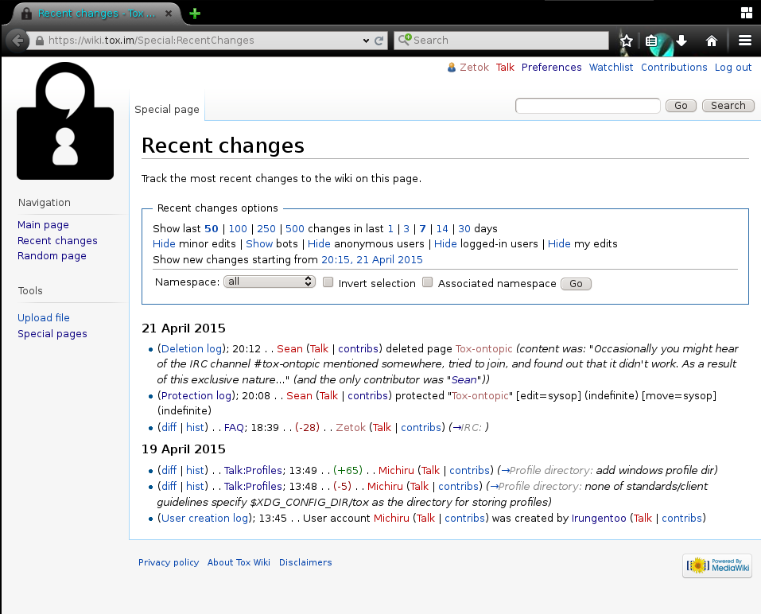
2015-04-21, Tox Wiki: https://wiki.tox.im/Special:RecentChanges
To open outside of LibreOffice: Right-click on image → Save graphic → save as file.png → open file.png with your image browser

Since article is rather long, I'm commenting only on parts that are simply lies. Whole article in its initial form, and after modification when it was already a gist is in background directory, along with difference between those. In quoted text, I've stripped formatting to ease reading.

The channel exists as a way for this same group to joke around and have fun in a non professional manner (often called shitposting), knowing they can be as sarcastic or crazy as they want, with the understanding that nothing discussed in it should be taken as fact.
2015-04-21, GitHub Gist: https://gist.github.com/stqism/513e335568472fe279ca
While it's true that discusses matters are hardly serious or not serious at all, this is not always the case. Plenty of times #tox-ontopic was used to have conversations about important matters.

The channel has a couple set in stone rules and a global catch-all rule that let's the channels many operators make up totally random and dumb rules for no reason that the others can easily override or toss out anything for fun. The channel does have some set in stone rules though, these being:

* No logging
* No taking anything said as fact
* No pasting text here to other channels or sites
* No dissent
* No discussing #tox-ontopic out of #tox-ontopic
* Outside of this wiki page, #Tox-ontopic is #Tox-{REDACTED}
* Any other rules made by operators on the fly
* Causing drama out of channel regarding actions in it
2015-04-21, GitHub Gist: https://gist.github.com/stqism/513e335568472fe279ca
Channel doesn't have any rules set in stone per se, except for the unwritten one that stqism does there what he wants to, without really caring about what other people think about it.
- "No logging" – stqism's own bot does logging. Bot had few different names like THE_KGB, THE_CIA, THE_FSB, current (2015-04-23) name is Tox_syncbot. Aside from himself violating this "rule", it was made up by him after I was banned by him on 2015-04-17, after I've asked whether I'm free to use logs from #tox-ontopic when he accused me of lying. There never was a rule to not have logs – the only "requirement" was an unspoken rule to not release logs outside of #tox-ontopic, to which so far (2015-04-23) I have conformed to.
- "No taking anything said as fact" – that's an interesting one. Sadly, my experiences contradict it:
  - I have been kicked out of #tox-ontopic for complimenting stqism's shitposting skills
  - I have been banned from #tox-ontopic for not taking seriously stqism's support site, about which conversation was about
- "No pasting text here to other channels or sites" – I have pasted text from #tox-ontopic on external services like GitHub Gist. Well, I did it to share logs from #tox-ontopic with other people from #tox-ontopic, who were not present at time when relevant to them conversation has happened. Note that this also goes against "No logging" 'rule'. With that in mind, it's interesting how I was never banned or in any other way penalized for it…
- "No dissent" – i.e. don't oppose stqism in any way. I have put stqism on ignore in my IRC client, so that I wouldn't be able to disagree with him, and I have announced that, so that he would know that I'm not able to disagree with him. I got banned for that.
- "No discussing #tox-ontopic out of #tox-ontopic" – I honestly have no idea how that's doable, given that:
  - I have been banned from #tox-ontopic
  - stqism simply ignored me when I have tried to talk to him via private means
- "Any other rules made by operators on the fly" – another 'rule' that he recently have made up. I.e. there have been no such rule, and it still does not exist.

Being a safe haven for elite project members, you can not get in by asking. If you're cool and are a good culture fit you'll be invited to join us.
2015-04-21, GitHub Gist: https://gist.github.com/stqism/513e335568472fe279ca
Well, I have written earlier what were initial criteria to enter #tox-ontopic (there were none), how it changed ("shitposters" were redirected there), to situation where it's basically stqism's call whether someone is welcomed there or not. He himself proves it quite nicely, when he invites someone whom he kicked out of channel earlier, just to (I think that it was his intention) try to annoy me, after I was banned from #tox-ontopic:
[19:28:35] <dylygs> I miss ontopic :(
[19:29:03] <zetok> /join #tox-real-ontopic
[19:29:06] <zetok> dylygs: ↑ :)
[19:29:28] <dylygs> jej
[19:29:29] <dylygs> ty
[19:29:38] <zetok> you're welcome ;)
[19:33:51] <Sqt> dylygs, Want back in?
[19:34:02] <Sqt> I kicked you out in the log leak purge
[19:34:49] <zetok> >log leak purge
[19:34:58] <zetok> why would you even need that?
[19:35:08] <Sqt> zetok, Logging is forbidden in #tox-{REDACTED}
[19:35:19] <zetok> Sqt: what do you mean?
[19:35:25] <dylygs> thx sqt
[19:35:52] <Sqt> dylygs, np bbygrill ;)))))
[19:36:07] <dylygs> ;-)))))))))))))))))))))))
[19:36:53] <Sqt> dylygs, Sorry about that, deinvited people to try to find the rat over the long run :)
[19:37:13] <dylygs> there was a rat?
[19:37:15] <Sqt> zetok, Like, making logs of any kind in #tox-{REDACTED} is a ban
[19:37:24] <zetok> Sqt: you're a moron
[19:37:33] <Sqt> dylygs, Aye, damn vermin poisoning the goodness that is redacted
[19:37:50] <Sqt> zetok, Insults violates your silly set of rules
[19:37:51] <dylygs> methinks some ratpoison was needed
[19:37:58] <zetok> >comparing dylygs to vermin
[19:38:07] <Sqt> I didn't call him vermin
[19:38:08] <dylygs> >implying I'm not vermin
[19:38:25] <Sqt> He's a goat thank you very much
[19:38:28] <Sqt> Isn't that right
[19:38:32] <dylygs> ( ͡~ ͜ʖ ͡°)
[19:38:40] <Sqt> yessir
2015-04-21, IRC, #tox-offtopic @ freenode

The process for becoming an operator is fairly easy, just ask the right people at the right time and don't piss people off generally.
2015-04-21, GitHub Gist: https://gist.github.com/stqism/513e335568472fe279ca
The actual process is to conform to stqism. And ask (sometimes beg) him for an OP.

You, the operator, have total control over everything as long as it doesn't start with the word chanserv.
2015-04-21, GitHub Gist: https://gist.github.com/stqism/513e335568472fe279ca
What it means, is that you actually can't do anything – you don't have any real control. When stqism wants to ban someone, he uses ChanServ, and thus other operators have no real way of changing anything in that regard.

Keep in mind that 99.9% of the time another operator will unban the person a second later. This is not to be taken personally, but is part of the developed culture.
2015-04-21, GitHub Gist: https://gist.github.com/stqism/513e335568472fe279ca
This is the kind of environment that stqism encourages. If you conform to stqism, you can do anything he allows you to do, after all, banning other people (even if it's for a short time) is such a nice way to get along. Unless you are stqism, then you just ban people, and other people have to pressure you to unban banned people after few days…

The easiest way to get kicked out for good is to violate the logging rule, but repeatedly insulting people and starting fights or just not being a good fit will result in your removal and ban for life.
2015-04-21, GitHub Gist: https://gist.github.com/stqism/513e335568472fe279ca
Actually, all of it is ~acceptable in #tox-ontopic, as long as you're fine with stqism. If you're not, expect being banned.

There's also nice list of "banned for life", on which I'm the only real person promptly listed (the other is a bot that was syncing #tox-ontopic to Tox groupchat). Well, all I gotta say is that afterlife does not feel differently from life, since I've been told that on 2015-04-22 I have been unbanned from #tox-ontopic…

There is also added later-on part "Transparency":
Due to the nature of the channel, documents like the Transparency policy have no say over it, nor do we formally acknoledge that the channel exists.
2015-04-21, GitHub Gist: https://gist.github.com/stqism/513e335568472fe279ca
Which is no less than bullshit. Anyone is free to ask about #tox-ontopic, and people can't deny that it exists. The only person in "we" is stqism.

If you wonder why am I even touching something that was described in gist as “Disclaimer, this document was wrritten humoriously”:
- If it's humorous, why it's not funny at all by itself?
- Why, just why would anyone write a humorous document, long after April 1st ended?
Not to mention that it was removed from official wiki shortly after I have pointed out that it contains lies.

Otherwise known as NikolaiToryzin, AlexStraunoff, sqt, Sqt, coup_de_shitlord, killallpolish. Common abbreviation: stq
Google Summer of Code: https://www.google-melange.com/gsoc/homepage/google/gsoc2015

