**Movie Database**

**Screenshots**

**Abdul Aaquib (800795370)**

**Nikhil Dahake (800804352)**

**Pritesh Bhere (800776144)**

**Home Page**

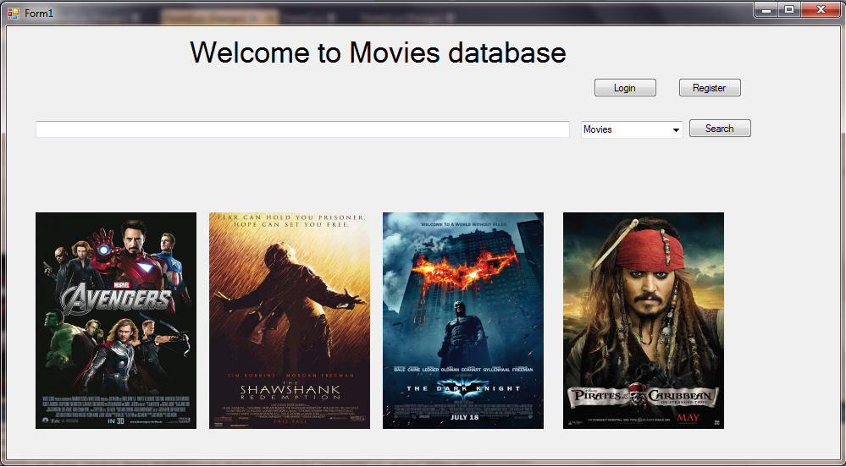

**Login and Register Page**

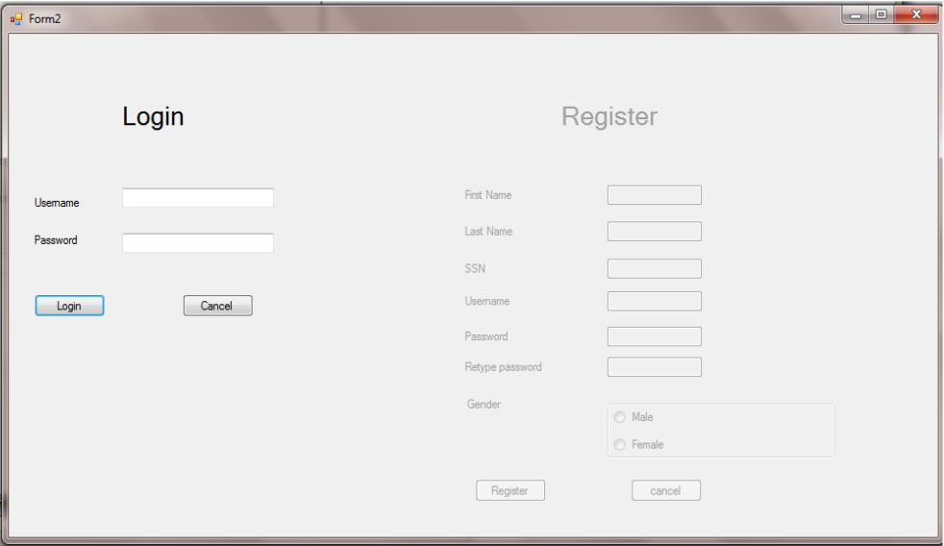

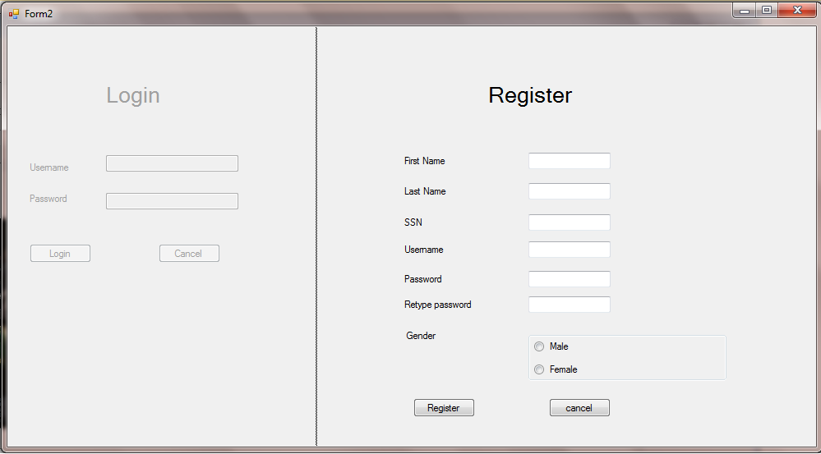

**Movie Page**

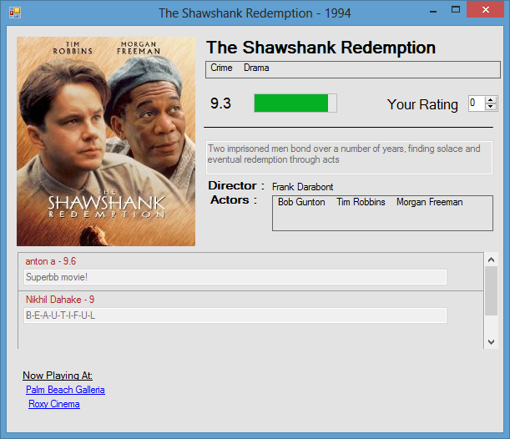

**Review page**

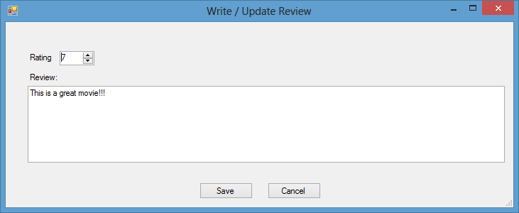

**User Home Page**

