**Tree & Shrub Survey Protocol**

1. Starting north, extend the meter tape out 10m from plot center.
2. Radiate meter tape to east (clockwise) until the meter tape hits a tree trunk or shrub.
3. *If there are no shrubs or trees, fill out empty data sheet and check the appropriate marks*

Trees (1 stem >2 cm DBH)

1. [If >5 cm DBH] Nail tree tag into tree with tag facing center of plot. Record tree tag #
2. Measure distance to center with meter tape.
3. Observe and record angle (degrees) from N to tree using compass.
4. Measure DBH (diameter at breast height or 1.37m off the ground)
5. Measure height using hypsometer or meter tape
6. Identify species
   1. If unidentifiable or unsure:
      1. Collect leaf/leaves, seeds, flowers, etc and fold into collecting notebook.
      2. Write down unique identifier on datasheet **and** in collecting notebook
         1. Example: “P01-pine1” or “P01- maple1” or “P01-spp1”
      3. Add notes about cones, fruit, flowers, size, location, etc into collecting notebook
         1. Is the tree opposite or alternate branching?
         2. Compound or simple leaves?
         3. Bark color, texture?

Shrubs (woody, 2+ stems, >1 meter height)

1. Identify species
   1. If unidentifiable, follow same steps as 9a above.
2. Measure distance to center with meter tape.
3. Observe and record angle (degrees) from N to tree using compass.
4. Measure height using hypsometer or meter tape
5. Count the number of stems, approximating if more than 10: 1, 2, 3, 4, 5, 6, 7, 8, 9, 10, 11-20, 20+

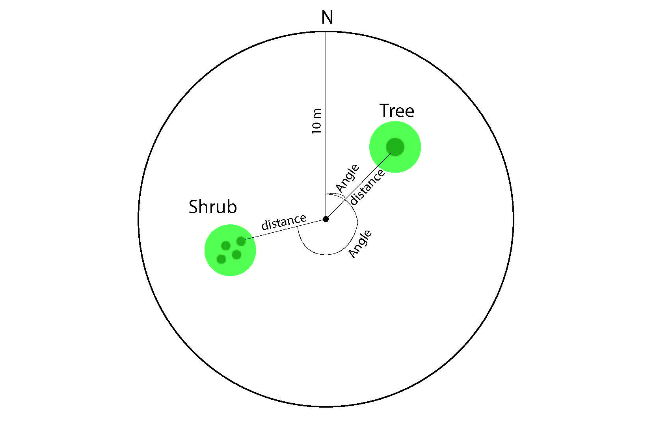

***At the end of the day, scan and email data sheets to Dr. ArchMiller aarchmil@cord.edu***