**1. SYNOPSIS**

1. **Title of Project:**

Sentiment Analysis and Personality Test

1. **Objective:**

* The main objective is to develop the web application to detect the sentiment of the text provided by the user.
* This project help to know find the opinion of the person.

1. **Description:**

Sentiment analysis is a kind of data mining where you measure the inclination of people’s opinions by using NLP (natural language processing), text analysis, and computational linguistics. It gives precise results to what the public opinion is about the subject. It classified its results in different categories such as: Very Negative, Negative, Neutral, Positive, Very Positive. In this application, it detect the person opinion from the text what the user have entered.

1. **Modules:**

Admin Module

User Module

1. **System Requirement Specification(SRS):**

**Hardware Requirement Specification:**

Processor : Standard processor with a speed of 1.6 GHz

RAM : 512 MB

Hard Disk : 10 GB

Monitor : Standard Color Monitor

Keyboard : Standard Keyboard

Mouse : Standard Mouse

**Software Requirement Specification:**

Operating System : Windows XP

Database : MySQL

Browser : Internet Explorer

1. **Used Technologies:**

Front End : Python Django

Web Technologies : HTML, CSS, JavaScript

Back End : SQLite3

**2. Introduction**

This project is designed so as to analysis the sentence using Natural Language Processing technique. This project is help to detect the sentiment of the sentence whether it’s represent the happy, sad or netural and also help to test the personality of the user. Sentiment Analysis is the most common text classification tool that analyses an incoming message and tells whether the underlying sentiment is positive, negative our neutral.

**Reason for the Project**

With advancements in computer technology, new attempts have been made to analyze psychological traits through computer programming and to predict them quickly, efficiently, and accurately. Especially with the rise of Machine Learning (ML), Deep Learning (DL), and Natural Language Processing (NLP), researchers in the field of psychology are widely adopting NLP to assess psychological construct or to predict human behaviors.

* There was a time when the social media  
  services like Facebook used to just have two emotions associated with  
  each post, i.e You can like a post or you can leave the post without any  
  reaction and that basically signifies that you didn’t like it. But, over time these reactions to post have  
  changed and grew into more granular sentiments which we see as of now,  
  such as “like”, “love”, “sad”,  
  “angry” etc.
* there are billions of people and they have their own style of communicating, i.e. a lot of tiny variations are added to the language and a lot of sentiments are attached to it which is easy for us to interpret but it becomes a challenge for the machines.
* Sentiment analysis is extremely useful in social media monitoring as it **allows us to gain an overview of the wider public opinion behind certain topics**.
* It's often used by businesses **to detect sentiment in social data, gauge brand reputation, and understand customers**.
* Personality Testing helps to understand your own character traits can be a powerful tool when deciding your career path.

**Problem Statement**

The problem in sentiment analysis is classifying the polarity of a given text at the document, sentence or feature/aspect level. Whether the expressed opinion in a document, a sentence or an entity feature/aspect is posivie, negative or netural.

The problem in the personality test is classifying the persoanlity of perrson on basis of MBTI model where model is train with the past data and help to predict from past train data.

**Aims & Objectives**

To develop the web application for the user to test the sentiment, persoanlity and language translator. This application help to detect the sentiment wheather the person is happy, sad or netural and personality test show which type of person is using this applicaion.

**Scope**

The web application is going to be developed is known as Sentiment and Persoanality Test.The main users of this system are administrator, and staff. This system help to provide the user to test the sentiment and the persoanlity and also it’s help to make to know the user mode. The model of this project are:

1. **User Module**

This model is used to register and login to the application for the user. So, that user can utitlitze the services of this application.

1. **Admin Module**

This model is admistration module where suprme user can look after all the infromation about the user and also can control and manage the application different part and data.

1. **Personality Module**

In this model, user id, user text, user result are store in the database where the user can test their persoanlity.

1. **Sentiment Module**

In this model, user id, user text, user result are store in the database where the user can test their sentiment where sad, happy and normal.

1. **Language Module**

In this model, user id, user text, user result are store in the database where the user can used to translate the english language to Kanada.

The system is a multi-user system since it is used by different groups of users. It is developed as a web application which can run in any platform where browser and internet is avliable. The database system that is going to be built for the application is SQLite.

**Project significance**

Sentiment And Personality Test is web application which developed website for the sentiment and personality test. It’s developed on Python programming language which is easy to understand and update in future.

**Expected Output**

Sentiment And Personality Test expected to be well manage and proper aplication. There should not have any errors occur for the predicting the output from the model as it learn from the past dataset.

**Conclusion**

Sentiment And Personality Test is one of the the intesting project and shows the power of natural language processing where user can check their personality and sentiment test which is work on the model trained by the past data taken from different platform.

**3. System Analysis**

To produce a web application based system that allow user to detect the sentiment and personality first the user have to register and login into application. It’s show almost high accuracy and very easy to used.

**Facts and Findings**

While developing this application the lots of website are using API which is made by gaint company. Sentiment and Persoanlity test is work on MBTI persoanlitly. Personality typing is a system of categorizing people according to their tendencies to think and act in particular ways. Personality typing attempts to find the broadest, most important ways in which people are different, and make sense of these differences by sorting people into meaningful groups. Sentiment Test is also of three types I.e Sad, Happy and Normal.

**Domain**

Sentiment and Personality Test is the machine language based on python program language. It’s based on Natural Language Programming. It’s one of the best personality and sentiment test web application in the domain of NLP and ML.

**Existing System**

Studying the current system is a method that is used to gather the requirements in the research. The purpose of studying the current system is to identify the current data and input. The user have to study the data and detect that the sentence is sad, happy or netural. It’s also detect the persoanlity test by the interview and many other thing so work load and many people are engaged and time consuming. The summary of the research made and are shown in below.

**Case Study – Using Simulation to chose between Sentiment and Personality Test**

This research seeks to determine the relationship between human emotional states and

interaction, as well as to demonstrate that emotion has a greater impact on interaction than other factors. One of the primary goals of this research is to determine the relationship between human emotional states and interactions. As a result, it will aid the researcher in comprehending and inventing new techniques and technologies to realize the goal of affective computing as mentioned above. Our research team performed trials with real individuals who were interacting with different computer systems to evaluate this hypothesis, and they discovered the importance of the emotional state in human-computer interaction. In this experiment, the following are the goals that will be pursued. As we know that, there is a big difference in personality

type and their characteristics respectively. The personality type may be negative, positive, very negative, very positive and neutral in general, but the characteristics refer their properties. The personality is referred as the combination of characteristics which form a person’s distinction. On the other side if the personality is being identified from unknown persons using a media like Facebook, twitter and other likelihood as platforms then it becomes critical to identify the personality. For that reason, we need the word and sentence data set with its description and context where these are used and when. There are some other called big-5 personality traits might be Openness, conscientiousness, extraversion, introversion, extroversion, agreeableness, sensitiveness and neuroticism, which makes a person different from others.

**Technique**

First, I gather the data from the internet and get with what type of persroanlity that text are carried on and from their I clean and preprocessing the data. After that I preprocesed the data and apply machine learning algorithm and detect and sentiment classification and personality test.

## Machine Learning

This introduction to machine learning provides an overview of its history, important definitions, applications and concerns within businesses today.

## What is machine learning?

Machine learning is a branch of artificial intelligence (AI) and computer science which focuses on the use of data and algorithms to imitate the way that humans learn, gradually improving its accuracy.

IBM has a rich history with machine learning. One of its own, Arthur Samuel, is credited for coining the term, “machine learning” with his research (PDF, 492 KB) (link resides outside IBM) around the game of checkers. Robert Nealey, the self-proclaimed checkers master, played the game on an IBM 7094 computer in 1962, and he lost to the computer. Compared to what can be done today, this feat almost seems trivial, but it’s considered a major milestone within the field of artificial intelligence. Over the next couple of decades, the technological developments around storage and processing power will enable some innovative products that we know and love today, such as Netflix’s recommendation engine or self-driving cars.

Machine learning is an important component of the growing field of data science. Through the use of statistical methods, algorithms are trained to make classifications or predictions, uncovering key insights within data mining projects. These insights subsequently drive decision making within applications and businesses, ideally impacting key growth metrics. As big data continues to expand and grow, the market demand for data scientists will increase, requiring them to assist in the identification of the most relevant business questions and subsequently the data to answer them.

## Machine Learning vs. Deep Learning vs. Neural Networks

Since deep learning and machine learning tend to be used interchangeably, it’s worth noting the nuances between the two. Machine learning, deep learning, and neural networks are all sub-fields of artificial intelligence. However, deep learning is actually a sub-field of machine learning, and neural networks is a sub-field of deep learning.

The way in which deep learning and machine learning differ is in how each algorithm learns. Deep learning automates much of the feature extraction piece of the process, eliminating some of the manual human intervention required and enabling the use of larger data sets. You can think of deep learning as "scalable machine learning" as Lex Fridman notes in this MIT lecture (1:08:05) (link resides outside IBM). Classical, or "non-deep", machine learning is more dependent on human intervention to learn. Human experts determine the set of features to understand the differences between data inputs, usually requiring more structured data to learn.

"Deep" machine learning can leverage labeled datasets, also known as supervised learning, to inform its algorithm, but it doesn’t necessarily require a labeled dataset. It can ingest unstructured data in its raw form (e.g. text, images), and it can automatically determine the set of features which distinguish different categories of data from one another. Unlike machine learning, it doesn't require human intervention to process data, allowing us to scale machine learning in more interesting ways. Deep learning and neural networks are primarily credited with accelerating progress in areas, such as computer vision, natural language processing, and speech recognition.

Neural networks, or artificial neural networks (ANNs), are comprised of a node layers, containing an input layer, one or more hidden layers, and an output layer. Each node, or artificial neuron, connects to another and has an associated weight and threshold. If the output of any individual node is above the specified threshold value, that node is activated, sending data to the next layer of the network. Otherwise, no data is passed along to the next layer of the network. The “deep” in deep learning is just referring to the depth of layers in a neural network. A neural network that consists of more than three layers—which would be inclusive of the inputs and the output—can be considered a deep learning algorithm or a deep neural network. A neural network that only has two or three layers is just a basic neural network.

See the blog post “AI vs. Machine Learning vs. Deep Learning vs. Neural Networks: What’s the Difference?” for a closer look at how the different concepts relate.

## How machine learning works

UC Berkeley (link resides outside IBM) breaks out the learning system of a machine learning algorithm into three main parts.

1. A Decision Process: In general, machine learning algorithms are used to make a prediction or classification. Based on some input data, which can be labelled or unlabeled, your algorithm will produce an estimate about a pattern in the data.
2. An Error Function: An error function serves to evaluate the prediction of the model. If there are known examples, an error function can make a comparison to assess the accuracy of the model.
3. An Model Optimization Process: If the model can fit better to the data points in the training set, then weights are adjusted to reduce the discrepancy between the known example and the model estimate. The algorithm will repeat this evaluate and optimize process, updating weights autonomously until a threshold of accuracy has been met.

## Machine learning methods

Machine learning classifiers fall into three primary categories.

### Supervised machine learning

Supervised learning, also known as supervised machine learning, is defined by its use of labeled datasets to train algorithms that to classify data or predict outcomes accurately. As input data is fed into the model, it adjusts its weights until the model has been fitted appropriately. This occurs as part of the cross validation process to ensure that the model avoids overfitting or underfitting. Supervised learning helps organizations solve for a variety of real-world problems at scale, such as classifying spam in a separate folder from your inbox. Some methods used in supervised learning include neural networks, naïve bayes, linear regression, logistic regression, random forest, support vector machine (SVM), and more.

### Unsupervised machine learning

Unsupervised learning, also known as unsupervised machine learning, uses machine learning algorithms to analyze and cluster unlabeled datasets. These algorithms discover hidden patterns or data groupings without the need for human intervention. Its ability to discover similarities and differences in information make it the ideal solution for exploratory data analysis, cross-selling strategies, customer segmentation, image and pattern recognition. It’s also used to reduce the number of features in a model through the process of dimensionality reduction; principal component analysis (PCA) and singular value decomposition (SVD) are two common approaches for this. Other algorithms used in unsupervised learning include neural networks, k-means clustering, probabilistic clustering methods, and more.

### Semi-supervised learning

Semi-supervised learning offers a happy medium between supervised and unsupervised learning. During training, it uses a smaller labeled data set to guide classification and feature extraction from a larger, unlabeled data set. Semi-supervised learning can solve the problem of having not enough labeled data (or not being able to afford to label enough data) to train a supervised learning algorithm.

For a deep dive into the differences between these approaches, check out "Supervised vs. Unsupervised Learning: What's the Difference?"

## Reinforcement machine learning

Reinforcement machine learning is a behavioral machine learning model that is similar to supervised learning, but the algorithm isn’t trained using sample data. This model learns as it goes by using trial and error. A sequence of successful outcomes will be reinforced to develop the best recommendation or policy for a given problem.

The IBM Watson® system that won the Jeopardy! challenge in 2011 makes a good example. The system used reinforcement learning to decide whether to attempt an answer (or question, as it were), which square to select on the board, and how much to wager—especially on daily doubles.

Learn more about reinforcement learning.

## Real-world machine learning use cases

Here are just a few examples of machine learning you might encounter every day:

Speech Recognition: It is also known as automatic speech recognition (ASR), computer speech recognition, or speech-to-text, and it is a capability which uses natural language processing (NLP) to process human speech into a written format. Many mobile devices incorporate speech recognition into their systems to conduct voice search—e.g. Siri—or provide more accessibility around texting.

Customer Service:  Online chatbots are replacing human agents along the customer journey. They answer frequently asked questions (FAQs) around topics, like shipping, or provide personalized advice, cross-selling products or suggesting sizes for users, changing the way we think about customer engagement across websites and social media platforms. Examples include messaging bots on e-commerce sites with virtual agents, messaging apps, such as Slack and Facebook Messenger, and tasks usually done by virtual assistants and voice assistants.

Computer Vision: This AI technology enables computers and systems to derive meaningful information from digital images, videos and other visual inputs, and based on those inputs, it can take action. This ability to provide recommendations distinguishes it from image recognition tasks. Powered by convolutional neural networks, computer vision has applications within photo tagging in social media, radiology imaging in healthcare, and self-driving cars within the automotive industry.

Recommendation Engines: Using past consumption behavior data, AI algorithms can help to discover data trends that can be used to develop more effective cross-selling strategies. This is used to make relevant add-on recommendations to customers during the checkout process for online retailers.

Automated stock trading: Designed to optimize stock portfolios, AI-driven high-frequency trading platforms make thousands or even millions of trades per day without human intervention.

## Challenges of Machine Learning

As machine learning technology advances, it has certainly made our lives easier. However, implementing machine learning within businesses has also raised a number of ethical concerns surrounding AI technologies. Some of these include:

### Technological Singularity

While this topic garners a lot of public attention, many researchers are not concerned with the idea of AI surpassing human intelligence in the near or immediate future. This is also referred to as superintelligence, which Nick Bostrum defines as “any intellect that vastly outperforms the best human brains in practically every field, including scientific creativity, general wisdom, and social skills.” Despite the fact that Strong AI and superintelligence is not imminent in society, the idea of it raises some interesting questions as we consider the use of autonomous systems, like self-driving cars. It’s unrealistic to think that a driverless car would never get into a car accident, but who is responsible and liable under those circumstances? Should we still pursue autonomous vehicles, or do we limit the integration of this technology to create only semi-autonomous vehicles which promote safety among drivers? The jury is still out on this, but these are the types of ethical debates that are occurring as new, innovative AI technology develops.

### AI Impact on Jobs:

While a lot of public perception around artificial intelligence centers around job loss, this concern should be probably reframed. With every disruptive, new technology, we see that the market demand for specific job roles shift. For example, when we look at the automotive industry, many manufacturers, like GM, are shifting to focus on electric vehicle production to align with green initiatives. The energy industry isn’t going away, but the source of energy is shifting from a fuel economy to an electric one. Artificial intelligence should be viewed in a similar manner, where artificial intelligence will shift the demand of jobs to other areas. There will need to be individuals to help manage these systems as data grows and changes every day. There will still need to be resources to address more complex problems within the industries that are most likely to be affected by job demand shifts, like customer service. The important aspect of artificial intelligence and its effect on the job market will be helping individuals transition to these new areas of market demand.

### Privacy:

Privacy tends to be discussed in the context of data privacy, data protection and data security, and these concerns have allowed policymakers to make more strides here in recent years. For example, in 2016, GDPR legislation was created to protect the personal data of people in the European Union and European Economic Area, giving individuals more control of their data. In the United States, individual states are developing policies, such as the California Consumer Privacy Act (CCPA), which require businesses to inform consumers about the collection of their data. This recent legislation has forced companies to rethink how they store and use personally identifiable data (PII). As a result, investments within security have become an increasing priority for businesses as they seek to eliminate any vulnerabilities and opportunities for surveillance, hacking, and cyberattacks.

### Bias and Discrimination:

Instances of bias and discrimination across a number of intelligent systems have raised many ethical questions regarding the use of artificial intelligence. How can we safeguard against bias and discrimination when the training data itself can lend itself to bias? While companies typically have well-meaning intentions around their automation efforts, Reuters (link resides outside IBM) highlights some of the unforeseen consequences of incorporating AI into hiring practices. In their effort to automate and simplify a process, Amazon unintentionally biased potential job candidates by gender for open technical roles, and they ultimately had to scrap the project. As events like these surface, Harvard Business Review (link resides outside IBM) has raised other pointed questions around the use of AI within hiring practices, such as what data should you be able to use when evaluating a candidate for a role.

Bias and discrimination aren’t limited to the human resources function either; it can be found in a number of applications from facial recognition software to social media algorithms.

As businesses become more aware of the risks with AI, they’ve also become more active this discussion around AI ethics and values. For example, last year IBM’s CEO Arvind Krishna shared that IBM has sunset its general purpose IBM facial recognition and analysis products, emphasizing that “IBM firmly opposes and will not condone uses of any technology, including facial recognition technology offered by other vendors, for mass surveillance, racial profiling, violations of basic human rights and freedoms, or any purpose which is not consistent with our values and Principles of Trust and Transparency.”

To read more about this, check out IBM’s policy blog, relaying its point of view on “A Precision Regulation Approach to Controlling Facial Recognition Technology Exports.”

### Accountability

Since there isn’t significant legislation to regulate AI practices, there is no real enforcement mechanism to ensure that ethical AI is practiced. The current incentives for companies to adhere to these guidelines are the negative repercussions of an unethical AI system to the bottom line. To fill the gap, ethical frameworks have emerged as part of a collaboration between ethicists and researchers to govern the construction and distribution of AI models within society. However, at the moment, these only serve to guide, and research (link resides outside IBM) (PDF, 1 MB) shows that the combination of distributed responsibility and lack of foresight into potential consequences isn’t necessarily conducive to preventing harm to society.

**4. Technologies Used**

**Python [Front- End]:**

Python is a widely-used, interpreted, object-oriented, and high-level programming language with dynamic semantics, used for general-purpose programming. It’s everywhere, and people use numerous Python-powered devices on a daily basis, whether they realize it or not.

Python was created by Guido van Rossum, and first released on February 20, 1991. While you may know the python as a large snake, the name of the Python programming language comes from an old BBC television comedy sketch series called *Monty Python’s Flying Circus*.

Python is omnipresent, and people use numerous Python-powered devices on a daily basis, whether they realize it or not. There are billions of lines of code written in Python, which means almost unlimited opportunities for code reuse and learning from well-crafted examples. What’s more, there is a large and very active Python community, always happy to help.

Python is a great choice for career paths related to software development, engineering, DevOps, machine learning, data analytics, web development, and testing. What's more, there are also many jobs outside the IT industry that use Python. Since our lives are becoming more computerized every day, and the computer and technology areas previously associated only with technically gifted people are now opening up to non-programmers, Python has become one of the must-have tools in the toolbox of educators, managers, data scientists, data analysts, economists, psychologists, artists, and even secretaries.

There are also a couple of factors that make Python great for learning:

* It is easy to learn – the time needed to learn Python is shorter than for many other languages; this means that it’s possible to start the actual programming faster;
* It is easy to use for writing new software – it’s often possible to write code faster when using Python;
* It is easy to obtain, install and deploy – Python is free, open and multiplatform; not all languages can boast that.

In 1999, Guido van Rossum defined his goals for Python:

* an easy and intuitive language just as powerful as those of the major competitors;
* open source, so anyone can contribute to its development;
* code that is as understandable as plain English;
* suitable for everyday tasks, allowing for short development times.

**Python is a great choice for:**

* Web and Internet development (e.g., Django and Pyramid frameworks, Flask and Bottle micro-frameworks)
* Scientific and numeric computing (e.g., SciPy – a collection of packages for the purposes of mathematics, science, and engineering; Ipython – an interactive shell that features editing and recording of work sessions)
* Education (it’s a brilliant language for teaching programming!)
* Desktop GUIs (e.g., wxWidgets, Kivy, Qt)
* Software Development (build control, management, and testing – Scons, Buildbot, Apache Gump, Roundup, Trac)
* Business applications (ERP and e-commerce systems – Odoo, Tryton)
* Games (e.g., Battlefield series, Sid Meier’s Civilization IV…), websites and services (e.g., Dropbox, UBER, Pinterest, BuzzFeed…)

**Python Django**

Django is a high-level Python web framework that enables rapid development of secure and maintainable websites. Built by experienced developers, Django takes care of much of the hassle of web development, so you can focus on writing your app without needing to reinvent the wheel. It is free and open source, has a thriving and active community, great documentation, and many options for free and paid-for support.

Django helps you write software that is:

**Complete**

Django follows the "Batteries included" philosophy and provides almost everything developers might want to do "out of the box". Because everything you need is part of the one "product", it all works seamlessly together, follows consistent design principles, and has extensive and up-to-date documentation.

**Versatile**

Django can be (and has been) used to build almost any type of website — from content management systems and wikis, through to social networks and news sites. It can work with any client-side framework, and can deliver content in almost any format (including HTML, RSS feeds, JSON, and XML).

Internally, while it provides choices for almost any functionality you might want (e.g. several popular databases, templating engines, etc.), it can also be extended to use other components if needed.

**Secure**

Django helps developers avoid many common security mistakes by providing a framework that has been engineered to "do the right things" to protect the website automatically. For example, Django provides a secure way to manage user accounts and passwords, avoiding common mistakes like putting session information in cookies where it is vulnerable (instead cookies just contain a key, and the actual data is stored in the database) or directly storing passwords rather than a password hash.

A password hash is a fixed-length value created by sending the password through a cryptographic hash function. Django can check if an entered password is correct by running it through the hash function and comparing the output to the stored hash value. However due to the "one-way" nature of the function, even if a stored hash value is compromised it is hard for an attacker to work out the original password.

Django enables protection against many vulnerabilities by default, including SQL injection, cross-site scripting, cross-site request forgery and clickjacking (see Website security for more details of such attacks).

**Scalable**

Django uses a component-based "shared-nothing" architecture (each part of the architecture is independent of the others, and can hence be replaced or changed if needed). Having a clear separation between the different parts means that it can scale for increased traffic by adding hardware at any level: caching servers, database servers, or application servers. Some of the busiest sites have successfully scaled Django to meet their demands (e.g. Instagram and Disqus, to name just two).

**Maintainable**

Django code is written using design principles and patterns that encourage the creation of maintainable and reusable code. In particular, it makes use of the Don't Repeat Yourself (DRY) principle so there is no unnecessary duplication, reducing the amount of code. Django also promotes the grouping of related functionality into reusable "applications" and, at a lower level, groups related code into modules (along the lines of the Model View Controller (MVC) pattern).

**Portable**

Django is written in Python, which runs on many platforms. That means that you are not tied to any particular server platform, and can run your applications on many flavors of Linux, Windows, and macOS. Furthermore, Django is well-supported by many web hosting providers, who often provide specific infrastructure and documentation for hosting Django sites.

In a traditional data-driven website, a web application waits for HTTP requests from the web browser (or other client). When a request is received the application works out what is needed based on the URL and possibly information in POST data or GET data. Depending on what is required it may then read or write information from a database or perform other tasks required to satisfy the request. The application will then return a response to the web browser, often dynamically creating an HTML page for the browser to display by inserting the retrieved data into placeholders in an HTML template.

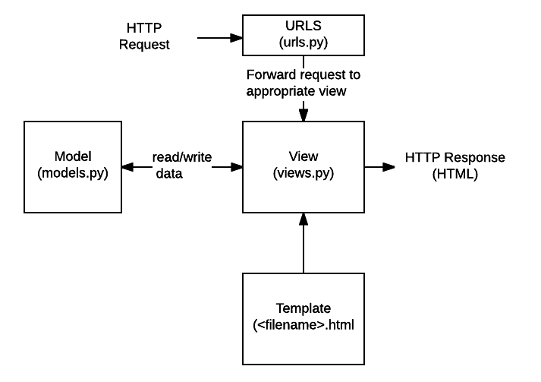URLs:

While it is possible to process requests from every single URL via a single function, it is much more maintainable to write a separate view function to handle each resource. A URL mapper is used to redirect HTTP requests to the appropriate view based on the request URL. The URL mapper can also match particular patterns of strings or digits that appear in a URL and pass these to a view function as data.

* View: A view is a request handler function, which receives HTTP requests and returns HTTP responses. Views access the data needed to satisfy requests via models, and delegate the formatting of the response to templates.
* Models: Models are Python objects that define the structure of an application's data, and provide mechanisms to manage (add, modify, delete) and query records in the database.
* Templates: A template is a text file defining the structure or layout of a file (such as an HTML page), with placeholders used to represent actual content. A view can dynamically create an HTML page using an HTML template, populating it with data from a model. A template can be used to define the structure of any type of file; it doesn't have to be HTML!

**Database Design**

**SQLite Database:**

SQLite is an in-process library that implements a self-contained, serverless, zero-configuration, transactional SQL database engine. It is a database, which is zero-configured, which means like other databases you do not need to configure it in your system.

SQLite engine is not a standalone process like other databases, you can link it statically or dynamically as per your requirement with your application. SQLite accesses its storage files directly.

## Why SQLite?

* SQLite does not require a separate server process or system to operate (serverless).
* SQLite comes with zero-configuration, which means no setup or administration needed.
* A complete SQLite database is stored in a single cross-platform disk file.
* SQLite is very small and light weight, less than 400KiB fully configured or less than 250KiB with optional features omitted.
* SQLite is self-contained, which means no external dependencies.
* SQLite transactions are fully ACID-compliant, allowing safe access from multiple processes or threads.
* SQLite supports most of the query language features found in SQL92 (SQL2) standard.
* SQLite is written in ANSI-C and provides simple and easy-to-use API.
* SQLite is available on UNIX (Linux, Mac OS-X, Android, iOS) and Windows (Win32, WinCE, WinRT).

## SQLite Limitations

There are few unsupported features of SQL92 in SQLite which are listed in the following table.

|  |  |
| --- | --- |
| S.No | Feature & Description |
| 1 | **RIGHT OUTER JOIN**  Only LEFT OUTER JOIN is implemented. |
| 2 | **FULL OUTER JOIN**  Only LEFT OUTER JOIN is implemented. |
| 3 | **ALTER TABLE**  The RENAME TABLE and ADD COLUMN variants of the ALTER TABLE command are supported. The DROP COLUMN, ALTER COLUMN, ADD CONSTRAINT are not supported. |
| 4 | **Trigger support**  FOR EACH ROW triggers are supported but not FOR EACH STATEMENT triggers. |
| 5 | **VIEWs**  VIEWs in SQLite are read-only. You may not execute a DELETE, INSERT, or UPDATE statement on a view. |
| 6 | **GRANT and REVOKE**  The only access permissions that can be applied are the normal file access permissions of the underlying operating system. |

## SQLite Commands

The standard SQLite commands to interact with relational databases are similar to SQL. They are CREATE, SELECT, INSERT, UPDATE, DELETE and DROP. These commands can be classified into groups based on their operational nature −

## DDL - Data Definition Language

|  |  |
| --- | --- |
| S.No | Command & Description |
| 1 | **CREATE**  Creates a new table, a view of a table, or other object in database. |
| 2 | **ALTER**  Modifies an existing database object, such as a table. |
| 3 | **DROP**  Deletes an entire table, a view of a table or other object in the database. |

## DML - Data Manipulation Language

|  |  |
| --- | --- |
| S.No. | Command & Description |
| 1 | **INSERT**  Creates a record |
| 2 | **UPDATE**  Modifies records |
| 3 | **DELETE**  Deletes records |

## DQL - Data Query Language

|  |  |
| --- | --- |
| S.No | Command & Description |
| 1 | **SELECT**  Retrieves certain records from one or more tables |

## **Jupyter Notebook**

The Jupyter Notebook is an incredibly powerful tool for interactively developing and presenting data science projects. This article will walk you through how to use Jupyter Notebooks for data science projects and how to set it up on your local machine.

A notebook integrates code and its output into a single document that combines visualizations, narrative text, mathematical equations, and other rich media. In other words: it’s a single document where you can run code, display the output, and also add explanations, formulas, charts, and make your work more transparent, understandable, repeatable, and shareable.

Using Notebooks is now a major part of the data science workflow at companies across the globe. If your goal is to work with data, using a Notebook will speed up your workflow and make it easier to communicate and share your results.

Jupyter Notebooks can also act as a flexible platform for getting to grips with pandas and even Python, as will become apparent in this tutorial.

We will:

* Cover the basics of installing Jupyter and creating your first notebook
* Delve deeper and learn all the important terminology
* Explore how easily notebooks can be shared and published online.

The short answer: each .ipynb file is one notebook, so each time you create a new notebook, a new  .ipynb file will be created.

**5. General Description**

Sentiment analysis, also referred to as opinion mining, is **an approach to natural language processing (NLP) that identifies the emotional tone behind a body of text**. This is a popular way for organizations to determine and categorize opinions about a product, service, or idea.

The Meyers-Briggs Type Indicator (MBTI) is **a self-help assessment test which helps people gain insights about how they work and learn**. It is a framework for relationship-building, developing positivism, and achieving excellence.

**What is MBTI?**

The Myers Briggs Type Indicator (or MBTI for short) is a personality type system that divides everyone into 16 distinct personality types across 4 axis:

* Introversion (I) – Extroversion (E)
* Intuition (N) – Sensing (S)
* Thinking (T) – Feeling (F)
* Judging (J) – Perceiving (P)

(More can be learned about what these mean here)

So for example, someone who prefers introversion, intuition, thinking and perceiving would be labelled an INTP in the MBTI system, and there are lots of personality based components that would model or describe this person’s preferences or behaviour based on the label.

It is one of, if not the, the most popular personality test in the world. It is used in businesses, online, for fun, for research and lots more. A simple google search reveals all of the different ways the test has been used over time. It’s safe to say that this test is still very relevant in the world in terms of its use.

From scientific or psychological perspective it is based on the work done on cognitive functions by Carl Jung i.e. Jungian Typology. This was a model of 8 distinct functions, thought processes or ways of thinking that were suggested to be present in the mind. Later this work was transformed into several different personality systems to make it more accessible, the most popular of which is of course the MBTI.

Recently, its use/validity has come into question because of unreliability in experiments surrounding it, among other reasons. But it is still clung to as being a very useful tool in a lot of areas, and the purpose of this dataset is to help see if any patterns can be detected in specific types and their style of writing, which overall explores the validity of the test in analysing, predicting or categorising behaviour.

## Content

This dataset contains over 8600 rows of data, on each row is a person’s:

* Type (This persons 4 letter MBTI code/type)
* A section of each of the last 50 things they have posted (Each entry separated by "|||" (3 pipe characters))

This data was collected through the PersonalityCafe forum, as it provides a large selection of people and their MBTI personality type, as well as what they have written.

Some basic uses could include:

* Use machine learning to evaluate the MBTIs validity and ability to predict language styles and behaviour online.
* Production of a machine learning algorithm that can attempt to determine a person’s personality type based on some text they have written.

# Myers–Briggs Type Indicator

Several terms (e.g., ENTP and ISFJ) redirect here. These are Myers–Briggs personality types but are also used in Socionics and the Keirsey Temperament Sorter.

[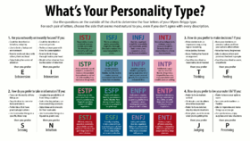](https://en.wikipedia.org/wiki/File:MyersBriggsTypes.png)

A chart with descriptions of each Myers–Briggs personality type and the four dichotomies central to the theory.

In personality typology, the **Myers–Briggs Type Indicator** (**MBTI**) is an introspective self-report questionnaire indicating differing psychological preferences in how people perceive the world and make decisions. The test attempts to assign a value to each of four categories: introversion or extraversion, sensing or intuition, thinking or feeling, and judging or perceiving. One letter from each category is taken to produce a four-letter test result, such as "INTJ" or "ESFP".

The MBTI was constructed by two Americans, Katharine Cook Briggs and her daughter Isabel Briggs Myers, who were inspired by the book *Psychological Types* by Swiss psychiatrist Carl Jung. Isabel Myers was particularly fascinated by the concept of introversion and she typed herself as an INFP. However, she felt the book was too complex for the general public, and therefore she tried to organize the Jungian cognitive functions to make it more accessible.

Most of the research supporting the MBTI's validity has been produced by the Center for Applications of Psychological Type, an organization run by the Myers-Briggs Foundation, and published in the center's own journal, the *Journal of Psychological Type (JPT)*, raising questions of independence, bias, and conflict of interest.Though the MBTI resembles some psychological theories, it has been criticized as pseudoscience and is not widely endorsed by academic researchers in the psychology field. The indicator exhibits significant scientific (psychometric) deficiencies, including poor validity, poor reliability, measuring categories that are not independent, and not being comprehensive.

## History

[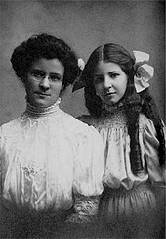](https://en.wikipedia.org/wiki/File:Art-mb2-300x0.jpeg)

Briggs began her research into personality in 1917. Upon meeting her future son-in-law, she observed marked differences between his personality and that of other family members. Briggs embarked on a project of reading biographies, and subsequently developed a typology wherein she proposed four temperaments: *meditative* (or thoughtful), *spontaneous*, *executive*, and *social*.

After the English translation of Carl Jung's book *Psychological Types* was published in 1923 (first published in German in 1921), Briggs recognized that Jung's theory was similar to, but went far beyond, her own. Briggs's four types were later identified as corresponding to the *IXXXs* (Introverts: "meditative"), *EXXPs* (Extraverts & Prospectors: "spontaneous"), *EXTJs* (Extraverts, Thinkers & Judgers: "executive") and *EXFJs* (Extraverts, Feelers & Judgers: "social"). Her first publications were two articles describing Jung's theory, in the journal *New Republic* in 1926 ("Meet Yourself Using the Personality Paint Box") and 1928 ("Up From Barbarism"). After extensively studying the work of Jung, Briggs and her daughter extended their interest in human behavior into efforts to turn the theory of psychological types to practical use.

Although Myers graduated from Swarthmore College in 1919, neither Myers nor Briggs was formally educated in the discipline of psychology, and both were self-taught in the field of psychometric testing. Myers therefore apprenticed herself to Edward N. Hay, who was personnel manager for a large Philadelphia bank. From Hay, Myers learned rudimentary test *construction*, *scoring*, *validation*, and *statistical* methods.

Briggs and Myers began creating their indicator during World War II[2] in the belief that a knowledge of personality preferences would help women entering the industrial workforce for the first time to identify the sorts of war-time jobs that would be the "most comfortable and effective" for them. The *Briggs Myers Type Indicator Handbook* was published in 1944, and changed its name to "Myers–Briggs Type Indicator" in 1956.

Myers' work attracted the attention of Henry Chauncey, head of the Educational Testing Service. Under these auspices, the first MBTI "manual" was published, in 1962. The MBTI received further support from Donald W. MacKinnon, head of the Institute of Personality and Social Research at the University of California, Berkeley; W. Harold Grant, a professor at Michigan State University and Auburn University; and Mary H. McCaulley of the University of Florida. The publication of the MBTI was transferred to Consulting Psychologists Press in 1975, and the Center for Applications of Psychological Type was founded as a research laboratory.

After Myers' death in May 1980, Mary McCaulley updated the MBTI manual, and the second edition was published in 1985. The third edition appeared in 1998.

### Format and administration[edit]

In 1987, an advanced scoring system was developed for the MBTI. From this was developed the Type Differentiation Indicator (TDI),which is a scoring system for the longer MBTI, Form J,which includes the 290 items written by Myers that had survived her previous item analyses. It yields 20 subscales (five under each of the four dichotomous preference scales), plus seven additional subscales for a new "comfort-discomfort" factor (which parallels, though not perfectly measuring, the missing factor of neuroticism). This factor's scales indicate a sense of overall comfort and confidence versus discomfort and anxiety. They also load onto one of the four type dimensions:

* guarded-optimistic (T/F),
* defiant-compliant (T/F),
* carefree-worried (T/F),
* decisive-ambivalent (J/P),
* intrepid-inhibited (E/I),
* leader-follower (E/I), and
* proactive-distractible (J/P).

Also included is a composite of these called "strain". There are also scales for type-scale consistency and comfort-scale consistency. Reliability of 23 of the 27 TDI subscales is greater than 0.50, "an acceptable result given the brevity of the subscales."

In 1989, a scoring system was developed for only the 20 subscales for the original four dichotomies. This was initially known as Form K or the Expanded Analysis Report. This tool is now called the MBTI Step II.

Form J or the TDI included the items (derived from Myers' and McCaulley's earlier work) necessary to score what became known as Step III. (The 998 *MBTI Manual* reported that the two instruments were one and the same) It was developed in a joint project involving the following organizations: the Myers-Briggs Company, the publisher of all the MBTI works; the Center for Applications of Psychological Type (CAPT), which holds all of Myers' and McCaulley's original work; and the MBTI Trust headed by Katharine and Peter Myers. Step III was advertised as addressing type development and the use of perception and judgment by respondents.

## Concepts

The MBTI is based on the influential theory of psychological types proposed by Swiss psychiatrist Carl Jung in 1921, who had speculated that people experience the world using four principal psychological functions—sensation, intuition, feeling, and thinking—and that one of these four functions is dominant for a person most of the time. The four categories are introversion/extraversion, sensing/intuition, thinking/feeling, judging/perceiving. According to the MBTI, each person is said to have one preferred quality from each category, producing 16 unique types.

The MBTI emphasizes the value of naturally occurring differences. "The underlying assumption of the MBTI is that we all have specific preferences in the way we construe our experiences, and these preferences underpin our interests, needs, values, and motivation."

The MBTI *Manual* states that the indicator "is designed to implement a theory; therefore, the theory must be understood to understand the MBTI". Fundamental to the MBTI is the hypothesis of psychological types as originally developed by Carl Jung. Jung proposed the existence of two dichotomous pairs of cognitive functions:

* The "rational" (judging) functions: thinking and feeling.
* The "irrational" (perceiving) functions: sensation and intuition.

Jung believed that for every person, each of the functions is expressed primarily in either an introverted or extraverted form. Based on Jung's original concepts, Briggs and Myers developed their own theory of psychological type, described below, on which the MBTI is based. However, although psychologist Hans Eysenck called the MBTI a moderately successful quantification of Jung's original principles as outlined in *Psychological Types*, he also said, "[The MBTI] creates 16 personality types which are said to be similar to Jung's theoretical concepts. I have always found difficulties with this identification, which omits one half of Jung's theory (he had 32 types, by asserting that for every *conscious* combination of traits there was an opposite *unconscious* one). Obviously, the latter half of his theory does not admit of questionnaire measurement, but to leave it out and pretend that the scales measure Jungian concepts is hardly fair to Jung." In any event, both models remain hypothetical, with no controlled scientific studies supporting either Jung's original concept of type or the Myers–Briggs variation.

### Differences from Jung

Jung did not see the types (such as intra- and extraversion) as dualistic, but rather as tendencies: both are innate and have the potential to balance.

Jung's typology theories postulated a sequence of four cognitive functions (thinking, feeling, sensation, and intuition), each having one of two polar tendencies (extraversion or introversion), giving a total of eight dominant functions. The MBTI is based on these eight hypothetical functions, although with some differences in expression from Jung's model. While the Jungian model offers empirical evidence for the first three dichotomies, whether the Briggs had evidence for the J-P preference is unclear.[*verification needed*]

The most notable addition of Myers' and Briggs' ideas to Jung's original thought is their concept that a given type's fourth letter (J or P) indicates a person's most preferred extraverted function, which is the dominant function for extraverted types and the auxiliary function for introverted types.

Jung hypothesised that the dominant function acts alone in its preferred world: exterior for extraverts and interior for introverts. The remaining three functions, he suggested, operate in the opposite orientation. Some MBTI practitioners, however, place doubt on this concept as being a category error with next to no empirical evidence backing it relative to other findings with correlation evidence, yet as a theory it still remains part of Myers' and Briggs' extrapolation of their original theory despite being discounted.

Jung's hypothesis can be summarised as: if the dominant cognitive function is introverted, then the other functions are extraverted and vice versa. The MBTI *Manual* summarizes Jung's work of balance in psychological type as follows: "There are several references in Jung's writing to the three remaining functions having an opposite attitudinal character. For example, in writing about introverts with thinking dominant ... Jung commented that the counterbalancing functions have an extraverted character." Using the INTP type as an example, the orientation according to Jung would be as follows:

* Dominant introverted thinking
* Auxiliary extraverted intuition
* Tertiary introverted sensing
* Inferior extraverted feeling

#### Type dynamics and development

[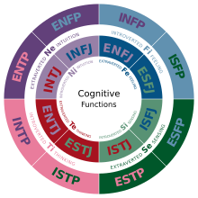](https://en.wikipedia.org/wiki/File:Cognitive_Functions.svg)

A diagram depicting the cognitive functions of each type: A type's background color represents it’s dominant function and its text color represents its auxiliary function.

Jung's typological model regards psychological type as similar to left or right handedness: people are either born with, or develop, certain preferred ways of perceiving and deciding. The MBTI sorts some of these psychological differences into four opposite pairs, or "dichotomies", with a resulting 16 possible psychological types. None of these are considered to be "better" or "worse"; however, Briggs and Myers theorized that people innately "prefer" one overall combination of type differences.In the same way that writing with the left hand is difficult for a right-hander, so people tend to find using their opposite psychological preferences more difficult, though they can become more proficient (and therefore behaviorally flexible) with practice and development.

The 16 types are typically referred to by an abbreviation of four letters—the initial letters of each of their four type preferences (except in the case of intuition, which uses the abbreviation "N" to distinguish it from introversion). For instance:

* **ESTJ**: extraversion (E), sensing (S), thinking (T), judgment (J)
* **INFP**: introversion (I), intuition (N), feeling (F), perception (P)

These abbreviations are applied to all 16 types.

The interaction of two, three, or four preferences is known as "type dynamics". Although type dynamics has received little or no empirical support to substantiate its viability as a scientific theory, Myers and Briggs asserted that for each of the 16 four-preference types, one function is the most *dominant* and is likely to be evident earliest in life. A secondary or *auxiliary* function typically becomes more evident (differentiated) during teenaged years and provides balance to the dominant. In normal development, individuals tend to become more fluent with a third, *tertiary* function during mid-life, while the fourth, *inferior* function remains least consciously developed. The inferior function is often considered to be more associated with the unconscious, being most evident in situations such as high stress (sometimes referred to as being "in the grip" of the inferior function).

However, the use of type dynamics is disputed: in the conclusion of various studies on the subject of type dynamics, James H. Reynierse writes, "Type dynamics has persistent logical problems and is fundamentally based on a series of category mistakes; it provides, at best, a limited and incomplete account of type related phenomena"; and "type dynamics relies on anecdotal evidence, fails most efficacy tests, and does not fit the empirical facts". His studies gave the clear result that the descriptions and workings of type dynamics do not fit the real behavior of people. He suggests getting completely rid of type dynamics, because it does not help, but hinders understanding of personality. The presumed order of functions 1 to 4 did only occur in one out of 540 test results.

**Product Perspective:**

Persoanlity and Sentiment test is a web application which will be operate by the user and control by admistration. It’s support to many pheripharal device like keyboard, monitor, mobile, etc.

**Product Functions:**

* It is very easy to use.
* It saves a lot of time, money and labour.
* The software acts as an office that is open 24/7.
* It helps to know the characterstics of people.
* It helps to know the sentiments of the people.

**User Characteristics:**

This application will be operate by basic technical skills of the user where user can easily operate application properly. User will be very interest to used this application and user will also know about themselves by using this application.

**General Constraints:**

While designing this system, we can’t able to imagine what is going to the user mind. User can also write false information that manipulate the application.

**Assumptions and Dependencies:**

While developing this software, we assume that the computer is having preinstall minimum web browser in the system and with python installed.

**6. Functional Requirements and Non-functional Requirements**

Requirement analysis is a software engineering technique that is composed of the various tasks that determine the needs or conditions that are to be met for a new or altered product, taking into consideration the possible conflicting requirements of the various users.

**I. Functional Requirements:**

Functional requirements are those requirements that are used to illustrate the internal working nature of the system, the description of the system, and explanation of each subsystem. It consists of what task the system should perform, the processes involved, which data should the system holds and the interfaces with the user.

The functional requirements identified are:

* **User’s registration:** The system should allow new users to register and test the personality and sentiments.
* **Personality Test:** User is allow to type the text in the textbox and used to perdict what type of persoanlity user is having.
* **Automatic update to database once reservation is made or new customer registered:** Whenever there’s new reservation or new registration, the system should be able update the database without any additional efforts from the admin.
* **Sentiment Test:** User is allow to type the text in the textbox and used to predict what type of sentiment test about the user.
* **Language Translate:** User is allow to type the text in the textbox in english and help to convert into Kannada Language.
* **Admin Mode:** It is used to keep the record of administration and manage the whole application. It’s also called super user.

**II. Non-Functional Requirements**

It describes aspects of the system that are concerned with how the system provides the functional requirements.

They are:

* **Security:**

The subsystem should provide a high level of security and integrity of the data held by the system, only authorized personnel of the company can gain access to the company’s secured page on the system; and only users with valid password and username can login to view user’s page.

* **Performance and Response time:**

The system should have high performance rate when executing user’s input and should be able to provide feedback or response within a short time span usually 50 seconds for highly complicated task and 20 to 25 seconds for less complicated task.

* **Error handling:**

Error should be considerably minimized and an appropriate error message that guides the user to recover from an error should be provided. Validation of user’s input is highly essential. Also the standard time taken to recover from an error should be 15 to 20 seconds.

* **Availability:**

This system should always be available for access at 24 hours, 7 days a week. Also in the occurrence of any major system malfunctioning, the system should be available in 1 to 2 working days, so that the business process is not severely affected.

* **Ease of use:**

Considered the level of knowledge possessed by the users of this system, a simple but quality user interface should be developed to make it easy to understand and required less training.

**7. System Architecture**

Here, we have one Desktop application which is connected with Database and one is for User who operate the Software.

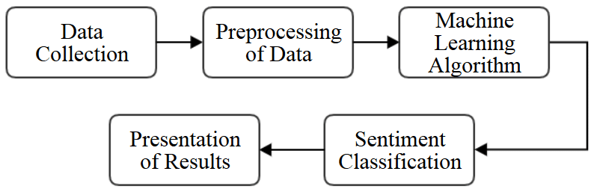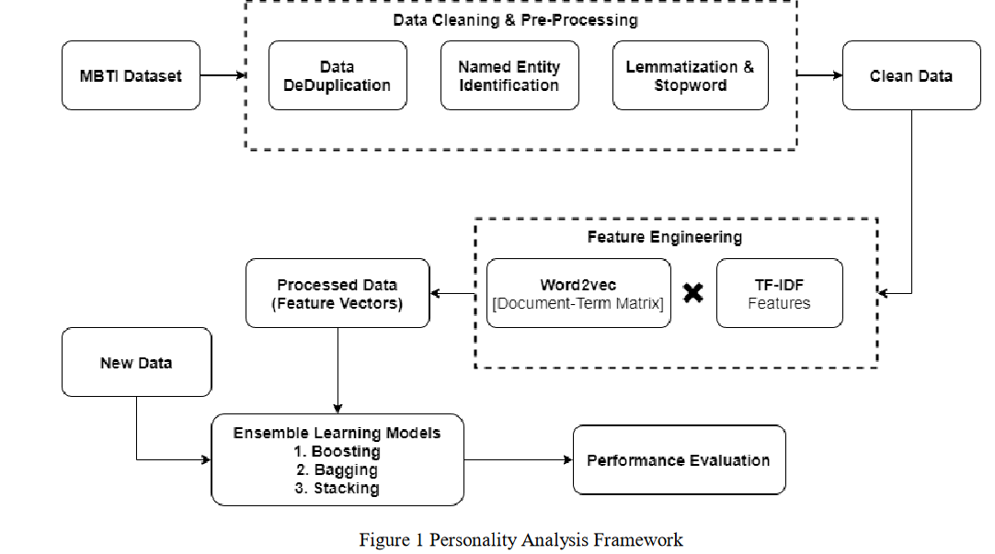Fig. Of System Architecture

**8. System Model**

The SDLC(Software Development Life Cycle) method will be used to defining tasks performed at each step in the software development process. SDLC is a structure followed by a development team within the software organization. It consists of a detailed plan describing how to develop, maintain and replace specific software.

**Waterfall Model:**

For SDLC, we used **Waterfall Model** which is developed by W. W. Royce and defined as the development of sequential completion of one steps after the other like analysis, design, implementation, 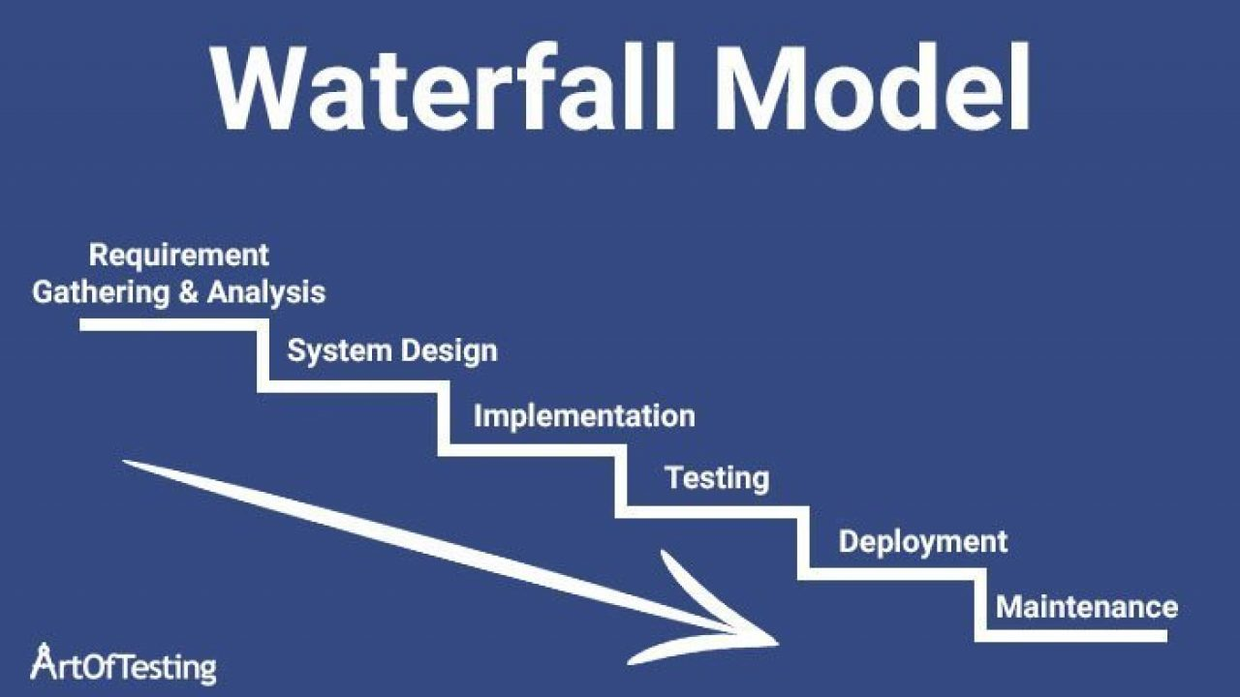testing, integration and maintenance.

1. **Requirement Gathering and Analysis:**

We gather the information of the manual Rental System and analysis the drawbacks. So, to overcome that drawback we are going to implement all the services in VRMS(Vehicle Rental Management System) . We gather the customer details and requirement about the process where we perform different feasibility study like

**Feasibility Study:**

A feasibility study is an analysis that considers all of a project's relevant factors—including economic, technical, legal, and scheduling considerations—to ascertain the likelihood of completing the project successfully. We perform different feasibility study whether to take project further or not. They are:

**Economic Feasibility:**

After studying all the requirement we came to know that software is profitable or not for us.

**Technical Feasibility:**

We also study, what type of technology to used in the project and to developed the project.

**Operational Feasibility:**

We also research on whether the staff can operate it properly or not.

**II. Software Design:**

Software Design is an iterative process through which requirements are translated into a “blueprint” for developing the software.

**ER Model**

* ER model stands for an Entity-Relationship model. It is a high-level data model. This model is used to define the data elements and relationship for a specified system.
* It develops a conceptual design for the database. It also develops a very simple and easy to design view of data.
* In ER modeling, the database structure is portrayed as a diagram called an entity-relationship diagram.

For example, Suppose we design a school database. In this database, the student will be an entity with attributes like address, name, id, age, etc. The address can be another entity with attributes like city, street name, pin code, etc and there will be a relationship between them.

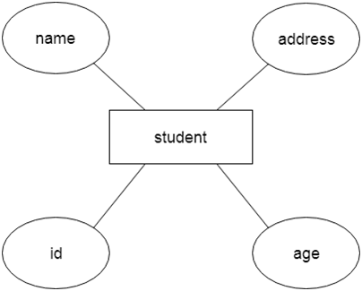

## Component of ER Diagram

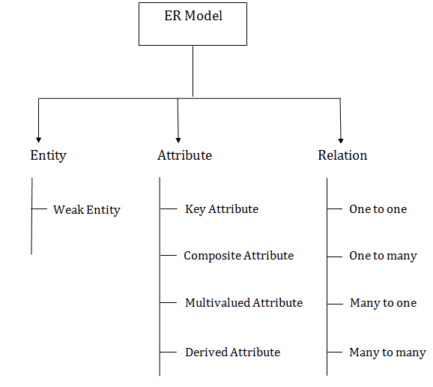

### 1. Entity:

An entity may be any object, class, person or place. In the ER diagram, an entity can be represented as rectangles.

Consider an organization as an example- manager, product, employee, department etc. can be taken as an entity.

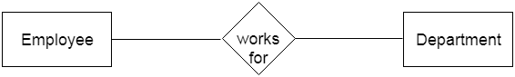

a. Weak Entity

An entity that depends on another entity called a weak entity. The weak entity doesn't contain any key attribute of its own. The weak entity is represented by a double rectangle.

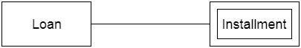

### 2. Attribute

The attribute is used to describe the property of an entity. Eclipse is used to represent an attribute.

For example, id, age, contact number, name, etc. can be attributes of a student.

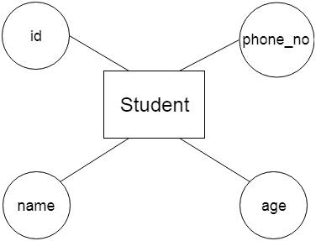

a. Key Attribute

The key attribute is used to represent the main characteristics of an entity. It represents a primary key. The key attribute is represented by an ellipse with the text underlined.

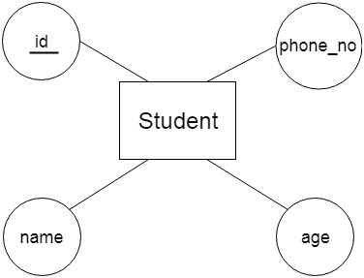

b. Composite Attribute

An attribute that composed of many other attributes is known as a composite attribute. The composite attribute is represented by an ellipse, and those ellipses are connected with an ellipse.

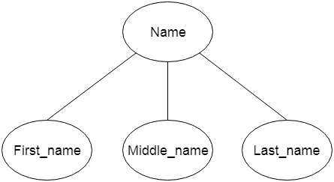

c. Multivalued Attribute

An attribute can have more than one value. These attributes are known as a multivalued attribute. The double oval is used to represent multivalued attribute.

For example, a student can have more than one phone number.

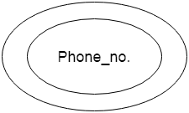

d. Derived Attribute

An attribute that can be derived from other attribute is known as a derived attribute. It can be represented by a dashed ellipse.

For example, A person's age changes over time and can be derived from another attribute like Date of birth.

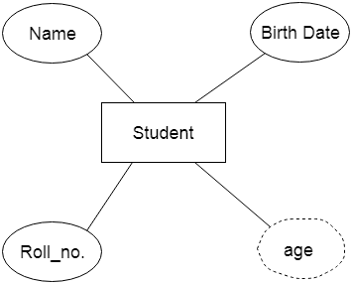

### 3. Relationship

A relationship is used to describe the relation between entities. Diamond or rhombus is used to represent the relationship.

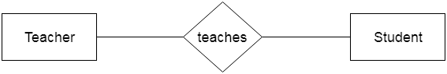

Types of relationship are as follows:

a. One-to-One Relationship

When only one instance of an entity is associated with the relationship, then it is known as one to one relationship.

For example, A female can marry to one male, and a male can marry to one female.

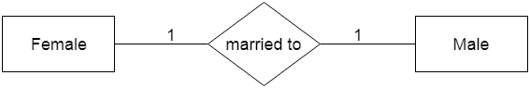

b. One-to-many relationship

When only one instance of the entity on the left, and more than one instance of an entity on the right associates with the relationship then this is known as a one-to-many relationship.

For example, Scientist can invent many inventions, but the invention is done by the only specific scientist.

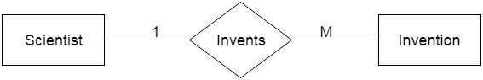

c. Many-to-one relationship

When more than one instance of the entity on the left, and only one instance of an entity on the right associates with the relationship then it is known as a many-to-one relationship.

For example, Student enrolls for only one course, but a course can have many students.

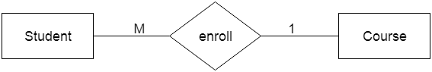

d. Many-to-many relationship

When more than one instance of the entity on the left, and more than one instance of an entity on the right associates with the relationship then it is known as a many-to-many relationship.

For example, Employee can assign by many projects and project can have many employees.

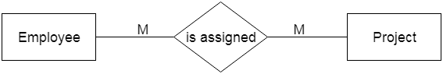

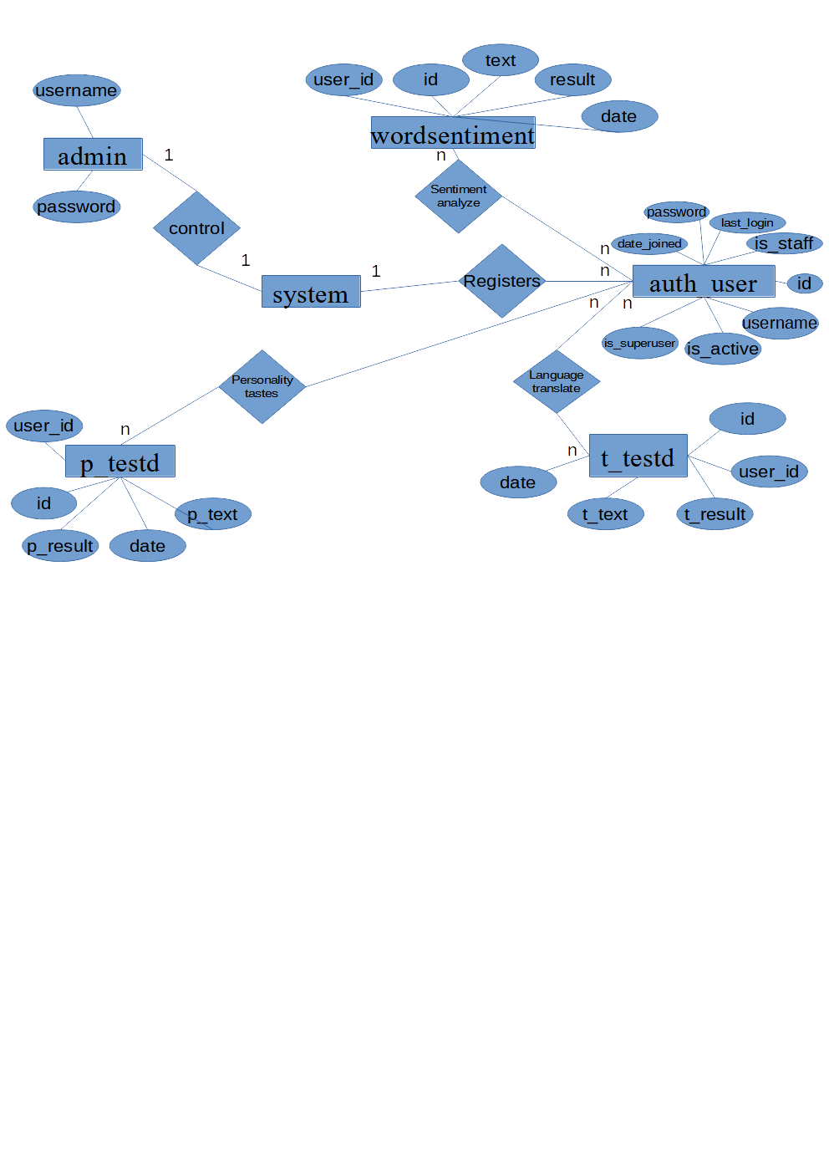Fig. Of ER Diagram

# **UML - Use Case Diagrams**

To model a system, the most important aspect is to capture the dynamic behavior. Dynamic behavior means the behavior of the system when it is running/operating.

Only static behavior is not sufficient to model a system rather dynamic behavior is more important than static behavior. In UML, there are five diagrams available to model the dynamic nature and use case diagram is one of them. Now as we have to discuss that the use case diagram is dynamic in nature, there should be some internal or external factors for making the interaction.

These internal and external agents are known as actors. Use case diagrams consists of actors, use cases and their relationships. The diagram is used to model the system/subsystem of an application. A single use case diagram captures a particular functionality of a system.

Hence to model the entire system, a number of use case diagrams are used.

## Purpose of Use Case Diagrams

The purpose of use case diagram is to capture the dynamic aspect of a system. However, this definition is too generic to describe the purpose, as other four diagrams (activity, sequence, collaboration, and Statechart) also have the same purpose. We will look into some specific purpose, which will distinguish it from other four diagrams.

Use case diagrams are used to gather the requirements of a system including internal and external influences. These requirements are mostly design requirements. Hence, when a system is analyzed to gather its functionalities, use cases are prepared and actors are identified.

When the initial task is complete, use case diagrams are modelled to present the outside view.

In brief, the purposes of use case diagrams can be said to be as follows −

* Used to gather the requirements of a system.
* Used to get an outside view of a system.
* Identify the external and internal factors influencing the system.
* Show the interaction among the requirements are actors.

## How to Draw a Use Case Diagram?

Use case diagrams are considered for high level requirement analysis of a system. When the requirements of a system are analyzed, the functionalities are captured in use cases.

We can say that use cases are nothing but the system functionalities written in an organized manner. The second thing which is relevant to use cases are the actors. Actors can be defined as something that interacts with the system.

Actors can be a human user, some internal applications, or may be some external applications. When we are planning to draw a use case diagram, we should have the following items identified.

* Functionalities to be represented as use case
* Actors
* Relationships among the use cases and actors.

Use case diagrams are drawn to capture the functional requirements of a system. After identifying the above items, we have to use the following guidelines to draw an efficient use case diagram

* The name of a use case is very important. The name should be chosen in such a way so that it can identify the functionalities performed.
* Give a suitable name for actors.
* Show relationships and dependencies clearly in the diagram.
* Do not try to include all types of relationships, as the main purpose of the diagram is to identify the requirements.
* Use notes whenever required to clarify some important points.

Following is a sample use case diagram representing the order management system. Hence, if we look into the diagram then we will find three use cases **(Order, SpecialOrder, and NormalOrder)** and one actor which is the customer.

The SpecialOrder and NormalOrder use cases are extended from *Order* use case. Hence, they have extended relationship. Another important point is to identify the system boundary, which is shown in the picture. The actor Customer lies outside the system as it is an external user of the system.

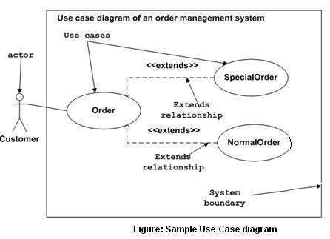

## Where to Use a Use Case Diagram?

As we have already discussed there are five diagrams in UML to model the dynamic view of a system. Now each and every model has some specific purpose to use. Actually these specific purposes are different angles of a running system.

To understand the dynamics of a system, we need to use different types of diagrams. Use case diagram is one of them and its specific purpose is to gather system requirements and actors.

Use case diagrams specify the events of a system and their flows. But use case diagram never describes how they are implemented. Use case diagram can be imagined as a black box where only the input, output, and the function of the black box is known.

These diagrams are used at a very high level of design. This high level design is refined again and again to get a complete and practical picture of the system. A well-structured use case also describes the pre-condition, post condition, and exceptions. These extra elements are used to make test cases when performing the testing.

Although use case is not a good candidate for forward and reverse engineering, still they are used in a slightly different way to make forward and reverse engineering. The same is true for reverse engineering. Use case diagram is used differently to make it suitable for reverse engineering.

In forward engineering, use case diagrams are used to make test cases and in reverse engineering use cases are used to prepare the requirement details from the existing application.

Use case diagrams can be used for −

* Requirement analysis and high level design.
* Model the context of a system.
* Reverse engineering.
* Forward engineering.

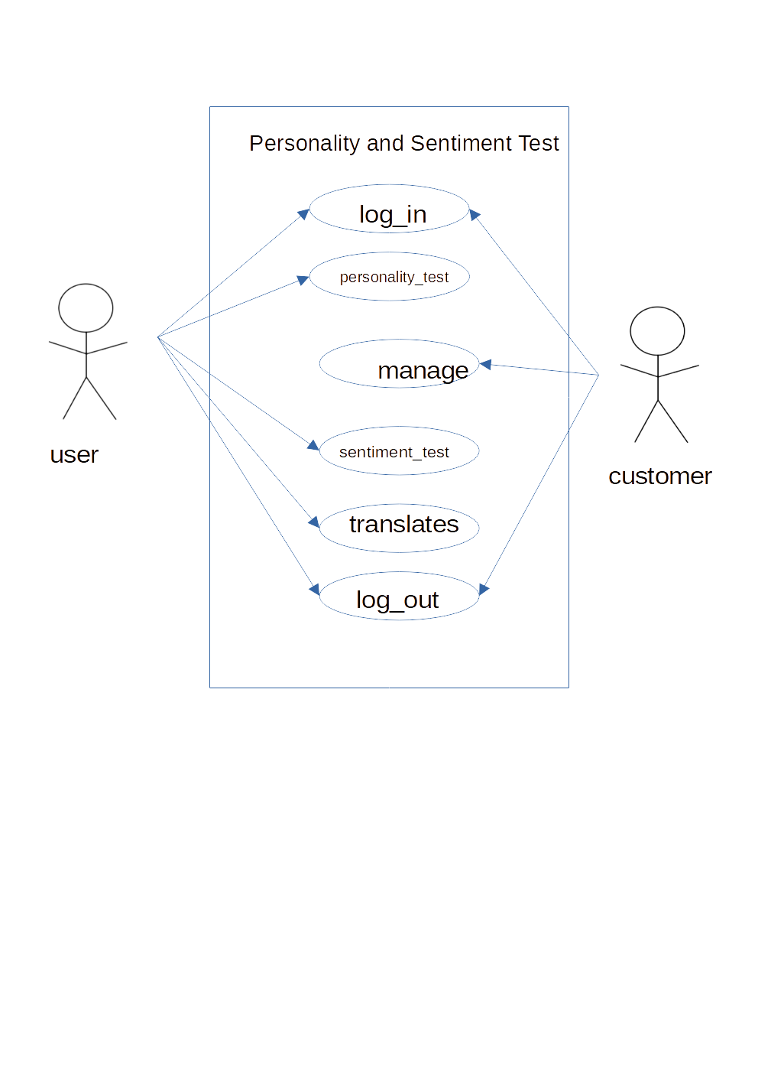fig. Of Use Case Digram

**III. Implementation**

We implement the plan of the our project after designing the process by using python django. Python Django is a web framework that allows to quickly create efficient web pages. Django is also called batteries included framework because it provides built-in features such as Django Admin Interface, default database – SQLite3, etc. When you’re building a website, you always need a similar set of components: a way to handle user authentication (signing up, signing in, signing out), a management panel for your website, forms, a way to upload files, etc. Django gives you ready-made components to use.

**Python Django FrameWork Model:**

Django, a Python framework to create web applications, is based on Model-View-Template (MVT) architecture. MVT is a software design pattern for developing a web application. It consists of the following three entities:

1. Model
2. View
3. Template

### Model

A Model is an object that defines the structure of the data in the Django application.

It is responsible for maintaining the entire application’s data for which it provides various mechanisms to add, update, read and delete the data in the database.

### View

A View is a handler function that accepts HTTP requests, processes them, and returns the HTTP response.

It retrieves the necessary data to fulfill the request using Models and renders them on the user interface using Templates.

It can also create an HTML page using an HTML template dynamically, and populate it with data fetched from the model.

### Template

A Template is a text file that defines the structure or layout of the user interface. The text file can be any type of file; for example HTML, XML, etc.

It can accept data from the view and render it using jinja syntax.

* The user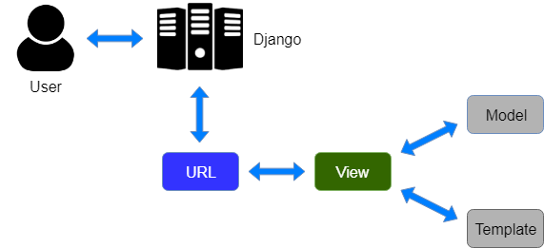 interacts with a Django application using a URL that is passed to the MVT architecture. A URL mapper is used to redirect the requests to the appropriate view based on the request URL.
* If an appropriate view is found, it will be invoked.
* The View will interact with the Model and retrieve the necessary data from the database via Model.
* The View will render an appropriate template along with the retrieved data to the user.

**IV. Testing**

Testing is the process of analyzing a software item to detect the differences between existing and required conditions and to evaluate the features of the software item.

We have perform following testing in the software.

* **Unit Testing:**

Individual components are tested to ensure that they operate correctly or not. Each component is tested independently, without referring other system components. We have tested each and every component of the software like command button, form behavior, etc.

* **Module Testing:**

A module is a collection of dependent components such as an object class, an abstract data type or some collection of procedures and function. We have tested each and every module like Staff/User module, Customer Module, etc how they are interacting with software.

* **Integration Testing:**

This phase involves testing collection of modules which have been integrated into sub-systems. We integrated each and every component and module and tested colletively to confirm wheather the system working correctly or not.

* **Acceptance Testing:**

This is the final stage in the testing process before the system is accepetd for operational use. In this testing, we provide the different input to see the how data is interacting with the software.

* **Validation:**

Validation is the process of checking that what has been specified in what the user actually wanted. We perform different validation technique to get proper input from the user like phone number validation, serial number validation, full name validation, email validation to work the software effiectively.

**V. Maintenance:**

If any problems will occurs in future, we and our team ensure for the proper maintenance of the software and the User side also have to cooperate and interact with software properly.

**9. Screen Shots**

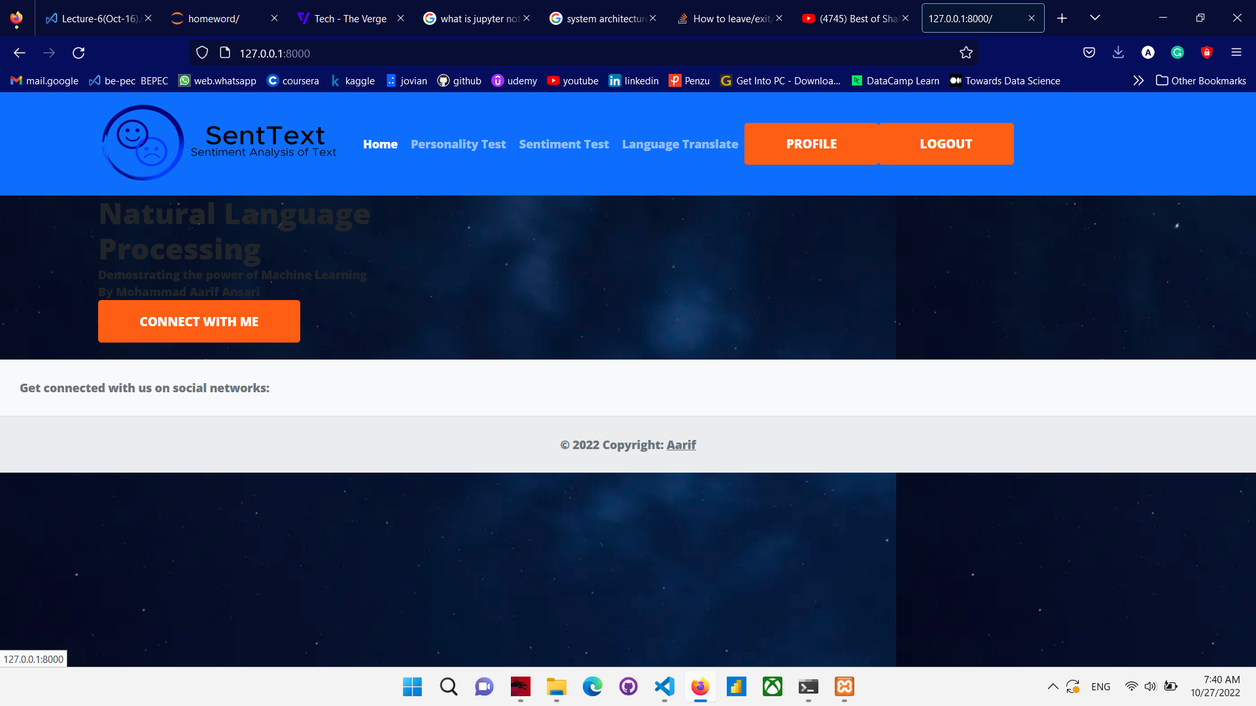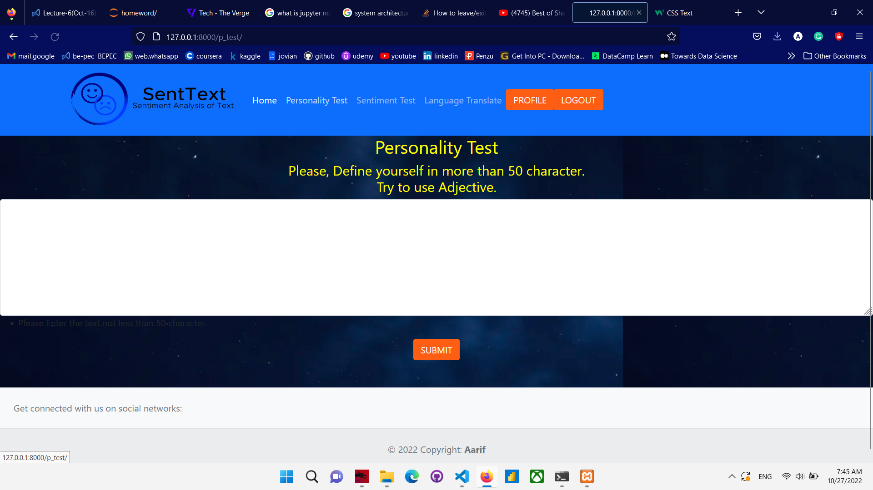

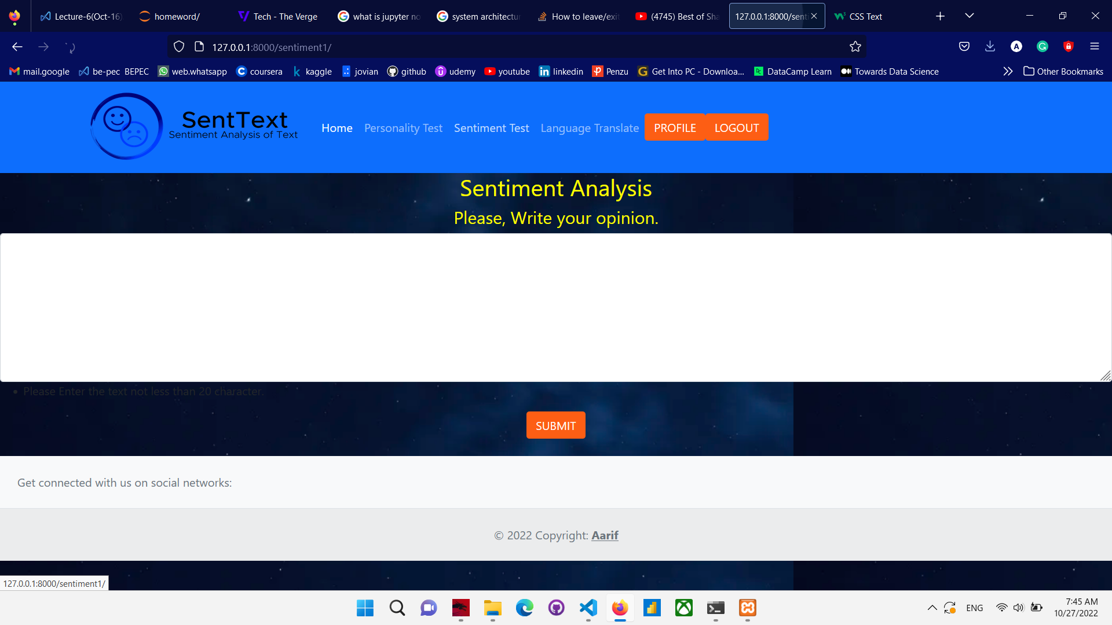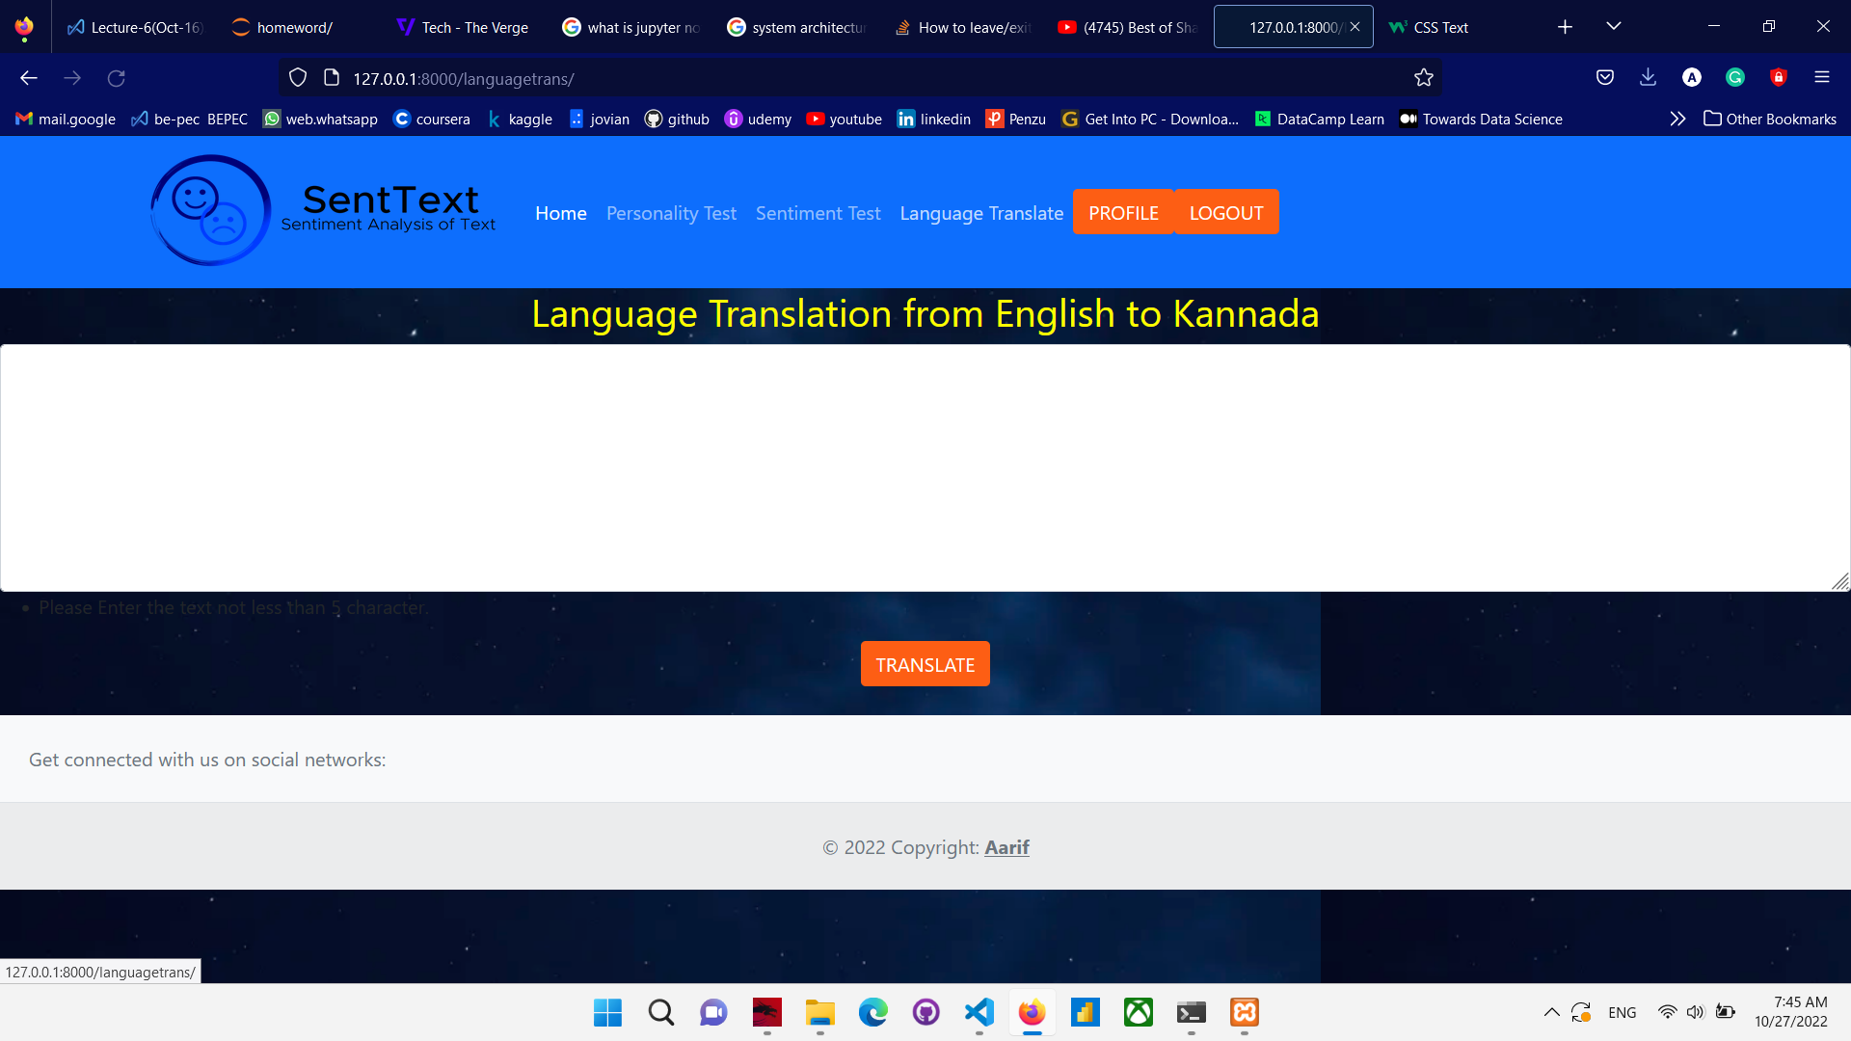

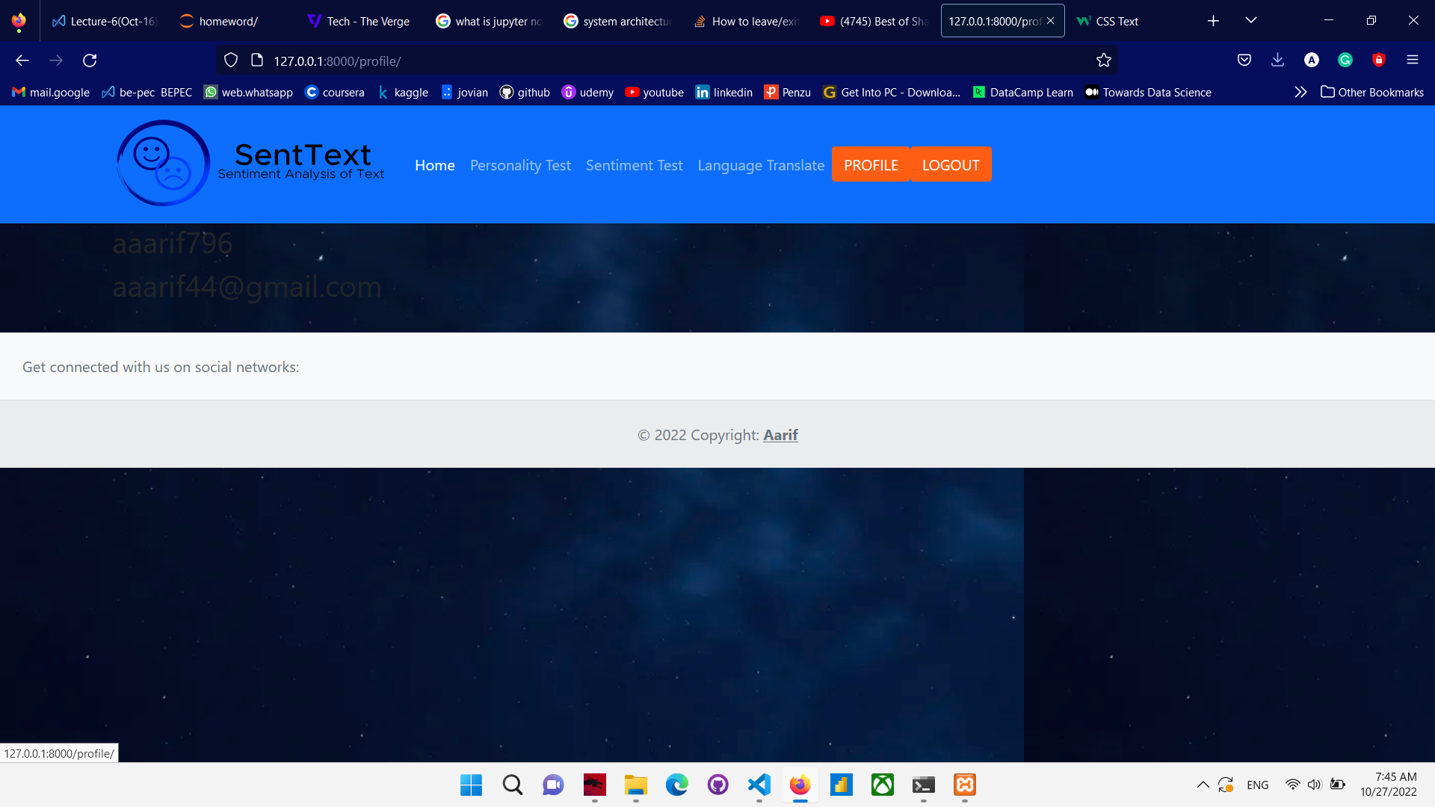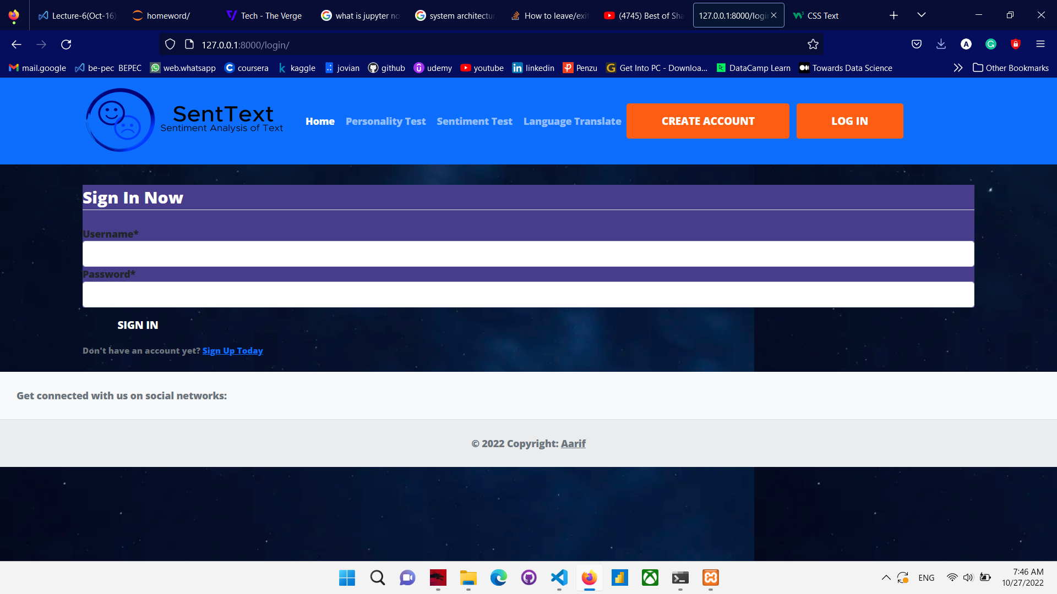

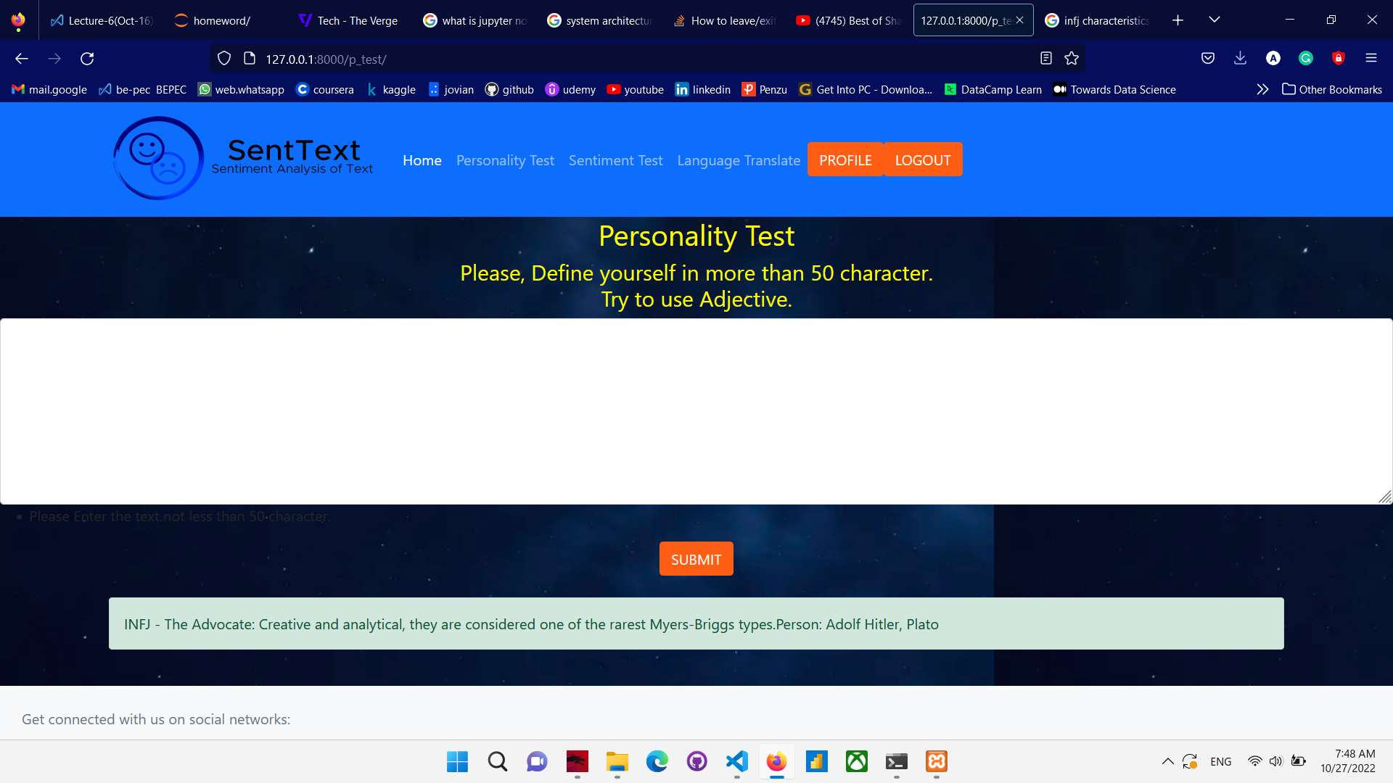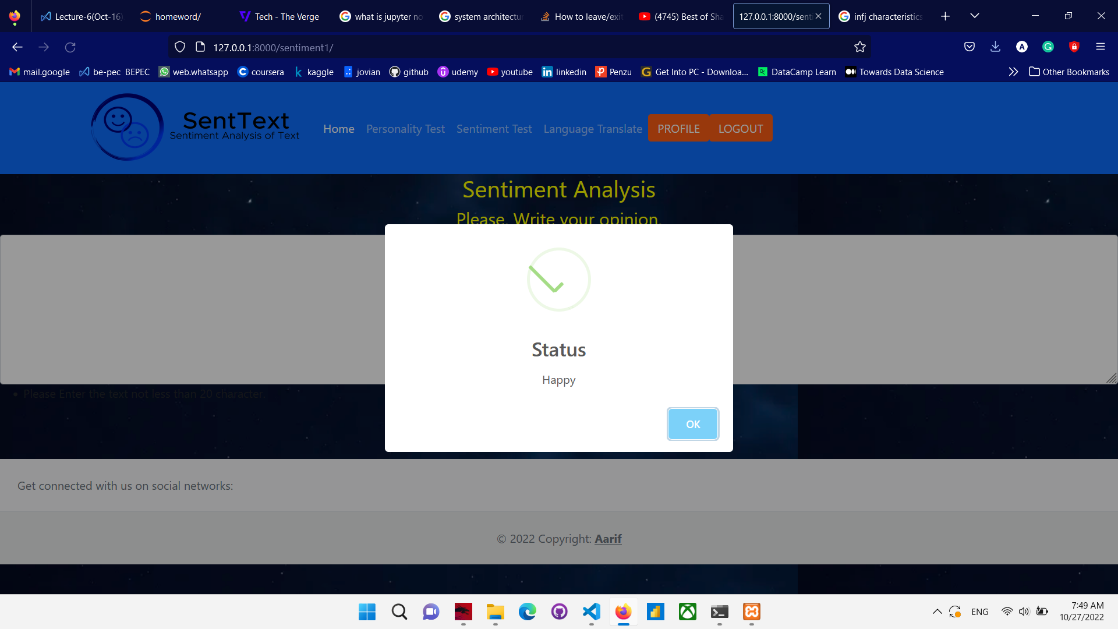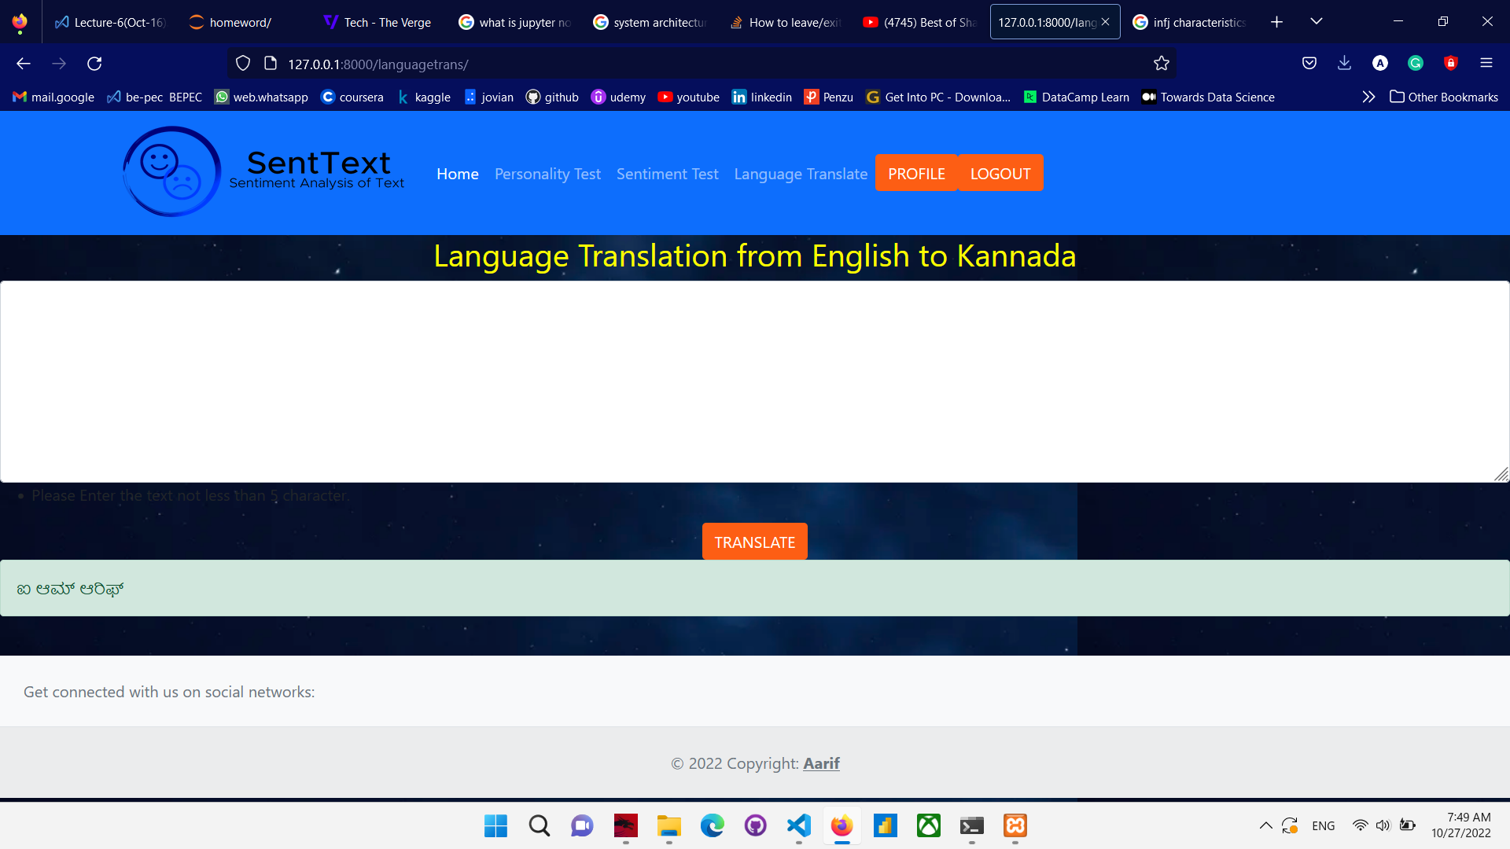

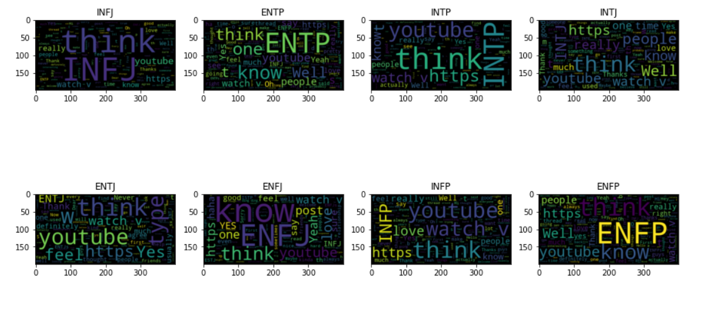

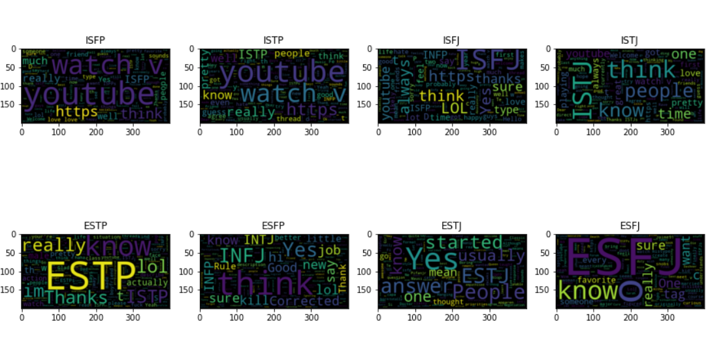

**10. Database**

auth_user

|  |  |  |  |  |  |  |  |  |
| --- | --- | --- | --- | --- | --- | --- | --- | --- |
| Id | username | email | password | date_joined | last_login | is_superuser | is_staff | is_active |
| Number | Varchar | Varchar | Varchar | Date | Date | Bool | Bool | bool |

authentication_wordsentiment

|  |  |  |  |  |
| --- | --- | --- | --- | --- |
| user_id | id | Text | date | result |
| number | number | Varchar | date | varchar |

authentication_t_testd

|  |  |  |  |  |
| --- | --- | --- | --- | --- |
| user_id | id | t_text | date | t_result |
| number | number | Varchar | date | varchar |

authentication_p_testd

|  |  |  |  |  |
| --- | --- | --- | --- | --- |
| user_id | id | p_text | date | p_result |
| number | number | Varchar | date | varchar |

**auth_user:**

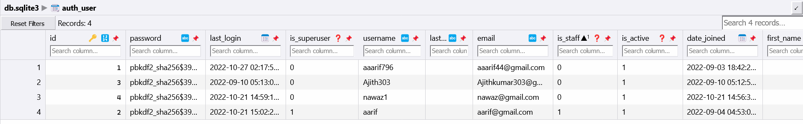

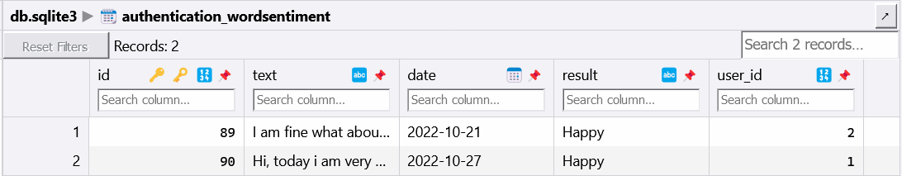**authentication_wordsentiment:**

**authentication_t_testd:**

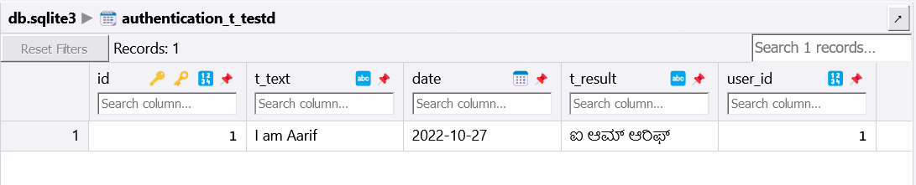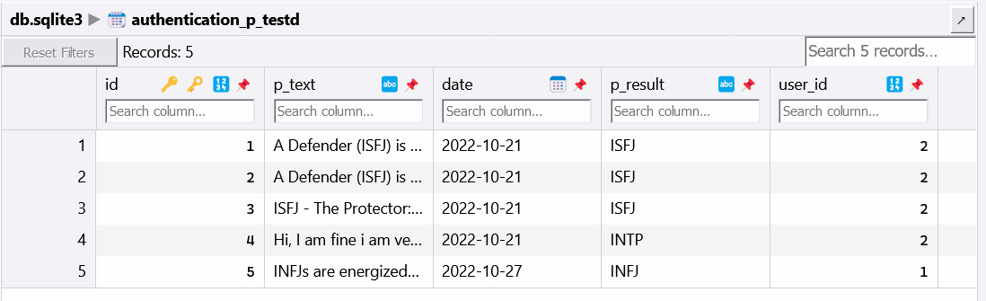**authentication_p_testd:**

**11. Coding**

**base.html**

<!doctype html>

{% load static %}

<html lang="en">

  <head>

    <!-- Required meta tags -->

    <meta charset="utf-8">

    <meta name="viewport" content="width=device-width, initial-scale=1">

    <!--Css Style -->

    <link rel="stylesheet" href="{% static 'css/main.css' %}" type="text/css">

    <!-- Bootstrap CSS -->

    <link href="https://cdn.jsdelivr.net/npm/bootstrap@5.0.0-beta3/dist/css/bootstrap.min.css" rel="stylesheet" integrity="sha384-eOJMYsd53ii+scO/bJGFsiCZc+5NDVN2yr8+0RDqr0Ql0h+rP48ckxlpbzKgwra6" crossorigin="anonymous">

    <!--Font Link-->

    <link rel="preconnect" href="https://fonts.gstatic.com">

    <link href="https://fonts.googleapis.com/css2?family=Montserrat:wght@500&family=Open+Sans:wght@800&display=swap" rel="stylesheet">

  </head>

  <body id="bg" style="background-image: url({% static 'images/bg.png' %});">

  {% load static %}

    <nav class="navbar navbar-expand-lg navbar-dark bg-primary" id="main-navbar">

        <div class="container">

          <a class="navbar-brand" href="{% url 'home' %}"><img src="{% static 'images/s_logo.png' %}" width="300" height="100" bgcolor="white" alt="" ></a>

          <button class="navbar-toggler" type="button" data-bs-toggle="collapse" data-bs-target="#navbarNavAltMarkup" aria-controls="navbarNavAltMarkup" aria-expanded="false" aria-label="Toggle navigation">

            <span class="navbar-toggler-icon"></span>

          </button>

          <div class="collapse navbar-collapse" id="navbarNavAltMarkup">

            <div class="navbar-nav">

              <a class="nav-link active" aria-current="page" href="{% url 'home' %}">Home</a>

              {% if user.is_authenticated %}

                <a class="nav-link" href="{% url 'p_test' %}">Personality Test</a>

                <a class="nav-link" href="{% url 'sentimentWord' %}" aria-current="page">Sentiment Test</a>

                <a class="nav-link" href="{% url 'languagetrans' %}" aria-current="page">Language Translate</a>

              {% else %}

                <a class="nav-link" href="">Personality Test</a>

                <a class="nav-link" href="" aria-current="page">Sentiment Test</a>

                <a class="nav-link" href="" aria-current="page">Language Translate</a>

              {% endif %}

            </div>

            <form class="d-flex" id="authstyle">

              {% if user.is_authenticated %}

                <a href="{% url 'profile' %}" class="btn" style="color: white; background-color: #fd5e14;"type="submit" id="header-links"> Profile </a>

                <a href="{% url 'logout' %}" class="btn" style="color: white; background-color: #fd5e14;"type="submit" id="header-links"> Logout </a>

              {% else %}

                <a href="{% url 'register' %}" class="btn" style="color: white; background-color: #fd5e14;"type="submit" id="header-links"> Create Account </a>

                <a href="{% url 'login' %}" class="btn" style="color: white; background-color: #fd5e14; margin-left: 10px; "type="submit" id="header-links">Log In</a>

              {% endif %}

              </form>

          </div>

        </div>

    </nav>

      <div>

        {% comment %} <div class="container">

          {% if messages %}

          {% for message in messages %}

            <div class="alert alert-{{message.tags}}">{{message}}</div>

          {% endfor %}

        {% endif %}

        </div> {% endcomment %}

        {% block content %}

        {% endblock content %}

      </div>

      <!-- Optional JavaScript; choose one of the two! -->

      <!-- Option 1: Bootstrap Bundle with Popper -->

      <script src="https://cdn.jsdelivr.net/npm/bootstrap@5.0.0-beta3/dist/js/bootstrap.bundle.min.js" integrity="sha384-JEW9xMcG8R+pH31jmWH6WWP0WintQrMb4s7ZOdauHnUtxwoG2vI5DkLtS3qm9Ekf" crossorigin="anonymous"></script>

      <!-- Option 2: Separate Popper and Bootstrap JS -->

      <!--

      <script src="https://cdn.jsdelivr.net/npm/@popperjs/core@2.9.1/dist/umd/popper.min.js" integrity="sha384-SR1sx49pcuLnqZUnnPwx6FCym0wLsk5JZuNx2bPPENzswTNFaQU1RDvt3wT4gWFG" crossorigin="anonymous"></script>

      <script src="https://cdn.jsdelivr.net/npm/bootstrap@5.0.0-beta3/dist/js/bootstrap.min.js" integrity="sha384-j0CNLUeiqtyaRmlzUHCPZ+Gy5fQu0dQ6eZ/xAww941Ai1SxSY+0EQqNXNE6DZiVc" crossorigin="anonymous"></script>

      -->

      <!-- Footer -->

  <br>

<footer class="text-center text-lg-start bg-light text-muted" button="0" style="flex-direction:column;">

  <!-- Section: Social media -->

  <section class="d-flex justify-content-center justify-content-lg-between p-4 border-bottom">

    <!-- Left -->

    <div class="me-5 d-none d-lg-block">

      <span>Get connected with us on social networks:</span>

    </div>

    <!-- Left -->

    <!-- Right -->

    <!-- Right -->

  </section>

  <div class="text-center p-4" style="background-color: rgba(0, 0, 0, 0.05);">

    © 2022 Copyright:

    <a class="text-reset fw-bold" href="">Aarif</a>

  </div>

  <!-- Copyright -->

</footer>

<!-- Footer -->

  </body>

</html>

**home.html**

{% extends 'base.html' %}

{% load static %}

{% block content %}

<link rel="stylesheet" href="{% static 'css/main.css' %}">

    <div class="container">

            <div class="row g-0">

                <div class="col-sm-6 col-md-8" id="header-text" style="color:white;">

                  <h1 id="header-h1">Natural Language <br> Processing </h1>

                  <p id="header-paragraph">Demostrating the power of Machine Learning <br> By Mohammad Aarif Ansari</p>

                  <a class="btn" href="https://www.linkedin.com/in/aarif-ansari-a6b869b6/" style="color: white; background-color: #fd5e14;"type="submit" id="body-link-row">Connect with Me</a>

                </div>

                <div class="col-6 col-md-4" id="header-image"><img src="" alt=""></div>

              </div>

    </div>

{% endblock content %}

**languagetrans.html**

{% extends 'base.html' %}

{% load crispy_forms_tags %}

{% block content%}

<form method="POST" action="">

  {% csrf_token %}

  <div class="form-group">

    <h2 style="color:yellow;text-align:center;">Language Translation from English to Kannada</h2>

  <textarea class="form-control" id="exampleFormControlTextarea1" name="text1" rows="8"></textarea>

  <label><ul><li>Please Enter the text not less than 5 character.</li></ul></label>

  <br><center>

  <button class="btn" style="color: white; background-color: #fd5e14;" type="submit" id="submit"> Translate </button>

  </center>

</div>

</form>

{% for message in messages%}

  {% if message.tags == 'success' %}

  <div id="a1" class="alert alert-{{message.tags}}">{{message}}</div>

  {% endif %}

{% endfor %}

{% endblock %}

**login.html**

{% extends 'base.html' %}

{% load crispy_forms_tags %}

{% load static %}

{% block content %}

    <link rel="stylesheet" href="{% static 'css/main.css' %}">

    <div class="container" style="margin-top: 30px;">

    <form action="" method="POST">

      {% csrf_token %}

      <fieldset class="form-group" style="background-color:darkslateblue;">

          <legend class="border-bottom mb-4" style="color: white;">Sign In Now</legend>

          {{ form|crispy }}

      </fieldset>

      <div class="form-group" id="signup-button">

          <button class="btn ">Sign In</button>

      </div>

      <div class="form-group">

          <small class="text-muted ml-3" >Don't have an account yet? <a href="{% url 'register' %}">Sign Up Today</a></small>

      </div>

    </form>

    </div>

{% endblock %}

**logout.html**

{% extends 'base.html' %}

{% load crispy_forms_tags %}

{% block content %}

  <div class='container' style="color:white;">

    <h1>You have been logged out</h1>

    <h5><a href="{% url 'login' %}">LogIn In Again</a></h5>

  </div>

{% endblock %}

**p_test.html:**

{% extends 'base.html' %}

{% load crispy_forms_tags %}

{% block content%}

<script src="https://unpkg.com/sweetalert/dist/sweetalert.min.js"></script>

<form method="POST" action="">

  {% csrf_token %}

  <div class="form-group">

    <h2 style="color:yellow;text-align:center;">Personality Test</h2>

    <h4 style="color:yellow;text-align:center;">Please, Define yourself in more than 50 character.<br>Try to use Adjective.</h4>

  <textarea class="form-control" id="exampleFormControlTextarea1" name="text1" rows="8"></textarea>

  <label><ul><li>Please Enter the text not less than 50 character.</li></ul></label>

  <br><center>

  <button class="btn" style="color: white; background-color: #fd5e14;" type="submit" id="submit"> Submit </button>

  </center>

</div>

</form>

<div>

<br>

<div class="container">

    {% if messages %}

    {% for message in messages %}

      <div id="a1" class="alert alert-{{message.tags}}">{{message}}</div>

    {% endfor %}

  {% endif %}

</div>

{% endblock %}

**profile.html**

{% extends 'base.html' %}

{% load crispy_forms_tags %}

{% block content %}

    <div class='container'>

    <h2>{{user.username}}</h2>

    <h2>{{user.email}}</h2>

    </div>

{% endblock %}

register.html

{% extends 'base.html' %}

{% load crispy_forms_tags %}

{% load static %}

{% block content %}

    <link rel="stylesheet" href="{% static 'css/main.css' %}">

    <div class="container" style="margin-top: 30px;">

    <form action="" method="POST">

      {% csrf_token %}

      <fieldset class="form-group" style="background-color:darkslateblue;">

          <legend class="border-bottom mb-4" style="color: white;">Join Now</legend>

          {{ form|crispy }}

      </fieldset>

      <div class="form-group" id="signup-button">

          <button class="btn ">Sign Up</button>

      </div>

      <div class="form-group">

          <small class="text-muted ml-3" >Already have an account? <a href="{% url 'login' %}">Sign In</a></small>

      </div>

    </form>

    </div>

{% endblock %}

**sentiment1.html**

{% extends 'base.html' %}

{% load crispy_forms_tags %}

{% block content%}

<form method="POST" action="">

  {% csrf_token %}

  <div class="form-group">

    <h2 style="color:yellow;text-align:center;">Sentiment Analysis</h2>

    <h4 style="color:yellow;text-align:center;">Please, Write your opinion.</h4>

  <textarea class="form-control" id="exampleFormControlTextarea1" name="text1" rows="8"></textarea>

  <label><ul><li>Please Enter the text not less than 20 character.</li></ul></label>

  <br><center>

  <button class="btn" style="color: white; background-color: #fd5e14;" type="submit" id="submit"> Submit </button>

  </center>

</div>

</form>

{% for message in messages%}

  {% if message.tags == 'success' %}

    <script src="https://unpkg.com/sweetalert/dist/sweetalert.min.js"></script>

    <script>

      var m="{{message}}";

      swal("Status",m,"success")

    </script>

  {% else %}

  <script src="https://unpkg.com/sweetalert/dist/sweetalert.min.js"></script>

  <script>

    var m="{{message}}";

    swal("Perfect",m,"error")

  </script>

  {% endif %}

{% endfor %}

{% endblock %}

**admin.py**

from django.contrib import admin

from authentication.models import wordSentiment

from .models import p_testd, t_testd, wordSentiment

# Register your models here.

admin.site.register(wordSentiment)

admin.site.register(p_testd)

admin.site.register(t_testd)

**apps.py**

from django.apps import AppConfig

class AuthenticationConfig(AppConfig):

    default_auto_field = 'django.db.models.BigAutoField'

    name = 'authentication'

**forms.py:**

from django.contrib.auth.models import User

from django.contrib.auth.forms import UserCreationForm

from django import forms

class UserRegisterForm(UserCreationForm):

    email=forms.EmailField()

    class Meta:

        model=User

        fields=['username','email','password1','password2']

**models.py**

from tkinter import CASCADE

from django.db import models

from django.contrib.auth.models import User

from django_userforeignkey.models.fields import UserForeignKey

# Create your models here.

class wordSentiment(models.Model):

    user=models.ForeignKey(User,on_delete=models.CASCADE)

    text=models.TextField(error_messages = {

                 'required':"Please Enter the Text"

                 })

    date=models.DateField()

    result=models.CharField(max_length=12)

    def __str__(self):

        return self.result

class p_testd(models.Model):

    user=models.ForeignKey(User,on_delete=models.CASCADE)

    p_text=models.TextField(error_messages = {

                 'required':"Please Enter the Text"

                 })

    date=models.DateField()

    p_result=models.CharField(max_length=12)

    def __str__(self):

        return self.p_result

class t_testd(models.Model):

    user=models.ForeignKey(User,on_delete=models.CASCADE)

    t_text=models.TextField(error_messages = {

                 'required':"Please Enter the Text"

                 })

    date=models.DateField()

    t_result=models.CharField(max_length=12)

    def __str__(self):

        return self.t_result

**urls.py**

from django.contrib import admin

from django.urls import path,include

from django.contrib.auth import views as auth_view

from . import views

urlpatterns = [

    path('',views.home,name='home'),

    path('register/',views.register,name='register'),

    path('profile/',views.profile,name='profile'),

    path('login/',auth_view.LoginView.as_view(template_name='login.html'),name='login'),

    path('logout',auth_view.LogoutView.as_view(template_name='logout.html'),name='logout'),

    path('sentiment1/',views.sentimentWord,name='sentimentWord'),

    path('p_test/',views.p_test,name='p_test'),

    path('languagetrans/',views.languagetrans,name='languagetrans')

]

**view.py**

from datetime import datetime

from email import message

import re

from django.http import HttpResponse,HttpRequest

from django.shortcuts import redirect, render

from django.http import HttpResponse

from django.contrib.auth.forms import UserCreationForm

from django.contrib import messages

from authentication.forms import UserRegisterForm

from authentication.models import wordSentiment,p_testd,t_testd

from textblob import TextBlob

from datetime import datetime

from nltk.stem import WordNetLemmatizer

from tqdm import tqdm

import re

import joblib

import nltk

import os

import numpy

from catboost import CatBoostClassifier

from django.contrib import messages

# Create your views here.

def home(request):

    return render(request,"home.html")

def register(request):

    if request.method=="POST":

        form=UserRegisterForm(request.POST)

        if form.is_valid():

            form.save()

            username=form.cleaned_data.get('username')

            messages.success(request,f'Hi {username},your account was created sucessfully')

            return redirect('home')

    else:

        form=UserRegisterForm()

    return render(request,'register.html',{'form':form})

def profile(request):

    return render(request,'profile.html')

def sentiment_analysis(text):

    blob=TextBlob(text)

    sent_polarity=blob.sentiment.polarity

    if(sent_polarity<-0.1):

        return "Sad"

    elif(sent_polarity>0.1):

        return "Happy"

    else:

        return "Neutral"

def languagetrans(request):

    if request.method=="POST":

        text=request.POST.get('text1')

        if len(text)>=5:

            blob=TextBlob(text)

            result=blob.translate(from_lang="en",to="kn")

            p_testdbb=t_testd(user=request.user,t_text=text,t_result=result,date=datetime.today())

            p_testdbb.save()

            messages.success(request, result)

        else:

            messages.success(request,"Please Enter character more than 5")

    return render(request,'languagetrans.html')

def sentimentWord(request):

    if request.method=="POST":

        text=request.POST.get('text1')

        if len(text)>=20:

            result=sentiment_analysis(text)

            wordsentiemt=wordSentiment(user=request.user,text=text,result=result,date=datetime.today())

            wordsentiemt.save()

            messages.success(request, result)

        else:

            messages.error(request,"Please Enter character more than 20")

    return render(request,'sentiment1.html')

# Create your views here.

def p_test(request):

    if request.method=="POST":

        text=request.POST.get('text1')

        if len(text)<=50:

            messages.success(request,"Enter the text greater than 50")

            return render(request,'p_test.html')

        list_text=[text]

        def Lemmatizer():

            lemmatizer=WordNetLemmatizer()

        def clear_text1(data):

            data_length=[]

            lemmatizer=WordNetLemmatizer()

            cleaned_text=[]

            for sentence in tqdm(data):

                sentence=sentence.lower()

                sentence=re.sub('https?://[^\s<>"]+|www\.[^\s<>"]+','',sentence)

                sentence=re.sub('[^0-9a-z]',' ',sentence)

                data_length.append(len(sentence.split()))

                cleaned_text.append(sentence)

            return cleaned_text

        text_data=clear_text1(list_text)

        target=joblib.load(os.path.join('./model/target_enc1.pkl'))

        vector=joblib.load(os.path.join('./model/vectorizertext1.pkl'))

        main_model=joblib.load(os.path.join('./model/catboostmodel1.pkl'))

        text_v=vector.transform(text_data).toarray()

        a=main_model.predict(text_v)

        result=target.classes_[a[0][0]]

        p_testdbb=p_testd(user=request.user,p_text=text,p_result=result,date=datetime.today())

        p_testdbb.save()

        str1=""

        if result=='ISTJ':

            str1="ISTJ - The Inspector: Reserved and practical, they tend to be loyal, orderly, and traditional.Person: George Washington, Henry Ford"

        elif result=='ISTP':

            str1="ISTP - The Crafter: Highly independent, they enjoy new experiences that provide first-hand learning.Person: Ernest Hemingway"

        elif result=='ISFJ':

            str1="ISFJ - The Protector: Warm-hearted and dedicated, they are always ready to protect the people they care about.Person: William H. Taft"

        elif result=='ISFP':

            str1="ISFP - The Artist: Easy-going and flexible, they tend to be reserved and artistic.Person: Marie Antoineete"

        elif result=='INFJ':

            str1="INFJ - The Advocate: Creative and analytical, they are considered one of the rarest Myers-Briggs types.Person: Adolf Hitler, Plato"

        elif result=='INFP':

            str1="INFP - The Mediator: Idealistic with high values, they strive to make the world a better place. Person: Willian Shakespeare"

        elif result=="INTJ":

            str1="INTJ - The Architect: High logical, they are both very creative and analytical. Peron: Augustus Caesar"

        elif result=="INTP":

            str1="INTP - The Thinker: Quiet and introverted, they are known for having a rich inner world.Person: Albert Einstein, Abraham Lincoln"

        elif result=="ESTP":

            str1="ESTP - The Persuader: Out-going and dramatic, they enjoy spending time with others and focusing on the here-and-now.Person: Malcolm X, Steve Jobs"

        elif result=="ESTJ":

            str1="ESTJ - The Director: Assertive and rule-oriented, they have high principles and a tendency to take charge.Person: Andrew Jackson, Saddam Hussein"

        elif result=="ESFP":

            str1="ESFP - The Performer: Outgoing and spontaneous, they enjoy taking center stage.Person: Ronal Reagan"

        elif result=="ESFJ":

            str1="ESFJ - The Caregiver: Soft-hearted and outgoing, they tend to believe the best about other people.Person: William McKinley"

        elif result=="ENFP":

            str1="ENFP - The Champion: Charismatic and energetic, they enjoy situations where they can put their creativity to work.Person: Charles Dickens, Dr. Seuss"

        elif result=="ENFJ":

            str1="ENFJ - The Giver: Loyal and sensitive, they are known for being understanding and generous.Person: Martin Luther King, Jr, Nelson Mandela"

        elif result=="ENTP":

            str1="ENTP - The Debater: Highly inventive, they love being surrounded by ideas and tend to start many projects (but may struggle to finish them).Person: Leonardo da Vinci"

        else:

            str1="ENTJ - The Commander: Outspoken and confident, they are great at making plans and organizing projects. Person: Alexander Hamilton, Elizabeth I"

        messages.success(request, str1)

    return render(request,'p_test.html')

**settings.py**

"""

Django settings for Sentiment project.

Generated by 'django-admin startproject' using Django 4.0.6.

For more information on this file, see

https://docs.djangoproject.com/en/4.0/topics/settings/

For the full list of settings and their values, see

https://docs.djangoproject.com/en/4.0/ref/settings/

"""

import os

from pathlib import Path

from django.contrib import messages

# Build paths inside the project like this: BASE_DIR / 'subdir'.

BASE_DIR = Path(__file__).resolve().parent.parent

# Quick-start development settings - unsuitable for production

# See https://docs.djangoproject.com/en/4.0/howto/deployment/checklist/

# SECURITY WARNING: keep the secret key used in production secret!

SECRET_KEY = 'django-insecure-a5g-nl&u%3bvr9rgn8z_!_+$9yr(er%@uqrsu-_vgn*@ntt7u6'

# SECURITY WARNING: don't run with debug turned on in production!

DEBUG = True

ALLOWED_HOSTS = []

# Application definition

INSTALLED_APPS = [

    'jazzmin',

    'django.contrib.admin',

    'django.contrib.auth',

    'django.contrib.contenttypes',

    'django.contrib.sessions',

    'django.contrib.messages',

    'django.contrib.staticfiles',

    'authentication.apps.AuthenticationConfig',

    'crispy_forms',

    'django_userforeignkey',

]

MIDDLEWARE = [

    'django.middleware.security.SecurityMiddleware',

    'django.contrib.sessions.middleware.SessionMiddleware',

    'django.middleware.common.CommonMiddleware',

    'django.middleware.csrf.CsrfViewMiddleware',

    'django.contrib.auth.middleware.AuthenticationMiddleware',

    'django.contrib.messages.middleware.MessageMiddleware',

    'django.middleware.clickjacking.XFrameOptionsMiddleware',

    'django_userforeignkey.middleware.UserForeignKeyMiddleware',

    'django.contrib.sessions.middleware.SessionMiddleware',

]

ROOT_URLCONF = 'Sentiment.urls'

TEMPLATES = [

    {

        'BACKEND': 'django.template.backends.django.DjangoTemplates',

        'DIRS': [os.path.join(BASE_DIR,"templates")],

        'APP_DIRS': True,

        'OPTIONS': {

            'context_processors': [

                'django.template.context_processors.debug',

                'django.template.context_processors.request',

                'django.contrib.auth.context_processors.auth',

                'django.contrib.messages.context_processors.messages',

            ],

        },

    },

]

WSGI_APPLICATION = 'Sentiment.wsgi.application'

# Database

# https://docs.djangoproject.com/en/4.0/ref/settings/#databases

DATABASES = {

    'default': {

        'ENGINE': 'django.db.backends.sqlite3',

        'NAME': BASE_DIR / 'db.sqlite3',

    }

}

# Password validation

# https://docs.djangoproject.com/en/4.0/ref/settings/#auth-password-validators

AUTH_PASSWORD_VALIDATORS = [

    {

        'NAME': 'django.contrib.auth.password_validation.UserAttributeSimilarityValidator',

    },

    {

        'NAME': 'django.contrib.auth.password_validation.MinimumLengthValidator',

    },

    {

        'NAME': 'django.contrib.auth.password_validation.CommonPasswordValidator',

    },

    {

        'NAME': 'django.contrib.auth.password_validation.NumericPasswordValidator',

    },

]

# Internationalization

# https://docs.djangoproject.com/en/4.0/topics/i18n/

LANGUAGE_CODE = 'en-us'

TIME_ZONE = 'UTC'

USE_I18N = True

USE_TZ = True

# Static files (CSS, JavaScript, Images)

# https://docs.djangoproject.com/en/4.0/howto/static-files/

STATIC_URL = 'static/'

# Default primary key field type

# https://docs.djangoproject.com/en/4.0/ref/settings/#default-auto-field

DEFAULT_AUTO_FIELD = 'django.db.models.BigAutoField'

STATICFILES_DIRS=[

    os.path.join(BASE_DIR,'static'),

]

CRISPY_TEMPLATE_PACK='bootstrap4'

LOGIN_REDIRECT_URL='home'

**model_construction**

import pandas as pd

from catboost import CatBoostClassifier

from sklearn.tree import DecisionTreeClassifier

from sklearn.metrics import classification_report

from sklearn.linear_model import LogisticRegression

from sklearn.preprocessing import LabelEncoder

from sklearn.feature_extraction.text import TfidfVectorizer

from tqdm import tqdm

import nltk

from nltk.stem import WordNetLemmatizer

from nltk.corpus import stopwords

import re

from sklearn.model_selection import train_test_split

from sklearn.svm import SVC,LinearSVC

from sklearn.ensemble import RandomForestClassifier,GradientBoostingClassifier

from xgboost import XGBClassifier

import matplotlib.pyplot as plt

import seaborn as sns

from sklearn.metrics import accuracy_score

from sklearn.naive_bayes import MultinomialNB

# from sklearn.experimental import enable_hist_gradient_boosting

from sklearn.ensemble import HistGradientBoostingClassifier

from imblearn.over_sampling import SMOTE

import plotly.express as px

import warnings

warnings.filterwarnings('ignore')

data=pd.read_csv('mbti.csv')

data.head()

data.describe(include='all')

data.describe()

train_data,test_data=train_test_split(data,test_size=0.2,random_state=42,

stratify=data.type)

def clear_text(data):

data_length=[]

lemmatizer=WordNetLemmatizer()

cleaned_text=[]

for sentence in tqdm(data.posts):

sentence=sentence.lower()

sentence=re.sub('https?://[^\s<>"]+|www\.[^\s<>"]+','',sentence)

sentence=re.sub('[^0-9a-z]',' ',sentence)

data_length.append(len(sentence.split()))

cleaned_text.append(sentence)

return cleaned_text,data_length

train_data.posts,train_length=clear_text(train_data)

test_data.posts,test_length=clear_text(test_data)

def Lemmatizer(sentence):

for word in sentence.split():

if len(word)>2:

lemmatizer.lemmatize(word)

def Lemmatizer():

lemmatizer=WordNetLemmatizer()

vectorizer=TfidfVectorizer(max_features=5000,stop_words='english',tokenizer=Lemmatizer())

vectorizer.fit(train_data.posts)

train_post=vectorizer.transform(train_data.posts).toarray()

test_post=vectorizer.transform(test_data.posts).toarray()

target_encoder=LabelEncoder()

train_target=target_encoder.fit_transform(train_data.type)

test_target=target_encoder.fit_transform(test_data.type)

model_log=LogisticRegression(max_iter=3000,C=0.5,n_jobs=-1)

model_log.fit(train_post,train_target)

print('train classification report \n',classification_report(train_target,model_log.predict(train_post),

target_names=target_encoder.inverse_transform(

[i for i in range(16)])))

print('test classification report \n',

classification_report(test_target,model_log.predict(test_post),

target_names=target_encoder.inverse_transform(

[i for i in range(16)])))

models_accuracy['logistic regression']=accuracy_score(test_target,

model_log.predict(test_post))

model_linear_svc=LinearSVC(C=0.1)

model_linear_svc.fit(train_post,train_target)

print('train classification report\n',

classification_report(train_target,model_linear_svc.predict(train_post),

target_names=target_encoder.inverse_transform([i for i in range(16)])))

print('test classification report\n',

classification_report(test_target,model_linear_svc.predict(test_post),

target_names=target_encoder.inverse_transform(

[i for i in range(16)])))

models_accuracy['Linear Support Vector Classifier']=accuracy_score(

test_target,model_linear_svc.predict(test_post))

model_cat=CatBoostClassifier(loss_function='MultiClass',eval_metric='MultiClass',

task_type='GPU',verbose=False)

model_cat.fit(train_post,train_target)

print('Train Classification report\n',

classification_report(train_target,model_cat.predict(train_post),

target_names=target_encoder.inverse_transform(

[i for i in range(16)])))

print('Test Classification report\n',

classification_report(test_target,model_cat.predict(test_post),

target_names=target_encoder.inverse_transform(

[i for i in range(16)])))

models_accuracy['CatBoost Classifier']=accuracy_score(test_target,

model_cat.predict(test_post))

def clear_text1(data):

data_length=[]

lemmatizer=WordNetLemmatizer()

cleaned_text=[]

for sentence in tqdm(data):

sentence=sentence.lower()

sentence=re.sub('https?://[^\s<>"]+|www\.[^\s<>"]+','',sentence)

sentence=re.sub('[^0-9a-z]',' ',sentence)

data_length.append(len(sentence.split()))

cleaned_text.append(sentence)

return cleaned_text

**12. Conclusion**

Hence, Sentiment and Persoanlity Test web application is application which is used to predict the Sentiment and Personality of the user and also help to translate the English language to Kannada. It’s one of the fine project which is user-friendly.

**13. Limitation**

* **Django is Monolithic**– Django framework has a certain way to define and perform tasks. It is a logical file structure and easy to learn. But, that also makes it mandatory that you can’t use your own file structure. It is because the framework has a way, popularly known as “The Django way” of doing things. If you don’t follow those rules, you may not be able to deploy anything using Django.
* Heavy Application – It’s is very light weight application but it’s consume a lot of space as it contain lot of data.
* Only one language – It’s only in English language. So, other language people feel difficult to operate.
* **Not Access with out internet –** As it’s new web application so it can’t be used without internet.

**14. Future Enhancement**

Sentiment analysis is simply **the process of categorizing the sentiments underlying a text**. It is such a simple task that it can also be done manually; simply read each piece of feedback and determine whether it is positive or negative.

Personality traits are defined as relatively constant patterns of thoughts, feelings, and behavior that have been linked to a variety of significant life outcomes and decisions.

This system is enhance in future with the help of data as this project is based on data. So, when the user enter the data, it’s help to relearn from that data to make the algorithm stornger and stronger and make enchancement in application.

**15. Bibliography**

1. **Medium**: https://medium.com/@bian0628/data-science-final-project-myers-briggs-prediction-ecfa203cef8
2. **16personalities**: https://www.16personalities.com/free-personality-test
3. **Monkey Learn**: https://monkeylearn.com/sentiment-analysis/
4. **Computer Learning Arena for All**: https://gichaidon.co.ke/
5. **Google Clour**: https://cloud.google.com/translate/docs/languages
6. **SQLite**: https://www.sqlite.org/index.html
7. **w3schools** : https://www.w3schools.com/django/
8. **CatBoost**: https://catboost.ai/docs//