When does an embodied agent stop recognising a room it knows?
Aarav Srivastava · Neural Systems Lab · 24 September 2026
Everything here is generated from committed result files; no number is typed by hand. This replaces the 17 September write-up: there is a seventh agent, a new set of experiments, and one earlier claim that turned out to be wrong.

1. The question
An agent learns to find the fridge in a room. We then repaint the walls, swap the furniture for different models of the same furniture, or add clutter. Nothing about the layout moves: same room, same fridge, same distances. A person would not hesitate.
We measure how much the agent loses, and — this is the part that makes it a benchmark rather than an anecdote — exactly which change caused the loss, for seven different kinds of agent.

2. How the benchmark works
Five house pairs from ProcTHOR. Each agent trains in one house (house A) and is then evaluated, without any further learning, in that house and in eleven variants of it.
The variants come in two families:
- The ladder — changes stacked on top of each other. L1 repaints walls, floor and lighting. L2 additionally changes every object's appearance. L3 additionally adds clutter. There is also L2 with the target left alone, which isolates the target.
- Single-change houses — each changes exactly one thing, so damage can be attributed. These are derived from the ladder houses rather than drawn fresh, so the single change is byte-identical to the change the ladder made.
What is held fixed, and checked by a gate that must pass on three independent loads of each house:
- Identical floor: every reachable position in a variant is a reachable position in house A. An asset swap that would block a corridor is rejected.
- Identical start poses: evaluation starts are pinned (position and facing), measured once in house A and reused by every variant, so no comparison can drift.
- Identical yardstick: the optimal path length is measured once in house A, so a differently-shaped fridge cannot change the denominator of the efficiency metric.
- Held-out starts: 20% of the floor is reserved for evaluation and never used in training, so these are places the agent has never stood.
- Static scene: everything is fixed in place. We found that the agent's body was nudging objects as it walked, so a house slowly stopped being the house it started as — during training as well as evaluation.
Each agent type is trained with 5 random seeds in each of the 5 houses: 25 independent agents per type, 175 in total, all at 300,000 environment steps.

3. The seven agents
agent | what it is
PPO | standard model-free RL; learns its own vision from scratch
PPO + augmentation | same, but trained on colour-jittered images — told that appearance is noise
PPO + I-JEPA | vision replaced by a frozen pretrained encoder that learned by predicting hidden regions' representations
PPO + MAE | same but the encoder learned by redrawing hidden pixels (matched pair with I-JEPA)
PPO + DINOv2 | same but DINOv2, the strongest available frozen encoder and the one robotics actually uses
DreamerV3 | world model that must redraw the scene from its internal state
TD-MPC2 | world model with no image decoder; plans through what it learned

For the three frozen-encoder agents only a small action head is trained (0.17M parameters against PPO's 4.8M). That is standard for this kind of evaluation, and it belongs in limitations.

4. Result 1 — everyone breaks, and the world models break least
Share of the agent's own in-house success that is lost. Brackets give the range across the five houses, which is large and is itself a finding: pooled numbers describe no single house.
agent | in-house success | L1 repaint | L2 + objects | L3 + clutter
PPO | 0.93 | 45% (6–95) | 69% (13–96) | 68%
PPO + aug | 0.93 | 44% (9–74) | 62% (13–79) | 63%
PPO + JEPA | 0.90 | 50% (13–81) | 58% (27–88) | 58%
PPO + MAE | 0.92 | 63% (8–96) | 72% (25–95) | 72%
PPO + DINOv2 | 0.92 | 22% (3–59) | 28% (14–69) | 28%
TD-MPC2 | 0.99 | 35% (7–86) | 46% (8–81) | 46%
DreamerV3 | 0.90 | 38% (1–96) | 36% (2–86) | 35%

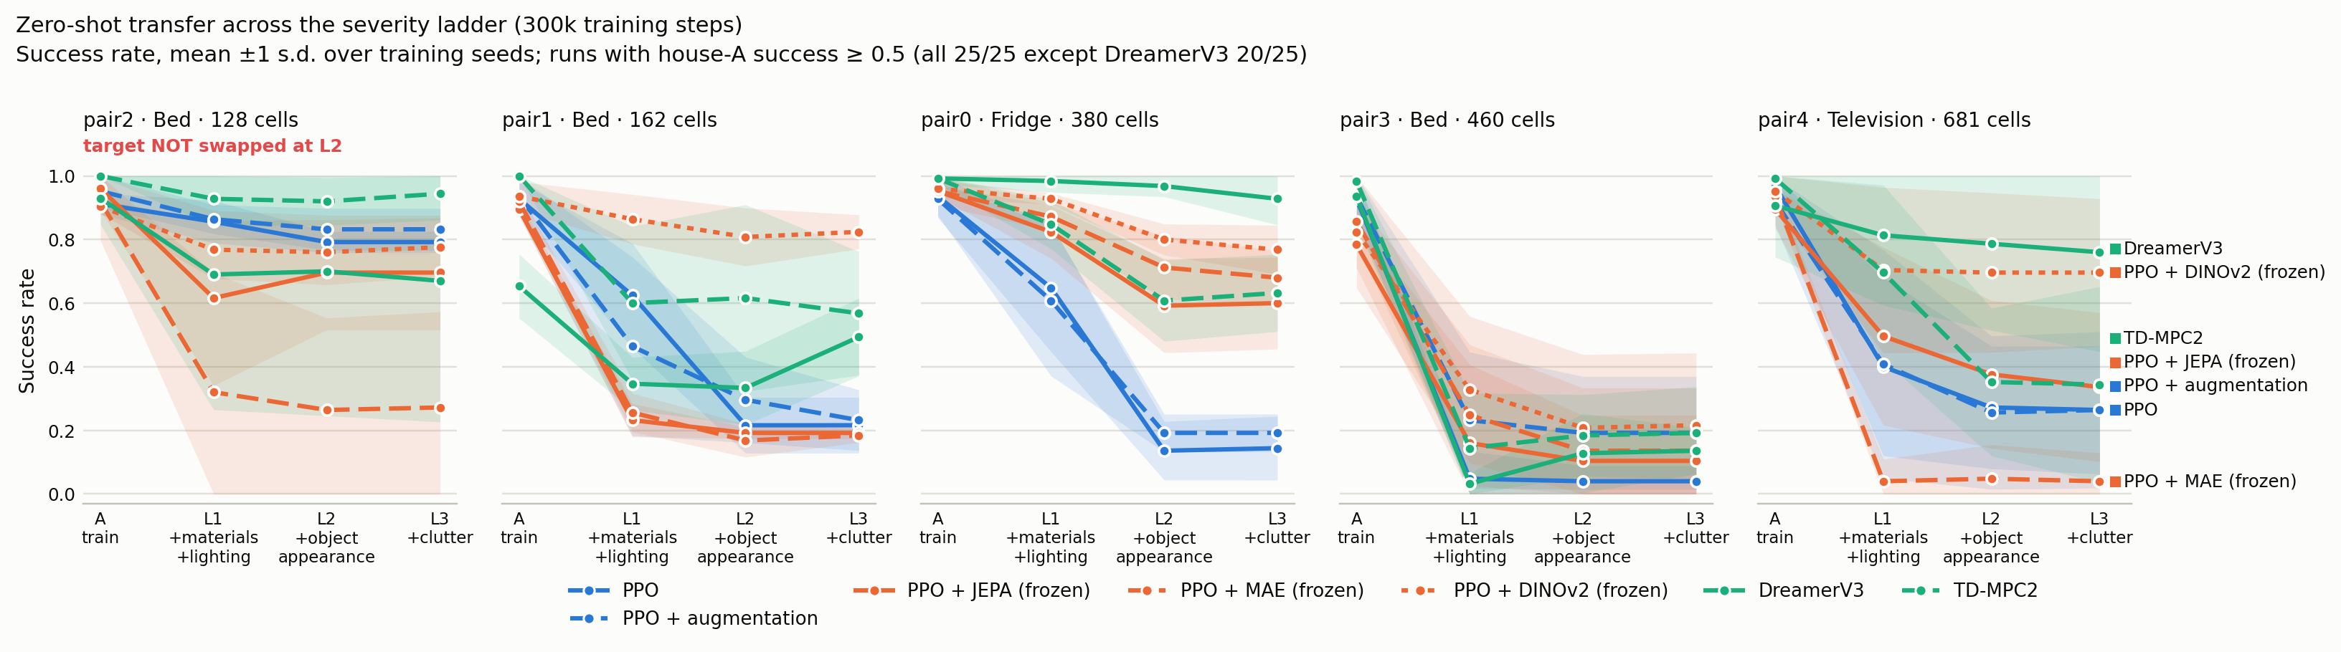
Figure 1. Success along the ladder, one panel per house. The spread between houses is as large as the spread between agents.

5. Result 2 — DINOv2, and a claim of ours that was wrong
In the last write-up we said a frozen pretrained encoder does not fix this. That was tested on I-JEPA and MAE, both trained on ImageNet by predicting hidden parts of an image. It holds for them and is false for DINOv2, which is trained differently and on more data.
DINOv2 loses 22% where PPO loses 45%, and it beats every other agent at L1 — all six comparisons significant after correction, worst p = 0.045. Its in-house success is 0.92 with no failed runs, so this is not an artefact of it simply learning better.
But it does not solve the problem: it still loses 22%, and 59% in the worst house. What survives the best frozen encoder available is precisely the residual a learned perceptual bottleneck would have to address.
The sharper version: the pretraining objective matters more than pretraining scale. MAE and DINOv2 are both large frozen vision transformers, and they sit at opposite ends of the table (63% versus 22%).

6. Result 3 — one change at a time
The ladder stacks changes, so it cannot say which one did the damage. These houses change exactly one thing. Averaged over the seven agents:
change, on its own | success lost | range across agents
clutter added | 0% | −2 to 1
lighting colour and brightness | 2% | 0 to 9
every object except the target | 5% | 1 to 8
the sky through the windows | 5% | −2 to 19
the target's own appearance | 9% | −12 to 39
walls, floor and ceiling | 33% | 20 to 50

One change out of six does nearly all the damage. Repainting beats a lighting change for six of seven agents after correction. Clutter costs nothing for anyone — every p = 1.00. And the two axes this benchmark was originally built around, object appearance and clutter, turn out to be nearly free on their own.
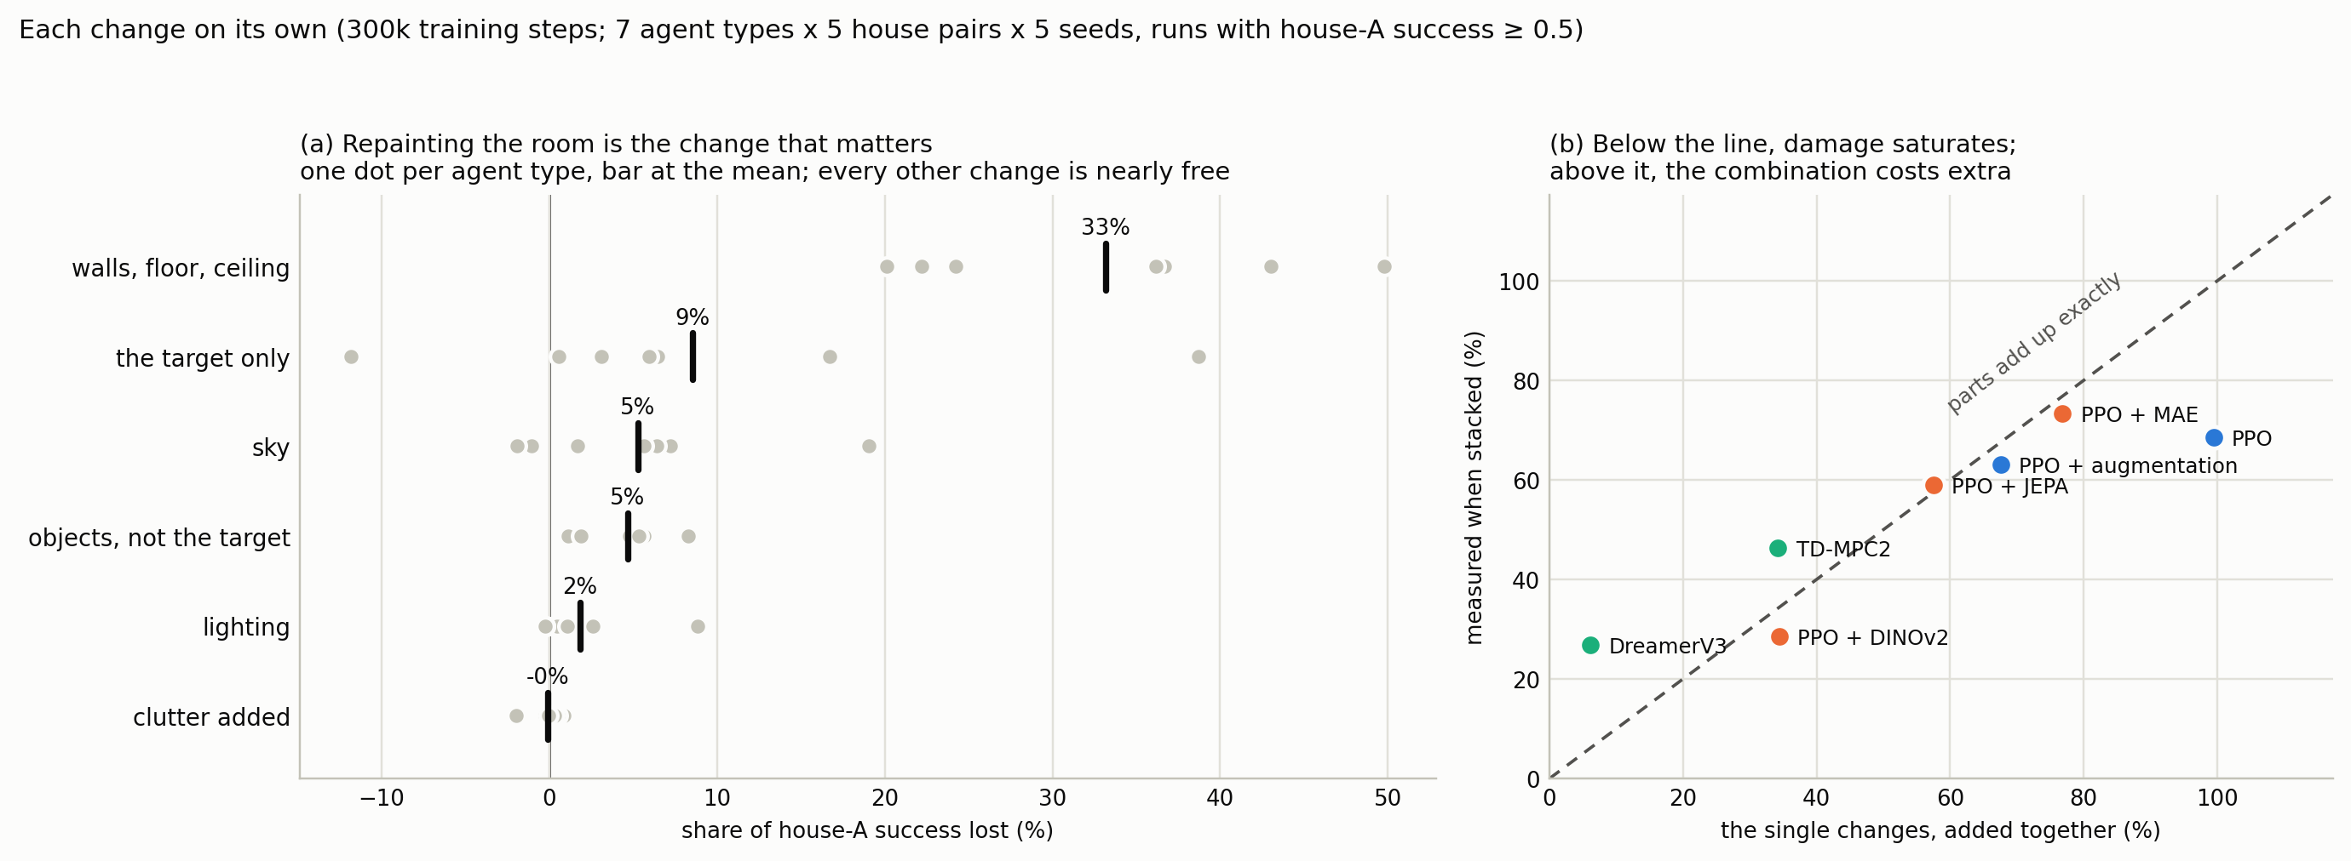
Figure 2. Left: the ranking, one dot per agent type. Right: the single losses added together against what was measured when stacked. Below the line, damage saturates; above it, the combination costs extra.
A qualification worth knowing: on the repaint alone, DINOv2 (22%) is not better than the world models (TD-MPC2 24%, DreamerV3 20%). Its advantage at L1 comes from lighting and sky, not from the repaint. Quoting the ladder result alone would overstate it.

7. Result 4 — model-free agents lean on what the target looks like
Comparing the same agent in two houses that differ only in whether the target's appearance changed:
agent | target unchanged | target changed | difference | p (corrected)
PPO | 0.37 | 0.17 | +0.20 | 0.026
PPO + aug | 0.38 | 0.23 | +0.14 | 0.023
PPO + MAE | 0.35 | 0.27 | +0.09 | 0.005
TD-MPC2 | 0.50 | 0.45 | +0.06 | 0.32
PPO + JEPA | 0.37 | 0.32 | +0.05 | 0.26
PPO + DINOv2 | 0.66 | 0.63 | +0.04 | 0.42
DreamerV3 | 0.59 | 0.60 | −0.02 | 0.53

Built-in check: one house has a target with no alternative model, so its two houses are literally the same file. Five of seven agents return exactly zero there, as they must.
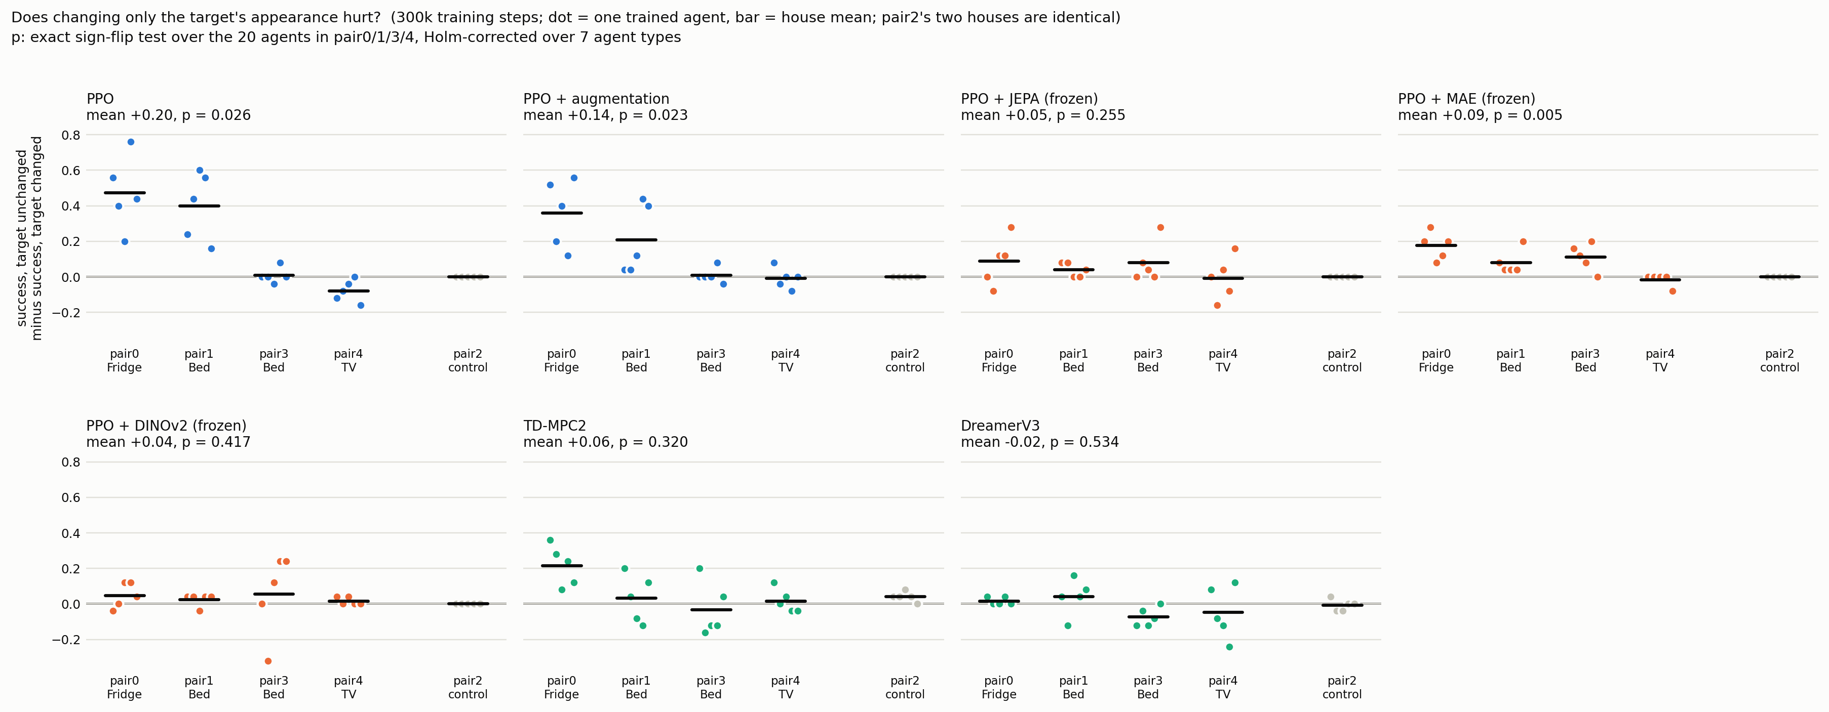
Figure 3. One dot per trained agent. The grey panel is the house where the two conditions are the same file — the control.

8. Result 5 — how much the picture changes does not decide the damage
We photographed every evaluation start pose in every house, with no agent involved, and measured how much the image changed. Correlation with damage is positive but not significant (ρ = +0.80, p = 0.13 across five houses), and the counterexamples are clear: two houses change by almost the same amount and lose 24% and 80%.
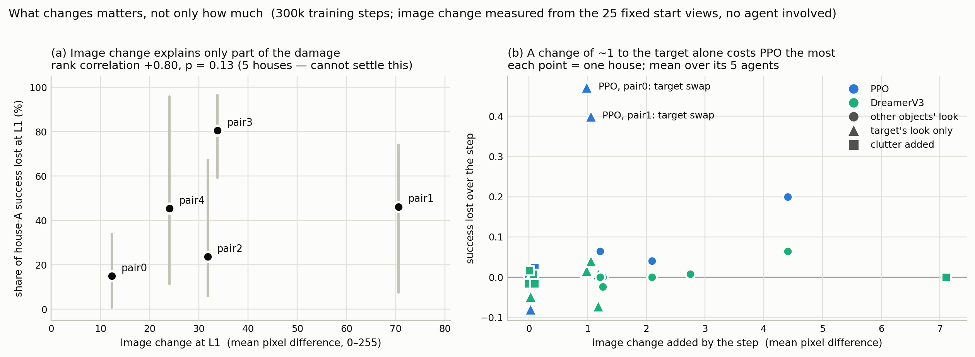
Figure 4. Left: image change against damage, one point per house. Right: what each step of the ladder adds to the picture, against what it costs.

9. Things we corrected in our own claims
- "A frozen pretrained encoder does not help" — false for DINOv2. Corrected above.
- Augmentation looked like it helped at 150,000 steps and does not at 300,000. The augmented agent was simply less converged at the shorter budget. The world models' advantage survived the budget change; augmentation's did not.
- Adding agents makes every earlier comparison harder to pass. One result moved from significant to not when two agents were added, with no change in the data. We now report three comparison families side by side, each with the date it was fixed and whether its numbers had been seen first, rather than quietly picking the flattering one.
- The scene was never static: the agent's body nudged objects as it walked. Fixed, and it applies retroactively to the earlier runs.

10. Limitations
- One task (find an object) in one room per house, with a fixed target location. Real ObjectNav would place the target randomly and needs far more compute.
- DreamerV3 is the least reliable agent: 5 of its 25 runs never learned the task and are excluded from the damage ratios, which is stated wherever it matters.
- The same seed does not reproduce the same agent on GPU, so only multi-seed means are meaningful.
- The frozen-encoder agents train far fewer parameters than PPO. Inherent to the method, but a capacity difference.
- Image change is measured only from the starting views.

11. Where this sits next to the paper you sent
Gao, Xie, Xiao, Finn and Sadigh, Efficient Data Collection for Robotic Manipulation via Compositional Generalization. They vary factors — object type, table texture, table height — and show that imitation policies handle unseen combinations of factor values they each saw somewhere, which lets you skip collecting the cross-product.
The distinction matters and we will state it: they test an unseen combination of seen values; we test a value never seen in any form, because each of our agents trains in a single house. Theirs is the optimistic result, ours the pessimistic one, in the same vocabulary.
The follow-up it suggests, which we cannot run on existing models: vary a factor during training — two lighting conditions and two paint schemes, train on three of the four combinations, test the fourth. That asks whether RL agents compose factors the way imitation policies do. Our benchmark is built for the question and currently cannot answer it.

12. What I need from you
- LEAP on 7 October, or hold for a conference? The workshop allows work under review elsewhere, so both is possible.
- Which comparison family do we report as the headline — all pairs corrected together (conservative), or the families fixed before each agent existed? It changes which results are significant, so I would rather you pick than me.
- Is the composition experiment above worth a new training grid, or does it wait for the next paper?
- DrQ-v2 and object-level augmentation are still on your list from last time. Both are real work; say which matters more if only one fits.
- Authorship, and meeting cadence.

13. Where everything lives
Repository: github.com/aaarvs07ranger/neural-systems-lab. Every table and figure here regenerates from committed data with one command.
- results/tables/ — main tables at both budgets, all statistical tests, the single-change summary
- results/plots/ — every figure in light and dark versions, plus filmstrips of agents succeeding and failing
- results/tracker/runs.csv — 2,936 rows, one per agent per house, rebuilt from scratch and verified identical on a second rebuild
- Total: 175 trained agents and 93,450 evaluation episodes across all result trees, with zero failed cells in the final sweeps

