Where embodied RL agents break under visual change
Phase-1 benchmark results · Neural Systems Lab · 17 September 2026
Aarav Srivastava, with Vishwas Sathish and Rajesh Rao · target: LEAP workshop @ CoRL 2026 (deadline 7 Oct)
Summary. Five pairs of ProcTHOR houses that are physically identical but look different, with the difference applied in controlled steps. Six agent types, 5 houses × 5 seeds each = 150 trained agents (plus 100 more at half budget). Every agent loses heavily to a change a person would call cosmetic. World models lose least. Domain randomisation helps only before convergence. Large frozen pretrained encoders do not help at all. Model-free agents specifically depend on what the target looks like. Which change hurts is not predicted by how much of the image changed.

1. Question
An agent that finds a fridge in one kitchen should still find it after the walls are repainted — same room shape, same fridge, same task. We measure whether current embodied RL agents do, and exactly where they fail. Existing domain-generalisation benchmarks change many things at once, so failures are unattributable; we change one thing at a time and hold physics fixed.
This is the evidence that the lab's masking-network + CSCG direction is needed, and the specification of what it must fix.

2. Benchmark
Five house pairs from ProcTHOR-10k, 128–681 reachable floor cells. House A is where the agent trains; the rest are the same house with appearance changed cumulatively.
rung | what changes | paper name
A | nothing — the training house | A
L1 | wall/floor materials, lighting, skybox | L1
L2noT | L1 + every object's appearance EXCEPT the target | L2
L2 | L1 + every object's appearance INCLUDING the target | L3
L3 | L2 + distractor objects | L4

L2noT is the designed control: it differs from L2 in exactly one thing, whether the target itself was restyled. That separates "depends on what the goal looks like" from "depends on the room looking familiar".
Every variant passes a runtime check on three independent simulator loads (identical floor cells, start poses, target count). This caught restyled furniture silently blocking floor cells, and — subtler — the agent's collider nudging objects as it walks until one came to rest on a start pose. All objects are now fixed in place.

3. Protocol
rule | why
Identical 300k-step budget across agents | The fairness currency; no cross-agent claim survives without it.
Equal budget is necessary but NOT sufficient — in-domain competence must match too | At 150k, augmentation had not converged (0.835 vs PPO's 0.920), flattering its transfer score.
Start poses pinned by construction (position and heading) | A blocked cell previously caused a silent re-draw: A and B began in different places, nothing errored.
20% of floor cells held out for evaluation only | So results are not memorised start positions.
Path-length yardstick measured once in house A | A restyled fridge has a different mesh, which would move the yardstick itself.
A policy is only evaluated under the renderer it trained with | The same checkpoint scored 0.92 on the cluster and 0.00 locally.
Exclusions require a documented defect, never an inconvenient value | Rule fixed before looking at numbers.

4. The six agents
agent | vision | trained? | predicts future? | trainable params
PPO | small CNN | yes | no | 4.8M
PPO + augmentation | CNN, colour-jittered inputs in training | yes | no | 4.8M
PPO + JEPA | I-JEPA ViT-H/14, 631M | NO — frozen | no | 0.17M
PPO + MAE | MAE ViT-H/14, 631M | NO — frozen | no | 0.17M
TD-MPC2 | CNN | yes | yes — next latent, reward, value; no decoder | ~5M
DreamerV3 | CNN | yes | yes — and must redraw the image | ~19M

The two frozen encoders are a matched pair: same architecture, size, and ImageNet-1K pretraining data, frozen identically, identical policy head. Only the pretraining objective differs — MAE redraws missing pixels, I-JEPA predicts the representation of missing regions.
Terminology: neither is a world model. Both predict within a still image — no time, no actions. The JEPA-family world model is V-JEPA 2-AC (action-conditioned video). These two answer the reviewer question "why not just use a modern pretrained encoder?"

5. Results
150 trained agents, each evaluated on all five rungs, 25 episodes per rung; plus a full second grid at 150k steps for the budget contrast.

5.1 Success rate
agent | A (training) | L1 | L2noT | L2 | L3
PPO | 0.93 | 0.52 | 0.45 | 0.29 | 0.29
PPO + augmentation | 0.93 | 0.52 | 0.47 | 0.35 | 0.34
PPO + JEPA (frozen) | 0.90 | 0.47 | 0.43 | 0.39 | 0.39
PPO + MAE (frozen) | 0.92 | 0.35 | 0.34 | 0.27 | 0.26
TD-MPC2 | 0.99 | 0.64 | 0.59 | 0.54 | 0.54
DreamerV3 | 0.76 | 0.61 | 0.64 | 0.60 | 0.62

DreamerV3's house-A figure is depressed by 5 of its 25 runs that never learned the task (see Limitations).
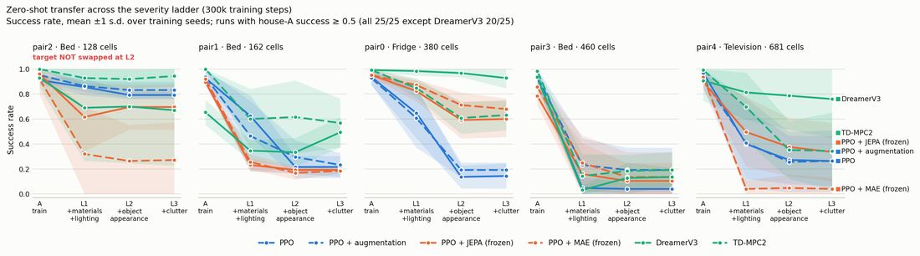
Figure 1. Degradation across the ladder, one panel per house, ordered by size. Hue = architecture class, dash = member. Bands ±1 s.d. over seeds. The spread between houses is itself a result: pair3 collapses for every agent, pair2 barely moves for any.

5.2 Share of house-A success lost
agent | runs counted | L1 | L2 | L3
PPO | 25 of 25 | 45% | 69% | 68%
PPO + augmentation | 25 of 25 | 44% | 62% | 63%
PPO + JEPA (frozen) | 25 of 25 | 50% | 58% | 58%
PPO + MAE (frozen) | 25 of 25 | 63% | 72% | 72%
TD-MPC2 | 25 of 25 | 35% | 46% | 46%
DreamerV3 | 20 of 25 | 38% | 36% | 35%

Runs below 0.5 in house A are excluded from this ratio only — a near-zero denominator makes the percentage meaningless. Rule fixed before the numbers were seen.

5.3 Six findings
1. Every agent breaks. Repainting walls and changing lighting alone (L1) costs every agent a third to two-thirds of its training-house ability. No architecture is immune.
2. World models lose least, significantly. PPO → TD-MPC2 +22.4 points (p = 0.0004); PPO → DreamerV3 +33.5 (p = 0.0017). Both survive correction. Which kind of world model is better is unresolved — DreamerV3 vs TD-MPC2 is 11 points, p = 0.17. An earlier single-house result suggested DreamerV3 clearly won; across five houses it does not.
3. Domain randomisation only appears to work at a small budget.
comparison at L2 | 150k steps | 300k steps
PPO vs PPO + augmentation | +24.4 pts, p = 0.0001 | +6.7 pts, p = 0.11 (n.s.)
PPO vs TD-MPC2 | +26.0 pts, p < 0.0001 | +22.4 pts, p = 0.0002

Two real mechanisms: jittered inputs are harder to fit, so at a shared budget the augmented agent had not converged; and its absolute L2 success *fell* with more training, 0.474 → 0.354. Augmentation delays overfitting to the training house; it does not prevent it. Only available because we kept both budgets.
4. Model-free agents depend on what the target looks like.
agent | effect | p (corrected, 6 agents) | real?
PPO | +0.20 | 0.021 | yes
PPO + augmentation | +0.14 | 0.019 | yes
PPO + MAE | +0.09 | 0.004 | yes
PPO + JEPA | +0.05 | 0.19 | no
TD-MPC2 | +0.06 | 0.21 | no
DreamerV3 | −0.02 | 0.53 | no

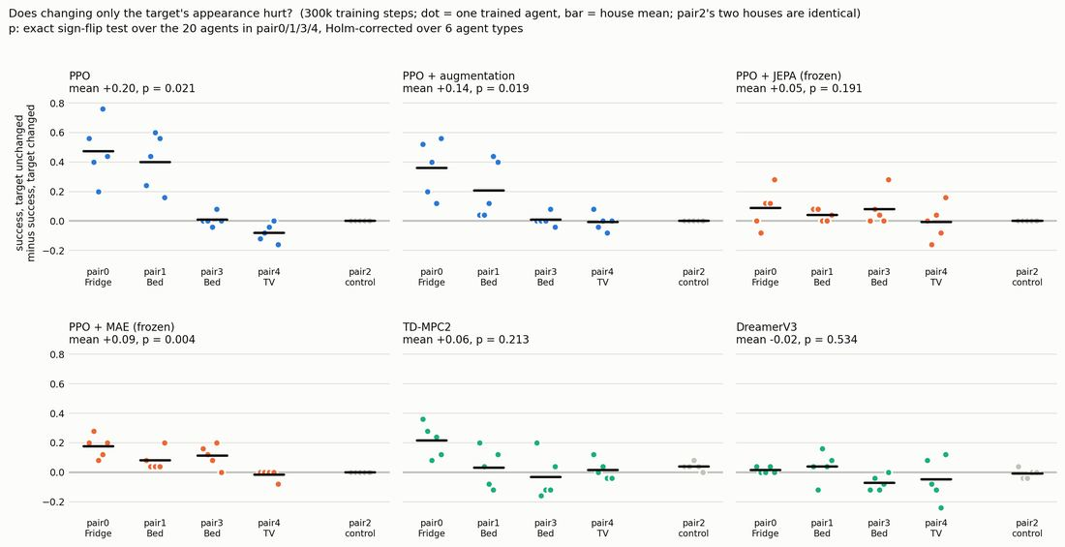
Figure 2. Each dot is one trained agent: success with the target's original appearance minus success with it restyled. Bar = house mean. pair2 is the negative control — its two houses are the same file, and every agent correctly shows ~0.
PPO loses 0.20 purely because the fridge was restyled; the room is otherwise identical. World models show no such dependence. The effect concentrates in two houses — in a third the agent has already collapsed at L1, and in the fourth the target is barely visible from the start positions.
5. A large pretrained encoder does not fix this.
comparison at L1 | difference | p | verdict
PPO vs MAE | MAE worse by 18.4 pts | 0.017 | significantly worse
PPO vs JEPA | JEPA worse by 4.9 pts | 0.48 | statistically a tie

Neither 631M-parameter encoder, pretrained on millions of internet images, beats a small CNN trained from scratch in one room. The honest claim is "no better", not "worse" — that only holds for MAE. Suggestive but not established: I-JEPA beats MAE in the same direction at every rung (14.3 pts at L2, raw p = 0.022), which would say pretraining to predict representations transfers better than pretraining to redraw pixels. It does not survive correction across 15 comparisons (p = 0.17).
6. What changes matters more than how much changes.
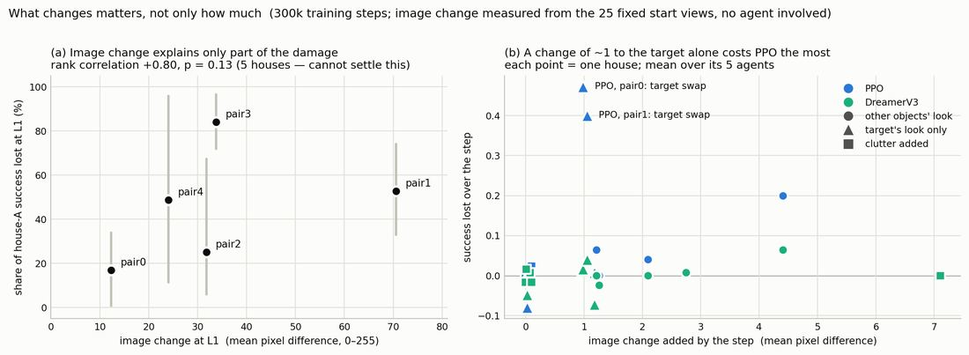
Figure 3. (a) Per house: how much L1 alters the camera image vs how much success is lost — five houses cannot settle this either way. (b) Within house: the target swap adds ~1 unit on a 0–255 scale and costs PPO 0.47 success; clutter changes the image seven times more and costs nothing.
Panel (b) is the stronger evidence because it is within-house: the smallest image change in the ladder is among the most damaging, while a much larger one is free.

5.4 What it looks like
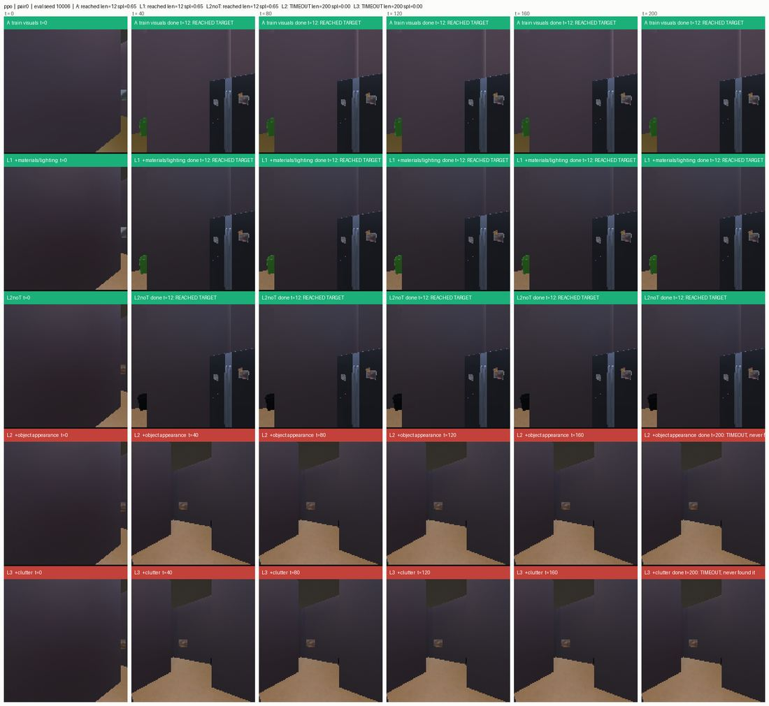
Figure 4. One PPO agent, one fixed start, all five rungs. Reaches the fridge in 12 steps in the training house, the repainted house, and with other objects restyled — then fails completely once the fridge itself is restyled.
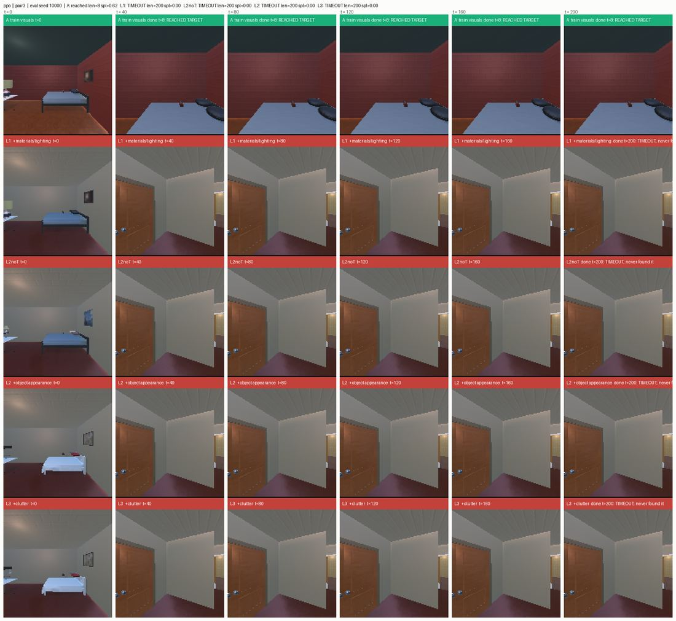
Figure 5. Another house. Reaches the bed in 8 steps in training; after only walls, floor and lighting change, it turns away from a plainly visible bed and never finds it.

6. Statistics, and an honest problem
Permutation tests shuffling labels within each house, so between-house differences cannot manufacture a result. The target test is exact (all 1,048,576 sign patterns). Every script self-tests on known answers; each result was recomputed by an independent implementation.
The problem: six agents means 15 pairwise comparisons, and some will look impressive by chance. Correcting for that raised the bar and two results fell below it:
claim | raw p | corrected across 15
I-JEPA beats MAE | 0.022 | 0.17 — not significant
PPO + augmentation vs TD-MPC2 | 0.0064 | 0.058 — not significant

The second was significant when we had four agents. Adding two agents made an existing result harder to defend with no number changing. Decision needed: correct across all 15, or treat pre-specified comparisons as their own family. The latter is defensible — the matched pair and its single question were timestamped in the project log before those runs — but a reviewer may push, and we should agree a position rather than pick the flattering one per claim.

7. Limitations we will disclose
- DreamerV3 reliability: 5 of 25 runs never learned the training house; it needs more samples than the others.
- Same seed, different agent: retraining a cell with an identical seed gave 0.24 vs 1.00 in the training house. GPU non-determinism means only multi-seed means are meaningful.
- Trainable capacity is unmatched for the frozen-encoder agents — 0.17M vs PPO's 4.8M. Inherent to freezing and standard in that literature; does not affect JEPA-vs-MAE, which share a head.
- One task type (object-goal navigation). A sequential variant is built but not run.
- Image change is measured from the starting view only, so an out-of-frame target registers little change.
- Five houses limits per-house statistics; the target control uses the four whose target could be restyled.
- Dense-shaped reward and auto-termination on success — easier than the strict Habitat protocol.

8. Status, and what we would like to decide
All experiments are complete: 250 trained agents across two budgets; every figure and table generated from committed data by script, nothing transcribed by hand. Writing was scheduled to start 27 September against the 7 October deadline.
- Multiple-comparison position (section 6) — pre-specified families, or correct across all 15?
- Worth 5 more seeds on JEPA and MAE to settle representation- vs pixel-pretraining? ~30 h of cluster time, and it would have to be pre-registered since we have already seen the result.
- Workshop now, or build toward a conference? The benchmark plus these six agents is a complete workshop paper today. The natural conference-scale extension is a planning agent on a video world model — imagine the consequence of an action, score it, act — i.e. TD-MPC2's structure with a pretrained imagination. That is a new method, needs weeks, and cannot meet this paper's budget-parity rule, so not before 7 October.
- Authorship order — we assume Aarav, Vishwas, Rao unless you would order it differently.

9. Reproducibility
Every number regenerates from committed files by script. The experiment tracker holds 946 rows — one per trained agent per rung — each carrying the git commit and cluster job id that produced it. Raw per-episode CSVs, the tracker and the paper tables were cross-checked and agree to three decimals on all six agents.
Repository: github.com/aaarvs07ranger/neural-systems-lab · results in results/grid_300000/ (headline), results/grid/ (150k appendix), tracker in results/tracker/.

