**LAB 01:** **BASIC ELECTRONICS + ARDUINO ASSIGNMENTS**

**Exercise 1: 3 Sample Circuits**. (Individual work)

Reviews:

# [Voltage, Current, Resistance, and Ohm's Law](https://learn.sparkfun.com/tutorials/voltage-current-resistance-and-ohms-law)

1. [How to use a breadboard?](http://www.instructables.com/id/How-to-use-a-breadboard/)

Materials and Components:

1. AC DC charger
2. //voltage regulator
3. resistor
4. buzzer
5. potentiometer
6. LED
7. switch
8. bread board

Schematic:

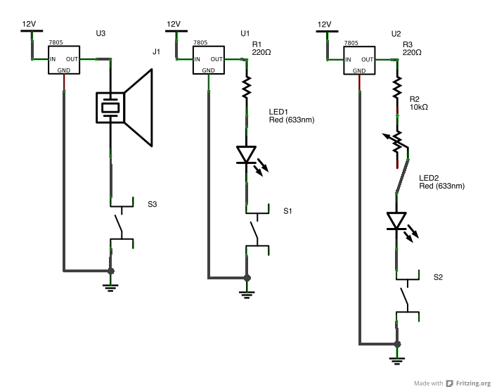

**Exercise 2: ARDUINO assignments**

Reviews:

[Micro Controllers: The Basics](http://itp.nyu.edu/physcomp/lessons/microcontrollers/microcontrollers-the-basics/)

Materials and Components:

1. [Arduino](http://arduino.cc/) (Install IDE)

Assignments:

Do it with Aven:

太空船控制器中心

Play around on your own:

独立完成并记录项目书中项目3和4