Mini Project Report

# Comparing the Effectiveness of Multimedia-Supported Instruction vs. Traditional Instruction

## 1. Introduction

Education has shifted significantly with the rise of digital tools. Traditional methods rely heavily on textbooks, lectures, and board explanations, while multimedia-supported instruction incorporates videos, animations, presentations, and interactive platforms. This project aims to compare the two approaches in terms of student learning outcomes, engagement, and retention.  
  
Research Question: Is multimedia-supported instruction more effective than traditional instruction in enhancing student learning and engagement?

## 2. Objectives

- To evaluate the effectiveness of multimedia-supported instruction.  
- To compare it with traditional teaching methods.  
- To analyze student performance, interest, and retention under both methods.

## 3. Methodology

Sample Group: 20–40 students (split into two groups randomly).  
  
Procedure:  
1. Select a topic (e.g., 'Photosynthesis' in biology or 'Pythagoras’ theorem' in math).  
2. Group A (Traditional): Teach the topic using lecture + textbook + blackboard.  
3. Group B (Multimedia): Teach the same topic using videos, animations, PowerPoint, and interactive quizzes.  
4. Both groups are given:  
 - Pre-test: to measure prior knowledge.  
 - Post-test: to measure knowledge gained after instruction.  
5. Conduct a short feedback survey on student engagement, clarity, and enjoyment.  
  
Tools: Multimedia (videos, PowerPoint, interactive simulations), Traditional (chalk/whiteboard, textbook, lecture notes), Google Forms / Paper for tests and survey.

## 4. Data Collection & Analysis

Example (Hypothetical Results):  
  
| Group | Avg. Pre-test Score | Avg. Post-test Score | Avg. Gain | Engagement (out of 5) |  
|--------------|---------------------|----------------------|-----------|------------------------|  
| Traditional | 6/20 | 12/20 | +6 | 3.2 |  
| Multimedia | 7/20 | 16/20 | +9 | 4.5 |

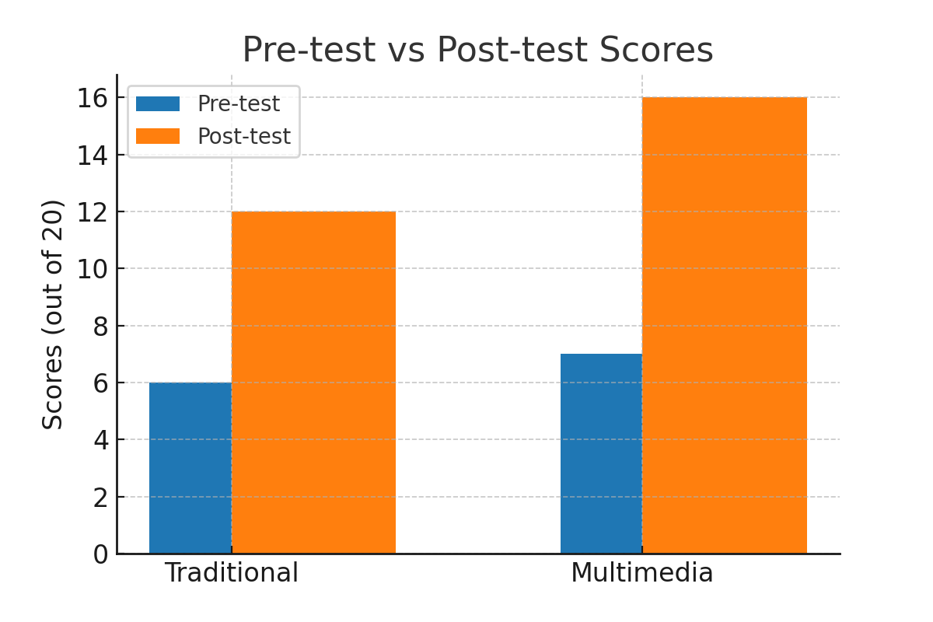

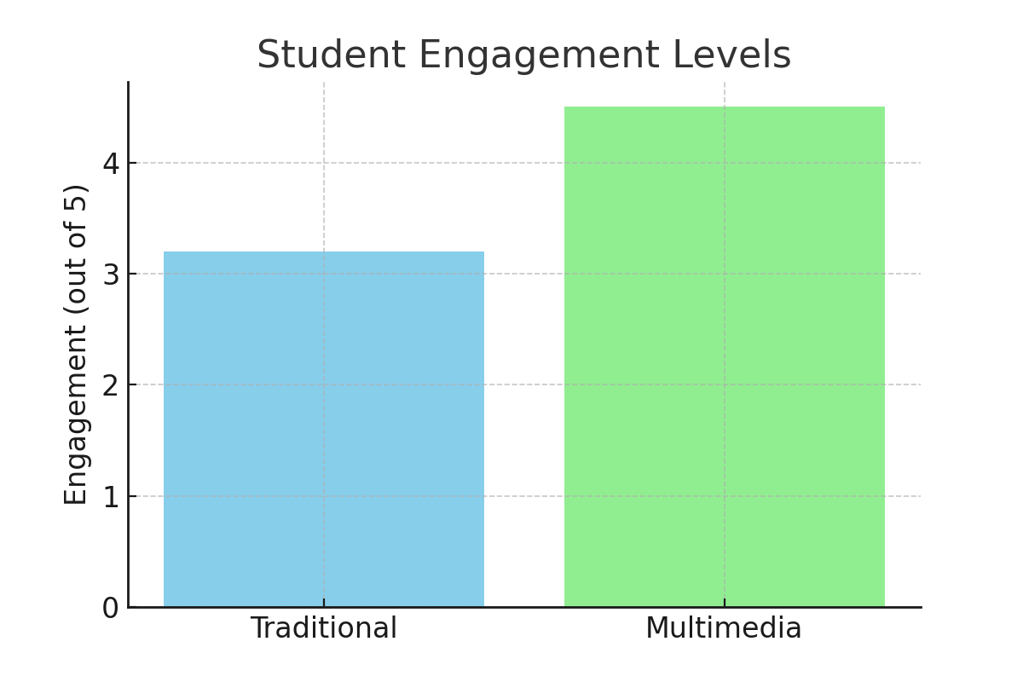

## 5. Findings

- Students taught with multimedia showed higher learning gains.  
- Engagement and enjoyment levels were significantly higher in the multimedia group.  
- Traditional methods were still effective but less engaging.

## 6. Conclusion

The mini project demonstrates that multimedia-supported instruction can improve both understanding and engagement compared to traditional methods. However, a blended approach (using both traditional and multimedia methods) may provide the best outcomes, as traditional instruction supports discipline and focus, while multimedia adds clarity and interest.

## 7. Recommendations

- Teachers should integrate multimedia resources into lesson planning.  
- Schools should invest in digital tools and teacher training.  
- Further studies with larger groups and different subjects can provide stronger evidence.