Background:

The variables taken into consideration in this model are the size of the claim, the size of the premium and the probability of a customer making a claim. The size of the claim ,denoted by X, is drawn from a Pareto Distribution with the density function below;

**1. Basic Calculation and Analysis**

**1.1 Calculating the Cumulative Distribution Function of**

Since is a continuous random variable, this is obtained by integrating the density function from 0 to

**1.2 Expectation of**

**Conditions for the parameters:**

is a positive random variable, therefore clearly leading to a positive mean size of claims. Also for the same reason, ensuring that the basic integration step can be applied. Clearly, to ensure that the mean size of claim is well defined.

**1.3 Median of**

Let

Solving for *,*

**1.4 Variance of**

By definition,

**Conditions for the parameters:**

Variance is strictly positive . Hence . Clearly , again ensuring that the variance is well defined.

**1.5 The Inversion Method**

1. Generate ui (0,1)
2. Set ui=F(xi) and make xi the subject

This can be done since F(x) is continuous and strictly increasing based on the restrictions imposed on the parameters.

**1.6 Simulation of 1000 Values Drawn from X**

1. set.seed(123)
2. alpha<-3
3. beta<-100000
4. n<-10000
5. u<-runif(n)
6. x<-beta*(1/((1-u)^(1/alpha))-1)

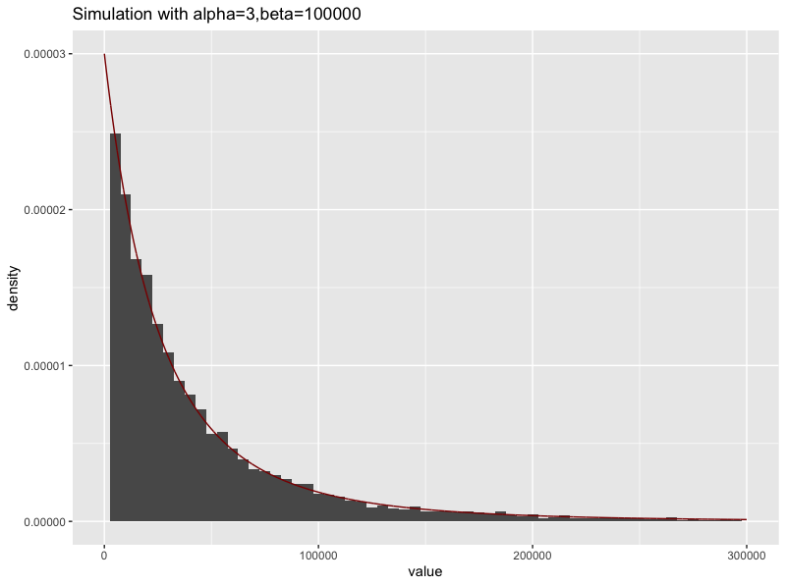

Figure 1-1

**1.7 Reasons for Use of Pareto Distribution to Describe Size of Claims**

* The Pareto Distribution is positively skewed and has a heavy tail on the right.

For this reason, we use Pareto for insurance applications to model extreme

loss,especially for more risky types of insurance,

* It is a mixture of the exponential distribution with gamma mixing weights.
* In financial applications , the study of heavy tailed distributions provides information about the potential for financial failure(bankruptcy)

1. **Models of Year End Assets**

**2.1 Build the Model**

Base on the given information, we built up the asset model as follows:

*:* the assets of the company at the end of the year.

represents the current assets of the company.

represents the annual premium.

represents the number of the customers.

Total claim:

Pareto distribution i.i.d.

: the number of clients making a claim this year.

For .:

We should calculate the bankruptcy probability:

1. AssetSim<-function(n,premium,prob){
2. balance<-0
3. **for** (k **in** 1:n) {
4. claim<-rbinom(1000,1,prob)
5. cost<-0
6. **for** (i **in** 1:1000) {
7. **if**(claim[i]==1){cost<-cost+rpareto(1,alpha,beta)}
8. }
9. balance[k]<-250000+1000*premium-cost
10. }
11. balance
12. }

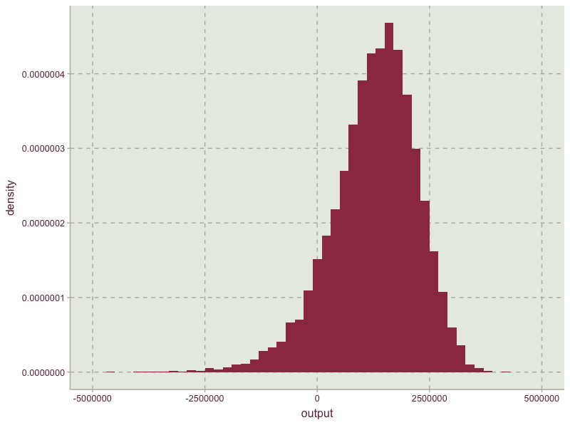

Figure 2-1

As it can be seen from the simulation graph 2-1, the distribution of assets are negatively skewed which is clearly compatible with the positive skewness of the Pareto distribution. Assets and Total size of claims are negatively related. S, denoted by the total size of claims here is a combination of the Pareto distribution and the Bernoulli distribution.

**2.2 Impact of Premium and Probability of Making a Claim**

**The effect of premium on probability of bankruptcy**

Throughout this analysis we only change the premium ,whilst controlling for the rest of the variables in the question. We analysed the effects for premium levels ranging from £5500 to £8000 increasing it by £500 each time.

The outcome is as follows:

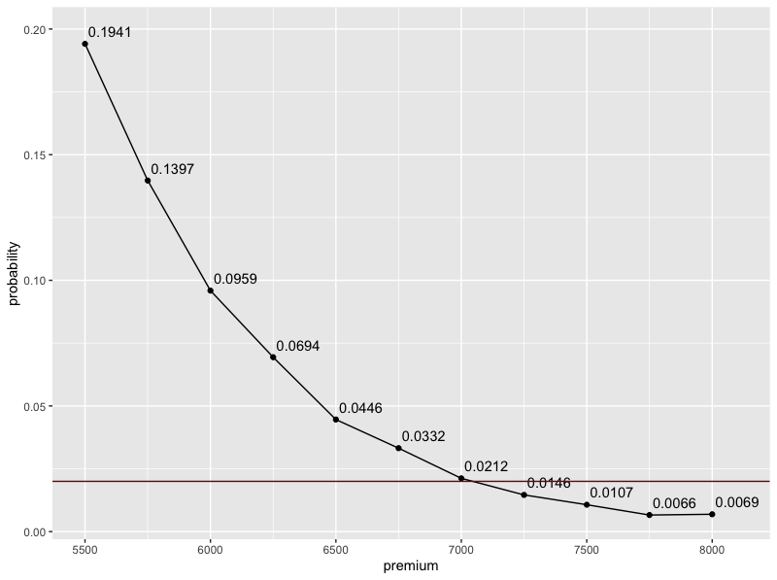

Figure 2-2

|  |  |  |
| --- | --- | --- |
| premium | balance | probability |
| 5500 | 741136.600292234 | 0.1941 |
| 5750 | 1003137.73320141 | 0.1397 |
| 6000 | 1255157.61448557 | 0.0959 |
| 6250 | 1498083.97452799 | 0.0694 |
| 6500 | 1759673.68190743 | 0.0446 |
| 6750 | 2002743.62758197 | 0.0332 |
| 7000 | 2251394.98058984 | 0.0212 |
| 7250 | 2490678.65689442 | 0.0146 |
| 7500 | 2740845.10927589 | 0.0107 |
| 7750 | 2994727.17767397 | 0.0066 |
| 8000 | 3255043.86669691 | 0.0069 |

Table 2-1

Clearly, the probability of bankruptcy declines with an increase of premium levels.

However to ensure that the probability of bankruptcy is no more than 2% we need to charge for a premium of at least £7250.

**The effect of probability of a customer making a claim on the probability of bankruptcy**

Here, we change the probability of a customer making a claim ,controlling for premium and other variables in the question.

The analysis has been carried out for probability ranging from 0.05 to 0.15 increasing it by a 0.005 each time.The outcome is as follows:

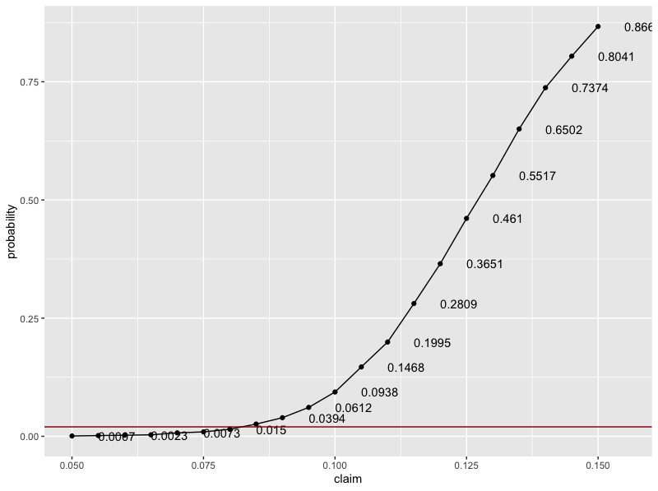

Figure 2-3

|  |  |  |
| --- | --- | --- |
| claim | balance | probability |
| 0.05 | 3759849.64385291 | 0.0007 |
| 0.055 | 3497623.5856642 | 0.0016 |
| 0.06 | 3260109.47219399 | 0.0023 |
| 0.065 | 3009525.64706615 | 0.0032 |
| 0.07 | 2746500.63048726 | 0.0073 |
| 0.075 | 2490617.99967582 | 0.0094 |
| 0.08 | 2243506.9708276 | 0.015 |
| 0.085 | 1998117.96791791 | 0.0259 |
| 0.09 | 1740876.91939939 | 0.0394 |
| 0.095 | 1499039.79317023 | 0.0612 |
| 0.1 | 1251768.85848942 | 0.0938 |
| 0.105 | 993418.842385709 | 0.1468 |
| 0.11 | 754042.482872268 | 0.1995 |
| 0.115 | 502591.533068519 | 0.2809 |
| 0.12 | 252371.527546531 | 0.3651 |
| 0.125 | -1004.49002706269 | 0.461 |
| 0.13 | -242388.017059418 | 0.5517 |
| 0.135 | -497185.30799758 | 0.6502 |
| 0.14 | -746170.992160119 | 0.7374 |
| 0.145 | -991378.617794178 | 0.8041 |
| 0.15 | -1247132.70224009 | 0.8669 |

Table 2-2

We observe a positive trend between the two variables as expected. The higher the chance of a customer making a claim, the higher the claims that the company has to pay for, thus increasing the probability of bankruptcy as premium is fixed.

We also observe an increase in the steepness of the curve

Find the optimal portfolio

|  |  |
| --- | --- |
| Probability | premium |
| 0.05 | 5500 |
| 0.055 | 5500 |
| 0.06 | 5500 |
| 0.065 | 5500 |
| 0.07 | 5500 |
| 0.075 | 5750 |
| 0.08 | 5750 |
| 0.085 | 6250 |
| 0.09 | 6500 |
| 0.095 | 7250 |
| 0.1 | 7250 |
| 0.105 | 7750 |
| 0.11 | 7750 |

Table 2-3

Assumption

To apply the pareto distribution to the insurance problem, we should set few assumptions especially for the variables selected in our model. Besides, except for the basic assumptions given by the case, there should be some adding assumptions which ensure the model working well.

The first and the second assumption is that for each year, one customer can only make one claim, and the probability of customers making a claim is fixed and equal for each customer. It implies that the total number of customers making claims follows a discrete and identical distribution, and the simulation data should also be annual, too. Claims are made independently of each other and no customer is influenced by the other. That is, there is no probable situation that the decisions of one customer could be influenced by another one. Mathematically speaking, the number of making a claim follows an independent and identical pareto distribution.

To solve the computational problem, we also assume that the value of the premium is fixed irrespective of the size of the claim. Practically speaking, we assume that every customer of the insurance company will buy identical products with equal premium. Besides, we don’t consider the situation that some of the customers drop out at any circumstance. For instance, some customers might quit due to the increasing of premium when the financial crisis happens.

In real insurance contract, when a customer buy insurance to protect herself against unforeseen risks, she should agree to pay for the first part of the future loss. This part payed by customers is so-called deductible, which has also been dropped in our model. The company will pay all the loss for customers, which potentially increases the probability of bankruptcy.

In corporate finance, the calculation of total asset need specific data from financial statements. To simplify the calculating procedures, we assume that the company will retain all premiums charged with itself and not invest on anything else.

Factors that the company can control

Based on the assumptions and outcomes of simulation, there are factors can be controlled by the company in order to reduce the risk of bankruptcy.

The first factor that the company should pay more attention to is the premium. In this case, to ensure the risk of bankruptcy to be less than 2%, the minimum premium that the company should charge is £7250. It is best if the company can stand firm with this pricing which will indeed improve the company’s reputation.

The second factor is the customers buying the insurance products. The company can forecast the probability of a customer making a claim before accepting customers and accept those who are at most 8% likely to make a claim. This probably can ensure the risk of bankruptcy to be less than 2% based on the previous calculation.

Besides, the company can also find the relationship between number of claims per year and the risk of bankruptcy, and then control and limit to the maximum number of claims with minimal risk.

Apart from the technical advices, there are also non-technical factors which company can control. For one thing, the company should not wait till the net balance has reached to zero to calculate the risk of bankruptcy. That is, the company should always keep updated with the evaluations.

For another, the company can mitigate its risk by exploring the option of reinsurance, which can spread the risk to other financial institutions. What’s more, the company should also conduct frequent seminars, providing advice to minimize avoidable risks and network with the customers.

However, the results based on our prediction are not absolute. We should make some adjustments when we are considering specific scenarios. For example, I assumed the probability of each customer making a claim in a year to be 0.1, but that can be quite different when we consider factors such as the age, gender, income of the customers. Also, claims made by customers are not always independent from each other. I believe there are some clients of your company who are friends or relatives and you cannot avoid them talking through their feedback about your products. They might make same decisions for whether continuing their investments in your company, so public praise is quite important for our company. Please attach more importance to it. I also hope you can provide me with more previous data, especially the amount of claims each time. That can help me simulate the distribution and make a better prediction because in my model I assumed the parameters based on general circumstances for this kind of insurance, while it varies among different companies and client groups.

Based on these disadvantages, I made a more comprehensive model and hope that can be helpful for our company. I extended the time period to be ten years because we should have a long-term consideration and not just focus on the end of this year. I also considered the fluctuation of number of customers every year and the scenario that a customer may make more than one claim per year. In the analysis, I discovered as time going by, the risk of bankruptcy is increasing. But if we can overcome the difficulties and exclude some small probability events (too much claims exceeding average levels), we can expect the assets of our company increasing continuously. The risk of bankruptcy in ten years is 0.1456. It is a little high for us. I suggest we can increase the premium for each year to be ￡7,500 and make the bankrupt probability to be 0.02.

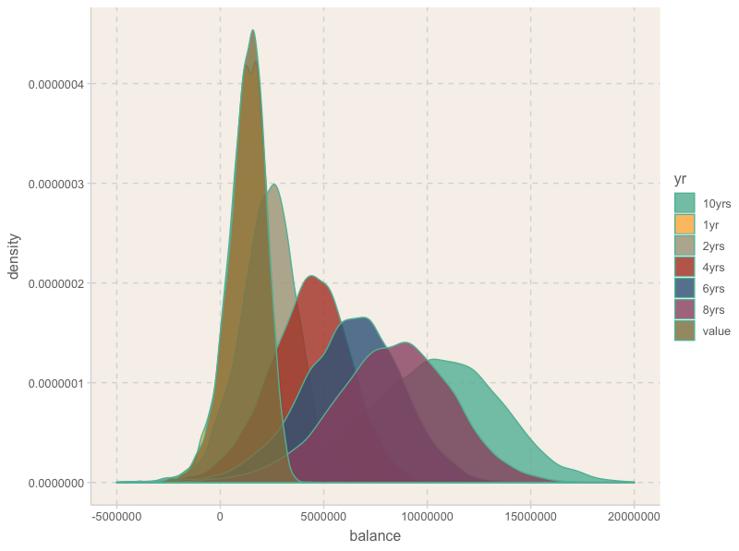

Appendix

The extending model:

Assumptions:

1. Consider 10 years’ time period
2. The number of customers is not fixed every year and the premium is not necessarily paid at the start of a year. The total number of paying for annual premium has a Poisson distribution.
3. The probability of customers making a claim is not identical for everyone. Assume the number of times making a claim also has a Poisson distribution.

The equation of new model:

: the assets of the company at the end of the year .

represents the current assets of the company.

represents the annual premium.

: the number of times for paying for premium until year . It has a Poisson distribution of parameter . The pdf of is:

Total claim till the end of year :

Pareto distribution i.i.d.

: the number of claims made until year . It has a Poisson distribution of parameter. The pdf of is:

Assume , , we can simulate the assets of the company in the end of year t and compare the probability of bankruptcy at the end of each year.

1. PoisSim<-function(n,t,premium,lambda1,lambda2){
2. balance<-matrix(0,n,t)
3. **for** (k **in** 1:n){
4. **for** (i **in** 1:t) {
5. num<-rpois(1,lambda2)
6. claim<-sum(rpareto(num,alpha,beta))
7. **if**(i==1){
8. balance[k,i]<-250000+premium*rpois(1,lambda1)-claim
9. }
10. **else**{
11. balance[k,i]<-balance[k,i-1]+premium*rpois(1,lambda1)-claim
12. }
13. }
14. }
15. balance
16. }
17. ######1
18. rm(list=ls())
19. library(ggplot2)
20. library(dplyr)
21. library(actuar)
22. library(ggthemr)
23. library(tidyr)
24. set.seed(123)
25. alpha<-3
26. beta<-100000
27. n<-10000
28. u<-runif(n)
29. x<-beta*(1/((1-u)^(1/alpha))-1)
30. options(scipen = 200)
31. z=seq(0,299970,30)
32. data.frame(value=x)%>%
33. ggplot(.,aes(x=value))+geom_histogram(aes(y=..density..),binwidth = 5000)+
34. geom_line(aes(z,dpareto(z,alpha,beta)),color="darkred")+
35. xlim(0,300000)+ggtitle("Simulation with alpha=3,beta=100000")
36. ######2
37. AssetSim<-function(n,premium,prob){
38. balance<-0
39. **for** (k **in** 1:n) {
40. claim<-rbinom(1000,1,prob)
41. cost<-0
42. **for** (i **in** 1:1000) {
43. **if**(claim[i]==1){cost<-cost+rpareto(1,alpha,beta)}
44. }
45. balance[k]<-250000+1000*premium-cost
46. }
47. balance
48. }
49. output<-AssetSim(10000,6000,0.1)
50. summary(output)
51. ggthemr("grape")
52. ggplot(as.data.frame(output),aes(x=output))+geom_histogram(aes(y=..density..),binwidth = 200000)+xlim(-5000000,5000000)
53. cat(paste("The expected asset: ",mean(output)))
54. cat(paste("The probability of bankrupt: ",mean(output<0)))
56. #######3
57. premium<-seq(5500,8000,250)
58. prob<-seq(0.05,0.15,0.005)
59. dt1<-data.frame(premium=premium, balance=0,probability=0)
60. dt2<-data.frame(claim=prob, balance=0,probability=0)
61. **for** (i **in** 1:length(premium)){
62. output<-AssetSim(10000,premium[i],0.1)
63. dt1$balance[i]<-mean(output)
64. dt1$probability[i]<-mean(output<0)
65. }
66. p<-ggplot(dt1,aes(premium,probability))+geom_text(aes(label=probability),check_overlap=TRUE,nudge_y=0.005,nudge_x=100)+geom_point()+geom_line()
67. p+geom_hline(aes(yintercept = 0.02),colour="dark red")
68. cat("Minimal premium level:",min(dt1$premium[dt1$probability<0.02]),"\n")
70. **for** (i **in** 1:length(prob)){
71. output<-AssetSim(10000,6000,prob[i])
72. dt2$balance[i]<-mean(output)
73. dt2$probability[i]<-mean(output<0)
74. }
75. p<-ggplot(dt2,aes(claim,probability))+geom_point()+geom_text(aes(label=probability),check_overlap=TRUE,hjust=0,nudge_x=0.005)+geom_line()
76. p+geom_hline(aes(yintercept = 0.02),colour="dark red")
77. cat("maximal probability of making a claim:",max(dt2$claim[dt2$probability<0.02],"\n"))
79. #### find optimal portfolio
80. prob<-as_tibble(prob) %>%mutate(premium=0)
81. **for** (i **in** 1:length(prob$value)){
82. j=1
83. **while** (j <=length(premium)) {
84. prob0<-mean(AssetSim(1000,premium[j],prob$value[i])<0)
85. **if**(prob0<0.02){
86. prob$premium[i]<-premium[j]
87. **break**}
88. j=j+1
89. }
90. }
92. ###extending model
93. ##control lambda1=10000, lambda2=1000
94. PoisSim<-function(n,t,premium,lambda1,lambda2){
95. balance<-matrix(0,n,t)
96. **for** (k **in** 1:n){
97. **for** (i **in** 1:t) {
98. num<-rpois(1,lambda2)
99. claim<-sum(rpareto(num,alpha,beta))
100. **if**(i==1){
101. balance[k,i]<-250000+premium*rpois(1,lambda1)-claim
102. }
103. **else**{
104. balance[k,i]<-balance[k,i-1]+premium*rpois(1,lambda1)-claim
105. }
106. }
107. }
108. balance
109. }
110. out<-PoisSim(10000,10,6000,1000,100)
111. **is**.neg<-apply(out,1,function(row) any(row<0))
112. length(which(**is**.neg))/10000
114. Summary_table<-as_tibble(output) %>% mutate("1yr"=0,"2yrs"=0,"4yrs"=0,"6yrs"=0,"8yrs"=0,"10yrs"=0)
115. Summary_table[2]<-out[,1]
116. Summary_table[3]<-out[,2]
117. Summary_table[4]<-out[,4]
118. Summary_table[5]<-out[,6]
119. Summary_table[6]<-out[,8]
120. Summary_table[7]<-out[,10]
121. new_table<-gather(data=Summary_table,key="yr",value="balance",value,"1yr","2yrs","4yrs","6yrs","8yrs","10yrs")
122. ggthemr("light")
123. ggplot(new_table,aes(x=balance,fill=yr))+geom_density(alpha=.8)+theme(legend.position = "right")+xlim(-5000000,20000000)
125. #build functions to find out the bankrupcy probability
126. ProbOfBank<-function(n,t,premium,lambda1,lambda2,threshold){
127. outcome<-PoisSim(n,t,premium,lambda1,lambda2)
128. **is**.neg<-apply(outcome,1,function(row) any(row<threshold))
129. length(which(**is**.neg))/n
130. }
132. dt3<-data.frame(premium=seq(5500,8000,250),prob=0)
133. **for** (i **in** 1:length(premium)){
134. dt3$prob[i]<-ProbOfBank(1000,10,premium[i],1000,100,0)
135. }
136. cat("Minimal premium level:",min(dt3$premium[dt3$prob<0.02]),"\n")
137. write.csv(prob[1:13],"result.xlsx",applend=TRUE)