# Assignment3

## Question2

library(tidyverse)

set.seed(17053777)

kc_house_data <- read_csv("kc_house_data.csv")

my_houses <- kc_house_data %>% sample_n(20000)

my_houses <- my_houses %>%

select(-id, -date, -lat, -long, -zipcode, sqft_above,

-sqft_living15, -sqft_lot15)

## Question3

library(GGally)

my_houses %>% cor()

ggpairs(my_houses, columns = c("price","sqft_living", "sqft_above", "grade"))

# Based on the correlations, I choose sqft_living, grade and sqtl_above as predictors.

# We observe that there is a positive linear relationship between price and sqft_living with 0.702 strong correlation.

#There is a positive linear relationship between price and sqft_above and the correlation is 0.607 which is a moderate correlation.

#We can observe there is a positive linear relationship between price and grade but the trend is curved, so they have a quadratic relationship but still linear with 0.666 moderate correlation.

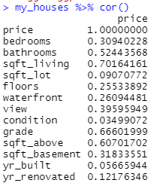

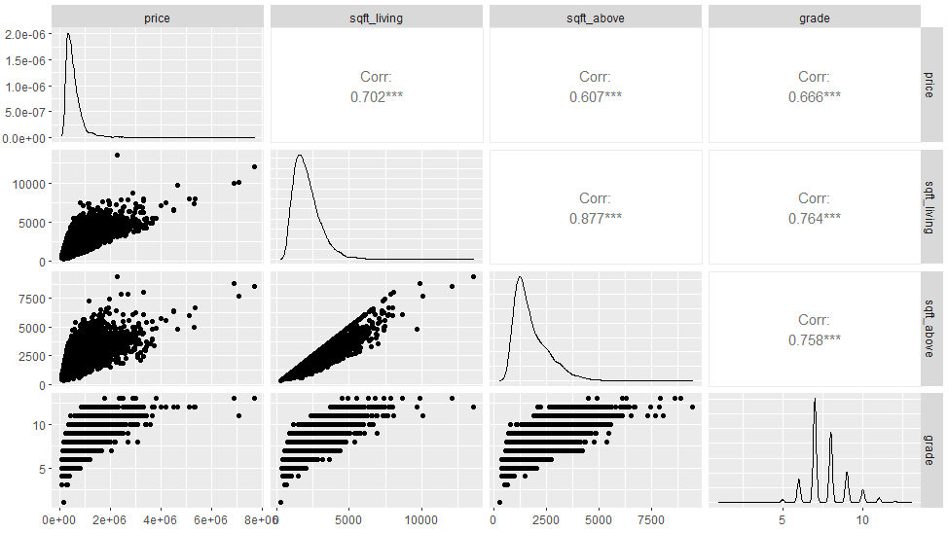

## Question3

m1 <- lm(price ~ (sqft_living + sqft_above + grade), data = my_houses)

summary(m1)

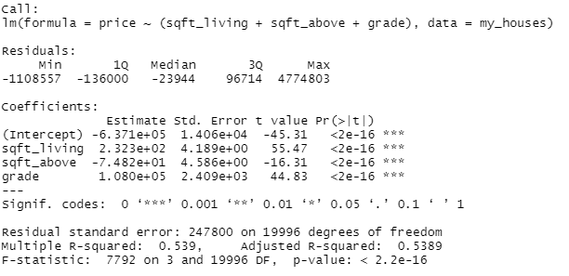

Coefficients:

Price = 237.1 * sqft_living – 74.82 * sqft_above + 10800 * grade

Adjusted R^2 = 0.5389

Residual standard error = 247800 on 19996 degrees od freedom

## Question5

library(leaps)

par(mfrow = c(1, 1))

all_mods <- regsubsets(price ~ ., data = my_houses)

plot(all_mods, scale = 'Cp')

# As we know, the lower the Cp, the better the model. We can observe that sqft_lot, sqft_above, yr_build and sqft_basement are the variables that need to be dropped. So the predictors which need to be contained in the best model is bedrooms, bathrooms, sqft_living, floors, waterfront, view, condition, grade and yr_renovated.

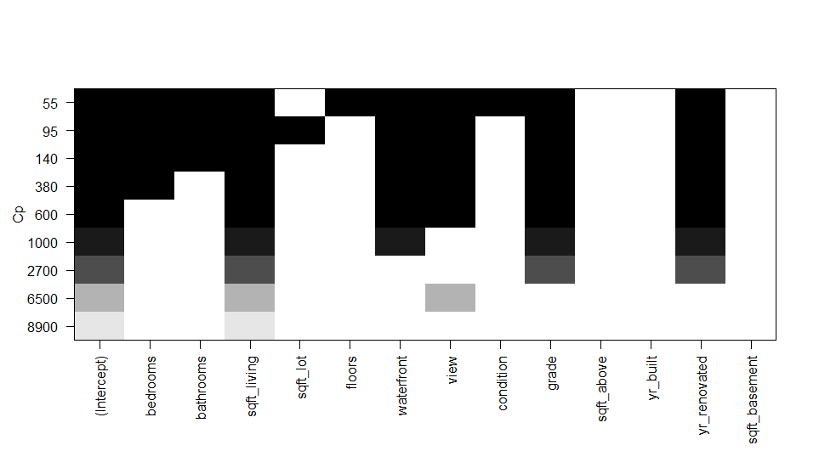

## Question6

m2 <- lm(price ~ (bedrooms + bathrooms + sqft_living + floors + waterfront + view + condition + grade + yr_renovated), data = my_houses)

summary(m2)

# adjusted R^2 = 0.6062, residual standard error = 229000 on 19990 degrees of freedom

# From m1 to m2, we hae more variables as predictors. We observe that the adjusted R^2 increased from 0.5389 to 0.6062 and the residual standard error is smaller. As the adjusted R^2 increases, we can say the model is improved. As residual standard error decreases, we can say the predictions are better and m2 is better than m1.

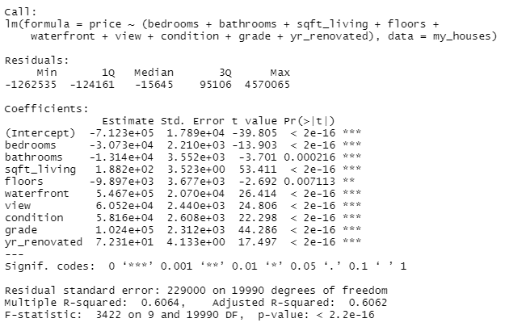

## Question7

par(mfrow = c(2, 2))

plot(m2)

# From Normal Q-Q, we observe that after theoretical qualities is greater than 2, the observation points are further way from predicted line. The residuals increase as the qualities increase.

# From Residuals vs Leverage, we observe that there are some points which are close to the red dash line 0.5, which could be considered as outliers.

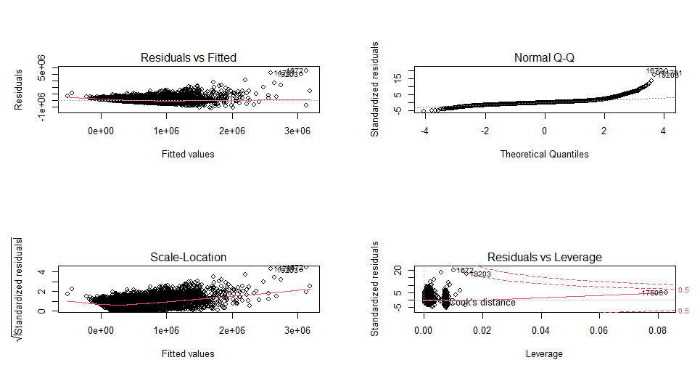

## Question8

new_houses <- tibble(bedrooms = c(3, 4), bathrooms = c(1.5, 2.5),

sqft_living = c(1200, 1920), sqft_lot = c(15606, 8562),

floors = c(1, 2), waterfront = c(0, 0), view = c(0, 0),

condition = c(3, 4), grade = c(7, 7),

sqft_basement = c(0, 0), yr_built = c(1985, 1994),

yr_renovated = c(0, 0))

predict(m2, new_houses, interval = 'confidence')

predict(m2, new_houses, interval = 'prediction')

# the prediction interval is for an individual outcome drawn from the distribution of the response.

# he confidence interval is for an estimate of the mean of the distribution of the response.

