**TOBACTAX**

User Manual[1]

Version 1.07

*Fuchs Tarlovsky, Alan[2], Abdelkrim Araar[3]*

*Abstract*

This User Manual presents the TOBACco and TAXes (**TOBACTAX)** Stata package. This tool provides a user-friendly alternative to estimate the impact of the tobacco tax reforms on social welfare.

# **Preface**

# **Acknowledgements**

# **List of Acronyms and Abbreviations**

WB—The World Bank

**Contents**

**Preface** 2

**Acknowledgements** 2

**List of Acronyms and Abbreviations** 2

**Executive Summary** 3

**1.** **Introduction** 4

**2.** **TOBACTAX Models** 5

2.1 The theoretical framework of the **tobatref** Stata module 5

2.2 The theoretical framework of the **tobelas** Stata module 8

**3.** **The tobatref tool** 8

3.1 Installation 8

3.2 The **tobatref** Stata module 12

3.2.1 The data files 12

3.2.2 Preparing the dataset 12

3.2.3 Launch the tobatref dialog box 13

3.2.4 The “Main” tab 13

3.2.5 The Dialog box inputs 14

3.2.6 General information on the sampled households 15

3.2.7 Tobacco price elasiticities 15

3.2.8 Survey settings 15

3.2.9 The TOBATREF tabs 16

c- The “if/in” tab 17

3.3 The tobatref outputs 18

3.4 Examples of the tobatref tool 19

**References** 24

# **Executive Summary**

# **Introduction**

This User Manual presents the basic theoretical model as well as the TOBACTAX tool to analyze the impacts of the tobacco tax reforms on social welfare. In this second version, two main modules are added. The first is the module ***tobatref,*** which is designed to assess the impact of tobacco tax reforms on social welfare. The second module ***tobelas*** is to estimate the decile price elasiticities of Tobacco using cross-section data.

# **TOBACTAX Models**

Section 2 of this user Manual discusses the theoretical framework, assumptions and data requirements of the **tobatref** module, part of the **TOBACTAX** package for Stata.

## 2.1 The theoretical framework of the **tobatref** Stata module

The **TOBA**cco **T**ax **R**eforms (tobatref) Stata module is conceived to estimate the effect of the tobacco tax reforms basic on the social welfare framework (Pichón-Riviere et al. 2014, Verguet et al. 2015). Precisely, the objective is to estimate how tobacco taxes change household income, analyzing three factors:

1. The change in household well-being: approximated by the in tobacco expenditure due to tax/price increase;
2. The reduction in medical expenses due to lower tobacco consumption; and
3. The change in incomes due to additional years of labor recovered through mortality reduction.[4]

The aggregated income/welfare effect of the tax increase is estimated as follows:

|  |  |
| --- | --- |
| Income effect = change in tobacco expenditure (A) + lower medical expenses (B) + rise in income (C) | (01) |

The baseline scenario is obtained from the household expenditure survey (as described in section 2.e), which is used to measure general consumption and tobacco consumption, as well as medical expenditures. A partial equilibrium model allows the assessment of the distributional effects of the tobacco tax, resulting in an estimation of the first-order effects of these policies. We proceed using a partial equilibrium approach and evaluating the change in prices, which relies mainly on household expenditure patterns. This assessment only considers first-order effects, and does not include further behavioral changes of economic agents. Consequently, we observe upper-bound effects of the short-term response. These assumptions imply that the model uses the share of tobacco consumption in household budgets according to price increases. The loss of real income arising from price increases in products $i = 1, …, n$ is obtained by

|  |  |
| --- | --- |
| $\sum_{i}^{n}{\left(ω_{i}+∆ω_{i}\right)*\frac{∆p_{i}}{p_{i,o}}}$, | (02) |

where $ω_{i}$ is the share of product *i* in total household expenditure, and $∆p_{i}$ is the percent price increase.[5] Therefore, if 10 percent of the total budget is destined for cigarettes, for example, and the price of cigarettes increases by 10 percent, the real loss of income amounts to 1 percent; $∆ω_{i}$ is the change in consumption of the taxed good, and it will depend on the price elasticity of the product.

***Lost in real income*:** We estimate the variation in tobacco consumption, as a proxy of the change in household well-being or real income after the tax increase (increase in price of tobacco), by considering the change in prices ($∆P$), the tobacco price elasticity $ε$, and the tobacco expenditure of decile *d* in period 0 $({Expenditure}_{i0})$.

|  |  |
| --- | --- |
| $$∆ {Tobacco Expenditure}_{d}=(\left(1+∆P\right)\left(1+ε*∆P\right)-1)*{Expenditure}_{d0}$$ | (03) |

We divide the change in tobacco expenditure by the total expenditure for each decile group *d*, thereby obtaining a comparable per household measure of the change in tobacco expenditure relative to the total expenditure of each decile group.

|  |  |
| --- | --- |
| $$∆ Prop. Tobacco Expenditure =\frac{\left((1+∆P\right)\left(1+ε*∆P\right)-1)*{Expenditure}_{d0}}{{Total Expenditure}_{d}}$$ | (04) |

***Change in medical expenses*:** We estimate the change in medical expenses of tobacco-related diseases in equation (5), where the cost of the treatment of tobacco-related diseases for income decile *d* is obtained from Pichón-Riviere et al. (2014) and adjusted according to the expenditure survey.

|  |  |
| --- | --- |
| $$∆ Prop. Medical Exp.=\frac{(\left(1+ε*∆P\right)-1)*{Cost Treat. Tobacco Related Diseases}_{d}}{{Total Expenditure}_{d}}$$ | (05) |

Equation (05) shows the income gains related to the reduction of medical expenses because of the reduction of tobacco consumption in the long term. Although the calculation does not reflect short-term gains, we assume that the effects of tobacco-related diseases will immediately diminish with the reduction in tobacco consumption.[6]

***Increase in working life*:** We estimate the impact on incomes arising from the increase in labor years. In our base line scenario, we estimate the income lost because of lost working years associated with tobacco consumption (equation 6)[7]. The years lost are distributed across each decile proportionately to the number of households that consume tobacco, and the income lost is estimated as the average income per household. We then estimate the effect of the tax increase in relation to the income gains because of increases in working years. We expect that incomes will increase as the number of years lost because of premature deaths from tobacco consumption decrease.

|  |  |
| --- | --- |
| $Δ Proportional Income=\frac{\left(\left(1+ε*∆P\right)-1\right)*Years lost Per Decile*{IncomeLoss}_{d}}{{Total Expenditure}_{d}}$ | (06) |

Lastly, we estimate the total income gains for each income group by adding the results of the reduction of medical treatments, the gains in working years, and the increase in tobacco expenditures (see equation 1).

**Estimates, sampling design and standard errors**

Because of the complexity of the statistics that we estimate by deciles, we use the delta method (Gary (1992)) to estimate the STE, and this, by considering the full information of the sampling design. The delta method requires identifying the basic estimators of the complex estimate. This what we will expose in what follow. Let:

* $∆P$: is the proportional change in price of tobacco;
* $ε_{d}$: The price elasticity in decile *d;*
* ${hs}_{h}$: the household size of the household *h;*
* $\exp_{h }$: the total exependitures of the household *h;*
* ${expt}_{h}$: the total exependitures of the household *h* on tobacco*;*
* $I_{d,h}$: is an indicator that equals to 1 if the household *h* is in decile *d;*
* $I_{t,h}$: is an indicator that equals to 1 if the household *h* consumes the tobacco.

The estimated $Prop. Tobacco Expenditure$ for the decile $d$*:*

|  |  |
| --- | --- |
| ${∆ Prop. Tobacco Expenditure}_{d} =\frac{\sum_{h=1}^{H}{{\left((1+∆P\right)\left(1+ε_{d}*∆P\right)-1)*expt}_{h}I_{d,h}}}{\sum_{h=1}^{H}{{I_{d,h}exp}_{h}}}$ = $\frac{\hat{A}}{\hat{B}}$ | (07) |

Where *H* is the population size of households. Statistically, this estimate is simply a ratio between two totals. In stata, we can estimate this ratio by considering the sampling weight and the sampling design. The estimated $Prop. change with medical Expenditures$ for the decile *d*:

|  |  |
| --- | --- |
| $${∆ Prop. Medical Exp}_{d}=\frac{\sum_{h=1}^{H}{\left((1+∆P\right)\left(1+ε_{d}*∆P\right)-1)*medexp*I_{i,h}*I_{d,h}}}{\sum_{h=1}^{H}{I_{t,h}} \sum_{h=1}^{H}{{I_{d,h}exp}_{h}}}=\frac{\hat{C}}{\hat{D}*\hat{B}}$$ | (08) |

The estimated $Prop.change with working lost$ for decile *d*:

|  |  |
| --- | --- |
| $${∆ Prop. chang. with work. lost}_{ d}=\frac{\sum_{h=1}^{H}{\left((1+∆P\right)\left(1+ε_{d}*∆P\right)-1)*twl*I_{i,h}*I_{d,h}}}{\sum_{h=1}^{H}{I_{t,h}} \sum_{h=1}^{H}{I_{d,h}{hs}_{h}}}=\frac{\hat{E}}{\hat{D}*\hat{F}}$$ | (09) |

The total effect for decile *d*:

|  |  |
| --- | --- |
| $${∆ Prop. chang.total effect}_{ d}= \frac{\hat{A}}{\hat{B}}+\frac{\hat{C}}{\hat{D}*\hat{B}}+\frac{\hat{E}}{\hat{D}*\hat{F}}$$ | (10) |

## 2.2 The theoretical framework of the **tobelas** Stata module

Mainly, we assume that the user disposes at least one of many cross-section databases. The minimum required variables are the quantity of tobacco and the price – or the unit value-. The other important variable is the decile variable. The user can also use other explanatory variables, as the disposible income and the household characteristics.

***The model(s);***

Concerning the consumption of tobacco, the consumer behavior can be modeled with simple linear models. These simple models are mainly based on the assumption of separability for the tobacco item in the maximisation of the consumer utility function. (for instance, see Deaton (1997)). Precisely, we propose to fellow the Alan and Meneses (2017) methodologies to the estimate the tobacco price elasticity by income deciles.

**Model 1:**

$${lq}_{i}={εlp}_{i}+βX_{i}+γM_{i}+ϵ_{i}$$

where ${lq}_{i}$ refers to the log of the household' purchased quantity of ciguarettes, ${lp}_{i}$ the log of unit value or price for the household $i$, $X_{i}$ and $M_{i}$ are two sets of indepandent variables: continues and categorical respectively, and $ϵ$ the error term.

**Model 2:**

$${lq}_{i}=\sum_{d=1}^{10}{ε_{d}I\left[d_{i}=d\right]*{lp}_{i}}+βX_{i}+γM_{i}+ϵ_{i}$$

Where $I\left[true\right]=1$ and zero otherwise. The parameters to be estimated of the model(s) are $ε, β,γ$. More important, the parameter $ε$ is equal to average tobacco price-elasticity, while $ε_{d}$ is that of the decile $d$.

# **The TOBACTAX tool**

In this section, we discuss the installation, preparation of data and alternative methods of analysis available in **tobatref** module to estimate the impacts of tobacco tax reforms on social welfare. We also show how to use the ***tobelas*** module.

## 3.1 Installation

To install TOBACTAX execute the following commands in the Stata command line. Note that it is possible to either copy and paste these lines directly in the command window or in the dofile editor preferred by the User:

|  |
| --- |
| **Commands 01** |
| set more off  net from http://dasp.ecn.ulaval.ca/tobactax/Installer  net install tobactax, force  additmenu profile.do _tobactax_menu |

**Note**: The Stata command lines in the chart **Commands 01** tries to add the file profile.do automatically or add the command **_tobactax_menu** in this profile file, if the latter already exists. However, if the previous commands do not function, the User needs to manually copy and paste the [profile.do](ftp://ftp.subsim.org/modules/subsim2/profile.do) file in the following locations (based on the operating system of the computer):

1. *Windows OS system:* copy the file in **c:/ado/personal/**
2. *Macintosh system:* copy the file in one of the Stata system directories. To find these directories, type the command **sysdir**.

Once the previous steps were executed, the User should close all Stata sessions and restart the program. After opening a new window, the User should be able to go to the menu bar in Stata, click on the User option, choose the TOBACTAX package, Tobacco and Social Welfare > Tobacco Tax Reform and social Welfare option to launch the **tobatref** tool:

|  |
| --- |
| **Point and click 01** |
| User > TOBACTAX > Tobacco and Taxes > Tobacco and Tax Reform |
|  |

After selecting the “Tobacco Tax Reform and social Welfare” option, a window with the main user interfase of the **tobatref** module will open and the User can start interacting with the program:

Figure 3.1: Main tab in **tobatref** module interface

|  |
| --- |
|  |

Note that the TSWE package also provides the option of “TOBACTAX package manager” to manage updates in the tool, read the reference material or visit the TOBACTAX website[8] as shown in Figure 3.2 below:

Figure 3.2: TOBACTAX: Package Manage Window

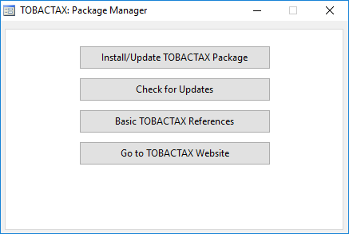

## 3.2 The **tobatref** Stata module

The **tobatref** tool is the main component of the TOBACTAX package for Stata and was designed to assess the impact of tocacco tax reforms on social welfare relying on the alternative theoretical models discussed in Section 2.1 of this User Manual.

### 3.2.1 The data files

The data requirements of the **tobatref** tool for Stata include:

**Micro-Data 1: the opened data file (* are required):**

* The household total expenditures.
* The variable household expenditures on tobacco;
* The variable household size
* The variable decile (categorical variable with modalities 1 to 10).

**Micro-Data 2: another stored data file (required):**

In another Stata data file, the user must have the data on the price elasticities by decile and for three modalities (medium, lower and upper) (10 observations). Example:

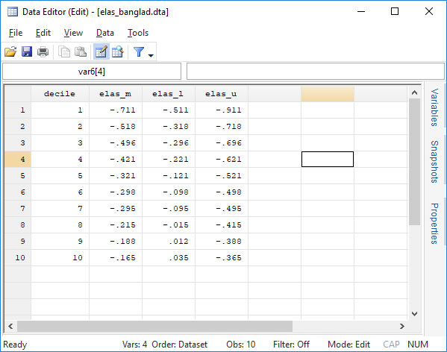

### 3.2.2 Preparing the dataset

Prior to launching the **tobatref** dialog box it is necessary to load in the memory of Stata a database including variables with the relevant information on consumption in the format required by the **tobatref** tool.  The **tobatref** tool requires information on the following dimensions of household characteristics and poverty measurement in the market:

* **The household expenditures;**
* **The household expenditures on tobacco;**
* **Household size;**
* **Dicile variable (modalities 1 to 10).**

In addition, the **tobatref** command allows to include the sample weights of the survey and, ideally, additional variables indicating the Primary Sampling Unit (PSU) and Strata. Moreover, the **tobatref** module also allows the user to include a variable with information on the finite sample population correction. However, if no information on the sample design of the survey is entered (the sampling design is not initialized), the simple random sampling is used by default.

### 3.2.3 Launch the tobatref dialog box

Once the relevant database is loaded in the memory of the Stata program, the dialog box of the **tobatref** Stata module enables the User to easily interact with the tool and identify the variables with the required information on household consumption, as well as to select the appropriate models—and their parameters—for the alternative market structures and estimations.

Once the **tobatref** tool in Stata is launched the user interface will show a window with the “Main” tab, where the variables and parameters can be selected. A second tab is optional and called “Table Options” to select the tables to be produced as well as the location to save an Excel file with such tables. The “Graph Options” tab allows the User to choose alternative options to produce graphs. Finally, the “if/in” allows the User to select a subsample of the observations for the analysis.

### 3.2.4 The “Main” tab

The “Main” tab of the **tobatref** tool for Stata is organized in six sections, as indicated by the red circles in Figure 3.2, each associated to a different element of the data available, characteristics of the sample design, market structure and survey design, among others.

Figure 3.2: Elements of the Main Tab Window

|  |
| --- |
|  |

In the rest of this section each of the options in the seven section of the Main tab showed in Figure 3.2 will be discussed in detail:

* Dialog box inputs;
* General information on the sampled households;
* Price elasticities;
* Simulated proportional price change;
* Medical expenditures and working time;
* Sampling design.

### 3.2.5 The Dialog box inputs

This is to load and save the dialog box information. The box enables the user to load information already saved into the TOBATREF window, or to save the information inserted in the dialog box in a file to be stored for future simulations. This information is stored in text files with the extension *.trw. You can test this feature by uploading the file “example.trw” provided with the toolkit. Note that you can load the file from one directory (“Load the Inputs”) and save it in a different directory with a different name (“Save the Inputs”).

### 3.2.6 General information on the sampled households

The box “General information on sampled households” is located at the top left of the window. This box includes four required variables

1. Total household expenditures continuous numerical variable with monetary values.
2. Total household expenditures on tobacco: continuous numerical variable with monetary values.
3. The household size: integer variable.
4. The decile variable: integer variable.

### 3.2.7 Tobacco price elasiticities

In this section, the user must indicate the data file in which the price elasticities are stored. The file must contain four variables and a size of 10 observations:

Figure 3.3: Example of the elasiticities data file



The four variables are:

1. The decile variable;
2. The variable of the estimated price elasiticities by decile;
3. The variable of the lower level estimated price elasiticities by decile;
4. The variable of the upper level estimated price elasiticities by decile;

### 3.2.8 Survey settings

Notice that to use the options for survey settings; the User needs to prepare the variables associated with the different dimensions of the survey design before launching **tobatref**. These settings include information on the sampling weights, sampling design, adjustment for finite population, among others. This can be done with the command “svyset” in Stata or using the button “Survey Settings…” located in the bottom right-hand corner of the **tobatref**

For more information on the alternative survey settings available in the **tobatref** tool, see the Stata Reference Manual on [Survey Data](https://www.stata.com/bookstore/survey-data-reference-manual/).

Figure 3.4: Survey Settings Options in the **tobatref** tool

|  |
| --- |
|  |

### 3.2.9 The TOBATREF tabs

This tab allows the user to select the tables’ options. The default option when you do not select the tables and override options is the production of all tables.

#### The “Table Options” tab

#### Tables: Select the tables to be produced

In case the user wishes to have only a selected number of tables the code of these tables can be indicated in the box. The list of codes with the titles of the tables can be seen by clicking on the question mark button “?”. For example, you can type “*1 3*” to produce tables 11 and 30 31 32 33 and 34 only (no commas, one space between numbers).

#### Excel file: Produce an Excel file of results

This box allows the user to define the Excel file where all tables should be stored. The user can select an existing file to override or create a new file. The user can either specify the name of the file or not. In the case of an existing file, the user should make sure that this file is closed when the program is launched, otherwise an error message will appear.

#### The “Graph Options” tab

The tab on the Graph Options allows the User to decide if she wants the **tobatref** tool to produce graphs.

#### Graphs: Select the graphs to be produced

This option allows the User to save only selected graphs by indicating the code of each graph. The list of codes with the titles of the graphs can be seen by clicking on the question mark button “?”. For example, if the user wishes to produce only Graphs 1, 2 and 4, the user will simply type “1 2 4” (no commas, one space between numbers).

#### Select the folder of graph results

This option allows the user to select the directory where the saved graphs should be stored. Note that all graph files are saved in three formats: .gph. .pdf and .emf. will save a folder with the name “Graphs” in the directory selected.

### The “if/in” tab

The “in/in” tab includes a single command box to select a relevant subsample from the database on memory to perform the analysis.

## 3.3 The tobatref outputs

After launching the **tobatref** computation, a series of results (tables and figures) are displayed. The main results tables provided are:

**List of tables:**

[01] Table 10: Price elasticities)

[02] Table 20: Population and expenditures

[03] Table 30: Price increase (summary estimate in %)

[04] Table 31: Price increase (past estimate in %)

[05] Table 32: Price increase (lower estimate in %)

[06] Table 33: Price increase (medium estimate in %)

[07] Table 34: Price increase (upper estimate in %)

[08] Table 40: Medical expenses (summary estimate in %)

[09] Table 41: Medical expenses (lower estimate in %)

[10] Table 42: Medical expenses (medium estimate in %)

[11] Table 43: Medical expenses (upper estimate in %)

[12] Table 50: Life lost (summary estimate in %)

[13] Table 51: Life lost (lower estimate in %)

[14] Table 52: Life lost (medium estimate in %)

[15] Table 53: Life lost (upper estimate in %)

[16] Table 60: Total net loss (summary estimate in %)

[17] Table 61: Total net loss (lower estimate in %)

[18] Table 62: Total net loss (medium estimate in %)

[19] Table 63: Total net loss (upper estimate in %)

**List of graphs:**

[01] Figure 01: Income Gains: Direct Effect of Taxes

[02] Figure 02: Income Gains: Medical Costs of Tobacco Taxes

[03] Figure 03: Income Gains: Life lost

[04] Figure 04: Total Income Effect: Direct and Indirect Effect of Taxes

## 3.4 Examples of the tobatref tool

**Example 01:**

clear all

set more off

/* Exemple */

/* Indicate the path to load the zipped folder of the example : data and do files */

global mydir C:\temp

/* Installing the TOBACTAX Stata package */

set more off

net from http://dasp.ecn.ulaval.ca/tobactax/Installer

net install tobactax, force

/* Changing the directory to the indicated working directory (WD)*/

cd $mydir

/* Coppying the zipped folder of the example in the WD */

copy http://dasp.ecn.ulaval.ca/tobactax/example.zip "$mydir/example.zip", replace

/* Unzipping the folder */

qui unzipfile "$mydir/example.zip"

/* Changing the directory to the folder example */

cd example

/* Opening the data file */

use data\BGD_tobacco_final16_vars, replace

/* Replacing the missing values of the expenditures on cigarettes by zeros. */

replace rs_exp_cigarettes=0 if rs_exp_cigarettes==.

/* It is important to indicate at least the sampling weight with the command svyset */

/* The TTRWEL command uses this weight automatically */

svyset _n [pweight=hhwgt], vce(linearized) singleunit(missing)

/* Opening the dialog box of the TTRWEL module */

db tobatref

/* Filling the values and the options of the TTRWEL with the file myproj.trw */

tobatrefl_ini_trw myproj.trw

/*********************************************************************************/

Figure 3.7: The first **tobatref** output tables



Figure 3.7: The **tobatref** output tables

|  |  |
| --- | --- |
|  | |
|  |  |
|  |  |

## 3.5 Using the ***tobelas*** module

The ***tobelas*** module can do the following tasks:

1. Estimate the models (1) and (2) if the variable decile is indicated;
2. Show the estimated two models in the same table;
3. Save a data file that contains the estimated elasticites per decile. This file can be used by the module ***tobatref***. It is composed of ten observations and four variables: *decile, est_medium, est_lower* and *est_upper*.
4. Draw the graph that shows the estimated elasticity by deciles, as well as, the confidence interval.

Figure 3.7: The **tobelas** dialog box

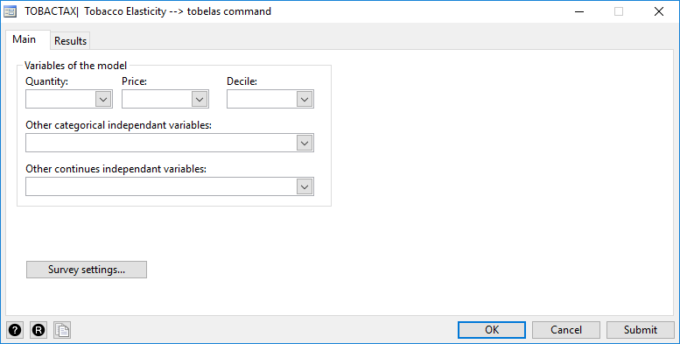

The minimum required variables are:

* The household' purchased quantity of ciguarettes;
* The household' price or unit value (=expenditures/quantity);

The other optional variables are:

* The decile variable;
* The other categorical explanatory variables (example: sex, living_area, etc.);
* The other continues explanatory variables (example: log_income, age, etc.);

In the TAB Results, the user can specify

* the number of decimals of the numerical results;
* to display the full regression results;
* to display the graph elasicities;
* to save the data file of elasiticities, which can be used latter by the ***tobatref*** module.

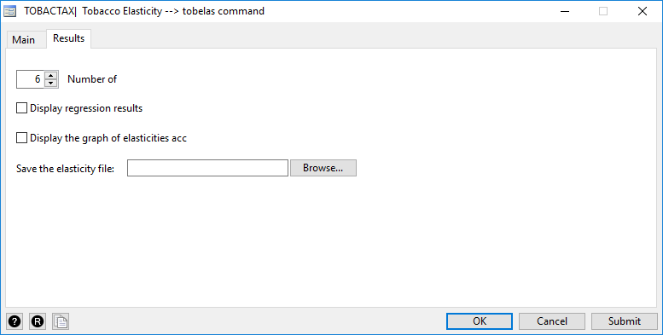

Example and results

The tobelas results:

use "http://dasp.ecn.ulaval.ca/tobactax/example/data/tobelas_example_data.dta" , replace

svyset _n [pweight=weight], vce(linearized) singleunit(missing)

tobelas quantity pricet, decile(decile) indcat(sex) indcon(lnx) dregres(0) dgra(1) elasfile(my_elas_file)



* In Model (01), the price elasticity is -0.6162 (for the whole population), the elasticity of per capita disposable income is 0.1533. In Model (2), and as it is expected, the absolute values of the price elasicities decrease with the increase of income.



# **References**

* Abdelkrim, A. and Verme, P. (2016). "[*Prices and welfare*](https://ideas.repec.org/p/wbk/wbrwps/7566.html)," [Policy Research Working Paper Series](https://ideas.repec.org/s/wbk/wbrwps.html) 7566, The World Bank.
* Gary W. Oehlert, (1992) « A Note on the Delta Method », [*The American Statistician*](https://fr.wikipedia.org/wiki/The_American_Statistician), vol. 46, no 1,‎ février 1992, p. 27-29.
* Coady DP, El Said M, Gillingham R, et al. The magnitude and distribution of fuel subsidies: evidence from Bolivia, Ghana, Jordan, Mali, and Sri Lanka. Published Online First: 2006.

52.

* Kpodar K, Djiofack C. The Distributional effects of oil price changes on household income: Evidence from Mali. Journal of African Economies 2009;19: 205–236.
* Pichón-Riviere, Andrés, Ariel Bardach, Joaquín Caporale, Andrea Alcaraz, Federico Augustovski, Francisco Caccavo, Carlos Vallejos, et al. 2014. “Carga de enfermedad atribuible al tabaquismo en Chile.” Documento Técnico IECS 8 (April), Instituto de Efectividad Clínica y Sanitaria, Buenos Aires.
* Verguet, Stéphane, Cindy L. Gauvreau, Sujata Mishra, Mary MacLennan, Shane M. Murphy, Elizabeth D. Brouwer, Rachel A. Nugent, Kun Zhao, Prabhat Jha, and Dean T Jamison. 2015. “The Consequences of Tobacco Tax on Household Health and Finances in Rich and Poor Smokers in China: An Extended Cost-Effectiveness Analysis.” *Lancet Global Health* 3 (4): e206–16.

1. TOBACTAX is a product of the World Bank.
2. World Bank, Washington DC.
3. University of Laval, Quebec City.
4. Other studies have also evaluated productivity loss, disability costs, externalities, and so on. Because of the availability of relevant data, we focus solely on medical expenses and income changes associated with shifts in mortality.
5. For a detailed discussion of the methodology, see Coady et al. (2006), Kpodar (2006) and Araar and Paolo (2016).
6. Other studies have forecast the pass-through between the decline in tobacco consumption and the effect on medical expenditures. These estimates may also differentiate the effect associated with people who stop consuming tobacco versus people who do not start because of the tax policies. Because of data restrictions, we cannot use these assumptions in this paper.
7. We assume that income is equal to the average consumption of each household per decile.
8. <http://dasp.ecn.ulaval.ca/tswel/ts/> [*…in construction*.]