Demand Systems, Prices and Income Elasticities

***Araar, A. Carlos, R.C., Sergio, O. and Eduardo, A.M.C.***

*Technical Note[1]*

*World Bank*

*April 2018*

Contents

1. Introduction **Erreur ! Signet non défini.**

2. Deaton’s (1988) Unit Value Model 4

2.1 The Deaton’s theoretical model 4

2.2 The empirical implementation and estimation 5

2.3 The DUVM Stata module 7

2.4 Examples of DUVM module 9

3. AIDS & QUAIDS Demand System Models 14

3.1 The Almost Ideal Demand System theoretical model (AIDS) 14

3.2 The Quadratic Almost Ideal System theoretical model (QUAIDS) 14

3.3 Practical exercise: The QUAIDS model 16

4. Exact Affine Stone Index (EASI) 18

4.1 The EASI theoretical model? 18

4.2 Computational tools to estimate the EASI model? 19

4.3 Practical exercise: The EASI model 20

# Demands system models, elasticities and WELCOM

As reported before, the consumer reaction to the change in prices is among the main determinant of the market power. Disposing the information on the price elasticities is thus primordial to study the impacts of the market power on well-being. Depending on, on the specific context of each study, the practitioner can decide to use the available information on the elasticity in the other empirical studied or even estimate the required price elasticities. As an important contribution of the WELCOM package, is to introduce the popular and most updated demand system models and to provide the user-friendly tools for the estimations.

Because of the complex-specific details of each demand system model, it will be helpful to start by introducing in a more concise form each of the models and thus the WELCOM Stata module to estimate it. Thus, our aim is to remember briefly the most popular models and especially to focus on the computational framework, as well as to document or to develop the Stata code for the estimations of price elasticities. During the last decades, there is a significant progress in developing the flexible demand system models, as the AIDS/QUIDS or the EASI models. However, handling the data and estimating the models require some expertise. The models that we cover are:

* the Deaton (1988) Unit Value Model (DUVM);
* the AIDS/QUAIDS model(s);
* and he EASI model.

# Deaton’s (1988) Unit Value Model

## The Deaton’s theoretical model

Estimating a demand system requires information on the household expenditures at different price levels. The price can vary spatially or temporally. However, accurate price-data are rare. This scarcity of data justifies switching to what we call the *unit value model*. In particular, for the case of large consumption groups with weak separability, Deaton (1988) develops a model to estimate the price and income elasticities, and this, using unit values, and where the model enables to compensate for the quality effect.

As reported by Deaton (1988), we assume that we have a given main set of expenditures, where each of them is composed of a predetermined group of items. Let $E_{c}$ denotes the household expenditures on the group of items $c$.

|  |  |
| --- | --- |
| $$E_{c}=p_{c}q_{c}$$ | (01) |

where $p_{c}$ and $q_{c}$ are vectors denoting the prices and the quantities of the group $c$. Within the group of commodities $c$, let $λ_{c}$ denotes the proxy unique price of the commodities $c$ and $v_{c}$ the indicator of quality such that:

|  |  |
| --- | --- |
| $$E_{c}=λ_{c}v_{c}Q_{c}$$ | (02) |

For the same level of expenditures $E_{c}$ the aggregated quantity within the group $c$ ($Q_{c}$) will depend on the quality of bought goods, $v_{c}$. More important, the estimated unit value $V_{c}=\frac{E_{c}}{Q_{c}}=λ_{c}v_{c}$ will depend on the product of proxy unique price and quality. Based on this model, the price elasticity is defined as follows:

|  |  |
| --- | --- |
| $$e_{c}=\frac{∂Q_{c}}{∂λ_{c}}=\frac{∂{lnQ}_{c}}{∂{lnV}_{c}}\left(1+\frac{∂{lnv}_{c}}{∂lnλ_{c}}\right)$$ | (03) |

Deaton (1988) proposes the adoption of the weak separable utility function with demands:

|  |  |
| --- | --- |
| $q_{c}$ = $f_{c}(\frac{E_{c}}{λ_{c}}, p_{c}^{*} )$ | (04) |

The consumer selects in the first stage the –normalized- budget $\frac{E_{c}}{λ_{c}}$ that is allocated to the group *c.* After that*,* and depending on the vector of the prevailed prices according to the quality ($p_{c}^{*}$), the consumer will select the levels of expenditures on the different items of the group *c*. In addition, the assumption of weak separability leads to:

|  |  |
| --- | --- |
| $$\frac{∂{lnv}_{c}}{∂lnλ_{c}}=\frac{\frac{∂{lnv}_{c}}{∂lnx}\frac{∂{lnQ}_{c}}{∂lnλ_{c}}}{\frac{∂{lnQ}_{c}}{∂lnx}}$$ | (05) |

## The empirical implementation and estimation

We start with the case of the standard unit value model, and where we assume that the quality effect is nil or can be neglected. As suggested by Deaton (1988), the simple model with the weak separability assumption is as follows:

|  |  |
| --- | --- |
| $$w_{c,i}=α_{0}+β_{0}x_{i}+γ_{0}z_{i}+ϕ_{0}\ln\left(V_{c,i}\right)+u_{0,i}$$ | (06) |

where

|  |  |
| --- | --- |
| $$w_{c,i}$$ | : The budget share of group $c$. |
| $$x_{i}$$ | : The household income. |
| $$z_{i}$$ | : Household characteristics |
| $$V_{c,i}$$ | : Unit value of group $c$. |

We have that:

$$\frac{∂{lnQ}_{c}}{∂{lnV}_{c}}=\frac{\frac{∂{lnw}_{c}}{∂{lnV}_{c}}}{w_{c}}-1$$

|  |  |
| --- | --- |
| $$e_{c}=\frac{∂Q_{c}}{∂λ_{c}}=\left(\frac{\frac{∂{lnw}_{c}}{∂{lnV}_{c}}}{w_{c}}-1\right)\left(1+\frac{∂{lnv}_{c}}{∂lnλ_{c}}\right)$$ | (07) |

For the standard unit value model and by assuming that the quality is uncorrelated with the price changes (i.e. $\frac{∂{lnv}_{c}}{∂lnλ_{c}}=0$), we have that:

|  |  |
| --- | --- |
| $${\hat{e}}_{c}=\left(\frac{{\hat{ϕ}}_{0}}{{\overline{w}}_{c}}-1\right)$$ | (08) |

The case where $\frac{∂{lnv}_{c}}{∂lnλ_{c}}$ is not nil and with the assumption of weak separability, we have that:

|  |  |
| --- | --- |
| $$e_{c}=\frac{∂Q_{c}}{∂λ_{c}}=\left(\frac{\frac{∂{lnw}_{c}}{∂{lnV}_{c}}}{w_{c}}-1\right)\left(1+\frac{\frac{∂{lnv}_{c}}{∂lnx}\frac{∂{lnQ}_{c}}{∂lnλ_{c}}}{\frac{∂{lnQ}_{c}}{∂lnx}}\right)$$ | (09) |

Deaton recommends three steps to estimate the parameters and the elasticities:

**Step 1:** using the simultaneous equations, we estimate the components $\frac{∂{lnv}_{c}}{∂lnx}$ and $\frac{∂{lnQ}_{c}}{∂lnx}$,

|  |  |
| --- | --- |
| $$w_{c,i} =α_{1}+β_{1}x_{i}+γ_{1}z_{i}+f_{c}+u_{1,i}$$ | (10) |
| $$\ln\left(V_{c,i}\right)=α_{2}+β_{2}x_{i}+γ_{2}z_{i}+f_{c}+u_{2,i}$$ | (11) |

Where $f_{c}$ is the fixed effect of the group $c$.

**Step 2:** estimating the component $\frac{∂{lnw}_{c}}{∂{lnV}_{c}}$ using the average predicted values of $w_{c,i}$ and $V_{c,i}$ at the cluster level and this using the following model.

|  |  |
| --- | --- |
| $${\tilde{w}}_{c}=α_{3}+ϕ_{3}\ln\left({\tilde{V}}_{c,i}\right)+u_{3}$$ | (12) |

It can be noted here that the estimation at this second stage is not ordinary least squares. Indeed, Deaton (1988) uses the correlation between the first stage residuals to estimate the severity of the measurement error. This is used to adjust the estimates and to correct for the structural correlation between quantity and unit value.

**Step 3:** Solving the equation (09) for the argument $\frac{∂Q_{c}}{∂λ_{c}}.$

***References***

* ***Angus Deaton***. Quality, quantity, and spatial variation of price. American Economic Review, 78(3), Jun 1988.
* ***Angus Deaton***. Price elasticities from survey data: Extensions and Indonesian results. Journal of Econometrics, 44:281–309, 1990.
* ***Angus Deaton***. The Analysis of Household Surveys: A Microeconometric Approach to Development Policy. Johns Hopkins University Press, 1997.
* ***McKelvey, Christopher***, 2011. "Price, unit value, and quality demanded," Journal of Development Economics, Elsevier, vol. 95(2), pages 157-169, July.

## The DUVM Stata module

The Deaton (1997) book’s includes a set of the Stata do files, which were updated in the WELCOM package to perform the estimation of unit value models. Our main contribution was to update the Stata code to produce a concise Stata ado file, which will be easier for the practitioner. Among the improvements, we find:

1. The possibility of using the sampling weight to consider the level of representativeness of each observation;
2. The possibility of tacking into account for the nil expenditures using the Heckman approach, or in short, the IMR component in the estimation;
3. Producing the elasticities different population groups;
4. The use of dialog box, saving the information of the dialog box;
5. Saving results in the Excel format;
6. Etc.

As we can show with some examples, these aspects can largely influence the estimated elasticities. The name of the new Stata command is **duvm**.

**Figure 1 : The DUVM dialog box**

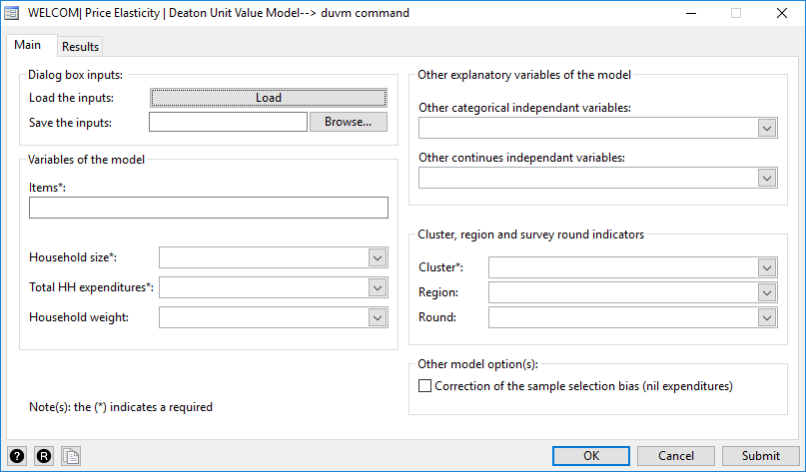

The basic syntax of the DUVM module is as follows:

duvm **namelist , [options]**

The **namelist** should contain the names of items of expenditures. Note that the data must contain two variables for each item in the **namelist**. The name of the first variable is composed of the letter **w** followed by the name of the item. The name of second variable is composed of the word **luv** and the name of the item. For instance, if the name is of the item is *flour*, we must have the two variables: *wflour* and *luvflour*, which refers to the expenditure share and the log of the unit value of the flour item respectively. The options of the **duvm** command are (required in bold):

|  |  |
| --- | --- |
| *inisave* | To save the duvm dialog box information. Mainly, all-important information in the dialog box will be saved in this file. In another session, the user can open the project using the command duvm_db_ini followed by the name. |
| ***hhsize*** | The household size. |
| ***expend*** | The household expenditures. |
| *hgroup* | Variable that captures a socio-demographic group. For example, this variable could equal 1 for rural households and 2 for urban ones. |
| *indcat* | The list of the independent variables that are categorical. |
| *indcon* | The list of the independent variables in continues form. |
| ***cluster*** | The cluster is required in an intermediate step to estimate the derivative of the log(exp_share) with regards to the log(unit value). |
| *region* | The region area. |
| *subround* | The round of the surveyed household. |
| *csb* | Correction of Selection Bias. In the case of csb(1), for each item, the routine estimates the beforehand IML ratio based on the binary model (Consumption is not nil ), and then, it uses the IMR variable in models of the first stage. |
| *hweight* | The sampling weight of the variable. |
| *boot* | boot(number of replications) : to estimate the standard errors of the price elasticities. |
| *xfil* | To indicate the name of Excel file, which will be used to save the results (*.xml format). |
| *dec* | To indicate number of decimals of the displayed results. |
| *sname* | To indicate the short names of items. |
| *dregres* | To display the regression results. |

## Examples of DUVM module

**The data**

For the ENIGH Mexican data of 2014, we have four groups of expenditures on the ***cereal products***: *corn, wheat, rice and other_cereals*. The size of the full dataset is 19477 observations/households. By using the extended data on expenditures and quantities, we can remark that:

* The household may or may not consume a part of the sub items, or even the item/group $c$;
* Each group (or item) $c$ can be composed of a set of sub items ($c,j)$;

**CORN**

A001 Grain corn

A002 Maize flour

A003 Mass of corn

A004 Corn tortilla

A005 Toast

A006 Other maize products

**WHEAT**

A007 Wheat flour

A008 Flour tortilla

A009 Pasta for soup

A010 Sweet cookies

A011 Crackers

A012 White bread: bolillo, telera, baguette, etc.

A013 Sweet bread in pieces

A014 Sweet bread packaged

A015 Bread for sandwich, hamburger, hot-dog and toasted

A016 Cakes and pastries in pieces or in bulk

A017 Packaged cakes and pastries

A018 Other Wheat Products

**RICE**

A019 Rice grain

A020 Other rice products

**OTHER CEREALS**

A021 Corn, wheat, rice, oat, granola, etc. cereal

A022 Botanas: fritters, popcorn, Cheetos, Doritos et cetera (except potatoes)

A023 Instant soups

A024 other cereals

For each group $c$, we need two information (for each household), which are the unit value and the expenditure share. The household expenditure share is easy to be computed, and it ranges between 0 and 1. For the unit value, the Laspyers index is usually used.

$$V_{c,i}=\sum_{j=1}^{J_{c}}{w_{c,j,i}V_{c,j,i}}$$

In the case where the household does not consume any item of the group, we can attribute to this household the average unit value of the group *c* at the level of his cluster. This can be justified by the fact that the household will have the same consumption habits and prices of the other households living in the same cluster. As another step in this example is that we exclude some observations wit where the expenditure share (relative to the current income) exceeds the 95%. After finishing the treatment, the data file (15866 observations) will contain among others the following variables:

|  |  |
| --- | --- |
| The variable names | The definition |
| *cluster* | Primary sampling unit |
| *hh_current_inc* | Current income of the household |
| *hhsize* | Household size |
| *sweight* | sampling weight |
|  |  |
| *sex* | Sex of household head |
| *age* | Age of household head |
| *psu* | Primary sampling unit |
| *education* | Diploma of the household head |
| *wcorn* | expenditures share of corn |
| *wwheat* | expenditures share of wheat |
| *wrice* | expenditures share of rice |
| *wother* | expenditures share of the rest of cereals |
|  |  |
| *luvcorn* | log of the unit val of flour |
| *luvwheat* | log of the unit val of semolina |
| *luvrice* | log of the unit val of couscous |
| *luvother* | log of the unit val of pasta |

For more information on the treatment of data, type the following Stata command:

**view** <http://dasp.ecn.ulaval.ca/welcom/examples/ds/example_cereals_data.do>

Example I-1

#delimit ;

use http://dasp.ecn.ulaval.ca/welcom/examples/ds/Mexico_2014_Cereals.dta , replace;

duvm corn wheat rice other, hhsize(hhsize) expend(hh_current_inc) hweight(sweight) cluster(psu) region(rururb)

inisave(ex1_duvm_db) indcat(sex educ) indcon(age) xfil(myfile) dregres(1) hgroup(decile) boot(50) ;

After executing the line command, a series of results are displayed.

*Part_1: Estimations of the first stage.*



*Part_2: Average expenditure shares, income and quality elasticities.*



In this first example, the elasticity of quality is very low. This is explained by the nature of goods. For instance, the quality of the flour group cannot vary largely.

*Part_3: Price elasticities.*



The price elasticity may vary largely across deciles. It is important to consider this aspect to assess accurately the impact of price changes on the poor group.

# AIDS & QUAIDS Demand System Models

## The Almost Ideal Demand System theoretical model (AIDS)

To present the AIDS model, we start by defining the PIGLOG model. This model can be represented via an expenditure function $c(P,U)$ that defines the minimum level of expenditure to reach a predetermined level of utility given prevailing prices:

$log\left(c(p,U)\right)=(1-U)log(a(p))+Ulog(b(p))$ (01)

where $U$ is the utility located between 0, the level of subsistence, and 1, the level of beatitude. The function $a(p)$ is found through the TRANSLOG form:

$log\left(a(p)\right)=α_{0}+\sum_{i=1}^{K}{‍}α_{i}log(p_{i})+\sum_{i=1}^{K}{‍}\sum_{j=1}^{K}{‍}γ_{i,j}^{*}log(p_{i})log(p_{j})$ (02)

The component $b(p)$ is defined as :

$log\left(b(p)\right)=log\left(a(p)\right)+β_{0}\prod_{i=1}^{K}{‍}{p_{i}}^{β_{i}}$ (03)

Thus, we find that:

$log\left(c(p,u)\right)=α_{0}+\sum_{i=1}^{K}{‍}α_{i}log\left(p_{i}\right)+\sum_{i=1}^{K}{‍}\sum_{j=1}^{K}{‍}γ_{i,j}^{*}log\left(p_{i}\right)log\left(p_{j}\right)+uβ_{0}\prod_{i=1}^{K}{‍}{p_{i}}^{β_{i}}.$ (04)

Using Shephard’s Lemma ($∂c(p,u)/∂p_{k}=x_{k}$) , the expenditure share on good $i$ becomes:

$w_{i}=α_{i}+\sum_{i=1}^{K}{‍}\sum_{j=1}^{K}{‍}γ_{i,j}log(p_{j})+β_{i}uβ_{0}\prod_{i=1}^{K}{‍}{p_{i}}^{β_{i}}$ (05)

and

$γ_{i,j}=\frac{1}{2}\left(γ_{i,j}^{*}+γ_{j,i}^{*}\right)$ (06)

Expenditure shares also simplify as:

$w_{i}=α_{i}+\sum_{j=1}^{K}{‍}γ_{i,j}log(p_{j})+β_{i}log(m/a(p))$ (07)

where $a(p)$ can be perceived as a price index equalling:

$log\left(a(p)\right)=α_{0}+\sum_{i=1}^{K}{‍}α_{i}log(p_{i})+\sum_{i=1}^{K}{‍}\sum_{j=1}^{K}{‍}γ_{i,j}^{*}log(p_{i})log(p_{j})$ (08)

The additional conditions of the model are:

$\begin{matrix}I: & \sum_{i=1}^{K}{‍}α_{k}=1 & Sum of expenditures shares is 1 \\ II: & \sum_{i=1}^{K}{‍}γ_{i,j}=0 ∀j and \sum_{i=1}^{K}{‍}β_{i}=0 & Homogeneity of degree 0 of demand functions \\ III: & γ_{i,j}=γ_{j,i} & Symmetry of the Slutsky matrix \end{matrix}$ (09

## The Quadratic Almost Ideal System theoretical model (QUAIDS)

Banks Blundell and Lewbel (1997) have proposed the Quadratic Almost Ideal System (QUAIDS) model that adds the quadratic logarithmic income term to the AIDS specification of Deaton and Muellbauer (1980). This was proposed in order to take into account the potential quadratic form of the Engel curve behaviour for some durable and luxury goods. The specification is as follows:

$w_{i}=α_{i}+\sum_{j=1}^{K}{‍}γ_{i,j}log(p_{j})+β_{i}log(m/a(p))+\frac{λ_{i}}{b(p)}log(m/a(p))^{2}$ (09)

The price index is given by:

$log\left(a(p)\right)=α_{0}+\sum_{i=1}^{K}{‍}α_{i}log(p_{i})+\sum_{i=1}^{K}{‍}\sum_{j=1}^{K}{‍}γ_{i,j}^{*}log(p_{i})log(p_{j})$ (10)

The price aggregator is given by:

$b\left(p\right)=\prod_{i=1}^{K}{‍}p_{i}^{β_{i}}$ (11)

The income and demand elasticities are defined as follows:

$\begin{matrix}I: & e_{i}=μ_{i}/w_{i}-1 & Income elasticity \\ II: & e_{i,j}^{nc}=μ_{i,j}/w_{i}-δ_{i,j} & Non compensated elasticity \\ III: & e_{i,j}^{c}=μ_{i,j}/w_{i}-e_{i}w_{i} & Compensated elasticity \end{matrix}$ (12)

where $\begin{matrix}μ_{i}=\frac{∂w_{i}}{∂log(m)}=β_{i}+2λ_{i}log\left(\frac{m}{a(p)}\right) & & & & & & & & & & & & & & & & & & & \\ & & & & & & & & & & & & & & & & & & & \\ μ_{i,j}=\frac{∂w_{i}}{∂log(p_{j})}=γ_{i,j}+μ_{i}\left(α_{j}+\sum_{k=1}^{K}{‍}γ_{k,j}log(p_{k})\right)-\frac{λ_{i}β_{j}}{b(p)}{\left\{log\left(\frac{m}{a(p)}\right)\right\}}^{2} & & & & & & & & & & & & & & & & & & & \\ & & & & & & & & & & & & & & & & & & & \end{matrix}$

***References***

* Banks, J., R. Blundell, and A. Lewbel. 1997. Quadratic Engel curves and consumer demand. *Review of Economics and Statistics* 79: 527–539.
* Deaton, A. S., and J. Muellbauer. 1980a. *Economics and Consumer Behaviour*. Cambridge: Cambridge University Press.
* ———. 1980b. An almost ideal demand system. *American Economic Review* 70: 312–326.

**Remark:**

The Stata module for the estimation of the AIDS and the QAIDS models is already available and well developed by Brian Poi (2012).

* *Poi, Brian P., (2012), Easy demand‐system estimation with quaids, Stata Journal, 12, issue 3, p. 433‐446*

The module **wquaids** uses implicitly the Brian Poi quaids Stata command (or its updated version wquaids). The improvements are:

1. The possibility of using the sampling weight to consider the level of representativeness of each observation;
2. The use of dialog box, saving the information of the dialog box;
3. Saving results in the Excel format;
4. Etc.

Figure 2: the dialog box of the AIDS/QUAIDS models

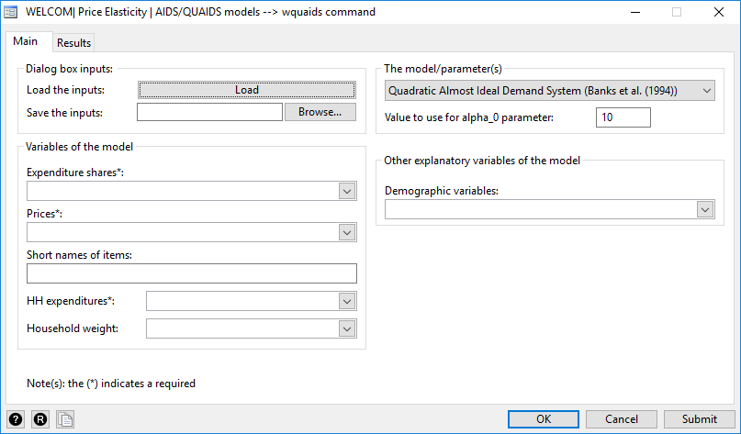

## Practical exercise: The QUAIDS model

**The data**

We use the same data of the DUVM example (see the subsection 2.4). For simplicity, we consider unit values as the observed prices.

/* The Stata code */

#delimit ;

use http://dasp.ecn.ulaval.ca/welcom/examples/ds/Mexico_2014_Cereals.dta , replace;

wquaids wcorn wwheat wrice wother wcomp,

anot(9.5)

prices(pcorn pwheat price pother pcomp)

snames(Corn Wheat Rice Other_cereal Rest)

expend(hh_current_inc)

hweight(sweight)

model(1)

inisave(ex1_quaids_db)

demographics(sex educa2- educa7 age)

dregres(1) dislas(0) xfil(myfil);

***Remarks:***

* The command *wquaids* is followed by the expenditure share variables. The variables *wcomp* is the expenditure share on the rest of items (outside the cereal products). The sum of the expenditure shares must be equal to one.
* The option anot() is the initial level of the parameter alpha_0 of the AIDS/QUAIDS model. It can be approximated to the log of the min(household income).
* The option model(1) is for the QUAIDS model. (2) is for the AIDS model.
* The option dislas(0) indicates that the results of the last item (complement or rest of items) will not be displayed.

The results:

|  |  |
| --- | --- |
| QUAIDS MODEL | Standard DUV MODEL |
| *Income elasticities* | |
|  |  |
| *Uncompensated price elasticities* | |
|  |  |

As we can remark, the two-demand system models give close estimates of the price elasticities.

# Exact Affine Stone Index (EASI)

## The EASI theoretical model?

To deal with the empirical nonlinear form of the Engel curve and to propose a more flexible model, Lewbel and Pendakur (2009) use the Shephard’s lemma to approximate real income. This linear approximation implies the use of the Stone price index (SPI), as in the case of the Linear Approximate Almost Ideal Demand System (LA/AIDS). Even with this restriction, among the advantages of the EASI model is the possibility of using a higher order of the polynomial real income, which enables to better fit the Engel function. Formally, the approximated EASI model can be defined through the implicit marshallian budget share as follow:

$w_{i}=\sum_{r=1}^{o}{‍}b_{r}{\tilde{y}}^{r}+\sum_{j=1}^{K}{‍}a_{k}log(p_{k})+\sum_{k=1}^{K}{‍}b_{k}log(p_{k})\tilde{y}+\tilde{ε}$

$=\sum_{r=1}^{o}{‍}b_{r}{\tilde{y}}^{r}+Ap+Bp\tilde{y}+\tilde{ε}$ (01)

where $\tilde{y}$ denotes here the log of the approximated real income: $y≈\tilde{y}=log(m)-\sum_{k=1}^{K}{‍}w_{k}log(p_{k})$. The parameter $o$ is the polynomial order of the real income and the parameter $\tilde{ε}$ is simply the error term of the estimation. For simplicity and compared to the Lewbel and Pendakur (2009) presentation of the model, we omit the household characteristic determinants. Based on the Shephard’s lemma and the cost function, Arthur and Pendakur (2009) show that the exact real income is equal to:

$y=\frac{m-p'w+p'Ap}{1-0.5*p'Bp}$ (02)

Thus, the exact EASI model can be defined as follows:

$w_{i}=\sum_{r=1}^{o}{‍}b_{r}{\left(\frac{m-p'w+p'Ap}{1-0.5*p'Bp}\right)}^{r}+Ap+Bp\left(\frac{m-p'w+p'Ap}{1-0.5*p'Bp}\right)+ε$ (03)

As was the case for the AIDS or the QAIDS models, additional conditions are imposed:

$\begin{matrix}I: & \sum_{i=1}^{K}{‍}a_{i,j}=0 ∀j and \sum_{i=1}^{K}{‍}b_{i}=0 & Homogeneity of degree 0 of demand functions \\ II: & a_{i,j}=a_{j,i} & Symmetry of the Slutsky matrix \end{matrix}$ (04)

Among the recommended econometric methods to estimate the model is the nonlinear three stages least squares (3SLS). Let $p_{c}$ denotes the vector of the log of prices after the change.

## Computational tools to estimate the EASI model?

In what follow, we introduce briefly the different tools, which can be used to estimate the EASI model and the elasticities. Mainly, we suggest three tools:

1-      *A set of Stata do files*: [EASI demand system with no interactions](http://www.sfu.ca/~pendakur/iterated_3sls_without_pz,py,zy.do) and[EASI demand system with interactions](http://www.sfu.ca/~pendakur/iterated_3sls_with_pz,py,zy.do) (Lewbel, A. (2009)).

2-      *Estimating EASI in R* (by Stephane Hoareau, Guy Lacroix, Mirella Hoareau, Luca Tiberti (2012) ) [easi-r](http://cran.r-project.org/web/packages/easi/).

3-      *Estimating EASI in R with Stata*: the ***sr_easi*** Stata module (Araar, A. (2018)).

The first two tools may require more skill in Stata and R. The third, enables to estimate the EASI model in an easy way, but it uses intermediately the easi R package.

**Reference(s)**

*St_ephane Hoareau, Guy Lacroix, Mirella Hoareau. Luca Tiberti (2012) , Exact Affine Stone Index Demand System in R: The easi Package* [*http://www2.uaem.mx/r-mirror/web/packages/easi/vignettes/easi.pdf*](http://www2.uaem.mx/r-mirror/web/packages/easi/vignettes/easi.pdf)

Figure 3: The dialog box of the sr_easi module

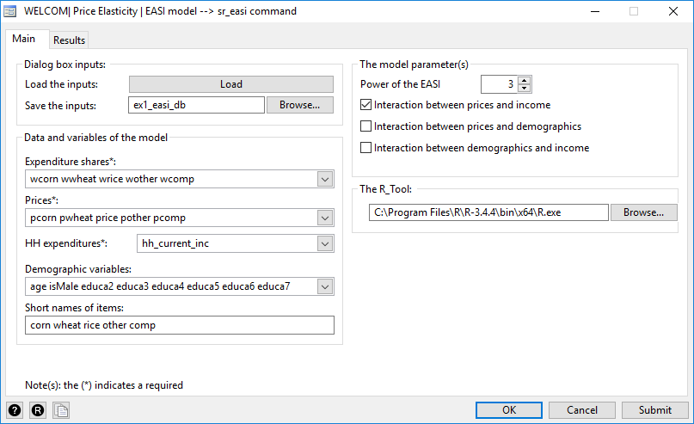

## Practical exercise: The EASI model

**The data**

We use the same data of the DUVM example (see the subsection 2.4). For simplicity, we consider unit values as the observed prices. For this practical example, I simply use a random subsample of 8000 observations of *the Mexican national household survey of 2014* (INEGI-2014) to estimate the elasticities of the he cereal products (corn, wheat, rice and other cereals). Thus, we have four cereals variable shares in addition to the complement share of expenditures on the rest of goods. Further, for the comparison purpose, we will estimate the income and price elasticities using the DUVM and the QUAIDS models.

**The Stata code**

**/****** THE DATA******************/**

#delimit ;

use http://dasp.ecn.ulaval.ca/welcom/examples/ds/Mexico_2014_Cereals.dta , replace;

set seed 4321;

bsample 8000;

**/****** THE DUVM MODEL******************/**

duvm corn wheat rice other , hhsize(hhsize) expend(hh_current_inc)

cluster(psu) indcon(age isMale educa1-educa10 nocup1-nocup4)

csb(0) boot(0) xfil(myres1);

**/****** THE QUAIDS MODEL\*\*\*\*\*\*\*\*\*\*\*\*\*\*\*\*\*\***/

wquaids wcorn wwheat wrice wother wcomp, anot(6)

prices(pcorn pwheat price pother pcomp)

expenditure(hh_current_inc)

demographics(hhsize age isMale educa1-educa10 nocup1-nocup4)

snames(corn wheat rice other complement) dislas(0) xfil(myres2) ;

**/****** THE EASI MODEL******************/**

sr_easi wcorn wwheat wrice wother wcomp, prices(pcorn pwheat price pother pcomp)

snames(corn wheat rice other comp)

expenditure(hh_current_inc)

demographics(hhsize age isMale educa1-educa10 nocup1-nocup4) dec(4) dregres(1) dislas(0)

inpy(0) inpz(0) inzy(0) power(5) xfil(myres3);

**The results:**

***Income elasticities***

|  |  |  |  |  |
| --- | --- | --- | --- | --- |
|  | corn | wheat | rice | other |
| **EASI** | 0.4375 | 0.5654 | 0.6920 | 1.2910 |
| **QUAIDS** | 0.3702 | 0.5042 | 0.6769 | 1.3472 |
| **DUVM** | 0.2763 | 0.4789 | 0.5607 | 1.2162 |

***Price elasticities***

|  |  |  |  |  |
| --- | --- | --- | --- | --- |
|  | **EASI** | | | |
|  | **corn** | **wheat** | **rice** | **other** |
| **corn** | -0.8993 | 0.0910 | -0.1513 | 0.0199 |
| **wheat** | 0.0611 | -0.9290 | 0.1263 | 0.0249 |
| **rice** | -0.0041 | 0.0176 | -1.2443 | -0.1754 |
| **other** | 0.0078 | 0.0065 | -0.1332 | -0.7849 |
|  | | | | |
|  | **QUAIDS** | | | |
|  | **corn** | **wheat** | **rice** | **other** |
| **corn** | -0.923 | 0.105 | -0.009 | 0.029 |
| **wheat** | 0.166 | -0.982 | 0.047 | -0.028 |
| **rice** | -0.155 | 0.464 | -1.310 | -0.152 |
| **other** | 0.606 | -0.395 | -0.213 | -0.865 |
|  | | | | |
|  | **DUVM** | | | |
|  | **corn** | **wheat** | **rice** | **other** |
| **corn** | -0.781 | 0.068 | 0.004 | -0.001 |
| **wheat** | 0.106 | -0.819 | 0.085 | 0.033 |
| **rice** | 0.055 | 0.844 | -1.223 | -0.147 |
| **other** | -0.054 | 0.450 | -0.206 | -0.647 |
|  | | | | |

1. This is a part of the WELCOM project research, which was sponsored by The World Bank. The authors gratefully acknowledges Tara Vishwanath, and members of the Global Solutions Group of Markets and Institutions for Poverty Reduction at the Poverty and Equity Global Practice for helpful comments.