**The AITSIM Manager package: Version 1.0**

Abdelkrim Araar[1] and Paolo Verme[2]

April 2016

The Stata package **aitsim_man** facilitates the installation and maintenance of the AITSIM package. This package can be used to install AITSIM, to check for updates, to read the reference material or to visit the SUBSIM website. Once installed, the user can invoke its dialog box by typing the command: ***db aitsim_man***.

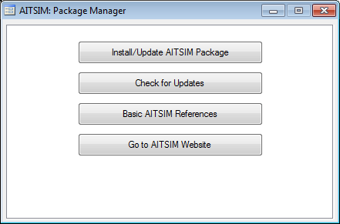

* By clicking on the button Install/Update AITSIM Package, the manager installs for the first time or re-installs AITSIM using the last updated version.
* By clicking on the button Check for updates, the manager compares the installed version with that of the last updated on the server and displays the information.
* By clicking on the button Check for updates, the manager lunches the machine browser by pointing on the web page that contains a list of AITSIM basic references.
* By clicking on the button Go to AITSIM Website, the manager lunches the machine browser by pointing to the home page of the AITSIM Website.

1. Département d’économique, PEP & CIRPÉE, Université Laval, Québec, Canada, [aabd@ecn.ulaval.ca](mailto:aabd@ecn.ulaval.ca)
2. World Bank, [pverme@worldbank.org](mailto:pverme@worldbank.org)