Secure Instant Messaging System

Project Report
Prepared by:
Syed Musaib Khaled – 60306222
Abdalrhman Abdalmjead - 60309340
Instructor:
Dr. Suzan Ali

1. Introduction
The chat system that supports secure communication and is easy to use is the main purpose of this project developed in Python. The server acts as an intermediate between two users and all conversations are protected by encryption. The main idea is to demonstrate the application of AES, RSA, and digital signatures in actual communication.

2. Cryptographic Design:
- RSA – for key generation, public key sharing, and digital signatures
- AES-128 – for encrypting chat messages
- SHA-256 – hashing algorithm for signature integrity

3. Main Features
1. Automatic RSA key generation for each user
2. Public key exchange between clients
3. AES session key creation and encrypted transmission
4. Fully encrypted chat messages
5. Digital signature verification for message authenticity

4. Project File Structure
• client.py – Client application
• server.py – Messaging server
• rsa_utils.py – RSA encryption, decryption, signatures
• crypto_utils.py – AES encryption/decryption
• screenshots/ – Folder for testing images
• README.md – System documentation

5. Testing and Results
The system was tested using two users (Ahmed and Sara).
All core functionalities worked successfully:
• RSA key generation
• Public key exchange
• AES session key setup
• Correct encryption and decryption
• Verified digital signatures
• Stable communication through server

6. Conclusion
The project meets all requirements by providing secure communication with encryption, authentication,
and message integrity.

Screenshots:
- Server started successfully and waiting for clients.
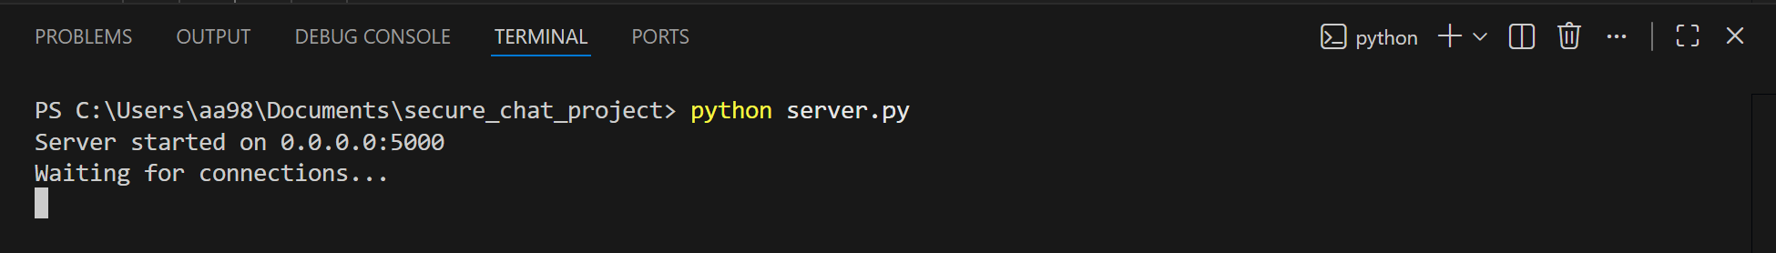

- Client Ahmed connected to the server and ready to chat.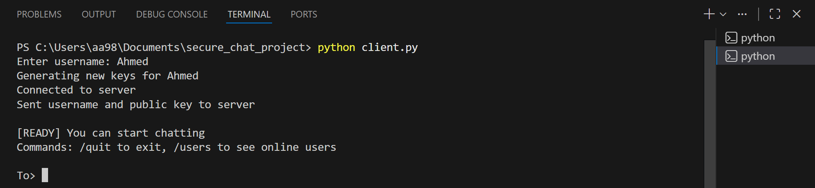

- Client Sara connected and registered on the server.
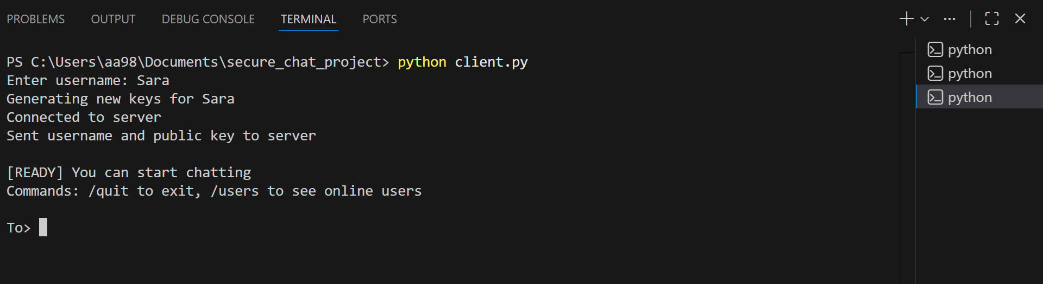

- Sara initiates the secure session by exchanging keys and transferring an encrypted message.
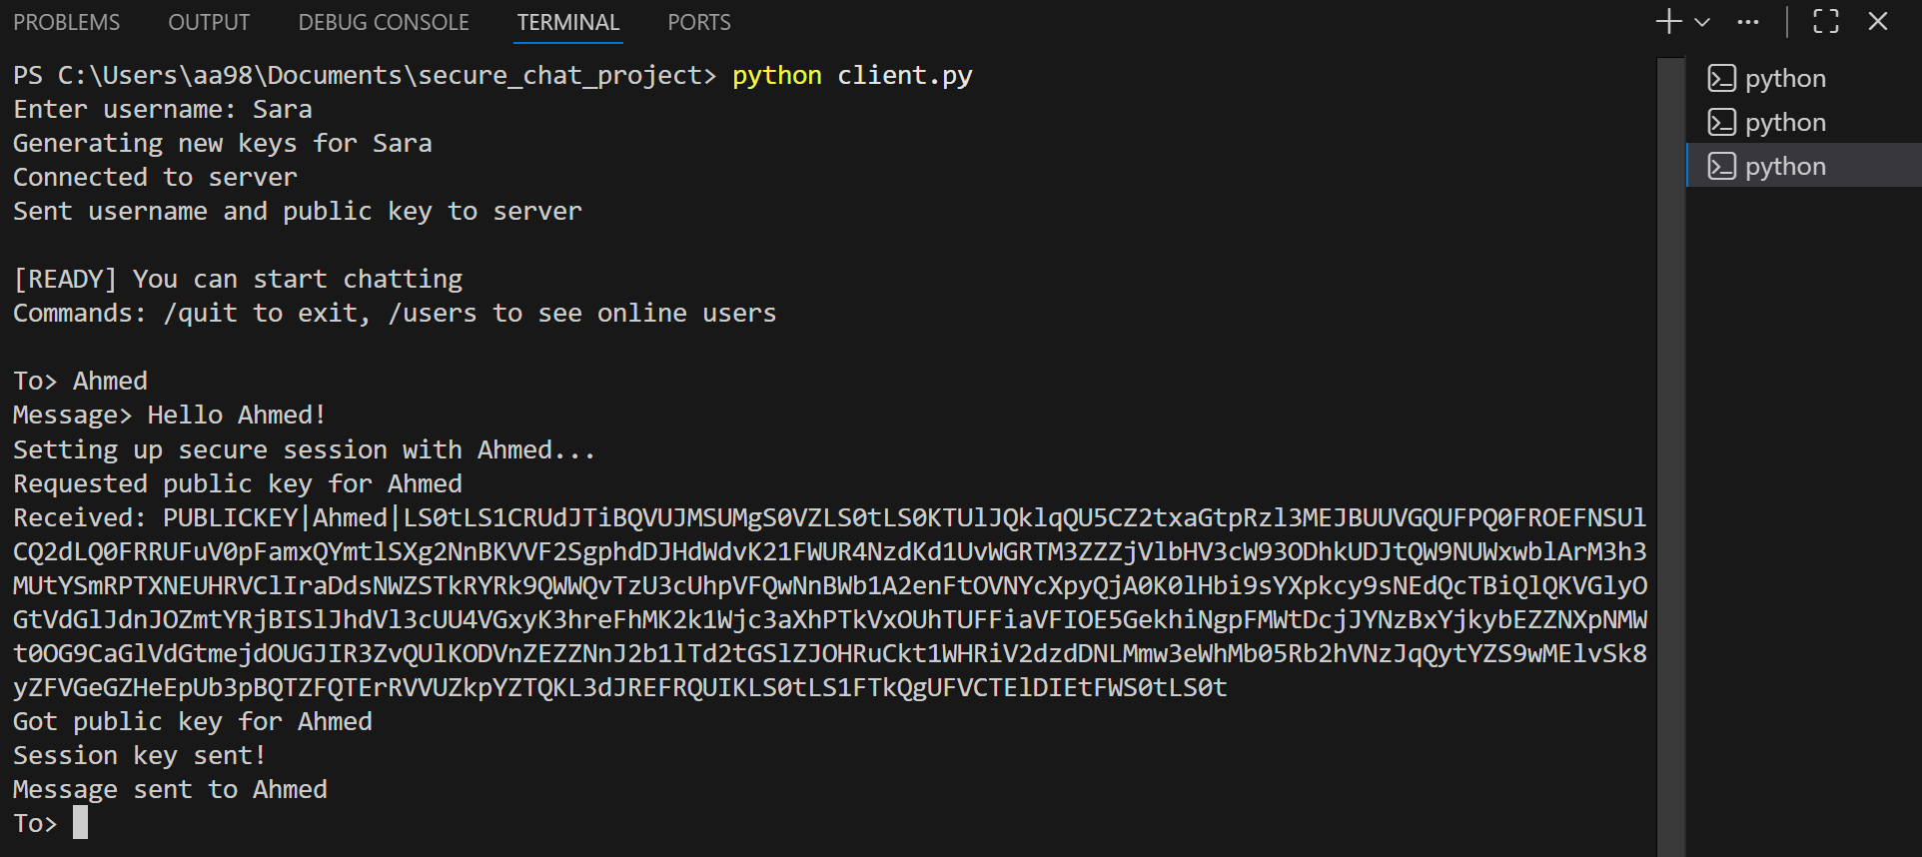
- Ahmed receives Sara’s message. AES key is established and signature verified.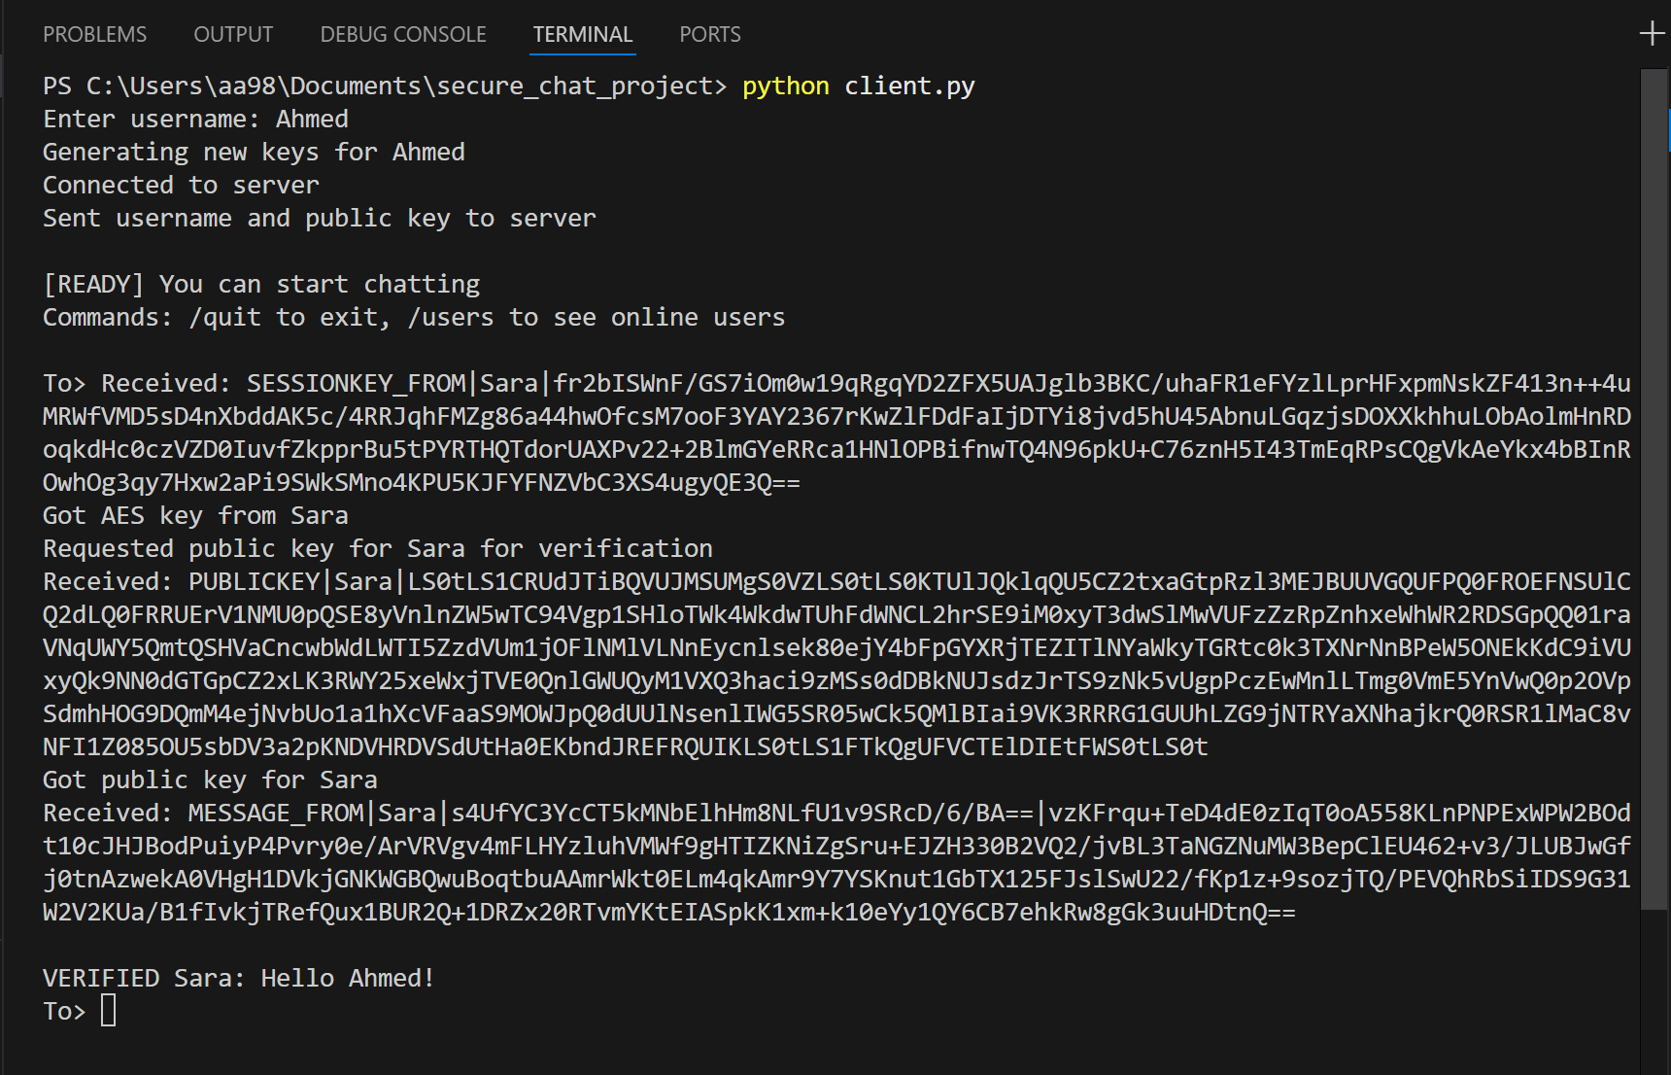
- Ahmed sending an encrypted and signed reply to Sara.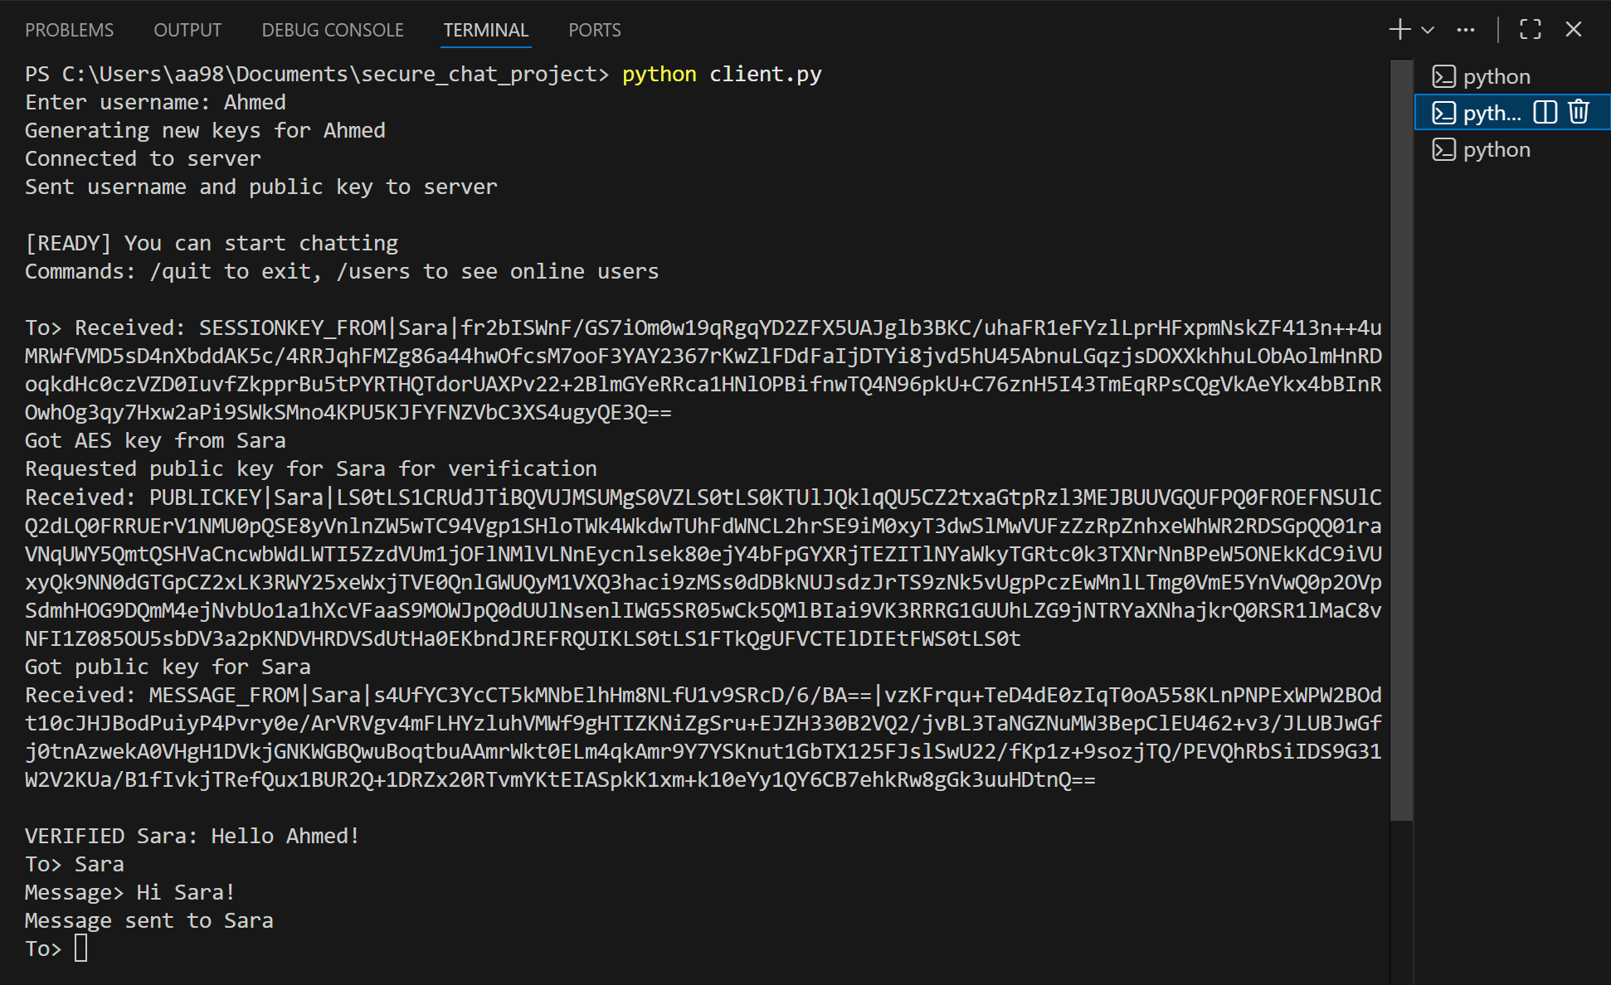
- Sara successfully receives and verifies Ahmed’s encrypted reply.