PULSE Instrument Cluster
System Architecture Description
Ahmed Abdelghany
2026-09-03
Table of Contents

Document control
Field | Value
Document ID | PULSE-SAD-001
Title | System Architecture Description
Version | 1.1
Status | Baseline for sprint 1 review
Date | 2026-09-03
Author | Ahmed Abdelghany
Reviewer | Cockpit Electronics / HMI Platform Group (sponsor)
Review gate | Sprint 1 review, week 3, 4 September 2026
Parent | PULSE-SyRS-001
Related | PULSE-StRS-001, PULSE-SAF-001, PULSE-SEC-001, PULSE-RTM-001

Change log
Version | Date | Author | Change
1.0 | 2026-09-03 | A. Abdelghany | First baseline, written from the running system: context, components, interfaces, runtime, deployment, decisions and deviations, signal contract appendix
1.1 | 2026-09-03 | A. Abdelghany | Layering, worked signal path (new section 5.4), runtime loop, manoeuvre state machine and deployment diagrams added; architecture principle diagram moved to draw.io

1. Purpose and scope
This document describes the architecture that satisfies PULSE-SyRS-001. It is the architecture baseline named in work package 01. It records what exists at week 3, what is planned, and the design decisions a later safety or security argument would need to know about (PULSE-SAF-001 SR-10).
It is a system-level description. Per-component software architecture (SWAD) is deferred to sprint 2 for the cluster and the providers.

2. Architectural principle
Every component meets every other component only at the signal broker, and only through named signals from a standard catalogue. No component knows the others exist. Above the broker there is no CAN, no DBC and no hardware. Below the broker there is no user interface.
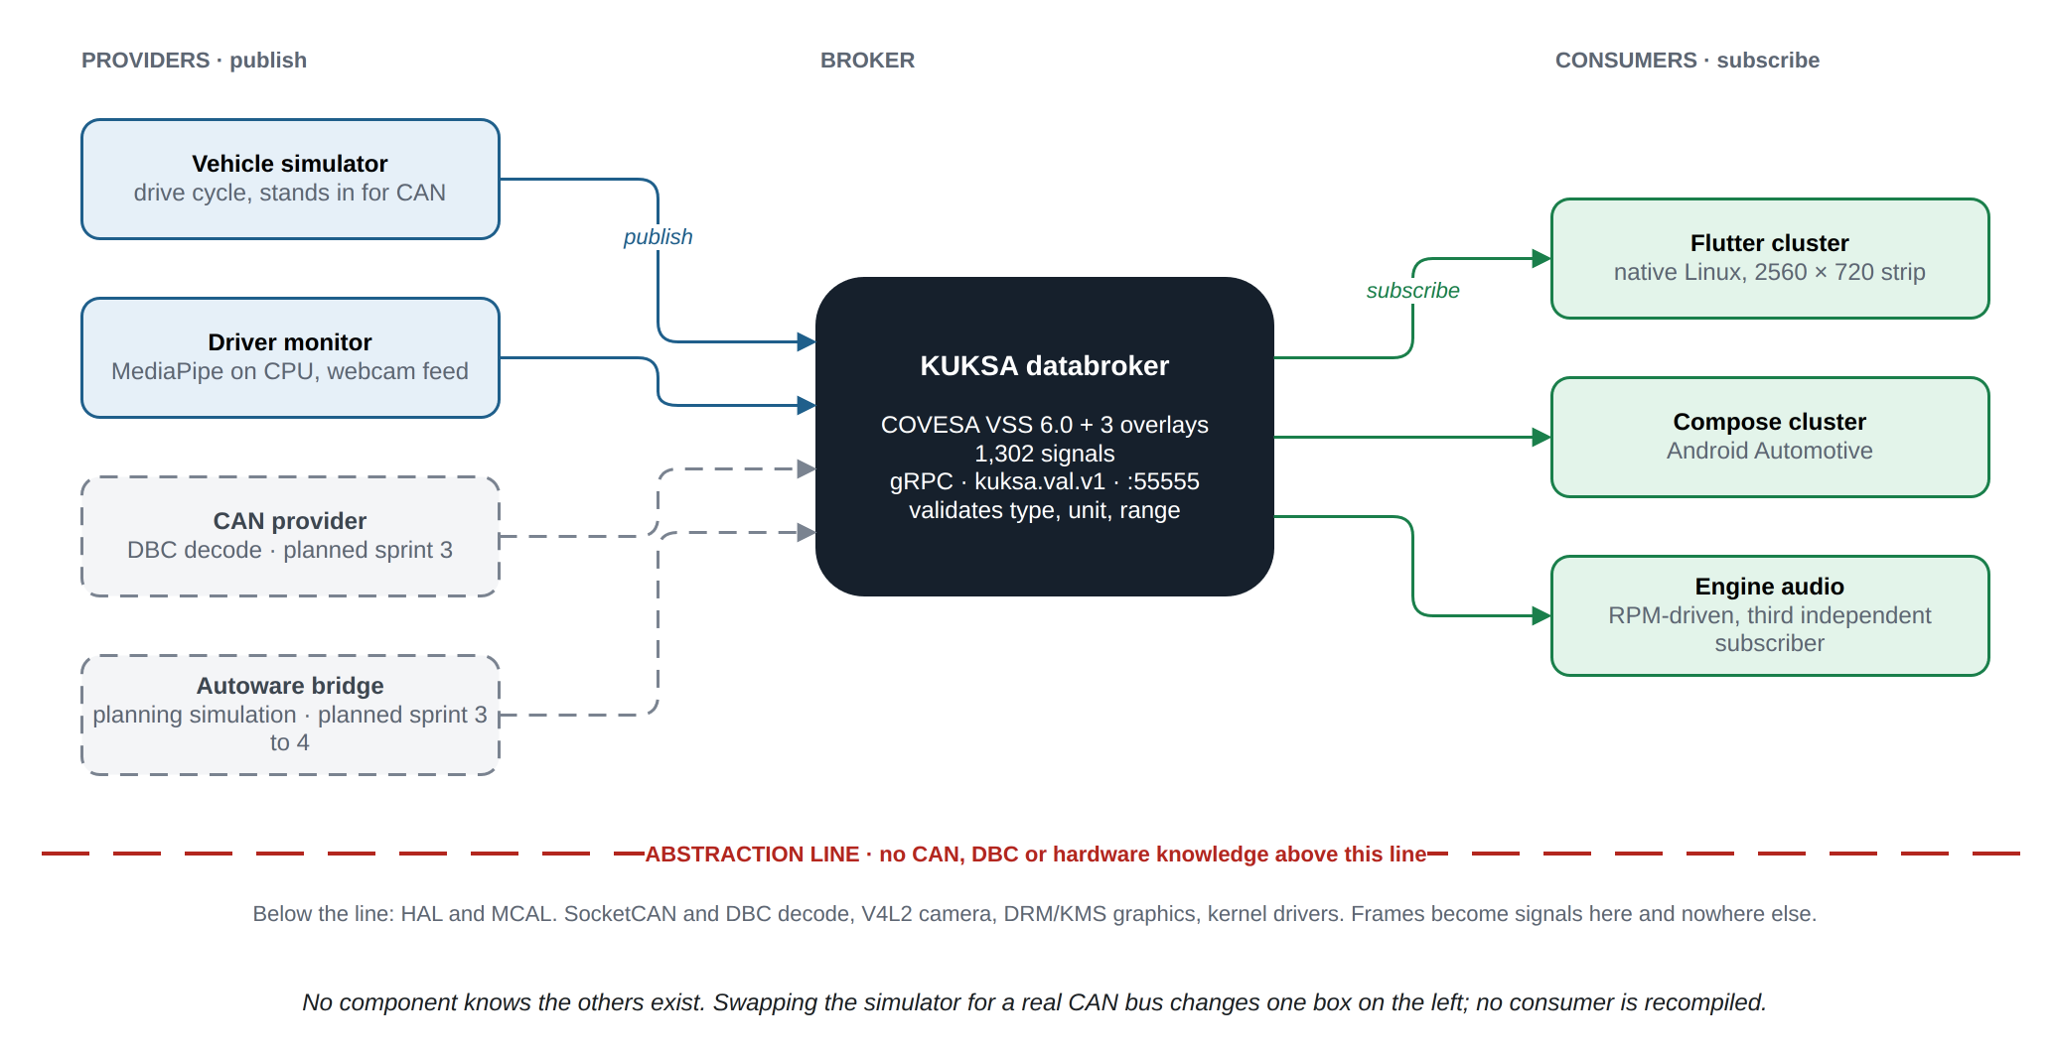
Architecture principle: providers publish, consumers subscribe, nothing meets anywhere but the broker.
Source: docs/diagrams/pulse-architecture.drawio (edit in draw.io, re-export with scripts/build-docs.sh).
Swapping the simulator for a real CAN bus changes one box on the left. No consumer is recompiled (FR-5, FR-8).

3. Context

3.1 System boundary
Inside the boundary | Outside the boundary
Signal catalogue and overlays | The vehicle and its buses (no vehicle exists on the desk rig)
Databroker | The driver (observed by the camera, addressed by the display)
Telemetry providers: simulator, driver monitor, later CAN feeder and Autoware bridge | The display panel hardware
Both HMI applications | The host operating system, container runtime and graphics stack
Orchestration scripts and the regression suite | The Android Automotive emulator or device

3.2 External interfaces
Interface | Direction | Technology | Notes
Camera | In | V4L2 (/dev/video0), 1280 x 720 at 30 fps | Frames never leave the driver-monitor process (CS-6)
Strip display | Out | DisplayPort alt mode over USB-C, 2560 x 720 | Located at runtime by xrandr, placement via CLUSTER_GEOM (IR-4)
Vehicle bus | In | SocketCAN (vcan0 then a CAN HAT on SPI) | Planned S3
Autonomy stack | In | Autoware planning simulation via ROS 2 bridge | Planned S3 to S4
Android surface | Out | ADB reverse to reach the broker on the host | Emulator today; device is backlog

4. Components

4.1 Component catalogue
Component | Role | Implementation | Provenance | Location
Signal catalogue | Names every signal, its type, unit, range and allowed values | COVESA VSS 6.0 plus AGL overlay plus two PULSE overlays, compiled with vss-tools to JSON | Upstream (VSS, AGL overlay), authored (PULSE overlays) | vss/
Databroker | Serves the tree, validates writes, fans out subscriptions | Eclipse KUKSA databroker 0.7.0, Rust, in a container | Upstream | scripts/start-databroker.sh
Vehicle simulator | Publishes a plausible, correlated drive cycle; runs the minimum-risk manoeuvre in cruise mode | Python, kuksa-client 0.5.2 | Authored | emulator/telemetry_sim.py
Driver monitor | Face landmarks to fatigue, distraction and alert state; publishes derived state only | Python, MediaPipe FaceLandmarker (3.7 MB model, CPU), OpenCV | Authored (pipeline), upstream (model) | emulator/dms.py, emulator/models/
Driver monitor viewer | Debug window: landmarks, metrics, thresholds; can stand in for the monitor | Python, OpenCV | Authored | emulator/dms_viewer.py
Engine audio | RPM-driven engine sound, a third independent subscriber | Python | Authored | emulator/engine_audio.py
Flutter cluster | The HMI on Linux; two screens (PULSE racing, classic analogue) in a swipeable pager | Flutter, Dart, custom-painted canvas; gRPC stubs generated from the KUKSA protos | Authored (UI, service), generated (stubs), scaffold (runner, one deliberate edit) | pulse-cluster/
Compose cluster | The same design on Android Automotive | Kotlin, Jetpack Compose, gRPC | Authored | pulse-cluster-android/
AGL reference cluster | AGL’s own Flutter cluster, used as a comparison point | Flutter | Upstream, cloned from AGL Gerrit, not part of this repository | flutter-instrument-cluster/
Orchestration | Start and stop the stack, place the window, fall back to a normal window | Bash | Authored | run.sh, scripts/
Documentation | Onboarding, this specification set, traceability generator | Markdown, Python | Authored | README.md, ONBOARDING.md, docs/
The two HMIs share no code. They share only the signal contract in appendix A.

4.2 Layering
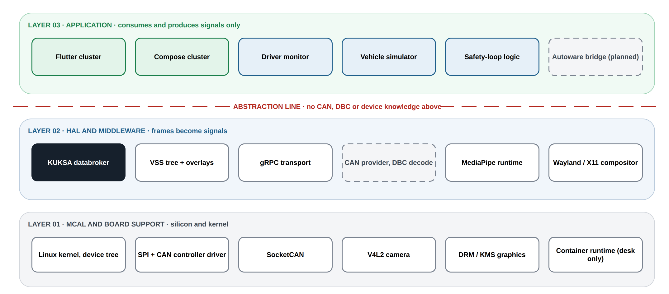
Three layers and the abstraction line. Nothing above the line knows a CAN frame, a DBC file or a device.
Source: docs/diagrams/layering.drawio.
Layer | Contents | Rule
03 Application | Flutter cluster, Compose cluster, driver monitor, safety-loop logic in the simulator, Autoware bridge, vehicle simulator | Consumes and produces signals only
Abstraction line |  | No CAN, DBC or device knowledge above this line
02 HAL and middleware | KUKSA databroker, VSS tree and overlays, gRPC transport, CAN provider with DBC decode, MediaPipe runtime, window system | Frames become signals here
01 MCAL and board support | Linux kernel and device tree, SPI and CAN controller driver, SocketCAN, V4L2 camera, DRM/KMS graphics | Silicon and kernel

5. Interfaces

5.1 Broker interface
Property | Value
Protocol | gRPC over HTTP/2
API | kuksa.val.v1 (Get, Set, Subscribe streaming)
Address | 127.0.0.1:55555, bound to loopback only
Transport security | None in the development configuration (--insecure); see PULSE-SEC-001
Authorisation | None in the development configuration; see PULSE-SEC-001 CS-4
Validation | Broker rejects a value whose datatype, allowed list or min/max does not match the catalogue (IR-2, CS-5)
Client stubs | Dart and Kotlin generated from the same .proto files; Python via kuksa-client
kuksa.val.v1 was chosen over the newer kuksa.val.v2 because AGL’s reference stack and the AGL overlay target v1. Migration to v2 is a recorded decision, section 8.

5.2 Publish rates
Producer | Signals | Rate
Vehicle simulator, fast group | Speed, engine speed, gear, throttle, lap time, DRS, ERS, intervention state | 10 Hz, changed values only
Vehicle simulator, slow group | Fuel, coolant, odometer, tyre pressures, heart rate | 1 Hz
Vehicle simulator, static | Units, performance mode, lamp states | Once at start
Driver monitor | Fatigue, distraction, attention, eyes-on-road, active, alert state | 10 Hz publish, 15 Hz processing

5.3 Signal contract
The signal contract is the set of VSS paths a consumer may rely on. It is listed in appendix A and is the only coupling between producers and consumers. A signal contract test (sprint 2) asserts that every path in appendix A resolves in the compiled tree with the expected datatype and unit.

5.4 Worked example: one signal, bottom to top
A wheel-speed frame arrives on SPI, the provider decodes it with the DBC and renames it to a VSS path, the broker validates and stores it, and every subscriber is pushed the new value over its open gRPC stream. gRPC exists only above the abstraction line; below it there is no RPC at all.
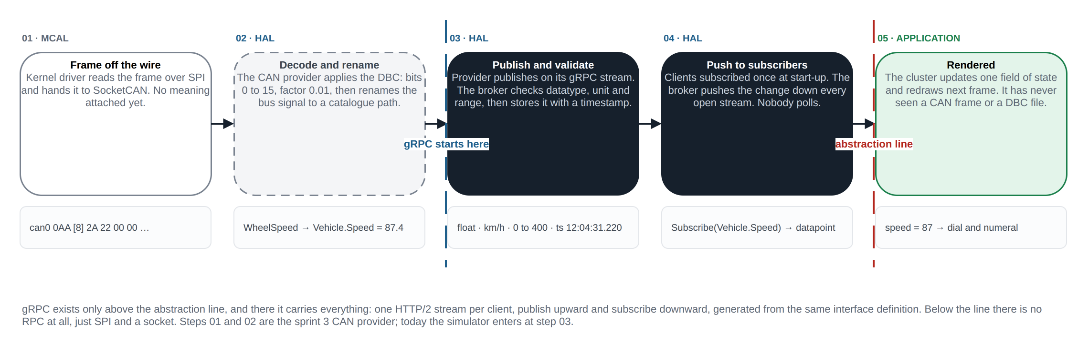
One signal from the wire to the dial. Steps 01 and 02 are the sprint 3 CAN provider; today the simulator enters at step 03.
Source: docs/diagrams/signal-path.drawio.

6. Runtime view
One turn of the loop, repeated at the broker tick:
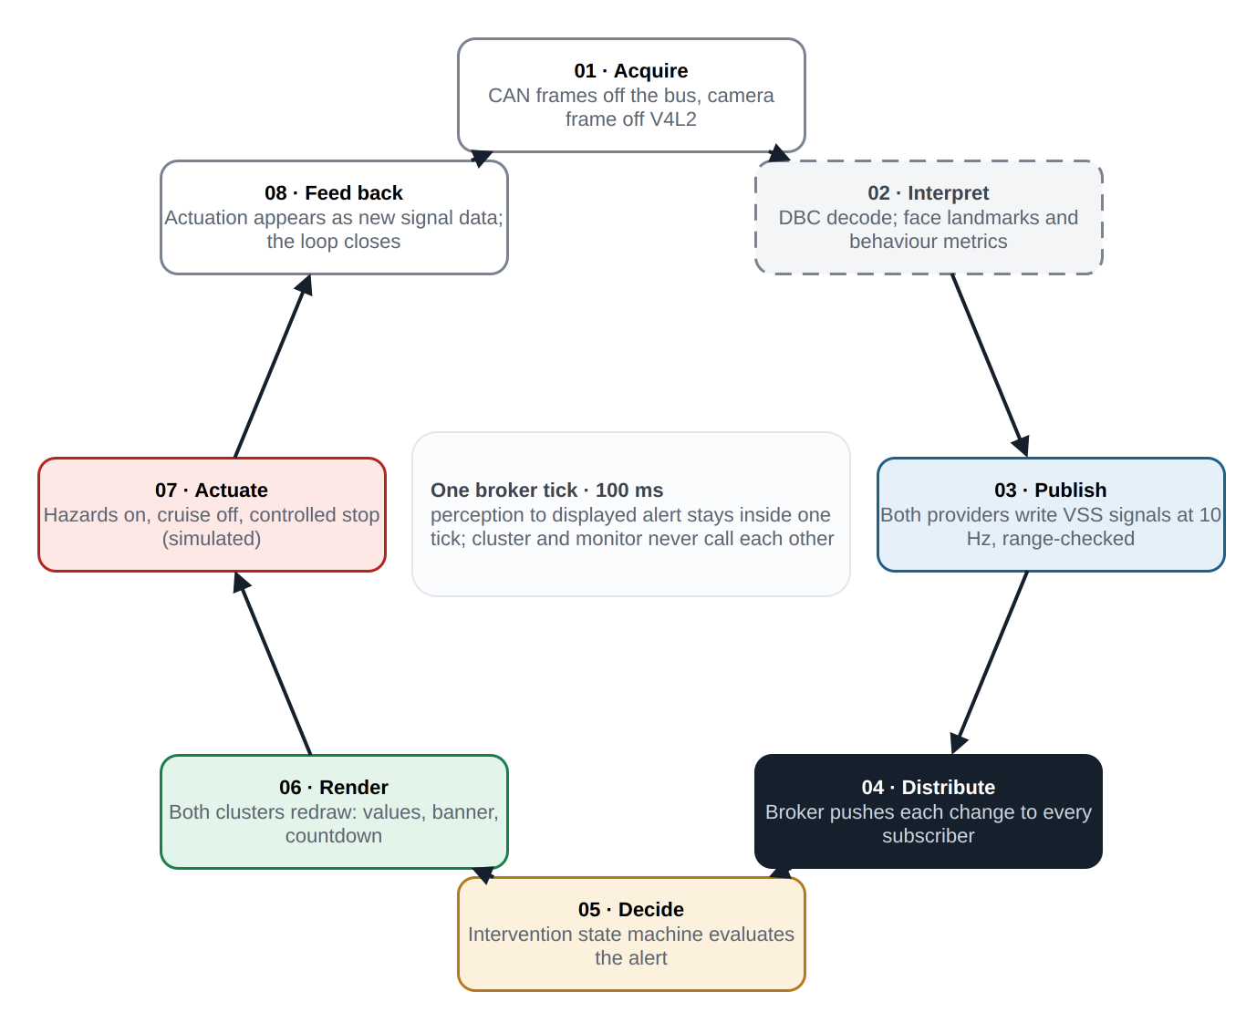
One turn of the cycle. It never stops turning, and no central coordinator drives it.
Source: docs/diagrams/runtime-loop.drawio.
Step | Name | What happens
01 | Acquire | CAN frames off the bus (simulator today), camera frame off V4L2
02 | Interpret | DBC decode on the vehicle side; face landmarks and behaviour metrics on the driver side
03 | Publish | Both providers write VSS signals at 10 Hz; the broker range-checks each value against the catalogue
04 | Distribute | The broker pushes each change down every open subscription stream; no provider knows who listens
05 | Decide | The simulator’s intervention state machine evaluates the alert state
06 | Render | Both clusters redraw: values, warnings, the alert banner, the countdown
07 | Actuate | Hazards on, cruise disengaged, controlled braking to standstill (simulated)
08 | Feed back | The actuation appears as new signal data and the loop closes without a central coordinator
Perception to displayed alert stays inside one 100 ms broker tick. Cluster and monitor never call each other.

6.1 Minimum-risk manoeuvre state machine
Held in the simulator’s cruise mode, driven only by Vehicle.Driver.Monitoring.AlertState:
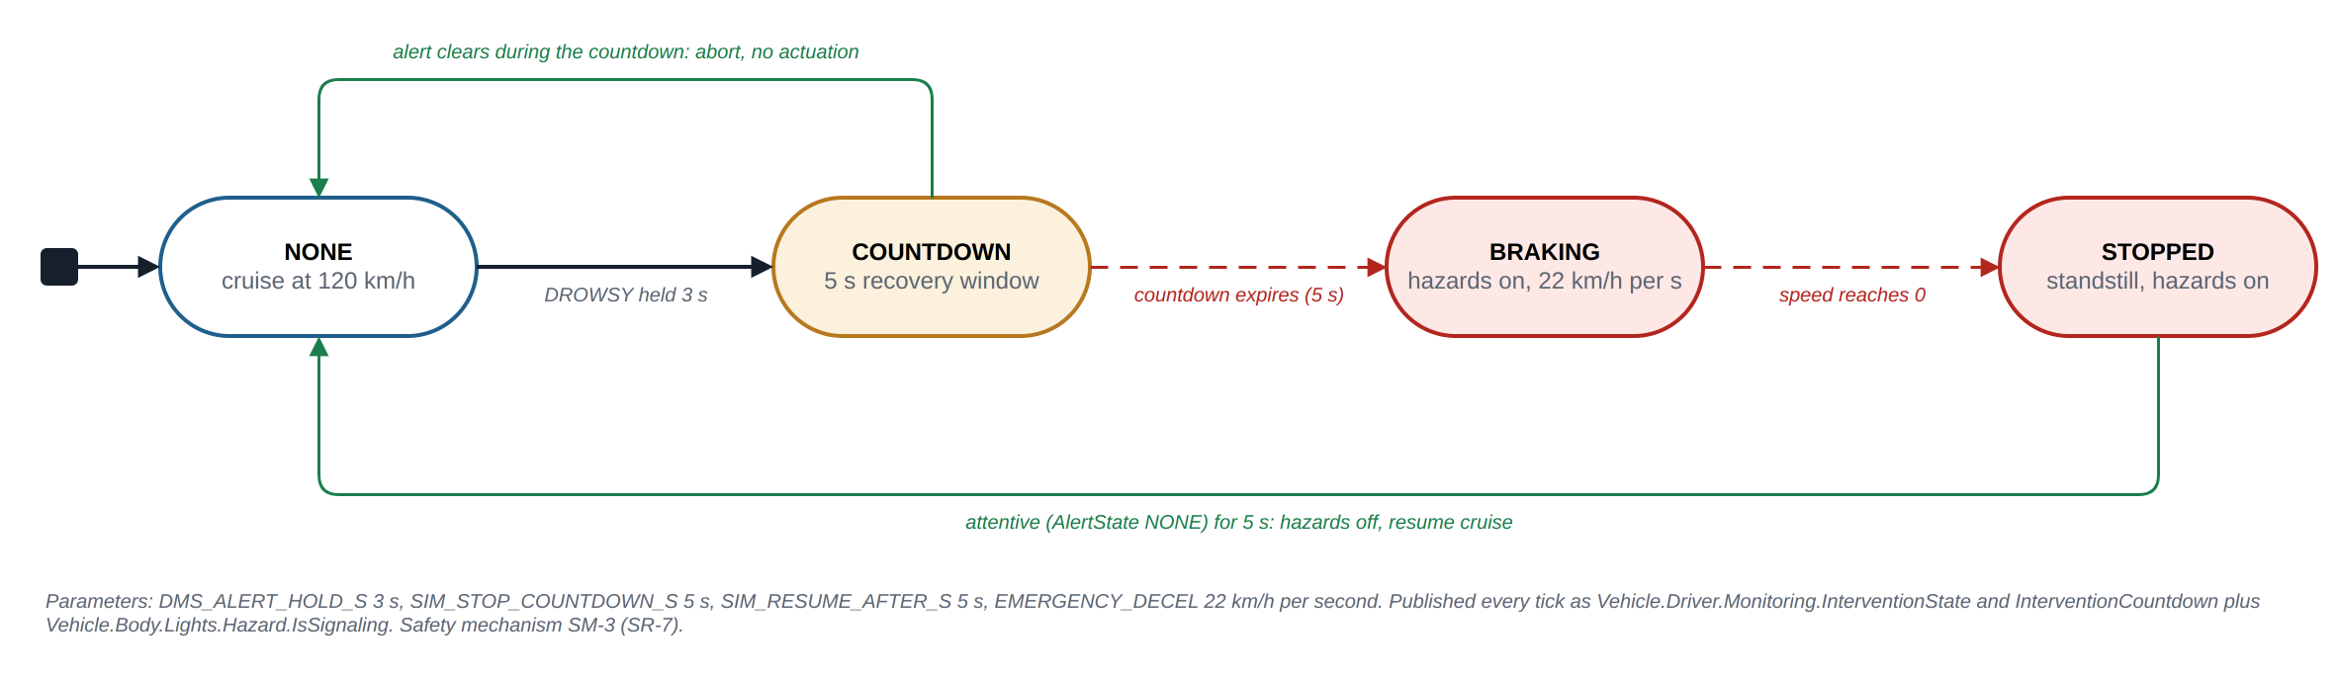
The minimum-risk manoeuvre state machine with its current parameters.
Source: docs/diagrams/mrm-state-machine.drawio.
State | Entry | Exit
NONE | Start, or countdown aborted, or resume complete | AlertState becomes DROWSY: go to COUNTDOWN
COUNTDOWN | DROWSY sustained past the 3 s alert hold | AlertState leaves DROWSY: back to NONE. Countdown of 5 s expires: go to BRAKING with hazards on
BRAKING | Countdown expired | Speed reaches 0: go to STOPPED
STOPPED | Standstill | AlertState NONE for 5 s: hazards off, resume cruise, back to NONE
The specification of this mechanism as a safety mechanism, with its parameters, is PULSE-SAF-001 SM-3.

7. Deployment view
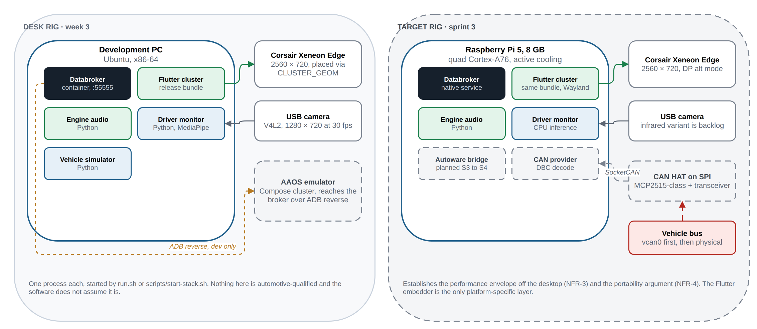
The desk rig at week 3 and the sprint 3 target rig. The same Flutter bundle runs on both; the embedder is the only platform-specific layer.
Source: docs/diagrams/deployment.drawio.

7.1 Desk rig, week 3
Node | Hosts | Notes
Development PC, Ubuntu, x86-64 | Databroker (container), simulator, driver monitor, engine audio, Flutter cluster | One process each; started by run.sh or scripts/start-stack.sh
Corsair Xeneon Edge | Flutter cluster surface | 2560 x 720, DisplayPort alt mode; located at runtime
USB camera | Driver monitor input | 1280 x 720 at 30 fps
Android Automotive emulator | Compose cluster | Reaches the host broker through ADB reverse

7.2 Target rig, sprint 3
Node | Hosts | Notes
Raspberry Pi 5, 8 GB | The whole Linux stack | Establishes the performance envelope off the desktop (NFR-3)
CAN HAT on SPI | MCP2515-class controller with transceiver | Exposed as SocketCAN; vcan0 first
Corsair Xeneon Edge, USB camera | As above
Nothing on either rig is automotive-qualified, and the software does not assume it is.

8. Design decisions and deviations
Recorded here because PULSE-SAF-001 SR-10 requires every decision that could block a later ASIL argument to be written down with its rationale.
ID | Decision | Rationale | Consequence for a production programme
DD-1 | HMI toolkit: Flutter on Linux as the primary path | AGL’s cluster toolkit of choice; open source; one engineer can reach it | No safety-qualified Flutter renderer exists; a production cluster would need a qualified renderer or a supervisor that verifies the drawn output (SR-6)
DD-2 | Second HMI: Jetpack Compose on Android Automotive | Answers the sponsor’s question with a measured pair | AAOS platform footprint is 25x the Linux path; Linux stays primary
DD-3 | Broker: Eclipse KUKSA databroker in a container | Reference implementation of the VSS broker; used by AGL | Container runtime is a desk convenience; target deployment runs it as a native service
DD-4 | API version: kuksa.val.v1 | Matches AGL and its overlay | Migration to v2 when AGL moves; stubs regenerate from the protos
DD-5 | Signal catalogue pinned to VSS 6.0 | Constraint C-2 | Upgrades are reviewed changes; the AGL overlay must be re-validated per version
DD-6 | Development transport: plaintext gRPC on loopback (--insecure) | Desk rig, one host | Removed by CS-3 in sprint 2; start-up warning until then
DD-7 | Window system on the desk rig: X11 with xrandr placement | Development host convenience | Target uses Wayland; the runner reads CLUSTER_GEOM so placement logic does not change
DD-8 | Driver monitor runs on CPU, no accelerator | 6.5 ms per frame is already inside budget; avoids hardware dependence (A-2) | A production DMS would still need an infrared camera and a qualified evaluation set (backlog)
DD-9 | Safety-loop actuation lives in the simulator | No vehicle exists; the manoeuvre must be demonstrable | On a real vehicle the actuation moves to a motion controller; the trigger signal contract stays
DD-10 | Databroker image consumed at tag latest | Convenience at project start | Violates NFR-8; pin to the 0.7.0 digest in sprint 2
DD-11 | Flutter SDK version not pinned | Convenience at project start | Violates NFR-8; pin via FVM or a recorded version in sprint 2

9. Verification approach
Level | What | When
Signal contract test | Every path in appendix A resolves in vss_agl.json with the expected type and unit; overlay paths present | Sprint 2, then every demo
Provider range test | Simulator and driver-monitor outputs stay inside catalogue ranges over a full cycle | Sprint 2
Broker smoke test | Broker up, tree served, a subscribe stream receives updates within one tick | Sprint 2, then every demo
UI smoke test | Each HMI launches, connects, and renders a known value | Sprint 2
HMI purity check | No CAN or DBC token in HMI source (FR-11) | Sprint 2
Benchmark | CPU, memory, artefact size under the replayed cycle, both HMIs | Sprint 4
Clean-machine bring-up | From README and ONBOARDING.md only | Done 2026-08-18; repeated at handover

Appendix A. Signal contract

A.1 Signals consumed by the HMIs
VSS path | Datatype | Unit | Source | Notes
Vehicle.Speed | float | km/h | Simulator | Primary value
Vehicle.Powertrain.CombustionEngine.Speed | uint16 | rpm | Simulator | Redline band, shift ghost
Vehicle.Powertrain.Transmission.SelectedGear | int8 |  | Simulator | -1 = R, 0 = N, 126 = P, 127 = D
Vehicle.Powertrain.Transmission.PerformanceMode | string |  | Simulator | Allowed values uppercase
Vehicle.Powertrain.FuelSystem.RelativeLevel | uint8 | percent | Simulator
Vehicle.Powertrain.FuelSystem.Range | uint32 | m | Simulator
Vehicle.TraveledDistance | uint32 | m | Simulator | Odometer
Vehicle.Chassis.Axle.Row1.Wheel.Left.Tire.Pressure | uint16 | kPa | Simulator | Front left
Vehicle.Chassis.Axle.Row1.Wheel.Right.Tire.Pressure | uint16 | kPa | Simulator | Front right
Vehicle.Chassis.Axle.Row2.Wheel.Left.Tire.Pressure | uint16 | kPa | Simulator | Rear left
Vehicle.Chassis.Axle.Row2.Wheel.Right.Tire.Pressure | uint16 | kPa | Simulator | Rear right
Vehicle.Body.Lights.Hazard.IsSignaling | boolean |  | Simulator | Set during the manoeuvre
Vehicle.Driver.HeartRate | uint16 | bpm | Simulator
Vehicle.Driver.AttentiveProbability | float | percent | Driver monitor
Vehicle.Driver.FatigueLevel | float | percent | Driver monitor
Vehicle.Driver.DistractionLevel | float | percent | Driver monitor
Vehicle.Driver.IsEyesOnRoad | boolean |  | Driver monitor
Vehicle.Driver.Monitoring.IsActive | boolean |  | Driver monitor | Overlay
Vehicle.Driver.Monitoring.AlertState | string |  | Driver monitor | Overlay; NONE, DROWSY, DISTRACTED, NO_FACE
Vehicle.Driver.Monitoring.InterventionState | string |  | Simulator | Overlay; NONE, COUNTDOWN, BRAKING, STOPPED
Vehicle.Driver.Monitoring.InterventionCountdown | uint8 | s | Simulator | Overlay; 0 when idle
Vehicle.Motorsport.LapNumber | uint16 |  | Simulator | Overlay
Vehicle.Motorsport.LapTime.Current | float | s | Simulator | Overlay
Vehicle.Motorsport.LapTime.Best | float | s | Simulator | Overlay; 0 until a lap completes
Vehicle.Motorsport.DRS.IsAvailable | boolean |  | Simulator | Overlay
Vehicle.Motorsport.DRS.IsActive | boolean |  | Simulator | Overlay
Vehicle.Motorsport.ERS.Level | uint8 | percent | Simulator | Overlay; max 100
Vehicle.Motorsport.ERS.State | string |  | Simulator | Overlay; DEPLOY, HARVEST, IDLE

A.2 Overlay files
File | Adds | Origin
vss/agl_vss_overlay.vspec | AGL’s cockpit signals: steering-wheel switches, infotainment, navigation, acceleration, angular velocity | AGL meta-agl-demo, vss-agl_6.0
vss/pulse_vss_overlay.vspec | Vehicle.Motorsport branch: lap number, lap times, DRS, ERS | PULSE
vss/dms_vss_overlay.vspec | Vehicle.Driver.Monitoring branch: active, alert state, intervention state, countdown | PULSE

A.3 Regeneration
The compiled tree is regenerated from the pinned VSS 6.0 specification and the three overlays by the command in the README section “Regenerate the VSS JSON”. Regeneration has been confirmed byte-identical (FR-3).

