PULSE Instrument Cluster
Cybersecurity Concept, preliminary (ISO/SAE 21434, UNECE R155)
Ahmed Abdelghany
2026-09-03
Table of Contents

Document control
Field | Value
Document ID | PULSE-SEC-001
Title | Cybersecurity Concept, preliminary
Version | 0.9.2
Status | Skeleton for sprint 1 review; not security-reviewed
Date | 2026-09-03
Author | Ahmed Abdelghany
Reviewer | Security manager, not yet assigned
Review gate | Sprint 1 review for structure; sprint 2 review for content
Parent | PULSE-SyRS-001
Related | PULSE-StRS-001, PULSE-SAD-001, PULSE-SAF-001, PULSE-RTM-001

Change log
Version | Date | Author | Change
0.9 | 2026-09-03 | A. Abdelghany | First skeleton: item and trust boundaries, assets, preliminary TARA, controls, development-configuration deviations, update concept outline, CS-1 to CS-11 with status
0.9.1 | 2026-09-03 | A. Abdelghany | Threat map and update-flow diagrams added; trust-boundary diagram moved to draw.io
0.9.2 | 2026-09-03 | A. Abdelghany | CS-9 and CS-11 status updated for the regression suite

1. Purpose and proportionality
The stack is a broker on an internal network with two consumers, two providers and one camera-based sensor. The security work is proportionate to that. The goal is the same as for safety: produce the artefacts a programme would need under ISO/SAE 21434 and UNECE R155, and remove the shortcuts that only exist because this runs on a desk.
Nothing in this document has been reviewed by a security manager. Ratings are the project engineer’s proposals.

2. Item and trust boundaries (CS-2)
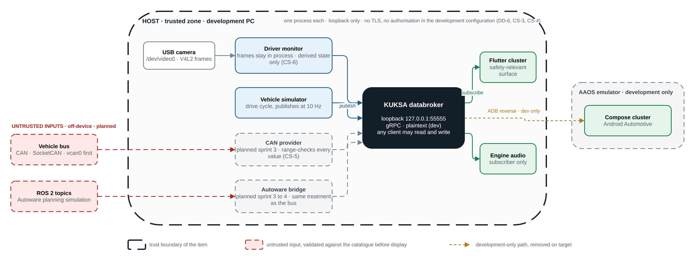
Item and trust boundaries in the development configuration, with the planned untrusted inputs.
Source: docs/diagrams/pulse-trust-boundaries.drawio (edit in draw.io, re-export with scripts/build-docs.sh).
Boundary | On-device or off-device | Trust today | Trust target
Broker gRPC endpoint | On-device, loopback only | Anyone on the host can read and write | Mutual TLS, per-client write authorisation (CS-3, CS-4)
Camera | On-device | Trusted input; frames stay in process | Same; add tamper and covering detection as backlog
Vehicle bus | Off-device (planned) | Not present | Untrusted; every decoded value range-checked (CS-5)
Autonomy stack | Off-device (planned) | Not present | Untrusted; same treatment as the bus
ADB reverse to the emulator | Development only | Trusted | Removed on target; the Android surface reaches the broker over an authenticated channel
Container image registry | Off-device | Image pulled at tag latest | Pinned digest, verified (CS-8)

3. Assets
Asset | Property to protect | Damage scenario
Safety-relevant signals (speed, gear, alert, intervention) | Integrity, availability | Driver misled; unintended manoeuvre
Signal catalogue (vss_agl.json) | Integrity | Broker serves a tampered tree; range checks bypassed
Camera frames | Confidentiality | Driver surveillance; privacy breach
Driver-state signals | Confidentiality, integrity | Personal data leakage; spoofed drowsiness
Broker configuration and credentials | Confidentiality, integrity | Unauthorised control of the signal path
Software artefacts (bundle, APK, container image) | Integrity, authenticity | Malicious update
Third-party dependencies | Integrity | Supply-chain compromise

4. Preliminary threat analysis and risk assessment (CS-1)
Attack feasibility per ISO/SAE 21434 annex: high, medium, low, very low. Impact: severe, major, moderate, negligible. Risk 1 to 5 from the standard’s matrix.
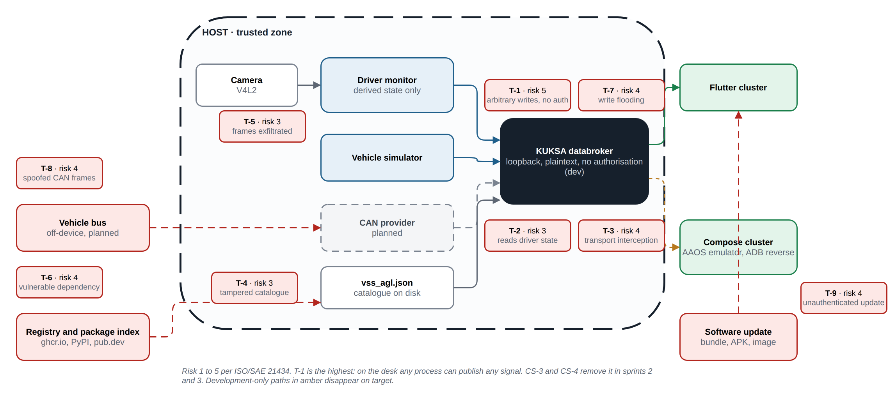
The nine threat scenarios placed on the architecture, with their risk values.
Source: docs/diagrams/tara-map.drawio.
ID | Threat scenario | Asset | Feasibility today | Impact | Risk | Treatment
T-1 | A process on the host publishes arbitrary values for speed or alert state to the broker | Safety-relevant signals | High (no authentication, no authorisation) | Severe | 5 | CS-3, CS-4: authenticate clients, authorise writes per client
T-2 | A process on the host subscribes to driver-state signals | Driver-state signals | High | Moderate | 3 | CS-3: authenticated transport; read scoping is backlog
T-3 | Interception or modification of gRPC traffic | Signals | Low on loopback; high once off-device | Severe | 4 at target | CS-3: mutual TLS before any off-device client
T-4 | Tampered signal catalogue mounted into the broker | Catalogue | Medium (file on disk, read-only mount) | Major | 3 | CS-8, CS-9: catalogue checksum in the regression suite; FR-3 reproducibility
T-5 | Camera frames exfiltrated or persisted by a modified driver monitor | Camera frames | Low | Severe (privacy) | 3 | CS-6: code review and a test that no file is written; process has no network beyond loopback
T-6 | Malicious or vulnerable dependency (Python package, Dart package, container image) | Dependencies | Medium (latest tag, no SBOM) | Major | 4 | CS-8: pinned digests, SBOM, vulnerability check
T-7 | Flooding the broker with writes to starve subscribers | Availability | High | Major | 4 | CS-4 limits writers; rate limiting is backlog; staleness detection (SR-4) keeps the display honest
T-8 | Spoofed CAN frames on the bus once the CAN provider exists | Safety-relevant signals | Medium on a physical bus | Severe | 4 | CS-5: range and plausibility checks; bus-level security is outside the item
T-9 | Unauthenticated software update replaces the cluster bundle | Artefacts | Medium | Severe | 4 | CS-10: signed packages, rollback on failure

5. Controls and the development-configuration deviations
Control | Requirement | State today | Removal of the shortcut
Transport encryption and client authentication | CS-3 | Broker started with --insecure, loopback only. The choice is recorded here and as DD-6 in PULSE-SAD-001, satisfying IR-5 | Sprint 2: enable TLS in the databroker with development certificates under certs/dev/ marked non-production; start-up prints a red warning whenever --insecure is used
Per-client write authorisation | CS-4 | None; any client can set any signal | Sprint 3: KUKSA JWT authorisation with one token per provider scoped to its signal set; consumers get read-only tokens
Catalogue validation of incoming values | CS-5 | Broker rejects wrong datatype, disallowed enumerations and out-of-range values on set | Sprint 2: HMI-side check as defence in depth; test that an out-of-range publish is refused
Camera data stays local | CS-6 | Driver monitor never writes frames and publishes derived state only | Sprint 2: test asserting no file output and no socket other than the broker
Security event logging | CS-7 | None | Sprint 3: broker and provider logs for authentication failure, refused write, client disconnect; timestamped; no personal data
Dependency pinning and SBOM | CS-8 | Python pinned in requirements.txt; Dart locked in pubspec.lock; container at latest; no SBOM | Sprint 2: pin the image digest; generate a CycloneDX SBOM per component; run a vulnerability check in the regression suite
No secrets in the repository | CS-9 | No credentials exist; nothing to leak | Sprint 2: secret scan in the regression suite; development certificates clearly named and gitignored where private
Update concept | CS-10 | None | Sprint 4: section 6 completed

6. Update concept (CS-10)
Outline, to be completed in sprint 4. UNECE R155 and R156 make this a type-approval matter, so the concept is written now and executed later.
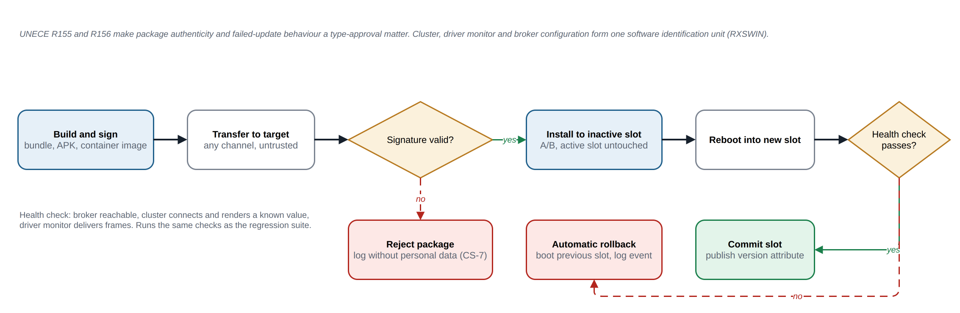
Update concept: signed package, A/B slot install, health check, automatic rollback.
Source: docs/diagrams/update-flow.drawio.
- Package authenticity: every deliverable (Linux bundle, APK, container image) is signed; the target verifies the signature before installation.
- Version identification: the cluster displays and publishes its software version as a VSS attribute so a fleet can be audited.
- Failed update: A/B slots on the Linux target; a failed boot after update reverts to the previous slot automatically; the Android side relies on the platform’s own A/B mechanism.
- Scope of RXSWIN: the cluster, driver monitor and broker configuration form one software identification unit for R156 purposes.

7. Cybersecurity requirements
ID | Requirement | Verification | Status (W3) | Evidence
CS-1 | A threat analysis and risk assessment (TARA) shall be recorded for the signal path, covering the broker, both HMI clients, the telemetry provider and the camera input, with attack feasibility rated per threat scenario (ISO/SAE 21434-15). | I | Partial | Section 4, nine scenarios; not yet security-reviewed
CS-2 | The item boundary and its trust boundaries shall be documented, distinguishing on-device interfaces from anything reachable off the device. | I | Implemented | Section 2
CS-3 | Broker communication shall support authenticated, encrypted transport (mutual TLS). Running without it shall be a configuration reserved for local development and flagged at start-up. | T | Planned S2 | Section 5; --insecure in scripts/start-databroker.sh today
CS-4 | Write access to the signal tree shall be authorised per client. A consumer shall not be able to publish, and no client shall write outside its declared signal set. | T | Planned S3 | Section 5
CS-5 | Signal values received from any provider shall be range- and type-validated against the catalogue before display, so a compromised provider cannot drive arbitrary content onto the cluster. | T | Partial | Broker-side validation implemented by KUKSA; HMI-side check and test in S2
CS-6 | Camera frames shall not leave the device and shall not be persisted. Only derived state, such as the drowsiness level, shall be published. | I | Implemented | emulator/dms.py publishes six derived signals and writes no files; test in S2
CS-7 | Security-relevant events, including authentication failure, unauthorised write attempt and client disconnection, shall be logged with a timestamp and without personal data. | T | Planned S3 | Section 5
CS-8 | All third-party dependencies shall be pinned and inventoried as a software bill of materials, and the inventory shall be checkable against published vulnerabilities. | T | Partial | Python and Dart pinned; container image at latest; no SBOM. S2
CS-9 | No credential, key or certificate shall be committed to the repository; the development configuration shall use clearly marked non-production material. | T | Implemented | Suite check secrets scans every tracked file for key and credential patterns; passing
CS-10 | An update concept shall be described for cluster and monitor software, covering authenticity of the package and behaviour on a failed update, as required for type approval under UNECE R155 and R156. | I | Planned S4 | Section 6 outline
CS-11 | Cybersecurity requirements shall be verified as part of the sprint regression suite, not as a separate end-of-project activity. | T | Partial | Suite exists (scripts/regression.sh) with range and secret checks for CS-5 and CS-9; CS-6 and CS-8 checks join in S2

8. Verification in the regression suite (CS-11)
From sprint 2 the regression suite run before every demo includes: catalogue checksum (T-4), out-of-range publish refused (CS-5), driver monitor writes no files and opens no socket other than the broker (CS-6), dependency vulnerability check against the SBOM (CS-8), secret scan (CS-9), and, once CS-3 lands, a check that the broker refuses a plaintext client unless the development flag is set.

