PULSE Instrument Cluster
System Requirements Specification
Ahmed Abdelghany
2026-09-03
Table of Contents

Document control
Field | Value
Document ID | PULSE-SyRS-001
Title | System Requirements Specification
Version | 1.2
Status | Draft frozen for review
Date | 2026-09-03
Author | Ahmed Abdelghany
Reviewer | Cockpit Electronics / HMI Platform Group (sponsor)
Review gate | Sprint 1 review, week 3, 4 September 2026
Parent | PULSE-StRS-001
Related | PULSE-SAD-001, PULSE-SAF-001, PULSE-SEC-001, PULSE-RTM-001

Change log
Version | Date | Author | Change
0.1 | 2026-08-25 | A. Abdelghany | Requirements FR-1 to FR-17, IR-1 to IR-5, NFR-1 to NFR-8 drafted
1.0 | 2026-09-03 | A. Abdelghany | Verification method, week-3 status and evidence added per requirement; driver monitoring (FR-18 to FR-21) and autonomy provider (FR-22) added; safety and security requirements moved to PULSE-SAF-001 and PULSE-SEC-001; frozen for review
1.1 | 2026-09-03 | A. Abdelghany | Requirement-group map added to the system overview
1.2 | 2026-09-03 | A. Abdelghany | Evidence for FR-3, FR-4, FR-6 and FR-11 now points at the regression suite (scripts/regression.sh) and its committed reports

1. Introduction

1.1 Purpose
This document states what the PULSE system shall do, in numbered, verifiable requirements. It realises the stakeholder needs in PULSE-StRS-001. The architecture that satisfies these requirements is in PULSE-SAD-001. Functional-safety and cybersecurity requirements are held in PULSE-SAF-001 and PULSE-SEC-001 so that their respective reviewers own them.

1.2 Conventions
Requirement IDs are stable. A withdrawn requirement keeps its number and is marked withdrawn; a new one takes the next free number. “Shall” is binding. “Should” is a recommendation.
Verification method uses the standard four:
Code | Method | Meaning
I | Inspection | Reading code, configuration or documents
A | Analysis | Reasoning, calculation or static analysis
D | Demonstration | Running the system and observing behaviour, no measured pass criterion
T | Test | Executed check with a recorded pass or fail
Status at week 3 uses:
Status | Meaning
Implemented | Met by the current build; evidence named
Partial | Partly met; the gap and its sprint are named
Planned S2 / S3 / S4 | Not yet started; scheduled for that sprint

1.3 System overview
PULSE is an instrument-cluster demonstrator on a standards-based software-defined-vehicle data stack. A KUKSA databroker serves a COVESA VSS 6.0 signal tree with overlays. Providers (a drive-cycle simulator, a camera-based driver monitor, later a CAN feeder and an Autoware bridge) publish into it. Two HMIs built from one visual design, Flutter on Linux and Jetpack Compose on Android Automotive, subscribe from it. Full detail is in PULSE-SAD-001.
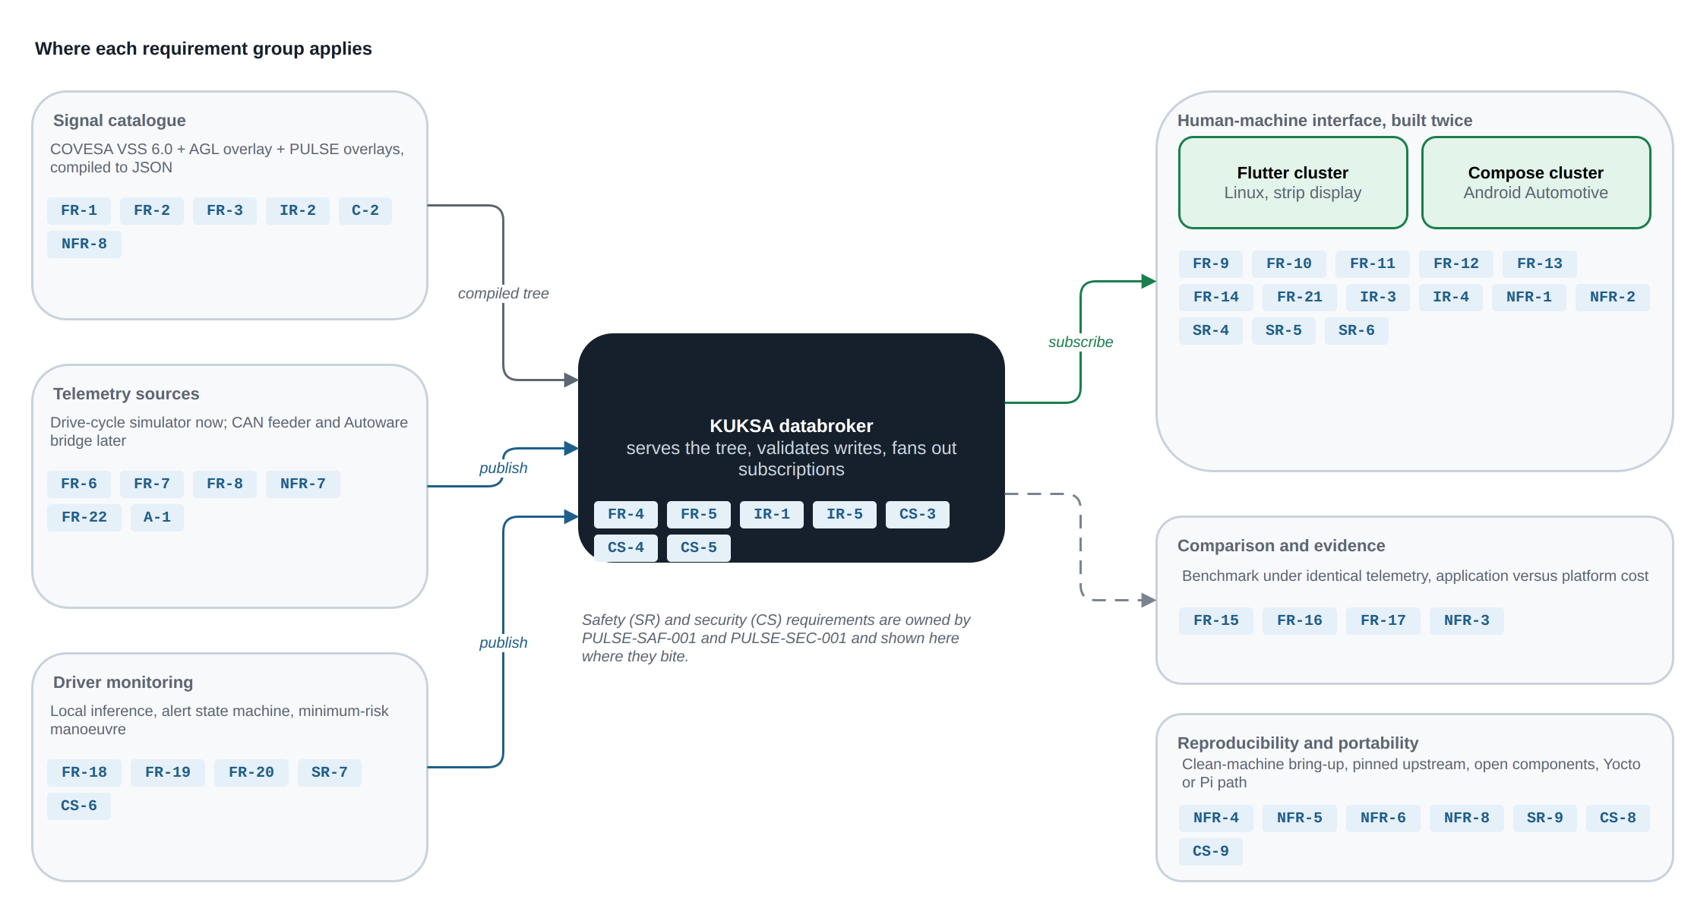
Where each requirement group applies on the system. Safety and security IDs are shown where they bite; their text lives in PULSE-SAF-001 and PULSE-SEC-001.
Source: docs/diagrams/requirements-map.drawio.

2. Functional requirements

2.1 Vehicle data abstraction
ID | Requirement | Verification | Status (W3) | Evidence
FR-1 | The system shall represent all vehicle data using an open, standardised signal catalogue (COVESA VSS), not proprietary or bus-specific identifiers. | I | Implemented | vss/vss_agl.json compiled from VSS 6.0; 1,302 leaf signals
FR-2 | The system shall extend the standard catalogue for domain-specific signals using the standard overlay mechanism only, with no forks of the upstream specification. | I | Implemented | vss/agl_vss_overlay.vspec, vss/pulse_vss_overlay.vspec, vss/dms_vss_overlay.vspec; upstream spec consumed unmodified
FR-3 | The compiled signal tree shall be reproducible from versioned source files by a documented command. | T | Implemented | README “Regenerate the VSS JSON”; byte-identical regeneration checked by the regression suite (vss-regeneration), report in docs/evidence/
FR-4 | A central broker shall serve the signal tree and allow multiple independent clients to subscribe concurrently. | D | Implemented | KUKSA databroker 0.7.0; Flutter cluster, Compose cluster and engine-audio service subscribe concurrently; suite check broker-up
FR-5 | Signal producers and consumers shall be mutually decoupled: neither needs knowledge of the other’s implementation. | I | Implemented | Providers and HMIs share no code, only VSS paths (PULSE-SAD-001 section 4)

2.2 Telemetry source
ID | Requirement | Verification | Status (W3) | Evidence
FR-6 | The system shall provide a telemetry source that generates physically plausible, correlated vehicle behaviour (speed, engine speed, gear, temperature, fuel, odometer) without any vehicle hardware. | D | Implemented | emulator/telemetry_sim.py: lap and cruise cycles, gear-dependent acceleration, RPM from speed and gear, fuel and odometer integrated from speed; suite check live-telemetry sees speed and RPM change within 3 s
FR-7 | The telemetry source shall run a repeatable cycle so that UI behaviour can be compared across runs and across implementations. | T | Partial | Cycle is a fixed phase table with no randomness, but sampling is wall-clock driven so two runs differ in sample timing. Fixed-step or recorded-log replay planned S4 with the measurement package
FR-8 | The telemetry source shall be replaceable by a real vehicle-bus provider without modification to any HMI code. | T | Partial | Met by design (HMIs subscribe to VSS paths only); verified when the virtual CAN feeder replaces the simulator in S3

2.3 Human-machine interface
ID | Requirement | Verification | Status (W3) | Evidence
FR-9 | The HMI shall display, updating live: road speed, engine speed with warning and redline indication, selected gear, fuel level and range, per-corner tyre pressures, and driver-relevant status indicators. | D | Implemented | pulse-cluster/lib/screen/pulse_screen.dart; subscribed paths listed in PULSE-SAD-001 appendix A
FR-10 | The HMI shall display motorsport telemetry: current lap number, current and best lap time, aerodynamic (DRS) state, and energy-recovery (ERS) level and state. | D | Implemented | Vehicle.Motorsport.* overlay signals rendered by both HMIs
FR-11 | The HMI shall subscribe to abstract signals only. It shall not contain CAN frame parsing, DBC knowledge, or hardware-specific decoding. | T | Implemented | Regression suite check hmi-purity scans both HMI sources for CAN, DBC and SocketCAN tokens; passing, report in docs/evidence/
FR-12 | The HMI shall be implemented twice, once in Flutter for Linux and once in Compose for Android Automotive, from a single shared visual design. | I | Implemented | pulse-cluster/ (Flutter) and pulse-cluster-android/ (Compose); design source in design/
FR-13 | Both implementations shall consume the identical signal source, so any observed difference is attributable to the platform, not the data. | D | Implemented | Both subscribe to the same broker on port 55555 via kuksa.val.v1
FR-14 | The HMI shall render full-screen on the target strip display, and shall degrade gracefully to a normal window when that display is absent. | D | Implemented | run.sh locates a 2560 x 720 output at runtime and passes CLUSTER_GEOM; unset means a normal window

2.4 Comparison and evidence
ID | Requirement | Verification | Status (W3) | Evidence
FR-15 | The system shall support measurement of both implementations under identical telemetry: CPU utilisation, memory footprint, and shipped artefact size. | T | Partial | Measured once by hand (BRIEF.md key result: 123 MB vs 46 MB app memory, 12.2 % vs 11.5 % CPU, 50 MB vs 23 MB artefact). Scripted, repeatable benchmark planned S4
FR-16 | Measurements shall distinguish application-level cost from platform-level cost, since these drive different procurement decisions. | A | Partial | Platform memory reported separately (AAOS 3.2 to 4.0 GB from emulator); target-hardware figures planned S3 to S4
FR-17 | Results shall be documented such that a reviewer can reproduce them from the repository. | T | Planned S4 | Benchmark script and results file to be committed under docs/

2.5 Driver monitoring and closed loop
ID | Requirement | Verification | Status (W3) | Evidence
FR-18 | The system shall derive driver fatigue and distraction levels from a driver-facing camera using inference executed entirely on the local device, and publish them as VSS driver signals. | D | Implemented | emulator/dms.py: MediaPipe FaceLandmarker on CPU; publishes Vehicle.Driver.FatigueLevel, DistractionLevel, AttentiveProbability, IsEyesOnRoad at 10 Hz
FR-19 | The system shall maintain a driver alert state (NONE, DROWSY, DISTRACTED, NO_FACE) with a configurable hold time before raising and clear time before releasing an alert, so that momentary events do not flicker the display. | T | Implemented | DMS_ALERT_HOLD_S 3.0 s, DMS_ALERT_CLEAR_S 2.0 s; state published as Vehicle.Driver.Monitoring.AlertState
FR-20 | When in cruise mode and the alert state is DROWSY, the vehicle model shall execute a minimum-risk manoeuvre: a countdown during which driver recovery aborts the manoeuvre, then hazard lights and controlled braking to standstill, then automatic resume after sustained attention. | T | Implemented | telemetry_sim.py cruise mode: 5 s countdown, 22 km/h/s deceleration, resume after 5 s attentive; states published as Vehicle.Driver.Monitoring.InterventionState and InterventionCountdown. Specified as a safety mechanism in PULSE-SAF-001 SM-3
FR-21 | The HMI shall render the driver attention level, the active alert as a full-width banner distinguishable by colour per alert type, and the intervention countdown. | D | Implemented | Attention panel and banner in pulse_screen.dart; attention meter in classic_screen.dart

2.6 Autonomy provider
ID | Requirement | Verification | Status (W3) | Evidence
FR-22 | The system shall accept an autonomy-stack provider that publishes planned trajectory, detected objects and drive mode into the broker as VSS signals, so that the cluster can render an autonomy state without knowing the stack behind it. | D | Planned S3 | Autoware planning-simulation bridge, work package 04; VSS overlay for autonomy signals to be added under vss/

3. Interface requirements
ID | Requirement | Verification | Status (W3) | Evidence
IR-1 | Client-to-broker communication shall use a language-neutral RPC interface supporting streaming subscriptions. | I | Implemented | gRPC over HTTP/2, kuksa.val.v1 Subscribe stream; Dart and Kotlin stubs generated from the same .proto
IR-2 | Signal semantics (units, ranges, allowed enumeration values, and encodings) shall be defined in the signal catalogue, not in client code. | I | Implemented | Units, allowed lists and max in the .vspec overlays; broker rejects out-of-catalogue values on set
IR-3 | The target display interface shall be a 2560 x 720 automotive strip panel. | D | Implemented | Corsair Xeneon Edge on the desk rig; layout designed at 2560 x 720
IR-4 | Display placement shall be configurable at runtime, not fixed at compilation. | D | Implemented | CLUSTER_GEOM environment variable read by the Linux runner; run.sh derives it from xrandr
IR-5 | The system shall run without transport security in the local development configuration, and the security posture shall be an explicit, documented choice. | I | Partial | --insecure set in scripts/start-databroker.sh; documented as a deviation in PULSE-SEC-001 section 5. Start-up warning (CS-3) planned S2

4. Non-functional requirements
ID | Requirement | Verification | Status (W3) | Evidence
NFR-1 | Responsiveness: displayed values shall track the telemetry source with no perceptible lag at a glance. | D | Implemented | Fast signals at 10 Hz, one broker tick from publish to render; observed at the review demo
NFR-2 | Legibility: primary values (speed, gear, engine speed) shall be readable in a sub-second glance, consistent with driver-distraction practice. | D | Implemented | Design reviewed on the strip; numerals sized for the 720 px height
NFR-3 | Footprint: the Linux implementation shall be deployable on constrained embedded hardware; total platform footprint is a first-class evaluation criterion. | T | Planned S3 | Raspberry Pi 5 baseline, work package 03, week 9
NFR-4 | Portability: migration to a different SoC or to a Yocto/AGL image shall not require HMI rework. | A | Planned S3 | Argument to be recorded with the Pi 5 baseline; Flutter embedder is the only platform-specific layer
NFR-5 | Reproducibility: a new engineer shall be able to bring up the full stack on a clean machine from documentation alone. | T | Implemented | Clean-machine bring-up performed 2026-08-18 and recorded in ONBOARDING.md, six blockers closed
NFR-6 | Openness: the stack shall be built from open-source components, with no proprietary runtime licence required for evaluation. | I | Implemented | KUKSA (Apache-2.0), VSS (MPL-2.0), Flutter (BSD), MediaPipe (Apache-2.0), AOSP; NOTICE file for the face model
NFR-7 | Determinism: repeated runs of the same cycle shall produce the same signal sequence, so comparisons are valid. | T | Partial | Same as FR-7: value sequence is deterministic in shape, sample timing is not. Fixed-step replay planned S4
NFR-8 | Maintainability: upstream components shall be consumed at pinned versions, not floating heads. | I | Partial | kuksa-client==0.5.2 and Python deps pinned in requirements.txt; VSS pinned to v6.0; Dart deps locked in pubspec.lock. Gaps: databroker image tag latest, Flutter SDK version unpinned. Closing in S2

5. Constraints and assumptions
Constraints C-1 to C-5 and assumptions A-1 to A-3 are owned by PULSE-StRS-001 section 5 and apply here unchanged.

6. Requirement summary at week 3
Group | Implemented | Partial | Planned | Total
Functional FR | 16 | 4 | 2 | 22
Interface IR | 4 | 1 | 0 | 5
Non-functional NFR | 4 | 2 | 2 | 8
Total | 24 | 7 | 4 | 35
Safety (SR) and security (CS) requirements are summarised in their own documents. The generated PULSE-RTM-001 recomputes this table from the source rows and is the authoritative count.

