PULSE Instrument Cluster
Functional Safety Concept, preliminary (ISO 26262)
Ahmed Abdelghany
2026-09-23
Table of Contents

Document control
Field | Value
Document ID | PULSE-SAF-001
Title | Functional Safety Concept, preliminary
Version | 0.9.5
Status | Skeleton for sprint 1 review; not safety-reviewed
Date | 2026-10-02
Author | Ahmed Abdelghany
Reviewer | Safety manager, not yet assigned
Review gate | Sprint 1 review for structure; sprint 2 review for content
Parent | PULSE-SyRS-001
Related | PULSE-StRS-001, PULSE-SAD-001, PULSE-SEC-001, PULSE-RTM-001

Change log
Version | Date | Author | Change
0.9 | 2026-09-03 | A. Abdelghany | First skeleton: item definition, safety-relevant signals with freshness proposals, preliminary HARA, safety mechanisms including the minimum-risk manoeuvre, interference argument outline, qualification gap list, SR-1 to SR-11 with status
0.9.1 | 2026-09-03 | A. Abdelghany | Safety-mechanism placement and manoeuvre state-machine diagrams added
0.9.2 | 2026-09-03 | A. Abdelghany | SR-9 evidence updated for the regression suite
0.9.3 | 2026-09-08 | A. Abdelghany | Worked ASIL derivation added for H-7 so the S, E and C columns can be read without knowing the method. SM-2 and the item-definition context reworded. SR-1 evidence tightened. Glossary pointer added
0.9.4 | 2026-09-23 | A. Abdelghany | SM-1 implemented in both HMIs; SR-4, SR-5 and SR-9 to Implemented. Freshness judged by arrival time rather than broker timestamp, with the reason recorded in section 3
0.9.5 | 2026-10-02 | A. Abdelghany | SR-4 and SR-5 verified on the Compose cluster on a device: all eight freshness criteria, instrumented smoke test, captures of the degraded and recovered display. Flutter recovery after a broker restart fixed and recorded on the strip; empty subscription entries no longer count as arrivals

1. Purpose and disclaimer
The PULSE demonstrator is not a qualified safety item and no ASIL is claimed. This document establishes compliance readiness: the artefacts and design decisions a production programme would need, produced as a by-product of the build rather than retrofitted later.
Every rating in the hazard analysis is a proposal by the project engineer and has not been reviewed by a safety manager. Ratings are recorded so that a reviewer has something concrete to disagree with.
Abbreviations used here are defined in the glossary, PULSE-StRS-001 section 8.

2. Item definition (SR-1)
Field | Content
Item name | PULSE cluster and driver-monitoring function
Purpose | Present vehicle state to the driver on a strip display; detect driver drowsiness and distraction from a driver-facing camera; on sustained drowsiness, trigger a minimum-risk manoeuvre
Functions | F1 display of road speed, engine speed, gear, fuel, range, tyre pressures, indicators. F2 display of motorsport telemetry. F3 driver-state estimation and alerting. F4 minimum-risk manoeuvre trigger and status display
System boundary | As PULSE-SAD-001 section 3.1: catalogue, broker, providers, both HMIs, orchestration
Assumed vehicle context | A passenger car or race car with a single driver. The cluster is the primary source of speed and gear information. On a real vehicle a separate motion controller executes braking; on the desk rig the simulator stands in for it
Interfaces crossing the boundary | Camera frames in (V4L2); display surface out (DisplayPort); vehicle bus in (SocketCAN, planned); autonomy stack in (planned); Android surface out
Operational situations | Highway cruise, urban driving, track driving, standstill; day and night (night is backlog for the camera)
Assumptions on other elements | The vehicle bus delivers correct signals. The motion controller executes a commanded stop safely. The display panel renders what it is sent

3. Safety-relevant signals (SR-3, SR-5)
Signals whose corruption or loss could mislead the driver. Each carries a proposed freshness criterion: a value older than the criterion is invalid and shall be shown as degraded, not as its last value.
Signal | Why safety-relevant | Publish rate | Proposed freshness | Degraded presentation
Vehicle.Speed | Speed misjudgement; legal and collision consequences | 10 Hz | 500 ms | Numeral replaced by dashes, dial greyed
Vehicle.Powertrain.Transmission.SelectedGear | Unexpected direction of travel at low speed | 10 Hz | 500 ms | Gear glyph replaced by “?”
Vehicle.Powertrain.CombustionEngine.Speed | Over-rev, engine damage; secondary | 10 Hz | 500 ms | Dial greyed
Vehicle.Body.Lights.Hazard.IsSignaling | Driver must know the vehicle is signalling a stop | 10 Hz on change | 2 s | Indicator shown as unknown
Vehicle.Driver.Monitoring.IsActive | Driver may assume monitoring when there is none | 10 Hz | 1 s | “Monitoring unavailable” banner
Vehicle.Driver.Monitoring.AlertState | Missing alert is a false negative; false alert triggers the manoeuvre | 10 Hz | 1 s | Treated as NO_FACE (monitoring lost), never as NONE
Vehicle.Driver.Monitoring.InterventionState | Driver must know the vehicle is about to brake | 10 Hz | 500 ms | Banner “vehicle state unknown”
Vehicle.Driver.Monitoring.InterventionCountdown | As above | 10 Hz | 500 ms | Countdown hidden, banner stays
Both HMIs enforce these criteria (SM-1). Freshness is judged by when a value last arrived, on the HMI’s own monotonic clock, rather than by the broker’s timestamp: that needs no clock agreement between hosts and catches a lost broker or link as well as a stalled provider. Providers therefore republish every signal in this table on every tick even when its value is unchanged.

4. Preliminary hazard analysis and risk assessment (SR-2)
Ratings follow ISO 26262-3: severity S0 to S3, exposure E0 to E4, controllability C0 to C3. The ASIL column is what the standard’s table returns for that combination. It is a lookup, not a claim about the software.
Worked example, reading H-7 below, the highest rating in the table. The malfunction is a false detection of drowsiness that starts the manoeuvre while the driver is attentive. The effect is unintended braking in moving traffic, which can injure severely, so severity is S3. It applies during highway cruise, which almost every drive includes, so exposure is E4. A driver who is alert can react and override, so controllability is C2, not C3. S3 with E4 and C2 returns ASIL C. Every other row reads the same way.
ID | Malfunction | Operational situation | Effect | S | E | C | ASIL proposal | Safety goal
H-1 | Speed displayed too low | Any driving | Driver exceeds intended speed | S1 | E4 | C2 | A | SG-1 The displayed speed shall not be lower than the actual speed by more than a defined tolerance
H-2 | Speed display frozen at last value | Any driving | Driver trusts a stale value; worse than blank | S2 | E4 | C2 | B | SG-2 A stale speed shall be recognisable as stale within its freshness criterion
H-3 | Wrong gear indicated (D shown, R engaged) | Manoeuvring at standstill | Vehicle moves in an unexpected direction | S2 | E3 | C2 | A | SG-3 Gear indication shall match the engaged gear or show unknown
H-4 | Display blank | Any driving | Loss of information, driver aware | S1 | E4 | C1 | QM | SG-4 Loss of display shall be obvious, not plausible
H-5 | Hazard or stop indication missing during the manoeuvre | Highway cruise, manoeuvre active | Driver surprised by braking | S2 | E2 | C2 | QM | SG-5 Manoeuvre state shall be displayed before actuation begins
H-6 | Drowsiness not detected (false negative) | Highway cruise, drowsy driver | No alert, no manoeuvre | S3 | E2 | C2 | A | SG-6 Sustained drowsiness shall raise an alert within the hold time
H-7 | Drowsiness falsely detected, manoeuvre executed | Highway cruise, attentive driver | Unintended braking in traffic | S3 | E4 | C2 | C | SG-7 The manoeuvre shall not begin without a driver-recovery window and a visible countdown
H-8 | Alert shown but manoeuvre state stale | Manoeuvre in progress | Driver cannot predict vehicle behaviour | S2 | E2 | C2 | QM | SG-5 as above
H-7 is the finding to carry forward: the actuation side of the loop, not the display, would carry the highest ASIL in a production programme. That is why the manoeuvre is specified as a safety mechanism with a recovery window (SM-3) rather than as a feature.

5. Safety mechanisms
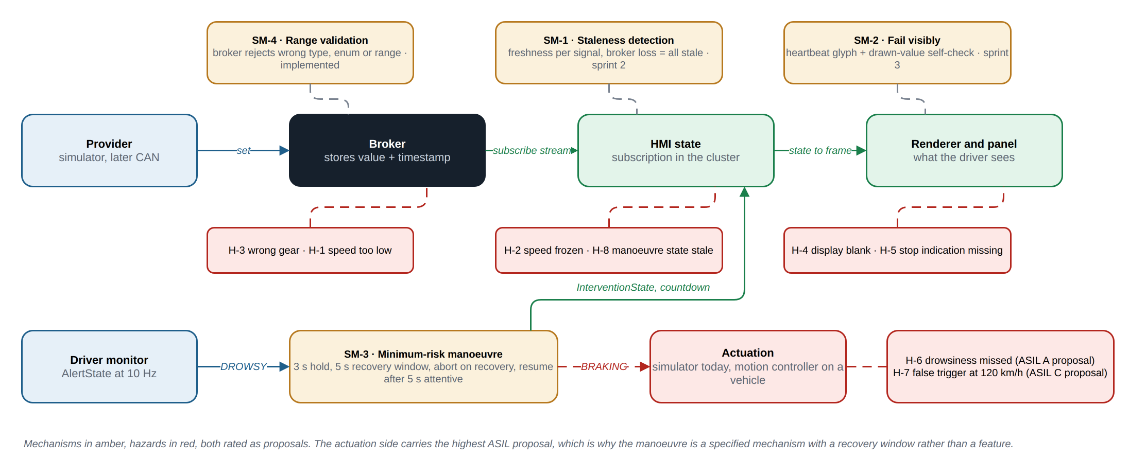
Where each safety mechanism sits on the signal path, and which hazards it addresses. Ratings are proposals.
Source: docs/diagrams/safety-mechanisms.drawio.

SM-1 Staleness detection and degraded display (SR-4, SR-5)
Each HMI shall track the arrival time of every safety-relevant signal and compare it to the freshness criterion in section 3 at least every 100 ms. Loss of the broker connection shall be treated as all signals stale at once. The degraded presentation in section 3 shall replace the value. Implemented in sprint 2: the Flutter cluster degrades within one second of the broker stopping, verified on screen and by widget test; the Compose cluster carries the same model, verified by compilation and unit test, not yet on a device.

SM-2 Fail visibly (SR-6)
A rendering fault shall not present a plausible but wrong value. Two mechanisms are proposed for the demonstrator. First, a heartbeat glyph that the renderer toggles every frame from the signal timestamp, so a frozen renderer becomes visible within one second. Second, a self-check that the speed numeral actually drawn matches the state value. A production programme would need more than this: a qualified renderer, or a supervisor that verifies the output (DD-1 in PULSE-SAD-001). Planned sprint 3.

SM-3 Minimum-risk manoeuvre on sustained drowsiness (SR-7)
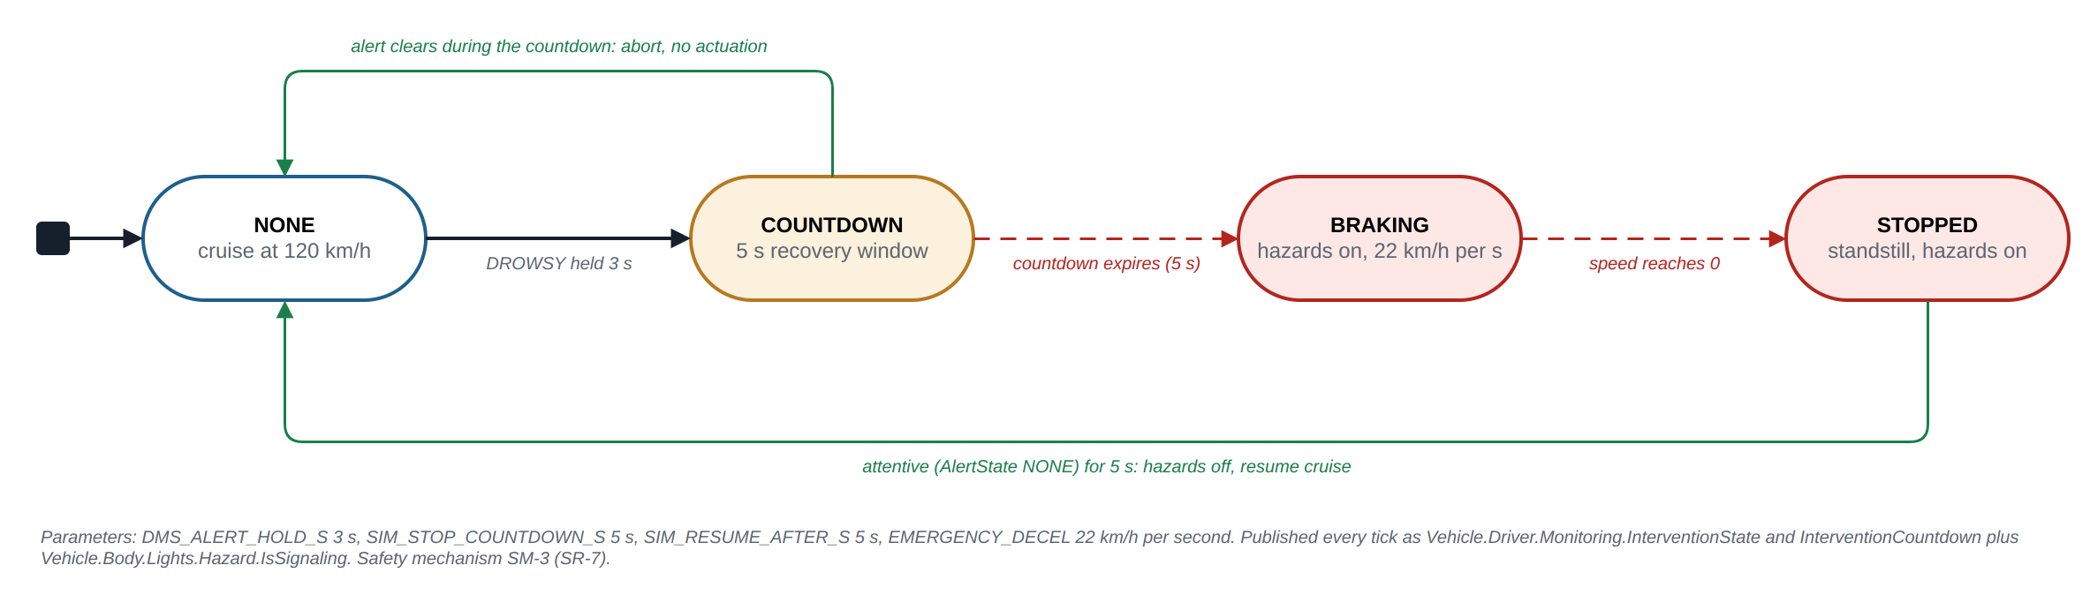
SM-3 as a state machine. Trigger, recovery window, escalation, abort and resume, with the current parameters.
Source: docs/diagrams/mrm-state-machine.drawio.
Element | Specification | Current value
Trigger condition | AlertState DROWSY sustained beyond the alert hold time, while in cruise mode | Hold 3.0 s (DMS_ALERT_HOLD_S), PERCLOS over 30 s window above 0.40, or microsleep over 1.5 s
Driver-recovery window | A countdown displayed on the cluster during which the alert clearing aborts the manoeuvre | 5 s (SIM_STOP_COUNTDOWN_S)
Escalation | Hazard lights on, cruise disengaged, controlled braking to standstill | 22 km/h per second, about 6 m/s squared
Abort condition | AlertState leaves DROWSY during the countdown | Immediate return to NONE
Resume | Driver attentive (AlertState NONE) for a sustained period after standstill | 5 s (SIM_RESUME_AFTER_S)
Status display | InterventionState and InterventionCountdown published every tick and rendered as a banner | Implemented
Implemented in the simulator’s cruise mode (FR-20). On a real vehicle the escalation moves to a motion controller; the trigger and status signal contract stays.

SM-4 Range validation at the broker (shared with CS-5)
The broker rejects values outside the catalogue’s datatype, allowed list or range, so a faulty provider cannot drive an impossible value onto the display. Implemented by KUKSA; a client-side check is added in sprint 2.

6. Freedom from interference (SR-8)
Argument outline for the mixed-criticality cockpit, to be completed in sprint 4:
- Spatial: the cluster and any infotainment surface run as separate processes; on the target, separate Wayland surfaces with the cluster surface always on top.
- Temporal: the cluster’s render loop does not depend on any infotainment process; broker fan-out is per-stream, so a slow subscriber does not delay another.
- Communication: infotainment is a subscriber only (CS-4 write authorisation); it cannot publish a safety-relevant signal.
- Evidence to produce: a stress test in which an infotainment process saturates CPU and the cluster’s frame time is measured.

7. Documented deviations (SR-10)
Held in PULSE-SAD-001 section 8, decisions DD-1 to DD-11. The ones that would block a later ASIL argument are DD-1 (unqualified renderer), DD-3 (container runtime), DD-7 (desk window system) and DD-9 (actuation in the simulator).

8. Qualification gap list (SR-11)
Component | What exists | What a production programme would still need
Linux kernel and board support | Ubuntu on x86-64; Raspberry Pi 5 planned | Safety-certified OS or a hypervisor partition for the cluster; qualified BSP
KUKSA databroker | Open-source Rust broker | Safety argument for the broker as a QM element with monitoring, or a qualified alternative; tool qualification not applicable
VSS toolchain | vss-tools at a pinned version | Tool confidence level assessment for the catalogue compiler
Flutter engine and renderer | Upstream Flutter, unqualified | Qualified renderer or output-verifying supervisor (SM-2)
Compose on Android Automotive | AOSP emulator | Not a candidate for the safety-relevant surface; infotainment only
Driver monitor | MediaPipe model on CPU | Evaluated dataset with known false-positive and false-negative rates; infrared camera; per-driver calibration; SOTIF (ISO 21448) analysis for the perception function
Simulator and actuation | Python simulator | Real motion controller with its own safety concept; PULSE only provides the trigger and status signals
Toolchain | Dart, Kotlin, Python, Bash | Qualified compilers where the safety-relevant code runs; coding guideline compliance

9. Safety requirements
ID | Requirement | Verification | Status (W3) | Evidence
SR-1 | An item definition shall be written for the cluster and driver-monitoring function, naming the system boundary, the assumed vehicle context, and the interfaces crossing that boundary (ISO 26262-3). | I | Partial | Section 2 of this document
SR-2 | A preliminary hazard analysis and risk assessment (HARA) shall be recorded for the displayed functions, with severity, exposure and controllability rated per malfunction and a resulting ASIL proposal. | I | Partial | Section 4; eight hazards rated; review in S2
SR-3 | Signals whose corruption or loss could mislead the driver (road speed, gear, warning indicators, drowsiness alert) shall be identified as safety-relevant and listed explicitly. | I | Implemented | Section 3
SR-4 | The system shall detect loss of a safety-relevant signal, including broker disconnection and stale values, and shall indicate the degraded state rather than continuing to display the last known value. | T | Implemented | SM-1. Flutter: pulse-cluster/test/cluster_smoke_test.dart, arrival_test.dart, and captures on the physical strip live, one second after the broker was stopped, and recovered within 4 s of its return (docs/evidence/screens/20261002-flutter-strip-*). Compose: FreshnessTest.kt, the instrumented ClusterSmokeTest.kt on the Android 16 car emulator (suite check compose-ui), and captures 1.4 s after the broker was stopped and after it returned, with no action on the app (docs/evidence/screens/20261002-compose-*)
SR-5 | Every safety-relevant signal shall carry a freshness criterion; a value older than its criterion shall be treated as invalid. | T | Implemented | Criteria in section 3 are the kFreshness table in vehicle_state.dart and FRESHNESS_NS in VssClient.kt, all eight in both since 2 October; providers republish them every tick (KEEPALIVE)
SR-6 | Safety-relevant display elements shall fail visibly. A rendering fault shall not present a plausible but wrong value. | T | Planned S3 | SM-2
SR-7 | The minimum-risk manoeuvre triggered by sustained driver drowsiness shall be specified as a safety mechanism: trigger condition, driver-recovery window, escalation, and abort condition. | D | Implemented | SM-3; implemented in emulator/telemetry_sim.py cruise mode; demonstrated live
SR-8 | Freedom from interference shall be argued for the mixed-criticality cockpit: infotainment content shall not be able to degrade or obscure the safety-relevant cluster surface. | A | Planned S4 | Section 6 outline
SR-9 | A safety-relevant requirement shall be traceable to the verification that demonstrates it, and each verification result shall be reproducible from the repository. | T | Implemented | PULSE-RTM-001 generated from this table; 16-check suite runs before each demo and in CI, report committed to docs/evidence/; SR-4 and SR-5 have named tests
SR-10 | Any decision that would block a later ASIL argument, such as the choice of graphics stack, operating system or toolkit, shall be recorded as a documented deviation with its rationale. | I | Implemented | PULSE-SAD-001 section 8, DD-1 to DD-11
SR-11 | A qualification gap list shall be maintained: for each component, what a production programme would still need (qualified toolchain, certified OS, evidence of a safety-qualified renderer). | I | Implemented | Section 8

10. Verification and traceability
Safety requirements are traced to user stories US-13, US-15 and US-17 in PULSE-StRS-001 and to their verification in PULSE-RTM-001. Test cases for SR-4, SR-5 and SR-6 are written in sprint 2 as part of the regression suite so that each demo re-runs them.

